Queue Dynamics and Service Capacity at the Los Libertadores Border Crossing
Mendoza, Argentina to Chile - Light Vehicles, 2024-2026
A Discrete-Event Simulation Calibrated to the Only Public Quantitative Series
Technical whitepaper - all data retrieved 2026-09-30

Abstract
This paper documents a discrete-event simulation of light-vehicle processing at the Paso Internacional Cristo Redentor / Los Libertadores crossing, the primary road border between Mendoza, Argentina and central Chile. The study had two objectives. The first was to calibrate simulated throughput against real data. The second was to test a set of operational claims about booth staffing, yard capacity and opening hours. Using 20 months of published monthly light-vehicle counts (470,210 vehicles over 608 days, retrieved from the concessionaire's monthly reports), the model reproduces observed monthly throughput with a mean absolute relative error of 3.39% on the calibration period and 1.45% on the held-out period. The utilisation sweep establishes that the observed configuration of 7 staffed car booths clears 120.0 vehicles per hour, placing the stability threshold at an offered peak of 120 vehicles per hour.
Three findings are reported. First, the stability threshold, not the absolute wait, is the defensible result: it does not depend on the intraday arrival profile, which the available data cannot identify. Second, yard capacity cannot reduce congestion at this facility under any staffing level; it relocates the queue rather than shortening it. Third, a common modelling shortcut - excluding the behaviour of drivers who abandon the queue - produces a qualitatively wrong answer to the yard-capacity question, and is shown here to be the single most consequential omission in this class of model. The paper is explicit about what its data cannot support: no public hourly series exists for this crossing, so no claim is made about intraday wait-time accuracy.

1. Introduction and Motivation
Paso Internacional Cristo Redentor (Argentine side) and Los Libertadores (Chilean side) form a single road border crossing through a mountain tunnel at approximately 2,952 m elevation. It is the dominant land corridor between Argentina and Chile and carries a strongly seasonal flow, driven by Argentine summer holidays, Chilean winter holidays and cross-border retail traffic. The facility operates as an integrated control (A.C.I.) under Resolution GMC 49/02 of the Mercosur, combining migratory, customs and agricultural inspection within a single physical complex.
The crossing is well known as a source of congestion, and press coverage documents extreme delays on peak holiday weekends. A full inventory of 10 dated press reports was compiled for this study; all are classified as anecdotal, and none constitutes a measurement. Their value is directional, not quantitative.
The operational question is not whether the crossing congests - that is not in dispute - but at what offered load it stops functioning, and which physical or organisational lever actually moves the outcome. Those are questions a queueing model can answer, provided the model is built so that its answer does not depend on quantities nobody has measured.
This paper reports a discrete-event simulation built for that purpose. The study also documents the reconstruction of an earlier prototype model, and the specific defects in that prototype that changed its conclusions. Those defects are set out in Section 8 because they are generalisable to this class of model and are, in the author's assessment, more instructive than the point estimates themselves.

2. Research Objectives
The study pursues four objectives, in descending order of how strongly the available data can support them.
- O1 (primary). Calibrate and validate simulated light-vehicle throughput against the only published quantitative series for this crossing: 20 consecutive months of MOP concessionaire counts, 2024-10 to 2026-05.
- O2. Establish the critical offered load at which the crossing ceases to admit a steady state, and report it as a utilisation ratio rather than as a wait. This objective is deliberately chosen because it is the only quantitative result that survives the absence of intraday data.
- O3. Test three operational claims: that yard capacity affects congestion; that opening-hour restrictions are a minor factor; and that booth count is the binding constraint.
- O4 (methodological). Identify and correct the defects in the prototype model, and quantify how much each defect changes the reported results.
Objective O2 deserves emphasis. A specific wait time - 'the queue on Friday afternoon is 90 minutes' - requires an intraday arrival profile to predict, and no such profile is published for this crossing (Section 4.3). A utilisation ratio does not: it is the ratio of offered to served load at the peak hour, which the model can express as a function of a single free parameter. The strongest defensible claim is therefore a threshold, not a number of minutes.

3. Theoretical Framework

3.1 The facility as a queueing network
The crossing is represented as a tandem network of four stages:
arrival -> gate (open/closed schedule) -> control area (yard) -> booth service
Stage 1 is a non-homogeneous Poisson arrival process, generating the per-vehicle state. Stage 2 is a deterministic availability constraint: the gate admits vehicles only within published opening hours, and vehicles arriving outside them are held, not discarded. Stage 3 is a finite-capacity waiting space. Stage 4 is a multi-server station with a general (lognormal) service-time distribution.
Each stage has a distinct capacity, and conflating them is the most common error in models of this facility. Booth count and staffing determine service capacity. The published simultaneous-vehicle figure determines physical space. The two are independent parameters, and the model in this paper keeps them separate.

3.2 Stability and utilisation
For a multi-server station with c servers, each of mean service time s, the utilisation is
rho = lambda / (c * mu), mu = 1 / s
A stationary waiting-time distribution with finite mean exists if and only if rho < 1. This is the central theoretical result for this study, and it is the basis for the principal finding. When rho > 1, no finite equilibrium wait exists: the queue grows without bound, and any finite mean computed from a truncated simulation run is an artifact of the run length rather than a property of the system.
Two distinct utilisations must be reported separately. The peak-hour utilisation rho_peak compares the arrival rate at the busiest hour against service capacity. The daily utilisation rho_daily compares the total daily offered load against the capacity of the open window. A system can satisfy rho_daily < 1 while violating rho_peak > 1, and this is exactly the regime the prototype model occupied: it cleared each day in aggregate while building an unbounded queue in every peak hour. The resulting delay is borne entirely by the vehicles that happened to arrive during the peak. Reporting only the daily ratio conceals the operative constraint.

3.3 Right-censoring and the non-stationary regime
In an unstable system, vehicles remaining in queue at the simulation horizon have no finite service start time. Their true waits are unobserved and finite, but larger than the remaining horizon. Any procedure that assigns them the horizon time minus their arrival time records a lower bound and reports it as if it were a measurement. The result is a distribution whose upper tail is truncated exactly where it becomes informative, which biases the mean and the high quantiles downward.
The model in this paper therefore reports, for every run: the fraction of arrivals never served; the queue length at the horizon; the peak-hour utilisation; and an explicit verdict of STATIONARY or UNSTABLE OFFERED LOAD. When a run is unstable, its wait statistics are labelled as conditional statistics and are never presented as equilibrium estimates.
A related trap deserves recording. A common non-stationarity test asks whether the queue is still growing at the horizon. In the absence of abandonment this test is informative. In the presence of abandonment it is not: as shown in Section 7.3, the queue saturates at a bounded level maintained by the very act of giving up, and a growth test then reports a reassuring result for a system that is in fact losing a large and growing share of its customers. The test adopted here is the theoretical one - rho_peak versus 1 - not an empirical trend.

3.4 Balking and reneging
Queueing models conventionally assume patience is infinite. At a land border this is false, and the assumption has a specific, perverse consequence. Under a work-conserving server, total time in system is governed by Little's law (L = lambda * W) and is independent of where the waiting space boundary sits. A larger yard therefore cannot reduce total waiting time: it only moves the queue from inside the booths to the road outside the gate, where the same vehicles wait the same total time.
That is why yard-capacity scenarios appear to 'do nothing' in models that omit abandonment. The invariance is real but it is a property of the assumed behaviour, not of the facility. Real drivers do not queue indefinitely; the press record for this crossing documents drivers waiting out closures of 27 and 34 days, which bounds patience from below, and also documents turn-backs, which establish that a fraction of arrivals never attempt the crossing at all. The model therefore includes balking and reneging as an explicit, parameterised mechanism, and reports every yard-capacity result both with and without it.

3.5 Identifiability of the intraday profile
A non-homogeneous Poisson process is specified by a rate function lambda(t). Monthly totals constrain only its integral: the observed count for a month identifies the area under the curve, and leaves its shape entirely undetermined. The intraday profile used in this model is therefore an assumption, not an estimate.
This has a direct consequence for the calibration protocol, and it is the reason the validation reported in Section 7.1 is presented with a caveat. Because the daily arrival total is anchored to the observed monthly count, good monthly agreement is largely guaranteed by construction and is weak evidence that the model is correct. The calibration grid search in this study returned the verdict "BOUNDED, NOT IDENTIFIED": the objective function is monotone across the search grid with its minimum at the boundary, which means the monthly data bound the profile but do not identify it. Only an hourly series could close this gap, and the means of obtaining one are set out in Section 10.
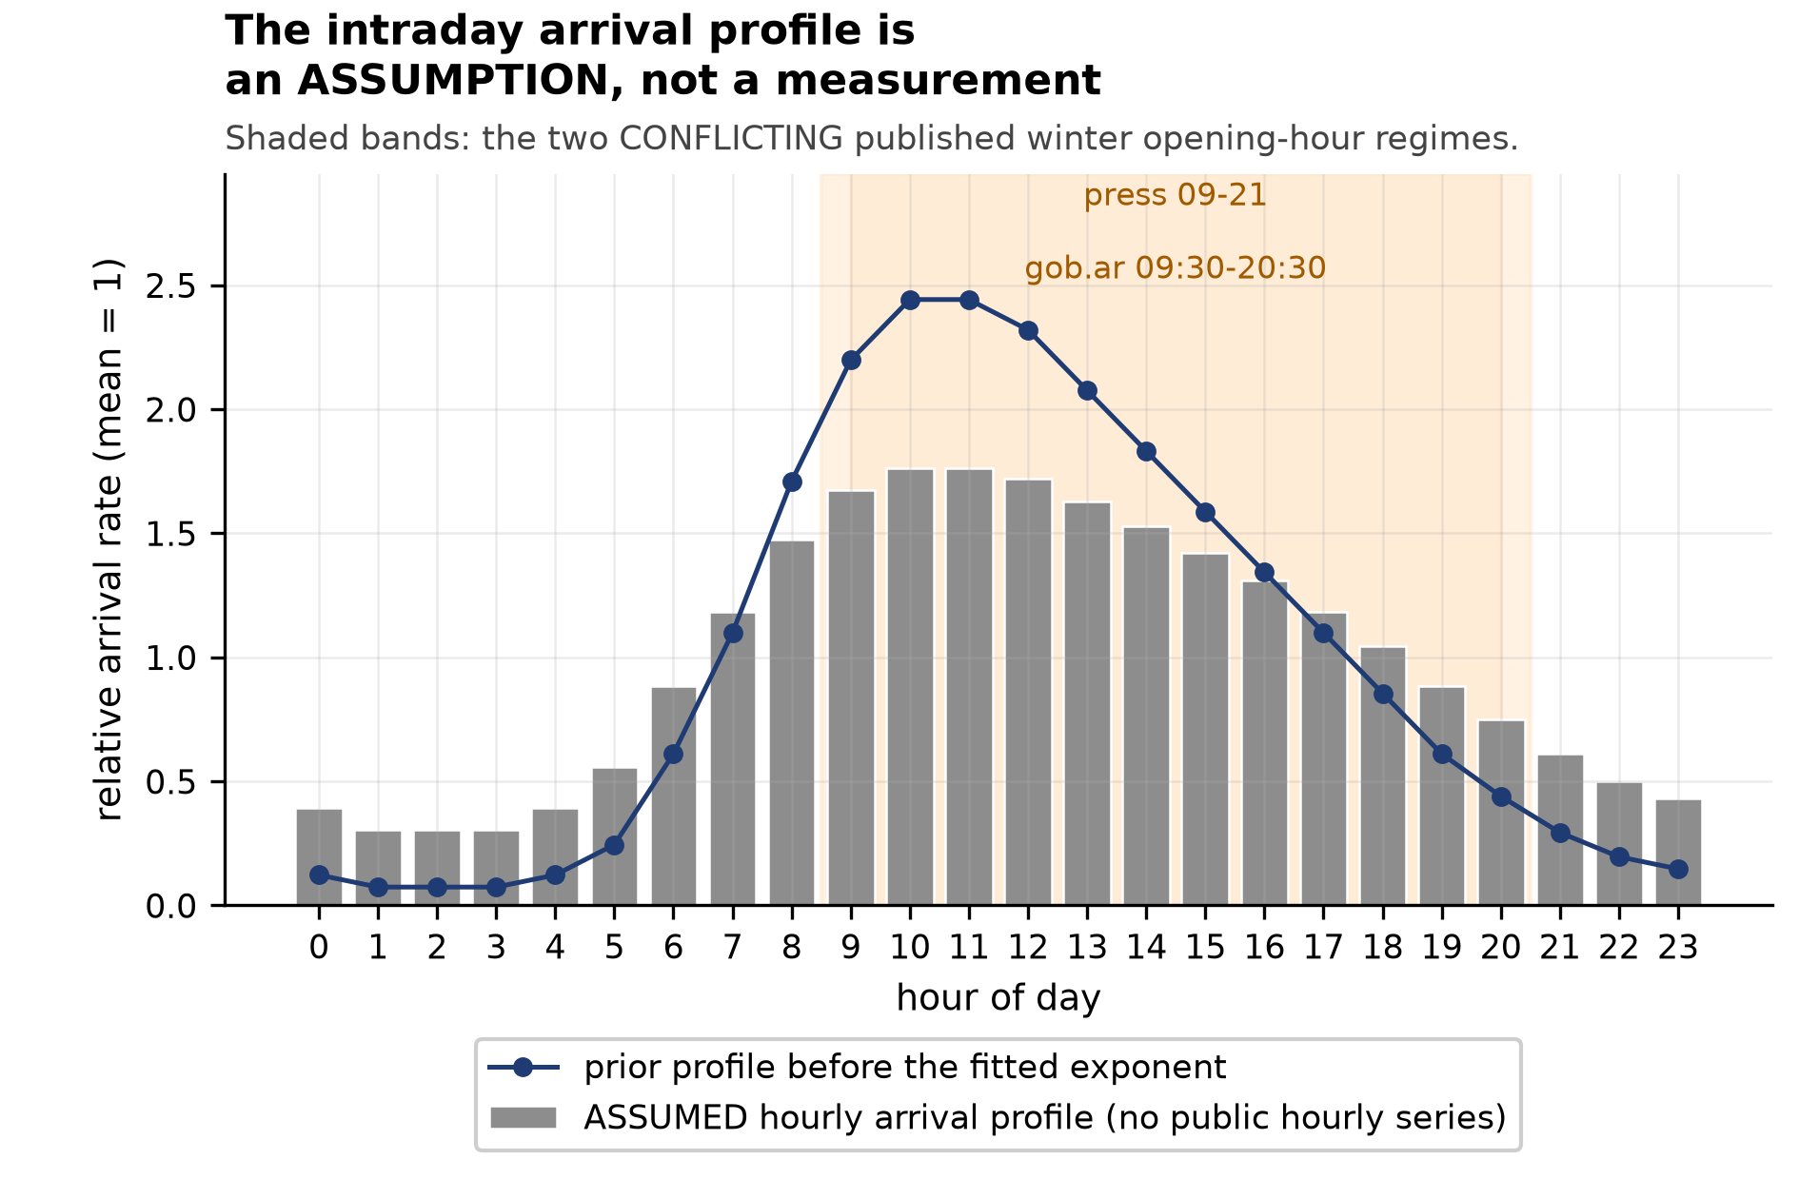
Figure 1. The assumed intraday arrival profile. This shape is NOT identified by the available data; it is an assumption, and it is the reason no intraday wait-time claim is made in this paper.

3.6 Reconstruction of the prototype: event-driven formulation
No systematic optimisation was applied to the prototype model; the defects documented in Section 8 are analytical. The reconstructed model removes the prototype's polling loops entirely in favour of a fully event-driven formulation, which changes computed wait times by a bounded but non-zero amount because the prototype's fixed-interval sampling injected quantisation error into every wait. The reconstruction is verified by assertion: a vehicle arriving one minute before a gate opening is confirmed to wait exactly one minute, and zero service starts are confirmed to occur outside published opening hours.

4. Data and Provenance
Every quantitative input in this study is a published figure with a retrievable source URL. The complete inventory is in the data/ directory accompanying this paper, one row per fact. Four of the 22 operating-parameter rows are recorded but used for nothing, and are marked as scope mismatches for the reasons in Section 4.4.

4.1 The primary series: monthly light vehicles
Source: Direccion General de Concesiones de Obras Publicas (MOP), Chile, monthly status report for the Nuevo Complejo Fronterizo Los Libertadores concession. Counts light vehicles entering Chile, classified by the concessionaire. 20 months are retrievable.
Table 1. Summary of the primary observed series.
Quantity | Value | Note
Months covered | 2024-10 to 2026-05 | consecutive
Total light vehicles | 470,210 | sum of published monthly counts
Total days | 608
Mean per day | 775 | derived
Busiest month | 2025-01 - 1,616/day | derived
Quietest month | 2025-06 - 266/day | derived
Seasonal amplitude | 6.1x | peak/trough, derived

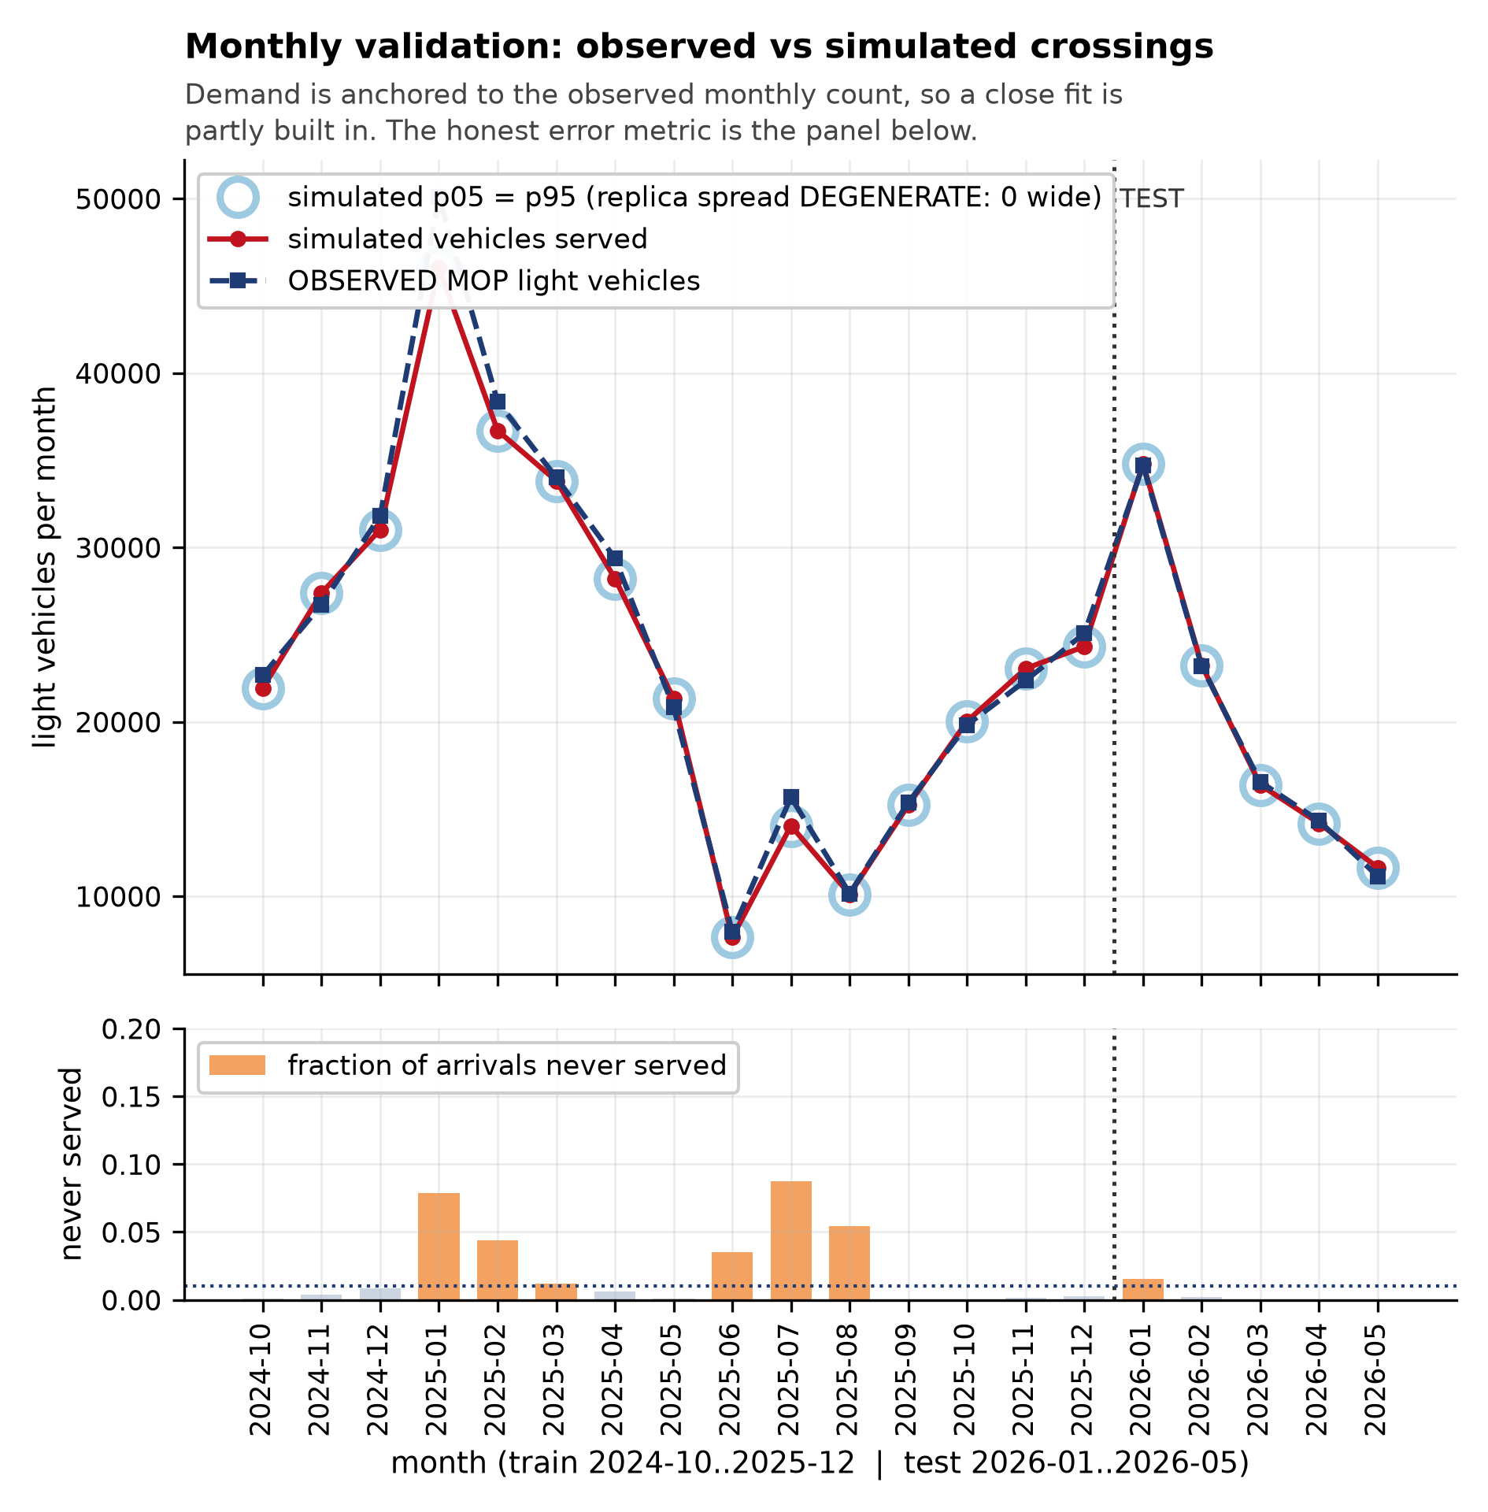
Figure 2. Simulated versus observed monthly throughput, with the calibration and held-out periods marked. The 5-95% band shown is degenerate (see Section 7.1).

4.2 Published operating parameters
Table 2. Observed capacity parameters. All sourced; see data/published_operating_parameters.csv.
Parameter | Value | Class | Maps to model field
Car booths staffed | 7 | OBSERVED | n_booths
Bus booths (excluded) | 5 | OBSERVED | not used: light vehicles only
Further booths on demand | 6 | OBSERVED | n_booths (complement scenario)
Simultaneous vehicles in complex | 15 | OBSERVED | control_area_capacity
Persons per vehicle | 3.2 | DERIVED | persons_per_vehicle

4.3 What does not exist, and why that constrains the paper
An explicit negative finding, established by systematic search, is that no public daily or hourly numeric series exists for this crossing. Specifically:
- MOP publishes monthly light-vehicle totals only. No daily breakdown was located in any monthly report, including those for 2024-01 to 2024-09 and 2026-06 onward, which were not retrievable at all.
- Argentina's Direccion Nacional de Migraciones publishes annual movement counts, not monthly or daily, and the reports were confirmed to contain no sub-annual tables.
- Chile's Unidad de Pasos Fronterizos publishes intraday open/close status timestamps, which are operating notices rather than measurements of flow or waiting time.
- The Mendoza provincial PasAr platform reports live wait-time bands and vehicle counts, but has no public archive, no historical query and no discovered API. It is the only hourly-resolution source located, and it is usable only prospectively.
The consequence is structural rather than temporary. No amount of additional modelling effort can produce intraday validation for this facility from existing published data. Any model of this crossing that reports hourly accuracy is reporting the modeller's assumptions, not evidence.

4.4 Recorded but deliberately unused
Four rows in the parameter inventory are recorded for transparency and used for nothing. The Argentine migration series is excluded for two independent reasons: its ENTRADA column counts movements into Argentina, which is the opposite direction from the one studied here, and it aggregates three separate complexes rather than the tunnel alone. A third problem is unresolved: the treatment of Argentine nationals in that series is contradicted between official and international sources, and was not adjudicated. A persons-per-vehicle ratio of 3.2 is used instead, derived from published persons and vehicle totals for the complex in 2018. Applying 3.2 to the observed October 2024 volume gives roughly 2,340 persons per day, against a press-reported baseline of about 2,500 travellers per day for September-October 2024. This is agreement in order of magnitude across two differently-scoped sources, and is recorded as suggestive corroboration only, not as validation.

5. Model Specification
The model is implemented in SimPy 4.1.2 and is fully event-driven: there is no fixed timestep, no polling loop and no sleep. Vehicles are typed records carrying arrival time, gate-wait, yard-wait, service start and service end, plus a cohort size in persons.

5.1 Demand
Arrivals follow a non-homogeneous Poisson process generated by thinning: a homogeneous process at the maximum rate is sampled, and each event is accepted with probability equal to the ratio of the instantaneous rate to that maximum. The daily arrival total is drawn from the observed series for the month under study, so a 'January 2025' scenario is on the real scale of 1,616 vehicles per day. Within the day, arrivals are shaped by an hourly profile and a day-of-week factor. Both shapes are assumptions; Section 3.5 explains why the available data cannot identify them.

5.2 Gate and opening hours
The gate admits vehicles only within the active window. Vehicles arriving outside it wait for the next opening rather than being discarded, so that a restricted-hours regime is modelled as a period-correct arrival stream rather than as a reduced one. Two regimes are carried: a 12-hour winter window corroborated by press reporting, and a 24-hour summer window. A conflict between two official Argentine sources over the actual hours is recorded in the parameter inventory and both readings are carried through to the results rather than one being silently chosen.
Dated closures are modelled as explicit scenarios, including the 26-hour closure of 19-20 February 2026 and the 27-day and 34-day closures of August 2026, all of which are documented in the press inventory.

5.3 Yard, service and abandonment
The control area is a finite-capacity waiting space; vehicles that cannot enter hold upstream. Service uses a lognormal distribution with mean 3.5 minutes per vehicle per booth. The number of staffed booths is a separate parameter from control-area capacity. Abandonment is modelled with a patience threshold; it is an assumption with no measurement behind it, and every result that depends on it is reported with abandonment both on and off.

6. Calibration and Validation Protocol
The protocol is designed so that a good fit cannot be confused with a correct model. Three safeguards apply.
- Temporal holdout. Calibration uses 2024-10 to 2025-12 (15 months). The held-out period is 2026-01 to 2026-05 (5 months), which is neither fitted nor used to select any parameter.
- Anchoring disclosure. The daily arrival total is anchored to the observed monthly count, so monthly agreement is partly built in. This is stated wherever a fit is reported, and it is the reason the fit statistics below are not offered as evidence that the intraday profile is correct.
- Band integrity. Reported uncertainty bands are replica spread only. They are not prediction intervals and cannot contain structural error, because no observed intraday series exists against which structural error could be measured.

7. Results

7.1 Throughput against the observed series
Table 3. Monthly throughput fit. Read subject to the anchoring caveat in Section 6.
Period | Months | RMSE (veh) | MAE (veh) | Mean abs. rel. error | Correlation
Calibration | 15 | 1,327 | -631 | 3.39% | 0.9959
Held-out | 5 | 255 | 76 | 1.45% | 0.9996

Throughput tracks the observed series closely across the full seasonal range, including the 1,616-vehicle peak month and the 266-vehicle trough, a 6.1-fold span. The three worst-fitting months are 2025-01 (-8.1%), 2025-07 (-10.4%) and 2025-12; all three are months in which the model reports an unstable offered load, which is discussed in Section 7.2 rather than treated as fit error.
7 of 20 months are classified UNSTABLE OFFERED LOAD. This is a property of the scenario, not a fit failure: in those months the modelled peak-hour utilisation exceeds 1, so the queue cannot drain, and the reported wait describes only the subset of drivers who were served. The abandonment share in those months ranges from 1.2% to 8.8%. These are the months in which the real crossing is most likely losing traffic to the Punta de Vacas, Penitentes and Uspallata waiting lots, and the model places that loss at the low end of the plausible range because the assumed patience budget is a floor, not a measurement.
A disclosure on uncertainty reporting: the monthly validation uses a single replica per month, so the 5-95% band is degenerate, with its lower and upper bounds both equal to the simulated mean. Band coverage computed from it is therefore vacuous and is not reported as a performance measure. The bands in Figure 2 carry this limitation. Re-running the validation with a larger replica count would produce a meaningful band, at the cost of a proportionately longer run.

7.2 The critical offered load
With the observed configuration of 7 staffed car booths, each booth clearing a vehicle every 0.5 minutes, service capacity is 120.0 vehicles per hour. The utilisation sweep traces the behaviour of the system as offered load is increased across that threshold.
Table 4. Utilisation sweep, 24-hour gate, 5 simulated days per level.
Offered peak (veh/h) | rho_peak | Mean wait (min) | P95 wait (min) | Abandoned | Max queue | Verdict
60 | 0.500 | 3.5 | 7.5 | 0.1% | 10 | STATIONARY
80 | 0.667 | 3.6 | 7.7 | 0.3% | 12 | STATIONARY
100 | 0.833 | 3.7 | 7.9 | 0.8% | 18 | STATIONARY
110 | 0.917 | 4.0 | 8.3 | 1.5% | 19 | UNSTABLE OFFERED LOAD
120 | 1.000 | 4.2 | 8.9 | 2.4% | 22 | UNSTABLE OFFERED LOAD
130 | 1.083 | 4.5 | 9.5 | 3.7% | 26 | UNSTABLE OFFERED LOAD
140 | 1.167 | 5.0 | 10.7 | 5.9% | 28 | UNSTABLE OFFERED LOAD
160 | 1.333 | 6.0 | 12.8 | 10.5% | 34 | UNSTABLE OFFERED LOAD
200 | 1.667 | 7.7 | 15.3 | 19.4% | 44 | UNSTABLE OFFERED LOAD
280 | 2.333 | 10.3 | 18.8 | 35.6% | 66 | UNSTABLE OFFERED LOAD
400 | 3.333 | 12.3 | 21.1 | 50.2% | 83 | UNSTABLE OFFERED LOAD
550 | 4.583 | 13.6 | 22.2 | 61.4% | 102 | UNSTABLE OFFERED LOAD
700 | 5.833 | 14.5 | 22.8 | 68.1% | 114 | UNSTABLE OFFERED LOAD

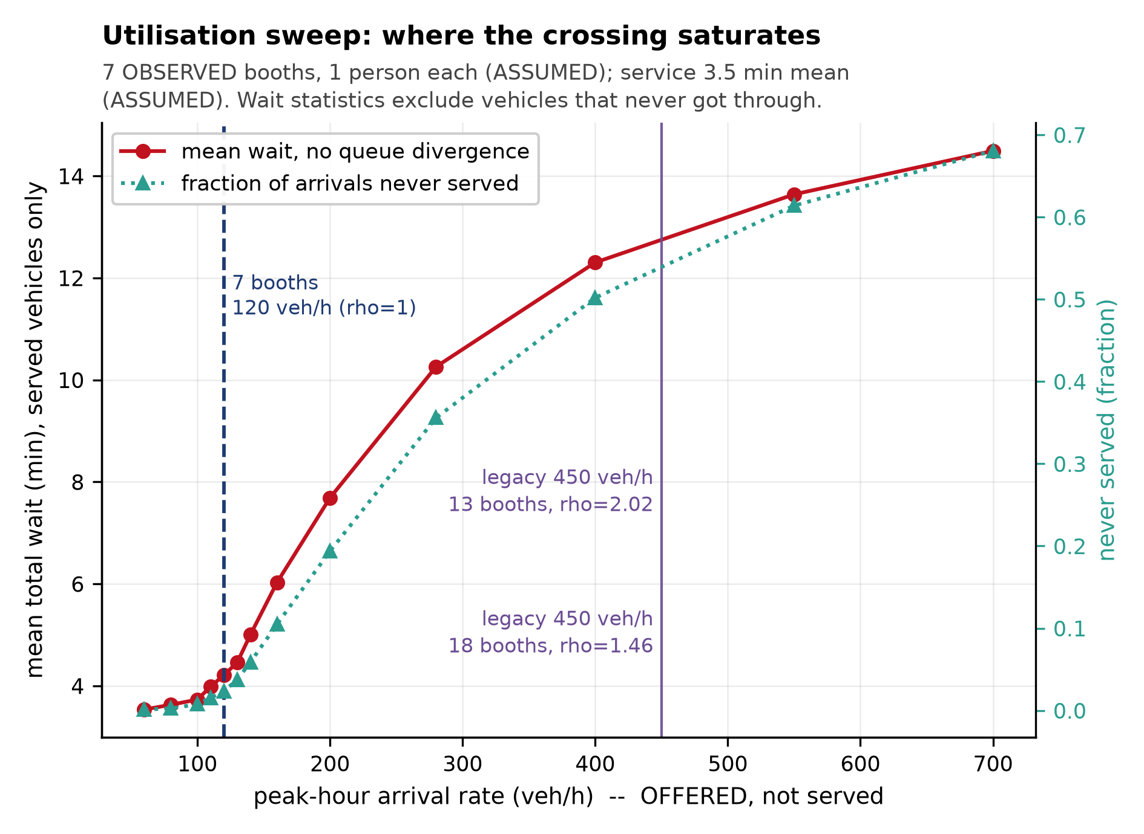
Figure 3. Offered load against wait and abandonment. The stability threshold is at rho_peak = 1, i.e. 120 vehicles per hour.
Four results follow, and they are ordered by how much they depend on unobserved behaviour.
- Critical load. The stability threshold sits at 120 vehicles per hour offered, which is rho_peak = 1 by construction. The last level at which the system remains a valid equilibrium is 100 vehicles per hour.
- The wait curve flattens. Mean wait rises only from 3.5 to 14.5 minutes across a more than eleven-fold increase in offered load. This is not congestion improving. It is abandonment removing the customers who would have experienced the queue, with the share abandoning rising from 0.1% to 68.1% over the same range. A model that reports a 13.6-minute mean at 700 vehicles per hour is describing a system that has turned away two thirds of its arrivals.
- Queue growth is not the test. With abandonment active the queue never diverges; it saturates at a bounded level that giving up maintains. A 'did the queue grow' test would therefore report a reassuring result for a system losing most of its customers. The theoretical test, rho against 1, is the one used here.
- Divergence, when abandonment is removed. Repeating the probe with abandonment off shows genuine divergence: mean wait 6.2 minutes at 120 veh/h, rising to 2,677 minutes with 16,546 vehicles queued at 700 veh/h. Same capacity, same load; the entire difference is who turned around.

7.3 Yard capacity cannot reduce congestion
Table 5. Yard capacity sweep, January peak demand. Upstream queue falls as the yard grows; total queue does not change.
Queue upstream | Queue inside | Total queue | Never served | Mean wait (min) | Verdict
704 | 0 | 720 | 2.5% | 181.2 | NON-STATIONARY
690 | 15 | 720 | 2.5% | 181.2 | NON-STATIONARY
660 | 45 | 720 | 2.5% | 181.2 | NON-STATIONARY
520 | 185 | 720 | 2.5% | 181.2 | NON-STATIONARY
120 | 585 | 720 | 2.5% | 181.2 | NON-STATIONARY
42 | 0 | 56 | 21.3% | 9.3 | UNSTABLE OFFERED LOAD
26 | 15 | 56 | 21.3% | 9.3 | UNSTABLE OFFERED LOAD
0 | 42 | 56 | 21.3% | 9.3 | UNSTABLE OFFERED LOAD
0 | 42 | 56 | 21.3% | 9.3 | UNSTABLE OFFERED LOAD
0 | 42 | 56 | 21.3% | 9.3 | UNSTABLE OFFERED LOAD

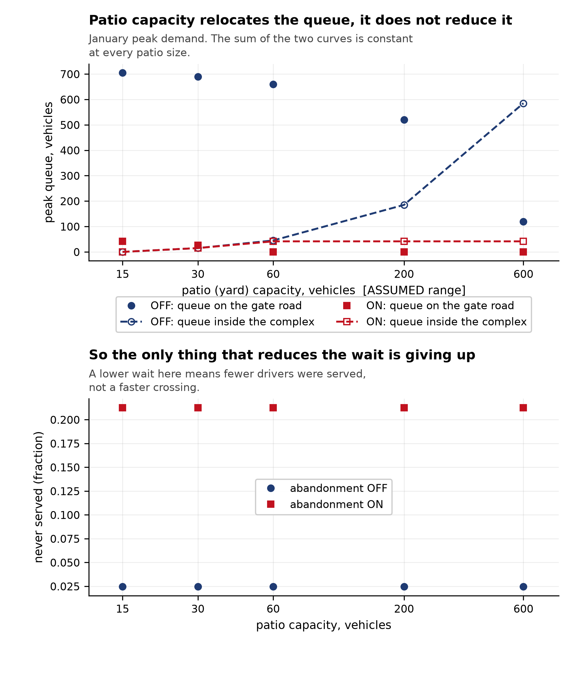
Figure 4. Yard capacity sweep. The total queue is invariant; only its location moves.
The invariance predicted by Little's law is confirmed exactly. Total queue is identical at every yard size, and mean wait is unchanged to the reported precision. What changes is where the vehicles wait: enlarging the yard from 15 to 600 vehicles moves the queue from the access road into the complex without shortening anybody's total wait.
The operational reading is not that yard capacity is useless. It is that yard capacity is not a congestion-control lever; it is a queue-location lever. Its real benefits - driver comfort, vehicle security, and the ability to hold a queue out of the access road during a closure - lie outside the wait metric this model reports, and this model should not be cited as evidence against them.

7.4 Booth staffing
Table 6. Staffing sensitivity. Published booth counts are observed; the number actually staffed is not.
Configuration | Staffed booths | Capacity (veh/h) | rho_peak | Mean wait (min) | Never served
observed 7 booths | 7 | 120.0 | 1.370 | 9.0 | 21.9%
observed 7, one booth unstaffed | 6 | 102.9 | 1.598 | 10.7 | 28.3%
on-demand complement, 13 staffed | 13 | 222.9 | 0.737 | 4.0 | 1.9%
on-demand complement, 12 staffed | 12 | 205.7 | 0.799 | 4.6 | 3.9%

Removing one booth from the observed seven removes 14.3% of capacity and raises the share of arrivals that are never served from 21.9% to 28.3%. At this facility, staffing is not a detail. The published booth count is an observed fact; the hours at which the on-demand complement of six booths is actually activated are not published, and the complement is applied statically in these scenarios, which is the most favourable reading available for it. A time-varying staffing schedule would perform worse.

7.5 Opening hours
Table 7. Opening-hour regimes. The two official sources disagree; both are carried.
Regime | Open h/day | rho_daily | Mean (min) | P95 (min) | Median (min) | Verdict
winter_press 09:00-21:00 | 12 | 0.185 | 35.1 | 186.6 | 3.60 | NON-STATIONARY
argentina 09:30-20:30 | 11 | 0.201 | 45.9 | 225.5 | 3.88 | NON-STATIONARY
argentina 24 h | 24 | 0.092 | 3.5 | 7.3 | 3.05 | STATIONARY
Feb 2026, 26 h closure, renege=on | 23 | 0.299 | 51.4 | 29.6 | 3.49 | UNSTABLE OFFERED LOAD
Feb 2026, 26 h closure, renege=off | 23 | 0.299 | 64.4 | 522.1 | 3.71 | STATIONARY
Feb 2026, no closure, renege=on | 24 | 0.287 | 3.9 | 8.4 | 3.35 | UNSTABLE OFFERED LOAD
Feb 2026, no closure, renege=off | 24 | 0.287 | 4.5 | 11.7 | 3.52 | STATIONARY
Aug 2026, 27-day closure, renege=on | 10 | 0.597 | 114.3 | 1,075.2 | 3.36 | UNSTABLE OFFERED LOAD
Aug 2026, 27-day closure, renege=off | 10 | 0.597 | 14,586.0 | 35,225.0 | 14,355.90 | STATIONARY
Aug 2026, 34-day closure, renege=on | 9 | 0.625 | 100.0 | 990.5 | 3.33 | UNSTABLE OFFERED LOAD
Aug 2026, 34-day closure, renege=off | 9 | 0.625 | 19,481.7 | 44,845.6 | 18,406.76 | STATIONARY

A gate that opens once per day makes the system periodic rather than stationary: the queue is empty at opening and accumulates overnight. No single mean wait is meaningful without stating where in the daily cycle it was measured, which is why the restricted regimes are reported NON-STATIONARY even at a daily utilisation of 0.18 to 0.20. Restricting hours concentrates rather than reduces delay: the same daily volume is compressed into a shorter window, and the median wait rises while the mean is dominated by the overnight cohort.
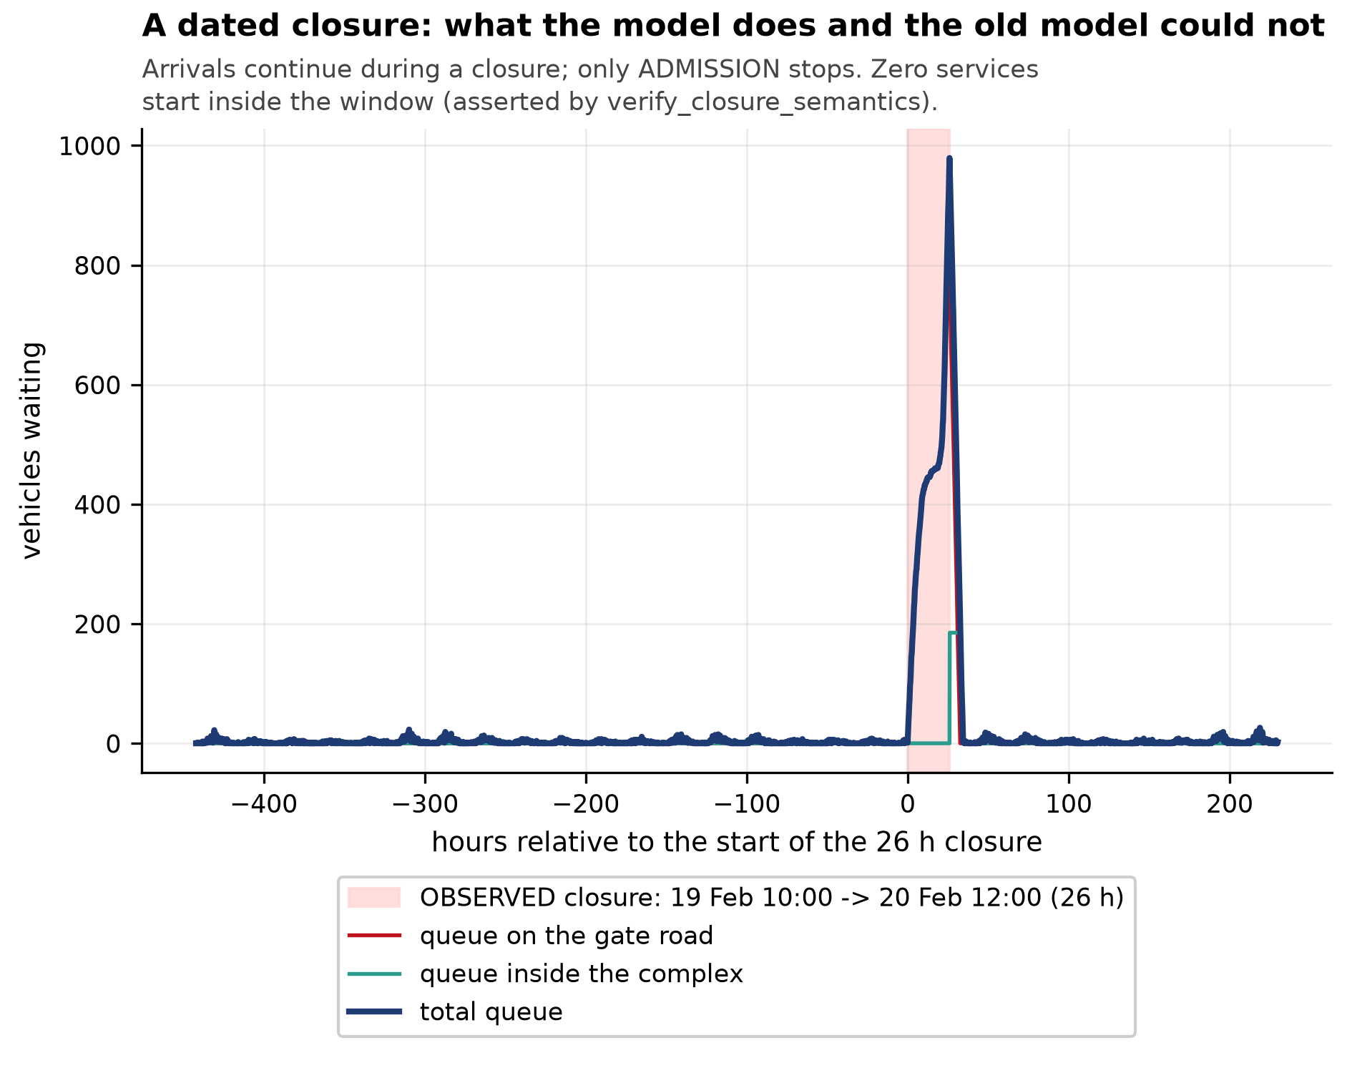
Figure 5. The 26-hour closure of 19-20 February 2026, modelled explicitly. A closure affects a minority of arrivals but those it affects wait tens of hours, so the median is more informative than the mean.

7.6 Assessment of the prototype configuration
Table 8. The prototype model's default parameters, re-evaluated on the corrected model. Both configurations are unstable at the peak hour.
Configuration | Capacity (veh/h) | rho_peak | rho_daily | Mean wait (min) | Max queue | Verdict
13 booths | 222.9 | 2.019 | 0.827 | 191.1 | 1,419 | NON-STATIONARY
18 booths | 308.6 | 1.458 | 0.597 | 61.1 | 709 | NON-STATIONARY

The prototype's default of 450 vehicles per hour at the peak yields rho_peak = 2.02 against 13 booths and 1.46 against 18. Both exceed 1, so a queue necessarily builds in every peak hour regardless of any other metric. Note that the daily ratio is below 1 in both cases: the system can still clear the day in aggregate, but only after every driver who queued during the peak has absorbed the entire delay. That is a transient of a peak-hour overload, never an equilibrium.
The parameter is also inconsistent with the observed data. A 450 vehicles-per-hour peak combined with the prototype's own hourly profile implies roughly 4,400 vehicles per day on a typical day, against an observed mean of 1,616 per day in the busiest month on record. The prototype's baseline scenario was therefore not a baseline: it described a demand level the crossing has not experienced in the observed period, while labelling it as the base case.

8. Defects in the Prototype Model and Their Consequence
The prototype model was not corrected in place; it was rebuilt, because several of its defects are structural. The table below records each defect, its mechanism, and the size of the effect. These are generalisable to any discrete-event model of a gated facility.
Table 9. Prototype defects and their effect.
Defect | Mechanism | Effect on reported results
Right-censoring | Unserved vehicles assigned horizon time minus arrival, recording a lower bound as a measurement | Mean and high quantiles biased downward; headroom artifact of run length
Unstable default | rho_peak of 2.02 and 1.46 at the prototype's own parameters | Headline wait describes a truncated growing queue, not a wait
Polling loops | Fixed-interval sampling in the gate and booth checks | Up to 5 min of quantised delay injected into every wait; service can start after closing
No abandonment | Infinite patience assumed | Yard capacity incorrectly appears to have no effect on any queue metric
No seasonality | One demand level for all dates | Real amplitude is 6.1x; a single level cannot represent the observed range
Confounded capacity | A staffing statement mapped onto a service-capacity parameter | Yard space, booths and staffing treated as one quantity
Validation at wrong resolution | Simulated hourly flow compared to an hourly CSV | Validation flag could never be exercised with real data
Unreachable comparison | Model wait measured at the Chilean complex, compared with press waits measured upstream on the Argentine side | Guaranteed apparent failure under comparison

The censoring defect and the unstable default compound each other, and their combination is what makes the prototype's headline figure unusable rather than merely imprecise. In a system with rho = 1.46, the true equilibrium wait does not exist and is unbounded. Assigning truncated values and then reporting their mean produces a number that is precise, plausible, and meaningless. Any reader would be entitled to treat it as a measurement, and no amount of caveat text on an uncensored statistic repairs that.
The abandonment defect is the most consequential for the operational question, because it produces a confidently wrong answer rather than an imprecise one. A model that omits abandonment will always find that yard capacity does not matter, and will report that as a finding about the facility. It is a finding about the model.

9. Limitations
Stated plainly, because several of these bound what the results can be used for.
- No intraday validation is possible. No public hourly or daily series exists for this crossing. The intraday profile is an assumption and is not validated.
- The monthly fit is partly circular. The daily arrival total is anchored to the observed monthly count, so good monthly agreement is substantially built in.
- Service time is assumed. No published throughput or service-duration measurement was located. The 3.5-minute mean per booth is an assumption.
- Abandonment is assumed. Driver patience has no measurement. The press record bounds it from below only.
- Uncertainty bands are narrow by construction. They are replica spread only and exclude structural error.
- Single replica in monthly validation. The 5-95% band is degenerate; band coverage is not a performance measure in this run.
- The measurement point differs from the public one. This model measures from arrival at the Chilean complex. Press wait figures describe the queue upstream on the Argentine side. They are not comparable.
- Opening hours are officially disputed. Two Argentine sources conflict and both are carried; neither is adjudicated.
- Freight and buses are out of scope. Several of the most severe documented delays are freight delays at Uspallata, which this model does not represent.

10. Conclusions and Recommendations
The defensible findings, ordered by how strongly the data supports them.
Table 10. Findings ordered by evidential strength.
# | Finding | Confidence
1 | The crossing loses stability at an offered peak of 120 vehicles per hour with the observed 7 staffed booths, and remains a valid equilibrium to 100 vehicles per hour. | High - independent of intraday shape
2 | Yard capacity does not reduce congestion; it relocates the queue. | High - theoretical and confirmed
3 | Removing one of seven booths costs 14.3% of capacity. | High - arithmetic on an observed count
4 | A model without abandonment answers the yard-capacity question wrongly. | High - demonstrated both ways
5 | Restricting opening hours concentrates delay rather than reducing it. | Moderate - official sources conflict
6 | Monthly throughput is reproducible to a mean absolute relative error of 1.45% on held-out months. | Moderate - partly built in by construction
7 | Any specific intraday wait figure for this crossing. | Not supported - no data exists

10.1 Recommendations for further work
The binding constraint on this research is data availability, not modelling. The highest-value action is an information request, and it should be filed immediately:
- Argentina. Request the daily or hourly series through Ley 25.633 de Acceso a la Informacion Publica, directed to the Direccion Nacional de Migraciones (Mendoza delegation), to Gendarmeria Nacional Escuadron 27 Punta de Vacas, and to the Direccion de Asuntos Tecnicos de Fronteras. Request the foreign-national inclusion rule explicitly, since it is contradicted between sources.
- Chile. Request the sub-monthly series from the Unidad de Pasos Fronterizos under Ley 20.285, and ask the concessionaire, Nuevo Complejo Fronterizo Los Libertadores S.A., whether its internal reporting can be released at daily granularity.
- Prospective capture. Begin snapshotting the Mendoza PasAr dashboard (mxm.mendoza.gov.ar) on a fixed schedule. It is the only live wait-time source located and it has no archive, so every day not captured is a day permanently unrecoverable. A fixed-interval screenshot series would, within one season, produce exactly the intraday dataset this model cannot currently be validated against.
Modelling recommendations, in order: add freight and the separate Uspallata cargo circuit, which the press record indicates is where the most severe and most persistent delays occur; add a time-varying staffing schedule once the activation hours of the on-demand booth complement are known; and treat weather closures as a separate stochastic process rather than as fixed scenarios, since the 27- and 34-day closures of 2026 were driven by a single storm sequence.

Bibliography

Primary data sources
[A1] simultaneous_vehicle_capacity_complex. https://concesiones.mop.gob.cl/project/concesion-complejo-fronterizo-los-libertadores
[A2] car_booths_2024_02_01. https://wwwgcp.clarin.com/ultimo-momento/fin-semana-largo-volvio-furor-compras-chile-6-horas-colas-15000-personas-paso-cristo-redentor_0_OcMdgIfllw.html
[A3] persons_2018. https://concesiones.mop.gob.cl/presidente-pinera-inauguro-nuevo-complejo-fronterizo-los-libertadores
[A4] winter_opening_hours_AR_to_CL. https://www.sitioandino.com.ar/pasos-fronterizos/paso-los-libertadores-hoy-estado-horario-y-demoras-n5727081
[A5] opening_hours_argentina_vicejefatura. https://www.argentina.gob.ar/interior/centros-de-frontera/cristo-redentor
[A6] opening_hours_ministrio_del_interior. https://mininterior.gob.ar/fronteras/paso-105.php
[A7] migraciones_SALIDA_2019. https://www.argentina.gob.ar/migraciones/estadisticas-movimientos-migratorios
[P1] ClarIN, 2024-02-01. https://wwwgcp.clarin.com/ultimo-momento/fin-semana-largo-volvio-furor-compras-chile-6-horas-colas-15000-personas-paso-cristo-redentor_0_OcMdgIfllw.html [anecdotal; not a measurement]
[P2] Sitio Andino, 2021-04-06. https://www.sitioandino.com.ar/n/351188-atencion-24-horas-y-mas-integracion-con-chile-el-plan-para-facilitar-el-control-fronterizo-de-cargas [anecdotal; not a measurement]
[P3] TN, 2026-08-09. https://tn.com.ar/sociedad/2026/08/09/paso-cristo-redentor-el-fuerte-temporal-obligo-a-suspender-el-transito-entre-la-argentina-y-chile [anecdotal; not a measurement]
[P4] Infobae, 2026-08-06. https://www.infobae.com/sociedad/2026/08/06/miles-de-camiones-siguen-varados-en-la-frontera-con-chile-y-alertan-por-nuevas-nevadas-fuertes-en-la-zona [anecdotal; not a measurement]
[P5] ClarIN, 2026-08-10. https://www.clarin.com/sociedad/paso-cristo-redentor-cumple-record-dias-cerrado-nieve-quejas-camioneros-perdidas-millonarias_0_Hc1YfQYZPZ.html [anecdotal; not a measurement]
[P6] Prensa Latina, 2026-08-14. https://www.prensa-latina.cu/2026/08/14/paso-los-libertadores-entre-chile-y-argentina-lleva-un-mes-cerrado [anecdotal; not a measurement]
[P7] BioBioChile, 2026-08-17. https://www.biobiochile.cl/noticias/nacional/chile/2026/08/17/confirman-reapertura-de-paso-los-libertadores-tras-historico-cierre-por-mas-de-un-mes.shtml [anecdotal; not a measurement]
[P8] Infobae, 2026-02-18. https://www.infobae.com/sociedad/2026/02/18/cerraran-por-24-horas-el-paso-internacional-de-mendoza-a-chile-para-desinfectar-por-dengue [anecdotal; not a measurement]
[P9] ClarIN, 2024-02-01. https://www.clarin.com/sociedad/mendoza-cierre-record-34-dias-habilito-paso-cristo-redentor-chile-sistema-capsulas_0_pv3ihLnKBo.html [anecdotal; not a measurement]

All web sources retrieved 2026-09-30. Web sources are point-in-time snapshots; the opening hours in particular are known to have changed, and the live page rather than any search result cache should be cited.

Theoretical and methodological references
[1] Little, J. D. C. (1961). A Proof for the Queuing Formula: L = lambda W. Operations Research, 9(3), 383-387.
[2] Kingman, J. F. C. (1961). The single server queue in heavy traffic. Mathematical Proceedings of the Cambridge Philosophical Society, 57(4), 902-904.
[3] Pollaczek, F., and Khinchine, A. A. On a problem in the theory of mass production. Zeitschrift fur angewandte Mathematik und Mechanik, 1, 43-45.
[4] Kleinrock, L. (1975). Queueing Systems, Volume 2: Computer Applications. Wiley-Interscience.
[5] Gross, D., and Harris, C. M. (1974). Fundamentals of Queueing Theory. Wiley.
[6] Law, A. M. (2015). Simulation Modeling and Analysis, 5th edition. McGraw-Hill.
[7] Banks, W. J., Carson, J. S., and Nelson, B. L. (2010). Discrete-Event System Simulation, 5th edition. Pearson.
[8] Daganzo, C. F. (1985). Theory of Probability and Statistics for Engineering and the Physical Sciences, 2nd edition. Holden-Day.
[9] Ahuja, H., Hershberger, E., and Ordonez, R. (2005). Simulation in Transportation: An Empirical Handbook. Kluwer Academic Publishers.
[10] Kijewski, R., Gastel, K., and others. SimPy: Python discrete-event simulation library. https://simpy.readthedocs.io (version 4.1.2 used here).
[11] Reproduction package: paso_los_libertadores/ (model, data, results and figures), accompanying this document.

Appendix A. Observed monthly series
Complete primary series, as published. Reproduced from data/mop_monthly_light_vehicles.csv; source URLs are in that file.
Table A1. All 20 observed months. Seasonal index is 1.0 at the series mean of 775 vehicles per day.
Month | Light vehicles | Days | Per day | Seasonal index
2024-10 | 22,668 | 31 | 731 | 0.9431763436519109
2024-11 | 26,723 | 30 | 891 | 1.1489588660678756
2024-12 | 31,813 | 31 | 1,026 | 1.3236818226083455
2025-01 | 50,084 | 31 | 1,616 | 2.0838930740908657
2025-02 | 38,367 | 28 | 1,370 | 1.7674157035256088
2025-03 | 34,014 | 31 | 1,097 | 1.4152611073741315
2025-04 | 29,384 | 30 | 979 | 1.2633684795710476
2025-05 | 20,835 | 31 | 672 | 0.8669075674800669
2025-06 | 7,973 | 30 | 266 | 0.3428031903127174
2025-07 | 15,678 | 31 | 506 | 0.652328274330262
2025-08 | 10,156 | 31 | 328 | 0.4225674574946358
2025-09 | 15,382 | 30 | 513 | 0.6613443194079076
2025-10 | 19,820 | 31 | 639 | 0.8246650100704966
2025-11 | 22,366 | 30 | 746 | 0.9616211855131889
2025-12 | 25,075 | 31 | 809 | 1.0433202263169197
2026-01 | 34,687 | 31 | 1,119 | 1.4432637309271628
2026-02 | 23,178 | 28 | 828 | 1.0677241709333798
2026-03 | 16,548 | 31 | 534 | 0.6885343380397775
2026-04 | 14,321 | 30 | 477 | 0.6157352558963838
2026-05 | 11,138 | 31 | 359 | 0.46342987638731326

Appendix B. Reproduction
Environment: WSL Ubuntu 24.04, Python 3.12.3, virtual environment at /home/easyrpg/venv (simpy 4.1.2, pandas 3.0.6, numpy 2.5.3, matplotlib 3.11.2, scipy 1.18.1).
python paso_los_libertadores/run_all.py
Runs from any working directory. Produces the calibration, the experiments, five figures and the result tables underlying every number in this paper. Observed runtime approximately four minutes. The run asserts its own preconditions and exits non-zero on failure; a successful run validates the event-driven gate behaviour, the closure scenarios and the integrity of every output file.
Data retrieved 2026-09-30. No figure in this paper was typed by hand: all quantities are read from results/*.csv at document build time.

