Autobiography of Eakkaphong

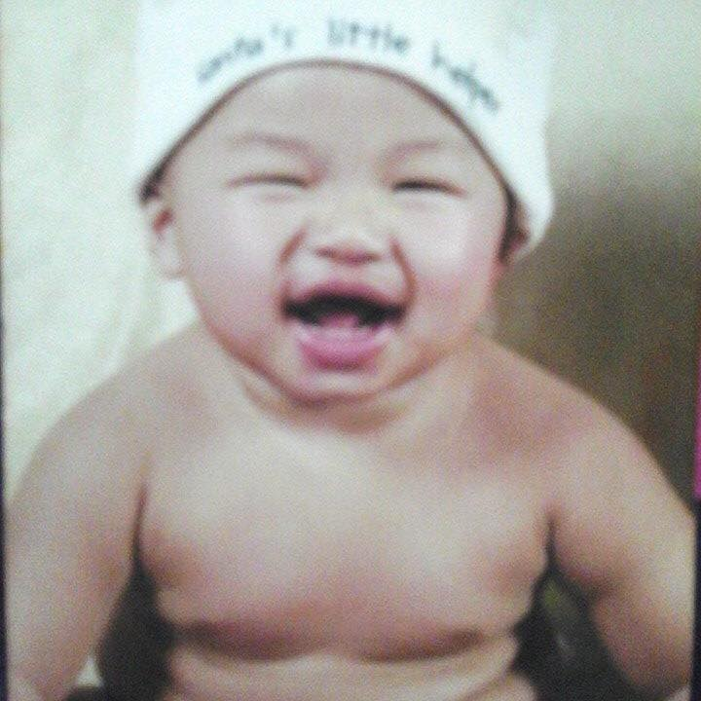A child was born on October 24, 2002, at night, during the rainy season, at Huachiew Hospital. It was a special night for that mother. And this child came to meet his warm family. Until the family named him Milo, the reason for this naming came from watching his parents' movies when young people found a movie about hackers. The protagonist of the story is a lovely and talented man named Milo that made my parents remember this name by heart. Most people probably think that his name comes from a famous dairy product. But it was actually from the experience of love that his parents had accumulated very well. Not long after This child has grown up until being loved by the people of the whole alley Everyone I met was always loving and teasing. Of course, he was an only child.

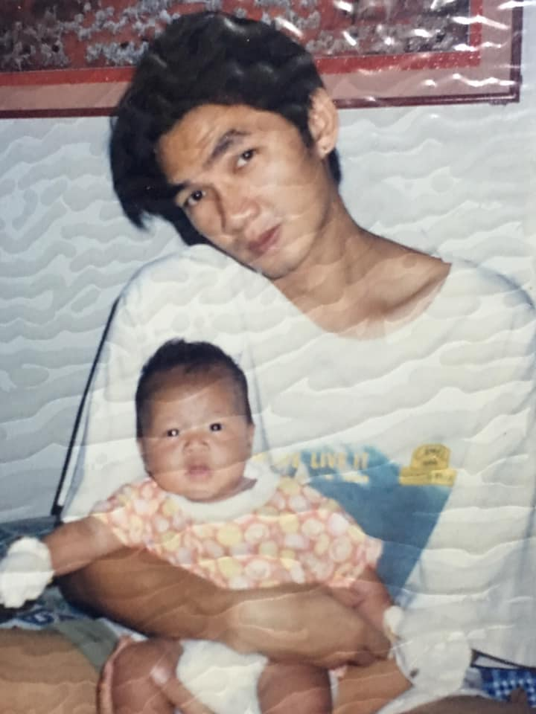Parents will take good care of him and have grandmothers, grandmothers, grandfathers, and grandfathers who take care of the children when they are out for work. They are like Another father and mother, Milo. In the past, we had family members, a total of 7 people, but there was a sudden accident with Grandfather. causing Milo to feel the loss of a loved one. When the cruel past has passed, Therefore, we must move on. But after Grandpa's departure, Grandpa didn't go anywhere. But Grandpa just came to be in our hearts for us to always miss. and their family relatives are both from Chiang Mai and Nakhon Nayok Provinces As a result, he traveled to the provinces often. His family was a middle-class family.

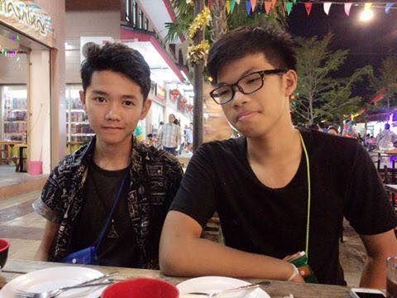I'm not rich and I don't even have to eat. In the past, the cost of living was not as expensive as today. His family had money to send him to a Christian school. He told as much as he could remember. It was a very strange school compared to the school he was in today. way of life about food Worshiping the Sacred Make him know that every religion teaches good people. He was a good human being from childhood. He has a lot of friends. Chow was a mischievous child that was often punished by his parents. until when he had the worst heroism, namely He used to poop in the middle of the classroom as a child. It was a heroic act that he remembered in his heart. Until in elementary school, he met a friend who was just as mischievous as him. and get close Although a bit naughty, they never leave school. And always help each other, there will be arguments about matters that should not be quarreled. They were always good friends. He studied elementary school at Pitchanok School, a no-name school. little known But when he entered that society He was able to recognize that it was a good quality school, another school that was not less than the famous schools. and over time Grade 5, he studied hard and became a nerdy student of the school, making the school famous. Whether it is a different competition competitive exam And what he was proud of what happened to this school when he was still alive was He and his friend were appointed as the student body president. When he was close to graduating elementary school He went to the secondary school entrance examination. Wat Sing Secondary School The reason this school is because it is a very large school and should have a large number of people. The building is big and nice to study in. And the last reason is close to home. My family and I decided to continue studying here.

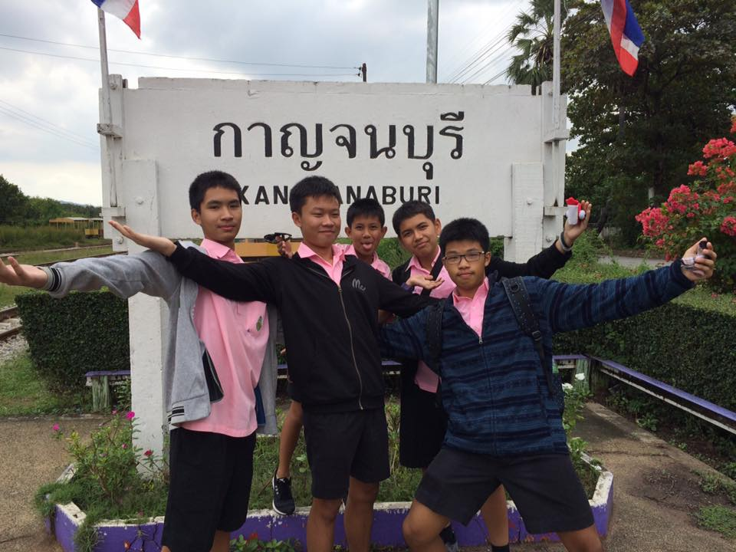From the past of the elementary school Later will be his middle school. which he said is the moment very happy for him met good friends There were many feats that had grown up for a little boy like him. In the first year of high school, he met his first friend named Ohm and we introduced ourselves. He told himself that his name was Milo, but Ohm heard Bella, which he didn't know why Ohm heard him say, Bella. And Ohm called his name for almost half a year. until realizing that his name was Milo, it was a little funny But it was the beginning of one of his best friends, and later he had a gang called Sperm, a gang name that shouldn't have been created with the most group name. But it was a very warm and naughty gang for teachers. His gang is the clown of the room. Every lesson with them will always cause laughter. But their gang never left school. He used to get a 4.00 grade, which was the few people in that room had. And he lived like that until high school.

During his high school, He had switched from being with most of his friends. start to change He began to fall in love with a woman named Meily. She was lovely and good-natured. until I didn't realize that he will get together He uses social media more often. For example, he had lost weight from 75 kg until now he weighs around 60-63. It is very difficult for one person to lose tens of kilograms. He was more worried about being handsome. He took more care of his body. to look good, but actually, his girlfriend said He doesn't have to look that good. But good habits are enough. And he lives happily in high school until now.

And activities or things that he is interested in is Likes to play computers, likes to play games, when he feels Have fun and meet friends But in high school, he wouldn't focus much on gaming. because he had to focus more on studying Which is affecting his future, which, of course, what he wants to be is derived from what he likes to be a computer engineer. is his dream team which before he decided to join this faculty A mix of things made him want to be. For example, his parents named Milo from watching a hacker movie. In those days, using a computer or writing code proficiently was something cool and charming to him. Of course, his favorite subject was math and physics Likes to calculate problems and solve problems. And he came across one Korean series that inspired him to become a computer engineer is Startup, which tells about a skilled engineer who develops software related to all kinds of data detection until big companies are Interested and have climbed to work with a global company. And that's his little inspiration to be the driving force in reading for college entrance exams. And of course, the university must have a computer engineering faculty. If he didn't get what he hoped for. He might have entered the Faculty of Civil Engineering instead, which was his backup plan. To enter the university or faculty that we wish to have, there must always be prepared. And whether he could join the hopeful faculty or not, he had done his best in this role. I saw this in my spare time. He has many things he likes to do such as playing sports, and his favorite sport is badminton. He says it's a sport that is very witty and cool when scoring. He had the idea of ​​becoming a badminton player for a while. But being a badminton player is quite difficult. Because he had started about badminton quite late. The basis in this matter is not much. And finally, he decided to just play for fun with his friends.

And when his college life was finished enter the working-age He will live his life-saving money for the future and raising his parents and family. He would gradually improve his quality of life to become a dependable person for his parents. What he had planned was to go to college after graduating from college. He wanted to go to a big company for a study visit. In a big successful company and with enough knowledge on what to do. He will bring the experience he gained when working for a long time. to open a company of their own and study many subjects around the area, not just Structure or writing software but will be looking at the business side to make a profit or to find a partner to develop his company At the moment when the company takes shape, he wants to start a family and he wants to get married when ready. By the time it was a stable phase of his life. He wants to travel abroad. Taking his family in the open-world And this was just his plan. There may be many variables causing this plan to be distorted. But he said that he would do his best.

He wasn't just thinking about the future. Maybe he was thinking about the past too. that it is a life experience It was something he had been able to overcome. no matter what obstacles That was the proof that would allow him to move forward steadily. To be a successful person is in his opinion. He believes that to be successful one must go through hardships. have to go through trial and error And we learn the pitfalls of such things as his idol, Elon Musk, who started out as a small investor. And being an engineer and inventor means that success doesn't always have to cost readily. It depends on the person how much he can devote himself and study that interest. If you can study what society wants We'll know the point in raising money, which Elon Musk has always known about, making Tesla's much-talked-about company the car of the future.

Finally, in his opinion, before he decided to choose this path It wasn't just a fraction of a minute thought. But it was all he liked. that we will be able to reach the dreamland We have to go through hard enough to be worthy of success.