**Autobiography of Jakathon**

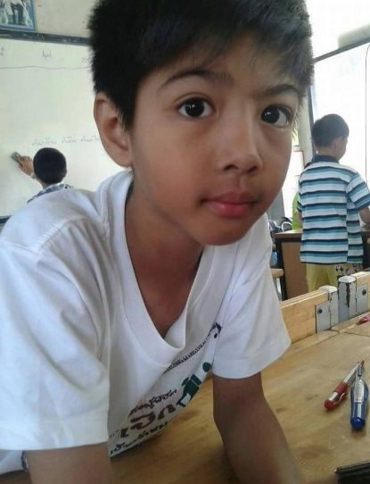

* Birthdate and place

On Sunday, October 19, 2003, a woman gave birth to a baby in the middle of the night. Late rainy and early winter at Mahachai Hospital, Samut Sakhon Province. Such a wonderful night for the parents of this baby boy. His parents gave the baby boy the real name, Jakathorn Sorwises, and his nicknamed is Pound. When this baby boy was born, there was a cartoon. The main character is Pang Pond. So, he was called Pang Pond. But Pond's friends because they thought her name came from the pound of bread and her real name means Authority. His mother gave her a monk that she revered to be a suitable one for her baby from her child's birth horoscope.

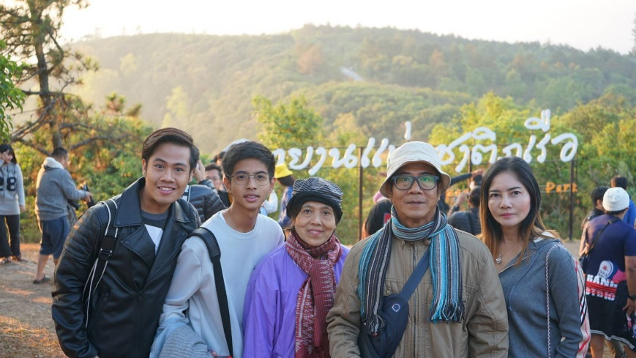

* Family Members

There are not many people in this family. They are a humble family consisting of boys, brothers, sisters, fathers, mothers, grandfathers, grandmothers, grandmothers. Mom and dad are very busy. Therefore, there is not much time to take care of the little ones.

So, the parents sent their children to live with their grandmother in their mother's hometown. Samut Sakhon is the home of the grandmother whose grandmother and grandfather raised their grandchildren with love, raising their grandchildren well, without any defects. The father and mother came to visit the boy from time to time. It comes with lots of souvenirs. Grandfather has salt pan not far from his house. As a child, the boy regularly went to help his grandfather. But he seems to be willing to play more. The boy's father is from Bangkok. graduated from Chulalongkorn University. The boy's mother is from Samut Sakhon Province. So, he was born at Mahachai Hospital.

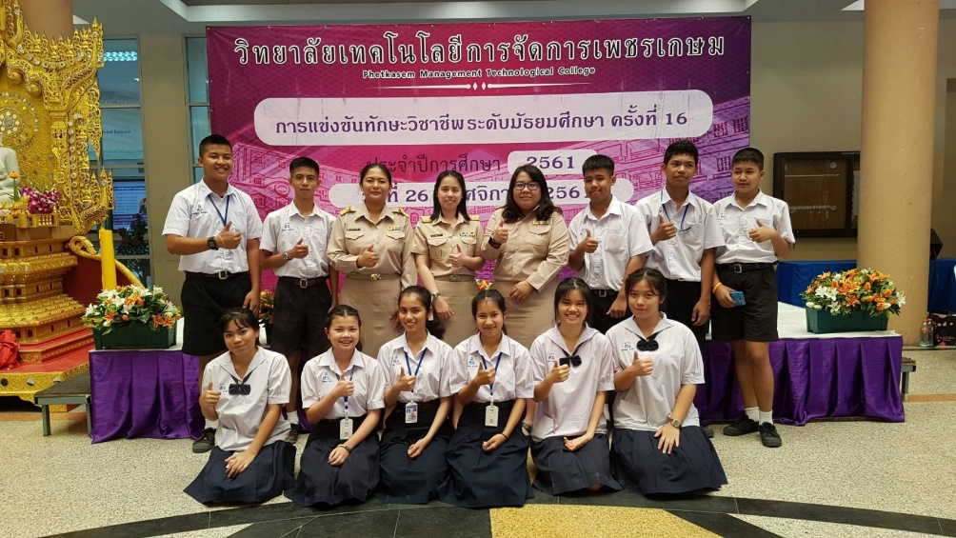

* **Childhood and School Life**

At that time, I was still a child. The boy stayed with his grandfather and grandmother until he was about 3 years old. The boy started attending a private school. One in Lom Mahachai Subdistrict Sue that Somrudee Samut Sakhon School. He attended because it was near his father's place of work. It is a good school, and he made many friends. He studied at Somrudee Samut Sakhon School for 10 years, from pre-kindergarten to grade 6 when he was in elementary school. He did very well in science subjects. But he's not good at math. The boy was so good at science that he was able to pass the exam. He competes at the national level and has been selected for the NSTDA project, which is a project on science and national technology in which he was the only one of the schools that received the blood selection for the NSTDA project at the primary and secondary level. He moved from Somrudee Samut Sakhon School. Come to Suksanaree Wittaya School for the science project due to the entrance exam. He got the second-best science score among all students, and it was a school very close to home. He could walk from home to school. It took less than 10 minutes during my junior high school years.

He lived a fun life as a normal child. There are games with friends, kicking a football with friends. And playing football with friends was the main reason for his noticeably darker skin. During the second year of high school, he had the opportunity to go on a study exchange in the Philippines for about 3 months, which is the Thai summer semester break. That made him feel like an open world. From where he initially thought that Thailand was good for having interesting friends. But while the boy was in the Philippines, his friends there showed him something cool. His English language skills have greatly improved since he returned because he rarely speaks, causing some congestion. And when he graduated from secondary school, which was the last year of junior high school. In high school, he began to study at Wat Sing Secondary School. He had great friends and lots of things to do in the first few months after he moved in. My friends are very welcome. Because he is still a new kid. And he still doesn't dare talk to his friends, but when he goes to the Gif camp, he gets closer to friends until he becomes a boy who talks a lot today.

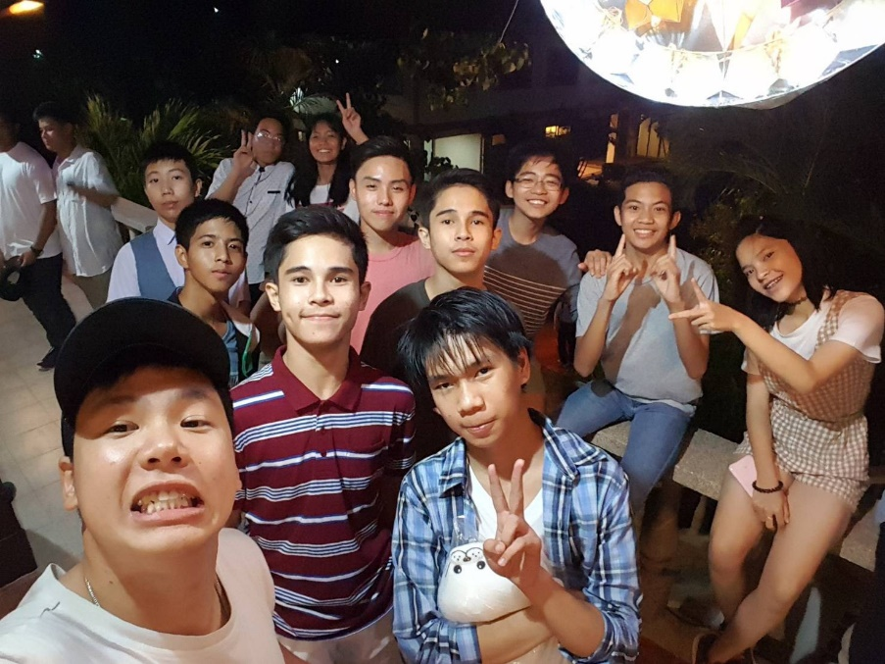

* Hobbies, Interests, and Activities

His hobbies are not many children. He is a cartoon. He watched a lot of movies. He played games and listened to music. His hobbies are listening to music, playing games, watching movies and comics because he has been attracted to comics since he was a child. Even now, he still likes to listen to music. As a part of his daily life, there are many things he is interested in. He's interested in science, technology, games, and science investment. He's been interested since he was a kid when he grew up. He was interested in technology because the first technology he used was a computer, and then a telephone. And the interesting technology that he's proud of for kids is Apple's device, which is about nine to ten years old. There is a world-class fan that he is very interested in because he only uses one Nokia phone.

At that time, the telephone in Thailand was still expensive. It took him several months to buy it. Finally, his father bought him a school, which is a cool thing because of the modern telephone.

Most of them are still gregarious or have an unstable Android system, so mobile phones are cool. Later, Apple launched the first great tablet movie, and he was very interested in the technology. Now he is interested in computers and investment. He has gone through a lot of training. He invests and thinks about science and data statistics. We can connect and understand it, and we will be able to generate huge revenue. The daily activities are playing games, listening to music, learning, and investing in practice.

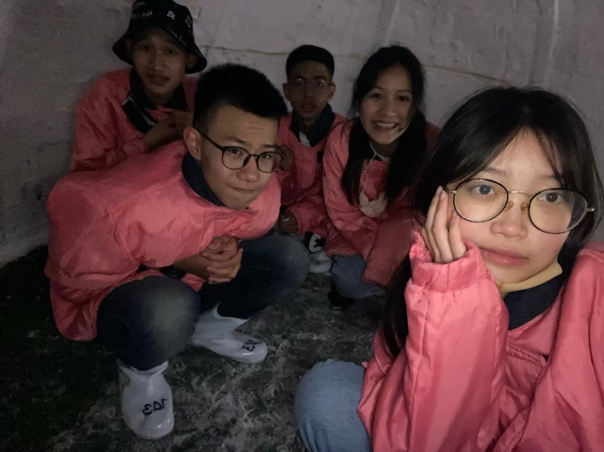

* Career

His dream career is as an information scientist because it is a career, it can be far away, and it gets high wages. Now, big companies need data scientists because of their scientists. Data is used to analyze old data as well as new data to analyze the future. The company forecasts that these three bus-driven directions will enable the company to grow higher. Because of these three data scientists, data scientists predict the possibility of analyzing the data. The stock market and the growth of the stock market as a career, he experienced the dream of an information scientist in the last stage of his life. I think it is a small fast-food restaurant. He likes spicy food because he has a small shop. As a housewife, not too many staff live together, brothers and sisters. Take your family to travel, have a comfortable home and a car to take your family to travel.

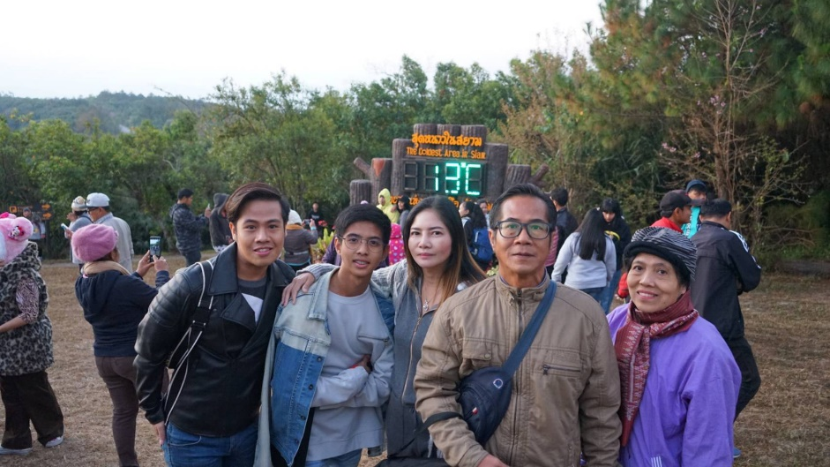

* Later Life/Old Age

This is one of his favorites and still inspires him to this day. Because his father used to be a senior chief operating officer or Chief Operating Officer of a private company.

* Photo and Likenesses

This is one of his favorites and still inspires him to this day. Because his father used to be a senior chief operating officer or Chief Operating Officer of a private company. He is on the board of directors of this company, a frozen food exporting company in which his father's income is not less, but not as much as being rich. But it's also a duty that makes it possible to have a warm family. Able to support a family can take the whole family to travel happily. It inspired him so much that he had to be able to be like his father. But not in terms of money, but in terms of being able to raise a family. We take your family to travel where you want to go. To make the family happy and well-being.