

22/04/2022

Environment Monitoring

System

**AONGHUS O DOMHNAILL**

**Bachelor of Engineering (Honours)**

**in Software and Electronic Engineering**

Supervisor

Brian O’Shea

Galway-Mayo Institute of Technology

Project Graphic (Optional)

**Declaration**

This project is presented in partial fulfilment of the requirements for the degree of Bachelor of Engineering (Honours) in Software and Electronic Engineering at Galway-Mayo Institute of Technology.

This project is my own work, except where otherwise accredited. Where the work of others has been used or incorporated during this project, this is acknowledged and referenced.



____________________________________________

**Acknowledgements**

Use this section to acknowledge anyone, if you wish to, who might have helped during your project.

**Table of Contents**

1 Summary 6

2 Poster 7

3 Introduction 8

4 Background 9

5 Project Architecture 10

6 Project Plan 11

7 Heading 12

7.1 Referencing 12

7.2 Notes on Content 13

8 Ethics 14

9 Conclusion 15

10 Appendix 16

11 References 17

# Summary

The summary should concisely summaries your whole project. Why? What? How? It should communicate:

The goal of the project.

* + Goal of project was to add automation to an indoor grow area with the aid of an environmental monitoring system.

The scope of the project.

* + For the project I grew 3 tomatoes and 2 cucumbers in a 3ftx3ft indoor tent. Used artificial lighting, a 250W metal halide for early growth and 1000W LED for mid to finish using only 120W electricity. For grow medium went with hydroponics in clay pebbles with a pump to circulate the water. There is an extractor fan and a circulating fan to control the air. The system is controlled by series of timers.

The important features of the project.

* + Frontend is built using React with Nextjs framework. Nodejs is used for backend.
  + Mongodb is used to store the data sent from ESP32 and hosted on AWS ec2 servers.

The approach to the project.

* + The main methods & technologies used.
  + What was accomplished.
  + The main conclusions.

The length of the summary should be 200-300 words, or fit on this page.

# Poster

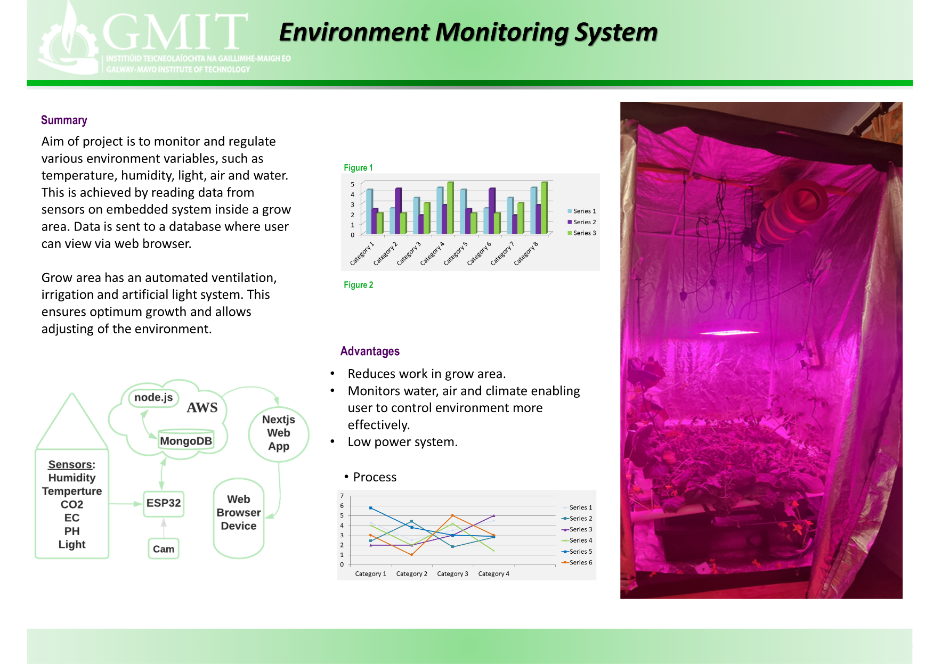

# Introduction

Inspiration for this project came from an increase in growing food at home in recent times, and an interest to have a mix of hardware and software to help further my understanding of both. There was a huge growth around lockdown and people have got more conscious about sustainability. Also, with an increase on imports and higher costs. However, our climate restricts certain crops and time of year when it is possible to grow crops.

Importing food results in higher costs and has a negative impact on the environment. Imported produce must be harvested before it has ripened fully and later sprayed with ethylene gas to aid in the ripening process, resulting in less taste and less nutritious produce.

Growing our own food has many benefits. Not only must

https://scholar.google.com/scholar?q=environment+monitoring+project+site:.edu&hl=en&as_sdt=0&as_vis=1&oi=scholart

Due to weather and light restrictions it is for hard for horticultural industry to monitor and control the various in a grow area.

Why im interested in it?

Altium

overall really enjoyed my project especially website server part and embedded part. I enjoyed attending to my plants also but I believe would have enjoyed more if it was..

Nice break away from technical stuff working in grow tent although

Code for sensors was easy enough o implement just matter of importing libraries. But when freertos was introduced ran into some problems like with the dht22.

Also we were using freertos as an embedded system so wanted to incorporate to help get better understanding

# Background

You should change the title of this section to suit your own project subject. The aim of this section is to introduce to the reader any relevant background information that is required for your project.

You may have multiple ‘background’ sections. Think of any of the questions you had to answer during the research phases of your project – these likely should be addressed in a section like this.

# Project Architecture

Your project architecture diagram should go here. This is an important section, and one most readers of your report will view.

Your diagram should be self-documenting. Use subsequent sections in your report to elaborate on technologies / software / hardware in your diagram.

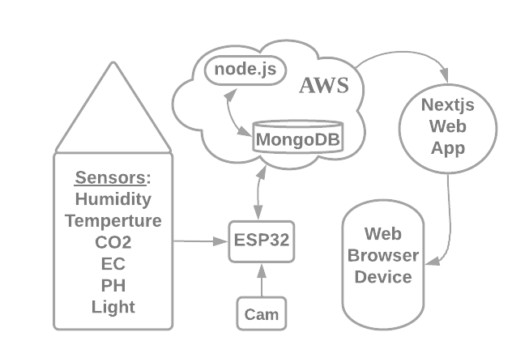

Figure ‑ Architecture Diagram

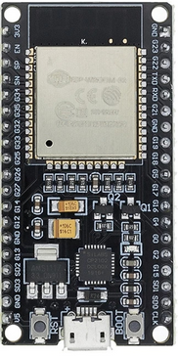

*ESP32 with Wi-Fi and Bluetooth:*

|  |  |
| --- | --- |
| Cores | 2 |
| Architecture | 32bit |
| RAM | 512 kB |
| FLASH | 16 MB |
| GPIO Pins | 36 |
| Busses | SPI, I²C, I²S,  CAN, UART |
| DAC Pins | 2 |
| ADC Pins | 18 |
| Power Consumption | 160-260mA |
| Deep Sleep | .001mA |

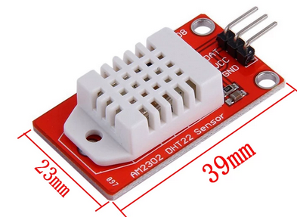

Digital Humidity and Temperature Sensor

Uses thermistor and humidity sensor to measure air

Sends back digital signal on data pin

|  |  |
| --- | --- |
| Temperature Range | -40 – 125°C /± 0.5°C |
| Humidity Range | 0 – 100% / ± 2-5% |
| Sampling Rate | 0.5Hz (1 Reading every 2 secs) |
| Body Size | 15.1mm x 25mm x 7.7mm |
| Operating Voltage | 3-5V |
| Max Current | 2.5mA |

# Project Plan

* 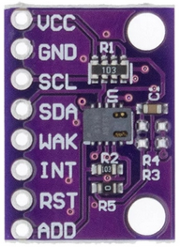Digital TVOC and CO2 sensor over I²C.
* Air quality monitor.

|  |  |
| --- | --- |
| Operating Voltage | 3-5V |
| Max Current | 30mA |
| Power Consumption | 60mW |
| Operating Temperature | -5-50°C |
| Operating Humidity | 10-95% |

*PH Sensor Module:*

* 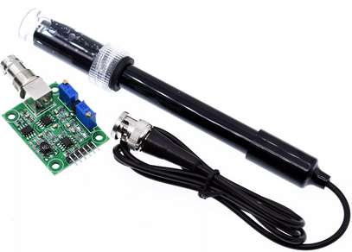 PH sensor that measures analog voltage signal.
* Measures water temperature also.

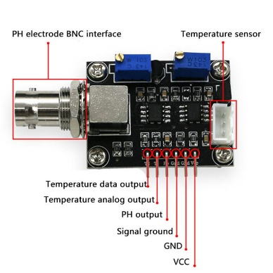

|  |  |
| --- | --- |
| Operating Voltage | 5V |
| Max Current | 5-10mA |
| Power Consumption | 0.5W |
| Detectable Range | PH 0-14 |
| Detectable Temperature | 0-80°C |

*ESP32 CAM:*

* 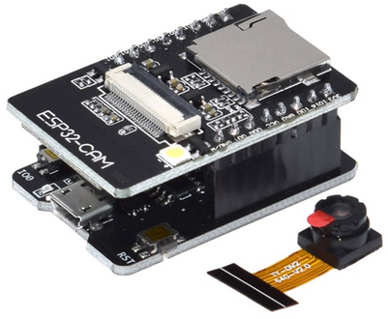 Take pictures daily to monitor and record progress.
* Use images to show timelapse on website.

|  |  |
| --- | --- |
| Operating Voltage | 5V |
| Power Consumption | 180mA |
| Deep-Sleep Usage | 6mA |

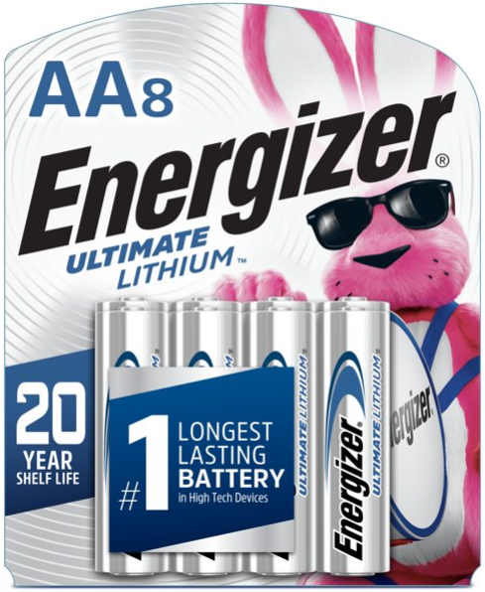

Lithium batteries will be used as power source.

Lithium batteries stay consistent voltage all the way up to 90% usage. So they are ideal for low powered system.

* 2 AA 1.5V will be used for the 3.3V port.
* 3 AA 1.5V will be used for 5V port and ESP32 CAM.
* Works well at extreme temperatures.

Estimated Run Time

= 52hrs = 187,200secs

÷ 120

1560 days

# 

# Hardware

This is an example heading for a section in a project. You choose your sections to suit your project.

## ESP32

This is a subheading, use subheadings to break up a large topic into smaller sections.

IEEE referencing style is recommended the default style to choose for citations and referencing, however if you are familiar with a different referencing style then you can use that.

When you need to reference add a citation in the relevant sentence, usually at the end, before the full stop. Then have this numbered citation referenced in the list of references at the end of the document.

Here I might write something about something, e.g. image processing, and I need to cite my sources, like this [1]. Here I have used MS

Code Overview

Program starts and takes readings and saved to sd

For css811 and bh1750 need to use a semaphore to share resources because they are usong I2C bus and I was getting wrong readings

We have software timer that increments variable by one second and sets a bit in the event group that allow Time Out task to run and putting it to sleep.

Word’s ‘Insert Citation’ feature, with IEEE style selected, to create that number inside brackets. Here’s another citation [2]. Word increments the number automatically. I can fill in the details about my reference now or later. I can then go the end of the document and create a page of references automatically. See the demonstration in class on this (also recorded via Teams). Here I am adding another citation [3]. And another [4].

You then need to insert a References section at the end of the document. In Word, choose References->Bibliography->References. This will pull all your citations into a reference page, as shown at the end of this document. The References section in this document also includes examples of further references that have not yet been cited in the text – to demonstrate IEEE style for different types of resources, i.e. books/websites/lectures/source code/etc.

You could also manually add all your citations & references, without using MS Word’s citation & referencing wizards.

## DHT22

Photographs are not technical diagrams and are not a good substitute for professional technical diagrams. Use photographs to enhance a report, but not as a replacement for diagrams.

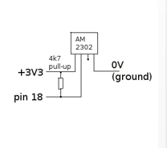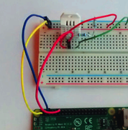

V

Figure 6‑2 A photograph is not a replacement for a circuit diagram

In describing software, you need diagrams and/or summaries of software design & layout. It is not sufficient to just paste some code. You should describe what your code is designed to do, in English. If you decided to put your code in functions or libraries or objects, describe this architecture. One good layout is to include a snippet(s) of code alongside an explanation. You do not have to explain every part of your code, pick the important parts.

Write out any mathematical equations or calculations that are important in your project and explain them.

Include details of any major problems or challenges you encountered in an area, and how you solved them.

## CCS811

## BH1750

# MERN Stack

## React

## Express

## Node

## Mongo DB

## NextJS

# AWS

## EC2 Server

Frontend, backend and mongodb database were hosted on an EC2 EU West server.

Server specs here!

## AWS IOT Core

## MQTT

IOT (Internet Of Things) describes the network of physical objects from small sensors, to devices that control large systems. There are few protocols to connect such devices to the internet for example TCP/IP, HTTP and HTTPS. However, they are not optimized for low power and battery efficiency like MQTT (Message Queue Telemetry Transport).

# Ethics

Include a short section on ethical considerations in your project or in the field of study of your project.

# Conclusion

Overall was great project and

Although it was not related raised an interest in horticulture

Write a short conclusion. What is the outcome of the project? Perhaps you have a product prototype, or some results, or a demonstratable system.

Do not use your conclusion to tell the reader what you might have done if you had more time, but keep it focussed on what you actually have done. You can mention future opportunities for further development of the work, but keep this part short.

# Appendix

# References

|  |  |
| --- | --- |
| [1] | H. Kinsley, "Reinforcement Learning," PythonProgramming, [Online]. Available: https://pythonprogramming.net/q-learning-reinforcement-learning-python-tutorial/. [Accessed 02 02 2021]. |
| [2] | [Online]. |
| [3] | MakeSigns, "Scientic Posters Tutorial," [Online]. Available: https://www.makesigns.com/tutorials/scientific-poster-parts.aspx. [Accessed 09 02 2021]. |
| [4] | Arduino. [Online]. Available: https://www.arduino.cc/. [Accessed 09 02 2021]. |
|  |  |
|  |  |

[x] J. C. Russ and F. Brent Neal. *The Image Processing Handbook*. 7th ed. Boca Raton FL: CRC Press, 2017.

[x] S. Lippman, J. Lajoie and B.E. Moo. “Classes” in *C++ Primer*. 5th ed. Massachusetts: Addison Wesley, 2013.

[x] IEEE Signal Processing Society. “Signal Processing for 5G”, *YouTube*, 2019. [Online]. Available: <https://www.youtube.com/watch?v=uca6X4Ykcmg&list=PLcZOnmyqlalacL9YqkhyufLQGIW_C78Os&index=6>. Accessed: Feb 2, 2021.

[x] Digilent. “Basys 3 Reference Manual”, *Digilent Reference*. [Online]. Available: <https://reference.digilentinc.com/basys3/refmanual>. Accessed: Feb 2, 2021.

[x] P. J. Ashenden. *Digital Design (Verilog): An Embedded Systems Approach Using Verilog*. Burlington: Morgan Kaufmann, 2007.

[x] M. Lynch. “Discrete Fourier Transform (DFT)”, Lecture, Digital Signal Processing, Galway-Mayo Institute of Technology, Galway, 2020.

[x] MRC Centre for Global infectious Disease Analysis. (2021). *Covid-Sim*. [Source Code]. Available: <https://github.com/mrc-ide/covid-sim>. Accessed: Feb 2, 2021.

[x] OpenCV. “Face Detection Using Haar Cascades”, *OpenCV-Python Tutorials*. [Online]. Available: <https://opencv-python-tutroals.readthedocs.io/en/latest/py_tutorials/py_objdetect/py_face_detection/py_face_detection.html#face-detection>. Accessed: Feb 2, 2021.