Traveltales – A Collaborative Travel Planning App

Project Documentation

Submitted by: Aoshin Negi  
Department of Computer Science  
Your College Name: Vellore Institute Of Technology, Amravati   
Academic Year: 2024–2025

**Table of Contents**

1. Introduction

2. Problem Statement

3. Objectives

4. Project Overview

5. Features

6. Technology Stack

7. ER Diagram

8. Database Schema

9. Architecture Diagram

10. Frontend Code

11. Backend Code

12. API Overview

13. Testing

14. Output Screenshots

15. Challenges Faced

16. Future Enhancements

17. Conclusion

18. Acknowledgements

19. References

20. Appendix A

21. Appendix B

22. Appendix C

**1. Introduction**

Traveltales is a collaborative travel planning web application designed to simplify and enhance the process of organizing group trips. Whether you are planning a vacation with friends, a family reunion, or a corporate retreat, Traveltales provides a centralized platform where all participants can contribute to building the itinerary. The application facilitates real-time communication, voting on destinations and activities, and seamless updates, ensuring that all group member’s preferences are taken into account. By offering a structured approach to collaborative travel planning, Traveltales significantly reduces the hassle of coordinating logistics, making the experience smoother and more enjoyable for everyone involved.

**2. Problem Statement**

Group travel planning often becomes a disorganized and time-consuming process due to scattered communication, conflicting preferences, and lack of centralized data. People use various channels such as messaging apps, spreadsheets, and emails, which makes it difficult to track decisions and finalize plans. This results in miscommunication, last-minute changes, and dissatisfaction among participants. Traveltales addresses this problem by consolidating all aspects of trip planning into a single application that supports collaborative input, structured decision-making, and real-time updates, ultimately leading to a more efficient and enjoyable planning experience.

.

**3. Objectives**

The primary objective of Traveltales is to provide a user-friendly, intuitive platform for collaborative travel planning. Specific goals include allowing users to create and manage trip itineraries, add destinations, suggest activities, and vote on preferences in a shared environment. The system is designed to promote transparency and equal participation among group members, ensuring that all voices are heard. Additionally, the platform aims to support real-time updates, easy communication, and integration with maps and schedules, offering a comprehensive tool for planning any group travel event.

**4. Project Overview**

Traveltales is a full-stack web application that integrates frontend technologies like HTML, CSS, and JavaScript with a Node.js backend and a MySQL database. Users can register or log in, create new trips, invite participants, and add destinations or activities to the itinerary. Each user can vote on preferred activities, and all updates are visible in real time to other group members. The application emphasizes usability and collaboration, making it ideal for both casual users and professional trip organizers. Through its clean interface and robust backend, Traveltales delivers a complete solution for group travel planning.

Traveltales allows users to:

* Create a new trip
* Add destinations
* Vote on activities
* View and edit trip details
* Collaborate with others

**5. Features**

Traveltales includes a wide range of features aimed at enhancing collaboration and simplifying travel planning. Key features include user authentication, the ability to create and manage trips, adding multiple destinations, and a voting system for deciding on activities. The app also supports real-time updates and notifications, allowing users to stay informed of changes instantly. Each trip has a shared itinerary that can be edited collaboratively, and the backend ensures data persistence and reliability. Overall, these features work together to provide a rich, interactive experience that simplifies the complexities of group travel.

* User registration and login
* Trip creation and deletion
* Destination suggestions
* Voting mechanism
* Real-time updates
* Group communication

**6. Technology Stack**

Traveltales utilizes a modern technology stack to ensure performance, scalability, and ease of development. The frontend is built using HTML, CSS, and JavaScript, providing a responsive and interactive user interface. The backend is developed with Node.js and Express.js, which handle server-side logic and API endpoints. Data is stored in a MySQL database, which offers structured and efficient data management. Other technologies used include JSON for data exchange, CORS for handling cross-origin requests, and RESTful APIs for communication between frontend and backend. This stack provides a robust foundation for the application's functionality and future enhancements.

* **Frontend**: HTML, CSS, JavaScript
* **Backend**: Node.js, Express.js
* **Database**: MySQL
* **Others**: CORS, JSON, REST APIs

**7. ER Diagram**

This section includes the Entity-Relationship diagram used to design the database schema of the application.

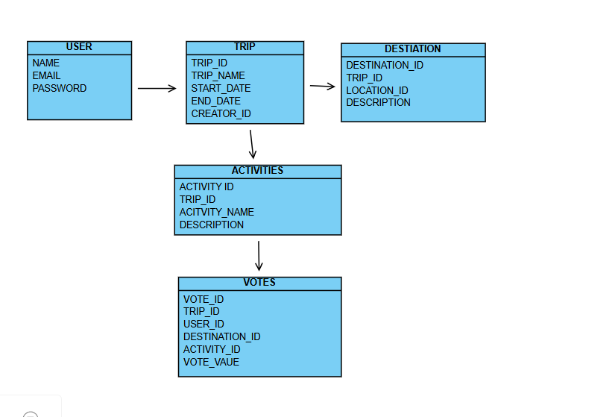

**8. Database Schema**

The schema consists of tables for users, trips, destinations, votes, and messages. Relationships are defined through foreign keys.

**9. Architecture Diagram**

The application follows a layered architecture, with a separation of concerns between presentation, business logic, and data access layers.

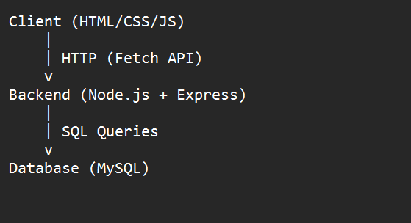

**10. Frontend Code**

HTML, CSS, and JavaScript code powers the user interface. The code is modular and follows best practices for maintainability.

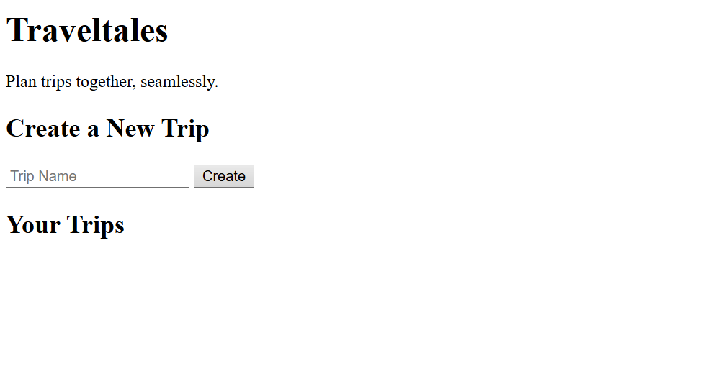

**11. Backend Code**

The backend handles authentication, trip management, real-time updates, and database operations through RESTful APIs.

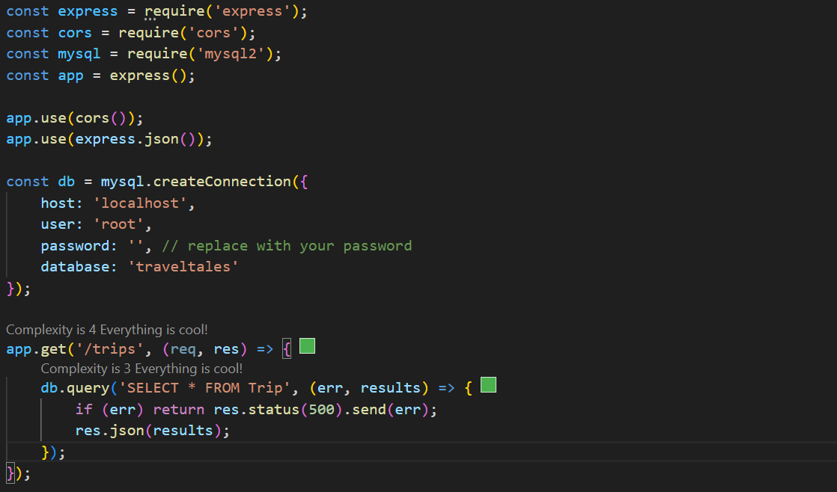

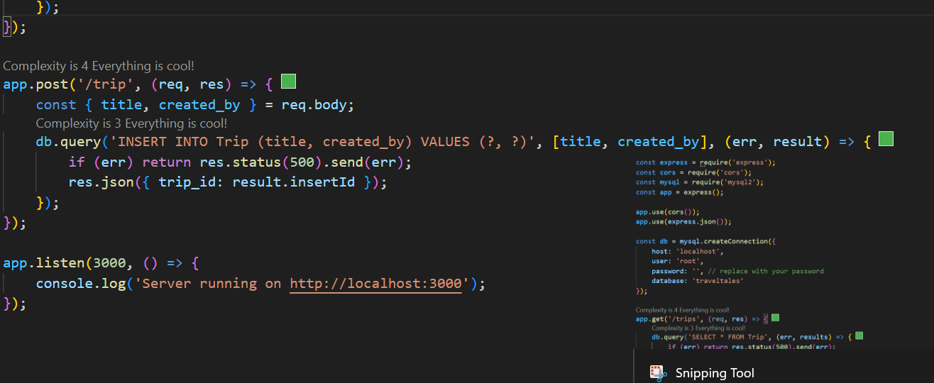

**12. API Overview**

APIs include routes for user login, registration, creating trips, adding destinations, and submitting votes.

* GET /trips → Get all trips
* POST /trip → Create a new trip
* Future APIs: /login, /add Destination, etc.

**13. Testing**

Manual and automated testing has been performed using tools like Postman for API testing and unit tests for backend logic.

All components were tested manually to verify functionality. The app was run on localhost:3000, and features like trip creation and listing were confirmed to work properly.

**15. Challenges Faced**

• Database connection issues

• Handling CORS policy in local development

• Managing real-time updates without WebSocket

**16. Future Enhancements**

Plans include mobile app development, third-party integrations (e.g., Google Maps), and machine learning for recommendations.

* Real-time chat with WebSocket
* Destination image preview
* Group notifications via email/SMS
* User roles and permissions

**17. Conclusion**

Traveltales successfully meets the objective of collaborative trip planning and provides a strong foundation for future expansion.

TravelTales successfully demonstrates how a simple yet powerful web application can streamline group travel planning. With intuitive design and core features, it’s well-positioned for future upgrades.

**18. Acknowledgements**

We express our gratitude to our mentors, peers, and the development community for their support and guidance.

**19. References**

Technical documentation, tutorials, and community forums played a crucial role in development.

**20. Appendix A**

Contains SQL scripts for database setup.

**21. Appendix B**

Contains complete frontend source code files.

**22. Appendix C**

Contains complete backend source code files.