Angular Product App Assignment

Build the application that performs CRUD operations with Product entity.

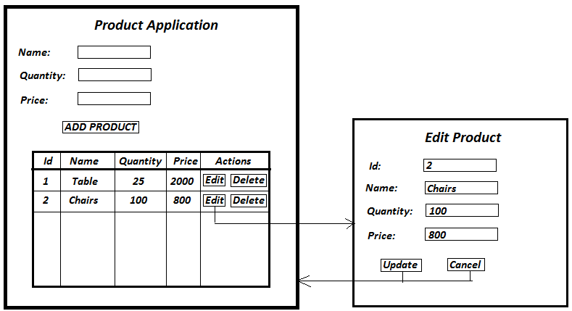

Steps to build the product application:

1. Create an Angular project ‘product_angular_app’ & open it into Visual Studio Code IDE.
2. Our application will have total four components:
   1. Add product form component: It will render add product form.
   2. Product table component: It will render different products in the form of a table.
   3. Edit product form component: It will render edit product form. Note that edit product form is a separate view page & not a popup window.
   4. Root component (app.component). It will render all above components as per requirement.
3. Create Add product form component without any event handling on ‘ADD PRODUCT’ button. Place it inside root component & confirm it is being properly rendered.
4. Create Product table component with static data without event handling. Place it inside root component & make sure it is properly displayed.
5. Add event handling on ‘ADD PRODUCT’ button. When you press this button, you need to read textbox values & insert a product into product table.
6. Add event handling on DELETE button which removes the product from product table.
7. Develop edit product component. Now add event handling on EDIT button that renders Edit product form with pre-loaded values of selected product.
8. Implement edit product ‘CANCEL’ button event that takes you back to products table.
9. Implement ‘UPDATE’ button event that updates information about existing product & takes you back to products table.