Cypress Introduction:

- Definition:
- Front end Web automation testing tool.
- Modern web applications
- React Js, Angular JS…….
- Any application which runs on browser…
- JavaScript
- Doesn’t use any selenium.
- Open source
- Test runner -free
- Dashboard -paid
- Node.js and comes with npm module.

- Who can use cypress -Dev & QA
End -to-end test cases
Integration tests
Unit test cases
API testing
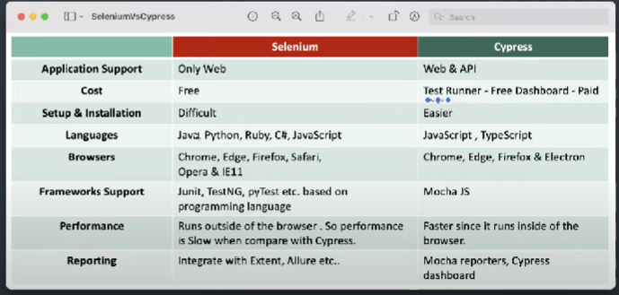

Cypress Eco system
1)Test Runner --- open source. locally installed
2)Dashboard – paid
Features
1)Time travel
2)Debuggability
3)Automatic waits (built-in waits)
4)consistence results
5)screenshots & videos
6)Cross browser testing -locally or remotely

Limitations
1)can’t automation window based /Mobile apps
2)Limited supports
3)JavaScript /Typescript
4)reading /writing data into file is difficults
5)Third party reporting tool integration is also limited …..
For installation go to url: https://www.cypress.io/
- Cypress E2E Web Automation | Environment setup on Windows & Mac OS:

Environment Setup:

1)Download & install NodeJS

2)Download & install visual studio code (VS code)

3)Create a new folder for project é open in VScode

4)open cmd /terminal then execute below command

Npm -I init → creates package.json file

5)to install cypress

Npm install cypress –save -dev

6)start cypress

Npx cypress open (or)

Node_modules/.bin/cypress open

Open project folder ins vscode and run the command:

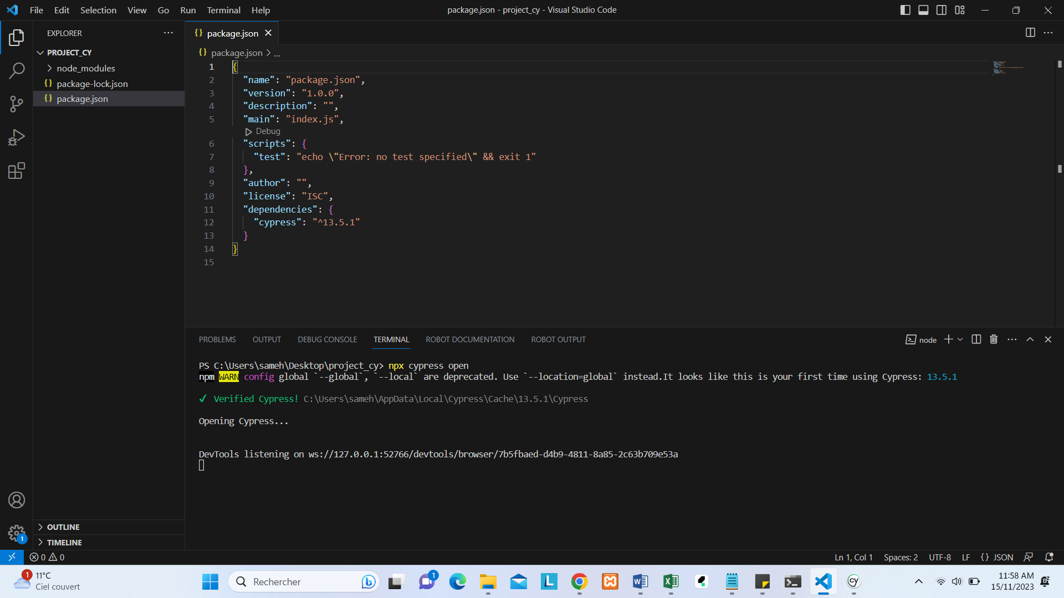

And Open Cypress:

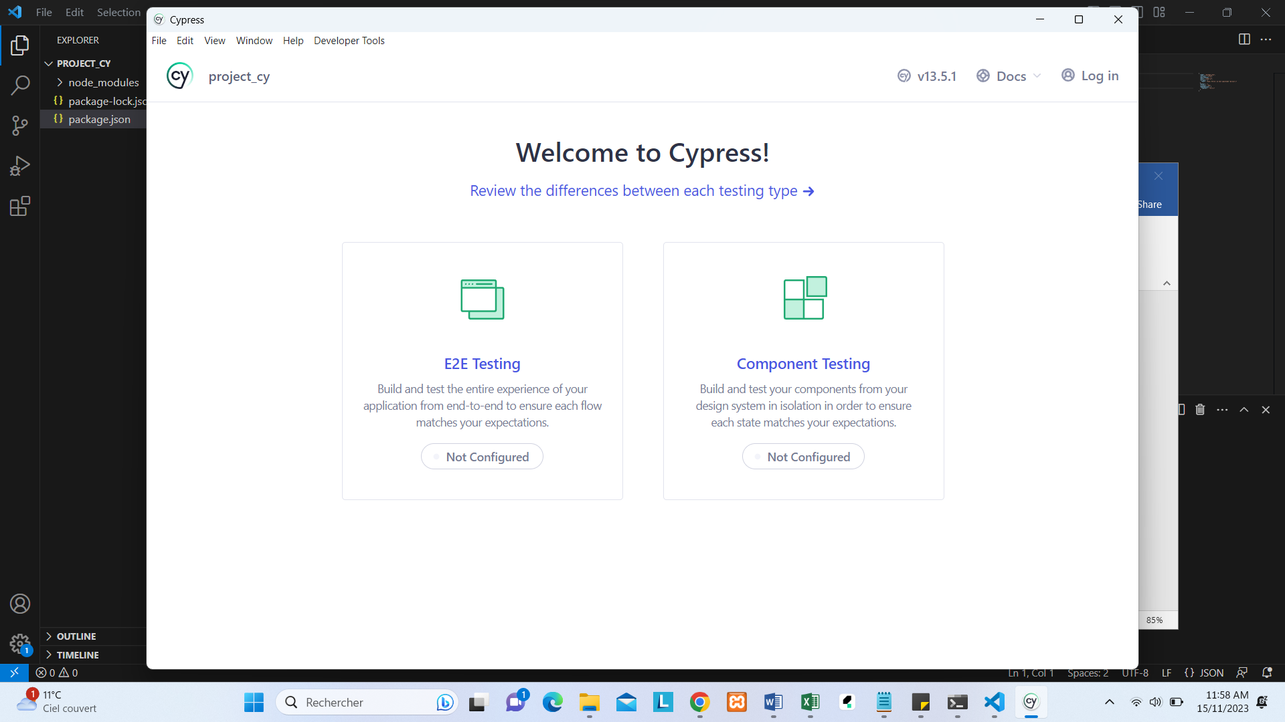

In the navigator, we found two type of testing E2E testing et Component testing: you click on link E2E testing

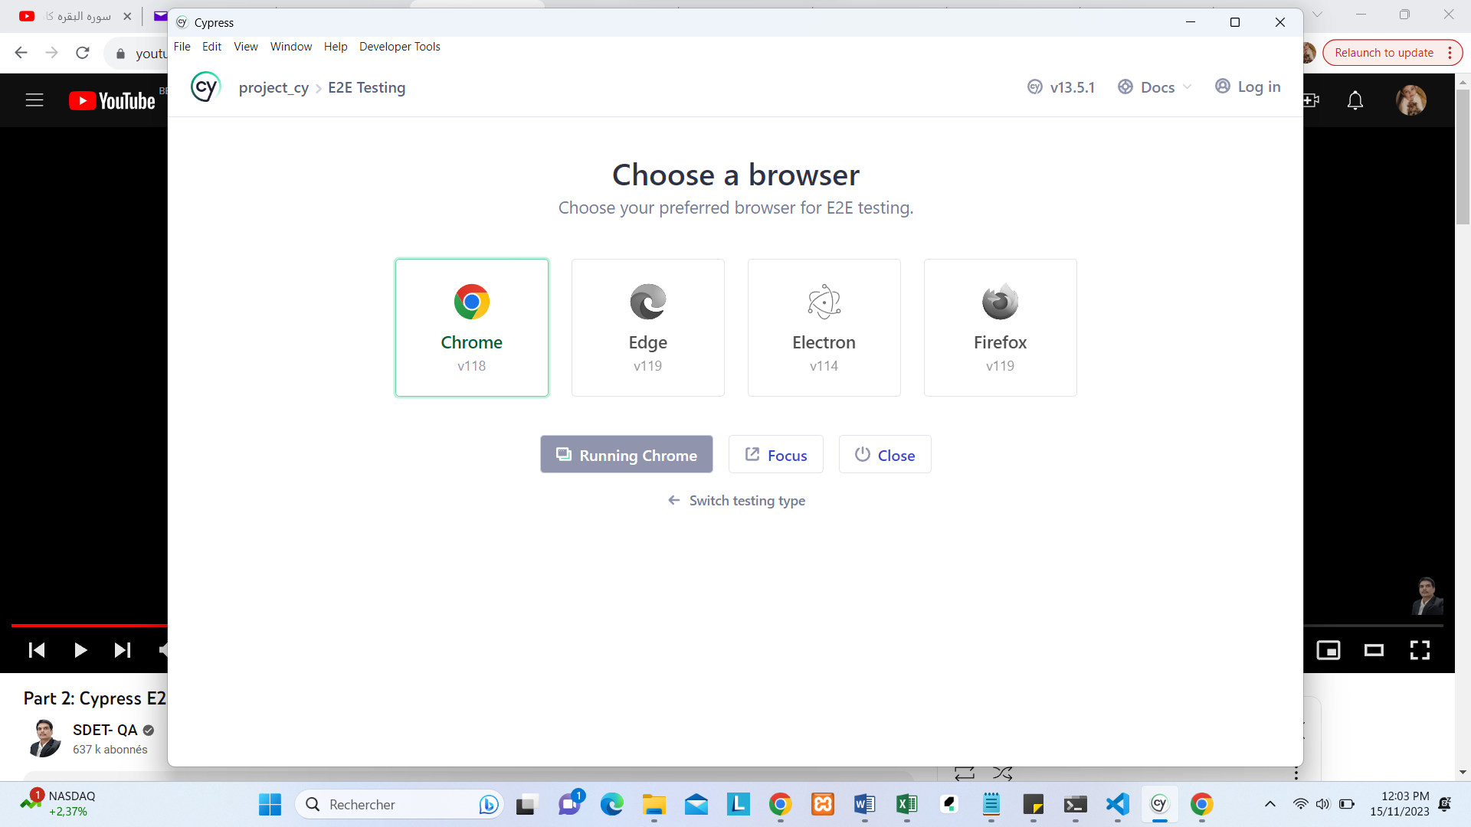
And after configure the project and click on to run project on chrome
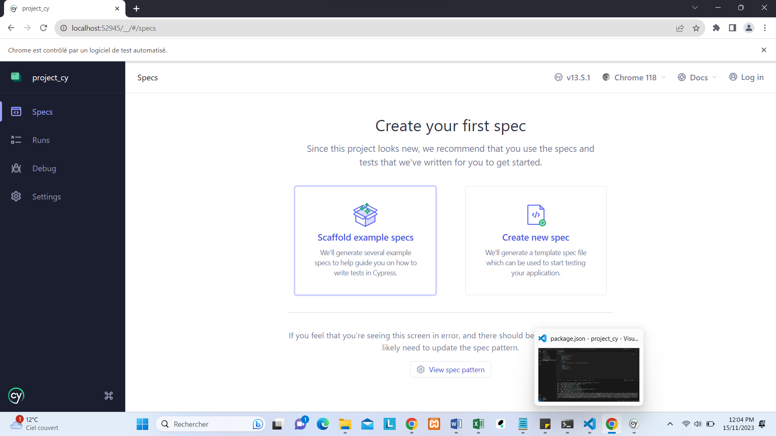
>Click on link scaffold example specs:
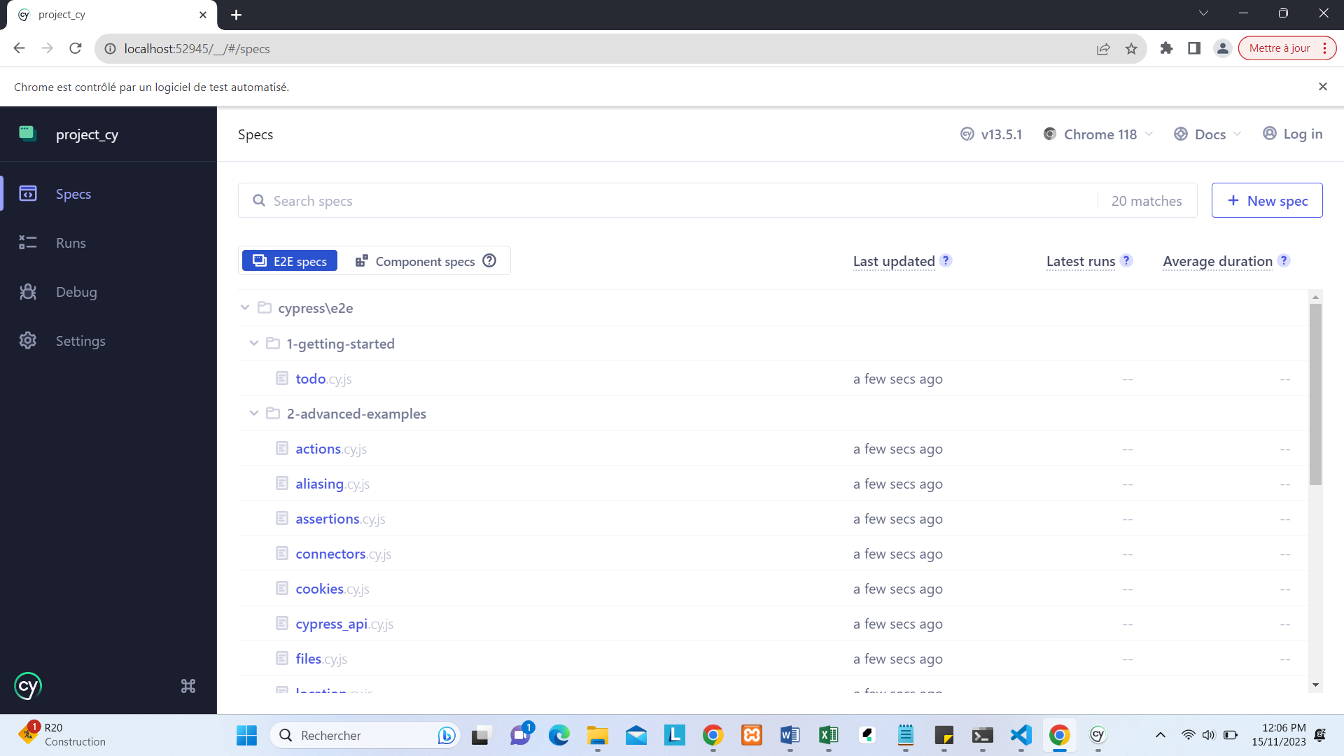
Writing & execution testing:
- Create a sample example of script with open the project and click on create new spec.cy.js
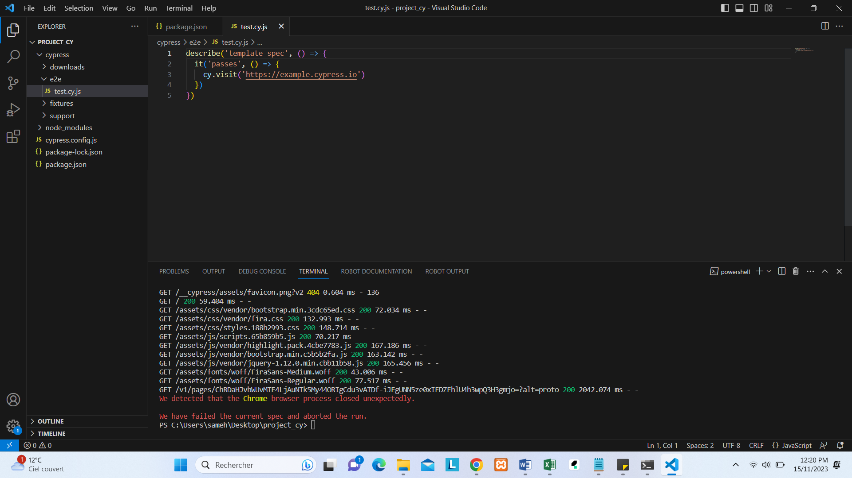
describe('My First Test', () => { ➔ Describe is keyword how can describe a suite name
it('Does not do much!', () => { → it block test 1
expect(true).to.equal(true) -> Assertion result expected (block on the function)
})
})
2 second method to run file:
Use the command npx cypress run in the terminal -> show result in console
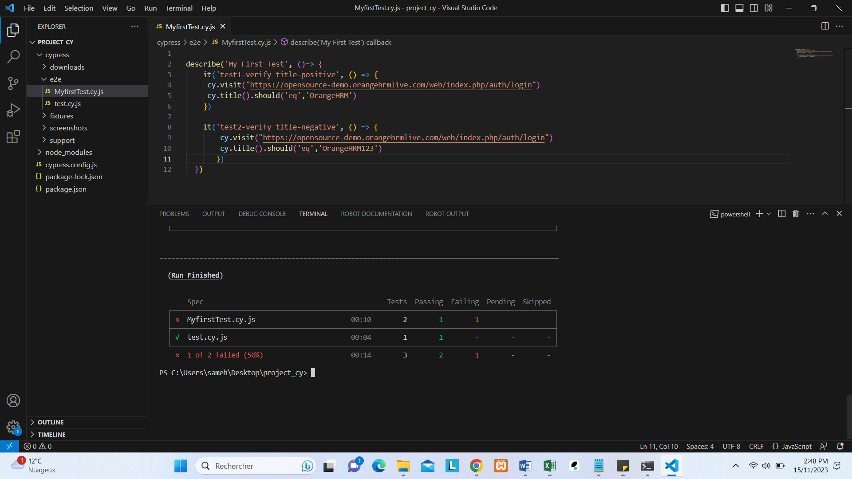
Use also other method execute directly in browser with the command:
- npx cypress run –headed
- also you can choose 1 test to execute with the relative path
- npx cypress run --spec cypress\e2e\test.cy.js
- With default, cypress execute test in Electron browser .
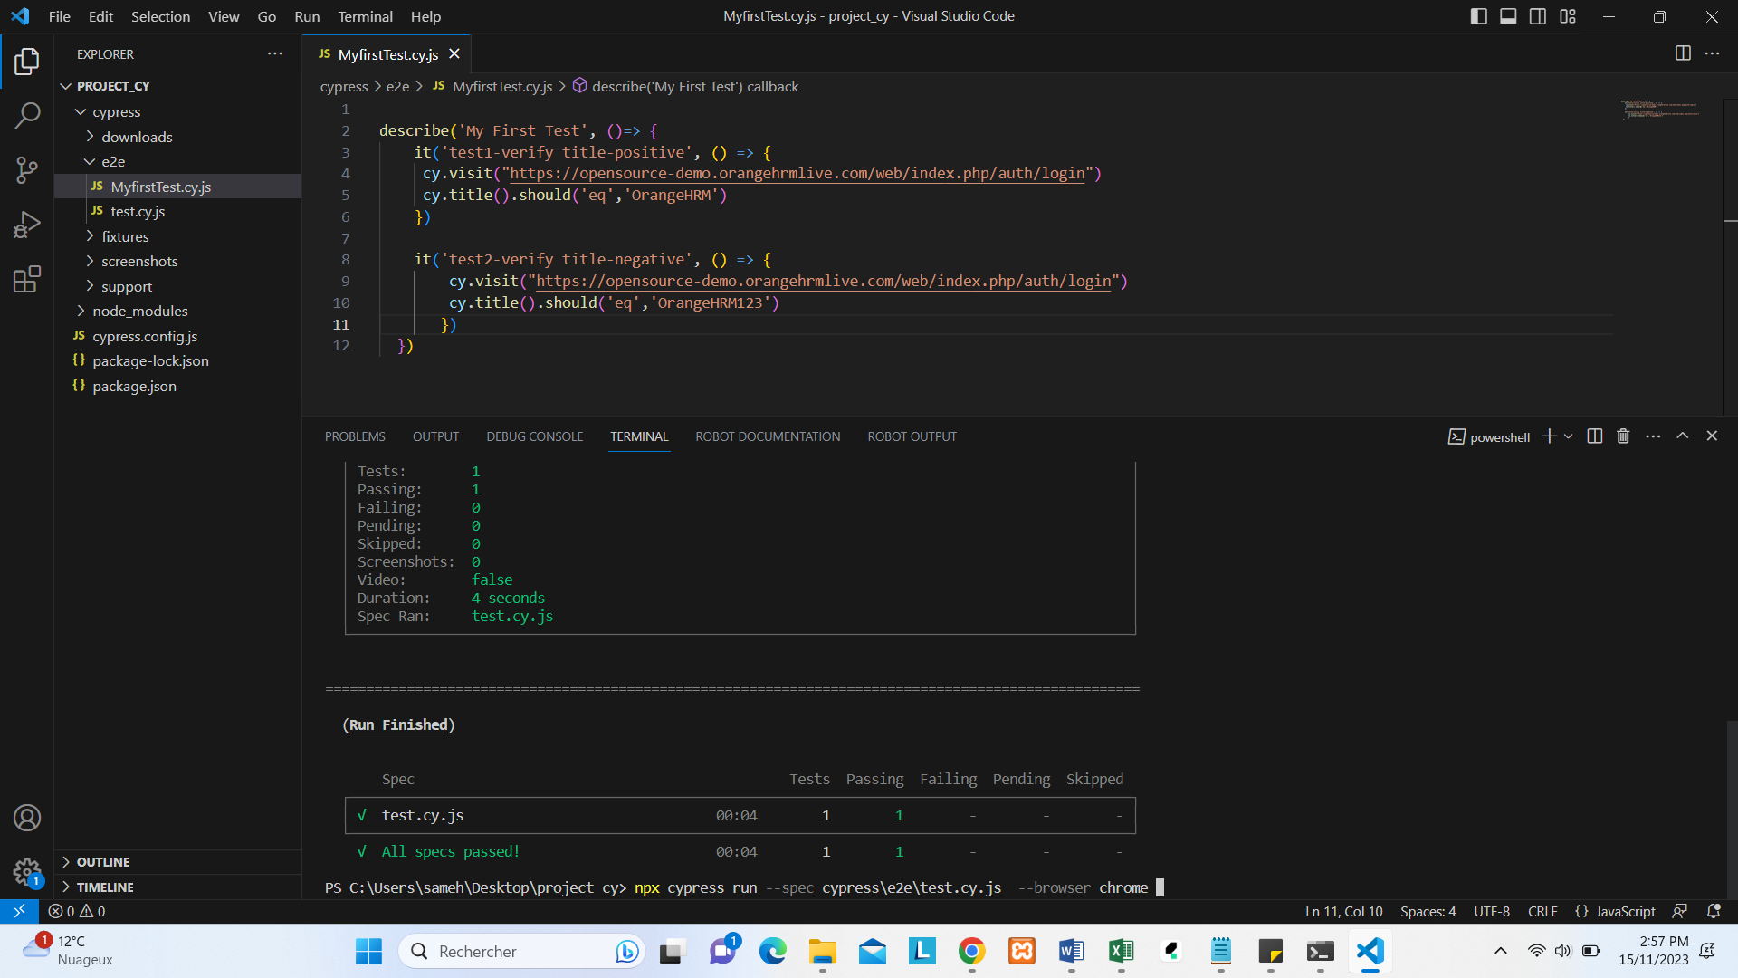
- npx cypress run --spec cypress\e2e\test.cy.js --browser chrome :with this command I change the browser chrome.
Test Suite->TestCase-Test Steps
Spec File (cy.js)---→ describe blocks(test suites)->it block (test)
- Locators:

CSS selector
XPath
Cy.get(Locator)

CSS selector
Tag id
Tag class
Tag attribute
Tag class
➔Pour determiner les locators , installer une extension à chrome chropath ou bien Selector Hub.
Tag #id
Tag.class
Tag [attribute=’value’]
Tag.class[attribute=’value ‘]

XPzth
*************
Npm install -D cypress -xpath
Xpath
Npm install -D cypress-xpath
Add entry in commands.js
/// <reference types="cypress-xpath" />
E2e.js
Require(‘cypress-xpath’)
Cypress Assertions
1/ Implicit assertions
Should
And
Ep
Contain
Include
Exist
Have.length
Have.value
Etc….
2/Explicit assertions
Expect -BDD
Assert -TDD

Cypress supports implicits asserts =>tous les élements web

