**ASSIGNMENT#04**

CSC103-Programming Fundamentals



Submitted by:

**AOUN-HAIDER**

**FA21-BSE-133**

**A**

Submitted to:

**Mr. Abdul Karim Shahid**

Submitted on: **December 20, 2021**

Instructions:

· Assignment should be uploaded on MS Teams.

· It should contain Title page, problem description, code (solution with proper comments and indentation) and output screen shot with white background.

Question 1:

You’re the owner of a hardware store and need to keep an inventory that can tell you what tools you have, how many you have and the cost of each one. Write a program that can handle max 100 records using struct inventory array, lets you input the data concerning each tool, enables you to list all your tools, lets you delete a record for a tool that you no longer have and lets you update any information in the array. The tool identification number should be the record number. Use the following information to start your array:

|  |
| --- |
| Record # Tool name Quantity Cost |
| 3 Electric sander 7 57.98 |
| 17 Hammer 76 11.99 |
| 24 Jigsaw 21 11.00 |
| 39 Lawnmower 3 79.50 |
| 56 Powersaw 18 99.99 |
| 68 Screwdriver 106 6.99 |
| 77 Sledgehammer 11 21.50 |
| 83 Wrench 34 7.50 |

CODES:

#include <stdio.h>

#include<string.h>

struct inventory{

int record;

char tool_name[30];

int quantity;

float cost; };

int main() {

struct inventory inv[100]= {{3,"Electric sander",7,57.98},{17,"Hammer",76,11.99},{24,"Jigsaw",21,11.00},

{39,"Lownmower",3,79.50},{56,"Powersaw",18,99.99},{68,"Screwdriver",106,6.99},

{77,"Sledgehammer",11,21.50},{83,"Wrench",34,7.50}};

struct inventory dell= {0,"",0,0.0};

int list,n1;

printf("|\4\4\4\4\4\4\4\4\4\4\4\4\4\4\4\4\4\4\4\4\4\4\4\4\4\4\4\4\4\4\4\4\4\4\4\4\4\4\4\4\4\4\4\4\4"

"\4\4\4\4\4\4\4\4\4\4\4\4\4\4\4\4\4\4\4\4\4\4\4\4\4\4\4\4\4\4\4\4\4|\n");

printf("|%3s|%19s|%19s|%17s|\n","RECORD","TOOL NAME","QUANTITY","COST");

for (int i=0;i<=7;i++) {

printf("\4_____________________________________________________________________________\4\n");

printf("\4%3d\n",inv[i].record);

printf("%25s",inv[i].tool_name);

printf("%19d",inv[i].quantity);

printf("%23.2f\n",inv[i].cost);

}

printf("|\4\4\4\4\4\4\4\4\4\4\4\4\4\4\4\4\4\4\4\4\4\4\4\4\4\4\4\4\4\4\4\4\4\4\4\4\4\4\4\4\4\4\4\4\4\4\4\4"

"\4\4\4\4\4\4\4\4\4\4\4\4\4\4\4\4\4\4\4\4\4\4\4\4\4\4\4\4\4\4|\n");

printf("\nEnter 1 to add record\nEnter 2 to update record\nEnter 3 to delete record\nEnter 4 to print record\n\nEnter 0 to exit\n");

scanf("%d",&list);

while(list!=0){

switch (list) {

case 1:

printf("Enter record number: ");

scanf("%d",&n1);

inv[n1].record=n1;

printf("Enter name:");

fflush(stdin);

gets(inv[n1].tool_name);

printf("Enter quantity:");

scanf("%d",&inv[n1].quantity);

printf("Enter cost:");

scanf("%f",&inv[n1].cost);

break;

case 2:

printf("Enter record no. to update: ");

scanf("%d",&n1);

for (int i=0;i<100;i++) {

if(inv[i].record==n1) {

inv[i].record=n1;

fflush(stdin);

printf("Enter tool name:");

gets(inv[i].tool_name);

printf("Enter quantity:");

scanf("%d",&inv[i].quantity);

printf("Enter cost:");

scanf("%f",&inv[i].cost);

}

}

break;

case 3:

printf("Enter record to delete: ");

scanf("%d",&n1);

for (int i=0;i<100;i++) {

if (inv[i].record==n1) {

inv[i]=dell; }

}

break;

case 4:

printf("\n\n");

printf("|\4\4\4\4\4\4\4\4\4\4\4\4\4\4\4\4\4\4\4\4\4\4\4\4\4\4\4\4\4\4\4\4\4\4\4\4\4\4\4\4\4\4\4\4\4"

"\4\4\4\4\4\4\4\4\4\4\4\4\4\4\4\4\4\4\4\4\4\4\4\4\4\4\4\4\4\4\4\4\4|\n");

printf("|%3s|%19s|%19s|%17s|\n","RECORD","TOOL NAME","QUANTITY","COST");

for (int i=0;i<100;i++) {

if (inv[i].record!=0) {

printf("|_____________________________________________________________________________|\n");

printf("|%3d\n",inv[i].record);

printf("%25s",inv[i].tool_name);

printf("%19d",inv[i].quantity);

printf("%23.2f\n",inv[i].cost);

}

}

printf("|\4\4\4\4\4\4\4\4\4\4\4\4\4\4\4\4\4\4\4\4\4\4\4\4\4\4\4\4\4\4\4\4\4\4\4\4\4\4\4\4\4\4\4\4\4"

"\4\4\4\4\4\4\4\4\4\4\4\4\4\4\4\4\4\4\4\4\4\4\4\4\4\4\4\4\4\4\4\4\4|\n");

break;

}

printf("\nEnter 1 to add record\nEnter 2 to update record\nEnter 3 to delete record\nEnter 4 to print record\n\nEnter 0 to exit\n");

scanf("%d",&list);

}

return 0;

}

OUTPUT:

Printing simple table:

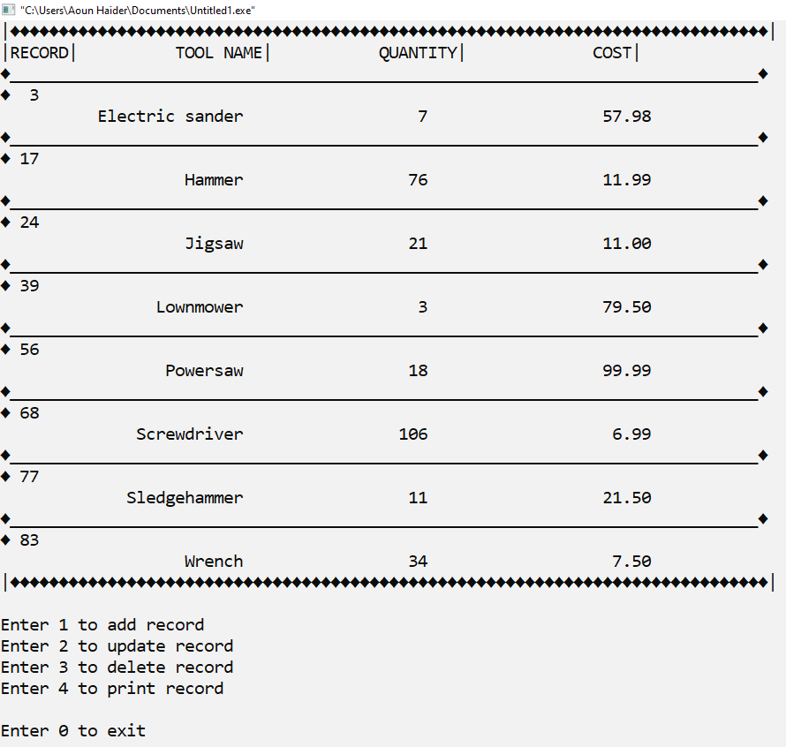

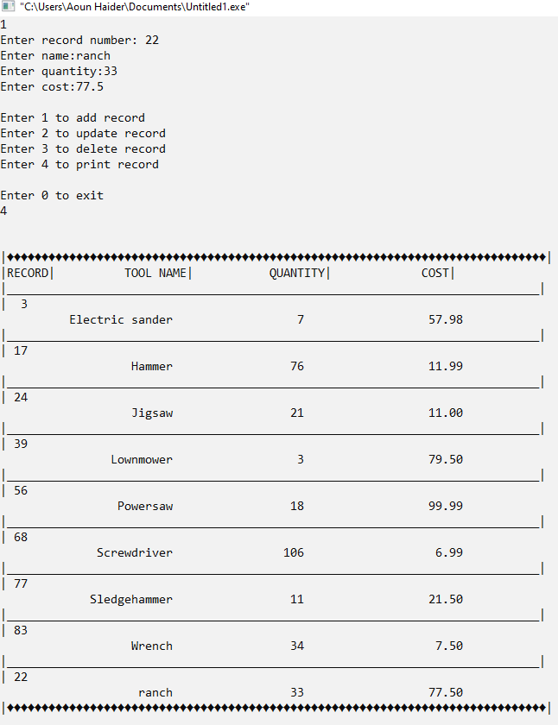Adding new record:

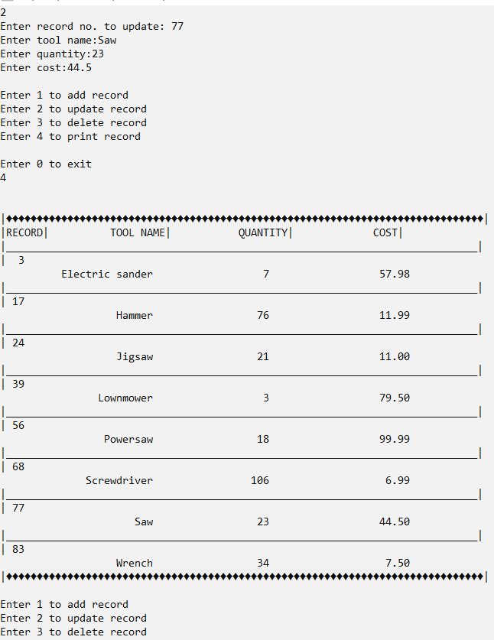Updating record:

Deleting record:

