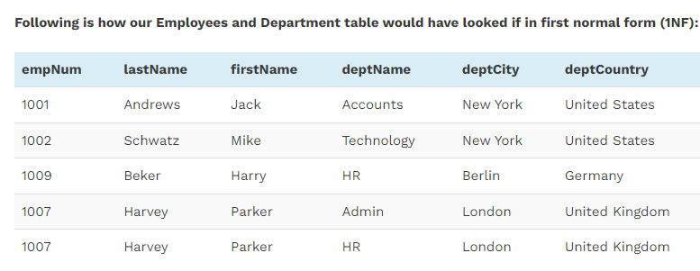

**1NF:** Already

**2NF:** Checking for functional dependencies:

Let’s assume empID as primary key (PK)

empID -> empNum, firstName, lastName

Lets assume depID as primary key (PK)

depID -> deptName, deptCity, deptCountry

**Employee**

|  |  |  |  |  |
| --- | --- | --- | --- | --- |
| empID(PK) | empNum | firstName | lastName | depID (FK) |

**Department**

|  |  |  |  |
| --- | --- | --- | --- |
| deptID | deptName | deptCity | deptCountry |

**3NF:** Checking for transitive dependency:

**Employee**

|  |  |  |  |  |
| --- | --- | --- | --- | --- |
| empID(PK) | empNum | firstName | lastName | depID (FK) |

**Department**

|  |  |
| --- | --- |
| deptID(PK) | deptName |

**Location**

|  |  |  |
| --- | --- | --- |
| deptID (FK) | deptCity | deptCountry |