**Quiz I – CS B**

**EE402 Digital Image Processing - spring 2018**

Time Allowed: 15 mins

**Instructions: There is only 1 problem in this exam. You can use your notes and books.**

Problem 1: We want to design a filter for calculating 2nd derivative of an image (in *x* direction

only), just as we made a filter to find 1st derivative. Assume that the first derivative can be found

by taking the following difference:



as illustrated in figure.

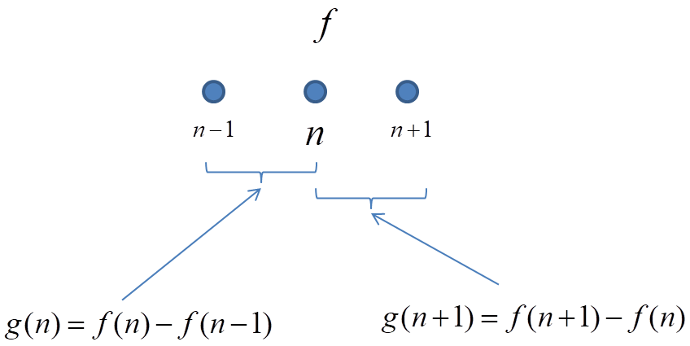



We can find the 2nd derivative by applying the same rule on



**Find a 3 x 3 kernel that when applied to image *f*, calculates its second horizontal derivative.**



You can begin by writing in terms of ***f.***