**Object Oriented Software Engineering**

**Name:** Aoun-Haider

**ID:** FA21-BSE-133

**Section:** A

**Date:** 28-05-23

**Assignment:** 03

**Submitted to:** Mam Sana-Maqbool

**Question no: 01**

**Create two or three classes linked by associations to represent the situations**

**below. Take care to specify appropriate multiplicity, as well as labels for the**

**associations. If there is more than one reasonable alternative, explain the**

**advantages and disadvantages of each.**

1. **Racing with vehicles and drivers.**

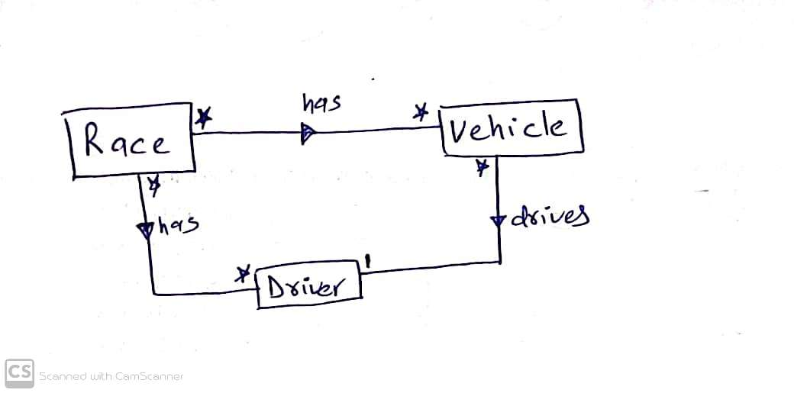

1. **A video rental shop, where you must purchase a membership before**

**renting anything.**

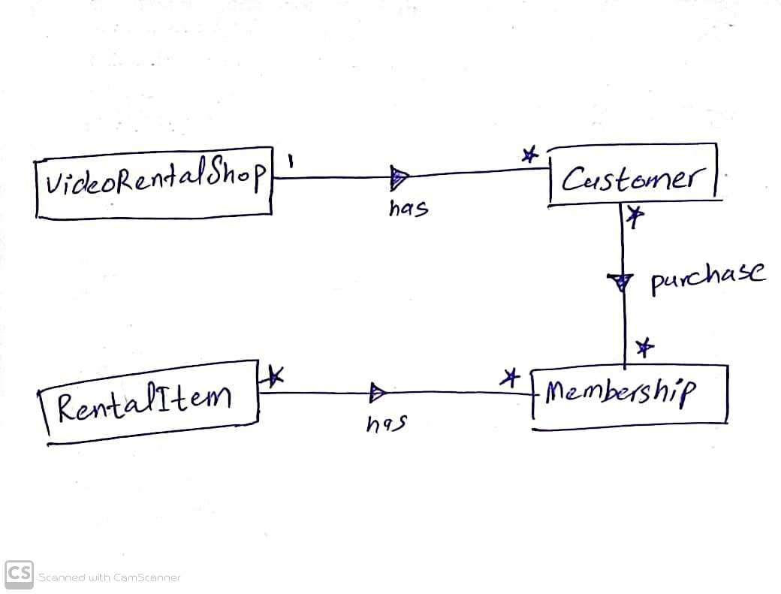

1. **A landlord renting apartments to tenants.**

1. **A diagram of a student

   Description automatically generated with low confidenceA student taking courses in a school.**
2. **A picture containing text, handwriting, sketch, drawing

   Description automatically generatedA professor teaching courses in a university.**
3. **A diagram of a book publishing

   Description automatically generated with low confidenceAn author writing books distributed by publishers.**
4. **A diagram of a company

   Description automatically generated with medium confidenceA repertory theater company is planning presentations of various plays.**

**Question: 02**

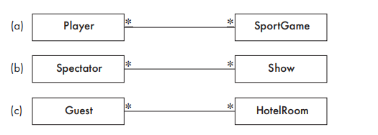**Add association classes to the three many-to-many associations.**

**Reserves**

**Attends**

**Participates**

**Question: 03**

**Draw a class diagram corresponding to the following situations.**

1. **An organization has three categories of employees: professional staff, technical staff, and support staff. The organization also has departments and divisions. Each employee belongs to either a department or a division Assume that people will never need to change from one category to another.**

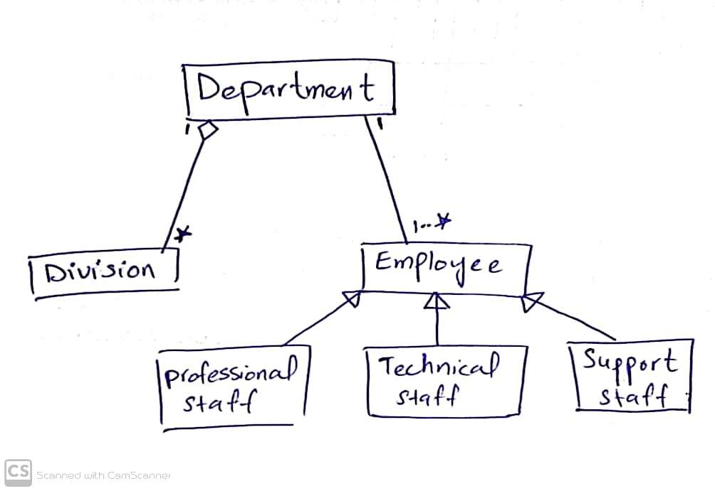

1. **A grocery store has some items sold by weight, and some per unit. Some items are taxable, while others are not. Some items have special prices when sold in groups (e.g., 3 for $2). Finally, some items have special prices if you have certain ‘membership cards. There could be several different membership prices on the same item, but you can only use one membership card per purchase.**

1. **A diagram of a plugin

   Description automatically generated with low confidenceA media player that can handle sound, images, and sequences of images. Each type of media requires a ‘plugin’, although some plugins can handle more than one type of media.**

**Question no: 04**

**Draw a class diagram that could generate the object diagram shown in**

**the figure. Make reasonable choices for multiplicity.**

**Class Diagram:**