**Object Oriented Software Engineering**

**Name:** Aoun-Haider

**ID:** FA21-BSE-133

**Section:** A

**Date:** 31-05-23

**Quiz:** 03

**Submitted to:** Mam Sana-Maqbool

**Question no: 01**

**Suggest a design pattern and convert the diagram into selected pattern.**

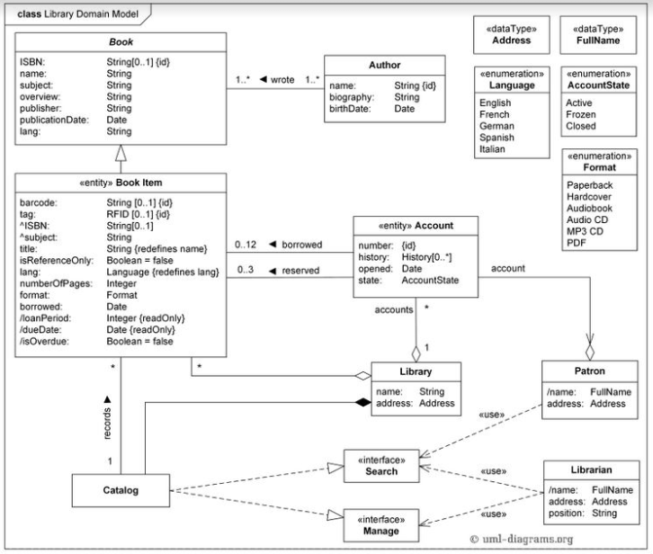

**Solution:**

The *Abstraction-Occurrences pattern* is used when dealing with a hierarchical structure of objects, where individual objects and groups of objects can be treated uniformly.

1 * *

<<Occurrence>>

<<Abstraction>>

**Question: 02**

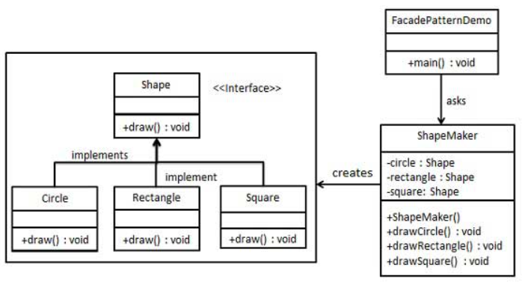 **Solution:**

The *Observer design pattern* is used when there is a one-to-many dependency between objects, where the state of one object (subject) changes, and all dependent objects (observers) are notified and updated automatically. This pattern enables loose coupling between the subject and observers, allowing for a flexible and efficient communication mechanism.

This scenario needs to follow the observable design pattern due to the requirement of tracking detail of Search and Manage interface. Observable interface will keep track of this class.

* *

<<Interface>>

Observer

update()

<<Observable>>

addObserver()

notifyObservers()

<<ConcreteObserver>>

<<ConcreteObserver>>