**CSC339 – Data Communication & Computer Networks**

**Name:** Mr. Aoun-Haider

**ID:** FA21-BSE-133

**Section:** A

**Lab Assignment:** 3 & 4

**CLO:03 Bloom Taxonomy Level: <*Applying*>**

**Question no. 01 [Assignment: 03]**

You need to do the following in ns2:

1. As in the paper, start with a network of 10 nodes (0 through 9) placed in a straight line (string topology). The distance between any two neighbouring nodes is 150m, which means that only nearest neighbour nodes can send data to each other. Each node has a queue for packets awaiting transmission, which holds up to 50 packets and is managed in a drop tail fashion. 2. Set up a single TCP connection between source node 0 and destination node 9. TCP packet size is 1460 bytes, 4 packets/sec and the duration of the simulation is 60s. Plot the results of your experiment as shown in Figure 2 of the paper (with window sizes of 4, 8 and 32)

**Code Snippet:**

**#Create a ns simulator**

set ns [new Simulator]

**#Open the NS trace file**

set tracefile [open out.tr w]

$ns trace-all $tracefile

**#Open the NAM trace file**

set namfile [open out.nam w]

$ns namtrace-all $namfile

proc finish {} {

global ns tracefile namfile

$ns flush-trace

close $tracefile

close $namfile

exec nam out.nam &

exit 0

}

**#Create 10 nodes**

**#create nodes,set distance and queue limit**

for {set i 0} {$i < 10} {incr i} {

set n($i) [$ns node]

$n($i) set X [expr $i * 150]

}

#create links

for {set i 0} {$i < 9} {incr i} {

$ns duplex-link $n($i) $n([expr $i+1]) 1Mb 10ms DropTail

$ns duplex-link-op $n($i) $n([expr $i+1]) orient right

$ns queue-limit $n($i) $n([expr $i+1]) 50

}

**# Setup a CBR Application over TCP connection**

set window_size 4

set tcp [new Agent/TCP]

$tcp set window_ $window_size

$ns attach-agent $n(0) $tcp

set cbr [new Application/Traffic/CBR]

$cbr set packetSize_ 1460

$cbr set rate_ 4.0Mb

$cbr attach-agent $tcp

set null [new Agent/TCPSink]

$ns attach-agent $n(9) $null

$ns connect $tcp $null

**# Start and stop the application**

$ns at 0.5 "$cbr start"

$ns at 4.5 "$cbr stop"

$ns at 5.0 "finish"

$ns run

**Sample run:**

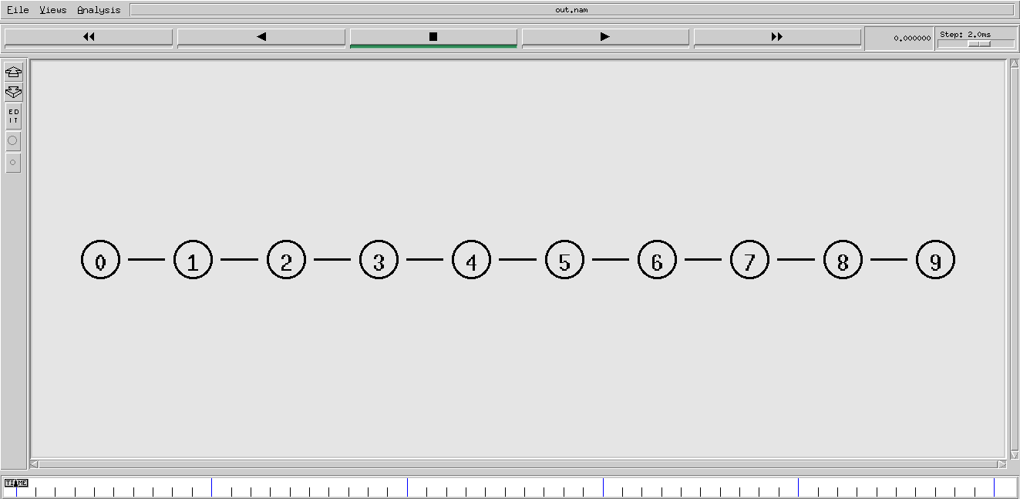

**[Window size = 4]**

1. 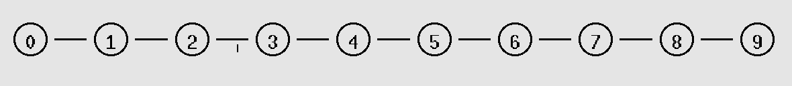A black and white image of numbers and a line

   Description automatically generated Sending SYN segment from n0 to n9
2. 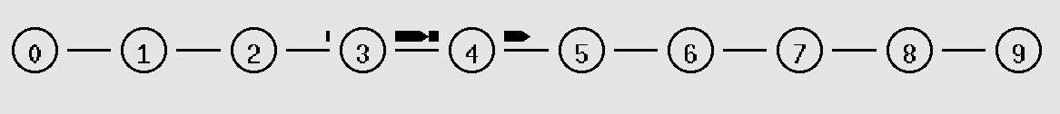A number and circle with black lines

   Description automatically generated with medium confidence Receiving ACK segment from n9 to n0

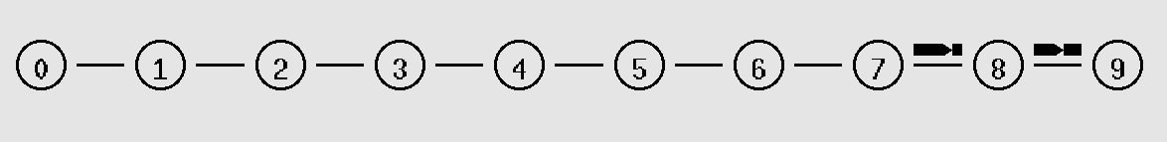

1. Sending Packets of 1460 bytes

1. Receiving ACK segment for packets

]**

1. Sending SYN segment from n0 to n9



1. 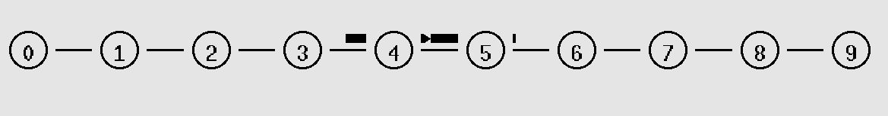 Receiving ACK segment from n9 to n0
2. Sending packet of 1460 bytes

1. Receiving ACK segment for packets

**[Window size = 8]**

1. Sending SYN segment from n0 to n9
2.  Receiving ACK segment from n9 to n0

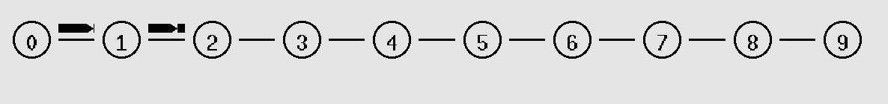

1. Sending packet of 1460 bytes

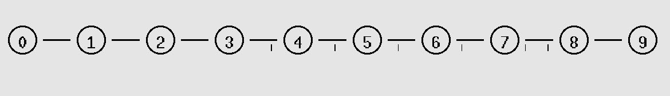

1. Receiving ACK segment for packets

**Connection b/w n3 and n4**

**Window size = 4**

**Code:**

**#Create a ns simulator**

set ns [new Simulator]

**#Open the NS trace file**

set tracefile [open out.tr w]

$ns trace-all $tracefile

#Open the NAM trace file

set namfile [open out.nam w]

$ns namtrace-all $namfile

proc finish {} {

global ns tracefile namfile

$ns flush-trace

close $tracefile

close $namfile

exec nam out.nam &

exit 0

}

**#Create 10 nodes**

#create nodes,set distance and queue limit

for {set i 0} {$i < 10} {incr i} {

set n($i) [$ns node]

$n($i) set X [expr $i * 150]

}

**#create links**

for {set i 0} {$i < 9} {incr i} {

$ns duplex-link $n($i) $n([expr $i+1]) 1Mb 10ms DropTail

$ns duplex-link-op $n($i) $n([expr $i+1]) orient right

$ns queue-limit $n($i) $n([expr $i+1]) 50

}

**# Setup a CBR Application over TCP connection**

set window_size 4

set tcp [new Agent/TCP]

$tcp set window_ $window_size

$ns attach-agent $n(3) $tcp

set cbr [new Application/Traffic/CBR]

$cbr set packetSize_ 1460

$cbr set rate_ 4.0Mb

$cbr attach-agent $tcp

set null [new Agent/TCPSink]

$ns attach-agent $n(4) $null

$ns connect $tcp $null

**# Start and stop the application**

$ns at 0.5 "$cbr start"

$ns at 4.5 "$cbr stop"

$ns at 5.0 "finish"

$ns run

**Sample run:**

**[Window size = 4]**

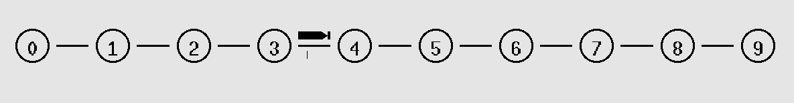**[Window size = 6]**

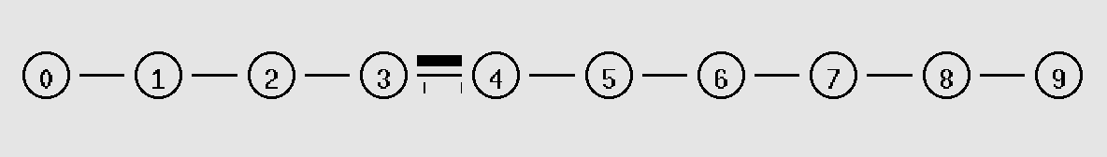**[Window size = 8]**

1. Keep window size fixed at 8. Start Two TCP connections. One from node 0 to node 3 and the other from node 6 to 9. Plot the throughput (of both streams) as a function of time. 5. Keep window size fixed at 8. Next, start two TCP connections one from 6 to 4 and the other from 2 to 3. Conduct two experiments. i) let both TCP connections start at the same time. ii) Let the second session start 10 seconds later than the first TCP session. Plot the results as in Figure 4 of the paper.

**Code Snippet:**

**#Create a simulator object**

set ns [new Simulator]

**#Open the output files**

set f0 [open f0.tr w]

set f1 [open f1.tr w]

**#Create 10 nodes**

for {set i 0} {$i < 10} {incr i} {

set n($i) [$ns node]

$n($i) set X [expr $i * 150]

}

**#Connect the nodes**

for {set i 0} {$i < 9} {incr i} {

$ns duplex-link $n($i) $n([expr $i+1]) 1Mb 10ms DropTail

$ns duplex-link-op $n($i) $n([expr $i+1]) orient right

$ns queue-limit $n($i) $n([expr $i+1]) 50

}

**#Define a 'finish' procedure**

proc finish {} {

global f0 f1

**#Close the output files**

close $f0

close $f1

**#Call xgraph to display the results**

exec xgraph f0.tr f1.tr -geometry 800x400 &

exit 0

}

proc attach-expoo-traffic { node sink window_size size burst idle rate } {

#Get an instance of the simulator

set ns [Simulator instance]

**#Create a UDP agent and attach it to the node**

set source [new Agent/TCP]

$source set window_ window_size

$ns attach-agent $node $source

**#Create an Expoo traffic agent and set its configuration parameters**

set traffic [new Application/Traffic/Exponential]

$traffic set packetSize_ $size

$traffic set burst_time_ $burst

$traffic set idle_time_ $idle

$traffic set rate_ $rate

**# Attach traffic source to the traffic generator**

$traffic attach-agent $source

#Connect the source and the sink

$ns connect $source $sink

return $traffic

}

**#Define a procedure which periodically records the bandwidth received by the**

**#three traffic sinks sink0/1/2 and writes it to the three files f0/1/2.**

proc record {} {

global sink0 sink1 sink2 f0 f1

#Get an instance of the simulator

set ns [Simulator instance]

#Set the time after which the procedure should be called again

set time 0.5

**#How many bytes have been received by the traffic sinks?**

set bw0 [$sink0 set bytes_]

set bw1 [$sink1 set bytes_]

**#Get the current time**

set now [$ns now]

**#Calculate the bandwidth (in MBit/s) and write it to the files**

puts $f0 "$now [expr $bw0/$time*8/1000000]"

puts $f1 "$now [expr $bw1/$time*8/1000000]"

**#Reset the bytes_ values on the traffic sinks**

$sink0 set bytes_ 0

$sink1 set bytes_ 0

**#Re-schedule the procedure**

$ns at [expr $now+$time] "record"

}

**#Create three traffic sinks and attach them to the node n4**

set sink0 [new Agent/LossMonitor]

set sink1 [new Agent/LossMonitor]

$ns attach-agent $n(3) $sink0

$ns attach-agent $n(9) $sink1

**#Create three traffic sources**

set source0 [attach-expoo-traffic $n(0) $sink0 8 1460 2s 1s 100k]

set source1 [attach-expoo-traffic $n(6) $sink1 8 1460 2s 1s 300k]

**#Start logging the received bandwidth**

$ns at 0.0 "record"

#Start the traffic sources

$ns at 10.0 "$source0 start"

$ns at 10.0 "$source1 start"

**#Stop the traffic sources**

$ns at 50.0 "$source0 stop"

$ns at 50.0 "$source1 stop"

**#Call the finish procedure after 60 seconds simulation time**

$ns at 60.0 "finish"

**#Run the simulation**

$ns run

**Sample Run:**

**Packet transmission at same time:**

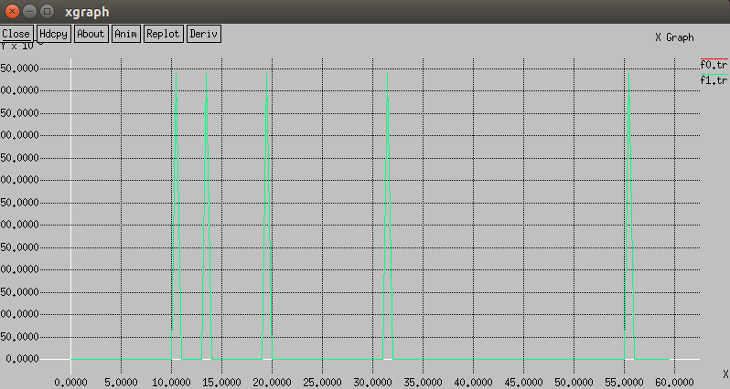

**Packet transmission at different time:**

**Connection b/w n6 and n4, n2 and n3**

**Window size = 8**

**UDP Transmission: \***

**Question no. 02 [Assignment: 04]**

In this lab, you’ll use your Web browser to access a file from a Web server. As in earlier Wireshark labs, you’ll use Wireshark to capture the packets arriving at your computer. Unlike earlier labs, you’ll also be able to download a Wireshark-readable packet trace from the Web server from which you downloaded the file. In this server trace, you’ll find the packets that were generated by your own access of the Web server. You’ll analyse the client- and server-side traces to explore aspects of TCP. You’ll evaluate the performance of the TCP connection between your computer and the Web server. You’ll trace TCP’s window behaviour, and infer packet loss, retransmission, flow control and congestion control behaviour, and estimated roundtrip time.

**Solution:**

***I followed the following steps to create a trace file in Wireshark.***

1. Go to web browser. Go the http://gaia.cs.umass.edu/wireshark-labs/alice.txt and retrieve an ASCII copy of Alice in Wonderland. Store this as a .txt file somewhere on your computer.
2. Next go to http://gaia.cs.umass.edu/wireshark-labs/TCP-wireshark-file1.html.
3. A close up of text

   Description automatically generatedThis is the web page where uploaded the alice.txt file and started Wireshark trace at the same time.
4. A screenshot of a computer

   Description automatically generatedAfter uploading file, trace file look like this

Figure 1

**TCP Performance:**

As TCP connection follows 3-way handshake, my pc sent a SYN segment to tell the server that I want to establish the connection. Server responded with SYN-ACK segment to allow the communication and then my pc sent the segment again to tell that connection is from legitimate client and alive. As we can see that there is small amount of loss of packets and data reliability is also ensured by addition checksum field in the header.

TCP ensures that all the packets are transferred without any interference.

1. **Throughput:** is almost constant in the given scenario and not decreasing too much due to successful transmission of almost all segments.
2. **Round-Trip Time (RTT):** is not much affected because initial time slice of transmission is 18.44.20.570381 and 18.44.20.596858 which is 0.0.0.26477.
3. **Packet Loss:** is very rare in this scenario of trace file as shown in Figure 1
4. **Retransmission Rate:** As packet loss is very rare that’s why retransmission is not required.
5. **TCP window size** changes most of the time in sequence 16384, 5840, 17520, 17520, 17520, 6780 …
6. **Congestion window size** is handled by TCP internally.
7. **Throughput delay product** has not very large factor of increase.
8. **Connection establishment time** is almost similar as initial time to create connection was 18.44.570381
9. **Connection termination time** takes quite a long time than establishment time. This can be due to increasing data in the receiver buffer.
10. **Window scaling** is performed which shows that the receiver is processing data at a higher speed than the sender’s sending rate.
11. **Buffer bloat** refers to excessively large buffers causing increased latency.
12. **TCP fast open (TFO)** a mechanism which allows sending data with SYN segment which is not used in the given scenario.
13. **Path MTU** maximum size of an IP packet that can be transmitted without any fragmentation. Fragmentation is also used for fast transmission and due to the very large size of packet.

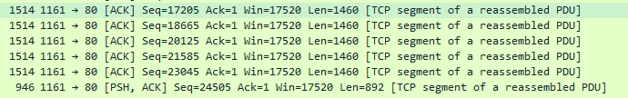

1. **Segment Size** is mostly 1514 bytes and often fragmentated.
2. **Flow control** is managed by performing fragmentation and advertising window size.
3. **Congestion control** is also managed but, in this case, receiver is advertising window size of increasing order which means congestion is not occurred yet.

**Additional Comments:**

1. Ensure that the measurements are taken under representative conditions, considering network characteristics and load.
2. Multiple measurements should be taken to account for variability.
3. Use both active measurements (tools generating traffic) and passive measurements (capturing existing traffic) for a comprehensive analysis.

**References:**

1. Ns2 tutorial: <https://www.isi.edu/nsnam/ns/tutorial/index.html>
2. Wireshark Lab helping material: <https://gaia.cs.umass.edu/kurose_ross/wireshark.php>