LSTM

Long Short Term Memory networks ,usually just called “LSTMs” are a special kind of RNN, capable of learning long-term dependencies.

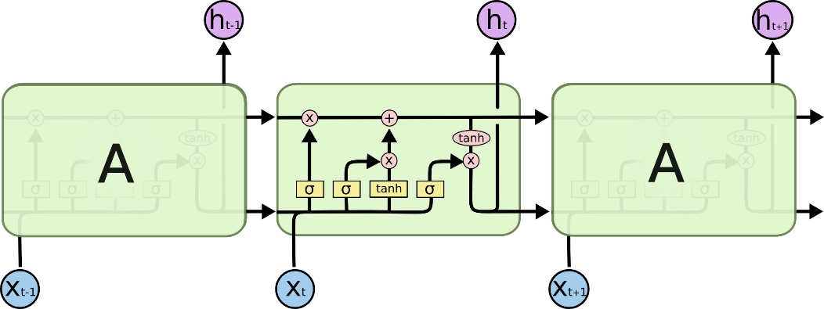

The key to LSTMs is the cell state, the horizontal line running through the top of the diagram.

The cell state is kind of like a conveyor belt. It runs straight down the entire chain, with only some minor linear interactions. It’s very easy for information to just flow along it unchanged.

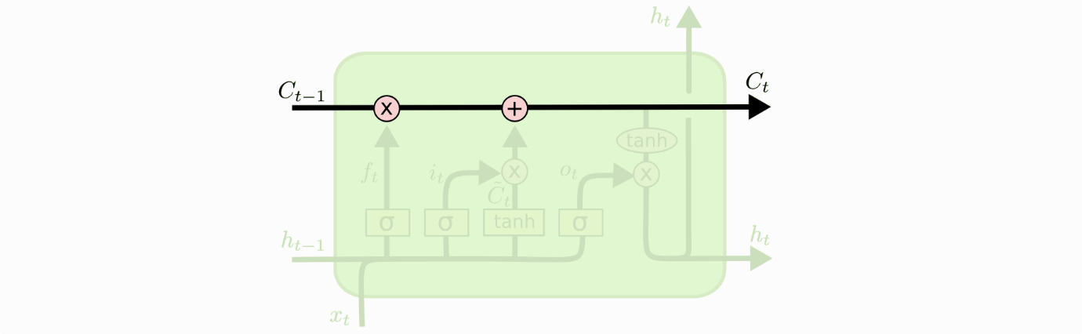

The LSTM does have the ability to remove or add information to the cell state, carefully regulated by structures called gates.

Gates are a way to optionally let information through. They are composed out of a sigmoid neural net layer and a pointwise multiplication operation.

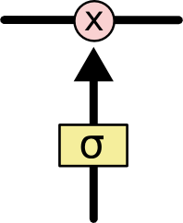

The sigmoid layer outputs numbers between zero and one, describing how much of each component should be let through. A value of zero means “let nothing through,” while a value of one means “let everything through!”

An LSTM has three of these gates, to protect and control the cell state.

The first step in our LSTM is to decide what information we’re going to throw away from the cell state. This decision is made by a sigmoid layer called the “forget gate layer.” It looks at ht−1 and xt, and outputs a number between 0 and 1 for each number in the cell state Ct−1. A 1 represents “completely keep this” while a 0 represents “completely get rid of this.”

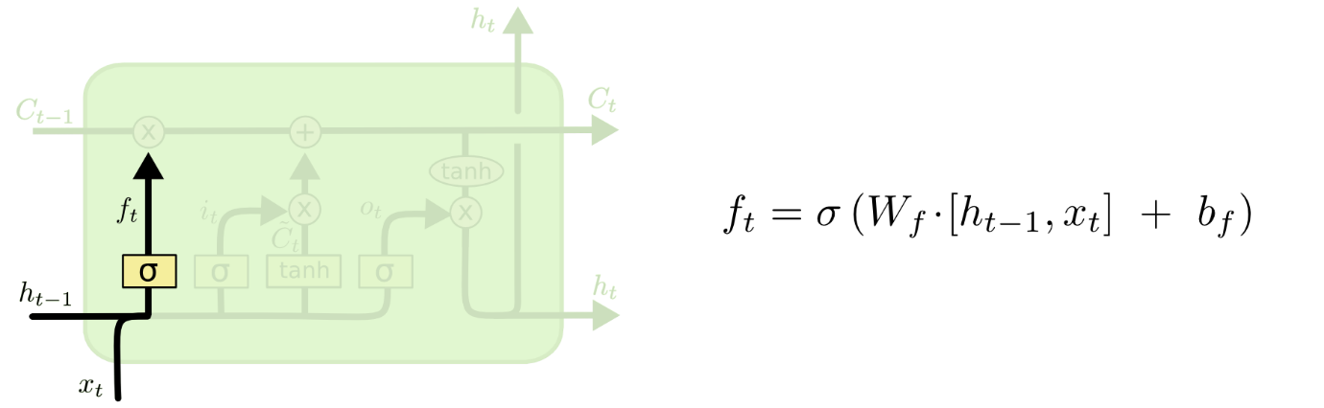

The next step is to decide what new information we’re going to store in the cell state. This has two parts. First, a sigmoid layer called the “input gate layer” decides which values we’ll update. Next, a tanh layer creates a vector of new candidate values, C~t, that could be added to the state. In the next step, we’ll combine these two to create an update to the state.

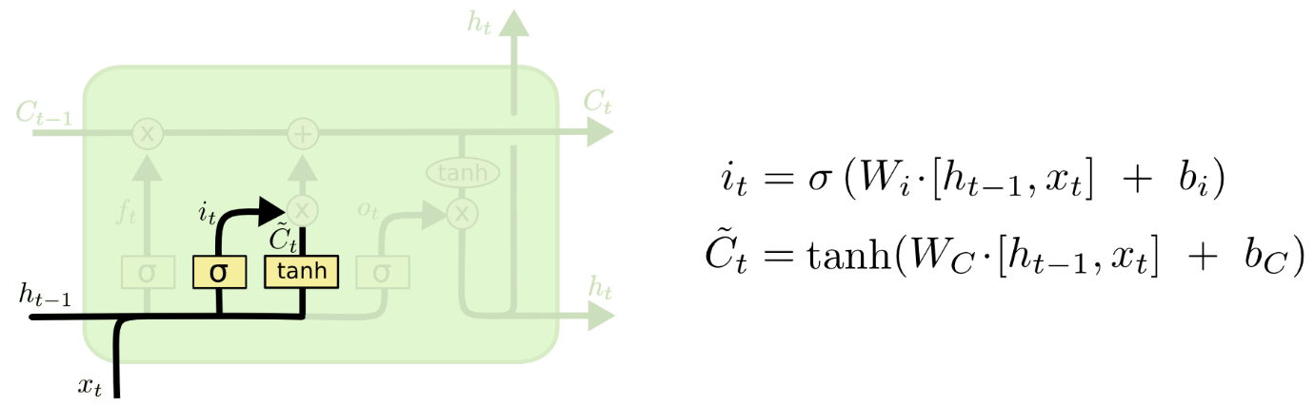

It’s now time to update the old cell state, Ct−1, into the new cell state Ct. The previous steps already decided what to do, we just need to actually do it.

We multiply the old state by ft, forgetting the things we decided to forget earlier. Then we add it∗C~t. This is the new candidate values, scaled by how much we decided to update each state value.

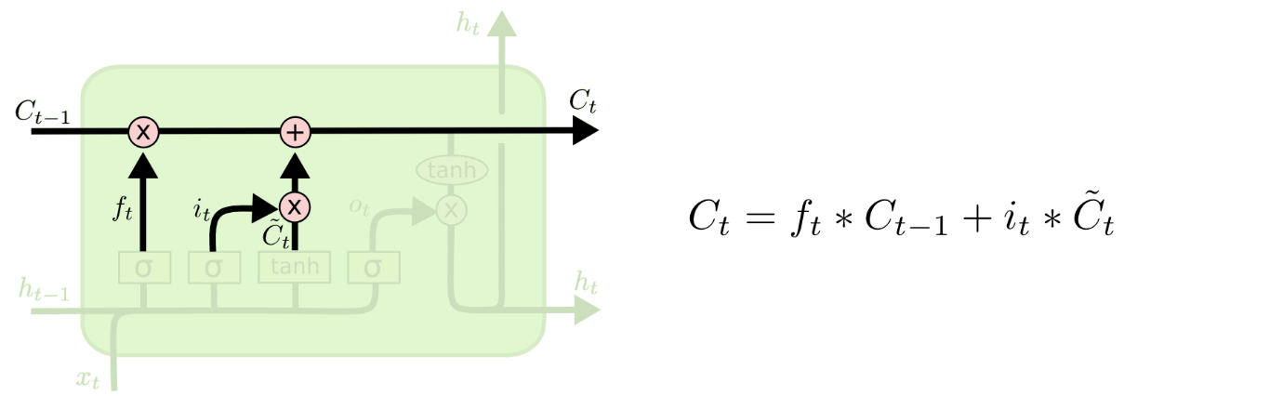

Finally, we need to decide what we’re going to output. This output will be based on our cell state, but will be a filtered version. First, we run a sigmoid layer which decides what parts of the cell state we’re going to output. Then, we put the cell state through tanh (to push the values to be between −1 and 1) and multiply it by the output of the sigmoid gate, so that we only output the parts we decided to.

*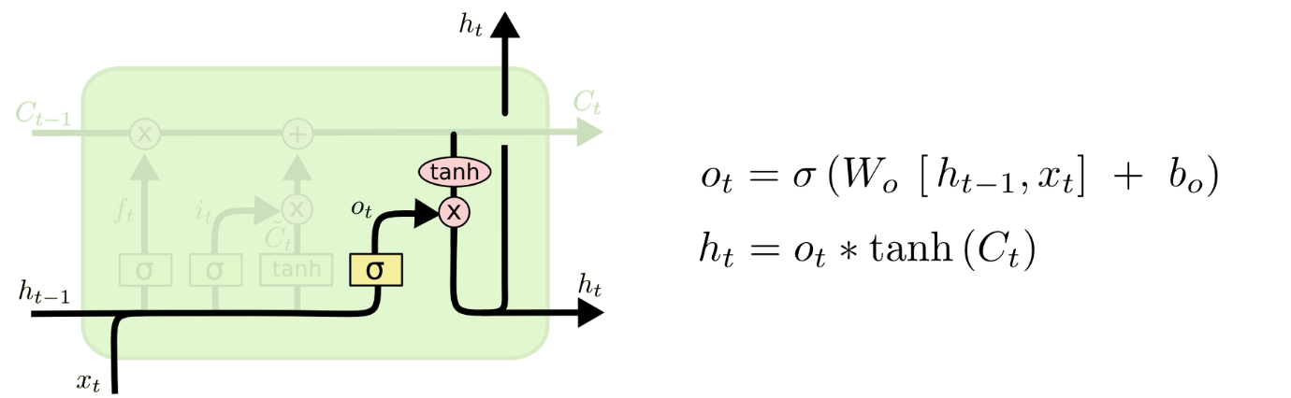s*