Railway Animal Detection System
Communication and Alerting Layer
BTP Major (SSE) — Mid-Semester Progress Report
Student: Apoorv Singh (230021004) | Department: Space Science & Engineering
Institute: IIT Indore | Supervisor: [Supervisor Name]

1. Introduction and Problem Statement
Animal-train collisions along Indian Railways routes cause significant loss of wildlife, occasional derailments, and recurring operational disruption. A number of ongoing efforts focus on the detection problem — using cameras, PIR motion sensors, and geophones at trackside nodes to identify when an animal is present. Detection alone, however, does not prevent a collision: the critical remaining gap is getting that information to a train driver quickly enough, and in a form simple enough, to act on within seconds, while simultaneously logging the event for a control room to track patterns over time.
This project addresses that gap directly: a communication and alerting layer that takes detection data from trackside nodes, determines how urgent each detection is, and pushes that decision to a driver-facing display and a control-room dashboard in real time.

2. Scope of Work
The overall Railway Animal Detection System has three parts: (a) trackside sensing hardware (ESP32-CAM, PIR, geophone), (b) a trained detection model (YOLOv8-nano, trained separately to 81.5% mAP50 on a wildlife dataset), and (c) the communication and alerting layer that connects detection output to human decision-makers. This report covers part (c), which is this student's specific and complete responsibility within the project: event ingestion, severity scoring, multi-node prioritization, data persistence, and the driver/control-room interfaces.

3. System Architecture
Detection events reach the system from one of two sources: a real edge node (ESP32-CAM capturing an image on PIR trigger) or, during development and testing, a simulator that posts realistic synthetic events over HTTP. Both paths converge on a single processing pipeline before touching any downstream logic — this was a deliberate design choice so that the full system (scoring, storage, both dashboards) could be built and demonstrated before hardware was ready, with zero difference in behaviour once real hardware is substituted in.
The pipeline stages are:
- Ingestion — a FastAPI server exposes endpoints for pre-scored JSON events, raw images requiring inference, and lightweight heartbeats; Pydantic models validate every incoming payload against a fixed schema.
- Inference (when needed) — a server-side module runs the trained YOLOv8-nano model on uploaded frames, since the ESP32-CAM lacks the compute to run inference on-device.
- Priority scoring — each event is scored from track position, animal size class, multi-sensor agreement, detection confidence, and herd size, producing a RED / YELLOW / GREEN severity label.
- Multi-node ranking — across simultaneously active nodes, events are ranked by severity and proximity so the driver display always shows the single most urgent situation, with others queued as secondary alerts.
- Persistence — every event is logged to a database for the control room's historical record and future animal-movement path tracing.
- Broadcast — scored events are pushed over WebSocket to two purpose-built dashboards: a high-contrast, color-coded driver display, and a denser control-room view with live logs and per-node status.

4. Work Completed to Date

4.1 Communication and alerting pipeline (complete, tested)
- Detection event JSON schema defined as the fixed contract between edge nodes and the server.
- FastAPI server with three ingestion endpoints (pre-scored JSON, raw image for inference, heartbeat) sharing one processing pipeline.
- Priority/severity scoring engine with tunable, documented weights for position, animal class, sensor agreement, confidence, and herd size.
- Multi-node, multi-animal prioritization and ranking logic.
- SQLite-backed persistence for the control room's historical event log.
- Driver dashboard: full-screen, color-coded (red/yellow/green) signal display with icon-driven action indicators (slow / brake / horn), designed for sub-second readability.
- Control room dashboard: live event feed, per-node status grid, daily detection statistics, historical table.
- Node simulator generating realistic multi-node detection traffic for end-to-end testing without physical hardware.
- Full pipeline tested live across two physically separate devices over a real WiFi network (not local-host only), confirming the system works across an actual network boundary.

4.2 Edge node firmware (written, not yet hardware-validated)
- ESP32-CAM firmware implementing deep-sleep power management with two wake sources: PIR-triggered capture-and-transmit, and a periodic timer heartbeat so node status remains meaningful between detections.
- On-trigger behaviour: capture a frame, transmit it with sensor metadata to the inference endpoint over WiFi.
- A flashing method identified and planned using an Arduino Mega 2560 as a USB-serial bridge, to work around a delayed component (USB programming shield).

4.3 Model integration
- Server-side inference module wired to accept the trained YOLOv8-nano model and route its output through the same scoring pipeline used for all other events.

5. Validation Evidence
The driver dashboard below is shown responding live to real events posted to the running server — not a mockup. Figure 1 shows the critical (RED) state, in which the horn indicator blinks in sync with the alert lamp; Figure 2 shows the caution (YELLOW) state, in which both the slow and brake indicators are lit. Icon- and color-driven signaling was chosen deliberately over descriptive text, since a driver has, at most, a second or two to register the alert.
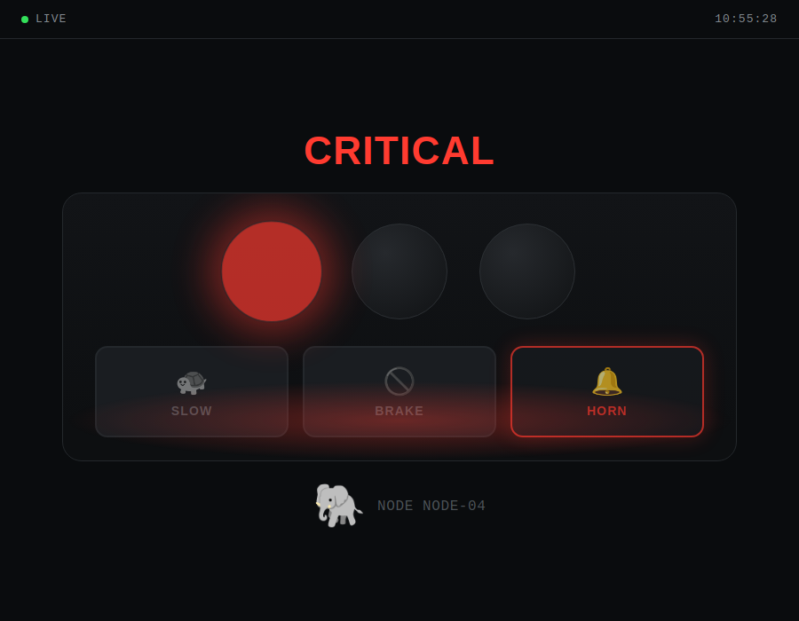  Figure 1: Driver dashboard, RED state | 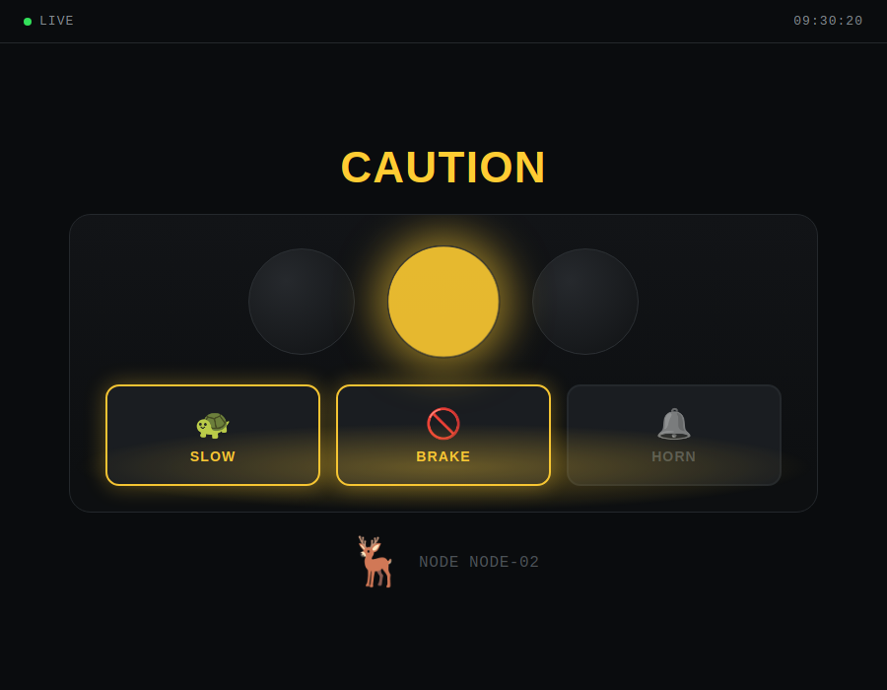  Figure 2: Driver dashboard, YELLOW state

Both states were produced by posting real detection events to the FastAPI server and observing the dashboard update live over a WebSocket connection across two physically separate devices on the same WiFi network, confirming the pipeline functions across an actual network boundary rather than only in a single-process test.

6. Current Status
The communication and alerting layer is fully functional and validated end-to-end using simulated node traffic over a real WiFi network — this is the current, reliable proof of concept. Edge node firmware is written and desk-reviewed but has not yet been flashed to physical hardware, due to a delayed USB programming shield in the ordered hardware batch; a workaround (Mega 2560 as a USB-serial bridge) has been identified and is the immediate next task. A geophone sensor, part of the original three-sensor design, is not present in the hardware procured so far and its inclusion is still to be resolved.

7. Plan for the Remainder of the Semester
- Flash and validate the ESP32-CAM firmware on physical hardware using the Mega-bridge method.
- Wire the PIR sensor and confirm a full physical trigger → capture → transmit → dashboard-update cycle.
- Integrate and validate the trained YOLOv8-nano model against the live inference endpoint using real captured frames.
- Recalibrate priority-scoring thresholds and the camera-based position heuristic against real sensor data, replacing current placeholder values.
- Resolve the geophone gap — source a sensor or make a deliberate, documented decision to defer it.
- Conduct multi-node testing under conditions approximating field deployment.
- Time permitting: add authentication and harden the system beyond its current campus-WiFi-only trust model, and begin the animal-path-tracing feature for the control room.

8. Conclusion
The communication and alerting layer — the core deliverable of this student's scope within the project — is complete in software and validated over a real network. The primary remaining risk is hardware integration, for which a concrete, scheduled plan exists. The project is on track to move from a software-validated prototype to a hardware-validated one within the remaining timeline.

