A REPORT

ON

STUDENT REPORT MANAGEMENT SYSTEM PROJECT

By

Name of the Student Registration No.

Adithya.Anne AP24110010129

Prepared in the partial fulfillment of the
Project Based Learning of Course CSE 201 – Coding Skill - 1



SRM UNIVERSITY, AP

NOVEMBER 2025

ABSTRACT

This project is a Student Report Management System made using the C programming language. It stores student information in text files and has a login system where users can enter as Admin, Staff, or Guest. Each user type has different permissions.

The system saves basic details like roll number, name, and marks. Based on the user’s role, they can perform tasks such as adding student data, viewing records, searching for a student, updating information, or deleting entries.

Admins have full access, staff members can view and search records, and guests are limited to only viewing the student list. This step-by-step permission setup helps keep the data safe and lets only approved users make changes.

INTRODUCTION

The Student Report Management System (SRMS) is a C program made to manage student records using simple file-handling techniques. It stores details like roll numbers, names, and marks in a text file, so the data stays saved even after closing the program. The system also includes a login setup with different user roles, which helps control who can use certain options.

The program provides three types of users: Admin, Staff, and Guest. Admins can use every feature, including adding new students, updating information, deleting records, searching for students, and viewing all stored data. Staff members can only view and search records, while guests are restricted to viewing the list of students.

By giving each user a different permission level, the system keeps the data safe and prevents unwanted changes. The project also demonstrates key C programming concepts such as structures, file handling, working with strings, and using conditions. In short, this system shows how basic C techniques can be used to organize and manage data in a simple real-world application.

OBJECTIVES

• To create a simple student information system in C that can safely store and manage student details.
• To add a login system that checks the user’s role and allows access based on that role.
• To control what each user can do by giving different permissions to Admin, Staff, and Guest users.
• To use text files for storing student records so the data stays saved even after the program closes.
• To give Admin users full control, such as adding new students, checking records, searching, updating details, and deleting entries when needed.
• To let Staff users use only viewing and searching options without the ability to edit any information.
• To give Guests basic viewing access so that important data stays protected.
• To practice main C concepts like structures, file handling, reading input, and using conditions.
• To protect the correctness of the data by making sure only approved users can change anything.
• To build a simple and easy menu system so users can move through the program without confusion.

MODULES

1. Main Program Module:
This module contains the main() function, which acts as the entry point of the program. It begins by invoking the login system to authenticate the user. After successful authentication, it automatically directs the user to the appropriate menu based on their assigned role—Admin, Staff, or Guest. The module operates independently at the start, requiring no inputs from other modules. Its outputs include the login status and seamless navigation to the respective role-specific interface.
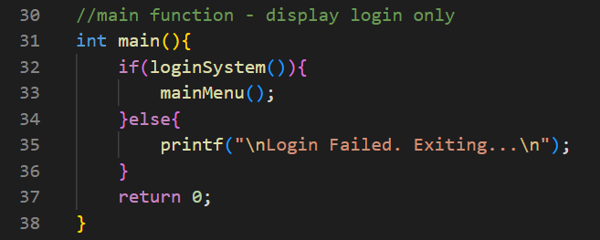

Output:
Successful Login:
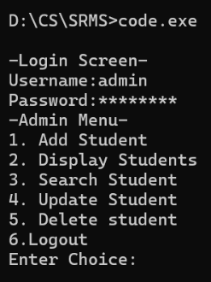

Unsuccessful Login:
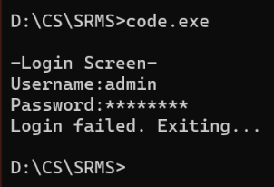

2. Login Module:
This module is implemented using the loginSystem() function, which is triggered by the main() function at the start of the program. Its primary role is to validate the user’s username and password against the stored records in credentials.txt.
It makes use of the \ function getHiddenPassword() to mask the password during input, ensuring better security. The module takes the entered username and password, compares them with the stored credentials, and determines whether the login attempt is valid.
If the details match, the system identifies the user's role—Admin, Staff, or Guest—and grants access to the corresponding menu. If the credentials are incorrect, it displays a login failure message.
The output of this module is either the user’s verified role for further access or a notification indicating that the login attempt was unsuccessful.

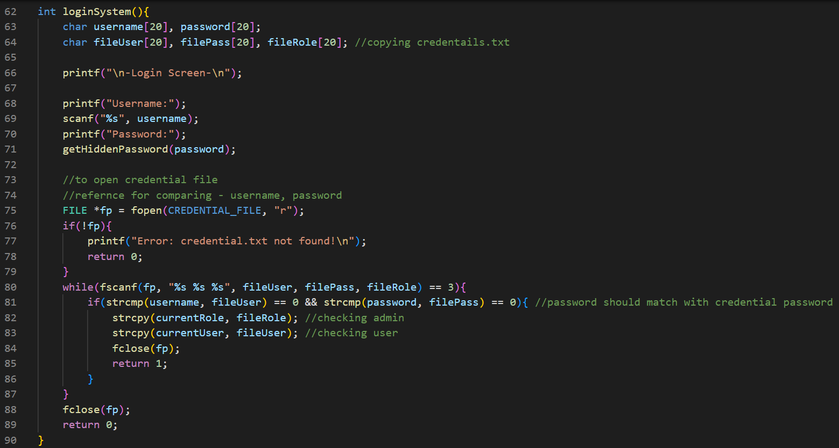

Helper function used:
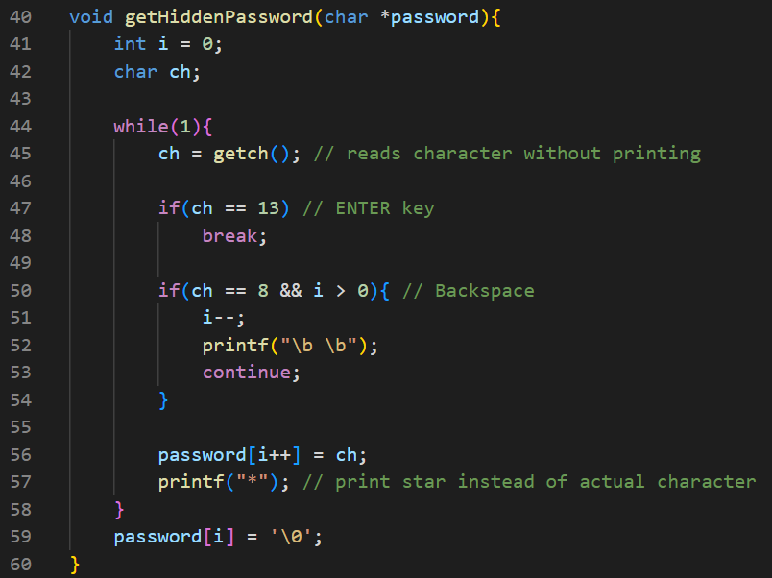

3. Main Menu Module:
This module is implemented using the mainMenu() function, which is executed after a successful login. Its purpose is to display the main menu options and route the user to the correct role-specific menu, such as Admin, Staff, or Guest.
It takes the user’s role as input and uses this information to decide which menu should be displayed. Based on the role, the function calls the appropriate menu handler to provide access to the relevant features.
The output of this module is smooth navigation to the selected menu, ensuring that each user accesses only the functionalities permitted for their designated role.

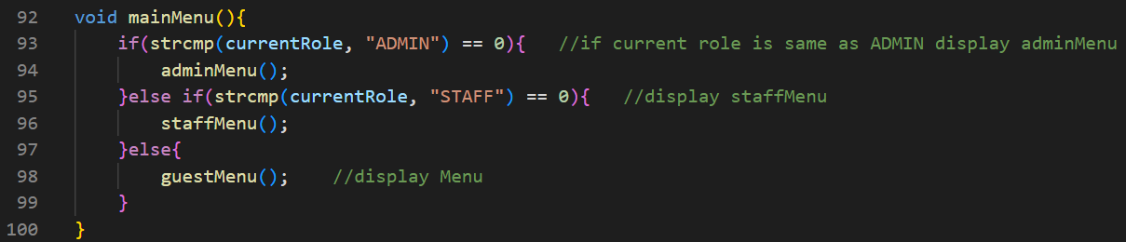

Output:
Admin Menu:
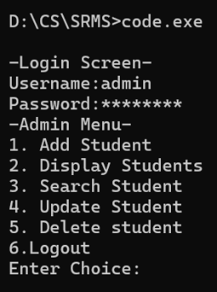

Staff Menu:
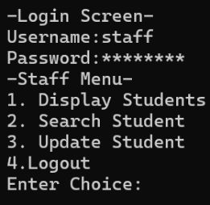

Guest Menu:
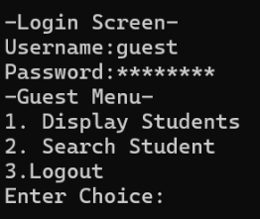

4. Admin Menu Module:
This module uses the adminMenu() function, accessed when an Admin logs in, to present options for adding, displaying, searching, updating, or deleting student records, along with logging out. It takes the Admin’s choice and calls the corresponding operation, producing the selected action or returning to the main menu for efficient student record management.

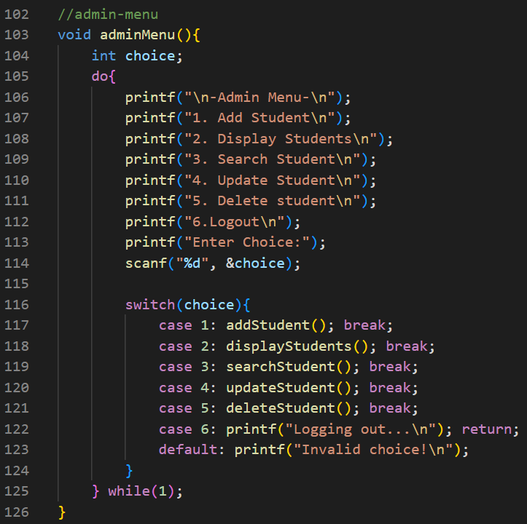

Output:
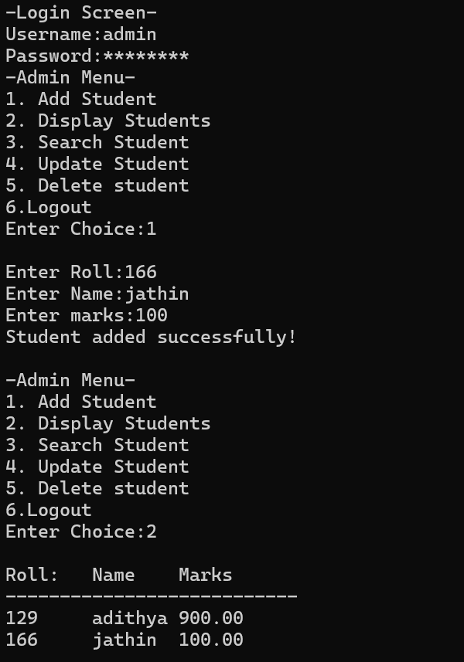

5. Staff Menu Module:
This module uses the staffMenu() function, accessed when a Staff user logs in, to present options for displaying, searching, updating student records, and logging out. It takes the Staff user’s choice as input and calls the relevant operation, producing the selected action or returning to the main menu, enabling Staff to manage student information within their allowed access.
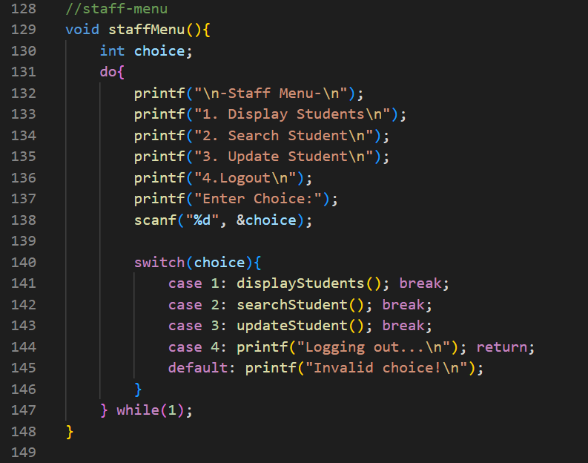

Output:
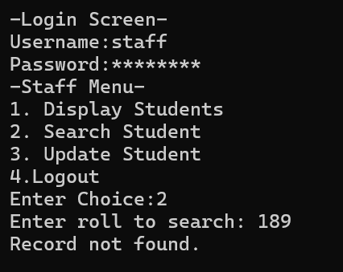

6. Guest Menu Module:
This module uses the guestMenu() function, accessed when a Guest user logs in, to provide options for displaying and searching student records, along with logging out. It takes the Guest user’s choice as input and calls the appropriate function, resulting in the selected action or returning to the main menu, allowing the Guest to view student information with limited access.

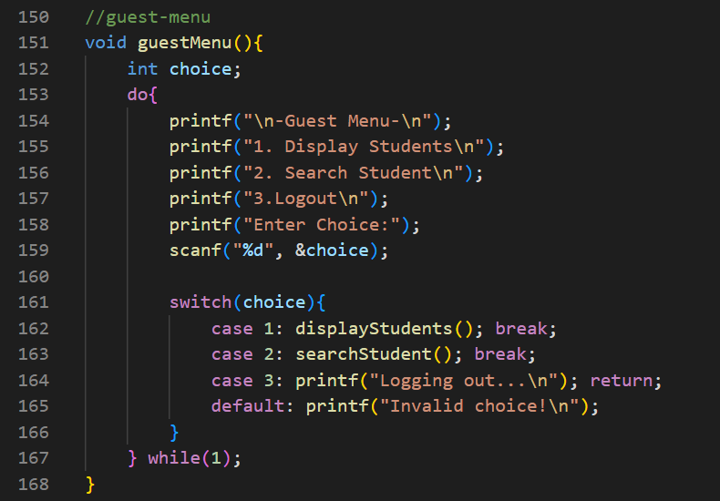

Output:
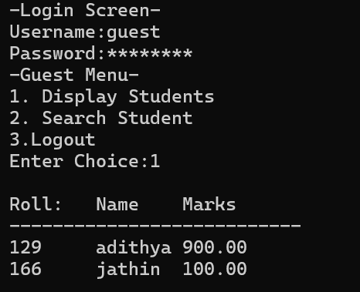

7. Add Student Module:
This module uses the addStudent() function, called from the Admin menu, to add new student records to students.txt. It takes the student’s roll number, name, and marks as input and writes them to the file, producing a successful addition of the record and enabling the Admin to expand the student database efficiently.

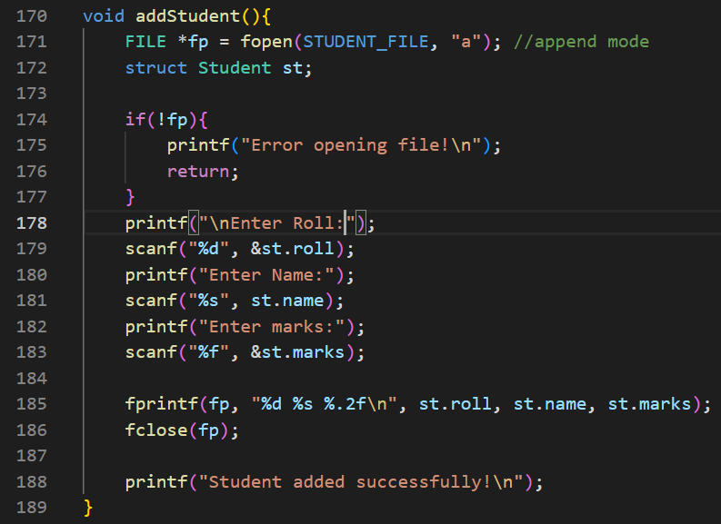

8. Display Students Module:
This module uses the displayStudents() function, accessible from the Admin, Staff, and Guest menus, to read all student records from students.txt and display each student's roll number, name, and marks. It requires no input and outputs the complete list of students, enabling users to view all student information easily.

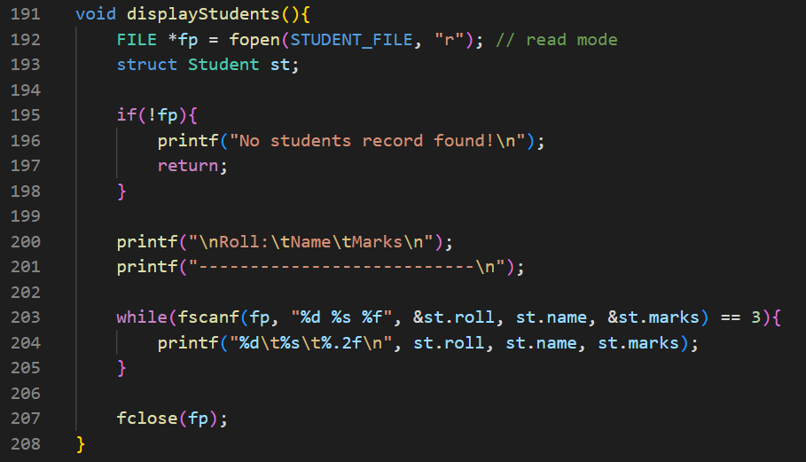

9. Search Student Module:
This module uses the searchStudent() function, available to Admin, Staff, and Guest users, to search for a student by roll number in students.txt. It takes the roll number as input and displays the student’s details if found, or shows a “Student not found” message if the record does not exist, making it easy to locate specific student information.

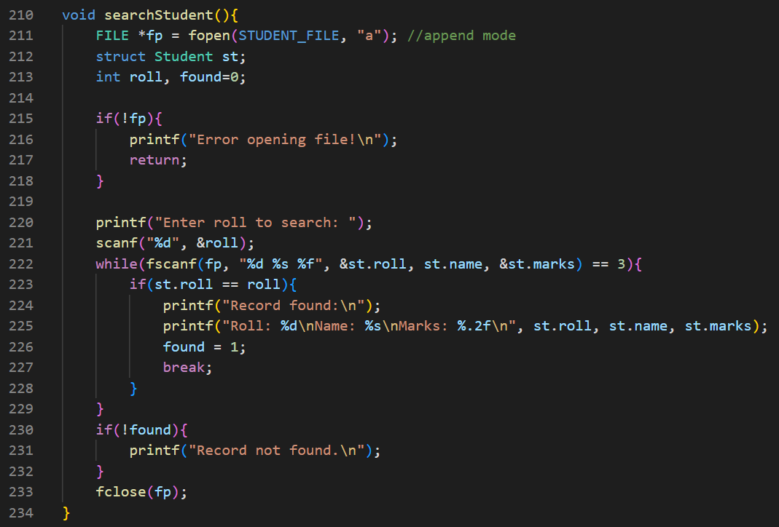

10. Update Student Module:
This module uses the updateStudent() function, accessible from the Admin and Staff menus, to update an existing student’s name and marks based on a provided roll number. It takes the roll number and new details as input, updates the corresponding record in students.txt, and outputs a confirmation message indicating whether the update was successful.

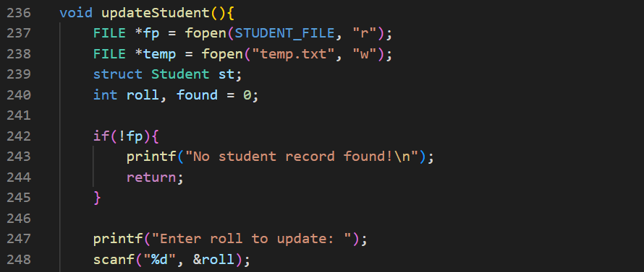

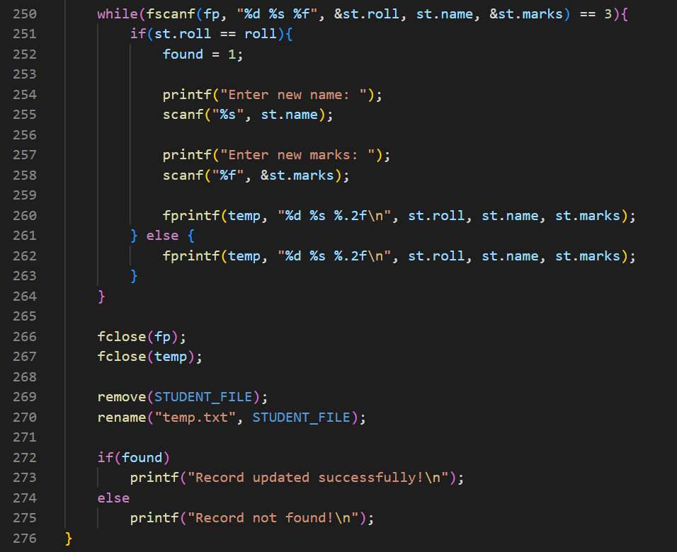

11. Delete Student Module:
This module uses the deleteStudent() function, available from the Admin menu, to delete a student record based on a provided roll number. It removes the corresponding entry from students.txt and outputs a confirmation message if deletion is successful or indicates failure if the record is not found, helping the Admin maintain accurate student records.

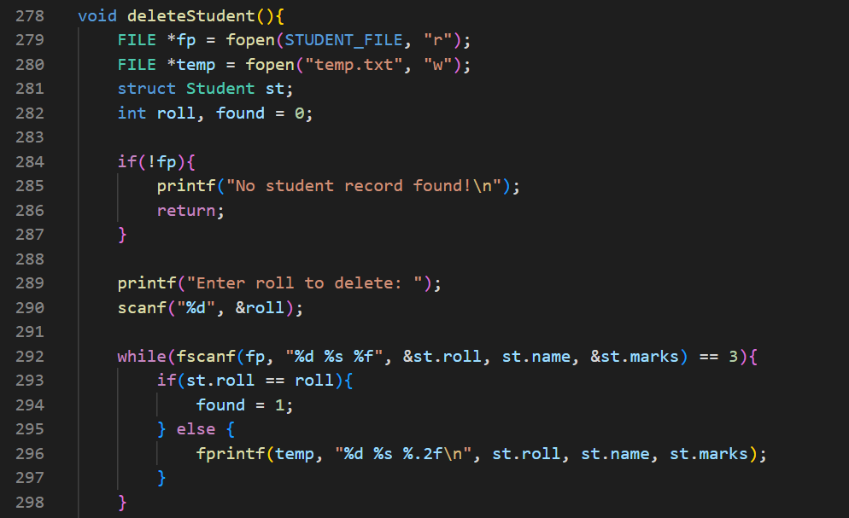

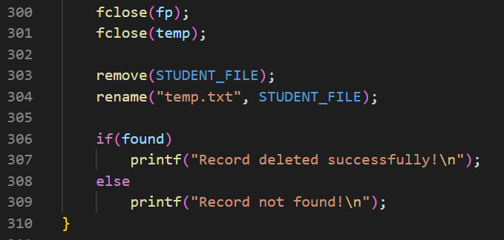

Credentials.txt:
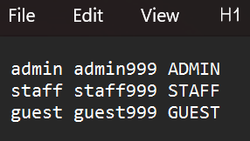

Students.txt:
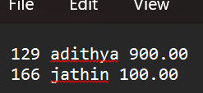

FLOW CHART DIAGRAM

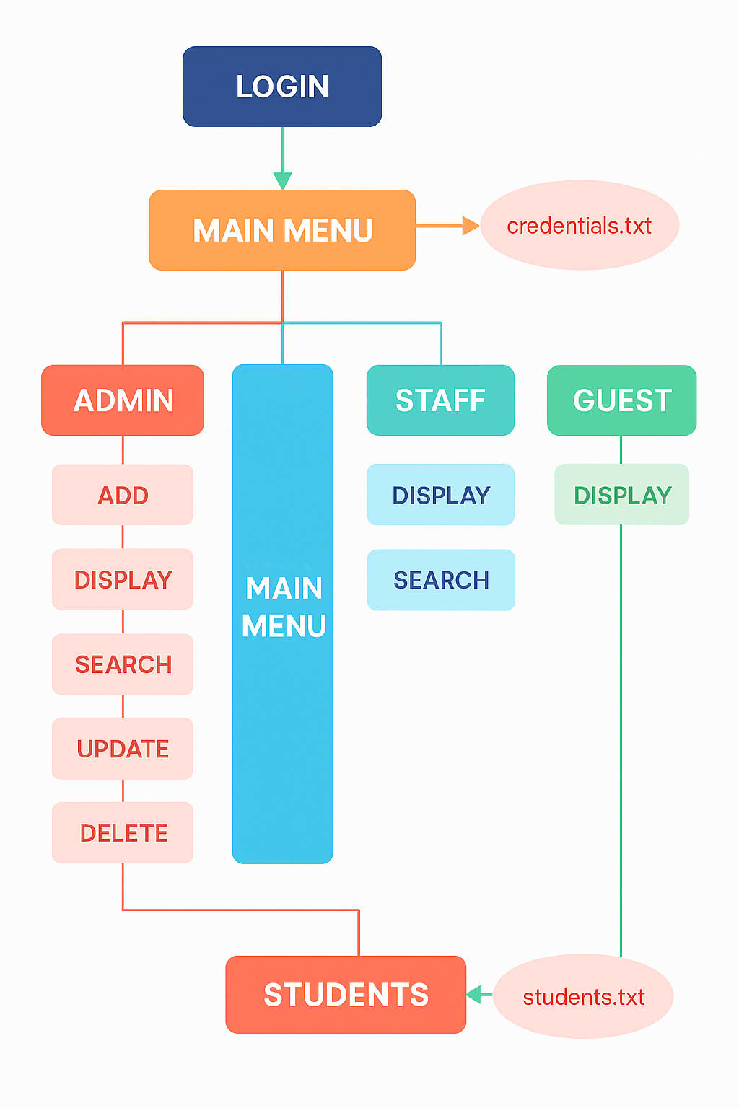

CONCLUSION

The Student Management System effectively showcases key C programming concepts, including file handling, structures, and role-based access control. It ensures secure authentication through credentials.txt and maintains student data in students.txt, providing reliable storage without requiring a database.

With dedicated menus for Admin, Staff, and Guest users, the system enables controlled access to operations such as adding, displaying, searching, updating, and deleting student records. Its modular design and use of temporary files contribute to accurate data handling and smooth program execution.

Overall, the project delivers a simple, efficient, and practical student management solution while offering a solid foundation for future upgrades, including GUI enhancements or database integration.

THANK YOU

