AIRBUS INDUSTRIE

砌**320**

PRODUCT SUPPORT DIRECTORATE

1 Rond Point Maurice BELLONTE 31707 BLAGNAC CEDEX FRANCE Tel: (33) 61-93-33-33

TeLex： AIRBU 530526 F

SERVICE BULLETIN CHANGE NOTICE

S.B. No. A320-21-1001 REV. 0

DATED： MAR 03/89

Mod. No. 20905/K0893

TITLE： AIR CONDITIONING - TRIM AIR

SYSTEM - REPLACE HOT TRIM DUCT (Y-DUCT)

DESCRIPTION

This notice is Bulletin is to

issued to inform the be changed as stated

affected operators that subject Service below.

Page 15z Para. 3.A. LIST OF COMPONENTS PER AIRCRAFT change as follows：

|  |  |  |  |  |  |
| --- | --- | --- | --- | --- | --- |
| ITEM | NEW P/N | QTY PER KIT 211001  A01 | DESCRIPTION | ITEM | OLD P/N |
| 6 | D2167200000200 | 1 | Duct | (6) | D2167200000000 |
| 10 | NSA8206-145 | 4 | O-Ring | C10) | — |
|  | TO | QTY PER KIT 211001 |  |  |  |
| ITEM | NEW P/N | A01 | DESCRIPTION | ITEM | OLD P/N |
| 21 | D2167200000200 | 1 | OuCt | (21) | D2167200000000 |
| 18 | NSA8206-145 | 4 | O-Ring | (18> | - |

FROM

This change wiLl be incorporated in the next revision of this Service BuLLetinz however no revision is planned at the present time.

FILING INSTRUCTIONS

FiLe this Change Notice in front of this Service Bulletin,

6 DATE: July06/89

SERVICE BULLETIN NO： A320-^1-1001

CHANGE NOTICE NO： OA

物厶**32**。

SERVICE BULLETIN

SUMMARY

AIRBUS INDUSTRIE

PRODUCT SUPPORT DIRECTORATE

1 Rond Point Maurice BELLONTE 31707 BLAGNAC CEDEX FRANCE TeL： (33) 61-93-33-33 .

Telex： AIRBU 530526 F

This summary

ns for information only and

is not D・G・A.C・ aporoved for modifi cation of the aircraft

ATA SYSTEM： 21

MODIFICATION NO： 20905/K0893

T I T L E ： AIR CONDITIONING - TRIM AIR

SYSTEM - REPLACE HOT TRIM DUCT (Y-DUCT)

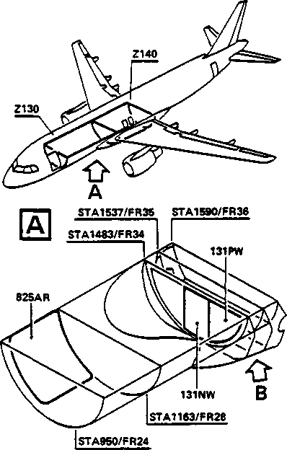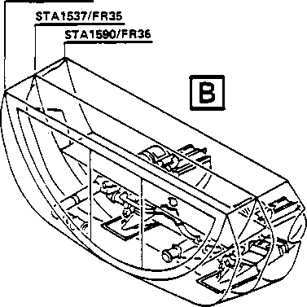

Duct of the Trim An r System.

on A/C MSN 005 010 thru 030.

Embodied prior

on A/C MSN 031

STA1483/FR34

<10 z « LOCH -z 9°N

REASON

During endurance tests it was found that after approximately 180,000 cycles a crack of 13 mm (0.512 in.) became evident in the Hot Trim

Up to the end of the endurance tests o-F 300,000 cycles, further crack propagation had extended only a further 5 mm (0.197 in.) giving a total crack detection of 18 mm (0.709 in)・

It is recommended that at 2Az000 flight hours the Hot Trim Duct should be replaced wi th a modified duct.

ACTION

Removing the Hot Trim Duct and instaLLing a modified Hot Trim Duct.

EFFECTIVITY

Applicable by Service Bulletin thru 008 and

to delivery and subsequent.

COMPLIANCE

Recommended

6 DATE： MAR

03/89

REVISION NO：

SERVICE BULLETIN NO： A320-21-1001

PAGE： 1 of 2

SERVICE BULLETIN

MANPOWER

Kit No. A320211001A01

Manhours: 17.00

Elapsed time (hours): 5 .00

MATERIAL INFORMATION

Quantity per aircraft:

1 Hot trim duct and 4 0-rings

NOTE: Modifi cation of one aircraft requi res : 1 A/C Ki t

・ 320211001A01.

6 DATE：  
REVISION NO：

MAR 03/S9

SERVICE

BULLETIN NO： A320-21-1001

PAGE: 2 of 2

^A32O

SERVICE BULLETIN

ATA SYSTEM： 21

AIRBUS INDUSTRIE

PRODUCT SUPPORT DIRECTORATE

1 Rond Point Maurice BELLONTE 31707 BLAGNAC CEDEX FRANCE TeL: C33) 61-93-33-33

TeLex： AIRBU 530526 F

MODIFICATION NO： 20905/K0893

T I T L E ： AIR CONDITIONING -

TRIM AIR SYSTEM - REPLACE HOT TRIM DUCT (Y-DUCT)

1. PLANNING INFORMATION

A. EFFECTIVITY

(1) Aircraft Models: 520-111, 320-211, 320-231

C2) Aircraft

Qty of Ki ts

211001A01

|  |  |  |  |  |
| --- | --- | --- | --- | --- |
| AAA 001-008 | 022, 023,  026, 027, | 024z  029, | 025  030 | 8 |
| AFR 001, 002 | 005, 007 |  |  | 2 |
| 004-007 | 014, 019, | 020, | 021 | 4 |
| BAW 001-005 | 006, 008, | 011, | 017, 018 | 5 |
| CYP 001 ■ | 028 |  |  | 1 |
| ITF 001-005 | 010, 012, | 013, | 015, 016 | 5 |

Customer

MSN

Fleet No.

This modifi cation is embodied prior to delivery on A/C

MSN 031 and subsequent.

Accomplishment of this Service Bulletin cancels the following Recordable Concession:

TH-72603 A/C MSN 6

C3) Spares

The embodiment of this modification renders these spares redundant.

D2167200000000 Duct

B. REASON

During endurance tests i t was found that after appro-ximately 180,000 cycles a crack of 13 mm CO .512 *in.) became evident in the hot trim duct of the trim air system. Up to the end of the endurance tests of 300,000 cycles, further crack propagation had extended only a further 5 mm CO.197 in.) giving a total crack detection of 18 mm (0.709 in.). 11 *i s recommended that at 24,000 flight hours the hot trim duct should be replaced with a modi fied duct.

6 DATE： MM 03/S?  
REVISION NO：

SERVICE BULLETIN NO： A320-21-1001

PAGE： 1 of 15

SERVICE BULLETIN

C. DESCRIPTION

Accomplishment of this Servi ce Bulletin consists of:

C1) Removing the hot trim duct (Y-duct) from the trim air system and replacing i t with a modi-fied hot trim duct.

D・ APPROVAL

This Service Bulletin is approved by Direction Generate de L* Aviation Civile - FRANCE (D.G.A.C.).

1. MANPOWER

This Service BuLLetin may be accomplished in the following approximate manhours and elapsed time:

|  |  |
| --- | --- |
|  | Manhours/Ai r era" Kit No. 211001A01 |
| Gain access | 2.50 |
| Modification | 9.00 |
| Test | 3.00 |
| Close-Up | 2.50 |
| Total manhours | 17.00 |
| Elapsed time (hours) | 5.00 |

NOTE： This Service Bulletin assumes that the aircra-ft has been placed in a maintenance status. The manhours/elapsed time estimates do not include preparation for the modification, non-productive elapsed timez or administrative functions.

1. MATERIAL・COST AND AVAILABILITY

C1) Material

Operators wi th aircraft listed under paragraph 1. A. C2)z should submi t purchase orders quoting this Service Bulletin to:

AIRBUS INDUSTRIE

SPARES SUPPORT CENTER

UIEG BEIM JAEGER 150

D2000 HAMBURG 63

GERMANY

DATE：

MAR 03/S9

REVISION NO：

SERVICE BULLETIN NO： A320-21-1001

PAGE： 2

SERVICE BULLETIN

(2) Cost and AvaiLabiLity

Kit

Cost

(U.S. DoLLars)

AvaiLabiLity*

A320211001A01

3,780

150

* Calendar days from receipt of order.

NOTE: SaLes terms (cost and avai Labi L i ty) are evaluated wi th respect to economi c conditions at the issue date of this Service Bulletin.

A discount of (10) percent will be accorded to all orders received wi thin a period of 120 days from the original issue date of this Servi ce Bulletin.

1. TOOLING ・ PRICE AND AVAILABILITY

None

1. WEIGHT AND BALANCE

None

1. REFERENCE

Aircraft Maintenance Manual 06-^1-53, 2^-00-00, 24-41-00,

52-10-00, 52-30-00,

49-^0~00,

53-35-13

PUBLICATIONS AFFECTED

Illustrated Parts Catalog 21-63-03

MAR 03/89

SERVICE BULLETIN

1. ACCOMPLISHMENT INSTRUCTIONS

A. GENERAL

WARNING： MAKE SURE THAT NO AIR IS SUPPLIED TO THE AIR CONDITIONING SYSTEM

FROM THE MAIN ENGINE, THE APU OR GROUND SOURCE.

(1) Preparation

(a) Electrically ground the aircraft (Refer to AMM 24-00-00, Page Block 301).

Cb) Put the correct access platform at the door of the FWD cargo compartment.

Cc> Open the door of the FWD cargo compartment (Refer to AMM 52-30-00, Page Block 201).

Cd) At the rear o,f the FWD cargo compartment, remove the parti tion panels 131NW and 131PW at FR34.

1. Put the correct access platform at access panels 191KB and 192KB.
2. Remove the access panels 191KB and 192KB (Refer to AMM 53-35-13, Page Block 401).

B. MODIFICATION

C1) Replacement of the Hot Trim Duct CY-duct) in the Trim Air System.

Refer to Figure 1

(a) Remove:

1 Vee damp i tem 1 (retain)

Cb) From the right side and the Left side of the hot trim duct (Y-duct)z i tem (21)夕 remove :

12 nuts i terns *2* (retain)

12 washers iterns 3 (retain)

12 boLts i terns 4 (retain)

NOTE ： The bonding leadsz i terns 5, become disconnected when i terns

2Z 3 and 4 are removed.

SERVICE BULLETIN

8—^

825AR

STA1590/FR36

STA1537/FR3S

STA14S3/FR34

B

131NW

131PW

10

STA1163/FR28

STA95O/FR24

<10 z 50 二Z 98N

Replacement of Hot

F igure 1

Trim Duct

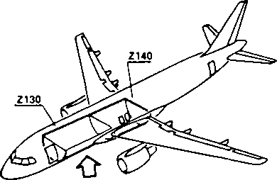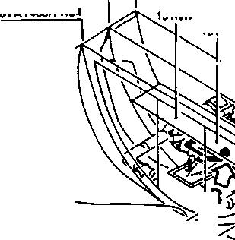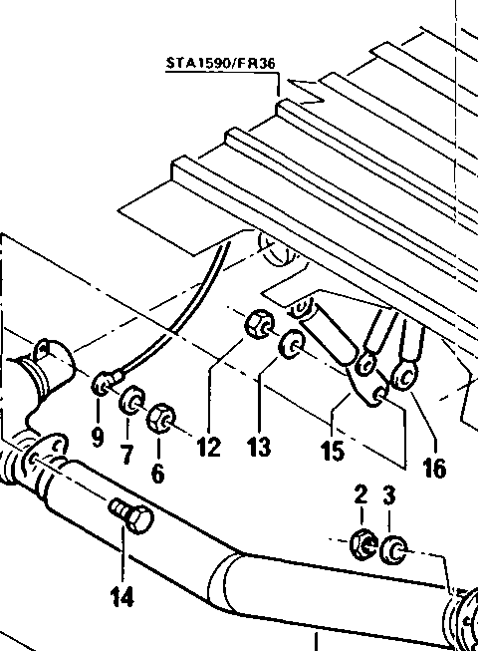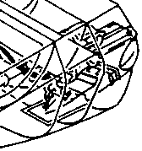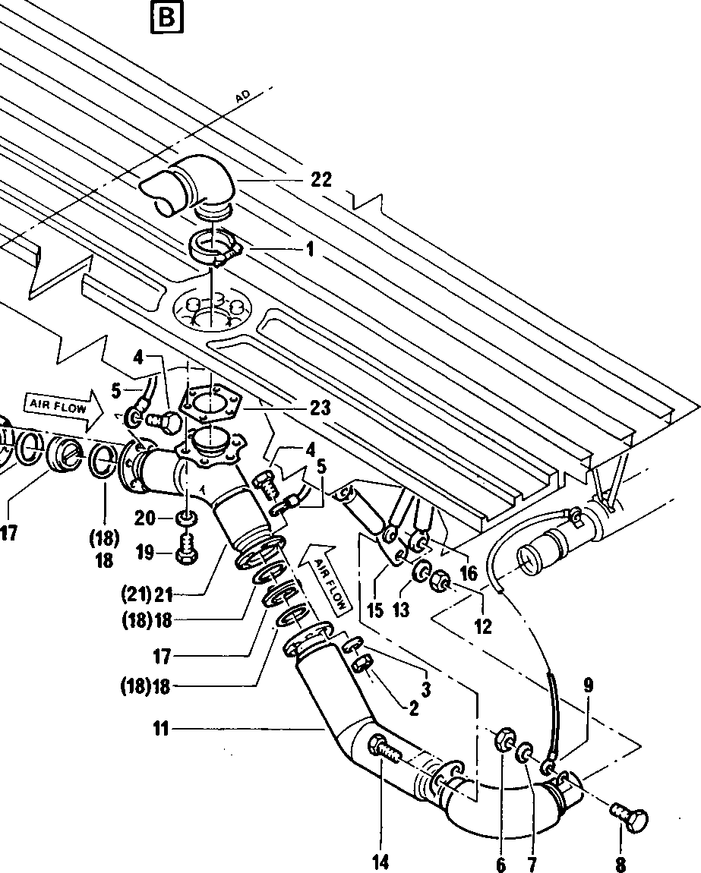

SERVICE BULLETIN

Cc) From the right side duct, i tern 10 and the Left side duct, i tem 11, remove :

2 nuts i terns 6 (retain)

2 washers iterns *7* <retain)

2 bolts iterns 8 (retain)

and disconnect bonding Leadsz i terns 9;

(d〉Support the ducts, i tem 10 right side and item 11 left side and remove :

A nuts iterns 12 (retain)

*H* washers iterns 13 (retain)

4 bolts iterns (retain)

and disconnect the tie-rods right side and Left side, item 15 and 16.

(e) Remove:

1 duct (right side) item 10 (retain)

1 duct (le-f t side) i tem 11 (retain)

(f)

From the right side and (21)z remove:

Left side o-f the hot trim duct (Y-duct), i tem

2 trim air check valves iterns 17

Cg) From the right side and the Left item (21) and the removed ductsz

4 0-rings iterns (18) (discard)

(retain)

side of the hot trim duct (Y-duct), i terns 10 and 11, remove:

Ch) At the bulkhead flange on the hot trim duct (Y-duct), i tem C21)z remove:

6 bolts iterns 19 (retain)

6 uashers iterns 20 (retain)

(i) From the elbow ductz i tem *22* and the bulkhead remove:

1 hot trim

1 bulkhead

duct seal

(Y-duct) D2167200000000 item C21) (discard) i tem 23 (retain)

NOTE： Make faces, the components condi tion.

sure

that the removed components, the component inter­parts uhich you retained from the removed and the adjacent area are dean and in the correct

SERVICE BULLETIN

(j) Put in the correct posi tion on the bulkhead:

1 bulkhead seal D2167200620000 item 23 (retained on removal).

(k) Install the replacement hot trim duct (Y-duct):

1 hot trim duct (Y-duct) D2167200000200

item 21 wi th on removal) removal)

6 washers AN960C416L i terns 20 (retained

6 bolts NAS1304-4 i tens 19 (retained on

of the hot trim duct

10 and 11:

Install in the right side and in the Left side CY-duct)z itern 21 and

the removed ducts夕 i terns

4 0-rings NSA8206-145 iterns 18

(m) At the right side and the Left side of the hot trim duct CY-duct) instaLL :

2 trim ai r check valves 745A0000-01 i terns 17 (retained on removal).

NOTE: Make sure that the check valve flaps open in the direction of the air flow, and make sure that the Locating pin on the check valve^ engages in the Locating hoLe on the flanges of the replacement hot trim duct (Y-duct).

Cn) Put in position and support:

1 duct (right side) D2157125100200 i tem 10 (retained on removal)

1. duct (Left side) D2157125200200 i tem 11 (retained on removal)

Co) Posi tion the tie-rods, right side and left sidez i terns 15 and 16, at the support brackets on the ductsz i terns 10 and 11 and install:

4 bolts NAS670AU9 i terns 14 (retained on removal)

4 washers AN960C416 i terns 13 (retained on removal)

4 nuts MS21043-4 i terns 12 (retained on removal)

but do not fully tighten them at this time.

Cp) InstaLL on the right side and the left side flanges of the hot trim duct CY-duct), i tem 21 and the ducts, i terns 10 and 11 :

1. bonding leads E0089-10-200 i terns 5

12 bolts A104-1D *i*terns 4 (retained on removal)

12 washers AN960C10L i terns 3 (retained on removal)

12 nuts MS21043-3 i terns 2 (retained on removal)

but do not fully tighten them at this time.

SERVICE BULLETIN NO： A320-21-1001

PAGE： 10

SERVICE BULLETIN

Cq) Connect:

*2* bonding Leads E0089-10-200 n terns 9 with

2 boL ts NAS6703U1 i terns 8 (retained on removal)

2 washers AN960C10L i terns 7 (retained on removal)

*2* nuts MS21043-3 i terns 6 (retained on removal)

(r) Make sure that the trim air ducts, i terns 10 and 11, are correctly Located and aligned then tighten all the nuts.

(s) At the bukhead, engage the eLbow duct, i terr 22 wi th the hot trim duct and install:

1 Vee damp NSA8601-09 i tem 1 (retained on removal)

and TORQUE it to the value given on the damp.

C. TEST

1. Preparation for the test.

(a) Make sure that the work area is clean and dear of tools and other iterns.

Cb) Put the correct access pLatform at the FWD passenger/crew door.

(c) Open the FWD passenger crew door (Re-fer to AMM 52-10-00,. Page Block 201).

Cd) Make sure these circuit breakers are closed•

PANEL SERVICE IDENT. LOCATION

| 122VU | AIR COND/PACK TEMP/CTL SYS1/1/115VAC | 1HH |
| --- | --- | --- |
| 122VU | AIR COND/PACK TEMP/CTL SYS2/1/ 115VAC | 2HH |
| 122VU | AIR COND/PACK TEMP/CTL SYS1/1/ 28VDC | 3HH |
| 122VU | AIR COND/PACK TEMP/CTL SYS2/1/ 28VDC | AHH |
| 122VU | AIR COND/PACK TEMP/CTL SYS1/2/115VAC | 21HH |
| 122VU | AIR COND/PACK TEMP/CTL SYS2/2/115VAC | 22HH |
| 122VU | AIR COND/PACK TEMP/CTL SYSV2/ 28VDC | 23HH |
| 122VU | AIR COND/PACK TEMP/CTL SYS2/2/ 28VDC | 2^HH |
| 122VU | AIR COND/ZONE TEMP/CTL/115VAC/SYS1 | 1HK |
| 122VU | AIR COND/ZONE TEMP CTL/115VAC/SYS2 | 2HK |
| 122VU | AIR COND/ZONE TEMP CTL/ 28VDC/SYS1 | 3HK |
| 122VU | AIR COND/ZONE TEMP CTL/ 28VDC/SYS2 | AHK |
| 122VU | AIR COND/FLOW/CTL AND IND/1 | 1HB |
| 122VU | AIR COND/FLOW/CTL AND IND/2 | 2HB |
| 122VU | AIR COND/FLOw/MIXER/FLAP | 3HB |
| 121VU | EIS/ECAM DU/LOWER/SWTG | 2AWT2 |
| 121VU | EIS/ECAM DU/LOWER/SPLY | 13W72 |
| 49VU | EIS/ECAM CTL/PNL | 15WT |

XYXYWYWYV

281920117

212122221

VVVVVVRRm

8 9 0 2 13 0 12

112 2 2 2 11 -I

SERVICE BULLETIN

NO: A320-21-10D1

PAGE： 11

DATE： MAR 0 3 /z 8 9

REVISION NO：

SERVICE 9ULLETIN

(e) Energi ze the ai rcraft eLecti caL Page Block 201).

Cf) On the overhead panel 30VU make

in the AUTO position.

(g) On the overhead panel 30VU push

NOTE: When the pack pushbutton light goes off.

C2) Do this test

ci rcui ts (Refer to AMM 24-41-00, sure that the X-SLEED selector is the pack 1 and 2 pushbutton switches.

swi tches are pushed the whi te OFF

(a) Start and operate the APU (Refer to AMM 49-40-00, Page Block 501).

NOTE: If the APU is not available, connect a ground supply source to the aircraft high pressure ground connector. The flow should not exceed 1.0 kg/s at a temperature of 200 °C C392 °F). Do the test but do not push the APU BLEED pushbutton swi tch.

ACTION

RESULT

C1) On the ECAM control panel 11VU： -push the BLEED pushbutton switch.

On the ECAM Lower display uni t: -the BLEED page comes on.

NOTE: When the test i s in progress you must moni tor the pack temperatures on ' the BLEED page on the ECAM lower display uni t:

(2) On the overhead panel 30VU:

-push the APU BLEED pushbutton - the blue ON light in the APU

swi tch. BLEED pushbutton switch comes on.

C3) On the trim air System:

-do a Leak check of the Y-Duct connections•

no Leaks are permi tted.

C4)

After approximately 15 minutes stop the APU CRe-fer to Page Block 501). (Or stop the ground air supply).

AMM 49-40-00,

(5) On the overhead panel 30VU:

• push the APU BLEED pushbutton swi tch.

-push the pack 1 and 2 pushbutton swi tches.

-the blue ON light in the APU BLEED pushbutton swi tch goes off.

■ the whi ts OFF lights in the pack

1 and 2 pushbutton swi tches come on.

會厶**32**。

SERVICE BULLETIN

D. CLOSE-UP

1. On the ECAM control panel 11VU set the Lower display and the upper display knobs to the OFF posi tSon.
2. Make sure that the work area is dean and clear o-f tools and other i terns .
3. InstaLL the access panels 191KB and 192KB (Refer to AMM 53-35-13, Page BLock 401)・
4. InstaLL the parti tion panels 131NW and 131PW at Frame 34z at the rear o-f the FWD cargo compartment.
5. Close the door of the FWD cargo compartment (Refer to AMM 52-30-00, Page Block 201).
6. Close the FWD passenger/crew door (Refer to AMM 52-10-00, Page BLock 201).

C7) Remove the access platforms.

(8) Disconnect the ai rcraft electrical ground connection (Refer to AMM 24*00-00, Page BLock 301).

SERVICE BULLETIN NO： A32D-21-1001 PAGE： 13/U

SERVICE BULLETIN

3. MATERIAL INFORMATION

Basis tot the ■following material data is per aircraf t.

A. LIST OF COMPONENTS PER AIRCRAFT

|  |  |  |  |  |  |
| --- | --- | --- | --- | --- | --- |
| ITEM | NEW P/N | QTY PER KIT 211001  A01 | DESCRIPTION | ITEM | OLD P/N |
| 6 | D2167200000200 | 1 | Duct | (6) | D2167200000000 |
| 10 | NSA8206-U5 | 4 | O-Ring | (10) | - |
| B. | LIST OF MATERIAL | -OPERATOR | SUPPLIED |  |  |

None

C. PARTS TO BE REIDENTIFIED BY OPERATOR

None