***A319/A320/A321***

|  |
| --- |
|  |

SERVICE BULLETIN

REVISION TRANSMITTAL SHEET

AIRBUS INDUSTRIE

CUSTOMER SERVICES DIRECTORATE

1 Rond Point Maurice BELLONTE

31707 BLAGNAC CEDEX FRANCE

Tel: (33) 5 61-93-33-33

Telex: AIRBU 530526 F

TITLE : AIR CONDITIONING - INSPECT PACK RAM AIR INLETS

MODIFICATION No. : INSPECTION ATA SYSTEM : 21

This page transmits Revision No. 02 of Service Bulletin No. A320-21-1062.

ADDITIONAL WORK

No additional work is required by this revision for aircraft modified by

any previous revision.

REASON

This Revision is issued to inform the affected customers that the effectivity is amended, a sentence is added and the approval sentence is new.

CHANGES

SUMMARY

Reason

- Sentence added.

Effectivity

- Customers CTN, SWR and TAI added, customer ITF deleted and sentence

added.

SERVICE BULLETIN

Planning Information

- Para. A.(1), Aircraft model 320-214 added.

- Para. A.(2), Customers CTN, SWR and TAI added, customer ITF deleted,

effectivity amended and sentences added.

- Para. B.(4), Para added.

- Para. D., Approval sentence new.

- Para. F.(1), Sentence and address amended.

- Para. G., Para added.

- Para. I., Service Bulletin A320-21-1091 added.

accomplishment Instructions

- Para. A.(1)(a), Sentence

- Para. A.(1)(e), Sentence

- Para. A.(1)(f), Sentence

added.

amended.

added.

6 DATE : Oct 14/93 SERVICE BULLETIN No. : A320-21-1062

REVISION No. : 02 - Jun 17/98

Printed in France

PAGE : 1 of 2

***A319/A320/A321***

|  |
| --- |
|  |

SERVICE BULLETIN

REVISION TRANSMITTAL SHEET

- Para. B.(1)(a), Brackets added to items.

- Para. B.(1)(a)1 thru 6, Brackets added to items.

- Para. B.(2), Brackets added to items.

- Para. B.(2)(a) thru (c), Brackets added to items.

- Para. B.(3), Brackets added to items.

- Para. B.(3)(a)1 and 2, Brackets added to items.

- Para. B.(3)(b) and (d), Brackets added to items.

- Para. B.(5)(a), Brackets added to items.

- Para. D.(1), Sentence amended.

- Para. D.(2), Sentence added.

- Figure 2, Brackets added to items.

- Figure 3, Brackets added to items.

Layout changes due to computerization of this Revision are not identified.

FILING INSTRUCTIONS

This Service Bulletin has been generated electronically and is reissued as

a complete document.

Replace the Service Bulletin completely.

Put this Revision Transmittal Sheet in front of the Service

Bulletin.

HISTORY OF PREVIOUS REVISIONS

Revision 01 was issued to inform the customers that the effectivity is updated, the address in Para. 1.F. is changed and the Note in Para. B.(1)(a)5 is added.

REVISION SEQUENCE

ORIGINAL : Oct 14/93

REVISION No. : 01 - Nov 23/94

REVISION No. : 02 - Jun 17/98

DATE : Oct 14/93 SERVICE BULLETIN No. : A320-21-1062

REVISION No. :

020 Jun 17/98

Printed in France

PAGE : 2

***A319/A320/A321***

|  |
| --- |
|  |

SERVICE BULLETIN

SUMMARY

AIRBUS INDUSTRIE

CUSTOMER SERVICES DIRECTORATE

1 Rond Point Maurice BELLONTE

31707 BLAGNAC CEDEX FRANCE

Tel: (33) 5 61-93-33-33

Telex: AIRBU 530526 F

This summary is for information only

and is not approved for modification of the aircraft

TITLE : AIR CONDITIONING - INSPECT PACK RAM AIR INLETS

MODIFICATION No. : INSPECTION ATA SYSTEM : 21

REASON/DESCRIPTION/OPERATIONAL CONSEQUENCES

Several operators have reported excessive wear of the inlet flap linkage

components which could lead to disconnection of the flap mechanism and

subsequent pack overheat.

This Service Bulletin introduces an inspection of the actuation mechanism

between the electrical actuator and the inlet flap for play and an

inspection of the gap between the intake nose and diffusor ramp.

These inspections ensure that the ram air inlets remain properly adjusted

as it could have an adverse impact on the reliability of the Air Cycle

Machine (ACM).

This Inspection Service Bulletin is recommended to be accomplished at the first 4A-Check and repeated at intervals of 4A. For aircraft that have passed the first 4A-Check first accomplishment is recommended at the next convenient A-Check after receipt of this Service Bulletin.

Accomplishment of Service Bulletin A320-21-1091 cancels the requirements

of this Service Bulletin.

EFFECTIVITY

This Service Bulletin is applicable to these customer(s) :

AAA, ACA, ADR, AFR, AIB, ALK, AMC, ANA, AZA, BAW, BV, CDN, CTN, CYP, DLH,

FHA, GFA, HP, IAC, IBE, KAC, MON, MSR, MXA, NWA, OYC, RJA, SAA, SHK, SWR,

TAI, TAR, UAL, XF, XP, XR, XW, XZ

SERVICE BULLETIN TO BE ACCOMPLISHED

PREVIOUSLY OR SIMULTANEOUSLY

None

REFERENCES/REPERCUSSIONS

|  |  |
| --- | --- |
| TFU | : 21.53.00.03 |
| OEB | : None |
| AOT | : None |
| SIL | : None |
| LIFE LIMIT | : None |

6 DATE : Oct 14/93 SERVICE BULLETIN No. : A320-21-1062

REVISION No. :

020  Jun 17/98

Printed in France

PAGE : 1 of 3

***A319/A320/A321***

|  |
| --- |
|  |

SERVICE BULLETIN

SUMMARY

LINE MAINTENANCE AFFECTED OTHER

NATURE OF THE WORK

|  |  |
| --- | --- |
| AIRCRAFT  EQUIPMENT  HARD  SOFT  OBRM COMPLIANCE Recommended MANPOWER  ON AIRCRAFT | :  :  :  :  : |

TOTAL MANHOURS

ELAPSED TIME (HOURS)

MATERIAL INFORMATION

AIRCRAFT DATA

None

EQUIPMENT DATA

None

APPENDICES

None

: None

: RFW D0113/91

YES

NO

NO

NO

NO

3.00

3.00

DATE : Oct 14/93 SERVICE BULLETIN No. : A320-21-1062

REVISION No. :

020 Jun 17/98

Printed in France

PAGE : 2

***A319/A320/A321***

|  |
| --- |
|  |

SERVICE BULLETIN

SUMMARY

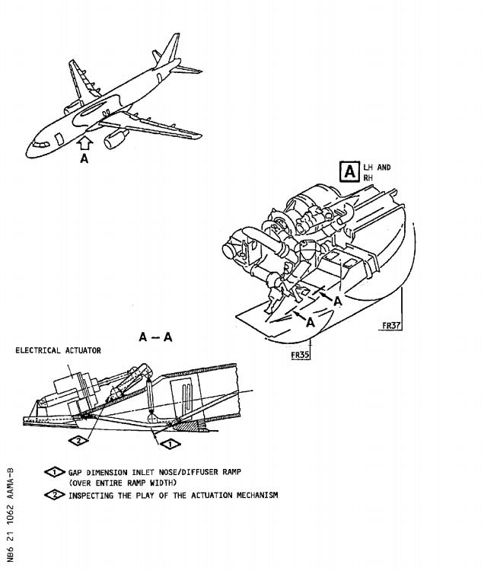

DATE : Oct 14/93 SERVICE BULLETIN No. : A320-21-1062

REVISION No. :

020 Jun 17/98

Printed in France

PAGE : 3

***A319/A320/A321***

|  |
| --- |
|  |

SERVICE BULLETIN

AIRBUS INDUSTRIE

CUSTOMER SERVICES DIRECTORATE

1 Rond Point Maurice BELLONTE

31707 BLAGNAC CEDEX FRANCE

Tel: (33) 5 61-93-33-33

Telex: AIRBU 530526 F

TITLE : AIR CONDITIONING - INSPECT PACK RAM AIR INLETS

MODIFICATION No. : INSPECTION ATA SYSTEM : 21

1. PLANNING INFORMATION

A. EFFECTIVITY

(1) Aircraft models :

(2) Aircraft

320-111, 320-211, 320-212, 320-214, 320-231,

320-232, 321-111, 321-112, 321-131

Customer and

Fleet No. AAA001-006

007-012

ACA201-206

207-212

213-218

219-224

225-230

231-234

ADR001-003

AFR001, 002

004-009

010-013

015

031-036

037-042

043-048

066-068

071-076

077, 078

080-085

101-104

MSN

022,023,024,025,026,027

029,030,140,142,157,229

059,068,073,084,122,126

127,141,149,150,154,159

183,233,242,248,253,254

255,265,277,290,310,311

324,330,333,341,342,350

359,378,384,426

043,113,114

005,007

014,019,020,021,002,004

003,010,012,013

016

061,062,063,100,101,102

128,129,133,186,187,188

226,227,228,285,286,287

033,036,044

108,115,130,155,156,184

214,239

278,337,352,236,237,377

498,509,521,529

Kit No.

none

Qty

of kits

Config

No.

6 DATE : Oct 14/93 SERVICE BULLETIN No. : A320-21-1062

REVISION No. :

020 Jun 17/98

Printed in France

PAGE : 1 of 21

***A319/A320/A321***

|  |
| --- |
|  |

SERVICE BULLETIN

Customer and

Fleet No.

201, 202

226, 227

231, 232

301, 302

305

401-403

441

AIB401, 402

ALK001, 002

AMC001, 002

ANA001-006

007-012

013-018

019, 020

AZA001-006

007-010

BAW001-006

007-010

BV051, 052

CDN401-405

407-411

415, 416

CTN101

CYP001-006

007, 008

DLH001-006

007-010

012-017

018-023

024-029

030-034

101-106

MSN

144,145

131,132

203,220

204,211

085

215,244,270

491

376,386

374,406

112,293

138,139,148,151,167,170

196,212,219,245,300,328

365,383,413,482,501,507

531,534

477,488,494,495,434,524

526,532,515,516

006,008,011,017,018,039

042,103,109,120

185,191

174,175,210,231,232

283,284,302,305,309

403,404

258

028,035,037,038,180,256

295,316

069,070,071,072,078,083

086,093,094,104

110,111,116,117,135,137

147,161,162,172,200,201

202,209,216,217,218,267

268,269,346,382,401

458,468,473,474,484,493

Kit No.

none

Qty

of kits

Config

No.

DATE : Oct 14/93 SERVICE BULLETIN No. : A320-21-1062

REVISION No. :

020  Jun 17/98

Printed in France

PAGE : 2

***A319/A320/A321***

|  |
| --- |
|  |

SERVICE BULLETIN

Customer and

Fleet No.

107-110

FHA001, 002

GFA801-806

807-812

814

HP620-622

624-629

631-636

637

IAC001-006

007-012

014-019

020-025

026-031

IBE001-006

007-012

013-018

019-022

KAC001-003

MON001, 002

MSR001-006

007

MXA001-006

007-010

012, 016

NWA301-306

307-312

313-318

319-324

325-330

331-336

337-342

MSN

412,502,505,518

332,369

313,325,345,375,419,421

438,445,459,466,481,497

537

052,053,054

055,064,065,066,067,076

077,081,082,091,092,098

099

045,046,047,048,049,050

051,056,057,058,074,075

080,089,090,095,096,097

396,398,416,423,431,432

451,469,486,490,492,499

134,136,143,146,158,173

176,177,199,207,223,224

240,241,246,264,266,274

303,312,323,356

181,182,195

379,389

165,166,178,194,198,351

366

252,259,260,261,275,276

296,320,321,353

368,433

031,032,034,040,041,060

106,107,118,121,125,152

153,160,171,192,197,206

208,213,262,263,272,273

281,282,297,298,306,307

318,319,329,339,340,355

358,360,367,372,380,381

Kit No.

none

Qty

of kits

Config

No.

DATE : Oct 14/93 SERVICE BULLETIN No. : A320-21-1062

REVISION No. :

020  Jun 17/98

Printed in France

PAGE : 3

***A319/A320/A321***

|  |
| --- |
|  |

SERVICE BULLETIN

Customer and

Fleet No.

343-348

349, 350

OYC001-006

RJA001, 002

SAA001-006

007

SHK001-003

SWR226

276-280

TAI051-054

TAR001-006

007, 008

UAL401-406

407-412

413-418

419-424

425-429

XF001-006

007-009

053-056

101

501, 502

504-508

510

551

XP053-058

059

062, 063

502, 503

504, 505

XR501-506

507-512

MSN

387,388,399,400,408,410

417,418

163,164,168,169,179,193

087,088

243,249,250,251,334,335

440

322,326,344

533

517,519,520,522,535

448,453,460,461

119,124,205,370,390,402

123,511

435,439,442,450,452,454

456,457,462,463,464,465

470,472,475,479,483,485

487,489,500,503,504,506

508,510,512,523,539

393,394,414,430,443,447

415,405,361

428,496,527,530

425

446,422

371,397,409,427,528

525

279

221,222,294,299,301,348

349

391,392

362,363

455,471

225,230,238,247,257,271

280,291,292,304,308,314

Kit No.

none

Qty

of kits

Config

No.

DATE : Oct 14/93 SERVICE BULLETIN No. : A320-21-1062

REVISION No. :

020  Jun 17/98

Printed in France

PAGE : 4

***A319/A320/A321***

|  |
| --- |
|  |

SERVICE BULLETIN

Customer and MSN Kit No. Qty Config

Fleet No. none of kits No.

513-518

519-524

525

XW501-506

509

XZ003, 004

101-106

107-110

315,317,327,336,338,429

444,449,467,476,478,480

437

347,354,357,373,411,424

441

189,190

234,235,288,289,331,343

395,407,420,436

Accomplishment of Service Bulletin A320-21-1091 cancels the

requirements of this Service Bulletin.

This document contains Airbus Industrie PROPRIETARY INFORMATION and

shall at all times remain the property of Airbus Industrie; no

intellectual property right or licence is granted by Airbus

Industrie in connection with any information contained in it. It is

delivered on the express condition that said document and the

information contained in it shall be treated as confidential, shall

not be used for any purpose other than that for which it is hereby

delivered. It shall not be disclosed in whole or in part to third

parties and shall not be duplicated in any manner (except for the

purposes of performing the tasks described hereunder and provided

that any recipient of such document shall comply with the

conditions herein), without Airbus Industrie‘s prior written

consent.

(3) Spares

None

B. REASON

(1) History

Several operators have reported excessive wear of the inlet flap

linkage components which could lead to disconnection of the flap

mechanism and subsequent pack overheat.

(2) Objective/Action

This Service Bulletin introduces an inspection of the actuation

mechanism between the electrical actuator and the inlet flap for

play and an inspection of the gap between the intake nose and

diffusor ramp.

(3) Advantages

To ensure sufficient air flow over the ACM fan and maintain ACM

reliability.

DATE : Oct 14/93 SERVICE BULLETIN No. : A320-21-1062

REVISION No. :

020 Jun 17/98

Printed in France

PAGE : 5

***A319/A320/A321***

|  |
| --- |
|  |

SERVICE BULLETIN

(4) Operational/Maintenance Consequences

None

(5) Accomplishment Timescale

This Inspection Service Bulletin is recommended to be accomplished at the first 4A-Check and repeated at intervals of 4A. For aircraft that have passed the first 4A-Check first accomplishment is recommended at the next convenient A Check after receipt of this Service Bulletin.

C. DESCRIPTION

To accomplish this Service Bulletin it is necessary to :

(1) Get access to the pack ram air inlets, LH and RH.

(2) Check the play of the actuation mechanism of the ram air inlets.

(3) Check the gap between the intake nose and the diffusor ramp and

adjust the gap if out of tolerance.

(4) Perform an operational test of the pack temperature control system.

(5) Close-up.

D. APPROVAL

The technical

the authority

E. MANPOWER

content of this Service Bulletin has been approved under

of the DGAC Design Organisation Approval No. F.JA.02.

This Service Bulletin is written for an aircraft in a

condition. The manhours/elapsed time estimates do not

to prepare for the inspection, non-productive elapsed

administration.

ON AIRCRAFT

maintenance

include the time

times or

Get access

0.25

1.50

1.00

0.25

3.00

3.00

Inspection

Test

Close-up

TOTAL MANHOURS

ELAPSED TIME (HOURS)

F. MATERIAL - COST AND AVAILABILITY

(1) Material

Customers with aircraft shown in the effectivity of this Service

Bulletin should send a purchase order to Airbus Industrie. Quote

the number of this Service Bulletin. The address is :

AIRBUS INDUSTRIE

DATE : Oct 14/93 SERVICE BULLETIN No. : A320-21-1062

REVISION No. :

020 Jun 17/98

Printed in France

PAGE : 6

***A319/A320/A321***

|  |
| --- |
|  |

SERVICE BULLETIN

MATERIEL SUPPORT

P.O.Box 630262

22312 HAMBURG

GERMANY

(2) Cost and availability

Kit No.

Cost

(US Dollars)

None

G. TOOLING - PRICE AND AVAILABILITY None

H. WEIGHT AND BALANCE

None

I. REFERENCES

Aircraft Maintenance Manual (AMM)

Consumable Material List (CML)

Service Bulletin (SB)

J. PUBLICATIONS AFFECTED

Maintenance Planning Document (MPD)

CENTER

Availability : Calendar

days from receipt of order

: 12-34-24, 21-52-00, 21-61-00,

21-61-51, 53-35-13

: A320-21-1091

DATE : Oct 14/93 SERVICE BULLETIN No. : A320-21-1062

REVISION No. :

020 Jun 17/98

Printed in France

PAGE : 7

***A319/A320/A321***

|  |
| --- |
|  |

SERVICE BULLETIN

This Page Intentionally Left Blank

DATE : Oct 14/93 SERVICE BULLETIN No. : A320-21-1062

REVISION No. :

020  Jun 17/98

Printed in France

PAGE : 8

***A319/A320/A321***

|  |
| --- |
|  |

SERVICE BULLETIN

2. ACCOMPLISHMENT INSTRUCTIONS

A. GENERAL

WARNING : MAKE SURE THAT YOU OBEY ALL THE WARNINGS AND ALL THE

CAUTIONS INCLUDED IN THE REFERENCED PROCEDURES.

(1) Preparation



(a)

(b)

(c)

(d)

(e)

PANEL

122VU

122VU

122VU

122VU

(f)

PANEL

122VU

122VU

122VU

122VU

|  |  |
| --- | --- |
| Make sure that the aircraft is electrically  AMM: 12-34-24, P. Block 201 ).  Put the access platform(s) in position.  Open the passenger/crew door (Refer to AMM:  201 ).  Get access to the avionic compartment.  Open, safety and tag these circuit breakers  8HH: | grounded (Refer to  52-10-00, P. Block  for the connector |

LOCATION

SERVICE

AIR COND/PACK

TEMP/CTL

SYS1/1/115VAC

AIR COND/PACK

TEMP/CTL

SYS1/1/28VDC

AIR COND/PACK

TEMP/CTL

SYS2/1/28VDC

AIR COND/PACK

TEMP/CTL

SYS2/1/115VAC

IDENT

1HH

X22

X21

3HH

Y19

4HH

Y18

2HH

Open, safety and tag these circuit breakers for the connector 28HH:

LOCATION

SERVICE

AIR COND/PACK

TEMP/CTL

SYS1/2/115VAC

AIR COND/PACK

TEMP/CTL

SYS1/2/28VDC

AIR COND/PACK

TEMP/CTL

SYS2/2/28VDC

AIR COND/PACK

TEMP/CTL

SYS2/2/115VAC

IDENT

21HH

W22

23HH

W21

24HH

Y21

22HH

Y20

DATE : Oct 14/93 SERVICE BULLETIN No. : A320-21-1062

REVISION No. :

020 Jun 17/98

Printed in France

PAGE : 9

***A319/A320/A321***

|  |
| --- |
|  |

SERVICE BULLETIN

(g) Put a warning notice in the cockpit to tell persons not to

operate the air cooling system (Refer to AMM: 21-52-00, P.

Block 501 ).

(h) Remove the access panels 191KB and 192KB (Refer to AMM:

53-35-13, P. Block 401 ).

(2) Standard Practices

None

B. INSPECTION

NOTE: The procedure is given for the pack ram air inlet LH; RH is

similar. Designations for RH side are given in brackets.

(1) Inspection of the ram air inlet actuation mechanism for play.

Refer to Figure 1

Refer to Figure 1

NOTE: Owing to the flexibilty of the structure at this position,

unnecessary force must not be used when determining play since this

could result in a false measurement.

(a) Try to move the diffusor ramp, item (4), by hand at position

shown in Figure 2, Sheet 1, section A-A and check the play:

1 Measure the play ’B’ (gap B2 minus gap B1) between the flaps

and intake nose as shown in detail J, refer to Figure 2, Sheet 1.

2 If the play is less than 1mm (0.039in.), repeat this

Inspection Service Bulletin at the next fourth A-check.

3 If the play is between 1mm (0.039in.) and 3mm (0.118in.),

inspect the gap dimension between the intake nose and the

diffusor ramp (Ref. Para. B.(3)).

4 If the play is more than 3mm (0.118in.), check the following

connections (at items); if necessary disconnect the lever,

item (15), at the electrical actuator and retain the bushes,

item (10), and fastening parts:

- at pins, item (20) and (22)

- between lever, item (11), of the inlet flap and rod,

item (6)

- between lever, item (12), and rod, item (6)

- between lever, item (12), and lever, item (15)

- between lever, item (15), and eye-end of the electrical

actuator, item (3)

- at the connection between actuator, item (3), and the

actuator bracket

DATE : Oct 14/93 SERVICE BULLETIN No. : A320-21-1062

REVISION No. :

020 Jun 17/98

Printed in France

PAGE : 10

***A319/A320/A321***

|  |
| --- |
|  |

SERVICE BULLETIN

5 Replace the respective component(s) and repeat the

inspection procedure as given before.

NOTE : The respective components are to be supplied from

the operators stock or ordered per spare purchase

order from AIRBUS INDUSTRIE AIRSPARES.

6 If the mechanism between lever, item (12), and lever, item

(15), was disconnected, an adjustment procedure as given in

Para. B.(2) has to be performed.

(2) Adjustment of the levers, item (12) and (15)

Refer to Figure 2 , Sheet 2

NOTE: This procedure is only necessary if the levers were

disconnected.

(a) Position the levers, item (12) and (15), in line with the

appropriate components. For the lever, item (12), with the

lever, item (11), of the inlet flap and for the lever, item

(15), with the electrical actuator, item (3). Secure the

positions temporarily with the setscrews, item (13).

(b) Position the lever, item (15), on the shaft, item (14), so that

the angle between the levers is 16deg, refer to detail F.

NOTE : If the lever, item (15), is positioned one tooth to the

left or right of the required position, the effective

position will then be 6deg or 26deg.

(c) When the levers are positioned correctly, secure the lever

positions with the setscrews, item (13), and apply LOCTITE 241,

Mat. No. 08-007.

(3) Check of the gap between intake nose and diffusor ramp

Refer to Figure 2

NOTE: This procedure will be performed at the actual

electrical actuator without any special tools.

(a) Set markings to the positions as follows, shown

position of the

in detail G

1 At the diffusor ramp, item (4):

- distance approx. 10mm (0.394in.) from the flap

- lateral distance approx. center of the intake

2 At the intake nose, item (5)

- distance approx. 10mm (0.394in.) from the edge

intake nose, item (5)

- lateral distance approx. center of the intake

(b) Measure the actual rod position ’A’ of the electrical

item (3), shown in detail H.

hinge

of the

actuator,

DATE : Oct 14/93 SERVICE BULLETIN No. : A320-21-1062

REVISION No. :

020  Jun 17/98

Printed in France

PAGE : 11

***A319/A320/A321***

|  |
| --- |
|  |

SERVICE BULLETIN

(c) Transfer the measured distance ’A’ to the graph and determine

the flap position ’B’ (inlet gap) with the graph.

(d) Measure the gap between the marked positions at the intake

nose, item (5) and the diffusor ramp, item (4).

(4) Compare the determined inlet gap ’B’ with the actual diffusor ramp

position ’B’, shown in detail G:

- If the actual diffusor ramp position (inlet gap) is in the

determined position ’B’, proceed with Para. B.(6).

- If the actual diffusor ramp position (inlet gap) is not in the

determined position ’B’ proceed with Para. B.(5).

NOTE : The tolerance of the compared diffusor ramp position is

+1.5mm (0.059in.).

(5) Adjustment of the gap between intake nose and diffusor ramp

(a) Disconnect the mechanism at the rod of the electrical actuator,

item (3) (Refer to AMM: 21-61-51, P. Block 401 ).

NOTE : Do not change the settings of the rod, item (6).

NOTE : Do not turn out the eye-end of the setting device, item

(7), more than 6mm (0.236in.).

(b) Adjust flap position by rotating the rod end half a turn (half

turn corresponds to 0.5mm (0.019in.) movement).

(c) After the

21-61-51,

0.60m.daN

(6) Make sure that

items.

C. REPAIR

None

D. TEST

adjustment, connect the mechanism (Refer to AMM:

P. Block 401 ) and torque tighten the lock nut to

(53.09lb.in.) and secure with the tab washer.

the work area is clean and clear of tools and other

(1) Remove the safety clips and tags and close the circuit breakers for

the connector 8HH:

SERVICE

LOCATION

X22

PANEL

122VU

IDENT

1HH

AIR COND/PACK

TEMP/CTL

SYS1/1/115VAC

AIR COND/PACK

X21

122VU

3HH

TEMP/CTL

SYS1/1/128VDC

AIR COND/PACK

Y19

122VU

4HH

TEMP/CTL

SYS2/1/128VDC

DATE : Oct 14/93 SERVICE BULLETIN No. : A320-21-1062

REVISION No. :

020 Jun 17/98

Printed in France

PAGE : 12

***A319/A320/A321***

|  |
| --- |
|  |

SERVICE BULLETIN

LOCATION

SERVICE

PANEL

IDENT

AIR COND/PACK

2HH

Y18

122VU

TEMP/CTL

SYS2/1/115VAC

(2) Remove the safety clips and tags and close the circuit breakers for

the connector 28HH:

SERVICE

LOCATION

W22

PANEL

122VU

IDENT

21HH

AIR COND/PACK

TEMP/CTL

SYS1/2/115VAC

AIR COND/PACK

W21

23HH

122VU

TEMP/CTL

SYS1/2/128VDC

AIR COND/PACK

Y21

24HH

122VU

TEMP/CTL

SYS2/2/128VDC

AIR COND/PACK

Y20

22HH

122VU

TEMP/CTL

SYS2/2/115VAC

WARNING: BEFORE YOU START THE TEST, MAKE SURE THAT THERE ARE NO

PERSONS NEAR THE RAM AIR OUTLET DOORS.

(3) Do the operational test of the pack temperature control system

(Refer to AMM: 21-61-00, P. Block 501 ).

E. CLOSE-UP

(1) Close the access panels 191KB and 192KB (Refer to AMM:

Block 401 ).

(2) Restore the aircraft to normal operating condition.

(3) Remove the warning notices.

F. DOCUMENTATION

Write in the applicable aircraft records that you have done

given in this Service Bulletin.

53-35-13, P.

all the work

DATE : Oct 14/93 SERVICE BULLETIN No. : A320-21-1062

REVISION No. :

020 Jun 17/98

Printed in France

PAGE : 13

***A319/A320/A321***

|  |
| --- |
|  |

SERVICE BULLETIN

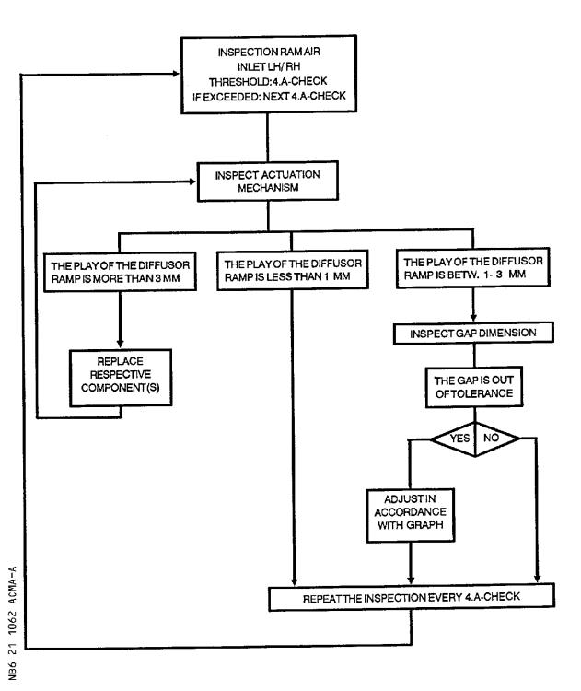

Flow Chart

Figure 1 Sheet 1

DATE : Oct 14/93 SERVICE BULLETIN No. : A320-21-1062

REVISION No. :

020  Jun 17/98

Printed in France

PAGE : 14

***A319/A320/A321***

|  |
| --- |
|  |

SERVICE BULLETIN

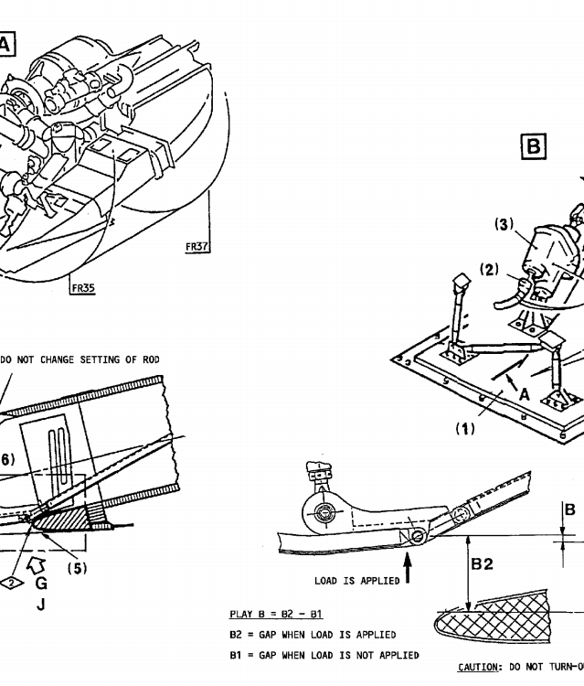

Inspection of the Ram Air Inlet

Figure 2 Sheet 1

DATE : Oct 14/93 SERVICE BULLETIN No. : A320-21-1062

REVISION No. :

020  Jun 17/98

Printed in France

PAGE : 16

***A319/A320/A321***

|  |
| --- |
|  |

SERVICE BULLETIN

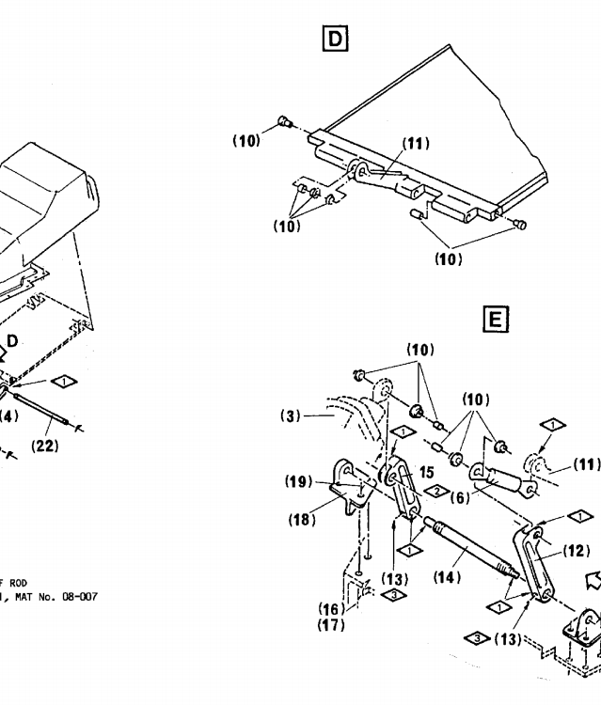

Inspection of the Ram Air Inlet

Figure 2 Sheet 2

DATE : Oct 14/93 SERVICE BULLETIN No. : A320-21-1062

REVISION No. :

020  Jun 17/98

Printed in France

PAGE : 18

***A319/A320/A321***

|  |
| --- |
|  |

SERVICE BULLETIN

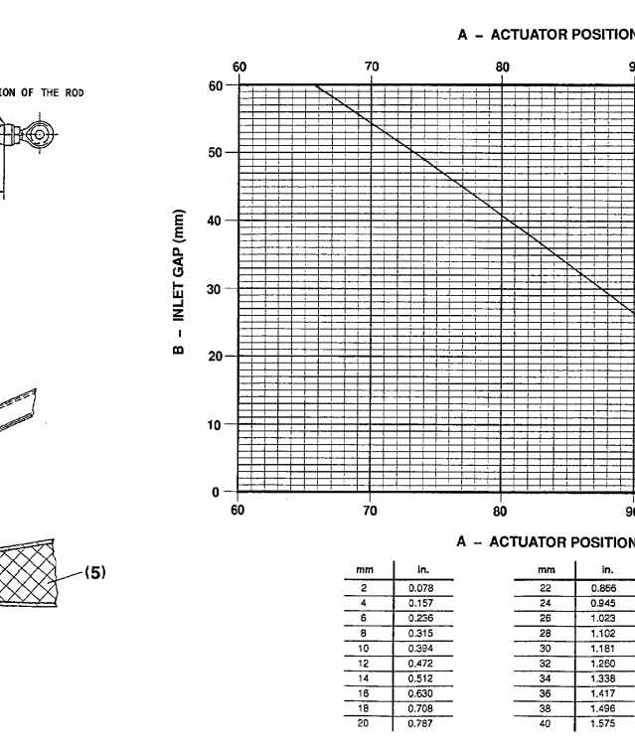

Adjustment of the Ram Air Inlet

Figure 3 Sheet 1

DATE : Oct 14/93 SERVICE BULLETIN No. : A320-21-1062

REVISION No. :

020  Jun 17/98

Printed in France

PAGE : 20

***A319/A320/A321***

|  |
| --- |
|  |

SERVICE BULLETIN

3. MATERIAL INFORMATION

A. LIST OF COMPONENTS

None

B. SPECIAL TOOLS

None

C. LIST OF MATERIAL - OPERATOR SUPPLIED

DESCRIPTION REFERENCE TO CML QTY PER A/C

Loctite 241 (Mat. No. 08-007) As required

D. PARTS TO BE RE-IDENTIFIED BY OPERATOR

None

DATE : Oct 14/93 SERVICE BULLETIN No. : A320-21-1062

REVISION No. : 020  Jun 17/98 PAGE : 21

Printed in France

***A319/A320/A321***

|  |
| --- |
|  |

SERVICE BULLETIN

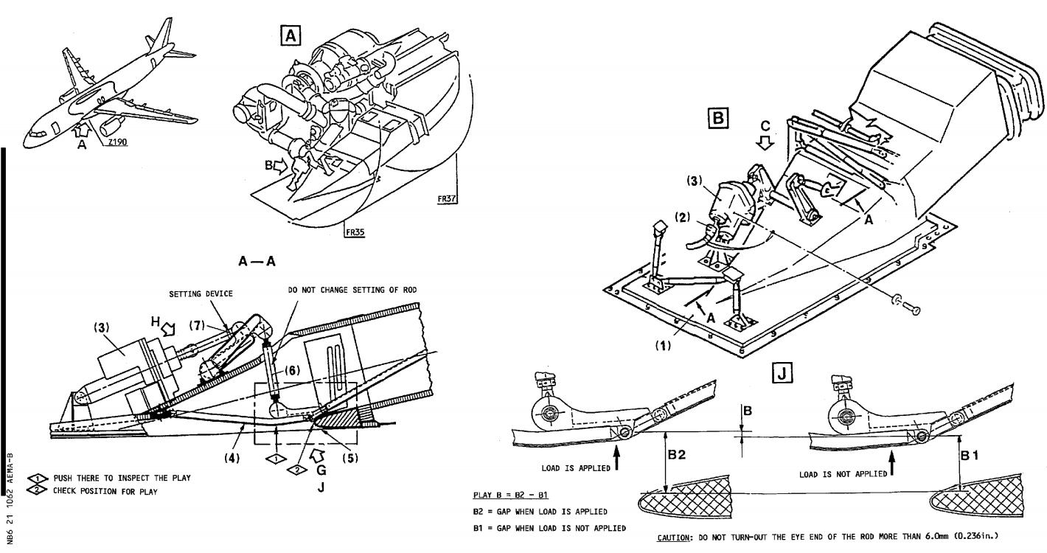

Inspection of the Ram Air Inlet

Figure 2 Sheet 1

DATE : Oct 14/93 SERVICE BULLETIN No. : A320-21-1062

REVISION No. : 02 - Jun 17/98

PAGE : 15 - 16

***A319/A320/A321***

|  |
| --- |
|  |

SERVICE BULLETIN

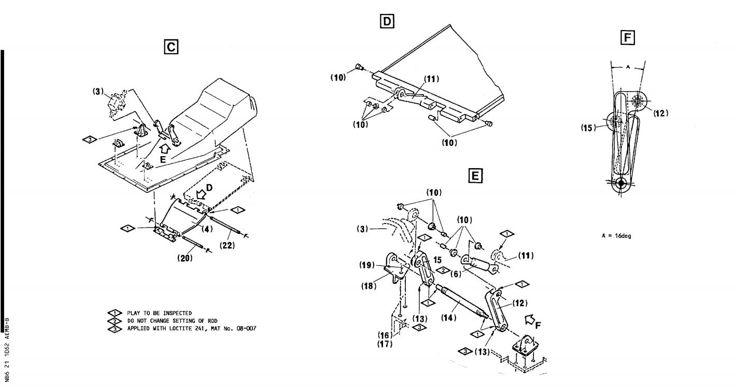

Inspection of the Ram Air Inlet

Figure 2 Sheet 2

DATE : Oct 14/93 SERVICE BULLETIN No. : A320-21-1062

REVISION No. : 02 - Jun 17/98

PAGE : 17 - 18

***A319/A320/A321***

|  |
| --- |
|  |

SERVICE BULLETIN

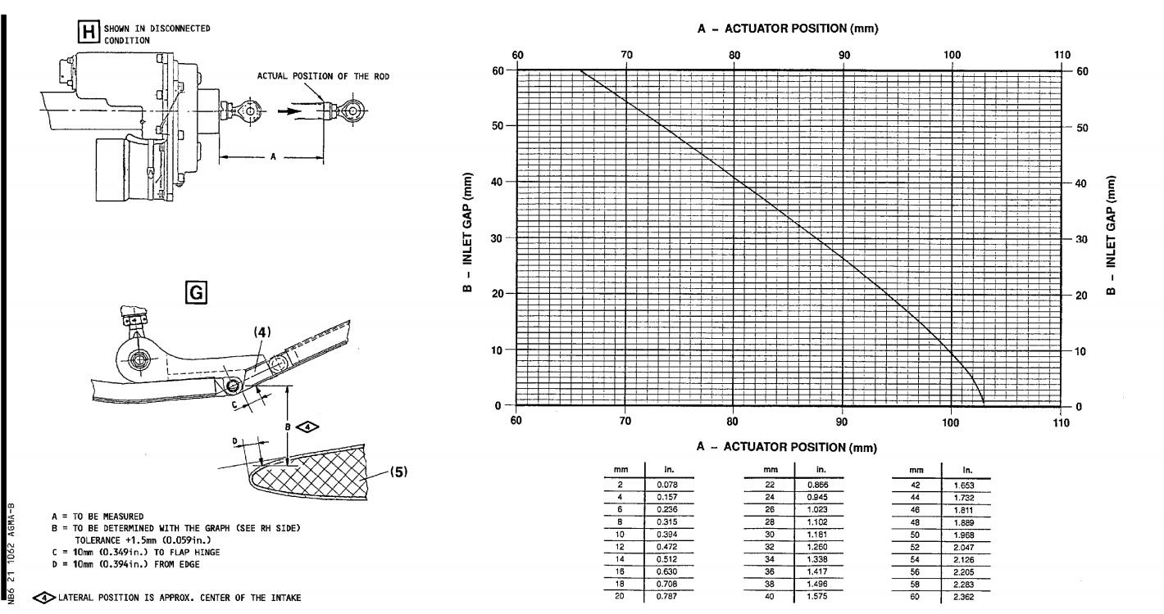

Adjustment of the Ram Air Inlet

Figure 3 Sheet 1

DATE : Oct 14/93 SERVICE BULLETIN No. : A320-21-1062

REVISION No. : 02 - Jun 17/98

PAGE : 19 - 20

***A319/A320/A321***

|  |
| --- |
|  |

|  |  |  |
| --- | --- | --- |
| FROM :  AIRLINE :   |  | | --- | | NAME : | | DATE : | |

SERVICE BULLETIN

ACCEPTANCE/REJECTION SHEET

AIRBUS INDUSTRIE

CUSTOMER SERVICES DIRECTORATE

1 Rond Point Maurice BELLONTE

31707 BLAGNAC CEDEX FRANCE

Tel: (33) 5 61-93-33-33

Telex: AIRBU 530526 F

TITLE : AIR CONDITIONING - INSPECT PACK RAM AIR INLETS

MODIFICATION No. : INSPECTION ATA SYSTEM : 21

|  |  |
| --- | --- |
| IS BEING HEREWITH  Please fill : | SUBMITTED TO YOU FOR REVIEW  ...REJECTED  ...WILL BE EMBODIED  ...EFFECTIVITY |

|  |
| --- |
| This SB can only be incorporated in your "customized" documentation within the agreed time schedule in so far as this sheet returned to us on purchase date and signed by a duly authorized and empowered officer or representative. |

|  |
| --- |
| Please return to :  AIRBUS INDUSTRIE  CUSTOMER SERVICES DIRECTORATE  1 Rond Point Maurice Bellonte  31707 BLAGNAC CEDEX FRANCE  Attn : AI/SE-D32 Technical Data  and Documentation Services  FAX : (+33) 5 61 93 28 06 |

6 DATE : Oct 14/93 SERVICE BULLETIN No. : A320-21-1062

REVISION No. :

020 Jun 17/98

Printed in France

PAGE : 1 of 1