***A319/A320/A321***

|  |
| --- |
|  |

SERVICE BULLETIN

REVISION TRANSMITTAL SHEET

AIRBUS INDUSTRIE

CUSTOMER SERVICES DIRECTORATE

1 Rond Point Maurice Bellonte

31707 BLAGNAC CEDEX FRANCE

Tel: (33) 5 61 93 33 33

Telex: AIRBU 530526 F

Fax : (33) 5 61 93 42 51

ATA SYSTEM : 21

TITLE : AIR CONDITIONING − AVIONICS EQUIPMENT VENTILATION − INTRODUCE NON

RETURN VALVE ON GROUND REFRIGERATION UNIT AIR INLET .

MODIFICATION No . : 25023P3860 25403P4114

This page transmits Revision No . 01 of Service Bulletin No . A320−21−1101 .

ADDITIONAL WORK

No additional work is required by this revision for aircraft modified by any

previous issue .

REASON

Revision No . 01 issued to add aircraft MSN 0414 and 0430 for operator CYP and Mod . No . 25403P4114 which installs a check valve 2250HM, PN CT141−1 instead of CT141, inside the air inlet .

CHANGES

SUMMARY :

− EFFECTIVITY

Operators updated .

− MATERIAL INFORMATION

PN of the check valve CT141 becomes CT141−1 .

− Figure

Figure

PLANNING

updated .

INFORMATION :

− EFFECTIVITY

Aircraft MSN 0414 and 0430 added for operator CYP .

− DESCRIPTION

Text updated .

− APPROVAL

Sentence concerning DGAC Approval updated and sentence concerning the

Approval for a possible adaptation added .

− MANPOWER

Text updated .

− REFERENCES

Reference to AMM 06−41−51 deleted and reference to 52−10−00 added .

Consumable Material List (CML) added .

MATERIAL INFORMATION :

L5

DATE : Aug 29/95

REVISION No . : 01 − Jun 27/01

SERVICE BULLETIN No . : A320−21−1101

Page : 1 of 2

***A319/A320/A321***

|  |
| --- |
|  |

SERVICE BULLETIN

REVISION TRANSMITTAL SHEET

− MATERIAL − PRICE AND AVAILABILITY

Sentence added .

− LIST OF COMPONENTS

NOTE(01), PN of the check valve CT141 becomes CT141−1 .

ACCOMPLISHMENT INSTRUCTIONS :

− GENERAL

Reference to AMM 06−41−52 becomes 52−10−00 . Sentence concerning the

specification of the material numbers added .

− MODIFICATION

Text updated .

− CLOSE−UP

Sentence concerning the removal of the circuit breakers added .

− ILLUSTRATIONS

Figure 1, Sheets 1 and 2 updated . Title modified .

NOTE : Lay−out changes due to computerization of this revision are not

identified .

FILING INSTRUCTIONS

This Service Bulletin has been generated electronically and is reissued as a

complete document . Replace the complete document .

Put this Revision Transmittal Sheet in front of the Service Bulletin .

REVISION SEQUENCE

ORIGINAL : Aug 29/95

REVISION No . : 01 − Jun 27/01

DATE : Aug 29/95

REVISION No . : 01 − Jun 27/01

SERVICE BULLETIN No . : A320−21−1101

Page : 2

 ***A319/A320/A321***

SERVICE BULLETIN

SUMMARY

AIRBUS INDUSTRIE

CUSTOMER SERVICES DIRECTORATE

1 Rond Point Maurice Bellonte

31707 BLAGNAC CEDEX FRANCE

Tel: (33) 5 61 93 33 33

Telex: AIRBU 530526 F

Fax : (33) 5 61 93 42 51

This summary is for information only

and is not approved for modification of the aircraft

ATA SYSTEM : 21

TITLE : AIR CONDITIONING − AVIONICS EQUIPMENT VENTILATION − INTRODUCE NON

RETURN VALVE ON GROUND REFRIGERATION UNIT AIR INLET .

MODIFICATION No . : 25023P3860 25403P4114

REASON/DESCRIPTION/OPERATIONAL CONSEQUENCES

Operational experience has shown that the ground cooling unit condenser stage

inlet duct PN D2121099500000 has been found collapsed in several cases .

Excessive differential pressure due to ground cooling skin air inlet valve non

closing, is at the origin of the duct rupture . This can occur when FCOM 3.02.21

P12 and MMEL 21−27−01 are not applied .

This Service Bulletin proposes to install a non return valve downstream of the

ground cooling skin air inlet valve .

|  |  |  |  |
| --- | --- | --- | --- |
| EVALUAT | | ION TABLE |  |
| COMPLIANCE | Desirable | CANCELS INSPECTION SB | No |
| POTENTIAL AD | No | A/C OPERATION AFFECTED | No |
| RELIABILITY AFFECTED | No | PAX COMFORT AFFECTED | No |
| COST SAVING | No | ETOPS AFFECTED | No |
| STRUCTURAL LIFE EXTN | No | VENDOR SB INVOLVED | No |
| KIT PRICE (USD) | 3,597 |  |  |

EFFECTIVITY

This Service Bulletin is applicable to these operators :

AIH ALK CTN CYP IAC KAC MSR MXA RJA SHK TNA

CONCURRENT REQUIREMENTS

Accomplishment of this Service Bulletin requires the prior or simultaneous

accomplishment of :

Service Bulletin No . A320−21−1067 Mod No . 20056P0073

REFERENCES/REPERCUSSIONS

L5

TFU

OEB

DATE : Aug 29/95

REVISION No . : 01

: 21 .27 .01 .001

: None

SERVICE BULLETIN No . : A320−21−1101

Page : 1 of 3

− Jun 27/01

Printed in France © Airbus Industrie 1995, All rights reserved

***A319/A320/A321***

|  |
| --- |
|  |

SERVICE BULLETIN

SUMMARY

AOT

SIL

LIFE LIMIT

: None

: None

: None

LINE MAINTENANCE AFFECTED : No

OTHER : None

NATURE OF THE WORK

AIRCRAFT : YES

EQUIPMENT : NO

HARD : NO

SOFT : NO

OBRM : NO

MANPOWER

Kit 211101A01

TOTAL MANHOURS 3.5

ELAPSED TIME (HOURS) 3 .5

MATERIAL INFORMATION

AIRCRAFT DATA

Blowing duct (equipped with a check valve PN CT141−1) .

APPENDICES

None

DATE : Aug 29/95

REVISION No . : 01 − Jun 27/01

SERVICE BULLETIN No . : A320−21−1101

Page : 2

Printed in France © Airbus Industrie 1995, All rights reserved

***A319/A320/A321***

|  |
| --- |
|  |

SERVICE BULLETIN

SUMMARY

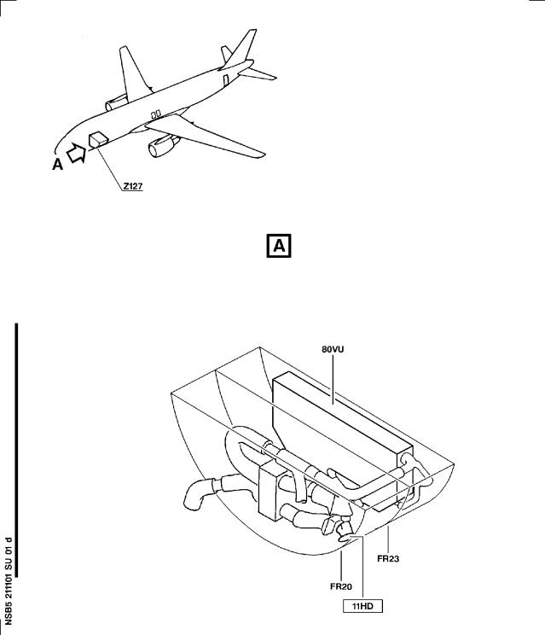

DATE : Aug 29/95

REVISION No . : 01 − Jun 27/01

SERVICE BULLETIN No . : A320−21−1101

Page : 3

***A319/A320/A321***

|  |
| --- |
|  |

SERVICE BULLETIN

AIRBUS INDUSTRIE

CUSTOMER SERVICES DIRECTORATE

1 Rond Point Maurice Bellonte

31707 BLAGNAC CEDEX FRANCE

Tel: (33) 5 61 93 33 33

Telex: AIRBU 530526 F

Fax : (33) 5 61 93 42 51

ATA SYSTEM : 21

TITLE : AIR CONDITIONING − AVIONICS EQUIPMENT VENTILATION − INTRODUCE NON

RETURN VALVE ON GROUND REFRIGERATION UNIT AIR INLET .

MODIFICATION No . : 25023P3860 25403P4114

This document contains AIRBUS INDUSTRIE PROPRIETARY INFORMATION and shall at all times remain the property of AIRBUS INDUSTRIE; no intellectual property right or licence is granted by AIRBUS INDUSTRIE in connection with any information contained in it . It is delivered on the express condition that said document and the information contained in it shall be treated as confidential, shall not be used for any purpose other than that for which it is hereby delivered . It shall not be disclosed in whole or in part to third parties and shall not be duplicated in any manner (except for the purposes of performing the tasks described hereunder and provided that any recipient of such document shall comply with the conditions herein), without AIRBUS INDUSTRIE’s prior written consent .

1. PLANNING INFORMATION

A . EFFECTIVITY

(1) Models

320−211 320−212 320−231 321−131

(2) Aircraft

(a) Effectivity by MSN

This Service Bulletin is applicable to Aircraft MSN :

0028 0035 0037 0038 0045−0051 0056−0058 0074 0075 0080

0087−0090 0095−0097 0163−0166 0168 0169 0178−0182 0194 0195

0198 0256 0258 0295 0316 0322 0326 0332 0344 0351 0366 0369

 0374 0396 0398 0406 0414 0416 0423 0430−0432 0451 0469 0486

0490 0492 0499 0538 0555 0569

|  |  |
| --- | --- |
| (b) | Effectivity by Operator  The Operator/MSN relationship is provided for information only  and is correct at the time of issue in accordance with the  information available to AIRBUS INDUSTRIE . Any future changes  resulting from transfer of an aircraft from one operator to  another will not be reflected in this list unless the Service  Bulletin is revised for another reason .  OPERATOR MSN  AIH 0163 0164 0168 0169 0179  ALK 0374 0406 |

L5 DATE : Aug 29/95 SERVICE BULLETIN No . : A320−21−1101

REVISION No . : 01 − Jun 27/01

Page : 1 of 14

Printed in France © Airbus Industrie 1995, All rights reserved

***A319/A320/A321***

|  |
| --- |
|  |

SERVICE BULLETIN

|  |  |  |  |  |  |  |  |  |  |  |
| --- | --- | --- | --- | --- | --- | --- | --- | --- | --- | --- |
| OPERATOR  CTN  CYP  IAC  KAC  MSR  MXA  RJA  SHK  TNA | MSN  0258  0028  0045  0074  0416  0181  0165  0332  0087  0322  0538 | 0035  0046  0075  0423  0182  0166  0369  0088  0326  0555 | 0037  0047  0080  0431  0195  0178  0569  0344 | 0038  0048  0089  0432  0194 | 0180  0049  0090  0451  0198 | 0256  0050  0095  0469  0351 | 0295  0051  0096  0486  0366 | 0316  0056  0097  0490 | 0414  0057  0396  0492 | 0430  0058  0398  0499 |

(c) Effectivity by MSN and Kit/Configuration

MSN

0028 0035 0037−0038 0045−0051 0056−0058 0074−0075 0080

0087−0090 0095−0097 0163−0166 0168−0169 0178−0182 0194−0195

0198 0256 0258 0295 0316 0322 0326 0332 0344 0351 0366 0369

 0374 0396 0398 0406 0414 0416 0423 0430−0432 0451 0469 0486

0490 0492 0499 0538 0555 0569

|  |  |  |  |
| --- | --- | --- | --- |
| KIT No . | QTY | PER | A/C CONFIGURATION |

211101A01

1

None

(3) Spares

blowing duct D5391413500000

B . CONCURRENT REQUIREMENTS

Accomplishment of this Service Bulletin requires the prior or

simultaneous accomplishment of :

Service Bulletin No . A320−21−1067 Mod No . 20056P0073

C . REASON

(1) History

Operational experience has shown that the ground cooling unit

condenser stage inlet duct PN D2121099500000 has been found

collapsed in several cases . Excessive differential pressure due to

ground cooling skin air inlet valve non closing, is at the origin

of the duct rupture .This can occur when FCOM 3.02.21 P12 and MMEL

21−27−01 are not applied .

(2) Objective/Action

This Service Bulletin proposes to install a non return valve

downstream of the ground cooling skin air inlet valve .

(3) Advantages

Accomplishment of this Service Bulletin permits to avoid subject

duct collapsing with subsequent loss of cabin pressure .

DATE : Aug 29/95

REVISION No . : 01 − Jun 27/01

SERVICE BULLETIN No . : A320−21−1101

Page : 2

Printed in France © Airbus Industrie 1995, All rights reserved

***A319/A320/A321***

|  |
| --- |
|  |

SERVICE BULLETIN

(4) Operational/Maintenance Consequences

None

D . DESCRIPTION

To accomplish this Service Bulletin it is necessary to : (1.1D.)(1) Kit 211101A01

(1.aD.)(1)(a) Replace the blowing duct .

E . COMPLIANCE

(1) Classification

DESIRABLE

(2) Accomplishment Timescale

In accordance with operators’ maintenance schedule .

F . APPROVAL

The technical content of this Service Bulletin has been approved under

the authority of the DGAC Design Organisation Approval No . F .JA .02 .

If an aircraft listed in the effectivity has a modification or repair

embodied that is not of AIRBUS origin, and which affects the content of

this Service Bulletin, the operator is responsible for obtaining

approval by its airworthiness authority for any adaptation necessary

before incorporation of the Service Bulletin .

G . MANPOWER

This Service Bulletin is written for an aircraft in a maintenance condition . The manhours/elapsed time estimates do not include the time to prepare for the modification, non−productive elapsed time or administration .

Kit 211101A01

Get access 0 .5 Replacement of the blowing duct 2 .0 Test 0.5 Close up 0 .5 TOTAL MANHOURS 3 .5 ELAPSED TIME (HOURS) 3 .5

H . WEIGHT AND BALANCE

Manufacturers Empty Weight : +0 .149 kg (+0 .3284 lb)

Effect on Balance : +1 .263 kgm (+9 .135 lb .ft)

I . ELECTRICAL LOAD DATA

Not changed

DATE : Aug 29/95

REVISION No . : 01 − Jun 27/01

SERVICE BULLETIN No . : A320−21−1101

Page : 3

Printed in France © Airbus Industrie 1995, All rights reserved

***A319/A320/A321***

|  |
| --- |
|  |

SERVICE BULLETIN

J . REFERENCES

Aircraft Maintenance Manual (AMM)

Consumable Material List (CML)

Service Bulletin No . A320−21−1067

K . PUBLICATIONS AFFECTED

Aircraft Maintenance Manual (AMM)

Illustrated Parts Catalog (IPC)

L . INTERCHANGEABILITY/MIXABILITY

:

:

:

06−41−53

21−27−52

21−26−56

21−26−01

12−34−24

24−41−00

21−26−56

21−27−00

52−10−00

|  |  |  |  |  |  |  |  |
| --- | --- | --- | --- | --- | --- | --- | --- |
| DESCRIPTION | OLD | PART | No . | NEW | PART | No . | INT MIXABILITY |

Blowing duct D5391413500000 D5391679100000 01 N/A

NOTE : For definitions of interchangeability codes shown in column INT .

refer to ATA 200 Chapter 1A−2 .

DATE : Aug 29/95

REVISION No . : 01 − Jun 27/01

SERVICE BULLETIN No . : A320−21−1101

Page : 4

Printed in France © Airbus Industrie 1995, All rights reserved

***A319/A320/A321***

|  |
| --- |
|  |

SERVICE BULLETIN

2. MATERIAL INFORMATION

A . MATERIAL − PRICE AND AVAILABILITY

(1) Material

Customers with aircraft shown in the effectivity of this Service

Bulletin should send a purchase order to AIRBUS INDUSTRIE . Quote

the number of this Service Bulletin . The address is :

AIRBUS INDUSTRIE

MATERIEL SUPPORT CENTER

P .O . Box 630262

22312 HAMBURG

GERMANY

(2) Price and Availability

Kit 211101A01

Cost : 3,597 .00 US Dollars

Availability : 120 Calendar days from receipt of order

The Kit availability given above is the standard lead time from the

date of your purchase order . If you require the Kit(s) before this

time, please include a retrofit planning schedule with your order

so that we can try to comply with your requirements .

The sales terms (costs and availability) are estimated in relation

to economic conditions at the issue date of the Service Bulletin .

B . INDUSTRY SUPPORT INFORMATION

None

C . LIST OF COMPONENTS

Kit 211101A01

ITEM NEW PART No . QTY UM KEYWORD ITEM OLD PART No . INT INST DISP

|  |  |  |  |  |  |  |
| --- | --- | --- | --- | --- | --- | --- |
| 1 | D5391679100000 | 1 | Duct | (1) | D5391413500000 | 01 (01)  * |
| 5 | NSA8603−737 | 1 | Clamp | (5) | NSA8603−737 | * |
| 6 | NSA8203−260 | 1 | O−Ring | (6) | NSA8203−260 | * |
| 8 | 55220−014−022 | 1 | Clamp | (8) | 55220−014−022 | * |
| 9 | NSA8205−171 | 1 | O−Ring | (9) | NSA8205−171 | * |
| 10 | NAS1153E8 | 10 | Screw | (10) | NAS1153E8 | * |
| 15 | ASNA2051DCJ3215 | 10 | Rivet | (15) | ASNA2051DCJ3215 | * |

 NOTE (01) Equipped with check valve CT141−1 .

NOTE (*) Discard

NOTE : Refer to the AIRBUS INDUSTRIE Standards Manual (SM) if you find

part numbers of hardware components in the related kit(s) which

you cannot identify in the LIST OF COMPONENTS of this Service

Bulletin . The SM will give you the correct part number to part

number relationship .

DATE : Aug 29/95

REVISION No . : 01 − Jun 27/01

SERVICE BULLETIN No . : A320−21−1101

Page : 5

Printed in France © Airbus Industrie 1995, All rights reserved

***A319/A320/A321***

|  |
| --- |
|  |

SERVICE BULLETIN

NOTE : For definitions of interchangeability codes shown in column INT .

refer to ATA 200 Chapter 1A−2 .

D . LIST OF MATERIALS − OPERATOR SUPPLIED

DESCRIPTION REFERENCE TO CML QTY PER A/C INST DISP

MAT . No .

Putty, Zinc Chromategeneral 05−002

Purpose

Polysulphide Sealant 09−016

Sealant 09−025

Methyl−Ethyl−Ketone 11−003

E . PARTS TO BE RE IDENTIFIED BY THE OPERATOR

None

F . TOOLING − PRICE AND AVAILABILITY

None

G . SPECIAL TOOLS

None

As required

As required

As required

As required

DATE : Aug 29/95

REVISION No . : 01 − Jun 27/01

SERVICE BULLETIN No . : A320−21−1101

Page : 6

***A319/A320/A321***

|  |
| --- |
|  |

SERVICE BULLETIN

3. ACCOMPLISHMENT INSTRUCTIONS

A . GENERAL

(1) Preparation

.aA.)(1)(a) De−energize the aircraft electrical circuits (Refer to AMM 24−41−00 Page block 201) .

.bA.)(1)(b) E lectrically ground the aircraft (Refer to AMM 12−34−24 Page block 201) .

.cA.)(1)(c) Put the access platform(s) in position .

.dA.)(1)(d) Open the access door 824, (Refer to AMM 06−41−53 Page block 001) and passenger/crew door 841, (Refer to AMM 52−10−00 Page block 001) .

.eA.)(1)(e) Open, safety and tag these circuit breakers :

PANEL DESIGNATION FIN LOCATION

23 W 11AC 03AC

122VU

123VU

123VU

AIR COND/VENT/GND/COOL/CTL

VENT/GND COOL/FAN

VENT/GROUND COOL/UNIT

Standard Practices

3HD

1HD

2HD

(2)

.aA.)(2)(a) To install the screws with anti−corrosion compound Putty, Zinc Chromategeneral Purpose (Mat . No . 05−002) .

.bA.)(2)(b) To clean the surfaces to be sealed using Methyl−Ethyl−Ketone (Mat . No . 11−003) .

.cA.)(2)(c) To apply Sealant (Mat . No . 09−025) to

|  |  |
| --- | --- |
| structure .  .dA.)(2)(d) To shorten the rivets  .eA.)(2)(e) For the specification refer to the CML . | as required .  of the material |

the interfaces of the

numbers (Mat . No . ),

B . MODIFICATION

.1B.)(1) Kit 211101A01

.aB.)(1)(a) Replace the blowing duct . Refer to figure 1 Sheets 1 Refer to AMM 21−27−52 Page

, 2 and 3

block 401

13.B . (1R)(ae)1move

:

1 Air inlet valve

1 O−Ring

10 Screws

:

23.B . (1R)(ae)2move

2 Clamps

1 Sleeve

1 Clamp

1 O−Ring

NSA8205−171

NAS1153E8

NSA8603−737

NSA8203−260

Item (2 ) Item (9) Item (10)

Item (3)

Item (4)

Item (5 )

Item (6)

Retain

Discard

Discard

Retain

Retain

Discard

Discard

DATE : Aug 29/95

REVISION No . : 01 − Jun 27/01

SERVICE BULLETIN No . : A320−21−1101

Page : 7

Printed in France © Airbus Industrie 1995, All rights reserved

***A319/A320/A321***

|  |
| --- |
|  |

SERVICE BULLETIN

1 Filter Item (7) Retain

1 Clamp 55220−014−022 Item (8) Discard

10 Rivets ASNA2051DCJ3215 Item (15 ) Discard

1 Blowing duct D5391413500000 Item (1 ) Discard

NOTE (01) To remove the PR sealant, use a non metallic

spatula; if there are scratches, polish the

surface and apply protection .

NOTE (02) Make sure that the work areas are clean and clear

of particles .

NOTE (03) Carefully remove the rivets, so as not damage the

rivet holes as you will install rivets of the

same dimension .

33.B . (1 I)(an)3stall :

1 Blowing duct D5391679100000 Item 1

10 Rivets ASNA2051DCJ3215 Item 15

1 Clamp 55220−014−022 Item 8

1 Filter Item (7)

1 O−Ring NSA8203−260 Item 6

1 Clamp NSA8603−737 Item 5

1 Sleeve Item (4)

2 Clamps Item (3)

NOTE (01) Items (3), (4), (7) were retained at removal .

NOTE (02) Before the installation of the fairing assy,

apply Polysulphide Sealant (Mat . No . 09−016) .

43.B . (1 I)(an)4stall :

11HD

1 Air inlet valve Item (2 )

1 O−Ring NSA8205−171 Item 9

10 Screws NAS1153E8 Item 10 NOTE : Item (2) was retained at removal .

C . TEST

.1C.)(1) Do an operational test of the avionics equipment ground cooling

fault warning . ((Refer to AMM 21−27−00 Page block 501) .

.2C.)(2) Do an inspection of the component interface and/or the adjacent

area .

D . CLOSE UP

.1D.)(1) Make sure that the work areas are clean and clear of tools and

other items of equipment .

.2D.)(2) Remove the safety clips and tags and close these circuit breakers :

DATE : Aug 29/95

REVISION No . : 01 − Jun 27/01

SERVICE BULLETIN No . : A320−21−1101

Page : 8

Printed in France © Airbus Industrie 1995, All rights reserved

***A319/A320/A321***

3 .D . (3)

3 .D . (4)

3 .D . (5)

3 .D . (6)

|  |
| --- |
|  |

SERVICE BULLETIN

DESIGNATION

LOCATION

PANEL

FIN

122VU

123VU

123VU

(3)

AIR COND/VENT/GND/COOL/CTL

23 W 11AC 03AC

3HD

1HD

2HD

VENT/GND COOL/FAN

VENT/GROUND COOL/UNIT

Close the access doors 824 (Refer to AMM 06−41−53 Page block 001)

and passenger/crew door 841 (Refer to AMM 52−10−00 Page block 201) .

(4)

(5)

(6)

Remove the access platform(s) .

Disconnect the aircraft electrical ground−connection

12−34−24 Page block 201) .

Restore the systems and aircraft to normal operating

(Refer to AMM

condition .

E . DOCUMENTATION

Write in the applicable aircraft records that you have done all the work

given in this Service Bulletin .

DATE : Aug 29/95

REVISION No . : 01 − Jun 27/01

SERVICE BULLETIN No . : A320−21−1101

Page : 9

Printed in France © Airbus Industrie 1995, All rights reserved

***A319/A320/A321***

|  |
| --- |
|  |

SERVICE BULLETIN

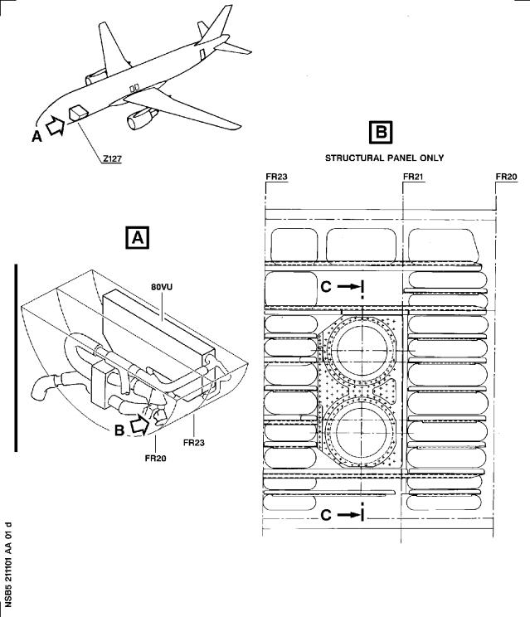

Figure 1 Sheet 1

Modification of the Blowing Duct, Kit 211101A01

DATE : Aug 29/95

REVISION No . : 01 − Jun 27/01

SERVICE BULLETIN No . : A320−21−1101

Page : 10

Printed in France © Airbus Industrie 1995, All rights reserved

***A319/A320/A321***

|  |
| --- |
|  |

SERVICE BULLETIN

Figure 1 Sheet 2

Modification of the Blowing Duct, Kit 211101A01

DATE : Aug 29/95

REVISION No . : 01 − Jun 27/01

SERVICE BULLETIN No . : A320−21−1101

Page : 12

***A319/A320/A321***

|  |
| --- |
|  |

SERVICE BULLETIN

Figure 1 Sheet 3

Modification of the Blowing Duct, Kit 211101A01

DATE : Aug 29/95

REVISION No . : 01 − Jun 27/01

SERVICE BULLETIN No . : A320−21−1101

Page : 14

***A319/A320/A321***

|  |
| --- |
|  |

SERVICE BULLETIN

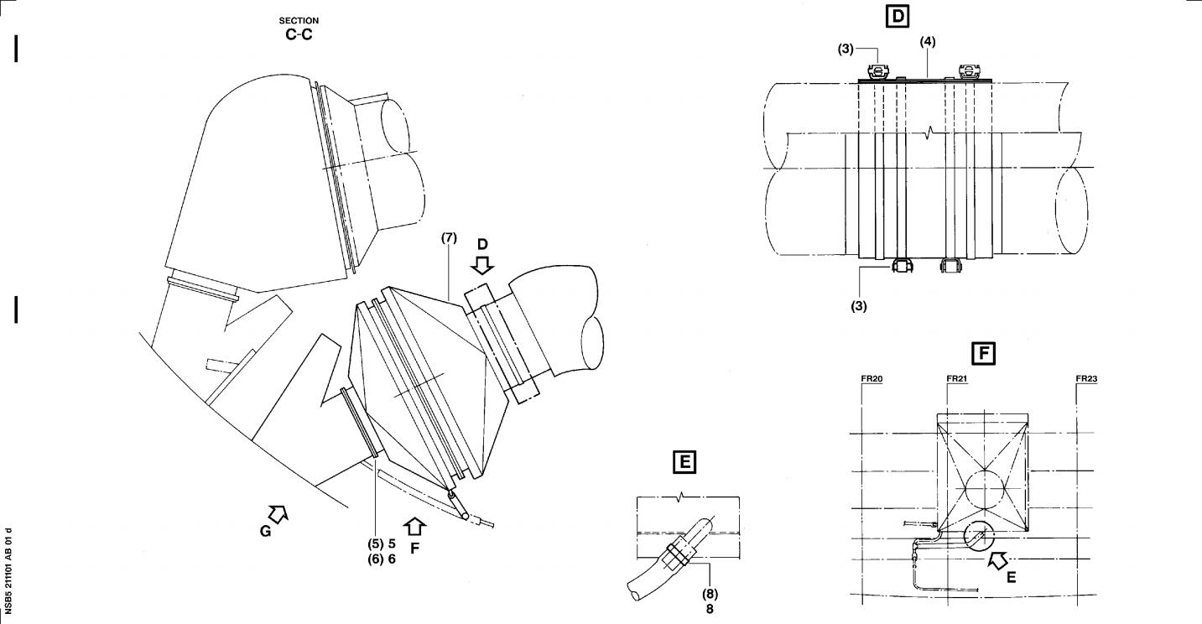

Figure 1 Sheet 2

Modification of the Blowing Duct, Kit 211101A01

DATE : Aug 29/95

REVISION No . : 01 − Jun 27/01

SERVICE BULLETIN No . : A320−21−1101

Page : 11/12

Printed in France © Airbus Industrie 1995, All rights reserved

***A319/A320/A321***

|  |
| --- |
|  |

SERVICE BULLETIN

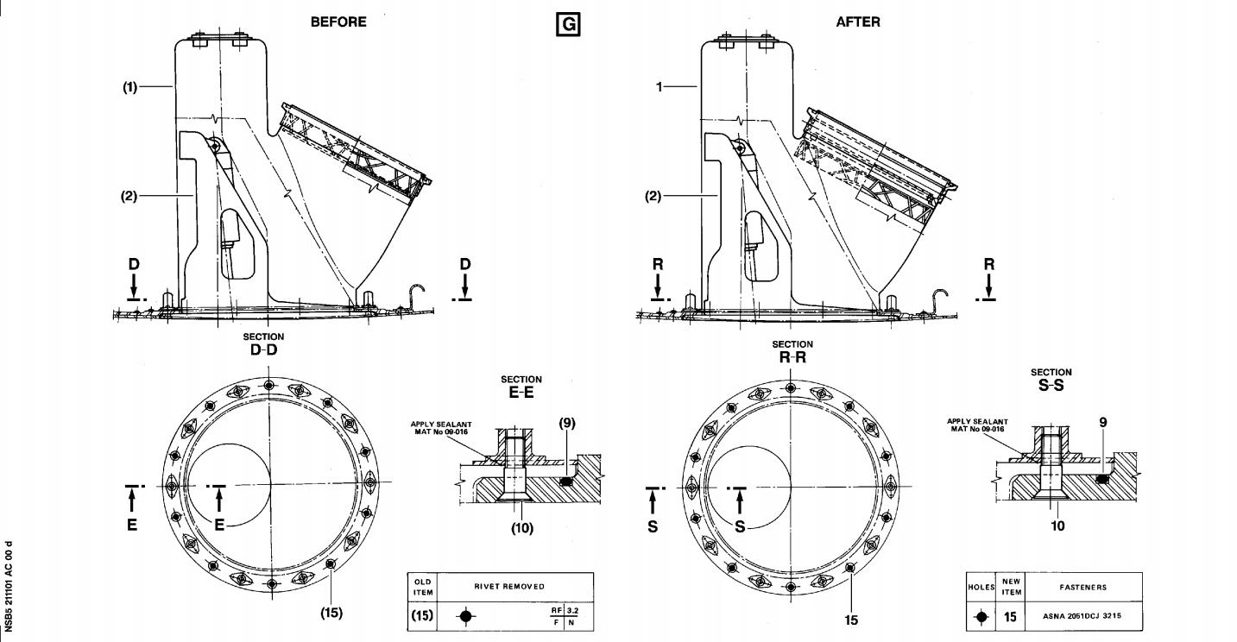

Figure 1 Sheet 3

Modification of the Blowing Duct, Kit 211101A01

DATE : Aug 29/95

REVISION No . : 01 − Jun 27/01

SERVICE BULLETIN No . : A320−21−1101

Page : 13/14

Printed in France © Airbus Industrie 1995, All rights reserved

 ***A319/A320/A321***

SERVICE BULLETIN

REPORTING SHEET

TITLE : AIR CONDITIONING − AVIONICS EQUIPMENT VENTILATION − INTRODUCE NON

RETURN VALVE ON GROUND REFRIGERATION UNIT AIR INLET .

MODIFICATION No . : 25023P3860 25403P4114

Please complete the appropriate item (A or B):

A − SB WILL BE embodied . . . . . . . . . . . . . .YES/NO (if NO please comment)

If YES, aircraft concerned (as per SB effectivity by default) and planned dates

(month/year) of embodiment: . . . . . . . . . . . . . . . . . . . . . . . . . .

. . . . . . . . . . . . . . . . . . . . . . . . . . . . . . . . . . . . . . . .

. . . . . . . . . . . . . . . . . . . . . . . . . . . . . . . . . . . . . . . .

B − SB HAS BEEN embodied on aircraft: . . . . . . . . . . . . . . . . . . . . .

. . . . . . . . . . . . . . . . . . . . . . . . . . . . . . . . . . . . . . . .

. . . . . . . . . . . . . . . . . . . . . . . . . . . . . . . . . . . . . . . .

Operator comments: . . . . . . . . . . . . . . . . . . . . . . . . . . . . . . .

. . . . . . . . . . . . . . . . . . . . . . . . . . . . . . . . . . . . . . . .

. . . . . . . . . . . . . . . . . . . . . . . . . . . . . . . . . . . . . . . .

From Airline: . . . . . . . . . . . . . . . . . . . . . . . . . . . . . . . . .

Name/Title: . . . . . . . . . . . . . . . . . . . . . . . . . . . . . . . . . .

Signature: . . . . . . . . . . . . Date: . . . . . . . . . . .

If operational documentation is affected (see Paragraph 1 .K of this SB): If information is needed prior to next normal revision or prior to SB embodiment, please indicate required service(s):

Either: Advance data . . . . . . . . . . . . . . . . . . . . . . YES/NO

Or : Intermediate/Temporary revision . . . . . . . . . . . . YES/NO

Important Information: This SB will only be incorporated in your maintenance and

operational documentation if this sheet is returned to Airbus Industrie and

signed by a duly authorised representative . With the next feasible revision,

this will result in

−updating of maintenance documentation to show pre and post SB data .

−updating of maintenance and operational documentation to show post SB data

after embodiment .

If this SB requires previous or simultaneous accomplishment of other SBs, Airbus

Industrie shall automatically include them in the manual revisions . Refer to SIL

00−037 for detailed information .

Please return this completed sheet to:

AIRBUS INDUSTRIE

CUSTOMER SERVICES DIRECTORATE

1 Rond Point Maurice Bellonte

31707 BLAGNAC CEDEX FRANCE

Attn: AI/SE−D32 Technical Data and Documentation Services Fax: (+33) 5 61 93 28 06

or via your Resident Customer Support Office .

Alternatively, SB lists via letters or fax are also accepted .

L5

DATE : Aug 29/95

REVISION No . : 01 − Jun 27/01

SERVICE BULLETIN No . : A320−21−1101

Page : 1 of 1

***A319/A320/A321***

|  |
| --- |
|  |

SERVICE BULLETIN

QUALITY PERCEPTION FORM

Use this form to tell us what is your perception of the quality of this Service Bulletin . The reported data that you provide us will be used to analyse areas of difficulties and to take corrective action to further improve the quality of our Service Bulletins .

We thank you for the time you have taken in completing this form .

(Please rate on a scale of 1 to 4, with 4 being the highest score)

|  |  |  |  |  |
| --- | --- | --- | --- | --- |
| − Quality | rating of this SB | 4 3 | 2 | 1 |
| − Quality | rating of the Accomplishment Instructions | 4 3 | 2 | 1 |
| − Quality | rating of the Illustrations | 4 3 | 2 | 1 |
| − Is this | SB easy to understand ? | Y / N |  |  |

If you have had difficulties in the accomplishment of this SB please quote below

the area(s) and give a short description of the issue .

Planning

X Effectivity

X Reason

X Manpower

X References

X Publication

Comments :

Material

X Kit Content

X List of Materials

Operator Supplied

X Re−identification

X Tooling

Instructions

X Preparation

X Mod/Inspection

X Test

X Close−up

X Illustrations

Operator :

Name/Title :

Date:

Please return this form to :

AIRBUS INDUSTRIE

CUSTOMER SERVICES DIRECTORATE

1 Rond Point Maurice Bellonte

31707 BLAGNAC CEDEX

Attn : AI/SE−T1 Service Bulletins Management

FAX : (33) 5 61 93 42 51

or via your Resident Customer Support Office .

L5

DATE : Aug 29/95

REVISION No . : 01 − Jun 27/01

SERVICE BULLETIN No . : A320−21−1101

Page : 1 of 1