***A319/A320/A321***

|  |
| --- |
|  |

SERVICE BULLETIN

SUMMARY

AIRBUS INDUSTRIE

CUSTOMER SERVICES DIRECTORATE

1 Rond Point Maurice BELLONTE

31707 BLAGNAC CEDEX FRANCE

Tel: (33) 5 61-93-33-33

Telex: AIRBU 530526 F

This summary is for information only

and is not approved for modification of the aircraft

TITLE : AIR CONDITIONING - PACK TEMPERATURE CONTROL - INTRODUCE IMPROVED PACK

TEMPERATURE CONTROLLER A-11

MODIFICATION No . :

27469K5430

ATA SYSTEM : 21

REASON/DESCRIPTION/OPERATIONAL CONSEQUENCES

In-service experience has shown that, in hot weather conditions (above

approx . 38 deg . C . (100 deg . F . )), the air conditioning pack discharge

temperature is kept above 5 deg . C . (41 deg . F . ) and the pack bypass

valve is almost closed (less than 25 degrees open) . In this

configuration, the pack automatic de- icing cycle is activated by the ’A’

pack controller; the bypass valve is then driven fully open for a period

of 50 seconds approximately every ten minutes . As a result of this, the

pack discharge pack temperature can exceed 40 deg . C . (104 deg . F . ) and

very hot air is blown into the cabin .

This Service Bulletin advises customers of the issue of the

LIEBHERR-AEROSPACE LINDENBERG GmbH Service Bulletin No . 759A-21-07 which

introduces a modified pack controller incorporating a software change and

also a modification of the main control limit for the ram air door to

40% .

Accomplishment of this modification will ensure that the pack de- icing cycle is activated as soon as the pack outlet temperature drops below 5 deg . C . (41 deg . F . ), independent of the bypass valve position .

EFFECTIVITY

This Service Bulletin is applicable to these customer(s) :

HP, TAI, XP, XR .

SERVICE BULLETIN TO BE ACCOMPLISHED

PREVIOUSLY OR SIMULTANEOUSLY

Service Bulletin No . A320-21-1082 (Mod . No . 24094K03554)

REFERENCES/REPERCUSSIONS

TFU : None

OEB : None

AOT : None

SIL : None

LIFE LIMIT : None

6 DATE : Jun 15/98 SERVICE BULLETIN No . : A320-21-1111

REVISION No . : 00 -

PAGE : 1 of 3

Printed in France

***A319/A320/A321***

|  |
| --- |
|  |

SERVICE BULLETIN

SUMMARY

LINE MAINTENANCE AFFECTED OTHER

NATURE OF THE WORK

: None

: None

AIRCRAFT

EQUIPMENT

HARD

SOFT

OBRM COMPLIANCE Desirable MANPOWER

On Aircraft

:

:

:

:

:

No

yes

NO

NO

NO

TOTAL MANHOURS

ELAPSED TIME (HOURS)

MATERIAL INFORMATION

AIRCRAFT DATA

None

EQUIPMENT DATA

1.25

1 .25

Designation : Pack Controller (7HH and 27HH)

Supplier : LIEBHERR-AEROSPACE LINDENBERG GmbH

Service Bulletin No . 759A-21-07

Old Part Number 759A0000-10

New Part Number 759A0000-11

Interchangeability code 200 (Refer to ATA 200 Chapter 1A-2)

Mixability : None

APPENDICES

None

DATE : Jun 15/98 SERVICE BULLETIN No . : A320-21-1111

REVISION No . : 00 -

PAGE : 2

Printed in France

***A319/A320/A321***

|  |
| --- |
|  |

SERVICE BULLETIN

SUMMARY

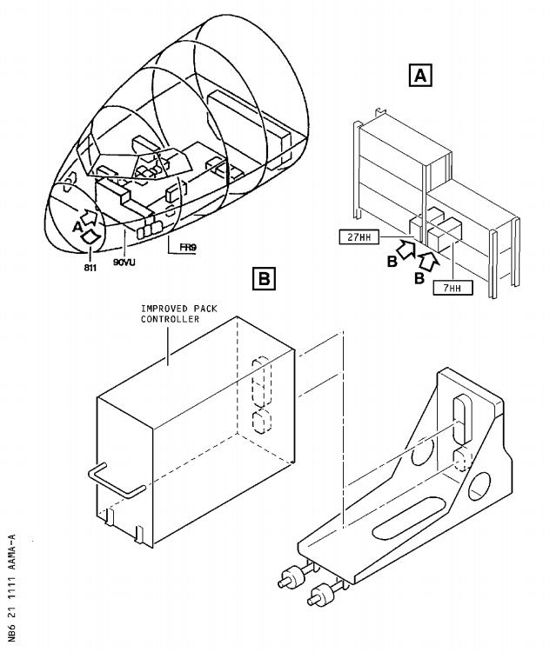

DATE : Jun 15/98 SERVICE BULLETIN No . : A320-21-1111

REVISION No . : 00 -

PAGE : 3

Printed in France

***A319/A320/A321***

|  |
| --- |
|  |

SERVICE BULLETIN

AIRBUS INDUSTRIE

CUSTOMER SERVICES DIRECTORATE

1 Rond Point Maurice BELLONTE

31707 BLAGNAC CEDEX FRANCE

Tel: (33) 5 61-93-33-33

Telex: AIRBU 530526 F

TITLE : AIR CONDITIONING - PACK TEMPERATURE CONTROL - INTRODUCE IMPROVED PACK

TEMPERATURE CONTROLLER A-11

MODIFICATION No . : 27469K5430 ATA SYSTEM : 21

1. PLANNING INFORMATION

A . EFFECTIVITY

(1) Aircraft models : 320-231, 320-232

(2) Aircraft

Customer and MSN Kit No . Qty Config

Fleet No . none of kits No .

HP620-622 052,053,054

624-629 055,064,065,066,067,076

631-636 077,081,082,091,092,098

637 099

TAI051-052 448,453

XR503 238

506 271

510 304

513, 514 315,317

XP504-506 455,471,584

To do this Service Bulletin you must do Service Bulletin

A320-21-1082 (Modification No . 24094K03554) before or at the same

time .

This document contains Airbus Industrie PROPRIETARY INFORMATION and

shall at all times remain the property of Airbus Industrie; no

intellectual property right or licence is granted by Airbus

Industrie in connection with any information contained in it . It is

delivered on the express condition that the said document and the

information contained in it shall be treated as confidential and

shall not be used for any purpose other than that for which it is

hereby delivered . It shall not be disclosed in whole or in part to

third parties and shall not be duplicated in any manner (except for

the purposes of performing the tasks described hereunder and

provided that any recipient of such document shall comply with the

conditions herein), without Airbus Industrie’s prior written

consent .

6 DATE : Jun 15/98 SERVICE BULLETIN No . : A320-21-1111

REVISION No . : 00 -

PAGE : 1 of 7

Printed in France

***A319/A320/A321***

|  |
| --- |
|  |

SERVICE BULLETIN

(3) Spares

None

B . REASON

(1) History

In-service experience has shown that, in hot weather conditions

(above approx . 38 deg . C . (100 deg . F . )), the air conditioning pack

discharge temperature is kept above 5 deg . C . (41 deg . F . ) and the

pack bypass valve is almost closed (less than 25 degrees open) . In

this configuration, the pack automatic de- icing cycle is activated

by the ’A’ pack controller; the bypass valve is then driven fully

open for a period of 50 seconds approximately every ten minutes . As

a result of this, the pack discharge pack temperature can exceed 40

deg . C . (104 deg . F . ) and very hot air is blown into the cabin .

(2) Objective/Action

This Service Bulletin advises customers of the issue of the

LIEBHERR-AEROSPACE LINDENBERG GmbH Service Bulletin No . 759A-21-07

which introduces a modified pack controller incorporating a

software change and also a modification of the main control limit

for the ram air door to 40% .

(3) Advantages

Accomplishment of this modification will ensure that the pack

de- icing cycle is activated as soon as the pack outlet temperature

drops below 5 deg . C . (41 deg . F . ), independent of the bypass valve

position .

(4) Operational/Maintenance Consequences

None

(5) Accomplishment Timescale

In accordance with operators’ maintenance schedule .

C . DESCRIPTION

To accomplish this Service Bulletin it is necessary to :

(1) Remove the pack controllers 7HH and 27HH .

(2) Perform the modification of the LIEBHERR-AEROSPACE LINDENBERG GmbH

Service Bulletin 759A-21-07 on bench or send the pack controllers

to LIEBHERR-AEROSPACE LINDENBERG GmbH .

(3) Install the modified pack controllers 7HH and 27HH .

D . APPROVAL

The technical

the authority

content of this Service Bulletin has been approved under

of the DGAC Design Organisation Approval No . F .JA .02 .

DATE : Jun 15/98 SERVICE BULLETIN No . : A320-21-1111

REVISION No . : 00 -

PAGE : 2

Printed in France

***A319/A320/A321***

|  |
| --- |
|  |

SERVICE BULLETIN

E . MANPOWER

This Service Bulletin is written for an aircraft in a maintenance

status . The manhours/elapsed time estimates do not include the time to

prepare for the modification, non-productive elapsed times or

administration .

On Aircraft: Refer to LIEBHERR-AEROSPACE LINDENBERG GmbH Service

Bulletin 759A-21-07 for manhours for bench modification .

Get access

Modification

Test

Close-up

TOTAL MANHOURS

ELAPSED TIME (HOURS)

F . MATERIAL - COST AND AVAILABILITY

0.25

0.25

0.50

0.25

1.25

1 .25

(1) Material

Modification of removed equipment should be negotiated directly with LIEBHERR-AEROSPACE LINDENBERG GmbH as per instructions given in Service Bulletin No . 759A-21-07 . The address is:

LIEBHERR-AEROSPACE LINDENBERG GmbH

Customer Service

P .O .BOX 1363

D-88153 Lindenberg

GERMANY

(2) Cost and availability

Kit No .

Cost

(US Dollars)

Availability :

days from receipt

Calendar of order

Refer to the vendor Service Bulletin LIEBHERR-AEROSPACE LINDENBERG

GmbH 759A-21-07 for the equipment modification sales terms .

G . TOOLING - PRICE AND AVAILABILITY

None

H . WEIGHT AND BALANCE Not changed

I . REFERENCES

Aircraft Maintenance Manual (AMM)

Service Bulletin (SB)

LIEBHERR-AEROSP . Service Bulletin (SB)

: 06-41-53, 12-34-24, 21-61-00,

21-61-34, 52-10-00

: A320-21-1082

: 759A-21-07

DATE : Jun 15/98 SERVICE BULLETIN No . : A320-21-1111

REVISION No . : 00 -

PAGE : 3

Printed in France

***A319/A320/A321***

|  |
| --- |
|  |

SERVICE BULLETIN

J . PUBLICATIONS AFFECTED

Aircraft Maintenance Manual (AMM)

Illustrated Parts Catalog (IPC)

: 21-61-00

: 21-61-08, 21-61-34

DATE : Jun 15/98 SERVICE BULLETIN No . : A320-21-1111

REVISION No . : 00 -

PAGE : 4

Printed in France

***A319/A320/A321***

|  |
| --- |
|  |

SERVICE BULLETIN

2. ACCOMPLISHMENT INSTRUCTIONS

A . GENERAL

WARNING : MAKE SURE THAT YOU OBEY ALL THE WARNINGS AND ALL THE

CAUTIONS INCLUDED IN THE REFERENCED PROCEDURES .

(1) Preparation

(a) Make sure that the aircraft is electrically grounded (Refer to

AMM: 12-34-24, P . Block 201 ) .

(b) Open the passenger/crew door(s) (Refer to AMM: 52-10-00, P .

Block 201 ) .

(c) Open, safety and tag the circuit breakers (Refer to AMM:

21-61-34, P . Block 401 ) .

(d) Open the avionics compartment door 811 (Refer to AMM: 06-41-53,

P . Block 001 ) for access to the pack controllers 7HH and 27HH .

(2) Standard Practices

None

B . MODIFICATION

Refer to Figure 1

(1) Remove the pack controllers 7HH and 27HH 759A0000-10, item (1),

(Refer to AMM: 21-61-34, P . Block 401 ) as shown in the Figure .

(2) Modify the pack controllers, item (1), (Refer to LIEBHERR-AEROSPACE

LINDENBERG GmbH Service Bulletin 759A-21-07) on bench or send them

to LIEBHERR-AEROSPACE LINDENBERG GmbH .

(3) Install the pack controllers 7HH and 27HH 759A0000-11, item 1,

(Refer to AMM: 21-61-34, P . Block 401 ) as shown in the Figure .

NOTE : For better performance Pack Discharge Sensor (PDS) PN

763A0000-03 should be installed .

C . TEST

Do an operational test of the pack temperature control (Refer to AMM:

21-61-00, P . Block 501 ) .

D . CLOSE-UP

(1) Close the avionics compartment door 811 (Refer to AMM: 06-41-53, P .

Block 001 ) .

(2) Close the circuit breakers (Refer to AMM: 21-61-34, P . Block 401 ) .

(3) Close the passenger/crew door(s) (Refer to AMM: 52-10-00, P . Block

201 ) .

E . DOCUMENTATION

Write in the applicable aircraft records that you have done all the work

given in this Service Bulletin .

DATE : Jun 15/98 SERVICE BULLETIN No . : A320-21-1111

REVISION No . : 00 - PAGE : 5

Printed in France

***A319/A320/A321***

|  |
| --- |
|  |

SERVICE BULLETIN

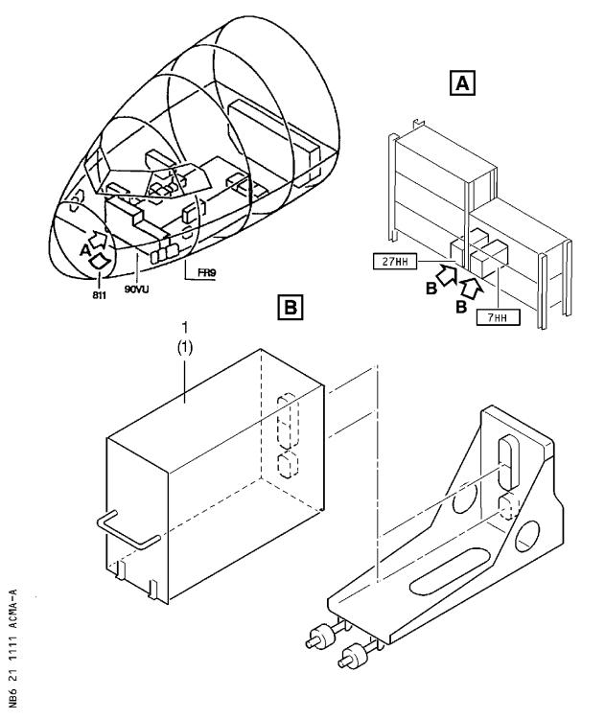

Removal and Installation of the Temperature Pack Controller (7HH and 27HH)

Figure 1 Sheet 1

DATE : Jun 15/98 SERVICE BULLETIN No . : A320-21-1111

REVISION No . : 00 -

PAGE : 6

Printed in France

***A319/A320/A321***

|  |
| --- |
|  |

SERVICE BULLETIN

3. MATERIAL INFORMATION

A . LIST OF COMPONENTS

ITEM NEW PART NO . QTY KEYWORD ITEM OLD PART NO . INT INST

DISP

1 759A0000-11 2 Packctrl (1) 759A0000-10 200 A

(A) Modification of removed pack controllers should be negotiated

directly with the vendor LIEBHERR-AEROSPACE LINDENBERG GmbH as per

instructions given in the Service Bulletin No . 759A-21-07 .

NOTE : For definition of interchangeability codes in column INT . refer to

ATA 200 Chapter IA-2 .

B . SPECIAL TOOLS

None

C . LIST OF MATERIAL - OPERATOR SUPPLIED

None

D . PARTS TO BE RE- IDENTIFIED BY OPERATOR

None

DATE : Jun 15/98 SERVICE BULLETIN No . : A320-21-1111

REVISION No . : 00 - PAGE : 7

Printed in France

***A319/A320/A321***

|  |
| --- |
|  |

|  |  |  |
| --- | --- | --- |
| FROM :  AIRLINE :   |  | | --- | | NAME : | | DATE : | |

SERVICE BULLETIN

ACCEPTANCE/REJECTION SHEET

AIRBUS INDUSTRIE

CUSTOMER SERVICES DIRECTORATE

1 Rond Point Maurice BELLONTE

31707 BLAGNAC CEDEX FRANCE

Tel: (33) 5 61-93-33-33

Telex: AIRBU 530526 F

TITLE : AIR CONDITIONING - PACK TEMPERATURE CONTROL - INTRODUCE IMPROVED PACK

TEMPERATURE CONTROLLER A-11

MODIFICATION No . :

27469K5430

ATA SYSTEM : 21

|  |  |
| --- | --- |
| IS BEING HEREWITH  Please fill : | SUBMITTED TO YOU FOR REVIEW  . . .REJECTED  . . .WILL BE EMBODIED  . . .EFFECTIVITY |

|  |
| --- |
| This SB can only be incorporated in your "customized" documentation within the agreed time schedule in so far as this sheet returned to us on purchase date and signed by a duly authorized and empowered officer or representative . |

|  |
| --- |
| Please return to :  AIRBUS INDUSTRIE  CUSTOMER SERVICES DIRECTORATE  1 Rond Point Maurice Bellonte  31707 BLAGNAC CEDEX FRANCE  Attn : AI/SE-D32 Technical Data  and Documentation Services  FAX : (+33) 5 61 93 28 06 |

6 DATE : Jun 15/98 SERVICE BULLETIN No . : A320-21-1111

REVISION No . : 00 -

PAGE : 1 of 1

Printed in France