 ***A319/A320/A321***

SERVICE BULLETIN

SUMMARY

AIRBUS INDUSTRIE

CUSTOMER SERVICES DIRECTORATE

1 Rond Point Maurice Bellonte

31707 BLAGNAC CEDEX FRANCE

Tel: (33) 5 61 93 33 33

Telex: AIRBU 530526 F

Fax : (33) 5 61 93 42 51

This summary is for information only

and is not approved for modification of the aircraft

ATA SYSTEM : 21

TITLE : AIR CONDITIONING - PACK TEMPERATURE CONTROL - INSTALL A MODIFIED PACK

CONTROLLER PN 759D0000-02

MODIFICATION No . : 28488K6156

REASON/DESCRIPTION/OPERATIONAL CONSEQUENCES

Operators have reported spurious PACK REGUL FAULT messages on the Electronic Centralized Aircraft Monitoring (ECAM) . There were no associated maintenance messages . The message occurred on aircraft with the pack controller PN 759D0000-01 .

Investigations have shown that the message is caused by an internal

communication failure between the primary and secondary channels of the pack

controller, as a result of which the primary channel is considered to be

inoperative . In all cases, the system could be reset .

Reports have also been made of repetitive pack maintenance status messages in

the PFR . Investigations have shown that this was due to the loss of altitude

signal from ADIRU 3, and flickering of the ’pack flow inop’ bit . This has no

adverse impact on the air conditioning pack operation .

This Service Bulletin introduces an improved common pack controller for A319,

A320 and A321 aircraft and advises the operators of the issue of LIEBHERR

AEROSPACE LINDENBERG Service Bulletin No . 759D-21-01 .

The modification to the pack controller includes:

- Improvement of RS232 monitoring

- Improvement of aircraft altitude- reception failure-monitoring

- Increase of watchdog test temporization

- Minor software modifications concerning BPV (Bypass Valve), PIPS (Packet Inlet

Pressure Sensor), PIFS (Pack Inlet Flow Sensor) and RAD (Ram Air Door)

L6

DATE : Jul 07/99

REVISION No . : 00 -

SERVICE BULLETIN No . : A320-21-1118

Page : 1 of 4

***A319/A320/A321***

|  |
| --- |
|  |

SERVICE BULLETIN

SUMMARY

|  |  |  |
| --- | --- | --- |
| EVALUATION TABLE |  |  |

|  |  |  |  |
| --- | --- | --- | --- |
| COMPLIANCE | Desirable | CANCELS INSPECTION SB | No |
| POTENTIAL AD | No | A/C OPERATION AFFECTED | No |
| RELIABILITY AFFECTED | Yes | PAX COMFORT AFFECTED | No |
| COST SAVING | No | ETOPS AFFECTED | No |
| STRUCTURAL LIFE EXTN | No | VENDOR SB INVOLVED | Yes |
| KIT PRICE (USD) | See SB |  |  |

EFFECTIVITY

This Service Bulletin is applicable to these operator(s) :

AEF AES AFR AIB AMM AMU ANA AUA AWE AZA BMA C3J CES CIB CJG CNW CSC CSN CTN DLH

EDW EIN EWG FIN G4I HDA IBE IWD LEI M4G MON NWA QAF QTR SAB SEU SLK SWR SYR TAI

TAM TAP TAR TAS UAL USA VIR

CONCURRENT REQUIREMENTS

None

REFERENCES/REPERCUSSIONS

|  |  |
| --- | --- |
| TFU | : 21 .61 .34 .008 |
| OEB | : None |
| AOT | : None |
| SIL | : 21-115 |
| LIFE LIMIT | : None |

LINE MAINTENANCE AFFECTED : None

OTHER : None

NATURE OF THE WORK

AIRCRAFT : NO

EQUIPMENT : YES

HARD : YES

SOFT : YES

OBRM : NO

MANPOWER

TOTAL MANHOURS

1 .25

1 .25

ELAPSED TIME (HOURS)

MATERIAL INFORMATION

AIRCRAFT DATA

None

DATE : Jul 07/99

REVISION No . : 00 -

SERVICE BULLETIN No . : A320-21-1118

Page : 2

|  |
| --- |
|  |

APPENDICES

None

***A319/A320/A321***

SERVICE BULLETIN

SUMMARY

DATE : Jul 07/99

REVISION No . : 00 -

SERVICE BULLETIN No . : A320-21-1118

Page : 3

Printed in France © Airbus Industrie 1999, All rights reserved

***A319/A320/A321***

|  |
| --- |
|  |

SERVICE BULLETIN

SUMMARY

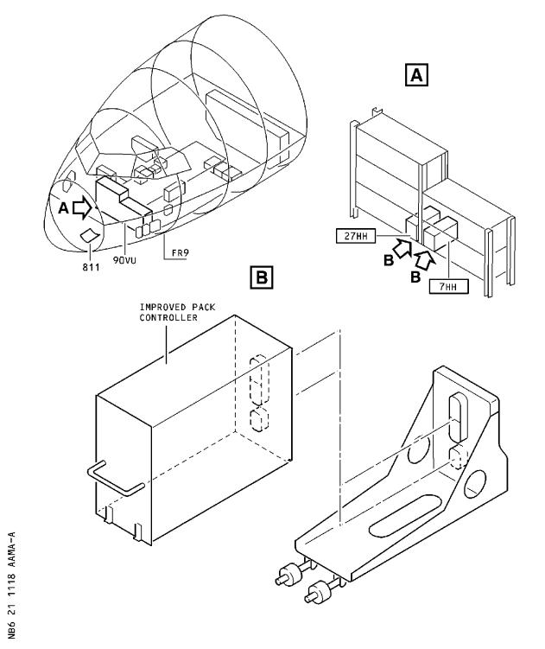

DATE : Jul 07/99

REVISION No . : 00 -

SERVICE BULLETIN No . : A320-21-1118

Page : 4

***A319/A320/A321***

|  |
| --- |
|  |

SERVICE BULLETIN

AIRBUS INDUSTRIE

CUSTOMER SERVICES DIRECTORATE

1 Rond Point Maurice Bellonte

31707 BLAGNAC CEDEX FRANCE

Tel: (33) 5 61 93 33 33

Telex: AIRBU 530526 F

Fax : (33) 5 61 93 42 51

ATA SYSTEM : 21

TITLE : AIR CONDITIONING - PACK TEMPERATURE CONTROL - INSTALL A MODIFIED PACK

CONTROLLER PN 759D0000-02

MODIFICATION No . : 28488K6156

This document contains AIRBUS INDUSTRIE PROPRIETARY INFORMATION and shall, at

all times, remain the property of AIRBUS INDUSTRIE; no intellectual property

right or licence is granted by AIRBUS INDUSTRIE in connection with any

information contained in it . It is delivered on the express condition that the

said document and the information contained in it shall be treated as

confidential, shall not be used for any purpose other than that for which it is

hereby delivered . It shall not be disclosed in whole or in part to third parties

and shall not be duplicated in any manner (except for the purposes of performing

the tasks described hereunder and provided that any recipient of such document

shall comply with the conditions herein), without AIRBUS INDUSTRIE’s prior

written consent .

1. PLANNING INFORMATION

A . EFFECTIVITY

(1) Models

319-111 319-112 319-114 319-115 319-131 319-132 319-133 320-211

320-212 320-214 320-232 320-233 321-111 321-112 321-131 321-211

321-231

(2) Aircraft

(a) Effectivity by MSN

This Service Bulletin is applicable to aircraft MSN

0844 0861 0863 0868-0869 0872 0876 0878 0880-1043 1045 1047

1049 1050 1054 1056 1057 1059 1063

(b) Effectivity by Operator

The Operator MSN relationship is provided for information only

and is correct at the time of issue in accordance with the

information available to Airbus Industrie . Any future changes

resulting from transfer of an aircraft from one operator to

another will not be reflected in this list unless the Service

Bulletin is revised for another reason .

OPERATOR MSN

AEF 0954 0990 1004

AES 0892

AFR 0938 0956 0985 0998 1000 1020 1025 1036

L6

DATE : Jul 07/99

REVISION No . : 00 -

SERVICE BULLETIN No . : A320-21-1118

Page : 1 of 10

***A319/A320/A321***

|  |
| --- |
|  |

SERVICE BULLETIN

|  |  |  |  |  |  |  |  |
| --- | --- | --- | --- | --- | --- | --- | --- |
| OPERATOR  AIB | MSN  0913 |  |  |  |  |  |  |
| AMM | 1006 |  |  |  |  |  |  |
| AMU | 0908 |  |  |  |  |  |  |
| ANA | 0963 | 1008 | 1042 |  |  |  |  |
| AUA | 0920 | 0935 |  |  |  |  |  |
| AWE | 0889 | 0924 | 0931 | 0953 | 1003 | 1043 | 1049 1050 1056 |
| AZA | 0940 | 0951 | 0959 | 0999 |  |  |  |
| BMA | 0934 | 0968 | 0974 | 1014 | 1045 |  |  |
| C3J | 0883 | 0914 |  |  |  |  |  |
| CES | 0925 | 1005 | 1028 | 1030 |  |  |  |
| CIB | 0884 | 0894 | 0905 | 0957 | 0971 |  |  |
| CJG | 0876 | 0921 |  |  |  |  |  |
| CNW | 0897 | 0909 | 0939 | 0967 | 0984 | 0986 | 1041 |
| CSC | 0878 | 0915 | 0919 | 1013 |  |  |  |
| CSN | 0881 | 0895 | 0900 | 0950 | 0966 | 1035 | 1039 1057 |
| CTN | 1009 | 1029 |  |  |  |  |  |
| DLH | 0887 | 0901 |  |  |  |  |  |
| EDW | 0942 | 0947 | 1026 |  |  |  |  |
| EIN | 0926 | 0991 | 1023 |  |  |  |  |
| EWG | 1016 |  |  |  |  |  |  |
| FIN | 0941 | 0961 |  |  |  |  |  |
| G4I | 1002 |  |  |  |  |  |  |
| HDA | 0930 | 0993 | 1024 |  |  |  |  |
| IBE | 0992 | 0994 | 1021 | 1027 | 1047 | 1059 | 1063 |
| IWD | 0888 |  |  |  |  |  |  |
| LEI | 1017 |  |  |  |  |  |  |
| M4G | 0910 |  |  |  |  |  |  |
| MON | 0983 | 1015 |  |  |  |  |  |
| NWA | 0903  1037 | 0907 | 0911 | 0923 | 0962 | 0964 | 0981 0988 0996 1011 |
| QAF | 0927 |  |  |  |  |  |  |
| QTR | 0928 | 0932 | 0943 | 0977 |  |  |  |
| SAB | 0970 | 0995 | 1012 | 1054 |  |  |  |
| SEU | 0973 |  |  |  |  |  |  |
| SLK | 0872 | 0899 | 0969 |  |  |  |  |
| SWR | 0891 | 0987 | 1018 |  |  |  |  |
| SYR | 0886 | 0918 | 1032 |  |  |  |  |
| TAI | 0902 | 0912 | 0916 | 1007 |  |  |  |
| TAM | 0976 | 1010 |  |  |  |  |  |
| TAP | 0906 | 0917 | 0933 | 0945 | 0960 | 0979 | 0982 1034 |
| TAR | 0869 | 0880 | 0958 | 0975 |  |  |  |
| TAS | 0937 |  |  |  |  |  |  |
| UAL | 0882  1001 | 0893  1022 | 0898  1031 | 0944 | 0948 | 0952 | 0955 0965 0980 0989 |

|  |  |  |  |  |  |  |  |  |  |
| --- | --- | --- | --- | --- | --- | --- | --- | --- | --- |
| USA | 0844 | 0861 | 0863 | 0868 | 0885 | 0890 | 0896 | 0904 | 0922 0929 |
|  | 0936 | 0946 | 0949 | 0972 | 0997 | 1019 | 1033 | 1038 | 1040 |

VIR 0978

(c) Effectivity by MSN and Kit/Configuration

None

DATE : Jul 07/99

REVISION No . : 00 -

SERVICE BULLETIN No . : A320-21-1118

Page : 2

***A319/A320/A321***

|  |
| --- |
|  |

SERVICE BULLETIN

(3) Spares

Pack temperature controller PN 759D0000-01 .

B . CONCURRENT REQUIREMENTS

None

C . REASON

(1) History

Operators have reported spurious PACK REGUL FAULT messages on the

Electronic Centralized Aircraft Monitoring (ECAM) . There were no

associated maintenance messages . The message occurred on aircraft

with the pack controller PN 759D0000-01 .

Investigations have shown that the message is caused by an internal

communication failure between the primary and secondary channels of

the pack controller, as a result of which the primary channel is

considered to be inoperative . In all cases, the system could be

reset .

Reports have also been made of repetitive pack maintenance status

messages in the PFR . Investigations have shown that this was due to

the loss of altitude signal from ADIRU 3, and flickering of the

’pack flow inop’ bit . This has no adverse impact on the air

conditioning pack operation .

(2) Objective/Action

This Service Bulletin is published to advise the operators of the

issue of LIEBHERR AEROSPACE LINDENBERG Service Bulletin No .

759D-21-01 which introduces the installation of an improved common

pack controller for A319, A320 and A321 aircraft .

(3) Advantages

The improvements of the pack controller consist in the following

software modifications:

- Improvement of RS232 monitoring

- Improvement of aircraft altitude- reception failure-monitoring

- Increase of watchdog test temporization

- Minor software modifications concerning BPV (Bypass Valve), PIPS

(Packet Inlet Pressure Sensor), PIFS (Pack Inlet Flow Sensor) and

RAD (Ram Air Door)

(4) Operational/Maintenance Consequences

None

D . DESCRIPTION

To accomplish this Service Bulletin it is necessary to :

(1.1D.)(1) Remove the pack controllers 7HH and 27HH .

(1.2D.)(2) Modify the pack controllers in accordance with LIEBHERR AEROSPACE

LINDENBERG Service Bulletin No . 759D-21-01 .

DATE : Jul 07/99

REVISION No . : 00 -

SERVICE BULLETIN No . : A320-21-1118

Page : 3

***A319/A320/A321***

|  |
| --- |
|  |

SERVICE BULLETIN

(1.3D.)(3) Install the modified pack controllers 7HH and 27HH .

E . COMPLIANCE

(1) Classification

Desirable

(2) Accomplishment Timescale

In accordance with operator’s maintenance schedule .

F . APPROVAL

The technical content of this Service Bulletin has been approved under

the authority of the DGAC Design Organisation Approval No . F .JA .02 .

If an aircraft listed in the effectivity has a modification or repair

embodied that is not of AIRBUS origin, and which affects the content of

this Service Bulletin, the operator is responsible for obtaining

approval by its airworthiness authority for any adaptation necessary

before incorporation of the Service Bulletin .

G . MANPOWER

This Service Bulletin is written for an aircraft in a maintenance status . The manhours/elapsed time estimates do not include the time to prepare for the modification, non-productive elapsed times or administration .

Get Access 0 .25

Removal/Installation 0 .25

Test 0.50

Close-up 0 .25

TOTAL MANHOURS 1 .25

ELAPSED TIME (HOURS) 1 .25

H . WEIGHT AND BALANCE Not changed

I . ELECTRICAL LOAD DATA

None

J . REFERENCES

Aircraft Maintenance Manual (AMM) : 12-34-24 21-61-00 21-61-34

LIEBHERR AEROSPACE LINDENBERG SB : 759D-21-01

K . PUBLICATIONS AFFECTED

Illustrated Parts Catalog (IPC) : 21-61-08 21-61-34 L . INTERCHANGEABILITY/MIXABILITY

DESCRIPTION OLD PART No . NEW PART No . INT MIXABILITY

Pack controller 759D0000-01 759D0000-02 02 YES

DATE : Jul 07/99

REVISION No . : 00 -

SERVICE BULLETIN No . : A320-21-1118

Page : 4

***A319/A320/A321***

|  |
| --- |
|  |

SERVICE BULLETIN

NOTE : For the definitions of interchangeability codes in the column

INT . refer to ATA 200 Chapter 1A-2 .

DATE : Jul 07/99

REVISION No . : 00 -

SERVICE BULLETIN No . : A320-21-1118

Page : 5

Printed in France © Airbus Industrie 1999, All rights reserved

***A319/A320/A321***

|  |
| --- |
|  |

SERVICE BULLETIN

This Page Intentionally Left Blank

DATE : Jul 07/99

REVISION No . : 00 -

SERVICE BULLETIN No . : A320-21-1118

Page : 6

Printed in France © Airbus Industrie 1999, All rights reserved

***A319/A320/A321***

|  |
| --- |
|  |

SERVICE BULLETIN

2. MATERIAL INFORMATION

A . MATERIAL - PRICE AND AVAILABILITY

(1) Material

Modification of removed equipment should be negotiated directly with LIEBHERR AEROSPACE LINDENBERG as per instructions given in Service Bulletin No . 759D-21-01 .

(2) Price and Availability

Refer to the vendor Service Bulletin No . 759D-21-01 for the

equipment modification sales terms .

B . INDUSTRY SUPPORT INFORMATION

None

C . LIST OF COMPONENTS

None

D . LIST OF MATERIALS - OPERATOR SUPPLIED

None

E . PARTS TO BE RE IDENTIFIED BY THE OPERATOR

For re- identification refer to LIEBHERR AEROSPACE LINDENBERG Service Bulletin No . 759D-21-01 .

F . TOOLING - PRICE AND AVAILABILITY

None

G . SPECIAL TOOLS

None

DATE : Jul 07/99 SERVICE BULLETIN No . : A320-21-1118

REVISION No . : 00 - Page : 7

Printed in France © Airbus Industrie 1999, All rights reserved

***A319/A320/A321***

|  |
| --- |
|  |

SERVICE BULLETIN

This Page Intentionally Left Blank

DATE : Jul 07/99

REVISION No . : 00 -

SERVICE BULLETIN No . : A320-21-1118

Page : 8

Printed in France © Airbus Industrie 1999, All rights reserved

***A319/A320/A321***

|  |
| --- |
|  |

SERVICE BULLETIN

3. ACCOMPLISHMENT INSTRUCTIONS

A . GENERAL

WARNING : MAKE SURE THAT YOU OBEY ALL THE WARNINGS AND CAUTIONS INCLUDED

IN THE REFERENCED PROCEDURES .

(1) Preparation

.aA.)(1)(a) Make sure that the aircraft is electrically grounded, (Refer to AMM 12-34-24 Page block 201) .

.bA.)(1)(b) Do the preparation (Refer to AMM 21-61-34 Page block 401) .

(2) Standard Practices

None

B . MODIFICATION

.1B.)(1) Removal and installation of pack temperature controller

Refer to Figure 1

.aB.)(1)(a) Remove the pack controllers 7HH and 27HH, (Refer to AMM

21-61-34 Page block 401) .

2 controllers 759D0000-01 Item (1 )

.bB.)(1)(b) Modify the pack controllers 7HH and 27HH, PN 759D0000-01 (Refer to LIEBHERR AEROSPACE LINDENBERG Service Bulletin No .759D-21-01) .

.cB.)(1)(c) Install the modified pack controllers 7HH and 27HH, (Refer to

AMM 21-61-34 Page block 401) .

2 controllers 759D0000-02 Item 1

C . TEST

.1C.)(1) Do the operational test, (Refer to AMM 21-61-00 Page block 501) .

D . CLOSE UP

.1D.)(1) Make sure that the work areas are clean and clear of tools and

other items of equipment .

.2D.)(2) Do the close-up (Refer to AMM 21-63-34 Page block 401) .

E . DOCUMENTATION

Write in the applicable aircraft records that you have done all the work

given in this Service Bulletin .

DATE : Jul 07/99 SERVICE BULLETIN No . : A320-21-1118

REVISION No . : 00 - Page : 9

***A319/A320/A321***

|  |
| --- |
|  |

SERVICE BULLETIN

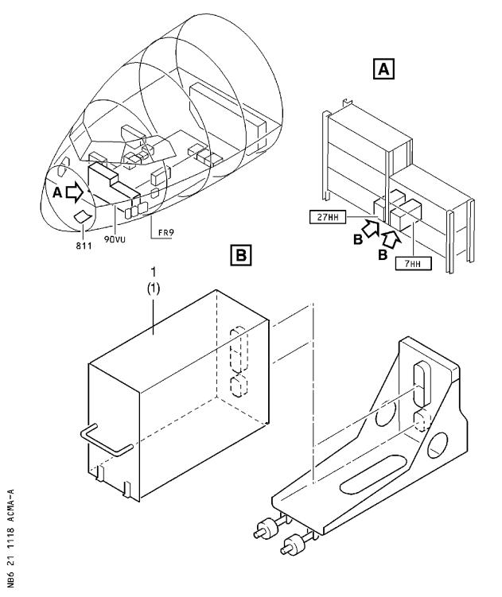

Figure 1 Sheet 1

Removal/Installation of Pack Controllers 7HH and 27HH

DATE : Jul 07/99

REVISION No . : 00 -

SERVICE BULLETIN No . : A320-21-1118

Page : 10

 ***A319/A320/A321***

SERVICE BULLETIN

REPORTING SHEET

TITLE : AIR CONDITIONING - PACK TEMPERATURE CONTROL - INSTALL A MODIFIED PACK

CONTROLLER PN 759D0000-02

MODIFICATION No . : 28488K6156

Please complete the appropriate item :

Accepted for embodiment . . . . . . . . . . .YES/NO

Embodied on MSN : . . . . . . . . . . . . . . . . . . . . . . . . . . . . . . . . .

..................................................

Rejected YES/NO

If YES, please provide

short explanation

From Airline : ..............................................................

Name/Title : ..............................................................

Signature : ..................... Date : .............

Important Information :

This SB will only be incorporated in your maintenance and operational

documentation if this sheet is returned to Airbus Industrie and signed by a duly

authorised representative . With the next feasible revision, this will result in

- updating of maintenance documentation to show pre and post SB data .

- updating of maintenance and operational documentation to show post SB data after embodiment .

If this SB requires previous or simultaneous accomplishment of other SBs, Airbus

Industrie shall automatically include them in the manual revisions . Refer to SIL 00-037 for detailed information Please return this completed sheet to :

AIRBUS INDUSTRIE

CUSTOMER SERVICES DIRECTORATE

1 Rond Point Maurice Bellonte

31707 BLAGNAC CEDEX FRANCE

Attn : AI/SE-D32 Technical Data and Documentation Services

FAX : (+33) 5 61 93 28 06

or via your Resident Customer Support Office .

Alternatively, SB lists via letters or fax are also accepted .

L6

DATE : Jul 07/99

REVISION No . : 00 -

SERVICE BULLETIN No . : A320-21-1118

Page : 1 of 1

***A319/A320/A321***

|  |
| --- |
|  |

SERVICE BULLETIN

QUALITY PERCEPTION FORM

Use this form to tell us what is your perception of the quality of this Service Bulletin . The reported data that you provide us will be used to analyse areas of difficulties and to take corrective action to further improve the quality of our Service Bulletins .

We thank you for the time you have taken in completing this form .

(Please rate on a scale of 1 to 4, with 4 being the highest score)

|  |  |  |  |  |
| --- | --- | --- | --- | --- |
| - Quality | rating of this SB | 4 3 | 2 | 1 |
| - Quality | rating of the Accomplishment Instructions | 4 3 | 2 | 1 |
| - Quality | rating of the Illustrations | 4 3 | 2 | 1 |
| - Is this | SB easy to understand ? | Y / N |  |  |

If you have had difficulties in the accomplishment of this SB please quote below

the area(s) and give a short description of the issue .

Planning

X Effectivity

X Reason

X Manpower

X References

X Publication

Comments :

Material

X Kit Content

X List of Materials

Operator Supplied

X Re- identification

X Tooling

Instructions

X Preparation

X Mod/Inspection

X Test

X Close-up

X Illustrations

Operator :

Name/Title :

Date:

Please return this form to :

AIRBUS INDUSTRIE

CUSTOMER SERVICES DIRECTORATE

1 Rond Point Maurice Bellonte

31707 BLAGNAC CEDEX

Attn : AI/SE-T1 Service Bulletins Management

FAX : (33) 5 61 93 42 51

or via your Resident Customer Support Office .

L6

DATE : Jul 07/99

REVISION No . : 00 -

SERVICE BULLETIN No . : A320-21-1118

Page : 1 of 1