@ A319/A320/A321

SERVICE BULLETIN

REVISION TRANSMITTAL SHEET

AIRBUS INDUSTRIE

CUSTOMER SERVICES DIRECTORATE

1 Rond Point Maurice Bellonte

31707 BLAGNAC CEDEX FRANCE

Tel : (33) 5 61 93 33 33

Telex : AIRBU 530526F

Fax : (33) 5 61 93 42 51

ATA SYSTEM : 21

TITLE : AIR CONDITIONING - PACK COOLING AIR CONTROL - INTRODUCE LOGIC RELAY FOR

CONTROL PACK CLOSURE AT ENGINE START .

MODIFICATION No . : 27993P5459

This page transmits Revision No . 03 of Service Bulletin No . A320-21-1121 . ADDITIONAL WORK

No additional work is required by this revision for aircraft modified by any

previous issue .

REASON

Revision 03 has been issued to update the test and the effectivity . CHANGES

PLANNING INFORMATION :

— EFFECTIVITY

. Effectivity updated .

ACCOMPLISHMENT INSTRUCTIONS :

— TESTS

. Test after the installation of the relay updated .

NOTE : Lay-out changes due to computerization of this revision are not

identified .

FILING INSTRUCTIONS

This Service Bulletin has been generated electronically and is reissued as a

complete document . Replace the complete document .

Put this Revision Transmittal Sheet in front of the Service Bulletin .

HISTORY OF PREVIOUS REVISIONS

Revision 01 was issued to change a bundle because of incorrect wire

identifications and wire terminal .

6 DATE : Nov 30/99

REVISION No . : 03 — Jan 29/03

SERVICE BULLETIN No . : A320— 21— 1121

Page : 1 of 2

Printed in FRANCE © AIRBUS INDUSTRIE, 2003 All rights reserved

@ A319/A320/A321

SERVICE BULLETIN

REVISION TRANSMITTAL SHEET

|  |  |  |  |  |
| --- | --- | --- | --- | --- |
| — 3612-0285  — 3612-0148  — 3612-0173  — 3612-0284  — 3612-0364  — 3612-1000 | on  on  on  on  on  on | aircraft  aircraft  aircraft  aircraft  aircraft  aircraft | should  should  should  should  should  should | be 2151-0285  be 2151-0148  be 2151-0173  be 2151-0284  be 2151-0364  be 3612-0100 |

The incorrect identified bundel was deleted from Kit A01 and was transfered

to the new created Kit A02 which now contains the new bundle (PN

D9000095120195) with correctly identified wires .

Config . 01 and Config . 02 were added .

Revision 02 was issued to incorporate minor changes . The revision also

includes the manhour requirements for the additional work which was added

during Revision No . 1 and to updates the effectifity .

REVISION SEQUENCE

ORIGINAL : Nov 30/99

REVISION No . : 01 — Nov 07/00

REVISION No . : 02 — Aug 22/01

REVISION No . : 03 — Jan 29/03

DATE : Nov 30/99 SERVICE BULLETIN No . : A320— 21— 1121

REVISION No . : 03 — Jan 29/03 Page : 2

Printed in FRANCE © AIRBUS INDUSTRIE, 2003 All rights reserved

@ A319/A320/A321

SERVICE BULLETIN

SUMMARY

AIRBUS INDUSTRIE

CUSTOMER SERVICES DIRECTORATE

1 Rond Point Maurice Bellonte

31707 BLAGNAC CEDEX FRANCE

Tel : (33) 5 61 93 33 33

Telex : AIRBU 530526F

Fax : (33) 5 61 93 42 51

This summary is for information only

and is not approved for modification of the aircraft

ATA SYSTEM : 21

TITLE : AIR CONDITIONING - PACK COOLING AIR CONTROL - INTRODUCE LOGIC RELAY FOR

CONTROL PACK CLOSURE AT ENGINE START .

MODIFICATION No . : 27993P5459

REASON/DESCRIPTION/OPERATIONAL CONSEQUENCES

Several operators have reported unexpected closure of both pack flow control

valves in flight . This was due to an erroneous signal from the Engine Interface

Unit (EIU) .

This Service Bulletin describes the modification to the aircraft wiring to take

into consideration the position of the Environmental Control System (ECS)

X-Bleed Valve . This will prevent the unexpected closure of both pack flow

control valves .

Accomplishment of this Service Bulletin will improve the independence of

operation of both pack-flow control valves during main engine start mode .

Furthermore, if the X-Bleed Valve is detected closed, the closure of only one

pack instead of two will be commanded by the EIU discrete signal .

This Service Bulletin has been validated before delivery on A320 aircraft MSN

0975.

|  |  |  |  |
| --- | --- | --- | --- |
| EVALUATION TABLE | | | |
| COMPLIANCE | Recommended | CANCELS INSPECTION SB | No |
| POTENTIAL AD | No | A/C OPERATION AFFECTED | Yes |
| RELIABILITY AFFECTED | No | PAX COMFORT AFFECTED | Yes |
| COST SAVING | No | ETOPS AFFECTED | Yes |
| STRUCTURAL LIFE EXTN | No | VENDOR SB INVOLVED | No |
| KIT PRICE (USD) | See SB |  |  |

EFFECTIVITY

This Service Bulletin is applicable to these customers:

6 DATE : Nov 30/99

REVISION No . : 03 — Jan 29/03

SERVICE BULLETIN No . : A320— 21— 1121

Page : 1 of 3

Printed in FRANCE © AIRBUS INDUSTRIE, 2003 All rights reserved

@ A319/A320/A321

SERVICE BULLETIN

SUMMARY

002 86Z AAR ACA ADR AEF AES AFR AIH AJM ALK AMC AMM AMU ANA AUA AWE AWW AZA BAW

BMA CES CIB CJG CNW CRX CSC CSN CTN CYP C3J C9L DLH EDW EIN EWG FIN F2I GFA G2X

G4I HDA HVN IAC IBE IWD I2L JMC KAC KZW LAJ LFR LXR MEA MON MSR MXA NWA OHY PAL

PIC QAF QTR RJA SAB SEU SHJ SHK SLK SSV SYR S2A TAI TAM TAP TAR TAS TCW TNA TWE

TWJ UAL USA VIR VKG VLE

CONCURRENT REQUIREMENTS

None

REFERENCES/REPERCUSSIONS

TFU

OEB

AOT

SIL

LIFE LIMIT

: 73 .25 .00 .019 (IAE

73.25.34.044 (CFM

: None

: None

: None

: None

Engines)

Engines)

LINE MAINTENANCE AFFECTED : None

OTHERS : None

NATURE OF THE WORK

AIRCRAFT : YES

EQUIPMENT : NO

HARD : NO

SOFT : NO

OBRM : NO

MANPOWER

Kit 211121A01R02 and Kit 211121A02R01

TOTAL MANHOURS

22 .0

18 .0

ELAPSED TIME (HOURS)

MATERIAL INFORMATION

AIRCRAFT DATA

bundle, placard set, relay

APPENDICES

None

DATE : Nov 30/99 SERVICE BULLETIN No . : A320— 21— 1121

REVISION No . : 03 — Jan 29/03 Page : 2

Printed in FRANCE © AIRBUS INDUSTRIE, 2003 All rights reserved

@ A319/A320/A321

SERVICE BULLETIN

SUMMARY

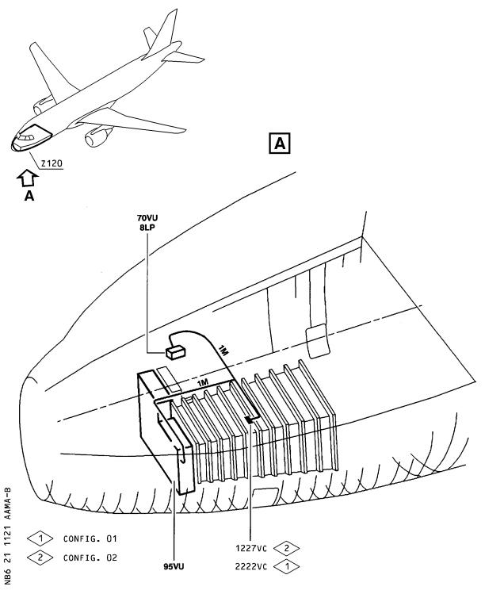

DATE : Nov 30/99 SERVICE BULLETIN No . : A320— 21— 1121

REVISION No . : 03 — Jan 29/03 Page : 3 Printed in FRANCE © AIRBUS INDUSTRIE, 2003 All rights reserved

@ A319/A320/A321

SERVICE BULLETIN

AIRBUS INDUSTRIE

CUSTOMER SERVICES DIRECTORATE

1 Rond Point Maurice Bellonte

31707 BLAGNAC CEDEX FRANCE

Tel : (33) 5 61 93 33 33

Telex : AIRBU 530526F

Fax : (33) 5 61 93 42 51

ATA SYSTEM : 21

TITLE : AIR CONDITIONING - PACK COOLING AIR CONTROL - INTRODUCE LOGIC RELAY FOR

CONTROL PACK CLOSURE AT ENGINE START .

MODIFICATION No . : 27993P5459

This document contains Airbus PROPRIETARY INFORMATION and shall at all times remain the property of Airbus; no intellectual property right or licence is granted by Airbus Industrie in connection with any information contained in it . It is delivered on the express condition that said document and the information contained in it shall be treated as confidential, shall not be used for any purpose other than that for which it is hereby delivered . It shall not be disclosed in whole or in part to third parties and shall not be duplicated in any manner (except for the purposes of performing the tasks described hereunder and provided that any recipient of such document shall comply with the conditions herein), without Airbus prior written consent .

1. PLANNING INFORMATION

A . EFFECTIVITY

(1) Models

319-111 319-112 319-113 319-114 319-115 319-131 319-132 319-133

320-111 320-211 320-212 320-214 320-231 320-232 320-233 321-111

321-112 321-131 321-211 321-231

(2) Aircraft

(a) Effectivity by MSN

This Service Bulletin is applicable to aircraft MSN :

0002-0008 0010-0014 0016-0078 0080-0104 0106-0373 0375-0432

0434-0480 0482-0535 0537-0707 0709-1020

NOTE (1) This modification is embodied before delivery on

aircraft MSN 1021 and subsequent .

NOTE (2) This Service Bulletin has been validated before

delivery on A320 aircraft MSN 0975 .

(b) Effectivity by Operator

The Operator/MSN relationship is provided for information only

and is correct at the time of issue in accordance with the

6 DATE : Nov 30/99

REVISION No . : 03 — Jan 29/03

SERVICE BULLETIN No . : A320— 21— 1121

Page : 1 of 36

Printed in FRANCE © AIRBUS INDUSTRIE, 2003 All rights reserved

@ A319/A320/A321

SERVICE BULLETIN

information available to AIRBUS . Any future changes resulting from transfer of an aircraft from one operator to another will not be reflected in this list unless the Service Bulletin is revised for another reason .

|  |  |  |  |  |  |  |  |  |  |  |
| --- | --- | --- | --- | --- | --- | --- | --- | --- | --- | --- |
| OPERATOR  002 | MSN  0588 |  |  |  |  |  |  |  |  |  |
| 86Z | 0460 |  |  |  |  |  |  |  |  |  |
| AAR | 0771 | 0855 |  |  |  |  |  |  |  |  |
| ACA | 0059 | 0068 | 0073 | 0084 | 0122 | 0126 | 0127 | 0141 | 0149 | 0150 |
|  | 0154 | 0159 | 0174 | 0175 | 0183 | 0210 | 0231 | 0232 | 0233 | 0242 |
|  | 0248 | 0253 | 0254 | 0255 | 0265 | 0277 | 0279 | 0283 | 0284 | 0290 |
|  | 0302 | 0305 | 0309 | 0310 | 0311 | 0324 | 0330 | 0333 | 0341 | 0342 |
|  | 0350 | 0359 | 0378 | 0384 | 0403 | 0404 | 0426 | 0546 | 0572 | 0634 |
|  | 0639 | 0649 | 0656 | 0670 | 0672 | 0674 | 0675 | 0682 | 0684 | 0688 |
|  | 0691 | 0693 | 0695 | 0697 | 0711 | 0719 | 0721 | 0728 | 0732 | 0736 |
|  | 0740 | 0742 | 0752 | 0757 | 0769 | 0773 | 0779 | 0785 | 0800 | 0813 |
|  | 0817 | 0829 | 0831 | 0840 | 0845 |  |  |  |  |  |
| ADR | 0043 | 0113 | 0114 |  |  |  |  |  |  |  |
| AEF | 0565  1004 | 0575 | 0580 | 0659 | 0661 | 0667 | 0787 | 0792 | 0954 | 0990 |
| AES | 0739 | 0743 | 0839 | 0892 |  |  |  |  |  |  |
| AFR | 0002 | 0003 | 0004 | 0005 | 0007 | 0010 | 0012 | 0013 | 0014 | 0016 |
|  | 0019 | 0020 | 0021 | 0033 | 0036 | 0044 | 0061 | 0062 | 0063 | 0100 |
|  | 0101 | 0102 | 0108 | 0115 | 0128 | 0129 | 0130 | 0131 | 0133 | 0144 |
|  | 0145 | 0155 | 0156 | 0184 | 0186 | 0187 | 0188 | 0203 | 0204 | 0211 |
|  | 0214 | 0215 | 0220 | 0226 | 0227 | 0228 | 0235 | 0236 | 0237 | 0239 |
|  | 0244 | 0270 | 0278 | 0285 | 0286 | 0287 | 0337 | 0352 | 0377 | 0491 |
|  | 0498 | 0509 | 0521 | 0529 | 0544 | 0598 | 0600 | 0608 | 0618 | 0625 |
|  | 0637  0998 | 0644  1000 | 0647  1020 | 0660 | 0761 | 0777 | 0796 | 0938 | 0956 | 0985 |
| AIH | 0163  0444 | 0164  0449 | 0168  0808 | 0169  0823 | 0179 | 0193 | 0230 | 0362 | 0363 | 0424 |
| AJM | 0422 | 0528 | 0624 | 0626 | 0628 | 0630 | 0666 | 0775 |  |  |
| ALK | 0304 | 0406 |  |  |  |  |  |  |  |  |
| AMC | 0112 | 0293 | 0331 |  |  |  |  |  |  |  |
| AMM | 0677 | 0781 | 0852 | 1006 | 1017 |  |  |  |  |  |
| AMU | 0550 | 0557 | 0573 | 0582 | 0620 | 0631 | 0805 | 0908 |  |  |
| ANA | 0138 | 0139 | 0148 | 0151 | 0167 | 0170 | 0196 | 0212 | 0219 | 0245 |
|  | 0300 | 0328 | 0365 | 0383 | 0413 | 0482 | 0501 | 0507 | 0531 | 0534 |
|  | 0549 | 0554 | 0658 | 0669 | 0685 | 0802 | 0811 | 0963 | 1008 |  |
| AUA | 0552 | 0570 | 0581 | 0768 | 0776 | 0797 | 0920 | 0935 |  |  |
| AWE | 0052 | 0053 | 0054 | 0055 | 0064 | 0065 | 0066 | 0067 | 0076 | 0077 |
|  | 0081 | 0082 | 0091 | 0092 | 0098 | 0099 | 0238 | 0271 | 0315 | 0317 |
|  | 0448 | 0455 | 0471 | 0527 | 0543 | 0584 | 0762 | 0770 | 0803 | 0856 |
|  | 0866 | 0889 | 0924 | 0931 | 0953 | 1003 |  |  |  |  |

DATE : Nov 30/99 SERVICE BULLETIN No . : A320— 21— 1121

REVISION No . : 03 — Jan 29/03 Page : 2

Printed in FRANCE © AIRBUS INDUSTRIE, 2003 All rights reserved

@ A319/A320/A321

SERVICE BULLETIN

|  |  |  |  |  |  |  |  |  |  |  |
| --- | --- | --- | --- | --- | --- | --- | --- | --- | --- | --- |
| OPERATOR | MSN |  |  |  |  |  |  |  |  |  |
| AWW | 0022 | 0023 | 0229 | 0397 | 0446 |  |  |  |  |  |
| AZA | 0434 | 0477 | 0488 | 0494 | 0495 | 0513 | 0514 | 0515 | 0516 | 0524 |
|  | 0526  0940 | 0532  0951 | 0576  0959 | 0583  0999 | 0586 | 0593 | 0599 | 0765 | 0819 | 0848 |
| BAW | 0006 | 0008 | 0011 | 0017 | 0018 | 0039 | 0042 | 0103 | 0109 | 0120 |
| BMA | 0806 | 0810 | 0835 | 0864 | 0934 | 0968 | 0974 | 1014 |  |  |
| C3J | 0772 | 0799 | 0828 | 0883 | 0914 | 0925 |  |  |  |  |
| C9L | 0547 | 0615 | 0622 | 0632 | 0662 |  |  |  |  |  |
| CES | 1005 |  |  |  |  |  |  |  |  |  |
| CIB | 0774 | 0793 | 0809 | 0884 | 0894 | 0905 | 0957 | 0971 |  |  |
| CJG | 0707 | 0724 | 0876 | 0921 |  |  |  |  |  |  |
| CNW | 0665 | 0754 | 0838 | 0854 | 0897 | 0909 | 0939 | 0967 | 0984 | 0986 |
| CRX | 0517 | 0519 | 0520 | 0577 | 0578 | 0585 | 0596 | 0603 | 0612 | 0621 |
|  | 0635 | 0643 | 0664 | 0673 | 0681 | 0701 | 0703 | 0713 | 0727 | 0734 |
|  | 0782 | 0827 | 0870 | 0891 | 0987 | 1018 |  |  |  |  |
| CSC | 0540 | 0551 | 0556 | 0878 | 0915 | 0919 | 1013 |  |  |  |
| CSN | 0696 | 0698 | 0704 | 0705 | 0709 | 0710 | 0712 | 0718 | 0720 | 0722 |
|  | 0849 | 0859 | 0881 | 0895 | 0900 | 0950 | 0966 |  |  |  |
| CTN | 0258 | 0767 | 0833 | 1009 |  |  |  |  |  |  |
| CYP | 0028 | 0035 | 0037 | 0038 | 0180 | 0256 | 0295 | 0316 | 0414 | 0430 |
| DLH | 0069 | 0070 | 0071 | 0072 | 0078 | 0083 | 0093 | 0104 | 0110 | 0111 |
|  | 0116 | 0117 | 0135 | 0137 | 0147 | 0161 | 0162 | 0172 | 0200 | 0201 |
|  | 0202 | 0209 | 0216 | 0217 | 0218 | 0267 | 0268 | 0269 | 0346 | 0382 |
|  | 0401 | 0412 | 0458 | 0468 | 0473 | 0474 | 0484 | 0493 | 0502 | 0505 |
|  | 0518 | 0560 | 0563 | 0564 | 0567 | 0595 | 0609 | 0610 | 0616 | 0623 |
|  | 0627 | 0636 | 0652 | 0689 | 0692 | 0694 | 0699 | 0700 | 0717 | 0723 |
|  | 0729 | 0738 | 0744 | 0853 | 0860 | 0875 | 0887 | 0901 |  |  |
| EDW | 0942 | 0947 |  |  |  |  |  |  |  |  |
| EIN | 0815 | 0841 | 0926 | 0991 |  |  |  |  |  |  |
| EWG | 0086 | 0646 | 0654 | 0794 | 1016 |  |  |  |  |  |
| F2I | 0025 | 0030 | 0140 | 0142 | 0157 | 0522 | 0533 | 0541 | 0545 | 0548 |
|  | 0553 | 0559 | 0562 | 0566 | 0574 | 0629 | 1012 |  |  |  |
| FIN | 0941 | 0961 |  |  |  |  |  |  |  |  |
| G2X | 0132 |  |  |  |  |  |  |  |  |  |
| G4I | 1002 |  |  |  |  |  |  |  |  |  |
| GFA | 0325 | 0375 | 0419 | 0421 | 0438 | 0445 | 0459 | 0466 | 0497 | 0537 |
| HDA | 0633 | 0756 | 0784 | 0812 | 0816 | 0877 | 0930 | 0993 |  |  |
| HVN | 0590  0648 | 0591  0650 | 0594 | 0597 | 0601 | 0605 | 0607 | 0611 | 0617 | 0619 |
| I2L | 0371 | 0530 | 0535 | 0542 | 0642 | 0726 |  |  |  |  |

DATE : Nov 30/99 SERVICE BULLETIN No . : A320— 21— 1121

REVISION No . : 03 — Jan 29/03 Page : 3 Printed in FRANCE © AIRBUS INDUSTRIE, 2003 All rights reserved

@ A319/A320/A321

SERVICE BULLETIN

|  |  |  |  |  |  |  |  |  |  |  |
| --- | --- | --- | --- | --- | --- | --- | --- | --- | --- | --- |
| OPERATOR | MSN |  |  |  |  |  |  |  |  |  |
| IAC | 0045 | 0046 | 0047 | 0048 | 0049 | 0050 | 0051 | 0056 | 0057 | 0058 |
|  | 0074 | 0075 | 0080 | 0089 | 0090 | 0095 | 0096 | 0097 | 0247 | 0257 |
|  | 0308 | 0314 | 0327 | 0336 | 0396 | 0398 | 0416 | 0423 | 0431 | 0432 |
|  | 0451 | 0469 | 0486 | 0490 | 0492 | 0499 |  |  |  |  |
| IBE | 0134 | 0136 | 0143 | 0146 | 0158 | 0173 | 0176 | 0177 | 0199 | 0207 |
|  | 0223  0323 | 0224  0356 | 0240  0992 | 0241  0994 | 0246 | 0264 | 0266 | 0274 | 0303 | 0312 |
| IWD | 0225 | 0879 | 0888 |  |  |  |  |  |  |  |
| JMC | 0393 | 0714 | 0716 | 0730 | 0735 |  |  |  |  |  |
| KAC | 0181 | 0182 | 0195 |  |  |  |  |  |  |  |
| KZW | 0094 | 0641 | 0651 | 0679 |  |  |  |  |  |  |
| LAJ | 0376 | 0386 | 0480 |  |  |  |  |  |  |  |
| LFA | 0313 | 0345 |  |  |  |  |  |  |  |  |
| LXR | 0191 | 0395 |  |  |  |  |  |  |  |  |
| MEA | 0640 | 0663 | 0668 | 0676 | 0760 |  |  |  |  |  |
| MON | 0379 | 0389 | 0391 | 0392 | 0983 | 1015 |  |  |  |  |
| MSR | 0165  0725 | 0166 | 0178 | 0194 | 0198 | 0351 | 0366 | 0680 | 0687 | 0715 |
| MXA | 0252 | 0259 | 0260 | 0261 | 0275 | 0276 | 0280 | 0291 | 0292 | 0296 |
|  | 0320  0415 | 0321  0428 | 0332  0467 | 0347 | 0353 | 0361 | 0368 | 0369 | 0373 | 0405 |
| NWA | 0031 | 0032 | 0034 | 0040 | 0041 | 0060 | 0106 | 0107 | 0118 | 0121 |
|  | 0125 | 0152 | 0153 | 0160 | 0171 | 0192 | 0197 | 0206 | 0208 | 0213 |
|  | 0262 | 0263 | 0272 | 0273 | 0281 | 0282 | 0297 | 0298 | 0306 | 0307 |
|  | 0318 | 0319 | 0329 | 0339 | 0340 | 0355 | 0358 | 0360 | 0367 | 0372 |
|  | 0380 | 0381 | 0387 | 0388 | 0399 | 0400 | 0408 | 0410 | 0417 | 0418 |
|  | 0766 | 0778 | 0786 | 0801 | 0807 | 0818 | 0830 | 0832 | 0846 | 0903 |
|  | 0907 | 0911 | 0923 | 0962 | 0964 | 0981 | 0988 | 0996 | 1011 |  |
| OHY | 0364 | 0385 |  |  |  |  |  |  |  |  |
| PAL | 0706 | 0745 | 0753 |  |  |  |  |  |  |  |
| PIC | 0604 | 0614 |  |  |  |  |  |  |  |  |
| QAF | 0927 |  |  |  |  |  |  |  |  |  |
| QTR | 0928 | 0932 | 0943 | 0977 |  |  |  |  |  |  |
| RJA | 0087 | 0088 | 0289 | 0407 | 0569 |  |  |  |  |  |
| S2A | 0024 | 0026 | 0027 | 0029 |  |  |  |  |  |  |
| SAB | 0970 | 0995 |  |  |  |  |  |  |  |  |
| SEU | 0653 | 0657 | 0737 | 0749 | 0973 |  |  |  |  |  |
| SHJ | 0910 |  |  |  |  |  |  |  |  |  |
| SHK | 0322 | 0326 | 0344 | 0478 |  |  |  |  |  |  |
| SLK | 0872 | 0899 | 0969 |  |  |  |  |  |  |  |

DATE : Nov 30/99 SERVICE BULLETIN No . : A320— 21— 1121

REVISION No . : 03 — Jan 29/03 Page : 4

Printed in FRANCE © AIRBUS INDUSTRIE, 2003 All rights reserved

@ A319/A320/A321

SERVICE BULLETIN

|  |  |  |  |  |  |  |  |  |  |  |
| --- | --- | --- | --- | --- | --- | --- | --- | --- | --- | --- |
| OPERATOR | MSN |  |  |  |  |  |  |  |  |  |
| SSV | 0338  0645 | 0409  0671 | 0427  0795 | 0429 | 0437 | 0447 | 0476 | 0496 | 0525 | 0579 |
| SYR | 0886 | 0918 |  |  |  |  |  |  |  |  |
| TAI | 0425  0912 | 0461  0916 | 0558  1007 | 0561 | 0733 | 0741 | 0747 | 0789 | 0874 | 0902 |
| TAM | 0243  1010 | 0249 | 0250 | 0251 | 0334 | 0335 | 0440 | 0453 | 0758 | 0976 |
| TAP | 0185 | 0234 | 0750 | 0755 | 0763 | 0790 | 0821 | 0837 | 0906 | 0917 |
|  | 0933 | 0945 | 0960 | 0979 | 0982 |  |  |  |  |  |
| TAR | 0119  0958 | 0123  0975 | 0124 | 0205 | 0370 | 0390 | 0402 | 0511 | 0869 | 0880 |
| TAS | 0814 | 0937 |  |  |  |  |  |  |  |  |
| TCW | 0354 | 0357 | 0394 | 0411 | 0443 |  |  |  |  |  |
| TNA | 0441 | 0538 | 0555 | 0602 | 0606 | 0731 | 0746 | 0791 | 0822 |  |
| TWE | 0288 | 0978 |  |  |  |  |  |  |  |  |
| TWJ | 0913 |  |  |  |  |  |  |  |  |  |
| UAL | 0435 | 0439 | 0442 | 0450 | 0452 | 0454 | 0456 | 0457 | 0462 | 0463 |
|  | 0464 | 0465 | 0470 | 0472 | 0475 | 0479 | 0483 | 0485 | 0487 | 0489 |
|  | 0500 | 0503 | 0504 | 0506 | 0508 | 0510 | 0512 | 0523 | 0539 | 0568 |
|  | 0571 | 0587 | 0589 | 0592 | 0613 | 0638 | 0655 | 0678 | 0683 | 0686 |
|  | 0690 | 0702 | 0748 | 0751 | 0759 | 0780 | 0783 | 0788 | 0798 | 0804 |
|  | 0820 | 0824 | 0825 | 0826 | 0834 | 0836 | 0842 | 0843 | 0847 | 0850 |
|  | 0851 | 0857 | 0858 | 0862 | 0865 | 0867 | 0871 | 0873 | 0882 | 0893 |
|  | 0898 | 0944 | 0948 | 0952 | 0955 | 0965 | 0980 | 0989 | 1001 |  |
| USA | 0844 | 0861 | 0863 | 0868 | 0885 | 0890 | 0896 | 0904 | 0922 | 0929 |
|  | 0936 | 0946 | 0949 | 0972 | 0997 | 1019 |  |  |  |  |
| VIR | 0764 |  |  |  |  |  |  |  |  |  |
| VKG | 0221 | 0222 | 0294 | 0299 | 0301 | 0348 | 0349 |  |  |  |
| VLE | 0085 | 0189 | 0190 | 0343 | 0420 | 0436 |  |  |  |  |

(c) Effectivity by MSN and Kit/Configuration

The kits and configurations applicable to these MSNs are given

at the end of this list:

0002-0008 0010-0014 0016-0021 0028 0031-0068 0073-0077

0080-0082 0084-0085 0087-0092 0095-0103 0106-0109 0112-0115

0118-0131

KIT No .

211121A01

211121A02

NOTE : Config . 01 21678K1694

QTY PER A/C CONFIGURATION

01

1

1

01

is valid for aircraft on which Mod . No .

(ELECTRICAL POWER - AC/DC ESSENTIAL POWER

DATE : Nov 30/99 SERVICE BULLETIN No . : A320— 21— 1121

REVISION No . : 03 — Jan 29/03 Page : 5

Printed in FRANCE © AIRBUS INDUSTRIE, 2003 All rights reserved

@ A319/A320/A321

SERVICE BULLETIN

DISTRIBUTION - PROVIDE PROVISIONS FOR ETOPS) is not

embodied .

The kits and configurations applicable to these MSNs at the end of this list:

0132-0432 0434-0480 0482-0535 0537-0707 0709-1020

are given

KIT No .

211121A01

211121A02

NOTE : Config . 02 21678K1694

QTY PER A/C CONFIGURATION

02

1

1

02

is valid for aircraft on which Mod . No .

(ELECTRICAL POWER - AC/DC ESSENTIAL POWER

DISTRIBUTION - PROVIDE PROVISIONS FOR ETOPS) is

embodied .

The kits and configurations applicable to these MSNs are given

at the end of this list:

0022-0027 0029-0030 0069-0072 0078 0083 0086 0093-0094 0104

0110-0111 0116-0117

KIT No . QTY PER A/C CONFIGURATION

211121A01

211121A02

1

1

01

02

01

02

NOTE (1) The wiring must be modified in accordance with

Config . 01 or Config . 02

Selection of Config . 01 or Config . 02 depends on

the embodiment of A320-24-1048 (Mod . No . 21678J0513,

No . 21678K1689, No . 21678K1694, No . 21678K1806, No .

21678P1731, No . 21678P1828) .

NOTE (2) Config . 01 is valid for aircraft on which Service

Bulletin No . A320-24-1048 (Mod . No . 21678J0513, No .

21678K1689, No . 21678K1694, No . 21678K1806, No .

21678P1731, No . 21678P1828) is not embodied .

NOTE (3) Config . 02 is valid for aircraft on which Service

Bulletin No . A320-24-1048 (Mod . No . 21678J0513, No .

21678K1689, No . 21678K1694, No . 21678K1806, No .

21678P1731, No . 21678P1828) is embodied .

DATE : Nov 30/99 SERVICE BULLETIN No . : A320— 21— 1121

REVISION No . : 03 — Jan 29/03 Page : 6

Printed in FRANCE © AIRBUS INDUSTRIE, 2003 All rights reserved

@ A319/A320/A321

SERVICE BULLETIN

(3) Spares

None

B . CONCURRENT REQUIREMENTS

None

C . REASON

(1) History

Several operators have reported unexpected closure of both pack

flow control valves in flight . This was due to an erroneous signal

from the Engine Interface Unit (EIU) .

(2) Objective/Action

This Service Bulletin describes the modification to the aircraft

wiring to take into consideration the position of the Environmental

Control System (ECS) X-Bleed Valve . This will prevent the

unexpected closure of both pack flow control valves .

(3) Advantages

Accomplishment of this Service Bulletin will improve the

independence of operation of both pack-flow control valves during

main engine start mode .

Furthermore, if the X-Bleed Valve is detected closed, the closure

of only one pack instead of two will be commanded by the EIU

discrete signal .

(4) Operational/Maintenance Consequences

This Service Bulletin has an operational impact . You are therefore

requested to inform AIRBUS, at least four weeks in advance, of your

intention to accomplish this Service Bulletin, in order to receive

required amendments to your operational documentation . For this

purpose, please send a fax, telex or mail to :

AI/SE-D, AIRBUS - Customer Services Directorate

Fax No . (33) 5 61 93 28 06

Sita No . TLSBP7X

E-mail sb . reporting@airbus .fr

These amendments will be confirmed by the next normal revision of

operational documentation, once your Service Bulletin

accomplishment report has been sent, as usual, to our Customer

Services Directorate (SE-D) .

DATE : Nov 30/99 SERVICE BULLETIN No . : A320— 21— 1121

REVISION No . : 03 — Jan 29/03 Page : 7

Printed in FRANCE © AIRBUS INDUSTRIE, 2003 All rights reserved

@ A319/A320/A321

SERVICE BULLETIN

D . DESCRIPTION

To accomplish this Service Bulletin it is necessary to :

(1) Kit 211121A01R02 and Kit 211121A02R01

(a) Modify the equipment and the wiring in the Shelf 95VU in the

FWD Electronics Rack 90VU .

(b) Modify the wiring between the Shelf 95VU in the FWD Electronics Rack 90VU and the Annunciator Light Test Unit 70VU .

E . COMPLIANCE

(1) Classification

Recommended

(2) Accomplishment Timescale

Accomplishment of this Service Bulletin is recommended at the

earliest opportunity where manpower and facilities are available .

F . APPROVAL

The technical content of this Service Bulletin has been approved under

the authority of the DGAC Design Organisation Approval No . F .JA .02 .

If an aircraft listed in the effectivity has a modification or repair

embodied that is not of AIRBUS origin, and which affects the content of

this Service Bulletin, the operator is responsible for obtaining

approval by its airworthiness authority for any adaptation necessary

before incorporation of the Service Bulletin .

G . MANPOWER

The manpower estimates given in this Service Bulletin are based on the

direct labor cost to do the work . These estimates assumes that the work

will be done by experienced personnel, and may need to be revised

upwards to suit operators' circumstances . The estimates do not include

the time to prepare, plan or inspect the work . Manufacture and

procurement of parts and tools, drying times for paints, sealants,

etc . . , and general administration work are also not included .

Kit 211121A01R02 and Kit 211121A02R01

Get access 1 .0

Modify equipment and 4.0

wiring in 95VU

Modify wiring between 95VU 13.0

and 70VU

Tests 3 .0

DATE : Nov 30/99 SERVICE BULLETIN No . : A320— 21— 1121

REVISION No . : 03 — Jan 29/03 Page : 8

Printed in FRANCE © AIRBUS INDUSTRIE, 2003 All rights reserved

@ A319/A320/A321

SERVICE BULLETIN

Close-up

TOTAL MANHOURS

ELAPSED TIME (HOURS)

H . WEIGHT AND BALANCE

Manufacturers Empty Weight : +0 .07 kg (+0 .15 lb)

1 .0

22 .0

18 .0

Effect on Balance

I . ELECTRICAL LOAD DATA

Not changed

: +0 .35 kgm (+2 . 55 lb .ft)

J . REFERENCES

Aircraft Maintenance Manual (AMM)

Elec . Std . Practices Manual (ESPM)

Service Bulletin

: 12-34-24 20-00-00 20-28-00

21-31-00 21-31-34 21-43-34

21- 51-00 21-61-34 24-22-33

24-38- 51 24-41-00 31-60-00

34-36-31 36-11-34 52-11-00

52-40-00 52-41-00

: 20-30-00 21- 51-10 20- 52-21

: A320-24-1048

K . PUBLICATIONS AFFECTED

Aircraft Wiring Manual (AWM)

Aircraft Schematic Manual (ASM)

Illustrated Parts Catalog (IPC)

Trouble Shooting Manual (TSM)

Aircraft Wiring Lists (AWL)

Flight Crew Operating Manual (FCOM)

Aircraft Maintenance Manual (AMM)

L . INTERCHANGEABILITY/MIXABILITY

None

: 21- 51-00 21- 51-03 21-63-07

36-12-00 36-12-02 93-00-00

93-00-95

: 21- 51-00 36-12-00

: 36-12-08

: 21-00-00

: Chapter 1-21-10 Vol . 1

: 21- 51-00

DATE : Nov 30/99 SERVICE BULLETIN No . : A320— 21— 1121

REVISION No . : 03 — Jan 29/03 Page : 9

Printed in FRANCE © AIRBUS INDUSTRIE, 2003 All rights reserved

@ A319/A320/A321

SERVICE BULLETIN

This Page Intentionally Left Blank

DATE : Nov 30/99 SERVICE BULLETIN No . : A320— 21— 1121

REVISION No . : 03 — Jan 29/03 Page : 10 Printed in FRANCE © AIRBUS INDUSTRIE, 2003 All rights reserved

@ A319/A320/A321

SERVICE BULLETIN

2. MATERIAL INFORMATION

A . MATERIAL — PRICE AND AVAILABILITY

(1) Material

Customers with aircraft shown in the effectivity of this Service

Bulletin should send a purchase order to AIRBUS . Quote the number

of this Service Bulletin . The address is :

AIRBUS

MATERIEL SUPPORT CENTER

P .O . Box 630262

22312 HAMBURG

GERMANY

(2) Price and Availability Kit 211121A01R02 and Kit 211121A02R01

Cost : * US Dollars

Availability : 150 calendar days from

* FOC - AIRBUS will make the material orders placed before Dec 31/02 .

receipt of order

available Free Of Charge for

The Kit availability given above is the standard lead time from the date of your purchase order . If you require the Kit(s) before this time, please include a retrofit planning schedule with your order so that we can try to comply with your requirements .

B . INDUSTRY SUPPORT INFORMATION

None

C . LIST OF COMPONENTS

Kit 211121A01R02

|  |  |  |  |  |  |  |  |  |  |  |
| --- | --- | --- | --- | --- | --- | --- | --- | --- | --- | --- |
| ITEM | NEW PART No . | QTY UM | KEYWORD | ITEM | OLD | PART | No . | INT | INST | DISP |

1

E0245-28A0

D9100095105695

E0250A0S

MS21042L04

NSA935401-03

NSA935401-04

NSA935401-05

NSA935401-08

1

1

1

2

105

25

80

80

Relay

PLCRDSET

Base

Nut

Tie

Tie

Tie

Tie

Kit 211121A02R01

DATE : Nov 30/99 SERVICE BULLETIN No . : A320— 21— 1121

REVISION No . : 03 — Jan 29/03 Page : 11

Printed in FRANCE © AIRBUS INDUSTRIE, 2003 All rights reserved

@ A319/A320/A321

SERVICE BULLETIN

|  |  |  |  |  |  |  |  |  |  |  |
| --- | --- | --- | --- | --- | --- | --- | --- | --- | --- | --- |
| ITEM | NEW PART No . | QTY UM | KEYWORD | ITEM | OLD | PART | No . | INT | INST | DISP |

D9000095120195 1 Bundle

D . LIST OF MATERIALS — OPERATOR SUPPLIED

None

E . PARTS TO BE RE— IDENTIFIED BY THE OPERATOR

None

F . TOOLING — PRICE AND AVAILABILITY

None

G . SPECIAL TOOLS

None

DATE : Nov 30/99 SERVICE BULLETIN No . : A320— 21— 1121

REVISION No . : 03 — Jan 29/03 Page : 12

Printed in FRANCE © AIRBUS INDUSTRIE, 2003 All rights reserved

@ A319/A320/A321

SERVICE BULLETIN

3. ACCOMPLISHMENT INSTRUCTIONS

A . GENERAL

WARNING : MAKE SURE THAT YOU OBEY ALL THE WARNINGS AND ALL THE CAUTIONS

INCLUDED IN THE REFERENCED PROCEDURES .

(1) Preparation

(a) Make sure that the aircraft is electrically grounded, (Refer

to AMM 12- 34-24 Page block 201) .

(b) Put the access platform(s) in position .

(c) Open the avionics compartment doors 811, 812, and 822, (Refer

to AMM 52-41-00 Page block 001) .

(d) Open, safety and tag these circuit breakers :

PANEL DESIGNATION FIN LOCATION

123VU GEN1/EGIU1/115VAC 23XU1 AF12

123VU GEN2/EGIU2/115VAC 23XU2 AF01

123VU GND/PWR/PROT 2XG AB07

122VU ELEC/EXT PWR/CTL 11XG X29

123VU APU GEN/EGIU2/115VAC 23XS AA08

106VU CSM/G /EV/MAN/SPLY 6XE B04

105VU ELEC/CSM/G /EV AUTO/SPLY 7XE C01

125VU BAT BUS/301PP/SPLY 11PB CC01

105VU ELEC/HOT BUS/701PP SPLY 12PB1 E01

105VU ELEC/HOT BUS/702PP SPLY 12PB2 E02

105VU ELEC/HOT BUS/701PP SPLY 5PB1 D01

105VU ELEC/HOT BUS/702PP SPLY 5PB2 D02

105VU ELEC/BAT/REF/BCL1 9PB1 AS01

105VU ELEC/BAT/REF/BCL2 9PB2 AS01

105VU FLT CTL/ELAC1/STBY SPLY 16CE1 A01

105VU FLT CTL/ELAC2/STBY/SPLY 16CE2 A02

105VU FLT CTL/SEC1/STBY SPLY 22CE B01

105VU ADIRS/ADIRU1/28VDC 6FP1 C02

105VU ELEC/STAT INV/CNTOR/CTL 14XB G02

(e) Disconnect the battery connectors (2PB1, 2PB2) before you do

this Service Bulletin, (Refer to AMM 24- 38- 51 Page block 401) .

(2) Standard Practices

(a) Put blanking caps on the disconnected electrical connectors .

(b) Do the electrical bonding, (Refer to AMM 20-28-00 Page block

201) .

DATE : Nov 30/99 SERVICE BULLETIN No . : A320— 21— 1121

REVISION No . : 03 — Jan 29/03 Page : 13

Printed in FRANCE © AIRBUS INDUSTRIE, 2003 All rights reserved

@ A319/A320/A321

SERVICE BULLETIN

(c) Obey the instructions of the wiring installation, (Refer to

ESPM 20-30-00) .

(d) After the installation or modification of electrical wires,

you must do a continuity test (Refer to ESPM 20- 52-21) .

B . MODIFICATION

(1) Kit 211121A01R02 and Kit 211121A02R01 , Config . 01

(a) Modify the equipment and the wiring in the Shelf 95VU in the

FWD Electronics Rack 90VU

Refer to figures 1 , 2 , 3 and 6

1 On aircraft

a Remove all the computers installed in the Shelf 95VU

Refer to figure 1

1

1

1

1

1

DATE : Nov 30/99

REVISION No . : 03 —

Printed

|  |  |  |  |  |  |  |
| --- | --- | --- | --- | --- | --- | --- |
| (Refer  (Refer  (Refer  (Refer  (Refer  (Refer | to  to  to  to  to  to | AMM  AMM  AMM  AMM  AMM  AMM | 34-36-31  24-22-33  36-11-34  21-31-34  21-61-34  21-43-34 | Page  Page  Page  Page  Page  Page | block  block  block  block  block  block | 401)  401)  401)  401)  401)  401) |

FIN 2RT1 (or FIN 40RT1)

ILS Receiver (or

Retain

MMR)

FIN 22XU1

EGIU

Retain

FIN 1HA1

BMC

Retain

FIN 11HL

CPC

Retain

FIN 7HH

Pack Controller

Retain

FIN 1HC (If Mod . No . 20082K0067 is embodied)

SERVICE BULLETIN No . : A320— 21— 1121

Jan 29/03 Page : 14

in FRANCE © AIRBUS INDUSTRIE, 2003 All rights reserved

@ A319/A320/A321

SERVICE BULLETIN

1 FWD Cargo Heat Retain

Controller

NOTE : You must install these computers again in ACCOMPLISHMENT INSTRUCTIONS paragraph 3.B.(1)(a)4 .

b Put blanking caps on the disconnected electrical

connectors .

c Disconnect the bonding braid .

d Remove the attachment hardware from the shelf .

NOTE : Retain the hardware .

2 Remove the Shelf 95VU and install it on the work bench

a Install the relay 7HV :

Refer to figure 1

1 Relay E0245-28A0 Item 1

1 Base E0250A0S

with :

2 Nuts MS21042L04

Adjacent to the relay, in front and at the rear of it,

bond the placard identified 7HV, supplied in :

1 Placard Set D9100095105695

b Modify the wiring in the Shelf 95VU in the FWD

Electronics Rack 90VU

Refer to figures 1 , 2 , 3 and 6

— Remove the wires shown on the lines 1 thru 6 (Refer to

figure 6) .

— Install the wires shown on the lines 11 thru 22 (Refer

to figure 6), supplied in :

Bundle D9000095120195

and route them with the wires that are on the

aircraft .

— Cut the wires to the necessary length, crimp the

terminals and connect them .

— Attach the wires with :

DATE : Nov 30/99 SERVICE BULLETIN No . : A320— 21— 1121

REVISION No . : 03 — Jan 29/03 Page : 15 Printed in FRANCE © AIRBUS INDUSTRIE, 2003 All rights reserved

@ A319/A320/A321

SERVICE BULLETIN

25 Ties-Cable NSA935401-03

25 Ties-Cable NSA935401-04

— Do a continuity test of the new electrical wires . 3 Install the Shelf 95VU on aircraft .

a Do the electrical bonding on the shelf attachment .

b Attach the Shelf 95VU and connect the bonding braid with

the hardware retained in ACCOMPLISHMENT INSTRUCTIONS

paragraph B . (1) (a) 1.

c Connect the related connectors .

4 In the Shelf 95VU, install :

|  |  |  |  |  |  |  |
| --- | --- | --- | --- | --- | --- | --- |
| (Refer  (Refer  (Refer  (Refer  (Refer  (Refer | to  to  to  to  to  to | AMM  AMM  AMM  AMM  AMM  AMM | 34-36-31  24-22-33  36-11-34  21-31-34  21-61-34  21-43-34 | Page  Page  Page  Page  Page  Page | block  block  block  block  block  block | 401)  401)  401)  401)  401)  401) |

FIN 2RT1 (or 40RT1)

1 ILS Receiver (or

MMR)

FIN 22XU1

1 EGIU

FIN 1HA1

1 BMC

FIN 11HL

1 CPC

FIN 7HH

1 Pack Controller

FIN 1HC (If Mod . No . 20082K0067 is embodied)

1 FWD Cargo Heat

Controller

DATE : Nov 30/99 SERVICE BULLETIN No . : A320— 21— 1121

REVISION No . : 03 — Jan 29/03 Page : 16

Printed in FRANCE © AIRBUS INDUSTRIE, 2003 All rights reserved

@ A319/A320/A321

SERVICE BULLETIN

NOTE : All these computers were retained at removal .

(b) Modify the wiring between the Shelf 95VU in the FWD

Electronics Rack 90VU and the Annunciator Light Test Unit 70VU

Refer to figures 2 , 3 and 6

1 Remove the wires shown on the line 7 (Refer to figure 6) .

2 Install the wires shown on the lines 23 thru 24 (Refer to

figure 6), supplied in :

Bundle D9000095120195

and route them with the wires that are in the aircraft .

3 Cut the wires to the necessary length, crimp the terminals

and connect them .

4 Attach the wires with :

80 Ties-Cable NSA935401-03

80 Ties-Cable NSA935401-05

80 Ties-Cable NSA935401-08

(2) Kit 211121A01R02 and Kit 211121A02R01 , Config . 02

(a) Modify the equipment and the wiring in the Shelf 95VU in the FWD Electronics Rack 90VU

Refer to figures 1 , 4 , 5 and 7

1 On aircraft

a Remove all the computers installed in the Shelf 95VU

Refer to figure 1

|  |  |  |  |  |  |  |
| --- | --- | --- | --- | --- | --- | --- |
| (Refer  (Refer  (Refer  (Refer  (Refer  (Refer | to  to  to  to  to  to | AMM  AMM  AMM  AMM  AMM  AMM | 34-36-31  24-22-33  36-11-34  21-31-34  21-61-34  21-43-34 | Page  Page  Page  Page  Page  Page | block  block  block  block  block  block | 401)  401)  401)  401)  401)  401) |

1

FIN 2RT1 (or FIN 40RT1)

ILS Receiver (or

MMR)

Retain

DATE : Nov 30/99 SERVICE BULLETIN No . : A320— 21— 1121

REVISION No . : 03 — Jan 29/03 Page : 17

Printed in FRANCE © AIRBUS INDUSTRIE, 2003 All rights reserved

@ A319/A320/A321

SERVICE BULLETIN

FIN 22XU1

1 EGIU Retain

FIN 1HA1

1 BMC Retain

FIN 11HL

1 CPC Retain

FIN 7HH

1 Pack Controller Retain

FIN 1HC (If Mod . No . 20082K0067 is embodied)

1 FWD Cargo Heat Retain

Controller

NOTE : You must install these computers again in ACCOMPLISHMENT INSTRUCTIONS paragraph 3.B.(2)(a)4 .

b Put blanking caps on the disconnected electrical

connectors .

c Disconnect the bonding braid .

d Remove the attachment hardware from the shelf .

NOTE : Retain the hardware .

2 Remove the Shelf 95VU and install it on the work bench

a Install the relay 7HV :

Refer to figure 1

1 Relay E0245-28A0 Item 1

1 Base E0250A0S

with :

2 Nuts MS21042L04

Adjacent to the relay, in front and at the rear of it,

bond the placard identified 7HV, supplied in :

1 Placard Set D9100095105695

b Modify the wiring in the Shelf 95VU in the FWD

Electronics Rack 90VU

DATE : Nov 30/99 SERVICE BULLETIN No . : A320— 21— 1121

REVISION No . : 03 — Jan 29/03 Page : 18 Printed in FRANCE © AIRBUS INDUSTRIE, 2003 All rights reserved

@ A319/A320/A321

SERVICE BULLETIN

Refer to figures 1 , 4 , 5 and 7

— Remove the wires shown on the lines 1 thru 6 (Refer to

figure 7) .

— Install the wires shown on the lines 11 thru 22 (Refer

to figure 7), supplied in :

Bundle D9000095120195

and route them with the wires that are on the

aircraft .

— Cut the wires to the necessary length, crimp the

terminals and connect them .

— Attach the wires with :

25 Ties-Cable NSA935401-03

25 Ties-Cable NSA935401-04

— Do a continuity test of the new electrical wires . 3 Install the Shelf 95VU on aircraft .

a Do the electrical bonding on the shelf attachment .

b Attach the Shelf 95VU and connect the bonding braid with

the hardware retained in ACCOMPLISHMENT INSTRUCTIONS

paragraph B . (2) (a) 1.

c Connect the related connectors .

4 In the Shelf 95VU, install :

|  |  |  |  |  |  |  |
| --- | --- | --- | --- | --- | --- | --- |
| (Refer  (Refer  (Refer  (Refer  (Refer  (Refer | to  to  to  to  to  to | AMM  AMM  AMM  AMM  AMM  AMM | 34-36-31  24-22-33  36-11-34  21-31-34  21-61-34  21-43-34 | Page  Page  Page  Page  Page  Page | block  block  block  block  block  block | 401)  401)  401)  401)  401)  401) |

FIN 2RT1 (or 40RT1)

1 ILS Receiver (or

MMR)

FIN 22XU1

1 EGIU

DATE : Nov 30/99 SERVICE BULLETIN No . : A320— 21— 1121

REVISION No . : 03 — Jan 29/03 Page : 19

Printed in FRANCE © AIRBUS INDUSTRIE, 2003 All rights reserved

@ A319/A320/A321

SERVICE BULLETIN

FIN 1HA1

1 BMC

FIN 11HL

1 CPC

FIN 7HH

1 Pack Controller

FIN 1HC (If Mod . No . 20082K0067 is embodied)

1 FWD Cargo Heat

Controller

NOTE : All these computers were retained at removal .

(b) Modify the wiring between the Shelf 95VU in the FWD

Electronics Rack 90VU and the Annunciator Light Test Unit 70VU

Refer to figures 4 , 5 and 7

1 Remove the wires shown on the line 7 (Refer to figure 7) .

2 Install the wires shown on the lines 23 thru 24 (Refer to

figure 7), supplied in :

Bundle D9000095120195

and route them with the wires that are in the aircraft .

3 Cut the wires to the necessary length, crimp the terminals

and connect them .

4 Attach the wires with :

80 Ties-Cable NSA935401-03

80 Ties-Cable NSA935401-05

80 Ties-Cable NSA935401-08

C . TEST

(1) Job Set-up

(a) Make sure that the electrical connectors are clean and in the

correct condition, before you connect them again, (Refer to

AMM 24- 38- 51 Page block 401) .

(b) Connect the battery connectors (2PB1, 2PB2), (Refer to AMM

24- 38- 51 Page block 401) .

(c) Close these circuit breakers :

DATE : Nov 30/99 SERVICE BULLETIN No . : A320— 21— 1121

REVISION No . : 03 — Jan 29/03 Page : 20

Printed in FRANCE © AIRBUS INDUSTRIE, 2003 All rights reserved

@ A319/A320/A321

SERVICE BULLETIN

PANEL

DESIGNATION

FIN

LOCATION

123VU

123VU

123VU

122VU

123VU

106VU

105VU

125VU

105VU

105VU

105VU

105VU

105VU

105VU

105VU

105VU

105VU

105VU

105VU

GEN1/EGIU1/115VAC

GEN2/EGIU2/115VAC

GND/PWR/PROT

ELEC/EXT PWR/CTL

APU GEN/EGIU2/115VAC

CSM/G /EV/MAN/SPLY

ELEC/CSM/G /EV AUTO/SPLY

|  |  |
| --- | --- |
| BAT BUS/301PP/SPLY  ELEC/HOT BUS/701PP  ELEC/HOT BUS/702PP  ELEC/HOT BUS/701PP  ELEC/HOT BUS/702PP  ELEC/BAT/REF/BCL1  ELEC/BAT/REF/BCL2  FLT CTL/ELAC1/STBY | SPLY  SPLY  SPLY  SPLY  SPLY |

FLT CTL/ELAC2/STBY/SPLY

FLT CTL/SEC1/STBY SPLY

ADIRS/ADIRU1/28VDC

ELEC/STAT INV/CNTOR/CTL

23XU1

23XU2

2XG

11XG

23XS

6XE

7XE

11PB

12PB1

12PB2

5PB1

5PB2

9PB1

9PB2

16CE1

16CE2

22CE

6FP1

14XB

AF12

AF01

AB07

X29

AA08

B04

C01

CC01

E01

E02

D01

D02

AS01

AS01

A01

A02

B01

C02

G02

(d) Energize the aircraft electrical circuits, (Refer to AMM

24-41-00 Page block 201) .

(e) Do the EIS start procedure, (Refer to AMM 31-60-00 Page block

201) .

(f) Make sure that the ground air supply unit is not connected to

the aircraft .

(g) On the Maintenance Panel 50VU :

— Make sure that the ON legend of the ENG/FADEC GND PWR 1(2)

push-button switch is off .

(h) On the CABIN PRESS section of the 25VU :

— Make sure that the ON legend of the DITCHING push-button

switch is off .

(i) On the center pedestal, on the ENG Panel 115VU :

— Make sure that the ENG/MASTER 1(2) control switch is set to

off .

(2) Procedure

DATE : Nov 30/99 SERVICE BULLETIN No . : A320— 21— 1121

REVISION No . : 03 — Jan 29/03 Page : 21

Printed in FRANCE © AIRBUS INDUSTRIE, 2003 All rights reserved

@ A319/A320/A321

SERVICE BULLETIN

(a) On each disconnected connector, do a visual check, connector

after connector (Refer to AMM 20-00-00), to make sure that :

(Refer to ESPM 20- 51-10)

— The label of the connector is the same as the label on the

support plate

— The connector is correctly locked .

(3) Test

(a) Do the operational test of the flow control and indicating

system, (Refer to AMM 21- 51-00 Page block 501) .

(b) Do the operational test of the pressure control and

monitoring, (Refer to AMM 21- 31-00 Page block 501) .

(c) Do the test after the removal/installation of the EGIU-1

(22XU1), (Refer to AMM 24-22- 33 Page block 401) .

(d) Do the test after the removal/installation of the ILS receiver

(2RT-1), (Refer to AMM 34- 36- 31 Page block 401)

or

Do the test after the removal/installation of the MMR

(40RT-1), (Refer to AMM 34- 36- 31 Page block 401) .

(e) Do the test after the removal/installation of the BMC (1HA-1),

(Refer to AMM 36-11- 34 Page block 401) .

(f) Do the test after the removal/installation of the cabin

pressure controller (11HL), (Refer to AMM 21- 31- 34 Page block

401) .

(g) Do the test after the removal/installation of the pack

controller (7HH), (Refer to AMM 21-61- 34 Page block 401) .

(h) If Mod . No . 20082K0067 is embodied :

Do the test after the removal/installation of the FWD cargo

heat controller (1HC), (Refer to AMM 21-43- 34 Page block 401) .

(4) Test procedure after the installation of the relay

DATE : Nov 30/99 SERVICE BULLETIN No . : A320— 21— 1121

REVISION No . : 03 — Jan 29/03 Page : 22

Printed in FRANCE © AIRBUS INDUSTRIE, 2003 All rights reserved

@ A319/A320/A321

SERVICE BULLETIN

|  |  |
| --- | --- |
| Action | Result |
| 01 . On the center pedestal, on the ENG  Panel 115VU :  - Make sure that the ENG selector  switch is in the MODE NORM position .  On the Air COND Panel 30VU :  - Push the PACK 1 and PACK 2  push-button switches . | On the Air COND Panel 30VU :  - Make sure that the FAULT legends on  the PACK 1 and PACK 2 push-button  switches are on . |
| 02. On the Center Pedestal 11VU :  - Push the BLEED push-button switch . | On the Center Pedestal 11VU :  - The light in the BLEED push-button  switch comes on (white) .  On the BLEED page of the lower ECAM  display unit :  - The pack flow control valve symbols  1 and 2 are closed and amber . |
| 03. On the Air COND Panel 30VU :  - Make sure that the X-BLEED selector  switch is in the OPEN position .  On the center pedestal, on the ENG  Panel 115VU :  - Make sure that the ENG selector  switch is in the IGN START position . | On the Center Pedestal 11VU, on the  BLEED page of the lower ECAM display  unit :  - The pack flow control valve symbols  1 and 2 are closed and green .  On the Air COND Panel 30VU :  - Make sure that the FAULT legends on  the PACK 1 and PACK 2 push-button  switches are off . |
| 04 . On the center Pedestal, on the ENG Panel 115VU :  - Make sure that the ENG selector switch is in the MODE NORM position . | On the Air COND Panel 30VU :  - Make sure that the FAULT legends on  the PACK 1 and PACK 2 push-button  switches are on .  On the Center Pedestal 11VU, on the  BLEED page of the lower ECAM display  unit :  - The pack flow control valve symbols  1 and 2 are closed and become amber  after approximately 30s . |
| 05. On the Circuit Breaker Panel 121VU:  - Open the ENGINE/ENG1/FADEC B/AND  EIU1 circuit breaker (4KS1)  On the Circuit Breaker Panel 49VU:  - Open the ENGINE/1/FADEC A/AND EIU1  circuit breaker (2KS1)  On the center pedestal, on the ENG  Panel 115VU :  - Make sure that the ENG selector  switch is in the IGN START position . | On the Center Pedestal 11VU, on the  BLEED page of the lower ECAM display  unit :  - The pack flow control valve symbols  1 and 2 are closed and green .  On the Air COND Panel 30VU :  - Make sure that the FAULT legends on  the PACK 1 and PACK 2 push-button  switches are off . |

DATE : Nov 30/99 SERVICE BULLETIN No . : A320— 21— 1121

REVISION No . : 03 — Jan 29/03 Page : 23

Printed in FRANCE © AIRBUS INDUSTRIE, 2003 All rights reserved

@ A319/A320/A321

SERVICE BULLETIN

|  |  |
| --- | --- |
| Action | Result |
| 06. On the Air COND Panel 30VU :  - Make sure that the X-BLEED selector  switch is in the SHUT position .  On the center pedestal, on the ENG  panel 115VU :  - Reset the ENG selector switch (set  the selector to NORM then to IGN  START) . | On the Air COND Panel 30VU :  - Make sure that the FAULT legend on  the PACK 1 push-button switch is on .  On the Center Pedestal 11VU, on the  BLEED page of the lower ECAM display  unit :  - The pack flow control valve symbol 1  is closed and becomes amber  immediately .  - The pack flow control valve symbol 2  is closed and becomes amber after  approximately 30s . |
| 07. On the Air COND Panel 30VU :  - Make sure that the X-BLEED selector  switch is in the OPEN position .  On the center pedestal, on the ENG  Panel 115VU :  - Reset the ENG selector switch (set  the selector to NORM then to IGN  START) . | On the Center Pedestal 11VU, on the  BLEED page of the lower ECAM display  unit :  - The pack flow control valve symbols  1 and 2 are closed and green .  On the Air COND Panel 30VU :  - Make sure that the FAULT legends on  the PACK 1 and PACK 2 push-button  switches are off . |
| 08. On the Circuit Breaker Panel 49VU  or 122VU:  - Open the AIR BLEED/X FEED VALVE/BAT  circuit breaker (2HV) .  On the center pedestal, on the ENG  Panel 115VU :  - Reset the ENG selector switch (set  the selector to NORM then to IGN  START) . | On the Air COND Panel 30VU :  - Make sure that the FAULT legend on  the PACK 1 push-button switch is on .  On the Center Pedestal 11VU, on the  BLEED page of the lower ECAM display  unit :  - The pack flow control valve symbol 1  is closed and becomes amber  immediately .  - The pack flow control valve symbol 2  is closed and becomes amber after  approximately 30s . |
| 09. On the Circuit Breaker Panel 49VU  or 122VU:  - Close the AIR BLEED/X FEED VALVE/BAT  circuit breaker (2HV) .  On the center pedestal, on the ENG  Panel 115VU :  - Reset the ENG selector switch (set  the selector to NORM then to IGN  START) . | On the Center Pedestal 11VU, on the  BLEED page of the lower ECAM display  unit :  - The pack flow control valve symbols  1 and 2 are closed and green .  On the Air COND Panel 30VU :  - Make sure that the FAULT legends on  the PACK 1 and PACK 2 push-button  switches are off . |

DATE : Nov 30/99 SERVICE BULLETIN No . : A320— 21— 1121

REVISION No . : 03 — Jan 29/03 Page : 24

Printed in FRANCE © AIRBUS INDUSTRIE, 2003 All rights reserved

@ A319/A320/A321

SERVICE BULLETIN

|  |  |
| --- | --- |
| Action | Result |
| 10 . On the center pedestal, on the ENG Panel 115VU :  - Make sure that the ENG selector switch is in the MODE NORM position . | On the Air COND Panel 30VU :  - Make sure that the FAULT legends on  the PACK 1 and PACK 2 push-button  switches come on after after  approximately 30s .  On the Center Pedestal 11VU, on the  BLEED page of the lower ECAM display  unit :  - The pack flow control valve symbols  1 and 2 are closed and become amber  after approximately 30s . |
| 11. On the Circuit Breaker Panel 121VU:  - Close the ENGINE/ENG1/FADEC B/AND  EIU1 circuit breaker (4KS1) .  On the Circuit Breaker Panel 49VU:  - Close the ENGINE/1/FADEC A/AND EIU1  circuit breaker (2KS1) .  - Open the ENGINE/2/FADEC A/AND EIU2  circuit breaker (2KS2) .  On the center pedestal, on the ENG  Panel 115VU :  - Make sure that the ENG selector  switch is in the IGN START position . | On the Center Pedestal 11VU, on the  BLEED page of the lower ECAM display  unit :  - The pack flow control valve symbols  1 and 2 are closed and green .  On the Air COND Panel 30VU :  - Make sure that the FAULT legends on  the PACK 1 and PACK 2 push-button  switches are off . |
| 12. On the Air COND Panel 30VU :  - Make sure that the X-BLEED selector  switch is in the SHUT position .  On the center pedestal, on the ENG  Panel 115VU :  - Reset the ENG selector switch (set  the selector to NORM then to IGN  START) . | On the Center Pedestal 11VU, on the  BLEED page of the lower ECAM display  unit :  - The pack flow control valve symbol 2  is closed and becomes amber  immediately .  - The pack flow control valve symbol 1  is closed and becomes amber after  approximately 30s .  On the Air COND Panel 30VU :  - Make sure that the FAULT legends on  the PACK 2 push-button switch are on . |

DATE : Nov 30/99 SERVICE BULLETIN No . : A320— 21— 1121

REVISION No . : 03 — Jan 29/03 Page : 25

Printed in FRANCE © AIRBUS INDUSTRIE, 2003 All rights reserved

@ A319/A320/A321

SERVICE BULLETIN

|  |  |
| --- | --- |
| Action | Result |
| 13. On the Air COND Panel 30VU :  - Make sure that the X-BLEED selector  switch is in the OPEN position .  On the center pedestal, on the ENG  Panel 115VU :  - Reset the ENG selector switch (set  the selector to NORM then to IGN  START) . | On the Center Pedestal 11VU, on the  BLEED page of the lower ECAM display  unit :  - The pack flow control valve symbol 1  is closed and becomes green  immediately .  - The pack flow control valve symbol 2  is closed and becomes green .  On the Air COND Panel 30VU :  - Make sure that the FAULT legends on  the PACK 1 and PACK 2 push-button  switches are off . |
| 14 . On the center pedestal, on the ENG  Panel 115VU :  - Make sure that the ENG selector  switch is in the MODE NORM position .  On the Circuit Breaker Panel 49VU:  - Close the ENGINE/2/FADEC A/AND EIU2  circuit breaker (2KS) .  On the Air COND Panel 30VU :  — Make sure that the X-BLEED selector  switch is in the AUTO position . |  |

D . CLOSE UP

(1) Make sure that the work areas are clean and clear of tools and

other items of equipment .

(2) Close the avionics doors 811, 812 and 822, (Refer to AMM 52-41-00

Page block 1) .

(3) Remove the access platform(s) .

(4) Restore the systems and the aircraft to normal operating condition .

E . DOCUMENTATION

Write in the applicable aircraft records that you have done all the work

given in this Service Bulletin .

DATE : Nov 30/99 SERVICE BULLETIN No . : A320— 21— 1121

REVISION No . : 03 — Jan 29/03 Page : 26

Printed in FRANCE © AIRBUS INDUSTRIE, 2003 All rights reserved

@ A319/A320/A321

SERVICE BULLETIN

Figure 1 Sheet 1

Modify the Equipment in the Shelf 95VU in the FWD Electronics Rack 90VU

(Goto A3 section)

DATE : Nov 30/99 SERVICE BULLETIN No . : A320— 21— 1121

REVISION No . : 03 — Jan 29/03 Page : 27

Printed in FRANCE © AIRBUS INDUSTRIE, 2003 All rights reserved

@ A319/A320/A321

SERVICE BULLETIN

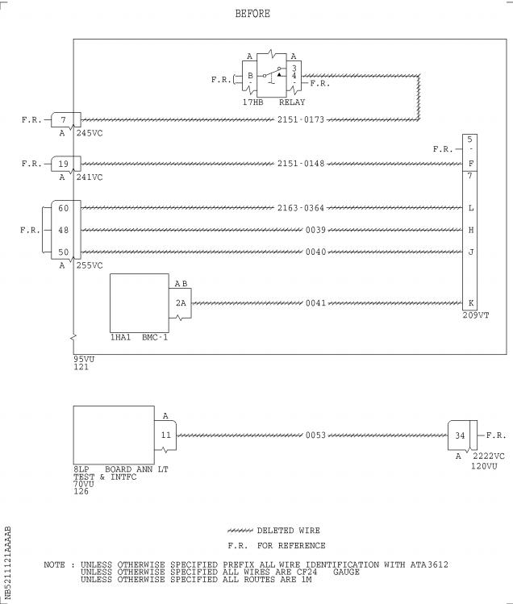

Figure 2 Sheet 1

Modify the Wiring in the Shelf 95VU in the FWD Electronics Rack 90VU

(Config . 01)

DATE : Nov 30/99 SERVICE BULLETIN No . : A320— 21— 1121

REVISION No . : 03 — Jan 29/03 Page : 29

Printed in FRANCE © AIRBUS INDUSTRIE, 2003 All rights reserved

@ A319/A320/A321

SERVICE BULLETIN

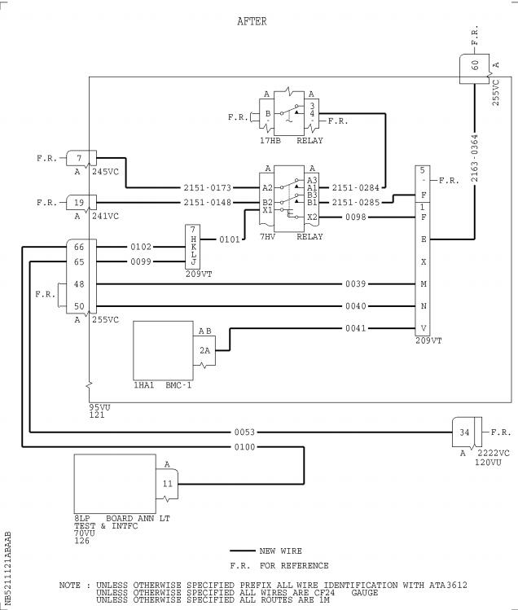

Figure 3 Sheet 1

Modify the Wiring between the 95VU and the 70VU (Config . 01)

DATE : Nov 30/99 SERVICE BULLETIN No . : A320— 21— 1121

REVISION No . : 03 — Jan 29/03 Page : 30 Printed in FRANCE © AIRBUS INDUSTRIE, 2003 All rights reserved

@ A319/A320/A321

SERVICE BULLETIN

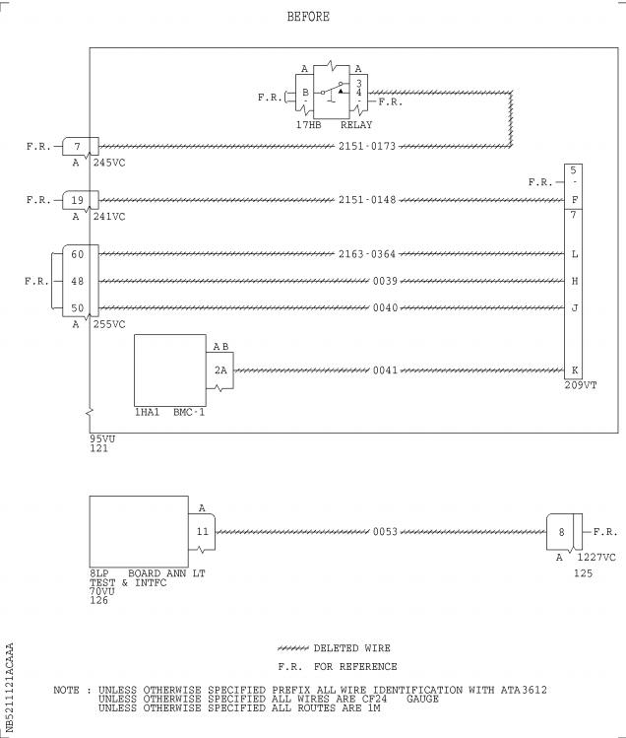

Figure 4 Sheet 1

Modify the Wiring in the Shelf 95VU in the FWD Electronics Rack 90VU

(Config . 02)

DATE : Nov 30/99 SERVICE BULLETIN No . : A320— 21— 1121

REVISION No . : 03 — Jan 29/03 Page : 31 Printed in FRANCE © AIRBUS INDUSTRIE, 2003 All rights reserved

@ A319/A320/A321

SERVICE BULLETIN

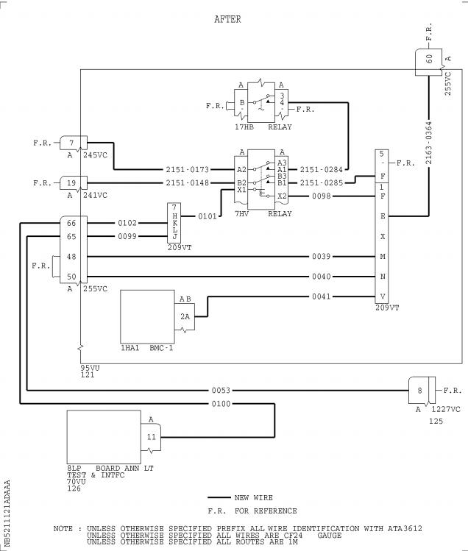

Figure 5 Sheet 1

Modify the Wiring between the 95VU and the 70VU (Config . 02)

DATE : Nov 30/99 SERVICE BULLETIN No . : A320— 21— 1121

REVISION No . : 03 — Jan 29/03 Page : 32 Printed in FRANCE © AIRBUS INDUSTRIE, 2003 All rights reserved

@ A319/A320/A321

SERVICE BULLETIN

Figure 6 Sheet 1

Hook-Up Chart (Config . 01)(Goto A3 section)

DATE : Nov 30/99 SERVICE BULLETIN No . : A320— 21— 1121

REVISION No . : 03 — Jan 29/03 Page : 33 Printed in FRANCE © AIRBUS INDUSTRIE, 2003 All rights reserved

@ A319/A320/A321

SERVICE BULLETIN

Figure 7 Sheet 1

Hook-Up Chart (Config . 02)(Goto A3 section)

DATE : Nov 30/99 SERVICE BULLETIN No . : A320— 21— 1121

REVISION No . : 03 — Jan 29/03 Page : 35 Printed in FRANCE © AIRBUS INDUSTRIE, 2003 All rights reserved

@ A319/A320/A321

SERVICE BULLETIN

REPORTING SHEET

TITLE : AIR CONDITIONING - PACK COOLING AIR CONTROL - INTRODUCE LOGIC RELAY FOR

CONTROL PACK CLOSURE AT ENGINE START .

MODIFICATION No . : 27993P5459

Please complete the appropriate item (A or B):

A - SB WILL BE embodied . . . . . . . . . . . . . YES/NO (if NO please comment)

If YES, aircraft concerned (as per SB effectivity by default) and planned dates

(month/year) of embodiment : . . . . . . . . . . . . . . . . . . . . . . . . . .

. . . . . . . . . . . . . . . . . . . . . . . . . . . . . . . . . . . . . . . .

. . . . . . . . . . . . . . . . . . . . . . . . . . . . . . . . . . . . . . . .

B - SB HAS BEEN embodied on aircraft : . . . . . . . . . . . . . . . . . . . . .

. . . . . . . . . . . . . . . . . . . . . . . . . . . . . . . . . . . . . . . .

. . . . . . . . . . . . . . . . . . . . . . . . . . . . . . . . . . . . . . . .

Operator comments : . . . . . . . . . . . . . . . . . . . . . . . . . . . . . .

. . . . . . . . . . . . . . . . . . . . . . . . . . . . . . . . . . . . . . .

. . . . . . . . . . . . . . . . . . . . . . . . . . . . . . . . . . . . . . .

From Airline : . . . . . . . . . . . . . . . . . . . . . . . . . . . . . . . . .

Name/Title : . . . . . . . . . . . . . . . . . . . . . . . . . . . . . . . . . .

Signature : . . . . . . . . . . . . . . Date : . . . . . . . . . . . . .

If operational documentation is affected (see Paragraph 1 .K of this SB): If information is needed prior to next normal revision or prior to SB embodiment, please indicate required service(s):

Either: Advance Data . . . . . . . . . . . . . . . . . . . . . YES/NO

Or : Intermediate/Temporary revision . . . . . . . . . . . . YES/NO

Important Information: This SB will only be incorporated in your maintenance and

operational documentation if this sheet is returned to Airbus Industrie and

signed by a duly authorised representative . With the next feasible revision,

this will result in

- updating of maintenance documentation to show pre and post SB data .

- updating of maintenance and operational documentation to show post SB data

after embodiment .

If this SB requires previous or simultaneous accomplishment of other SBs, Airbus

Industrie shall automatically include them in the manual revisions . Refer to SIL

00-037 for detailed information .

Please return this completed sheet to:

AIRBUS INDUSTRIE

CUSTOMER SERVICES DIRECTORATE

1 Rond Point Maurice Bellonte

31707 BLAGNAC CEDEX FRANCE

Attn: AI/SE-D32 Technical Data and Documentation Services

FAX: (+33) 5 61 93 28 06

or via your Resident Customer Support Office .

Alternatively, SB lists via letters or fax are also accepted .

6 DATE : Nov 30/99

REVISION No . : 03 — Jan 29/03

SERVICE BULLETIN No . : A320— 21— 1121

Page : 1 of 1

Printed in FRANCE © AIRBUS INDUSTRIE, 2003 All rights reserved

@ A319/A320/A321

SERVICE BULLETIN

QUALITY PERCEPTION FORM

Use this form to tell us what is your perception of the quality of this Service Bulletin . The reported data that you provide us will be used to analyse areas of difficulties and to take corrective action to further improve the quality of our Service Bulletins .

We thank you for the time you have taken in completing this form .

(Please rate on a scale of 1 to 4, with 4 being the highest score)

|  |  |  |  |
| --- | --- | --- | --- |
| - Quality rating of this SB | 4 3 | 2 | 1 |
| - Quality rating of the Accomplishment Instructions | 4 3 | 2 | 1 |
| - Quality rating of the Illustrations | 4 3 | 2 | 1 |
| - Is this SB easy to understand ? | Y / N |  |  |

If you have had difficulties in the accomplishment of this SB please quote below

the area(s) and give a short description of the issue .

Planning

X Effectivity

X Reason

X Manpower

X References

X Publication

Comments :

Material

X Kit content

X List of Materials

Operator Supplied

X Re-identification

X Tooling

Instructions

X Preparation

X Mod/Inspection

X Test

X Close-Up

X Illustrations

Operator :

Date:

Name/Title :

Please return this form to :

AIRBUS INDUSTRIE

CUSTOMER SERVICES DIRECTORATE

1 Rond Point Maurice Bellonte

31707 BLAGNAC

Attn : AI/SE-T1 Service Bulletins Management

FAX : (33) 5 61 93 42 51

Or via your Resident Customer Support Office .

6 DATE : Nov 30/99

REVISION No . : 03 — Jan 29/03

SERVICE BULLETIN No . : A320— 21— 1121

Page : 1 of 1

Printed in FRANCE © AIRBUS INDUSTRIE, 2003 All rights reserved

@ A319/A320/A321

SERVICE BULLETIN

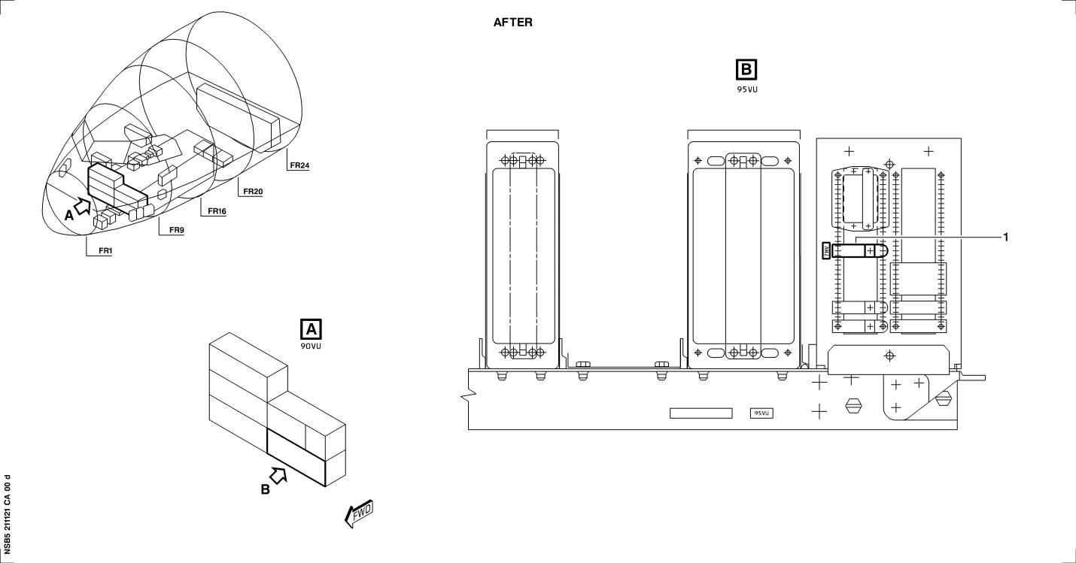

Figure 1 Sheet 1

Modify the Equipment in the Shelf 95VU in the FWD Electronics Rack 90VU

DATE : Nov 30/99

REVISION No . : 03 — Jan 29/03

SERVICE BULLETIN No . : A320— 21— 1121

Page : 27/28

Printed in FRANCE © AIRBUS INDUSTRIE, 2003 All rights reserved

@ A319/A320/A321

SERVICE BULLETIN

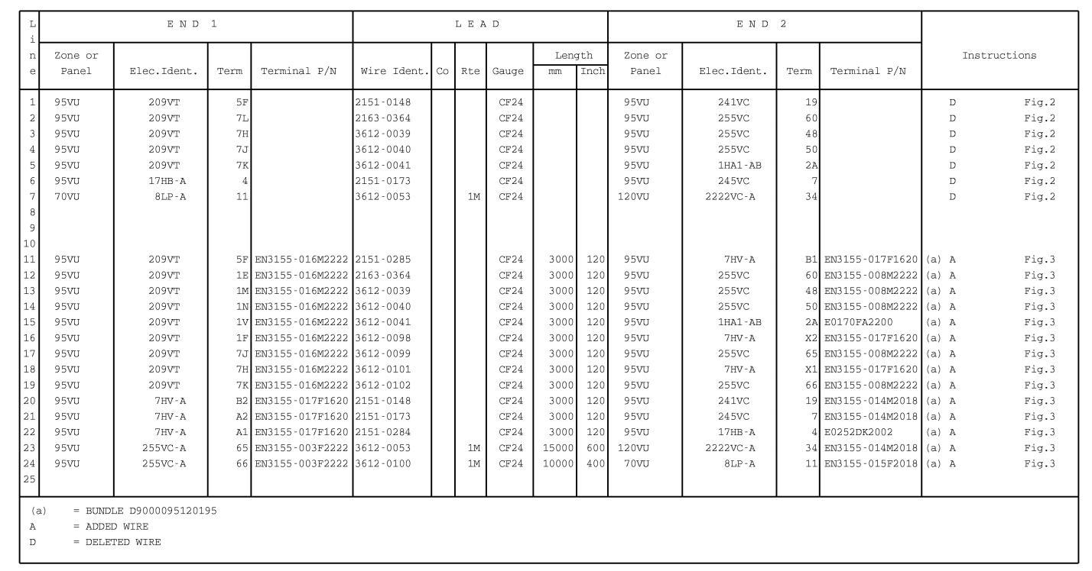

Figure 6 Sheet 1

Hook-Up Chart (Config . 01)

DATE : Nov 30/99

REVISION No . : 03 — Jan 29/03

SERVICE BULLETIN No . : A320— 21— 1121

Page : 33/34

Printed in FRANCE © AIRBUS INDUSTRIE, 2003 All rights reserved

@ A319/A320/A321

SERVICE BULLETIN

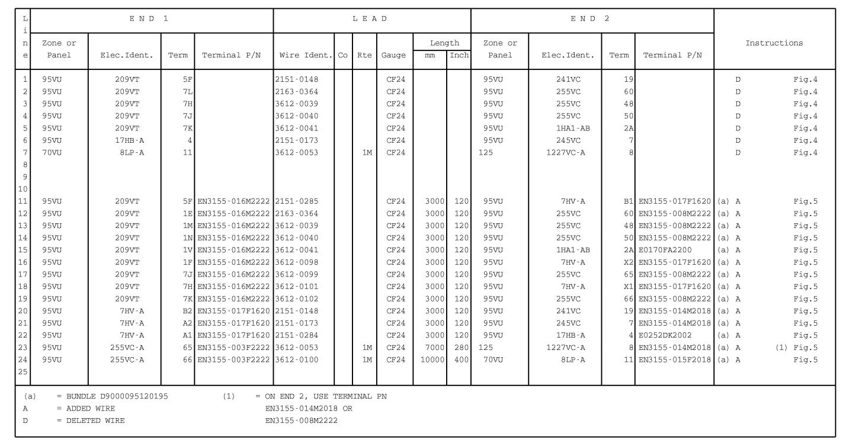

Figure 7 Sheet 1

Hook-Up Chart (Config . 02)

DATE : Nov 30/99

REVISION No . : 03 — Jan 29/03

SERVICE BULLETIN No . : A320— 21— 1121

Page : 35/36

Printed in FRANCE © AIRBUS INDUSTRIE, 2003 All rights reserved