***A319/A320/A321***

|  |
| --- |
|  |

SERVICE BULLETIN

REVISION TRANSMITTAL SHEET

AIRBUS INDUSTRIE

CUSTOMER SERVICES DIRECTORATE

1 Rond Point Maurice Bellonte

31707 BLAGNAC CEDEX FRANCE

Tel: (33) 5 61 93 33 33

Telex: AIRBU 530526 F

Fax : (33) 5 61 93 42 51

ATA SYSTEM : 21

TITLE : AIR CONDITIONING − PRESSURE CONTROL AND MONITORING − REPLACE THE

SUPPORT BRACKETS FOR THE OUTFLOW VALVE 10HL

MODIFICATION No . : 30421K6790

This page transmits Revision No . 01 of Service Bulletin No . A320−21−1125 .

ADDITIONAL WORK

No additional work is required by this revision for aircraft modified by any

previous issue .

REASON

This Revision has been issued to correct the details showing the hole

diameters at Figure 1, Sheet 3.

CHANGES

ACCOMPLISHMENT INSTRUCTIONS

− Illustration, Figure 1, Sheet 3, hole diameters revised .

NOTE : Layout changes due to computerization of this revision are not

identified .

FILING INSTRUCTIONS

This Service Bulletin has been generated electronically and is reissued as a

complete document . Replace the complete document .

Put this Revision Transmittal Sheet in front of the Service Bulletin .

HISTORY OF PREVIOUS REVISIONS

No previous revision .

REVISION SEQUENCE

ORIGINAL : Oct 25/00

REVISION No . : 01 − Jan 25/01

L6

DATE : Oct 25/00

REVISION No . : 01 − Jan 25/01

SERVICE BULLETIN No . : A320−21−1125

Page : 1 of 1

 ***A319/A320/A321***

2Eb^TCE Bn「「ElT/

2nNNVb人

VTbBn2 T/Dn2lbTE

Cn2l0NEb 2Eb^TCE2 DTbECl0bVlE

J bouq bo事u上 N9nL事cG BG((ou上G

2JS0S B「Ve/VC CEDEX EbV/CE

lG(: (22) 2 QJ o2 22 22

lG(Gx: VTbBn 2202sQ E

E9x : (22) 2 QJ o2 (s 2J

lp事2 2nuu9L入 事2 +oL 事u+oLu9上事ou ou(入

9uq 事2 uo上 9bbLo^Gq +oL uoq事+事c9上事ou o+ 上pG 9事LcL9+上 VlV 2人2lEN : sJ

lTl「E : VTb C0/DTlT0/T/e – bbE22nbE C0/lb0「 V/D N0/Tl0bT/e – bEb「VCE lHE

2nbb0bl BbVCKEl2 E0b lHE 0nlE「0N ^V「^E J0H「

N0DTETCVlT0/ /o . : 20(sJKQSo0

bEV20/\DE2CbTblT0/\0bEbVlT0/V「 C0/2EGnE/CE2

V a9b c9u LGu9事u 9+上GL 上pG 事u2上9((9上事ou o+ 上pG on上+(oN ^9(^G J0H「 上o 上pG +事xGq 2nbboL上 pL9ckG上2 . lp事2 a9b con(q (G9q 上o 上Gu2事ou . Vu入 a9b p92 pGGu p9(9ucGq p入 N92pGL2 事u 上pG bLoqnc上事ou (事uG pG+oLG qG(事^GL入 o+ 上pG 9事LcL9+上 .

Vu入 上Gu2事ou c9u (G9q 上o 9 qG+oLu9上事ou o+ 上pG ^9(^G +L9uG 9uq con(q 9++Gc上 上pG

事u上GaL事上入 o+ 上pG 9n上o uo上oL2 J0H「 –2 9uq J0H「 –( . T+ qG+oLu9上事ou occnL2 事上 N事(( ou(入 9++Gc上 上pG on上+(oN ^9(^G J0H「、 b/ s0So0–0JVV、 pn上 uo上 上pG 9q?9cGu上 9事L+L9uG 2上Lnc上nLG . T+ 上pG ^9(^G +L9uG 事2 qG+oLuGq、 上pG (G9k9aG L9上G qnL事ua 上pG +n2G(9aG bLG22nL事S9上事ou 上G2上 N事(( pG p事apGL 上p9u uoLu9( .

lp事2 2GL^事cG Bn((G上事u qG上9事(2 上pG NoLk uGcG229L入 上o LGb(9cG 上pG +事xGq pL9ckG上2 p入 9q?n2上9p(G pL9ckG上2 .

lpG 9q?n2上9p(G pL9ckG上2 N事(( bLG^Gu上 9u入 a9b2 上o pG p9(9ucGq 9uq N事(( u9kG 上pG 事u2上9((9上事ou o+ 上pG on上+(oN ^9(^G G92事GL .

lpG Gupoq事uGu上 o+ 上p事2 uoq事+事c9上事ou N事(( u9kG 9u入 +n上nLG LGb(9cGuGu上 o+ 上pG on上+(oN ^9(^G J0H「 G92事GL .

|  |  |  |  |
| --- | --- | --- | --- |
| E^V「nVlT0 | | / lVB「E |  |
| C0Nb「TV/CE | DG2事L9p(G | CV/CE「2 T/2bEClT0/ 2B | /o |
| b0lE/lTV「 VD | /o | V\C 0bEbVlT0/ VEEEClED | /o |
| bE「TVBT「Tl人 VEEEClED | /o | bVX C0NE0bl VEEEClED | /o |
| C02l 2V^T/e | /o | El0b2 VEEEClED | /o |
| 2lbnClnbV「 「TEE EXl/ | /o | ^E/D0b 2B T/^0「^ED | /o |
| KTl bbTCE (n2D) | Jo0 |  |  |

|  |  |  |  |  |  |  |  |  |  |  |  |  |
| --- | --- | --- | --- | --- | --- | --- | --- | --- | --- | --- | --- | --- |
| EEEEClT^Tl人  lp事2 2GL^事cG Bn((G上事u 事2 9bb(事c9p(G VVV VVb VCV VDb VEE VE「 VE2 VEb VTH BNV BXT C21 CD/ CE2 CTB C1e CNN C/N e(T eB「 eEV HDV H^/ TVC TBE TND Ts「 N2b NXV /NV 0H人 0人C 0sX bV「 GVE Glb lVT lVN lVb lVb lV2 l/V lbS lN1 nV「 | 上o 上pG2G obGL9上oL(2) :   |  |  |  |  |  |  |  | | --- | --- | --- | --- | --- | --- | --- | | V1N  C2C  1Bn  b1V  n2V | V「K C2/ 1NC b人/ ^Tb | VNC  Cl/  KVC  2VV  ^「E | VNN C人b 「V1 2VB Nel | VNn  DC2  「Bl  2En | V/V  D「H  「EV  2H1 | VnV  EDN  「bC  2HK | | VNE  ET/  「ln  2「K | VSV  ENe  「Xb  22^ | BVN  ET/  NEV  2Nb | BE2 ElT N0/ 2人b |

「Q

DVlE : 0c上 s2\00

bE^T2T0/ /o . : 0J – 19u s2\0J

2Eb^TCE Bn「「ElT/ /o . : V2s0–sJ– JJs2

b9aG : J o+ 2

|  |
| --- |
|  |

CONCURRENT REQUIREMENTS None

REFERENCES/REPERCUSSIONS

***A319/A320/A321***

SERVICE BULLETIN

SUMMARY

TFU

OEB

AOT

SIL

LIFE LIMIT

: None

: None

: None

: None

: None

LINE MAINTENANCE AFFECTED : None

OTHER : None

NATURE OF THE WORK

Kit 211125D01

AIRCRAFT : YES

EQUIPMENT : NO

HARD : NO

SOFT : NO

OBRM : NO

MANPOWER

Kit 211125D01

TOTAL MANHOURS

7 .25

5 .0

ELAPSED TIME (HOURS)

MATERIAL INFORMATION

AIRCRAFT DATA

Brackets and related attachment components and hardware .

APPENDICES

None

DATE : Oct 25/00

REVISION No . : 01 − Jan 25/01

SERVICE BULLETIN No . : A320−21−1125

Page : 2

Printed in France © Airbus Industrie 2000, All rights reserved

***A319/A320/A321***

|  |
| --- |
|  |

SERVICE BULLETIN

SUMMARY

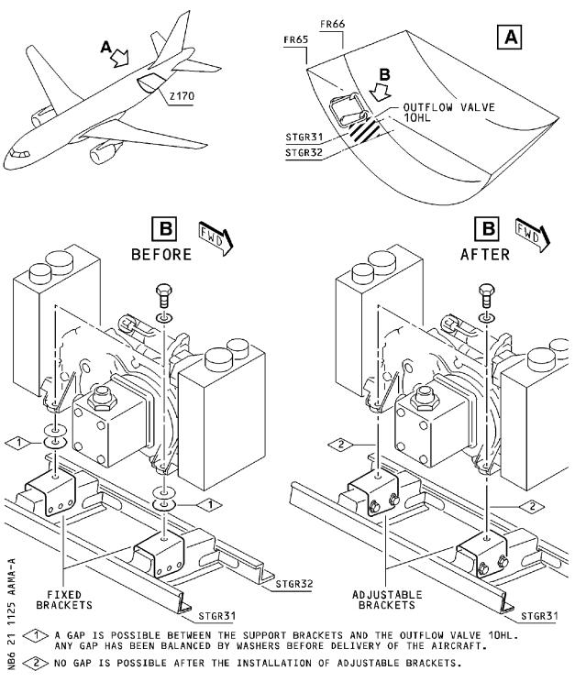

DATE : Oct 25/00

REVISION No . : 01 − Jan 25/01

SERVICE BULLETIN No . : A320−21−1125

Page : 3

***A319/A320/A321***

|  |
| --- |
|  |

SERVICE BULLETIN

AIRBUS INDUSTRIE

CUSTOMER SERVICES DIRECTORATE

1 Rond Point Maurice Bellonte

31707 BLAGNAC CEDEX FRANCE

Tel: (33) 5 61 93 33 33

Telex: AIRBU 530526 F

Fax : (33) 5 61 93 42 51

ATA SYSTEM : 21

TITLE : AIR CONDITIONING − PRESSURE CONTROL AND MONITORING − REPLACE THE

SUPPORT BRACKETS FOR THE OUTFLOW VALVE 10HL

MODIFICATION No . : 30421K6790

This document contains AIRBUS INDUSTRIE PROPRIETARY INFORMATION and shall, at

all times, remain the property of AIRBUS INDUSTRIE; no intellectual property

right or licence is granted by AIRBUS INDUSTRIE in connection with any

information contained in it . It is delivered on the express condition that the

said document and the information contained in it shall be treated as

confidential, shall not be used for any purpose other than that for which it is

hereby delivered . It shall not be disclosed in whole or in part to third parties

and shall not be duplicated in any manner (except for the purposes of performing

the tasks described hereunder and provided that any recipient of such document

shall comply with the conditions herein), without AIRBUS INDUSTRIE’s prior

written consent .

1. PLANNING INFORMATION

A . EFFECTIVITY

(1) Models

319−111 319−112 319−113 319−114 319−115 319−131 319−132 319−133

320−111 320−211 320−212 320−214 320−231 320−232 320−233 321−111

321−112 321−131 321−211 321−231

(2) Aircraft

(a) Effectivity by MSN

This Service Bulletin is applicable to aircraft MSN :

0002−0008

0010−0014 0016−0078 0080−0104 0106−0432 0434−0480 0482−0535

0537−0707 0709−1259 1262

(b) Effectivity by Operator

The Operator/MSN relationship is provided for information only

and is correct at the time of issue in accordance with the

information available to Airbus Industrie . Any future changes

resulting from transfer of an aircraft from one operator to

another will not be reflected in this list unless the Service

Bulletin is revised for another reason .

OPERATOR MSN

AAA 0022 0023 0024 0025 0026 0027 0029 0030 0140 0142

0157 0229 0288 0331 0547 0615 0622 0632 0662 0726

L6

DATE : Oct 25/00

REVISION No . : 01 − Jan 25/01

SERVICE BULLETIN No . : A320−21−1125

Page : 1 of 15

***A319/A320/A321***

|  |
| --- |
|  |

SERVICE BULLETIN

|  |  |  |  |  |  |  |  |  |  |  |
| --- | --- | --- | --- | --- | --- | --- | --- | --- | --- | --- |
| OPERATOR | MSN |  |  |  |  |  |  |  |  |  |
| AAR | 0771 | 0855 | 1060 |  |  |  |  |  |  |  |
| ACA | 0059 | 0068 | 0073 | 0084 | 0122 | 0126 | 0127 | 0141 | 0149 | 0150 |
|  | 0154 | 0159 | 0183 | 0233 | 0242 | 0248 | 0253 | 0254 | 0255 | 0265 |
|  | 0277 | 0290 | 0310 | 0311 | 0324 | 0330 | 0333 | 0341 | 0342 | 0350 |
|  | 0359 | 0378 | 0384 | 0426 | 0546 | 0572 | 0634 | 0639 | 0649 | 0656 |
|  | 0670 | 0672 | 0682 | 0688 | 0691 | 0693 | 0695 | 0697 | 0711 | 0719 |
|  | 0721 | 0728 | 0732 | 0736 | 0740 | 0742 | 0752 | 0757 | 0769 | 0773 |
|  | 0779 | 0785 | 0800 | 0813 | 0817 | 0829 | 0831 | 0840 | 0845 |  |
| ADR | 0043 | 0113 | 0114 |  |  |  |  |  |  |  |
| AEF | 0565  1004 | 0575  1195 | 0580  1199 | 0659  1218 | 0661 | 0667 | 0787 | 0792 | 0954 | 0990 |
| AEL | 0085 | 0131 | 0132 | 1132 | 1162 | 1179 | 1244 |  |  |  |
| AES | 0739 | 0743 | 0839 | 0892 |  |  |  |  |  |  |
| AFR | 0002 | 0003 | 0004 | 0005 | 0007 | 0010 | 0012 | 0013 | 0014 | 0016 |
|  | 0019 | 0020 | 0021 | 0033 | 0036 | 0044 | 0061 | 0062 | 0063 | 0100 |
|  | 0101 | 0102 | 0108 | 0115 | 0128 | 0129 | 0130 | 0133 | 0144 | 0145 |
|  | 0155 | 0156 | 0184 | 0186 | 0187 | 0188 | 0203 | 0204 | 0211 | 0214 |
|  | 0215 | 0220 | 0226 | 0227 | 0228 | 0236 | 0237 | 0239 | 0244 | 0270 |
|  | 0278 | 0285 | 0286 | 0287 | 0337 | 0352 | 0377 | 0491 | 0498 | 0509 |
|  | 0521 | 0529 | 0544 | 0598 | 0600 | 0608 | 0618 | 0625 | 0637 | 0644 |
|  | 0647 | 0660 | 0674 | 0675 | 0684 | 0761 | 0777 | 0796 | 0938 | 0956 |
|  | 0985  1190 | 0998  1201 | 1000  1216 | 1020 | 1025 | 1036 | 1133 | 1151 | 1169 | 1176 |
| AIH | 0163 | 0164 | 0168 | 0169 | 0179 | 0193 | 0362 | 0363 | 0424 | 0429 |
|  | 0449 | 0808 | 0823 | 1238 | 1250 |  |  |  |  |  |
| AJM  ALK  AMC | 0422  0374  0112 | 0528  0406  0293 | 0624 | 0626 | 0628 | 0630 | 0666 | 0775 | 1213 |  |
| AMM | 0292 | 0327 | 0336 | 0677 | 0781 | 0852 | 1006 | 1017 |  |  |
| AMU | 0550 | 0557 | 0573 | 0582 | 0620 | 0631 | 0805 | 0908 |  |  |
| ANA | 0138 | 0139 | 0148 | 0151 | 0167 | 0170 | 0196 | 0212 | 0219 | 0245 |
|  | 0300 | 0328 | 0365 | 0383 | 0413 | 0482 | 0501 | 0507 | 0531 | 0534 |
|  | 0549  1204 | 0554  1227 | 0658 | 0669 | 0685 | 0802 | 0811 | 0963 | 1008 | 1042 |
| AUA | 0552  1189 | 0570 | 0581 | 0768 | 0776 | 0797 | 0920 | 0935 | 1137 | 1150 |
| AWE | 0052 | 0053 | 0054 | 0055 | 0064 | 0065 | 0066 | 0067 | 0076 | 0077 |
|  | 0081 | 0082 | 0091 | 0092 | 0098 | 0099 | 0238 | 0271 | 0304 | 0315 |
|  | 0317 | 0448 | 0453 | 0455 | 0471 | 0527 | 0543 | 0584 | 0762 | 0770 |
|  | 0803 | 0856 | 0866 | 0889 | 0924 | 0931 | 0953 | 1003 | 1043 | 1049 |
|  | 1050 | 1056 | 1064 | 1075 | 1079 | 1083 | 1088 | 1110 | 1111 | 1116 |
|  | 1166 | 1178 | 1196 | 1223 | 1234 |  |  |  |  |  |
| AZA | 0434 | 0477 | 0488 | 0494 | 0495 | 0513 | 0514 | 0515 | 0516 | 0524 |
|  | 0526 | 0532 | 0576 | 0583 | 0586 | 0593 | 0599 | 0765 | 0819 | 0848 |
|  | 0940 | 0951 | 0959 | 0999 | 1138 | 1168 | 1217 | 1220 | 1226 |  |
| BAW | 0006 | 0008 | 0011 | 0017 | 0018 | 0039 | 0042 | 0103 | 0109 | 0120 |
|  | 1082  1239 | 1115  1258 | 1118 | 1142 | 1193 | 1197 | 1222 | 1225 | 1232 | 1236 |
| BES | 1256 |  |  |  |  |  |  |  |  |  |

DATE : Oct 25/00

REVISION No . : 01 − Jan 25/01

SERVICE BULLETIN No . : A320−21−1125

Page : 2

***A319/A320/A321***

|  |
| --- |
|  |

SERVICE BULLETIN

|  |  |  |  |  |  |  |  |  |  |  |
| --- | --- | --- | --- | --- | --- | --- | --- | --- | --- | --- |
| OPERATOR | MSN |  |  |  |  |  |  |  |  |  |
| BMA | 0806  1174 | 0810  1177 | 0835  1183 | 0864  1207 | 0934 | 0968 | 0974 | 1014 | 1045 | 1153 |
| BXI | 0591 |  |  |  |  |  |  |  |  |  |
| C3J | 0772 | 0799 | 0828 | 0883 | 0914 |  |  |  |  |  |
| CDN | 0174  0309 | 0175  0403 | 0210  0404 | 0231 | 0232 | 0279 | 0283 | 0284 | 0302 | 0305 |
| CES | 0925 | 1005 | 1028 | 1030 | 1070 | 1072 | 1093 | 1108 |  |  |
| CIB | 0774 | 0793 | 0809 | 0884 | 0894 | 0905 | 0957 | 0971 |  |  |
| CJG | 0707 | 0724 | 0876 | 0921 |  |  |  |  |  |  |
| CMM | 0397 | 0409 | 0427 | 0579 | 0645 | 0671 |  |  |  |  |
| CNW | 0665  1041 | 0754 | 0838 | 0854 | 0897 | 0909 | 0939 | 0967 | 0984 | 0986 |
| CSC | 0540 | 0551 | 0556 | 0878 | 0915 | 0919 | 1013 |  |  |  |
| CSN | 0696 | 0698 | 0704 | 0705 | 0709 | 0710 | 0712 | 0718 | 0720 | 0722 |
|  | 0849 | 0859 | 0881 | 0895 | 0900 | 0950 | 0966 | 1035 | 1039 | 1057 |
| CTN | 0258 | 0767 | 0833 | 1009 | 1029 | 1237 | 1252 |  |  |  |
| CYP | 0028 | 0035 | 0037 | 0038 | 0180 | 0256 | 0295 | 0316 |  |  |
| DCS | 1053 |  |  |  |  |  |  |  |  |  |
| DLH | 0069 | 0070 | 0071 | 0072 | 0078 | 0083 | 0086 | 0093 | 0094 | 0104 |
|  | 0110 | 0111 | 0116 | 0117 | 0135 | 0137 | 0147 | 0161 | 0162 | 0172 |
|  | 0200 | 0201 | 0202 | 0209 | 0216 | 0217 | 0218 | 0267 | 0268 | 0269 |
|  | 0346 | 0382 | 0401 | 0412 | 0458 | 0468 | 0473 | 0474 | 0484 | 0493 |
|  | 0502 | 0505 | 0518 | 0560 | 0563 | 0564 | 0567 | 0595 | 0609 | 0610 |
|  | 0616 | 0623 | 0627 | 0636 | 0641 | 0651 | 0652 | 0679 | 0689 | 0692 |
|  | 0694 | 0699 | 0700 | 0717 | 0723 | 0729 | 0738 | 0744 | 0853 | 0860 |
|  | 0875 | 0887 | 0901 | 1080 | 1161 | 1188 | 1214 |  |  |  |
| EDW | 0942 | 0947 | 1026 |  |  |  |  |  |  |  |
| EIN | 0815 | 0841 | 0926 | 0991 | 1023 | 1094 | 1242 |  |  |  |
| EWG | 0646 | 0654 | 0794 | 1016 | 1172 |  |  |  |  |  |
| FIN | 0941 | 0961 | 1073 | 1107 | 1185 | 1241 |  |  |  |  |
| FTI | 0230 | 0338 | 0437 | 0444 | 0476 |  |  |  |  |  |
| G4I | 1002 | 1157 |  |  |  |  |  |  |  |  |
| GBL | 1215 |  |  |  |  |  |  |  |  |  |
| GFA | 0313  0497 | 0325  0537 | 0345 | 0375 | 0419 | 0421 | 0438 | 0445 | 0459 | 0466 |
| HDA | 0633 | 0756 | 0784 | 0816 | 0877 | 0930 | 0993 | 1024 | 1253 |  |
| HVN | 0590 | 0594 | 0601 | 0605 | 0607 | 0611 | 0617 | 0619 | 0648 | 0650 |
| IAC | 0045 | 0046 | 0047 | 0048 | 0049 | 0050 | 0051 | 0056 | 0057 | 0058 |
|  | 0074 | 0075 | 0080 | 0089 | 0090 | 0095 | 0096 | 0097 | 0396 | 0398 |
|  | 0416 | 0423 | 0431 | 0432 | 0451 | 0469 | 0486 | 0490 | 0492 | 0499 |
| IBE | 0134 | 0136 | 0143 | 0146 | 0158 | 0173 | 0176 | 0177 | 0199 | 0207 |
|  | 0223 | 0224 | 0240 | 0241 | 0246 | 0264 | 0266 | 0274 | 0303 | 0312 |
|  | 0323 | 0356 | 0992 | 0994 | 1021 | 1027 | 1047 | 1059 | 1063 | 1067 |
|  | 1087  1247 | 1099  1255 | 1101  1262 | 1119 | 1154 | 1180 | 1200 | 1208 | 1221 | 1229 |

|  |  |  |  |  |  |  |
| --- | --- | --- | --- | --- | --- | --- |
| IWD | 0225 | 0308 | 0314 | 0879 | 0888 |  |
| I2L | 0405 | 0414 | 0415 | 0428 | 0430 | 0760 |
| JBU | 1123 | 1156 | 1173 | 1235 | 1240 | 1257 |
| JMC  KAC | 0354  0181 | 0357  0182 | 0393  0195 | 0394 | 0411 | 0443 0714 0730 |

DATE : Oct 25/00

REVISION No . : 01 − Jan 25/01

SERVICE BULLETIN No . : A320−21−1125

Page : 3

***A319/A320/A321***

|  |
| --- |
|  |

SERVICE BULLETIN

|  |  |  |  |  |  |  |  |  |  |  |
| --- | --- | --- | --- | --- | --- | --- | --- | --- | --- | --- |
| OPERATOR | MSN |  |  |  |  |  |  |  |  |  |
| LAJ | 0376 | 0386 | 0480 | 1194 |  |  |  |  |  |  |
| LBT | 1121 | 1175 |  |  |  |  |  |  |  |  |
| LFA | 0597 | 0604 | 0614 |  |  |  |  |  |  |  |
| LRC | 0425 | 0460 | 0461 | 0558 | 0561 |  |  |  |  |  |
| LTU | 0530 |  |  |  |  |  |  |  |  |  |
| LXR | 0395 |  |  |  |  |  |  |  |  |  |
| MEA | 0640 | 0663 | 0668 | 0676 |  |  |  |  |  |  |
| MON | 0379 | 0389 | 0391 | 0392 | 0446 | 0983 | 1015 | 1202 |  |  |
| MSR | 0165  0725 | 0166 | 0178 | 0194 | 0198 | 0351 | 0366 | 0680 | 0687 | 0715 |
| MXA | 0252 | 0259 | 0260 | 0261 | 0275 | 0276 | 0280 | 0291 | 0296 | 0320 |
|  | 0321 | 0332 | 0353 | 0361 | 0368 | 0369 | 0373 | 0467 |  |  |
| NWA | 0031 | 0032 | 0034 | 0040 | 0041 | 0060 | 0106 | 0107 | 0118 | 0121 |
|  | 0125 | 0152 | 0153 | 0160 | 0171 | 0192 | 0197 | 0206 | 0208 | 0213 |
|  | 0262 | 0263 | 0272 | 0273 | 0281 | 0282 | 0297 | 0298 | 0306 | 0307 |
|  | 0318 | 0319 | 0329 | 0339 | 0340 | 0355 | 0358 | 0360 | 0367 | 0372 |
|  | 0380 | 0381 | 0387 | 0388 | 0399 | 0400 | 0408 | 0410 | 0417 | 0418 |
|  | 0766 | 0778 | 0786 | 0801 | 0807 | 0818 | 0830 | 0832 | 0846 | 0903 |
|  | 0907 | 0911 | 0923 | 0962 | 0964 | 0981 | 0988 | 0996 | 1011 | 1037 |
|  | 1058 | 1062 | 1071 | 1078 | 1090 | 1091 | 1126 | 1129 | 1131 | 1149 |
|  | 1164 | 1167 | 1186 | 1191 | 1230 | 1249 |  |  |  |  |
| OHY | 0364 | 0385 |  |  |  |  |  |  |  |  |
| OYC | 0221 | 0222 | 0294 | 0299 | 0301 | 0349 |  |  |  |  |
| O2X | 0247 | 0257 |  |  |  |  |  |  |  |  |
| PAL | 0706 | 0745 | 0753 |  |  |  |  |  |  |  |
| QAF | 0927 |  |  |  |  |  |  |  |  |  |
| QTR | 0758 | 0928 | 0932 | 0943 | 0977 |  |  |  |  |  |
| RJA | 0087 | 0088 | 0289 | 0407 | 0569 |  |  |  |  |  |
| RYN | 0716 | 0735 |  |  |  |  |  |  |  |  |
| SAA | 0243 | 0249 | 0250 | 0251 | 0334 | 0335 | 0440 |  |  |  |
| SAB | 0970  1145 | 0995  1160 | 1012  1184 | 1048 | 1054 | 1068 | 1081 | 1086 | 1102 | 1124 |
| SEU | 0653 | 0657 | 0737 | 0749 | 0973 |  |  |  |  |  |
| SHJ | 0910 |  |  |  |  |  |  |  |  |  |
| SHK | 0322 | 0326 | 0344 | 0478 |  |  |  |  |  |  |
| SLK | 0872 | 0899 | 0969 | 1074 | 1098 | 1228 |  |  |  |  |
| SSV | 0348 | 0496 | 0525 | 0795 |  |  |  |  |  |  |
| SWR | 0517 | 0519 | 0520 | 0522 | 0533 | 0535 | 0541 | 0545 | 0548 | 0553 |
|  | 0559 | 0562 | 0566 | 0574 | 0577 | 0578 | 0585 | 0588 | 0596 | 0603 |
|  | 0612 | 0621 | 0629 | 0635 | 0642 | 0643 | 0664 | 0673 | 0681 | 0701 |
|  | 0703  1144 | 0713 | 0727 | 0734 | 0782 | 0827 | 0870 | 0891 | 0987 | 1018 |
| SYR | 0886 | 0918 | 1032 | 1076 | 1085 | 1117 |  |  |  |  |
| TAI | 0733  1113 | 0741  1140 | 0747  1159 | 0789 | 0874 | 0902 | 0912 | 0916 | 1007 | 1066 |
| TAM | 0976 | 1010 | 1092 | 1096 | 1103 | 1139 | 1143 | 1158 | 1246 | 1251 |
| TAP | 0185 | 0191 | 0234 | 0750 | 0755 | 0763 | 0790 | 0821 | 0837 | 0906 |
|  | 0917 | 0933 | 0945 | 0960 | 0979 | 0982 | 1034 | 1100 | 1106 | 1120 |
|  | 1127 | 1165 | 1181 | 1206 | 1231 |  |  |  |  |  |

DATE : Oct 25/00

REVISION No . : 01 − Jan 25/01

SERVICE BULLETIN No . : A320−21−1125

Page : 4

***A319/A320/A321***

|  |
| --- |
|  |

SERVICE BULLETIN

|  |  |  |  |  |  |  |  |  |  |  |
| --- | --- | --- | --- | --- | --- | --- | --- | --- | --- | --- |
| OPERATOR | MSN |  |  |  |  |  |  |  |  |  |
| TAR | 0119  0958 | 0123  0975 | 0124  1187 | 0205 | 0370 | 0390 | 0402 | 0511 | 0869 | 0880 |
| TAS | 0371 | 0814 | 0937 |  |  |  |  |  |  |  |
| TNA | 0441 | 0538 | 0555 | 0602 | 0606 | 0731 | 0746 | 0791 | 0812 | 0822 |
| TRZ | 0347 | 0447 |  |  |  |  |  |  |  |  |
| TWJ | 0913 |  |  |  |  |  |  |  |  |  |
| UAL | 0435 | 0439 | 0442 | 0450 | 0452 | 0454 | 0456 | 0457 | 0462 | 0463 |
|  | 0464 | 0465 | 0470 | 0472 | 0475 | 0479 | 0483 | 0485 | 0487 | 0489 |
|  | 0500 | 0503 | 0504 | 0506 | 0508 | 0510 | 0512 | 0523 | 0539 | 0568 |
|  | 0571 | 0587 | 0589 | 0592 | 0613 | 0638 | 0655 | 0678 | 0683 | 0686 |
|  | 0690 | 0702 | 0748 | 0751 | 0759 | 0780 | 0783 | 0788 | 0798 | 0804 |
|  | 0820 | 0824 | 0825 | 0826 | 0834 | 0836 | 0842 | 0843 | 0847 | 0850 |
|  | 0851 | 0857 | 0858 | 0862 | 0865 | 0867 | 0871 | 0873 | 0882 | 0893 |
|  | 0898 | 0944 | 0948 | 0952 | 0955 | 0965 | 0980 | 0989 | 1001 | 1022 |
|  | 1031 | 1104 | 1105 | 1128 | 1146 | 1163 | 1192 | 1211 | 1243 | 1248 |
| USA | 0844 | 0861 | 0863 | 0868 | 0885 | 0890 | 0896 | 0904 | 0922 | 0929 |
|  | 0936 | 0946 | 0949 | 0972 | 0997 | 1019 | 1033 | 1038 | 1040 | 1044 |
|  | 1046 | 1051 | 1052 | 1055 | 1061 | 1065 | 1069 | 1077 | 1084 | 1089 |
|  | 1095 | 1097 | 1109 | 1112 | 1114 | 1122 | 1134 | 1135 | 1136 | 1141 |
|  | 1147  1224 | 1148  1245 | 1155  1254 | 1170 | 1171 | 1182 | 1203 | 1205 | 1209 | 1210 |
| VIR | 0764 | 0978 | 1130 | 1219 | 1233 |  |  |  |  |  |
| VLE | 0189  1259 | 0190 | 0235 | 0343 | 0420 | 0436 | 0542 | 1125 | 1152 | 1198 |
| WGT | 1212 |  |  |  |  |  |  |  |  |  |

This modification is embodied before delivery on aircraft MSN

1260, 1261, 1263 and subsequent .

(c) Effectivity by MSN and Kit/Configuration

MSN

0002−0008

0010−0014 0016−0078 0080−0104 0106−0432 0434−0480 0482−0535

0537−0707 0709−1259 1262

|  |  |  |  |
| --- | --- | --- | --- |
| KIT No . | QTY | PER | A/C CONFIGURATION |

211125D01 1 None

(3) Spares

None

B . CONCURRENT REQUIREMENTS

None

C . REASON

(1) History

A gap can remain after the installation of the outflow valve 10HL

to the fixed support brackets . This gap could lead to tension . Any

gap has been balanced by washers in the production line before

delivery of the aircraft .

DATE : Oct 25/00

REVISION No . : 01 − Jan 25/01

SERVICE BULLETIN No . : A320−21−1125

Page : 5

***A319/A320/A321***

|  |
| --- |
|  |

SERVICE BULLETIN

Any tension can lead to a deformation of the valve frame and could

affect the integrity of the auto motors 10HL−3 and 10HL−4 . If

deformation occurs it will only affect the outflow valve 10HL, PN

20790−01AA, but not the adjacent airframe structure . If the valve

frame is deformed, the leakage rate during the fuselage

pressurization test will be higher than normal .

(2) Objective/Action

This Service Bulletin details the work necessary to replace the

fixed support brackets by adjustable support brackets .

(3) Advantages

The adjustable brackets will prevent any gaps to be balanced and

will make the installation of the outflow valve easier .

The embodiment of this modification will make any future

replacement of the outflow valve 10HL easier .

(4) Operational/Maintenance Consequences

In accordance with operators’ maintenance schedule .

D . DESCRIPTION

To accomplish this Service Bulletin it is necessary to :

(1.1D.)(1) Kit 211125D01

(1.aD.)(1)(a) Do a modification to the support brackets at the outflow valve 10HL .

E . COMPLIANCE

(1) Classification

Desirable .

(2) Accomplishment Timescale

In accordance with operators’ maintenance schedule .

F . APPROVAL

The technical content of this Service Bulletin has been approved under

the authority of the DGAC Design Organisation Approval No . F .JA .02 .

If an aircraft listed in the effectivity has a modification or repair

embodied that is not of AIRBUS origin, and which affects the content of

this Service Bulletin, the operator is responsible for obtaining

approval by its airworthiness authority for any adaptation necessary

before incorporation of the Service Bulletin .

G . MANPOWER

The manpower estimates given in this Service Bulletin are based on the direct labor cost to do the work . These estimates assume that the work will be done by experienced personnel, and may need to be revised upwards to suit operators’ circumstances . The estimates do not include the time to prepare, plan or inspect the work . Manufacture and procurement of parts and tools, drying time for paints, sealants, etc . and general administration work are also not included .

DATE : Oct 25/00

REVISION No . : 01 − Jan 25/01

SERVICE BULLETIN No . : A320−21−1125

Page : 6

***A319/A320/A321***

|  |
| --- |
|  |

SERVICE BULLETIN

Kit 211125D01

Get Access

Modification

Test

Close−up

TOTAL MANHOURS

ELAPSED TIME (HOURS)

H . WEIGHT AND BALANCE

Kit 211125D01

Manufacturers Empty Weight : +0 .10

Effect on Balance : +3 .13

I . ELECTRICAL LOAD DATA

None

J . REFERENCES

Aircraft Maintenance Manual (AMM) :

Structural Repair Manual (SRM) :

Consumable Material List (CML) :

Standards Manual (SM) :

K . PUBLICATIONS AFFECTED

Aircraft Maintenance Manual (AMM) :

Illustrated Parts Catalog (IPC) :

L . INTERCHANGEABILITY/MIXABILITY

None

0 .75

4 .75

1.00

0 .75

7 .25

5 .0

kg (+0 .72 lb)

kgm (+22 .64 lb .ft)

|  |  |  |
| --- | --- | --- |
| 12−34−24  21−31−51  51−42−11 | 20−21−11  25−55−12 | 21−31−00  52−30−00 |

21−31−51

21−31−04 21−31−51

DATE : Oct 25/00

REVISION No . : 01 − Jan 25/01

SERVICE BULLETIN No . : A320−21−1125

Page : 7

***A319/A320/A321***

|  |
| --- |
|  |

SERVICE BULLETIN

This Page Intentionally Left Blank

DATE : Oct 25/00

REVISION No . : 01 − Jan 25/01

SERVICE BULLETIN No . : A320−21−1125

Page : 8

***A319/A320/A321***

|  |
| --- |
|  |

SERVICE BULLETIN

2. MATERIAL INFORMATION

A . MATERIAL − PRICE AND AVAILABILITY

(1) Material

Customers with aircraft shown in the effectivity of this Service

Bulletin should send a purchase order to AIRBUS INDUSTRIE . Quote

the number of this Service Bulletin . The address is :

AIRBUS INDUSTRIE

MATERIEL SUPPORT CENTER

PO BOX 630262

22312 HAMBURG

GERMANY

(2) Price and Availability

Kit 211125D01

Cost : 190 US Dollars

Availability : 150 Calendar days from receipt of order

The Kit availability given above is the standard lead time from the

date of your purchase order . If you require the Kit(s) before this

time, please include a retrofit planning schedule with your order

so that we can try to comply with your requirements .

The sales terms (costs and availability) are estimated in relation

to the economic conditions at the issue date of the Service

Bulletin .

B . INDUSTRY SUPPORT INFORMATION

None

C . LIST OF COMPONENTS

Kit 211125D01

ITEM NEW PART No . QTY UM KEYWORD ITEM OLD PART No . INT INST DISP

1 D2137100000800 2 EA SECTION (1) D2137100000600

2 NAS1149C0363R 8 EA WASHER

3 NAS1303−21 4 EA BOLT

4 MS21042−3 4 EA NUT

5 D2137101020000 4 EA SLEEVE

NOTE : Refer to the AIRBUS INDUSTRIE Standards Manual (SM) if you find

part numbers for the hardware components in the related kit(s)

which you can not identify in the LIST OF COMPONENTS of this

Service Bulletin . The SM will give you the correct part number

relationship .

D . LIST OF MATERIALS − OPERATOR SUPPLIED

DESCRIPTION REFERENCE TO CML QTY PER A/C INST DISP

MAT . No .

Anti−Corrosion Primer

Topcoat Grey

16−001

16−002

As required

As required

DATE : Oct 25/00

REVISION No . : 01 − Jan 25/01

SERVICE BULLETIN No . : A320−21−1125

Page : 9

|  |
| --- |
|  |

DESCRIPTION

***A319/A320/A321***

SERVICE BULLETIN

REFERENCE TO CML QTY PER A/C INST DISP

MAT . No .

Cleaning Agent 11−026 As required

E . PARTS TO BE RE IDENTIFIED BY THE OPERATOR

None

F . TOOLING − PRICE AND AVAILABILITY

None

G . SPECIAL TOOLS

None

DATE : Oct 25/00

REVISION No . : 01 − Jan 25/01

SERVICE BULLETIN No . : A320−21−1125

Page : 10

***A319/A320/A321***

|  |
| --- |
|  |

SERVICE BULLETIN

3. ACCOMPLISHMENT INSTRUCTIONS

A . GENERAL

WARNING : MAKE SURE THAT YOU OBEY ALL THE WARNINGS AND CAUTIONS INCLUDED

IN THE REFERENCED PROCEDURES .

(1) Preparation

.aA.)(1)(a) Make sure that the aircraft is electrically grounded, refer to AMM 12−34−24 Page block 201.

.bA.)(1)(b) Put the access platform in position at the access panel 312AR . .cA.)(1)(c) Open the AFT cargo door, refer to AMM 52−30−00 Page block 201.

.dA.)(1)(d) Remove the access panel 162CW, refer to AMM 25−55−12 Page block 401.

(2) Standard Practices

.aA.)(2)(a) Refer to the AIRBUS INDUSTRIE Standards Manual (SM) if you find part numbers for the hardware components in the related kit(s) which you can not identify in the LIST OF COMPONENTS of this Service Bulletin . The SM will give you the correct part number relationship .

.bA.)(2)(b) For the specification of the consumable materials (Mat . No . ), refer to the Consumable Materials List (CML) .

.cA.)(2)(c) Put blanking caps on the disconnected electrical connectors . .dA.)(2)(d) After you have drilled the holes deburr them .

.eA.)(2)(e) C lean all areas with cleaning agent (Mat . No . 11−026) before you apply the anti−corrosion primer .

.fA.)(2)(f) Apply Anti−Corrosion Primer (Mat . No . 16−001) and Topcoat Grey (Mat . No . 16−002) to the holes after you have drilled them .

B . MODIFICATION

.1B.)(1) Kit 211125D01

.aB.)(1)(a) Do a modification to the support brackets at the outflow valve 10HL .

13.B . (1R)(ae)1move the outflow valve 10HL between FR65 and FR66, refer to AMM 21−31−51 Page block 401.

23.B . (1 )F(ar)2om the support brackets between STGR 31 and STGR 32, RH, remove the bolts, refer to SRM 51−42−11 .

Refer to Figure 1 , Sheet 1 , Detail A and B

Remove :

12 bolts ASNA0082A203 Item (2 ) discard

33.B . (1R)(ae)3move the brackets .

Refer to Figure 1 , Sheet 1 , Detail A and B

Remove :

2 brackets D2137100000600 Item (1 ) discard

43.B . (1B)(ae)4tween STGR 31 and STGR 32, RH, drill the holes 4.8 mm

DATE : Oct 25/00 SERVICE BULLETIN No . : A320−21−1125

REVISION No . : 01 − Jan 25/01 Page : 11

***A319/A320/A321***

|  |
| --- |
|  |

SERVICE BULLETIN

(0 .19in . ) dia . and deburr them as shown in Figure 1 ,

Sheet 2 and Sheet 3 , Detail D and E .

53.B . (1B)(ae)5tween STGR 31 and STGR 32, RH, drill the holes 10,0 (0 .39 in . ) dia . and deburr them as shown in Figure 1

mm

,

Sheet 2 and Sheet 3 , Detail C and F .

63.B . (1C)(al)6ean the work area .

73.B . (1 I)(an)7stall the sleeves to the structure .

Refer to Figure 1 , Sheet 2

Install :

4 sleeves D2137101020000 Item 5

83.B . (1 I)(an)8stall the adjustable brackets .

Refer to Figure 1 , Sheet 2

Install :

|  |  |  |  |
| --- | --- | --- | --- |
| 2 | brackets | D2137100000800 | Item 1 |
| 8 | washers | NAS1149C0363R | Item 2 |
| 4 | bolts | NAS1303−21 | Item 3 |
| 4 | nuts | MS21042−3 | Item 4 |

NOTE : Do not tighten the bolts, Item 3, and the nuts, Item

4.

93.B . (1 I)(an)9stall the outflow valve 10HL, refer to AMM 21−31−51 Page block 401.

NOTE : Tighten the bolts, Item 3, and the nuts, Item 4,

after the installation of the outflow valve 10HL .

13.0B. (1T)(ai)1g0 hten the bolts, Item 3, and the nuts, Item 4, refer to AMM 20−21−11 Page block 201.

C . TEST

.1C.)(1) Test the Pressure Control and Monitoring System .

.aC.)(1)(a) Do the operational test of the pressure control and monitoring system, refer to AMM 21−31−00 Page block 501.

.bC.)(1)(b) Do the operational test of the manual pressure control and monitoring system, refer to AMM 21−31−00 Page block 501.

D . CLOSE UP

.1D.)(1) Close the access panel 162CW, refer to AMM 25−55−12 Page block 401.

.2D.)(2) Make sure that the work areas are clean and clear of tools and

other items of equipment .

.3D.)(3) Close the AFT cargo door, refer to AMM 52−30−00 Page block 201. .4D.)(4) Remove the access platform in position .

E . DOCUMENTATION

Write in the applicable aircraft records that you have done all the work

given in this Service Bulletin .

DATE : Oct 25/00

REVISION No . : 01 − Jan 25/01

SERVICE BULLETIN No . : A320−21−1125

Page : 12

Printed in France © Airbus Industrie 2000, All rights reserved

***A319/A320/A321***

|  |
| --- |
|  |

SERVICE BULLETIN

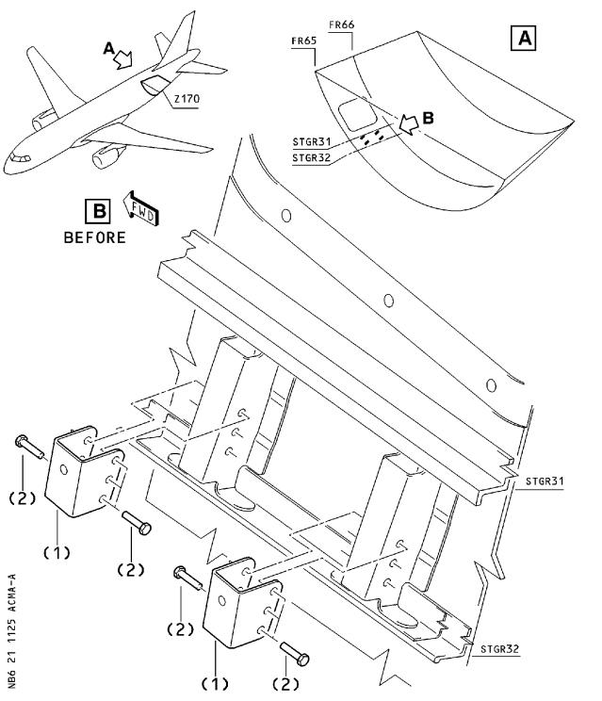

Figure 1 Sheet 1

Replacement of Support Brackets

DATE : Oct 25/00

REVISION No . : 01 − Jan 25/01

SERVICE BULLETIN No . : A320−21−1125

Page : 13

***A319/A320/A321***

|  |
| --- |
|  |

SERVICE BULLETIN

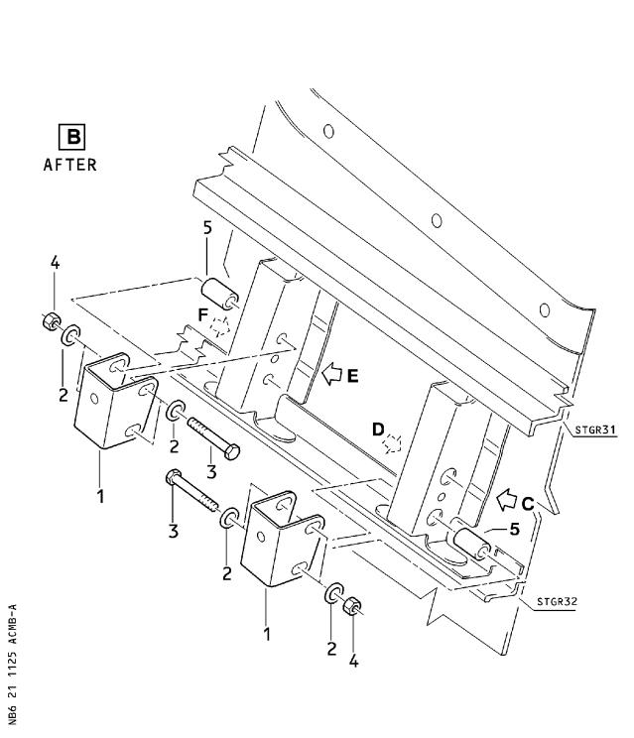

Figure 1 Sheet 2

Replacement of Support Brackets

DATE : Oct 25/00

REVISION No . : 01 − Jan 25/01

SERVICE BULLETIN No . : A320−21−1125

Page : 14

***A319/A320/A321***

|  |
| --- |
|  |

SERVICE BULLETIN

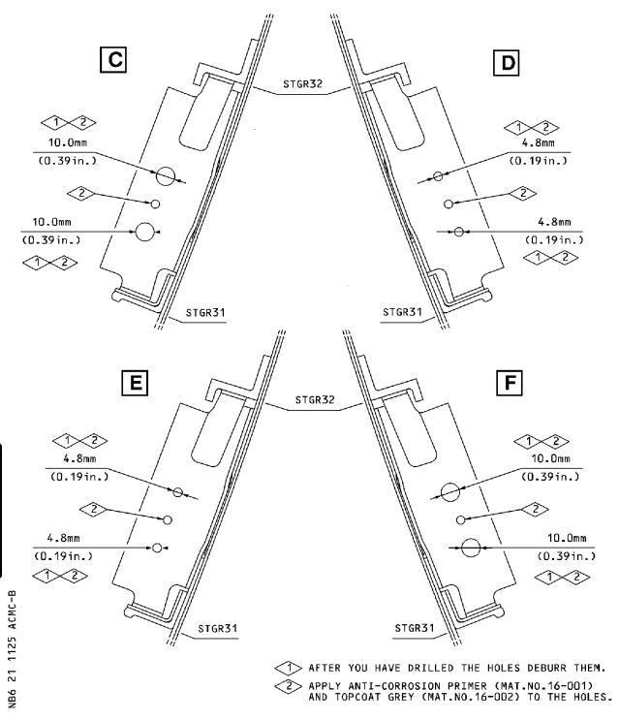

Figure 1 Sheet 3

Replacement of Support Brackets

DATE : Oct 25/00

REVISION No . : 01 − Jan 25/01

SERVICE BULLETIN No . : A320−21−1125

Page : 15

 ***A319/A320/A321***

SERVICE BULLETIN

REPORTING SHEET

TITLE : AIR CONDITIONING − PRESSURE CONTROL AND MONITORING − REPLACE THE

SUPPORT BRACKETS FOR THE OUTFLOW VALVE 10HL

MODIFICATION No . : 30421K6790

Please complete the appropriate item (A or B):

A − SB WILL BE embodied . . . . . . . . . . . . . .YES/NO (if NO please comment)

If YES, aircraft concerned (as per SB effectivity by default) and planned dates

(month/year) of embodiment: . . . . . . . . . . . . . . . . . . . . . . . . . .

. . . . . . . . . . . . . . . . . . . . . . . . . . . . . . . . . . . . . . . .

. . . . . . . . . . . . . . . . . . . . . . . . . . . . . . . . . . . . . . . .

B − SB HAS BEEN embodied on aircraft: . . . . . . . . . . . . . . . . . . . . .

. . . . . . . . . . . . . . . . . . . . . . . . . . . . . . . . . . . . . . . .

. . . . . . . . . . . . . . . . . . . . . . . . . . . . . . . . . . . . . . . .

Operator comments: . . . . . . . . . . . . . . . . . . . . . . . . . . . . . . .

. . . . . . . . . . . . . . . . . . . . . . . . . . . . . . . . . . . . . . . .

. . . . . . . . . . . . . . . . . . . . . . . . . . . . . . . . . . . . . . . .

From Airline: . . . . . . . . . . . . . . . . . . . . . . . . . . . . . . . . .

Name/Title: . . . . . . . . . . . . . . . . . . . . . . . . . . . . . . . . . .

Signature: . . . . . . . . . . . . Date: . . . . . . . . . . .

If operational documentation is affected (see Paragraph 1 .K of this SB): If information is needed prior to next normal revision or prior to SB embodiment, please indicate required service(s):

Either: Advance data . . . . . . . . . . . . . . . . . . . . . . YES/NO

Or : Intermediate/Temporary revision . . . . . . . . . . . . YES/NO

Important Information: This SB will only be incorporated in your maintenance and

operational documentation if this sheet is returned to Airbus Industrie and

signed by a duly authorised representative . With the next feasible revision,

this will result in

−updating of maintenance documentation to show pre and post SB data .

−updating of maintenance and operational documentation to show post SB data

after embodiment .

If this SB requires previous or simultaneous accomplishment of other SBs, Airbus

Industrie shall automatically include them in the manual revisions . Refer to SIL

00−037 for detailed information .

Please return this completed sheet to:

AIRBUS INDUSTRIE

CUSTOMER SERVICES DIRECTORATE

1 Rond Point Maurice Bellonte

31707 BLAGNAC CEDEX FRANCE

Attn: AI/SE−D32 Technical Data and Documentation Services Fax: (+33) 5 61 93 28 06

or via your Resident Customer Support Office .

Alternatively, SB lists via letters or fax are also accepted .

L6

DATE : Oct 25/00

REVISION No . : 01 − Jan 25/01

SERVICE BULLETIN No . : A320−21−1125

Page : 1 of 1

***A319/A320/A321***

|  |
| --- |
|  |

SERVICE BULLETIN

QUALITY PERCEPTION FORM

Use this form to tell us what is your perception of the quality of this Service Bulletin . The reported data that you provide us will be used to analyse areas of difficulties and to take corrective action to further improve the quality of our Service Bulletins .

We thank you for the time you have taken in completing this form .

(Please rate on a scale of 1 to 4, with 4 being the highest score)

|  |  |  |  |  |
| --- | --- | --- | --- | --- |
| − Quality | rating of this SB | 4 3 | 2 | 1 |
| − Quality | rating of the Accomplishment Instructions | 4 3 | 2 | 1 |
| − Quality | rating of the Illustrations | 4 3 | 2 | 1 |
| − Is this | SB easy to understand ? | Y / N |  |  |

If you have had difficulties in the accomplishment of this SB please quote below

the area(s) and give a short description of the issue .

Planning

X Effectivity

X Reason

X Manpower

X References

X Publication

Comments :

Material

X Kit Content

X List of Materials

Operator Supplied

X Re−identification

X Tooling

Instructions

X Preparation

X Mod/Inspection

X Test

X Close−up

X Illustrations

Operator :

Name/Title :

Date:

Please return this form to :

AIRBUS INDUSTRIE

CUSTOMER SERVICES DIRECTORATE

1 Rond Point Maurice Bellonte

31707 BLAGNAC CEDEX

Attn : AI/SE−T1 Service Bulletins Management

FAX : (33) 5 61 93 42 51

or via your Resident Customer Support Office .

L6

DATE : Oct 25/00

REVISION No . : 01 − Jan 25/01

SERVICE BULLETIN No . : A320−21−1125

Page : 1 of 1