@ A319/A320/A321

SERVICE BULLETIN

REVISION TRANSMITTAL SHEET

AIRBUS INDUSTRIE

CUSTOMER SERVICES DIRECTORATE

1 Rond Point Maurice Bellonte

31707 BLAGNAC CEDEX FRANCE

Tel : (33) 5 61 93 33 33

Telex : AIRBU 530526F

Fax : (33) 5 61 93 42 51

ATA SYSTEM : 21

TITLE : AIR CONDITIONING - AVIONICS EQUIPMENT VENTILATION - ADD RESISTOR ON AEVC

INLET SKIN AIR VALVE CONTROL LINE .

MODIFICATION No . : 30934P6961

This page transmits Revision No . 01 of Service Bulletin No . A320-21-1129 . ADDITIONAL WORK

No additional work is required by this revision for aircraft modified by any

previous issue .

REASON

Revision No . 01 issued to add reference to TFU 21.26.00.020 and modify the

effectivity .

CHANGES

SUMMARY :

— EFFECTIVITY

. Operators updated and NOTE modified .

— REFERENCES/REPERCUSSIONS

. Reference to TFU 21.26.00.020 added .

PLANNING INFORMATION :

— EFFECTIVITY

. Effectivity updated and NOTE modified .

— REFERENCES

. Reference to AWM 20-60-00 becomes ESPM 20-30-00 .

ACCOMPLISHMENT INSTRUCTIONS :

— GENERAL

— Standard Practices

5 DATE : Apr 03/01

REVISION No . : 01 — Mar 06/02

SERVICE BULLETIN No . : A320— 21— 1129

Page : 1 of 2

Printed in FRANCE © AIRBUS INDUSTRIE, 2002 All rights reserved

@ A319/A320/A321

SERVICE BULLETIN

REVISION TRANSMITTAL SHEET

. Reference to AWM 20-60-00 becomes ESPM 20-30-00 .

NOTE : Lay-out changes due to computerization of this revision are not

identified .

FILING INSTRUCTIONS

This Service Bulletin has been generated electronically and is reissued as a

complete document . Replace the complete document .

Put this Revision Transmittal Sheet in front of the Service Bulletin .

HISTORY OF PREVIOUS REVISIONS

No previous revisions .

REVISION SEQUENCE

ORIGINAL : Apr 03/01

REVISION No . : 01 — Mar 06/02

DATE : Apr 03/01 SERVICE BULLETIN No . : A320— 21— 1129

REVISION No . : 01 — Mar 06/02 Page : 2

Printed in FRANCE © AIRBUS INDUSTRIE, 2002 All rights reserved

@ A319/A320/A321

SERVICE BULLETIN

SUMMARY

AIRBUS INDUSTRIE

CUSTOMER SERVICES DIRECTORATE

1 Rond Point Maurice Bellonte

31707 BLAGNAC CEDEX FRANCE

Tel : (33) 5 61 93 33 33

Telex : AIRBU 530526F

Fax : (33) 5 61 93 42 51

This summary is for information only

and is not approved for modification of the aircraft

ATA SYSTEM : 21

TITLE : AIR CONDITIONING - AVIONICS EQUIPMENT VENTILATION - ADD RESISTOR ON AEVC

INLET SKIN AIR VALVE CONTROL LINE .

MODIFICATION No . : 30934P6961

REASON/DESCRIPTION/OPERATIONAL CONSEQUENCES

The skin air inlet valve closure command in the Avionics Equipment Ventilation

Computer (AEVC) can be aborted by a voltage spike related to the valve internal

relay .

Some electrical characteristics of wiring and the normal spectral reponse of the

valve lead to an unstable oscillation in the command circuit and cross over the

threshold of the current limitation protection of the AEVC .

In order to reduce the occurence of aborted closure command, this Service

Bulletin proposes addition of a resistor on the closure command wiring .

By an amplitude modulation rejection and an uncoupling between the valve, the

wiring and the computer, the resistor shifts the oscillating point to an other

which has shown through experience to be out of AEVC range .

|  |  |  |  |
| --- | --- | --- | --- |
| EVALUATION TABLE | | | |
| COMPLIANCE | Desirable | CANCELS INSPECTION SB | No |
| POTENTIAL AD | No | A/C OPERATION AFFECTED | No |
| RELIABILITY AFFECTED | No | PAX COMFORT AFFECTED | No |
| COST SAVING | No | ETOPS AFFECTED | No |
| STRUCTURAL LIFE EXTN | No | VENDOR SB INVOLVED | No |
| KIT PRICE (USD)  A01R02 | 260 |  |  |

EFFECTIVITY

This Service Bulletin is applicable to these operators :

5 DATE : Apr 03/01

REVISION No . : 01 — Mar 06/02

SERVICE BULLETIN No . : A320— 21— 1129

Page : 1 of 4

Printed in FRANCE © AIRBUS INDUSTRIE, 2002 All rights reserved

@ A319/A320/A321

SERVICE BULLETIN

SUMMARY

53Z AAA AAR ACA ADR AEF AES AFR AIH AJM ALK AMC AMM AMU ANA AUA AWE AWQ AZA BAW

BES BMA C3J C9G CES CIB CJG CMM CNW CSC CSN CTN CYP DCS DLH EDW EEZ EIN EWG F2I

FIN G2X G4I GBL GFA HDA HVN IAC IBE IWD JBU JKK JMC KAC KZW LAJ LAN LBT LTU LXR

MEA MON MSR MXA NWA O2X OHY OYC PAL PIC QAF QTR RJA RYN S2A SAB SEU SHJ SHK SLK

SSV SWR SYR TAI TAM TAP TAR TAS TNA TWJ UAL USA VIR VLE WGT

NOTE : This modification is embodied before delivery on A319 aircraft MSN 1371 ,

1373 , 1375 , 1395 , 1401 , 1414 , 1429 , 1444 , 1445 , 1463 , 1466 ,

1479 and subsequent, on A320 aircraft MSN 1367 , 1407 , 1405 , 1409 ,

1418 , 1424 , 1430 , 1432 , 1435 , 1439 , 1452 and subsequent, on A321

aircraft MSN 1356 , 1408 , 1417 , 1431 , 1433 , 1455 , 1462 , 1465 , 1476

, 1481 and subsequent .

CONCURRENT REQUIREMENTS

None

REFERENCES/REPERCUSSIONS

TFU

OEB

AOT

SIL

LIFE LIMIT

: 21 .26 .00 .020

: None

: None

: None

: None

LINE MAINTENANCE AFFECTED : No

OTHERS : None

NATURE OF THE WORK

AIRCRAFT : YES

EQUIPMENT : NO

HARD : NO

SOFT : NO

OBRM : NO

MANPOWER

Kit 211129A01R02

TOTAL MANHOURS

4 .0

4 .0

ELAPSED TIME (HOURS)

MATERIAL INFORMATION

AIRCRAFT DATA

Kit 211129A01R02

Resistor assy, bundle, placard set .

DATE : Apr 03/01 SERVICE BULLETIN No . : A320— 21— 1129

REVISION No . : 01 — Mar 06/02 Page : 2

Printed in FRANCE © AIRBUS INDUSTRIE, 2002 All rights reserved

@ A319/A320/A321

SERVICE BULLETIN

SUMMARY

APPENDICES

None

DATE : Apr 03/01 SERVICE BULLETIN No . : A320— 21— 1129

REVISION No . : 01 — Mar 06/02 Page : 3 Printed in FRANCE © AIRBUS INDUSTRIE, 2002 All rights reserved

@ A319/A320/A321

SERVICE BULLETIN

SUMMARY

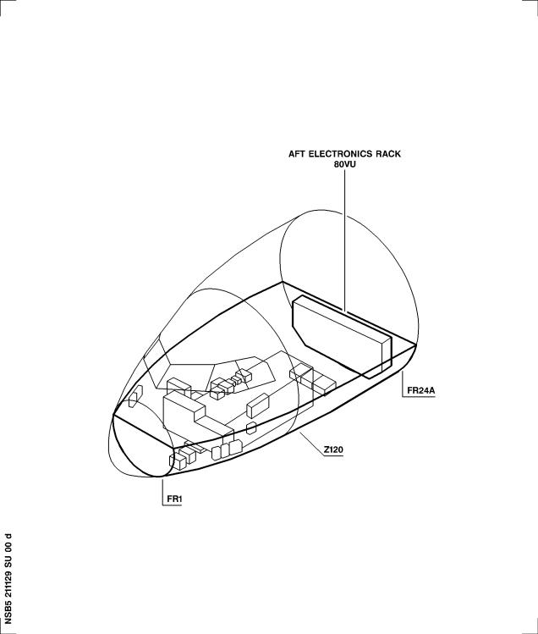

DATE : Apr 03/01 SERVICE BULLETIN No . : A320— 21— 1129

REVISION No . : 01 — Mar 06/02 Page : 4

Printed in FRANCE © AIRBUS INDUSTRIE, 2002 All rights reserved

@ A319/A320/A321

SERVICE BULLETIN

AIRBUS INDUSTRIE

CUSTOMER SERVICES DIRECTORATE

1 Rond Point Maurice Bellonte

31707 BLAGNAC CEDEX FRANCE

Tel : (33) 5 61 93 33 33

Telex : AIRBU 530526F

Fax : (33) 5 61 93 42 51

ATA SYSTEM : 21

TITLE : AIR CONDITIONING - AVIONICS EQUIPMENT VENTILATION - ADD RESISTOR ON AEVC

INLET SKIN AIR VALVE CONTROL LINE .

MODIFICATION No . : 30934P6961

This document contains AIRBUS PROPRIETARY INFORMATION and shall at all times

remain the property of AIRBUS; no intellectual property right or licence is

granted by AIRBUS in connection with any information contained in it . It is

delivered on the express condition that said document and the information

contained in it shall be treated as confidential, shall not be used for any purpose other than that for which it is hereby delivered . It shall not be disclosed in whole or in part to third parties and shall not be duplicated in any manner (except for the purposes of performing the tasks described hereunder and provided that any recipient of such document shall comply with the conditions herein), without AIRBUS' prior written consent .

1. PLANNING INFORMATION

A . EFFECTIVITY

(1) Models

319-111 319-112 319-113 319-114 319-115 319-131 319-132 319-133

320-111 320-211 320-212 320-214 320-231 320-232 320-233 321-111

321-112 321-131 321-211 321-231

(2) Aircraft

(a) Effectivity by MSN

This Service Bulletin is applicable to aircraft MSN :

0002-0008 0010-0014 0016-0078 0080-0104 0106-0373 0375-0432

0434-0480 0482-0535 0537-0707 0709-1277 1279-1355 1357-1366

1368-1370 1372 1374 1376-1394 1396-1400 1402-1404 1406

1410-1413 1415 1416 1419-1423 1425-1428 1434 1436-1438

1440-1443 1446-1451 1453 1456 1458 1460 1468 1471 1472 1474

1477

NOTE : This modification is embodied before delivery on A319

aircraft MSN 1371 , 1373 , 1375 , 1395 , 1401 , 1414 ,

1429 , 1444 , 1445 , 1463 , 1466 , 1479 and

subsequent, on A320 aircraft MSN 1367 , 1407 , 1405 ,

1409 , 1418 , 1424 , 1430 , 1432 , 1435 , 1439 , 1452

and subsequent, on A321 aircraft MSN 1356 , 1408 , 1417

5 DATE : Apr 03/01

REVISION No . : 01 — Mar 06/02

SERVICE BULLETIN No . : A320— 21— 1129

Page : 1 of 20

Printed in FRANCE © AIRBUS INDUSTRIE, 2002 All rights reserved

@ A319/A320/A321

SERVICE BULLETIN

, 1431 , 1433 , 1455 , 1462 , 1465 , 1476 , 1481 and

subsequent .

(b) Effectivity by Operator

The Operator/MSN relationship is provided for information only

and is correct at the time of issue in accordance with the

information available to AIRBUS . Any future changes resulting

from transfer of an aircraft from one operator to another will

not be reflected in this list unless the Service Bulletin is

|  |  |  |  |  |  |  |  |
| --- | --- | --- | --- | --- | --- | --- | --- |
| revised for  OPERATOR  53Z  AAA  AAR  ACA  ADR  AEF  AES  AFR  AIH  AJM  ALK  AMC  AMM  AMU | another reason .  MSN  1468  0022 0023 0024 0025  0157 0229 0288 0331  0771 0855 1060 1293  0059 0068 0073 0084  0154 0159 0174 0175  0248 0253 0254 0255  0302 0305 0309 0310  0350 0359 0378 0384  0639 0649 0656 0670  0697 0711 0719 0721  0757 0769 0773 0779  0840 0845  0043 0113 0114  0565 0575 0580 0659  1004 1195 1199 1218  0739 0743 0839 0892  0002 0003 0004 0005  0019 0020 0021 0033  0101 0102 0108 0115  0145 0155 0156 0184  0214 0215 0220 0226  0244 0270 0278 0285  0498 0509 0521 0529  0637 0644 0647 0660  0938 0956 0985 0998  1169 1176 1190 1201  1415 1449 1471  0163 0164 0168 0169  0449 0808 0823 1238  0422 0528 0624 0626  0406  0112 0293  0677 0781 0852 1006  0550 0557 0573 0582 | 0026  0547  0122  0183  0265  0311  0403  0672  0728  0785  0661  1421  0007  0036  0128  0186  0227  0286  0544  0674  1000  1216  0179  1250  0628  1017  0620 | 0027  0615  0126  0210  0277  0324  0404  0682  0732  0800  0667  1438  0010  0044  0129  0187  0228  0287  0598  0675  1020  1267  0193  0630  1306  0631 | 0029  0622  0127  0231  0279  0330  0426  0688  0736  0813  0787  0012  0061  0130  0188  0235  0337  0600  0684  1025  1271  0362  0666  1320  0805 | 0030  0632  0141  0232  0283  0333  0546  0691  0740  0817  0792  0013  0062  0131  0203  0236  0352  0608  0761  1036  1299  0363  0775  0908 | 0140  0662  0149  0233  0284  0341  0572  0693  0742  0829  0954  0014  0063  0133  0204  0237  0377  0618  0777  1133  1344  0424  1213 | 0142  0726  0150  0242  0290  0342  0634  0695  0752  0831  0990  0016  0100  0144  0211  0239  0491  0625  0796  1151  1404  0444  1390 |

DATE : Apr 03/01 SERVICE BULLETIN No . : A320— 21— 1129

REVISION No . : 01 — Mar 06/02 Page : 2

Printed in FRANCE © AIRBUS INDUSTRIE, 2002 All rights reserved

@ A319/A320/A321

SERVICE BULLETIN

|  |  |  |  |  |  |  |  |  |  |  |
| --- | --- | --- | --- | --- | --- | --- | --- | --- | --- | --- |
| OPERATOR  ANA  AUA  AWE  AWQ  AZA  BAW  BES  BMA  C3J  C9G  CES  CIB  CJG  CMM  CNW  CSC  CSN  CTN  CYP  DCS | MSN  0138  0300  0549  1204  0552  1189  0052  0081  0448  0866  1064  1196  1410  0542  0434  0526  0940  0006  1082  1239  1440  1256  0806  1174  0772  0460  1005  1330  0774  1416  0707  0132  0665  1041  0540  0696  0849  0258  0028  1053 | 0139  0328  0554  1227  0570  1387  0053  0082  0455  0889  1075  1223  1419  0477  0532  0951  0008  1115  1258  0810  1177  0799  1028  1357  0793  1437  0724  0397  0754  1316  0551  0698  0859  0767  0035 | 0148  0365  0658  0581  1458  0054  0091  0471  0924  1079  1234  0488  0576  0959  0011  1118  1261  0835  1183  0828  1030  1361  0809  0876  0409  0838  1345  0556  0704  0881  0833  0037 | 0151  0383  0669  0768  0055  0092  0527  0931  1083  1274  0494  0583  0999  0017  1142  1279  0864  1207  0883  1070  1377  0884  0921  0854  0878  0705  0895  1009  0038 | 0167  0413  0685  0776  0064  0098  0543  0953  1088  1281  0495  0586  1138  0018  1193  1295  0934  1383  0914  1072  1386  0894  1296  0897  0915  0709  0900  1029  0180 | 0170  0482  0802  0797  0065  0099  0584  1003  1110  1284  0513  0593  1168  0039  1197  1329  0968  0925  1093  0905  0909  0919  0710  0950  1237  0256 | 0196  0501  0811  0920  0066  0238  0762  1043  1111  1323  0514  0599  1217  0042  1222  1338  0974  1108  0957  0939  1013  0712  0966  1252  0295 | 0212  0507  0963  0935  0067  0271  0770  1049  1116  1350  0515  0765  1220  0103  1225  1380  1014  1285  0971  0967  0718  1035  0316 | 0219  0531  1008  1137  0076  0315  0803  1050  1166  1397  0516  0819  1226  0109  1232  1384  1045  1303  1381  0984  0720  1039  0414 | 0245  0534  1042  1150  0077  0317  0856  1056  1178  1406  0524  0848  0120  1236  1423  1153  1312  1402  0986  0722  1057  0430 |

DATE : Apr 03/01 SERVICE BULLETIN No . : A320— 21— 1129

REVISION No . : 01 — Mar 06/02 Page : 3

Printed in FRANCE © AIRBUS INDUSTRIE, 2002 All rights reserved

@ A319/A320/A321

SERVICE BULLETIN

OPERATOR MSN

|  |  |  |  |  |  |  |  |  |  |  |
| --- | --- | --- | --- | --- | --- | --- | --- | --- | --- | --- |
| DLH  EDW  EEZ  EIN  EWG  F2I  FIN  G2X  G4I  GBL  GFA  HDA  HVN  IAC  IBE  IWD  JBU  JKK  JMC  KAC  KZW  LAJ  LAN  LBT  LTU | 0069  0110  0200  0346  0502  0616  0717  1080  0942  1448  0815  0646  1054  0941  0249  1002  1215  0313  0497  0633  0590  0648  0045  0074  0327  0486  0134  0223  0323  1087  1247  0225  1123  1398  1276  0354  0181  0641  0376  1304  1121  0530 | 0070  0111  0201  0382  0505  0623  0723  1161  0947  0841  0654  1086  0961  1157  1428  0325  0537  0756  0591  0650  0046  0075  0336  0490  0136  0224  0356  1099  1255  0308  1156  1446  1333  0357  0182  0651  0386  1332  1175  1385 | 0071  0116  0202  0401  0518  0627  0729  1188  1026  0926  0794  1364  1073  0345  0784  0594  0047  0080  0396  0492  0143  0240  0992  1101  1262  0314  1173  1349  0443  0195  0679  0480  1351  1441 | 0072  0117  0209  0412  0560  0636  0738  1214  0991  1016  1107  0375  0812  0597  0048  0089  0398  0499  0146  0241  0994  1119  1288  0879  1235  1366  0716  1194  1355 | 0078  0135  0216  0458  0563  0652  0744  1260  1023  1172  1185  0419  0816  0601  0049  0090  0416  0158  0246  1021  1154  1292  0888  1240 | 0083  0137  0217  0468  0564  0689  0853  1273  1094  1241  0421  0877  0605  0050  0095  0423  0173  0264  1027  1180  1318  1257 | 0086  0147  0218  0473  0567  0692  0860  1337  1242  1309  0438  0930  0607  0051  0096  0431  0176  0266  1047  1200  1347  1270 | 0093  0161  0267  0474  0595  0694  0875  1365  1394  1352  0445  0993  0611  0056  0097  0432  0177  0274  1059  1208  1362  1280 | 0094  0162  0268  0484  0609  0699  0887  1443  0459  1024  0617  0057  0247  0451  0199  0303  1063  1221  1379  1302 | 0104  0172  0269  0493  0610  0700  0901  0466  1253  0619  0058  0257  0469  0207  0312  1067  1229  1396  1327 |

DATE : Apr 03/01 SERVICE BULLETIN No . : A320— 21— 1129

REVISION No . : 01 — Mar 06/02 Page : 4

Printed in FRANCE © AIRBUS INDUSTRIE, 2002 All rights reserved

@ A319/A320/A321

SERVICE BULLETIN

OPERATOR MSN

|  |  |  |  |  |  |  |  |  |  |  |
| --- | --- | --- | --- | --- | --- | --- | --- | --- | --- | --- |
| LXR  MEA  MON  MSR  MXA  NWA  O2X  OHY  OYC  PAL  PIC  QAF  QTR  RJA  RYN  S2A  SAB  SEU  SHJ  SHK  SLK  SSV  SWR  SYR | 0191  0640  0379  0165  0725  0252  0320  0415  0031  0125  0262  0318  0380  0766  0907  1058  1164  1434  0304  0364  0221  0706  0604  0927  0928  0087  0393  1413  0970  1184  0653  0910  0322  0872  0230  0645  0517  0559  0612  0703  1144  0886 | 0395  0663  0389  0166  0259  0321  0428  0032  0152  0263  0319  0381  0778  0911  1062  1167  1453  0385  0222  0745  0614  1335  0932  0088  0394  1450  0995  1283  0657  0326  0899  0338  0671  0519  0562  0621  0713  0918 | 0668  0391  0178  0260  0332  0467  0034  0153  0272  0329  0387  0786  0923  1071  1186  1456  0294  0753  0943  0289  0411  1012  1305  0737  0344  0969  0427  0795  0520  0566  0629  0727  1032 | 0676  0392  0194  0261  0347  0040  0160  0273  0339  0388  0801  0962  1078  1191  0299  0977  0407  0714  1048  1336  0749  0478  1074  0429  1411  0522  0574  0635  0734  1076 | 0760  0446  0198  0275  0353  0041  0171  0281  0340  0399  0807  0964  1090  1230  0301  0569  0730  1068  1370  0973  1098  0437  0533  0577  0642  0782  1085 | 0983  0351  0276  0361  0060  0192  0282  0355  0400  0818  0981  1091  1249  0348  0735  1081  1388  1228  0447  0535  0578  0643  0827  1117 | 1015  0366  0280  0368  0106  0197  0297  0358  0408  0830  0988  1126  1324  0349  1102  1422  0476  0541  0585  0664  0870 | 1202  0680  0291  0369  0107  0206  0298  0360  0410  0832  0996  1129  1325  1124  0496  0545  0588  0673  0891 | 0687  0292  0373  0118  0208  0306  0367  0417  0846  1011  1131  1346  1145  0525  0548  0596  0681  0987 | 0715  0296  0405  0121  0213  0307  0372  0418  0903  1037  1149  1392  1160  0579  0553  0603  0701  1018 |

DATE : Apr 03/01 SERVICE BULLETIN No . : A320— 21— 1129

REVISION No . : 01 — Mar 06/02 Page : 5

Printed in FRANCE © AIRBUS INDUSTRIE, 2002 All rights reserved

@ A319/A320/A321

SERVICE BULLETIN

OPERATOR MSN

0902

0747

1159

0453

1246

0821

1100

0402

0733

1113

0335

1143

0763

0982

1307

0370

0789

1300

0758

1251

0837

1106

0511

0425

0558

1007

1400

0251

1103

0750

0960

1206

0124

1187

0937

0555

0874

1334

0976

1368

0906

1120

0869

0561

1066

0334

1139

0755

0979

1231

0205

1372

0602

0461

0916

1374

0250

1096

0234

0945

1181

0123

0975

0814

0538

0741

1140

0440

1158

0790

1034

1399

0390

TAI

0912

1339

1010

1376

0917

1127

0880

1353

0243

TAM

TAP

1092

0185

0933

1165

0119

TAR

TAS

TNA

TWJ

UAL

0958

0371

0441

0746

0731

0606

0791

0822

0913

0435

0450

0472

0506

0592

0751

0826

0862

0952

1128

1290

1460

0868

0972

1055

1112

1170

1263

1294

1319

1369

1442

1219

0343

1259

0456

0483

0512

0655

0783

0842

0871

0980

1192

1341

0896

1033

1069

1134

1203

1268

1301

1331

1389

0457

0485

0523

0678

0788

0843

0873

0989

1211

1343

0904

1038

1077

1135

1205

1269

1310

1340

1391

0452

0475

0508

0613

0759

0834

0865

0955

1146

1291

1474

0885

0997

1061

1114

1171

1264

1297

1326

1378

1447

1233

0420

1308

0462

0487

0539

0683

0798

0847

0882

1001

1243

1359

0922

1040

1084

1136

1209

1275

1311

1342

1393

0463

0489

0568

0686

0804

0850

0893

1022

1248

1363

0929

1044

1089

1141

1210

1277

1313

1348

1403

0454

0479

0510

0638

0780

0836

0867

0965

1163

1321

1477

0890

1019

1065

1122

1182

1265

1298

1328

1382

1472

0439

0465

0503

0587

0702

0824

0857

0944

1104

1272

1426

0861

0946

1051

1097

1148

1245

1287

1315

1358

1425

0978

0189

1198

0442

0470

0504

0589

0748

0825

0858

0948

1105

1282

1427

0863

0949

1052

1109

1155

1254

1289

1317

1360

1436

1130

0190

1244

0464

0500

0571

0690

0820

0851

0898

1031

1266

1420

0844

USA

0936

1046

1095

1147

1224

1286

1314

1354

1412

0764

VIR

VLE

WGT

0085

1152

0436

1322

1132

1125

1451

1162

1179

1212

(c) Effectivity by MSN and Kit/Configuration

The kits and configurations applicable to these MSNs are given

at the end of this list:

0002-0008 0010-0014 0016-0078 0080-0104 0106-0373 0375-0432

0434-0480 0482-0535 0537-0707 0709-1277 1279-1355 1357-1366

1368-1370 1372 1374 1376-1394 1396-1400 1402-1404 1406

1410-1413 1415-1416 1419-1423 1425-1428 1434 1436-1438

DATE : Apr 03/01 SERVICE BULLETIN No . : A320— 21— 1129

REVISION No . : 01 — Mar 06/02 Page : 6

Printed in FRANCE © AIRBUS INDUSTRIE, 2002 All rights reserved

@ A319/A320/A321

SERVICE BULLETIN

1440-1443 1446-1451 1453 1456 1458 1460 1468 1471-1472 1474

1477

KIT No . QTY PER A/C CONFIGURATION

211129A01R02 1 None

(3) Spares

None

B . CONCURRENT REQUIREMENTS

None

C . REASON

(1) History

The skin air inlet valve closure command in the Avionics Equipment

Ventilation Computer (AEVC) can be aborted by a voltage spike

related to the valve internal relay .

Some electrical characteristics of wiring and the normal spectral

reponse of the valve lead to an unstable oscillation in the command

circuit and cross over the threshold of the current limitation

protection of the AEVC .

(2) Objective/Action

In order to reduce the occurence of aborted closure command, this

Service Bulletin proposes addition of a resistor on the closure

command wiring .

(3) Advantages

By an amplitude modulation rejection and an uncoupling between the

valve, the wiring and the computer, the resistor shifts the

oscillating point to an other which has shown through experience to

be out of AEVC range .

(4) Operational/Maintenance Consequences

None

D . DESCRIPTION

To accomplish this Service Bulletin it is necessary to :

(1) Modify the rear plate of the shelf 86VU .

(2) Install a resitor on the rear plate of the shelf 86VU .

DATE : Apr 03/01 SERVICE BULLETIN No . : A320— 21— 1129

REVISION No . : 01 — Mar 06/02 Page : 7 Printed in FRANCE © AIRBUS INDUSTRIE, 2002 All rights reserved

@ A319/A320/A321

SERVICE BULLETIN

(3) Modify the wiring in the shelf 86VU .

E . COMPLIANCE

(1) Classification

DESIRABLE

(2) Accomplishment Timescale

In accordance with operators' maintenance schedule .

F . APPROVAL

The technical content of this Service Bulletin has been approved under

the authority of the DGAC Design Organisation Approval No . F .JA .02 .

If an aircraft listed in the effectivity has a modification or repair

embodied that is not of AIRBUS origin, and which affects the content of

this Service Bulletin, the operator is responsible for obtaining

approval by its airworthiness authority for any adaptation necessary

before incorporation of the Service Bulletin .

G . MANPOWER

The manpower estimates given in this Service Bulletin are based on the direct labor cost to do the work . These estimates assume that the work will be done by experienced personnel, and may need to be revised upwards to suit operator's circumstances . The estimates do not include the time to prepare, plan or inspect the work . Manufacture and procurement of parts and tools, drying times for paints, sealants, etc, and general administration work are also not included .

Kit 211129A01R02

Get access 1 .0

Modification of rear plate 0.5

in 86VU

Installation of resitor in 0.5

86VU

Modification of wiring in 0.5

86VU

Tests 0 . 5

Close-up 1 .0

TOTAL MANHOURS 4 .0

ELAPSED TIME (HOURS) 4 .0

H . WEIGHT AND BALANCE

Not changed

DATE : Apr 03/01 SERVICE BULLETIN No . : A320— 21— 1129

REVISION No . : 01 — Mar 06/02 Page : 8

Printed in FRANCE © AIRBUS INDUSTRIE, 2002 All rights reserved

@ A319/A320/A321

SERVICE BULLETIN

I . ELECTRICAL LOAD DATA

Not changed

J . REFERENCES

Aircraft Maintenance Manual (AMM)

Consumable Material List (CML)

: 06-41- 53 11-00-00 12-34-24

21-26-34 25- 54-11 52-10-00

52-30-00 52-41-00

 Elec . Std . Practices Manual (ESPM)

Structural Repair Manual (SRM)

K . PUBLICATIONS AFFECTED

Illustrated Parts Catalog (IPC)

Aircraft Wiring List (AWL)

L . INTERCHANGEABILITY/MIXABILITY

None

: 20-30-00

: 51-44-11

: 21-26-08

DATE : Apr 03/01 SERVICE BULLETIN No . : A320— 21— 1129

REVISION No . : 01 — Mar 06/02 Page : 9

Printed in FRANCE © AIRBUS INDUSTRIE, 2002 All rights reserved

@ A319/A320/A321

SERVICE BULLETIN

This Page Intentionally Left Blank

DATE : Apr 03/01 SERVICE BULLETIN No . : A320— 21— 1129

REVISION No . : 01 — Mar 06/02 Page : 10 Printed in FRANCE © AIRBUS INDUSTRIE, 2002 All rights reserved

@ A319/A320/A321

SERVICE BULLETIN

2. MATERIAL INFORMATION

A . MATERIAL — PRICE AND AVAILABILITY

(1) Material

Customers with aircraft shown in the effectivity of this Service

Bulletin should send a purchase order to AIRBUS . Quote the number

of this Service Bulletin . The address is :

AIRBUS

MATERIEL SUPPORT CENTER

P .O . Box 630262

22312 HAMBURG

GERMANY

(2) Price and Availability

Kit 211129A01R02

Cost : 260 US Dollars

Availability : 120 calendar days from receipt of order

The Kit availability given above is the standard lead time from the

date of your purchase order . If you require the Kit(s) before this

time, please include a retrofit planning schedule with your order

so that we can try to comply with your requirements .

The sales terms (costs and availability) are estimated in relation

to economic conditions at the issue date of the Service Bulletin .

B . INDUSTRY SUPPORT INFORMATION

None

C . LIST OF COMPONENTS

Kit 211129A01R02

|  |  |  |  |  |  |  |  |  |  |  |
| --- | --- | --- | --- | --- | --- | --- | --- | --- | --- | --- |
| ITEM | NEW PART No . | QTY UM | KEYWORD | ITEM | OLD | PART | No . | INT | INST | DISP |

1

2

3

4

D9251488200000

NAS1100-04- 5

ASNA2397-4L

MS21042-04

D9000095214895

D9100095209695

NSA935401-03

NSA935401-05

NSA935401-08

1

2

4

2

1

1

1

1

1

Resistor

Screw

Washer

Nut

Bundle

Set

Tie

Tie

Tie

DATE : Apr 03/01 SERVICE BULLETIN No . : A320— 21— 1129

REVISION No . : 01 — Mar 06/02 Page : 11

Printed in FRANCE © AIRBUS INDUSTRIE, 2002 All rights reserved

@ A319/A320/A321

SERVICE BULLETIN

NOTE : Refer to the AIRBUS Standards Manual (SM) if you find part

numbers of hardware components in the related kit(s) which you

cannot identify in the LIST OF COMPONENTS of this Service

Bulletin . The SM will give you the correct part number to part

number relationship .

D . LIST OF MATERIALS — OPERATOR SUPPLIED

(1) Consumable Materials

|  |  |  |  |  |  |  |
| --- | --- | --- | --- | --- | --- | --- |
| DESCRIPTION | REFERENCE TO CML  MAT . No . | QTY | PER | A/C | INST | DISP |

Anti-Corrosion Primer 16-001

(Polyurethane)

Polyurethane Topcoat Grey 16-002

(2) Components

None

E . PARTS TO BE RE— IDENTIFIED BY THE OPERATOR

None

F . TOOLING — PRICE AND AVAILABILITY

None

G . SPECIAL TOOLS

None

As

As

required

required

DATE : Apr 03/01 SERVICE BULLETIN No . : A320— 21— 1129

REVISION No . : 01 — Mar 06/02 Page : 12

Printed in FRANCE © AIRBUS INDUSTRIE, 2002 All rights reserved

@ A319/A320/A321

SERVICE BULLETIN

3. ACCOMPLISHMENT INSTRUCTIONS

A . GENERAL

WARNING : MAKE SURE THAT YOU OBEY ALL THE WARNINGS AND THE CAUTIONS

INCLUDED IN THE REFERENCED PROCEDURES .

(1) Preparation

(a) Electrically ground the aircraft (Refer to AMM 12- 34-24 Page

block 201) .

(b) Put the access platforms in position at the access doors .

(c) Open the passenger/crew door 841 (Refer to AMM 52-10-00 Page

block 201) .

(d) Open the FWD cargo-compartment door 825 (Refer to AMM 52- 30-00

Page block 201) .

(e) Open the avionics-compartment door 824 (Refer to AMM 52-41-00

Page block 201) .

(f) In the FWD cargo-compartment at FR24A, remove the partition

panels 132EW, 131CW, 131AW and 132BW (Refer to AMM 06-41- 53

and AMM 25- 54-11 Page block 401) .

(g) Do the preparation procedure as specified in the

removal/installation of the AEVC (10HQ) (Refer to AMM 21-26- 34

Page block 401) .

(2) Standard Practices

(a) For the specification of the material number (Mat No .), refer

to CML .

(b) Drill and deburr the holes (Refer to SRM 51-44-11) .

(c) After drilling, apply Anti-Corrosion Primer (Polyurethane)

(Mat No . 16-001) and Polyurethane Topcoat Grey (Mat No .

16-002) .

(d) Bond the placards (Refer to AMM 11-00-00 Page block 201) .

(e) To install the new wires, cut them to the necessary length,

crimp the terminals and connect them .

(f) Do a continuity test of the modified and new wires .

(g) Route the new wires with the wires that are in the aircraft .

(h) Obey the instructions of the wiring installation (Refer to

ESPM 20-30-00) .

DATE : Apr 03/01 SERVICE BULLETIN No . : A320— 21— 1129

REVISION No . : 01 — Mar 06/02 Page : 13 Printed in FRANCE © AIRBUS INDUSTRIE, 2002 All rights reserved

@ A319/A320/A321

SERVICE BULLETIN

B . MODIFICATION

(1) Modify the rear plate of the shelf 86VU .

Refer to figure 1

(a) Drill

given

two holes to 3.5 mm (0 .138in .) dia . , at the dimension

in the figure .

(2) Install a resitor on the rear plate of the shelf 86VU .

Refer to figure 2

(a) Near the 1862VT and 1880VT, Install :

FIN 33HQ

1 Resistor

with :

2 Screw

4 Washer

2 Nut

assy

D9251488200000

NAS1100-04- 5

ASNA2397-4L

MS21042-04

Item 1

Item 2

Item 3

Item 4

(b) Near the resistor, bond the placard 33HQ, supplied in : Placard set D9100095209695

(3) Modify the wiring in the shelf 86VU .

Refer to figure 3

Refer to figure 4

(a) Remove the AEVC (10HQ) (Refer to AMM 21-26-34 Page block 401) .

(b) Modify the connection of wire shown on the lines 1 and 2

(Refer to figure 4) .

(c) Install the wire shown on the line 6 (Refer to figure 4)

supplied in :

Bundle D9000095214895

(d) Attach the wires with :

Cable-ties NSA935401-03

Cable-ties NSA935401-05

Cable-ties NSA935401-08

(e) Install the AEVC (10HQ) (Refer to AMM 21-26-34 Page block

401) .

C . TEST

(1) Do the test after the removal/installation of the AEVC (10HQ) (Refer to AMM 21-26-34 Page block 401) .

DATE : Apr 03/01 SERVICE BULLETIN No . : A320— 21— 1129

REVISION No . : 01 — Mar 06/02 Page : 14

Printed in FRANCE © AIRBUS INDUSTRIE, 2002 All rights reserved

@ A319/A320/A321

SERVICE BULLETIN

D . CLOSE UP

(1) Make sure that the work areas are clean and clear of tools and

other items of equipment .

(2) Do the close-up procedure as specified in the removal/installation

of the AEVC 10HQ (Refer to AMM 21-26- 34 Page block 401) .

(3) In the FWD cargo-compartment at FR24A, install the partition panels

132EW, 131CW, 131AW and 132BW (Refer to AMM 06-41- 53 and AMM

25- 54-11 Page block 401) .

(4) Close the avionics-compartment door 824 (Refer to AMM 52-41-00 Page

block 201) .

(5) Close the FWD cargo-compartment door 825 (Refer to AMM 52- 30-00

Page block 201) .

(6) Close the passenger/crew door 841 (Refer to AMM 52-10-00 Page block

201) .

(7) Remove the access platforms from the access doors .

(8) Disconnect the aircraft electrical ground-connection (Refer to AMM

12- 34-24 Page block 201) .

(9) Restore the systems and the aircraft to normal operating condition .

E . DOCUMENTATION

Write in the applicable aircraft records that you have done all the work

given in the Service Bulletin .

DATE : Apr 03/01 SERVICE BULLETIN No . : A320— 21— 1129

REVISION No . : 01 — Mar 06/02 Page : 15 Printed in FRANCE © AIRBUS INDUSTRIE, 2002 All rights reserved

@ A319/A320/A321

SERVICE BULLETIN

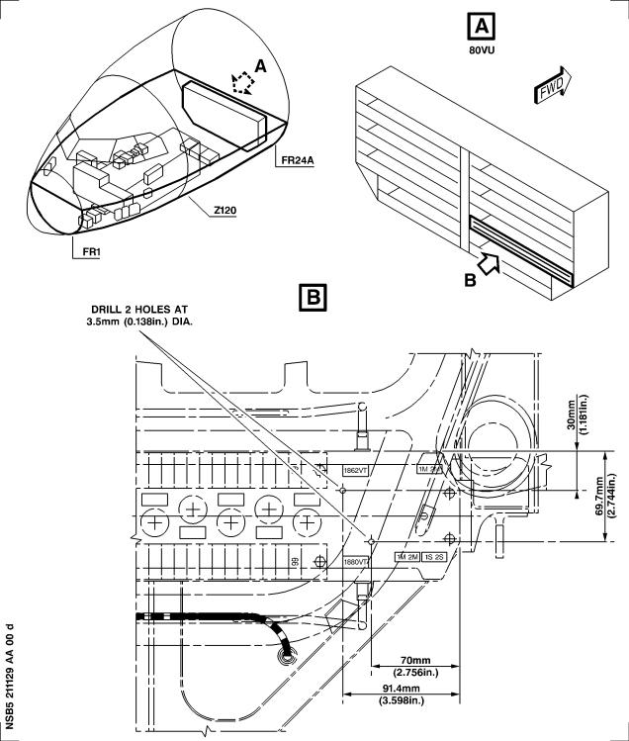

Figure 1 Sheet 1

Modification of Rear Plate of the Shelf 86VU

DATE : Apr 03/01 SERVICE BULLETIN No . : A320— 21— 1129

REVISION No . : 01 — Mar 06/02 Page : 16 Printed in FRANCE © AIRBUS INDUSTRIE, 2002 All rights reserved

@ A319/A320/A321

SERVICE BULLETIN

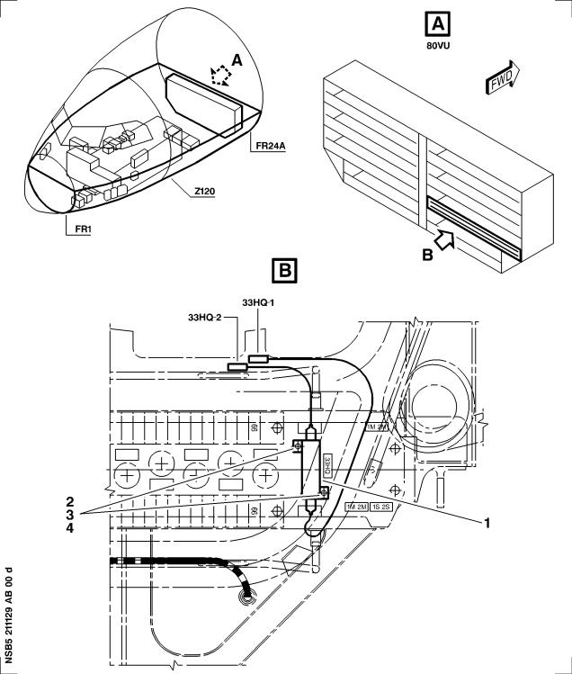

Figure 2 Sheet 1

Installation of the Resistor Assy in the Shelf 86VU

DATE : Apr 03/01 SERVICE BULLETIN No . : A320— 21— 1129

REVISION No . : 01 — Mar 06/02 Page : 17 Printed in FRANCE © AIRBUS INDUSTRIE, 2002 All rights reserved

@ A319/A320/A321

SERVICE BULLETIN

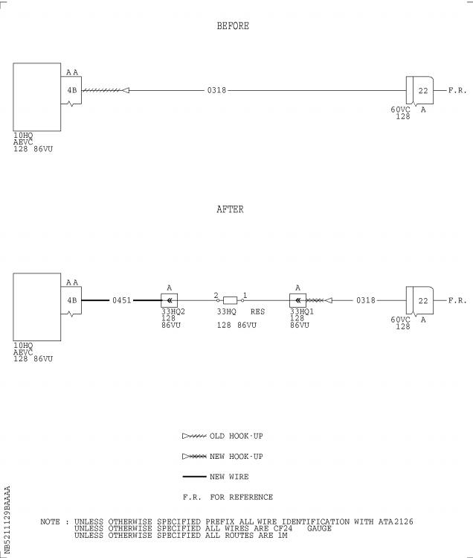

Figure 3 Sheet 1

Modification of the Wiring in the Shelf 86VU

DATE : Apr 03/01 SERVICE BULLETIN No . : A320— 21— 1129

REVISION No . : 01 — Mar 06/02 Page : 18 Printed in FRANCE © AIRBUS INDUSTRIE, 2002 All rights reserved

@ A319/A320/A321

SERVICE BULLETIN

Figure 4 Sheet 1

Hook-up Chart(Goto A3 section)

DATE : Apr 03/01 SERVICE BULLETIN No . : A320— 21— 1129

REVISION No . : 01 — Mar 06/02 Page : 19 Printed in FRANCE © AIRBUS INDUSTRIE, 2002 All rights reserved

@ A319/A320/A321

SERVICE BULLETIN

REPORTING SHEET

TITLE : AIR CONDITIONING - AVIONICS EQUIPMENT VENTILATION - ADD RESISTOR ON AEVC

INLET SKIN AIR VALVE CONTROL LINE .

MODIFICATION No . : 30934P6961

Please complete the appropriate item (A or B):

A - SB WILL BE embodied . . . . . . . . . . . . . YES/NO (if NO please comment)

If YES, aircraft concerned (as per SB effectivity by default) and planned dates

(month/year) of embodiment : . . . . . . . . . . . . . . . . . . . . . . . . . .

. . . . . . . . . . . . . . . . . . . . . . . . . . . . . . . . . . . . . . . .

. . . . . . . . . . . . . . . . . . . . . . . . . . . . . . . . . . . . . . . .

B - SB HAS BEEN embodied on aircraft : . . . . . . . . . . . . . . . . . . . . .

. . . . . . . . . . . . . . . . . . . . . . . . . . . . . . . . . . . . . . . .

. . . . . . . . . . . . . . . . . . . . . . . . . . . . . . . . . . . . . . . .

Operator comments : . . . . . . . . . . . . . . . . . . . . . . . . . . . . . .

. . . . . . . . . . . . . . . . . . . . . . . . . . . . . . . . . . . . . . .

. . . . . . . . . . . . . . . . . . . . . . . . . . . . . . . . . . . . . . .

From Airline : . . . . . . . . . . . . . . . . . . . . . . . . . . . . . . . . .

Name/Title : . . . . . . . . . . . . . . . . . . . . . . . . . . . . . . . . . .

Signature : . . . . . . . . . . . . . . Date : . . . . . . . . . . . . .

If operational documentation is affected (see Paragraph 1 .K of this SB): If information is needed prior to next normal revision or prior to SB embodiment, please indicate required service(s):

Either: Advance Data . . . . . . . . . . . . . . . . . . . . . YES/NO

Or : Intermediate/Temporary revision . . . . . . . . . . . . YES/NO

Important Information: This SB will only be incorporated in your maintenance and

operational documentation if this sheet is returned to Airbus Industrie and

signed by a duly authorised representative . With the next feasible revision,

this will result in

- updating of maintenance documentation to show pre and post SB data .

- updating of maintenance and operational documentation to show post SB data

after embodiment .

If this SB requires previous or simultaneous accomplishment of other SBs, Airbus

Industrie shall automatically include them in the manual revisions . Refer to SIL

00-037 for detailed information .

Please return this completed sheet to:

AIRBUS INDUSTRIE

CUSTOMER SERVICES DIRECTORATE

1 Rond Point Maurice Bellonte

31707 BLAGNAC CEDEX FRANCE

Attn: AI/SE-D32 Technical Data and Documentation Services

FAX: (+33) 5 61 93 28 06

or via your Resident Customer Support Office .

Alternatively, SB lists via letters or fax are also accepted .

5 DATE : Apr 03/01

REVISION No . : 01 — Mar 06/02

SERVICE BULLETIN No . : A320— 21— 1129

Page : 1 of 1

Printed in FRANCE © AIRBUS INDUSTRIE, 2002 All rights reserved

@ A319/A320/A321

SERVICE BULLETIN

QUALITY PERCEPTION FORM

Use this form to tell us what is your perception of the quality of this Service Bulletin . The reported data that you provide us will be used to analyse areas of difficulties and to take corrective action to further improve the quality of our Service Bulletins .

We thank you for the time you have taken in completing this form .

(Please rate on a scale of 1 to 4, with 4 being the highest score)

|  |  |  |  |
| --- | --- | --- | --- |
| - Quality rating of this SB | 4 3 | 2 | 1 |
| - Quality rating of the Accomplishment Instructions | 4 3 | 2 | 1 |
| - Quality rating of the Illustrations | 4 3 | 2 | 1 |
| - Is this SB easy to understand ? | Y / N |  |  |

If you have had difficulties in the accomplishment of this SB please quote below

the area(s) and give a short description of the issue .

Planning

X Effectivity

X Reason

X Manpower

X References

X Publication

Comments :

Material

X Kit content

X List of Materials

Operator Supplied

X Re-identification

X Tooling

Instructions

X Preparation

X Mod/Inspection

X Test

X Close-Up

X Illustrations

Operator :

Date:

Name/Title :

Please return this form to :

AIRBUS INDUSTRIE

CUSTOMER SERVICES DIRECTORATE

1 Rond Point Maurice Bellonte

31707 BLAGNAC

Attn : AI/SE-T1 Service Bulletins Management

FAX : (33) 5 61 93 42 51

Or via your Resident Customer Support Office .

5 DATE : Apr 03/01

REVISION No . : 01 — Mar 06/02

SERVICE BULLETIN No . : A320— 21— 1129

Page : 1 of 1

Printed in FRANCE © AIRBUS INDUSTRIE, 2002 All rights reserved

@ A319/A320/A321

SERVICE BULLETIN

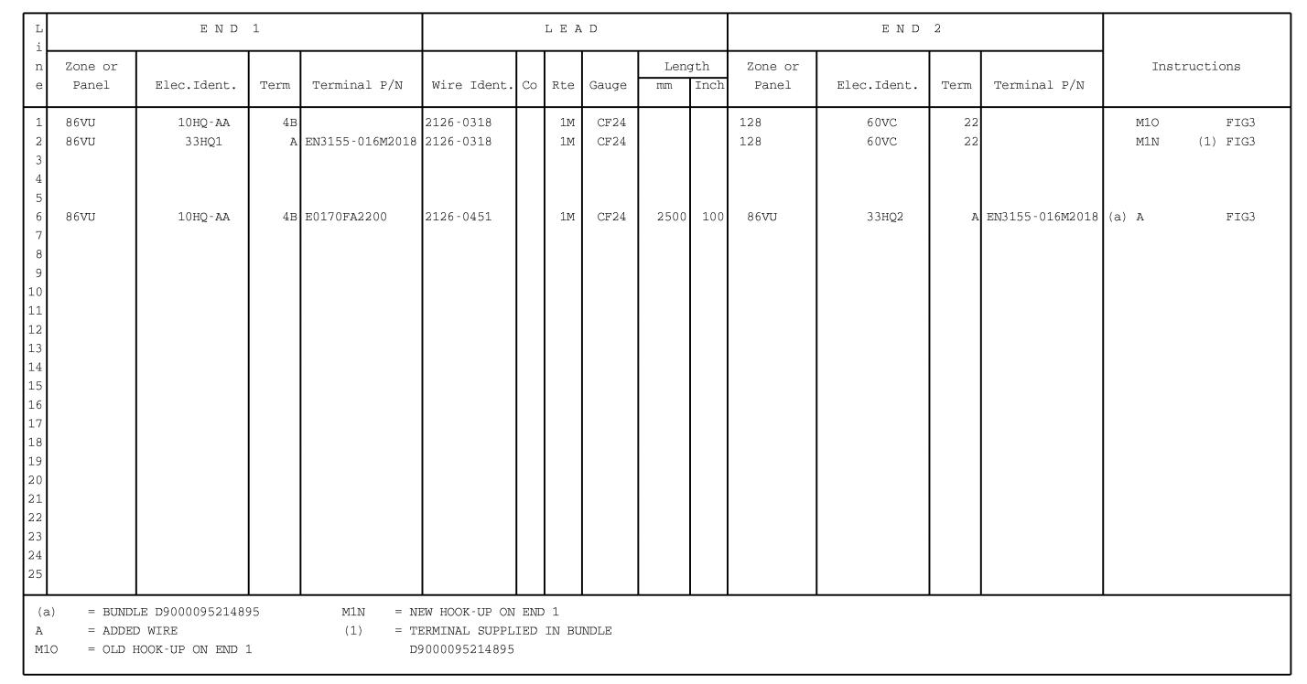

Figure 4 Sheet 1

Hook-up Chart

DATE : Apr 03/01

REVISION No . : 01 — Mar 06/02

SERVICE BULLETIN No . : A320— 21— 1129

Page : 19/20

Printed in FRANCE © AIRBUS INDUSTRIE, 2002 All rights reserved