@ A319/A320/A321

SERVICE BULLETIN

REVISION TRANSMITTAL SHEET

AIRBUS INDUSTRIE

CUSTOMER SERVICES DIRECTORATE

1 Rond Point Maurice Bellonte

31707 BLAGNAC CEDEX FRANCE

Tel : (33) 5 61 93 33 33

Telex : AIRBU 530526F

Fax : (33) 5 61 93 42 51

ATA SYSTEM : 21

TITLE : AIR CONDITIONING - GENERAL - FLOW CONTROL AND INDICATING - REMOVE A

PRESSURE SENSE LINE FOR FLOW CONTROL VALVE

MODIFICATION No . : 31332K7283

This page transmits Revision No . 02 of Service Bulletin No . A320-21-1131 . ADDITIONAL WORK

No additional work is required by this revision for aircraft modified by any

previous issue .

REASON

This Revision is issued to reduce the effectivity by those aircraft which

have already been modified on the production line .

CHANGES

SUMMARY

— REASON

Sentence added stating that accomplishment of this Service Bulletin is

permitted only for PNs 1303A0000-01 or -02 .

— EFFECTIVITY

Sentence added stating that accomplishment of this Service Bulletin is

permitted only for PNs 1303A0000-01 or -02 .

Sentence added stating that the serial embodiment point of Mod . No .

31332K7283 is on aircraft MSN 1618, 1630 and subsequent .

PLANNING INFORMATION

— EFFECTIVITY

Updated to remove the MSNs which have already been modified on the

production line .

Sentence added stating that the serial embodiment point of Mod . No .

31332K7283 is on aircraft MSN 1618, 1630 and subsequent .

6 DATE : Sep 27/01

REVISION No . : 02 — Sep 09/02

SERVICE BULLETIN No . : A320— 21— 1131

Page : 1 of 2

Printed in FRANCE © AIRBUS INDUSTRIE, 2002 All rights reserved

@ A319/A320/A321

SERVICE BULLETIN

REVISION TRANSMITTAL SHEET

Sentence added stating that accomplishment of this Service Bulletin is

permitted only for PNs 1303A0000-01 or -02 .

— REASON

Para . (1), sentence added stating that accomplishment of this Service

Bulletin is permitted only for PNs 1303A0000-01 or -02 .

ACCOMPLISHMENT INSTRUCTIONS

— MODIFICATION

NOTE added .

Para . (1)(a), in table, item (4), PN D2157143704000 added .

Para . (1)(c), in table, item (4), PN D2157143704400 added .

— ILLUSTRATIONS

Figure

Figure

Figure

Figure

Figure

Figure

1 Sheet

1 Sheet

1 Sheet

1 Sheet

1 Sheet

1 Sheet

2, Detail

3, Detail

4, Detail

5, Detail

6, figure

7, figure

G added .

G added .

G added .

G added .

added .

added .

NOTE : Layout changes due to computerization of this revision are not

identified .

FILING INSTRUCTIONS

This Service Bulletin has been generated electronically and is reissued as a

complete document . Replace the complete document .

Put this Revision Transmittal Sheet in front of the Service Bulletin .

HISTORY OF PREVIOUS REVISIONS

Revision No . 01 was issued to delete aircraft MSN 1618 and operator MXA from

the effectivity .

REVISION SEQUENCE

ORIGINAL : Sep 27/01

REVISION No . : 01 — Feb 08/02

REVISION No . : 02 — Sep 09/02

DATE : Sep 27/01 SERVICE BULLETIN No . : A320— 21— 1131

REVISION No . : 02 — Sep 09/02 Page : 2

Printed in FRANCE © AIRBUS INDUSTRIE, 2002 All rights reserved

@ A319/A320/A321

SERVICE BULLETIN

SUMMARY

AIRBUS INDUSTRIE

CUSTOMER SERVICES DIRECTORATE

1 Rond Point Maurice Bellonte

31707 BLAGNAC CEDEX FRANCE

Tel : (33) 5 61 93 33 33

Telex : AIRBU 530526F

Fax : (33) 5 61 93 42 51

This summary is for information only

and is not approved for modification of the aircraft

ATA SYSTEM : 21

TITLE : AIR CONDITIONING - GENERAL - FLOW CONTROL AND INDICATING - REMOVE A

PRESSURE SENSE LINE FOR FLOW CONTROL VALVE

MODIFICATION No . : 31332K7283

REASON/DESCRIPTION/OPERATIONAL CONSEQUENCES

The pressure sense line for the flow control valves 8HB and 11HB is no longer

necessary on aircraft that have the flow control valve PN 1303A0000-01 or PN

1303A0000-02 installed . The accomplishment of this Service Bulletin is permitted

only for these PNs .

This Service Bulletin details the procedure for removal of the pressure sense

line between FR35 and FR36 and installation of blanking caps .

The removal of the pressure sense line will permit spares commonality .

|  |  |  |  |
| --- | --- | --- | --- |
| EVALUATION TABLE | | | |
| COMPLIANCE | Desirable | CANCELS INSPECTION SB | No |
| POTENTIAL AD | No | A/C OPERATION AFFECTED | No |
| RELIABILITY AFFECTED | No | PAX COMFORT AFFECTED | No |
| COST SAVING | No | ETOPS AFFECTED | No |
| STRUCTURAL LIFE EXTN | No | VENDOR SB INVOLVED | No |
| KIT PRICE (USD) | No kit |  |  |

EFFECTIVITY

This Service Bulletin is applicable to these operator(s) :

AAR AEF AES AFR AJM AMM AMU ANA AUA AWE AZA BAW BMA CES CIB CJG CNW CRX CSC CSN

CTN C3J DCS DLH EDW EIN EWG F2I FIN G4I GBL HDA IBE IWD JBU KZW LAJ LBT MON NWA

QAF QTR SAB SEU SHJ SLK SYR TAI TAM TAP TAR TAS TWE TWJ UAL USA VLE WGT

The accomplishment of this Service Bulletin is permitted only if the flow

control valve PN 1303A0000-01 or PN 1303A0000-02 is installed .

6 DATE : Sep 27/01

REVISION No . : 02 — Sep 09/02

SERVICE BULLETIN No . : A320— 21— 1131

Page : 1 of 3

Printed in FRANCE © AIRBUS INDUSTRIE, 2002 All rights reserved

@ A319/A320/A321

SERVICE BULLETIN

SUMMARY

Serial embodiment point of Mod . No . 31332K7283 is on aircraft MSN 1618 , 1630

and subsequent .

CONCURRENT REQUIREMENTS

None

REFERENCES/REPERCUSSIONS

TFU

OEB

AOT

SIL

LIFE LIMIT

: None

: None

: None

: None

: None

LINE MAINTENANCE AFFECTED : No

OTHERS : None

NATURE OF THE WORK

AIRCRAFT : YES

EQUIPMENT : NO

HARD : NO

SOFT : NO

OBRM : NO

MANPOWER

TOTAL MANHOURS

2 .25

0 .75

ELAPSED TIME (HOURS)

MATERIAL INFORMATION

AIRCRAFT DATA

None

APPENDICES

None

DATE : Sep 27/01 SERVICE BULLETIN No . : A320— 21— 1131

REVISION No . : 02 — Sep 09/02 Page : 2

Printed in FRANCE © AIRBUS INDUSTRIE, 2002 All rights reserved

@ A319/A320/A321

SERVICE BULLETIN

SUMMARY

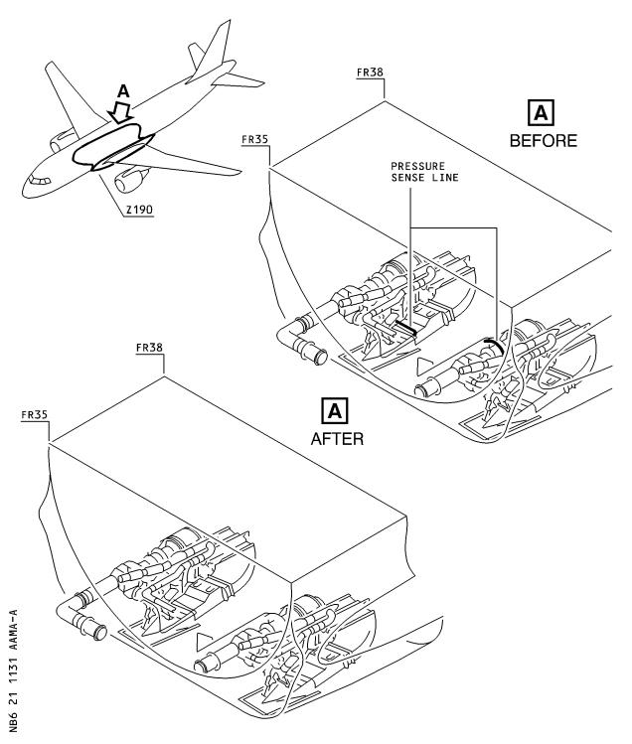

DATE : Sep 27/01 SERVICE BULLETIN No . : A320— 21— 1131

REVISION No . : 02 — Sep 09/02 Page : 3 Printed in FRANCE © AIRBUS INDUSTRIE, 2002 All rights reserved

@ A319/A320/A321

SERVICE BULLETIN

AIRBUS INDUSTRIE

CUSTOMER SERVICES DIRECTORATE

1 Rond Point Maurice Bellonte

31707 BLAGNAC CEDEX FRANCE

Tel : (33) 5 61 93 33 33

Telex : AIRBU 530526F

Fax : (33) 5 61 93 42 51

ATA SYSTEM : 21

TITLE : AIR CONDITIONING - GENERAL - FLOW CONTROL AND INDICATING - REMOVE A

PRESSURE SENSE LINE FOR FLOW CONTROL VALVE

MODIFICATION No . : 31332K7283

This document contains AIRBUS PROPRIETARY INFORMATION and shall at all times remain the property of AIRBUS; no intellectual property right or licence is granted by AIRBUS in connection with any information contained in it . It is delivered on the express condition that the said document and the information contained in it shall be treated as confidential, shall not be used for any purpose other than that for which it is hereby delivered . It shall not be disclosed in whole or in part to third parties and shall not be duplicated in any manner (except for the purposes of performing the tasks described hereunder and provided that any recipient of such document shall comply with the conditions herein), without AIRBUS prior written consent .

1. PLANNING INFORMATION

A . EFFECTIVITY

(1) Models

319-111 319-112 319-113 319-114 319-115 319-131 319-132 319-133

320-211 320-212 320-214 320-232 320-233 321-111 321-112 321-131

321-211 321-231

(2) Aircraft

(a) Effectivity by MSN

This Service Bulletin is applicable to aircraft MSN :

0844 0861 0863 0868-0869 0872 0876 0878 0880-1215

(b) Effectivity by Operator

The Operator/MSN relationship is provided for information only and is correct at the time of issue in accordance with the information available to AIRBUS . Any future changes resulting from transfer of an aircraft from one operator to another will not be reflected in this list unless the Service Bulletin is revised for another reason .

6 DATE : Sep 27/01

REVISION No . : 02 — Sep 09/02

SERVICE BULLETIN No . : A320— 21— 1131

Page : 1 of 18

Printed in FRANCE © AIRBUS INDUSTRIE, 2002 All rights reserved

@ A319/A320/A321

SERVICE BULLETIN

OPERATOR MSN

|  |  |  |  |  |  |  |  |  |
| --- | --- | --- | --- | --- | --- | --- | --- | --- |
| AAR  AEF  AES  AFR  AJM  AMM  AMU  ANA  AUA  AWE  AZA  BAW  BMA  C3J  CES  CIB  CJG  CNW  CRX  CSC  CSN  CTN  DCS  DLH  EDW  EIN  EWG  F2I  FIN  G4I  GBL  HDA  IBE  IWD | 1060  0954  0892  0938  1169  1213  1006  0908  0963  0920  0889  1075  0940  1082  0934  0883  1005  0884  0876  0897  0891  0878  0881  1009  1053  0887  0942  0926  1016  1012  0941  1002  1215  0930  0992  1101  0888 | 0990  0956  1176  1017  1008  0935  0924  1079  0951  1115  0968  0914  1028  0894  0921  0909  0987  0915  0895  1029  0901  0947  0991  1172  1054  0961  1157  0993  0994  1119 | 1004  0985  1190  1042  1137  0931  1083  0959  1118  0974  0925  1030  0905  0939  1018  0919  0900  1080  1026  1023  1068  1073  1024  1021  1154 | 1195  0998  1201  1204  1150  0953  1088  0999  1142  1014  1070  0957  0967  1144  1013  0950  1161  1094  1081  1107  1027  1180 | 1199  1000  1189  1003  1110  1138  1193  1045  1072  0971  0984  0966  1188  1102  1185  1047  1200 | 1020  1043  1111  1168  1197  1153  1093  0986  1035  1214  1145  1059  1208 | 1025  1049  1116  1174  1108  1041  1039  1160  1063 | 1036 1133 1151  1050 1056 1064  1166 1178 1196  1177 1183 1207  1057  1184  1067 1087 1099 |

DATE : Sep 27/01 SERVICE BULLETIN No . : A320— 21— 1131

REVISION No . : 02 — Sep 09/02 Page : 2

Printed in FRANCE © AIRBUS INDUSTRIE, 2002 All rights reserved

@ A319/A320/A321

SERVICE BULLETIN

OPERATOR MSN

1123

1173

1124

1156

JBU

KZW

1086

1048

1194

1121

0983

0903

1037

1149

LAJ

1175

LBT

MON

NWA

1015

1202

0911

1062

1167

0907

0962

1078

1191

0981

1091

0996

1129

0964

1090

0923

1071

1186

1011

1131

0988

1126

1058

1164

0927

QAF

QTR

SAB

SEU

SHJ

SLK

SYR

TAI

TAM

TAP

TAR

TAS

TWE

TWJ

UAL

USA

0928

0932

0995

0943

0977

0970

0973

0910

0872

1098

1085

1066

1103

0960

1206

1187

0969

1032

0916

1092

0933

1165

0958

1074

1076

1007

1096

0945

1181

0975

0899

0918

0912

1010

0917

1127

0880

0886

1117

1113

1139

0979

0902

1140

1143

0982

1159

1158

1034

0976

0906

1106

1100

1120

0869

0937

0978

1130

0913

0882

0944

1104

0868

0972

1055

1112

1170

1162

0898

1031

0863

0949

1052

1109

1155

1152

0955

1146

0896

1033

1069

1134

1203

0893

1022

0861

0946

1051

1097

1148

1132

0965

1163

0904

1038

1077

1135

1205

0948

1105

0885

0997

1061

1114

1171

1179

0980

1192

0922

1040

1084

1136

1209

0952

1128

0890

1019

1065

1122

1182

1198

0989

1211

0929

1044

1089

1141

1210

1001

0844

0936

1046

1095

1147

1125

VLE

WGT

1212

Serial embodiment point of Mod . No . 31332K7283 is on aircraft

MSN 1618 , 1630 and subsequent .

The accomplishment of this Service Bulletin is permitted only

if the flow control valve PN 1303A0000-01 or PN 1303A0000-02

is installed .

DATE : Sep 27/01 SERVICE BULLETIN No . : A320— 21— 1131

REVISION No . : 02 — Sep 09/02 Page : 3 Printed in FRANCE © AIRBUS INDUSTRIE, 2002 All rights reserved

@ A319/A320/A321

SERVICE BULLETIN

(c) Effectivity by MSN and Kit/Configuration

No AIRBUS kit is required for the accomplishment of this

Service Bulletin .

(3) Spares

None

B . CONCURRENT REQUIREMENTS

None

C . REASON

(1) History

The pressure sense line for the flow control valves 8HB and 11HB is

no longer necessary on aircraft that have the flow control valve PN

1303A0000-01 or PN 1303A0000-02 installed . The accomplishment of

this Service Bulletin is permitted only for these PNs .

(2) Objective/Action

This Service Bulletin details the procedure for removal of the

pressure sense line between FR35 and FR36 and installation of

blanking caps .

(3) Advantages

The removal of the pressure sense line will permit spares

commonality .

(4) Operational/Maintenance Consequences

None

D . DESCRIPTION

To accomplish this Service Bulletin it is necessary to :

(1) Remove the pressure sense lines .

(2) Install the blanking caps at the tees .

E . COMPLIANCE

(1) Classification

Desirable

(2) Accomplishment Timescale

In accordance with operators' maintenance schedule .

DATE : Sep 27/01 SERVICE BULLETIN No . : A320— 21— 1131

REVISION No . : 02 — Sep 09/02 Page : 4

Printed in FRANCE © AIRBUS INDUSTRIE, 2002 All rights reserved

@ A319/A320/A321

SERVICE BULLETIN

F . APPROVAL

The technical content of this Service Bulletin has been approved under

the authority of the DGAC Design Organisation Approval No . F .JA .02 .

If an aircraft listed in the effectivity has a modification or repair

embodied that is not of AIRBUS origin, and which affects the content of

this Service Bulletin, the operator is responsible for obtaining

approval by its airworthiness authority for any adaptation necessary

before incorporation of the Service Bulletin .

G . MANPOWER

The manpower estimates given in this Service Bulletin are based on the direct labor cost to do the work . These estimates assume that the work will be done by experienced personnel, and may need to be revised upwards to suit operators' circumstances . The estimates do not include the time to prepare, plan or inspect the work . Manufacture and procurement of parts and tools, drying time for paints, sealants, etc . and general administration work are also not included .

Get Access

Modification

Close-up

TOTAL MANHOURS

ELAPSED TIME (HOURS)

H . WEIGHT AND BALANCE

A319

0 .75

0 . 50

1 .00

2 .25

0 .75

Manufacturers Empty Weight : -0 .63 kg (-1 .39 lb)

Effect on Balance : -9 .01 kgm (-65 .14 lb .ft)

A320

Manufacturers Empty Weight : -0 .63 kg (-1 .39 lb)

Effect on Balance : -10 .02 kgm (-72 .43 lb .ft)

A321

Manufacturers Empty Weight : -0 .63 kg (-1 .39 lb)

Effect on Balance : -12 .71 kgm (-91 .88 lb .ft)

I . ELECTRICAL LOAD DATA

Not changed

DATE : Sep 27/01 SERVICE BULLETIN No . : A320— 21— 1131

REVISION No . : 02 — Sep 09/02 Page : 5

Printed in FRANCE © AIRBUS INDUSTRIE, 2002 All rights reserved

@ A319/A320/A321

SERVICE BULLETIN

J . REFERENCES

Aircraft Maintenance Manual (AMM)

Standards Manual (SM)

Consumable Material List (CML)

K . PUBLICATIONS AFFECTED

Illustrated Parts Catalog (IPC)

L . INTERCHANGEABILITY/MIXABILITY

Not applicable

: 12-34-24 20-21-12 21- 51-41

:

:

: 21- 51-03

DATE : Sep 27/01 SERVICE BULLETIN No . : A320— 21— 1131

REVISION No . : 02 — Sep 09/02 Page : 6

Printed in FRANCE © AIRBUS INDUSTRIE, 2002 All rights reserved

@ A319/A320/A321

SERVICE BULLETIN

2. MATERIAL INFORMATION

A . MATERIAL — PRICE AND AVAILABILITY

None

B . INDUSTRY SUPPORT INFORMATION

None

C . LIST OF COMPONENTS

None

D . LIST OF MATERIALS — OPERATOR SUPPLIED

(1) Consumable Materials

None

(2) Components

ITEM NEW PART No . QTY UM KEYWORD ITEM OLD PART No . INT INST DISP

10

AS21914-6D

2

CAP

NOTE : As an alternate for cap PN AS21914-6D the cap PN MS21914-6D

is allowed .

E . PARTS TO BE RE— IDENTIFIED BY THE OPERATOR

None

F . TOOLING — PRICE AND AVAILABILITY

None

G . SPECIAL TOOLS

None

DATE : Sep 27/01 SERVICE BULLETIN No . : A320— 21— 1131

REVISION No . : 02 — Sep 09/02 Page : 7

Printed in FRANCE © AIRBUS INDUSTRIE, 2002 All rights reserved

@ A319/A320/A321

SERVICE BULLETIN

This Page Intentionally Left Blank

DATE : Sep 27/01 SERVICE BULLETIN No . : A320— 21— 1131

REVISION No . : 02 — Sep 09/02 Page : 8

Printed in FRANCE © AIRBUS INDUSTRIE, 2002 All rights reserved

@ A319/A320/A321

SERVICE BULLETIN

3. ACCOMPLISHMENT INSTRUCTIONS

A . GENERAL

WARNING : MAKE SURE THAT YOU OBEY ALL THE WARNINGS AND CAUTIONS INCLUDED

IN THE REFERENCED PROCEDURES .

(1) Preparation

(a) Make sure that the aircraft is electrically grounded, refer to

AMM 12- 34-24 Page block 201.

(b) Put an access platform in position .

(c) Open these access panels, refer to AMM 21- 51-41 Page block 4

01 :

— 191BB and 192FB .

(2) Standard Practices

(a) Refer to the AIRBUS Standards Manual (SM) if you find part

numbers for the hardware components in the related kit(s)

which you can not identify in the LIST OF COMPONENTS of this

Service Bulletin . The SM will give you the correct part number

to part number relationship .

(b) For the material specification (Mat . No .) given in this

Service Bulletin, refer to the Consumable Material List (CML

) .

(c) To torque threaded components, refer to AMM 20-21-12 Page block 201.

B . MODIFICATION

NOTE : The accomplishment of this Service Bulletin is permitted only if

the flow control valve PN 1303A0000-01 or PN 1303A0000-02 is

installed .

(1) Remove the pressure sense lines .

Refer to Figure 1

(a) Remove these items from the flow control valve LH, item (1)

and the tee, item (2), as shown in Sheet 1, Detail A, Sheet 2

, Sheet 3 , Details B and E, Sheet 6 , Sheet 7 , Detail G :

discard

hose

bolt

bolt

washer

washer

nut

nut

D2157143704000 Item (4)

Item (5)

Item (5)

Item (6)

Item (6)

Item (7)

Item (7)

1

1

1

1

1

1

1

discard

retain

discard

retain

discard

retain

DATE : Sep 27/01 SERVICE BULLETIN No . : A320— 21— 1131

REVISION No . : 02 — Sep 09/02 Page : 9

Printed in FRANCE © AIRBUS INDUSTRIE, 2002 All rights reserved

@ A319/A320/A321

SERVICE BULLETIN

3

1

clamp

clamp

Item (8)

Item (8)

discard

retain

NOTE : Retain one clamp, item (8), in position on the relevant

sense line for later installation .

(b) Install these items, as shown in Sheet 3 , Detail E :

1 clamp Item (8) retained

with :

1 bolt Item (5) retained

1 washer Item (6) retained

1 nut Item (7) retained

(c) Remove these items from the flow control valve RH, item (1)

and the tee, item (2), as shown in Sheet 1, Detail A, Sheet 4

, Sheet 5 Details C and F, Sheet 6 , Sheet 7 , Detail G :

 1

2

2

2

2

2

NOTE

hose

bolt

washer

nut

clamp

clamp

: Retain the two

relevant sense

|  |  |
| --- | --- |
| D2157143704400 Item (3)  Item (5)  Item (6)  Item (7)  Item (8)  Item (8) | discard  retain  retain  retain  discard  retain |

clamps, item (8), in position on the

line for later installation .

(d) Install these items, as shown in Sheet 5 , Detail F :

2 clamp Item (8) retained

with :

2 bolt Item (5) retained

2 washer Item (6) retained

2 nut Item (7) retained

(2) Install the blanking caps at the tees .

Refer to Figure 1

(a) Install at the tees LH and RH, item (2), these items, as shown

in Sheet 1, Details B and C, refer to AMM 20-21-12 Page block

201:

2 blanking cap AS21914-6D Item 10

C . TEST

None

DATE : Sep 27/01 SERVICE BULLETIN No . : A320— 21— 1131

REVISION No . : 02 — Sep 09/02 Page : 10

Printed in FRANCE © AIRBUS INDUSTRIE, 2002 All rights reserved

@ A319/A320/A321

SERVICE BULLETIN

D . CLOSE UP

(1) Make sure that the work areas are clean and clear of tools and

other items of equipment .

(2) Close the access panels, refer to AMM 21- 51-41 Page block 401 :

— 191BB and 192FB .

(3) Remove the access platform .

E . DOCUMENTATION

Write in the applicable aircraft records that you have done all the work

given in this Service Bulletin .

DATE : Sep 27/01 SERVICE BULLETIN No . : A320— 21— 1131

REVISION No . : 02 — Sep 09/02 Page : 11 Printed in FRANCE © AIRBUS INDUSTRIE, 2002 All rights reserved

@ A319/A320/A321

SERVICE BULLETIN

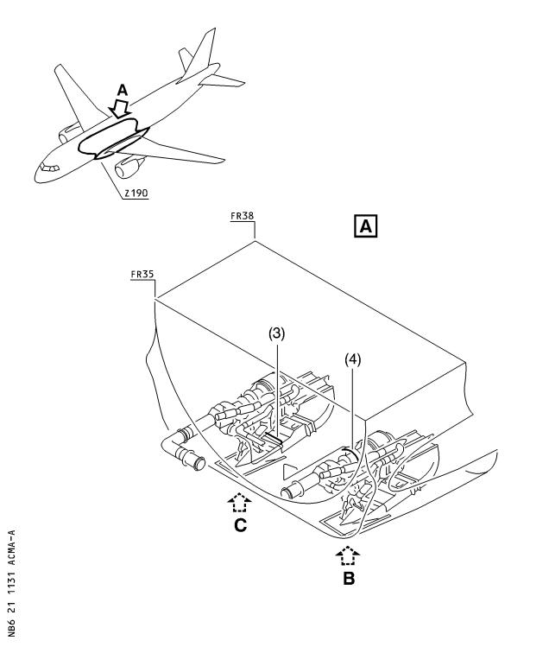

Figure 1 Sheet 1

Removal of Pressure Sense Line

DATE : Sep 27/01 SERVICE BULLETIN No . : A320— 21— 1131

REVISION No . : 02 — Sep 09/02 Page : 12 Printed in FRANCE © AIRBUS INDUSTRIE, 2002 All rights reserved

@ A319/A320/A321

SERVICE BULLETIN

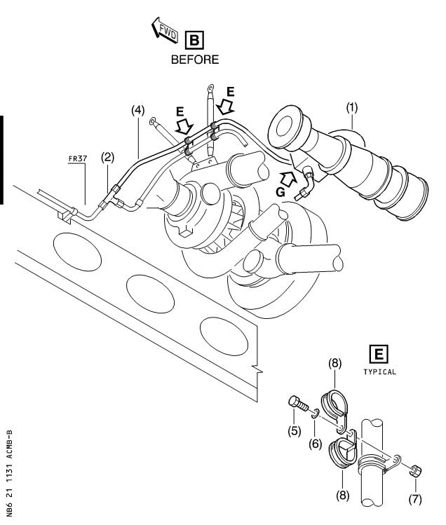

Figure 1 Sheet 2

Removal of Pressure Sense Line

DATE : Sep 27/01 SERVICE BULLETIN No . : A320— 21— 1131

REVISION No . : 02 — Sep 09/02 Page : 13 Printed in FRANCE © AIRBUS INDUSTRIE, 2002 All rights reserved

@ A319/A320/A321

SERVICE BULLETIN

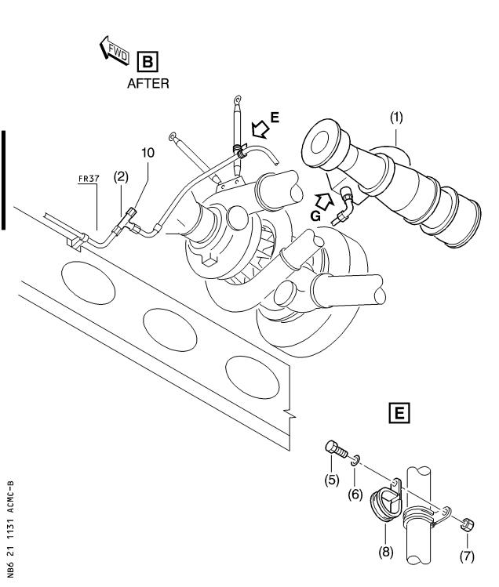

Figure 1 Sheet 3

Removal of Pressure Sense Line

DATE : Sep 27/01 SERVICE BULLETIN No . : A320— 21— 1131

REVISION No . : 02 — Sep 09/02 Page : 14 Printed in FRANCE © AIRBUS INDUSTRIE, 2002 All rights reserved

@ A319/A320/A321

SERVICE BULLETIN

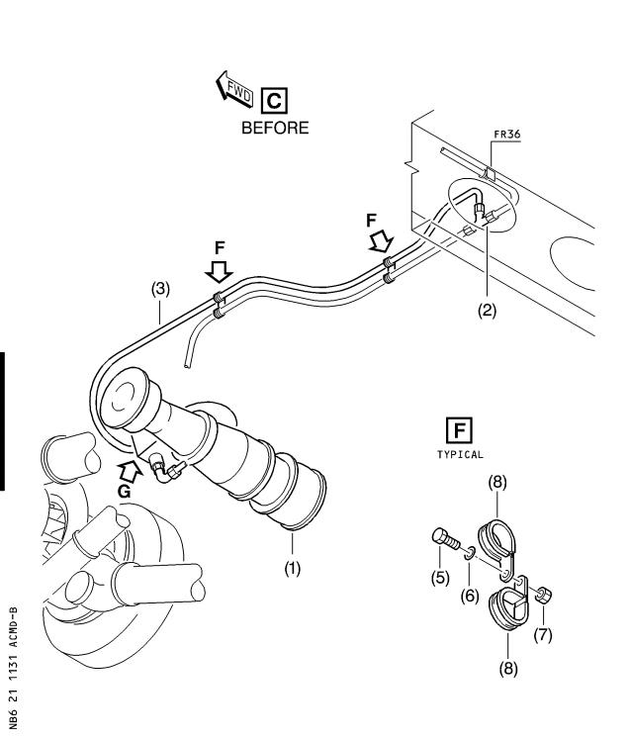

Figure 1 Sheet 4

Removal of Pressure Sense Line

DATE : Sep 27/01 SERVICE BULLETIN No . : A320— 21— 1131

REVISION No . : 02 — Sep 09/02 Page : 15 Printed in FRANCE © AIRBUS INDUSTRIE, 2002 All rights reserved

@ A319/A320/A321

SERVICE BULLETIN

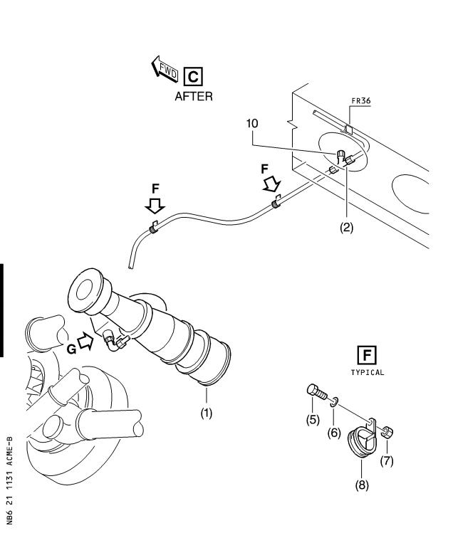

Figure 1 Sheet 5

Removal of Pressure Sense Line

DATE : Sep 27/01 SERVICE BULLETIN No . : A320— 21— 1131

REVISION No . : 02 — Sep 09/02 Page : 16 Printed in FRANCE © AIRBUS INDUSTRIE, 2002 All rights reserved

@ A319/A320/A321

SERVICE BULLETIN

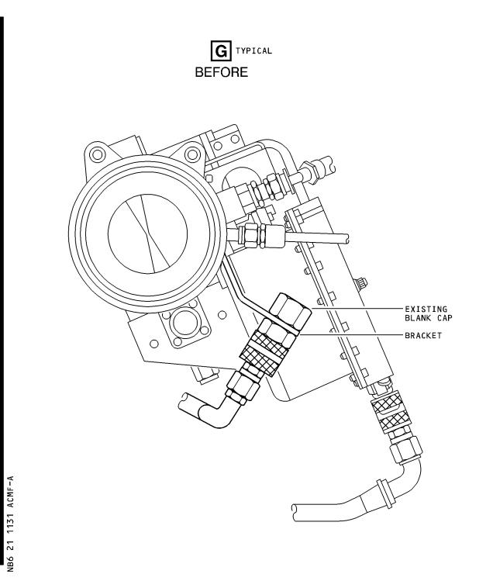

Figure 1 Sheet 6

Removal of Pressure Sense Line

DATE : Sep 27/01 SERVICE BULLETIN No . : A320— 21— 1131

REVISION No . : 02 — Sep 09/02 Page : 17 Printed in FRANCE © AIRBUS INDUSTRIE, 2002 All rights reserved

@ A319/A320/A321

SERVICE BULLETIN

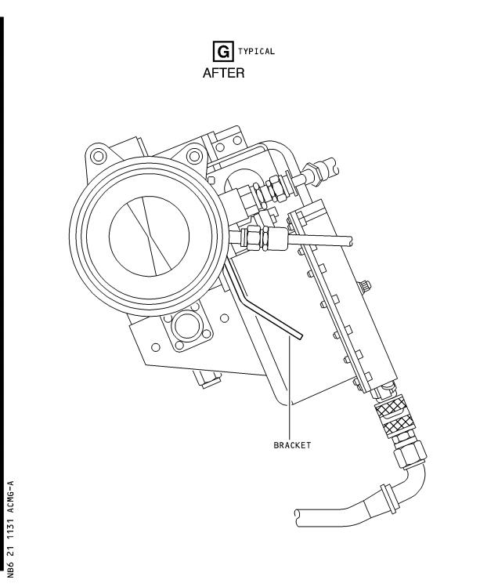

Figure 1 Sheet 7

Removal of Pressure Sense Line

DATE : Sep 27/01 SERVICE BULLETIN No . : A320— 21— 1131

REVISION No . : 02 — Sep 09/02 Page : 18 Printed in FRANCE © AIRBUS INDUSTRIE, 2002 All rights reserved

@ A319/A320/A321

SERVICE BULLETIN

REPORTING SHEET

TITLE : AIR CONDITIONING - GENERAL - FLOW CONTROL AND INDICATING - REMOVE A

PRESSURE SENSE LINE FOR FLOW CONTROL VALVE

MODIFICATION No . : 31332K7283

Please complete the appropriate item (A or B):

A - SB WILL BE embodied . . . . . . . . . . . . . YES/NO (if NO please comment)

If YES, aircraft concerned (as per SB effectivity by default) and planned dates

(month/year) of embodiment : . . . . . . . . . . . . . . . . . . . . . . . . . .

. . . . . . . . . . . . . . . . . . . . . . . . . . . . . . . . . . . . . . . .

. . . . . . . . . . . . . . . . . . . . . . . . . . . . . . . . . . . . . . . .

B - SB HAS BEEN embodied on aircraft : . . . . . . . . . . . . . . . . . . . . .

. . . . . . . . . . . . . . . . . . . . . . . . . . . . . . . . . . . . . . . .

. . . . . . . . . . . . . . . . . . . . . . . . . . . . . . . . . . . . . . . .

Operator comments : . . . . . . . . . . . . . . . . . . . . . . . . . . . . . .

. . . . . . . . . . . . . . . . . . . . . . . . . . . . . . . . . . . . . . .

. . . . . . . . . . . . . . . . . . . . . . . . . . . . . . . . . . . . . . .

From Airline : . . . . . . . . . . . . . . . . . . . . . . . . . . . . . . . . .

Name/Title : . . . . . . . . . . . . . . . . . . . . . . . . . . . . . . . . . .

Signature : . . . . . . . . . . . . . . Date : . . . . . . . . . . . . .

If operational documentation is affected (see Paragraph 1 .K of this SB): If information is needed prior to next normal revision or prior to SB embodiment, please indicate required service(s):

Either: Advance Data . . . . . . . . . . . . . . . . . . . . . YES/NO

Or : Intermediate/Temporary revision . . . . . . . . . . . . YES/NO

Important Information: This SB will only be incorporated in your maintenance and

operational documentation if this sheet is returned to Airbus Industrie and

signed by a duly authorised representative . With the next feasible revision,

this will result in

- updating of maintenance documentation to show pre and post SB data .

- updating of maintenance and operational documentation to show post SB data

after embodiment .

If this SB requires previous or simultaneous accomplishment of other SBs, Airbus

Industrie shall automatically include them in the manual revisions . Refer to SIL

00-037 for detailed information .

Please return this completed sheet to:

AIRBUS INDUSTRIE

CUSTOMER SERVICES DIRECTORATE

1 Rond Point Maurice Bellonte

31707 BLAGNAC CEDEX FRANCE

Attn: AI/SE-D32 Technical Data and Documentation Services

FAX: (+33) 5 61 93 28 06

or via your Resident Customer Support Office .

Alternatively, SB lists via letters or fax are also accepted .

6 DATE : Sep 27/01

REVISION No . : 02 — Sep 09/02

SERVICE BULLETIN No . : A320— 21— 1131

Page : 1 of 1

Printed in FRANCE © AIRBUS INDUSTRIE, 2002 All rights reserved

@ A319/A320/A321

SERVICE BULLETIN

QUALITY PERCEPTION FORM

Use this form to tell us what is your perception of the quality of this Service Bulletin . The reported data that you provide us will be used to analyse areas of difficulties and to take corrective action to further improve the quality of our Service Bulletins .

We thank you for the time you have taken in completing this form .

(Please rate on a scale of 1 to 4, with 4 being the highest score)

|  |  |  |  |
| --- | --- | --- | --- |
| - Quality rating of this SB | 4 3 | 2 | 1 |
| - Quality rating of the Accomplishment Instructions | 4 3 | 2 | 1 |
| - Quality rating of the Illustrations | 4 3 | 2 | 1 |
| - Is this SB easy to understand ? | Y / N |  |  |

If you have had difficulties in the accomplishment of this SB please quote below

the area(s) and give a short description of the issue .

Planning

X Effectivity

X Reason

X Manpower

X References

X Publication

Comments :

Material

X Kit content

X List of Materials

Operator Supplied

X Re-identification

X Tooling

Instructions

X Preparation

X Mod/Inspection

X Test

X Close-Up

X Illustrations

Operator :

Date:

Name/Title :

Please return this form to :

AIRBUS INDUSTRIE

CUSTOMER SERVICES DIRECTORATE

1 Rond Point Maurice Bellonte

31707 BLAGNAC

Attn : AI/SE-T1 Service Bulletins Management

FAX : (33) 5 61 93 42 51

Or via your Resident Customer Support Office .

6 DATE : Sep 27/01

REVISION No . : 02 — Sep 09/02

SERVICE BULLETIN No . : A320— 21— 1131

Page : 1 of 1

Printed in FRANCE © AIRBUS INDUSTRIE, 2002 All rights reserved