@ A319/A320/A321

SERVICE BULLETIN

SUMMARY

AIRBUS INDUSTRIE

CUSTOMER SERVICES DIRECTORATE

1 Rond Point Maurice Bellonte

31707 BLAGNAC CEDEX FRANCE

Tel : (33) 5 61 93 33 33

Telex : AIRBU 530526F

Fax : (33) 5 61 93 42 51

This summary is for information only

and is not approved for modification of the aircraft

ATA SYSTEM : 21

TITLE : AIR CONDITIONING - PRESSURIZATION CONTROL - MODIFICATION OF PIN

PROGRAMMING TO DISABLE USE OF EXTERNAL MODE (RETRO SOLUTION)

MODIFICATION No . : 32221K7821

REASON/DESCRIPTION/OPERATIONAL CONSEQUENCES

Operators have reported cases of cabin pressure fluctuation during the climb and

descent phase . Investigations have shown Cabin Pressure Controller (CPC) mode

switching between internal and external modes which results in cabin pressure

rate schedule changes . CPC switching is caused by a temporary loss of FMS data

which is normal during manual updating of the system in flight .

This Service Bulletin details the procedure to change the pin programming by

modification of the wiring in shelf 95VU and shelf 96VU in order to deactivate

the external mode function of the CPC .

The accomplishment of this Service Bulletin will avoid cabin pressure

fluctuations caused by CPC mode switching during the climb and descent phase .

|  |  |  |  |
| --- | --- | --- | --- |
| EVALUATION TABLE | | | |
| COMPLIANCE | Desirable | CANCELS INSPECTION SB | No |
| POTENTIAL AD | No | A/C OPERATION AFFECTED | No |
| RELIABILITY AFFECTED | No | PAX COMFORT AFFECTED | No |
| COST SAVING | No | ETOPS AFFECTED | No |
| STRUCTURAL LIFE EXTN | No | VENDOR SB INVOLVED | No |
| KIT PRICE  (USD)A01R00 | FOC |  |  |

EFFECTIVITY

This Service Bulletin is applicable to these operator(s) :

ACA CIB DLH SAS

6 DATE : Sep 30/02

REVISION No . : 00 —

SERVICE BULLETIN No . : A320— 21— 1138

Page : 1 of 3

Printed in FRANCE © AIRBUS INDUSTRIE, 2002 All rights reserved

@ A319/A320/A321

SERVICE BULLETIN

SUMMARY

CONCURRENT REQUIREMENTS

None

REFERENCES/REPERCUSSIONS

TFU

OEB

AOT

SIL

LIFE LIMIT

: None

: None

: None

: None

: None

LINE MAINTENANCE AFFECTED : No

OTHERS : None

NATURE OF THE WORK

Kit 211138A01R00

AIRCRAFT : YES

EQUIPMENT : NO

HARD : NO

SOFT : NO

OBRM : NO

MANPOWER

Kit 211138A01R00

TOTAL MANHOURS

12 .00

12 .00

ELAPSED TIME (HOURS)

MATERIAL INFORMATION

AIRCRAFT DATA

Kit 211138A01R00

Bundle .

APPENDICES

None

DATE : Sep 30/02 SERVICE BULLETIN No . : A320— 21— 1138

REVISION No . : 00 — Page : 2

Printed in FRANCE © AIRBUS INDUSTRIE, 2002 All rights reserved

@ A319/A320/A321

SERVICE BULLETIN

SUMMARY

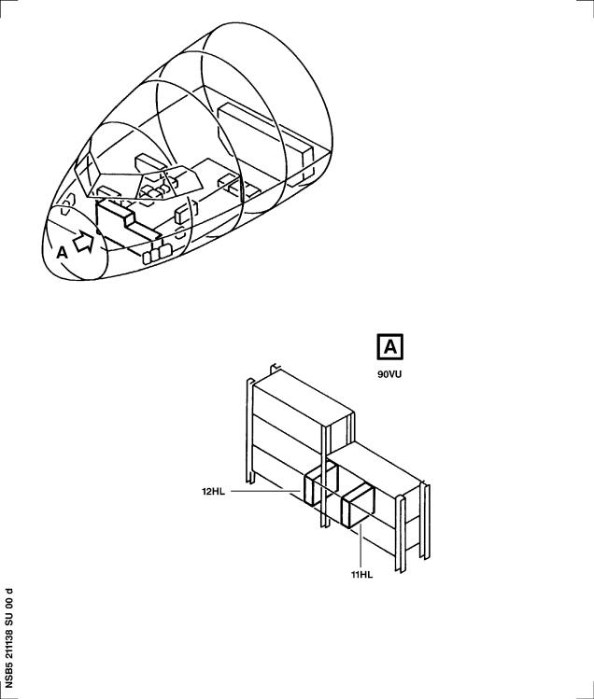

DATE : Sep 30/02 SERVICE BULLETIN No . : A320— 21— 1138

REVISION No . : 00 — Page : 3

Printed in FRANCE © AIRBUS INDUSTRIE, 2002 All rights reserved

@ A319/A320/A321

SERVICE BULLETIN

AIRBUS INDUSTRIE

CUSTOMER SERVICES DIRECTORATE

1 Rond Point Maurice Bellonte

31707 BLAGNAC CEDEX FRANCE

Tel : (33) 5 61 93 33 33

Telex : AIRBU 530526F

Fax : (33) 5 61 93 42 51

ATA SYSTEM : 21

TITLE : AIR CONDITIONING - PRESSURIZATION CONTROL - MODIFICATION OF PIN

PROGRAMMING TO DISABLE USE OF EXTERNAL MODE (RETRO SOLUTION)

MODIFICATION No . : 32221K7821

This document contains AIRBUS PROPRIETARY INFORMATION and shall at all times remain the property of AIRBUS; no intellectual property right or licence is granted by AIRBUS in connection with any information contained in it . It is delivered on the express condition that the said document and the information contained in it shall be treated as confidential, shall not be used for any purpose other than that for which it is hereby delivered . It shall not be disclosed in whole or in part to third parties and shall not be duplicated in any manner (except for the purposes of performing the tasks described hereunder and provided that any recipient of such document shall comply with the conditions herein), without AIRBUS prior written consent .

1. PLANNING INFORMATION

A . EFFECTIVITY

(1) Models

319-112 319-114 320-211 320-212 320-214 321-131 321-211 321-231

321-232

(2) Aircraft

(a) Effectivity by MSN

This Service Bulletin is applicable to aircraft MSN :

0717 0723 0729 0738 0744 0774 0793 0809 0853 0860 0875 0884

0887 0894 0901 0905 0957 0971 1080 1161 1188 1214 1260 1273

1337 1365 1367 1381 1402 1416 1437 1562 1577 1587 1602 1611

1619 1623 1630 1632 1638 1642 1668 1673 1675 1718-1719 1726

1742 1748 1756 1765 1772 1783 1798 1805 1807 1811 1817 1848

1853 1864 1874 1886 1940 1963 2018 2055

NOTE (01) This modification is applicable by Service Bulletin

only .

NOTE (02) This Service Bulletin is only applicable to aircraft

listed above on which Mod . No . 26251K4384 (AIR

CONDITIONING - PRESSURIZATION CONTROL - REMOVAL OF

6 DATE : Sep 30/02

REVISION No . : 00 —

SERVICE BULLETIN No . : A320— 21— 1138

Page : 1 of 16

Printed in FRANCE © AIRBUS INDUSTRIE, 2002 All rights reserved

@ A319/A320/A321

SERVICE BULLETIN

PIN PROGRAMMING TO ENABLE USE OF EXTERNAL MODE) is

embodied .

(b) Effectivity by Operator

The Operator/MSN relationship is provided for information only

and is correct at the time of issue in accordance with the

information available to AIRBUS . Any future changes resulting

from transfer of an aircraft from one operator to another will

not be reflected in this list unless the Service Bulletin is

revised for another reason .

|  |  |  |  |  |  |  |  |  |  |  |
| --- | --- | --- | --- | --- | --- | --- | --- | --- | --- | --- |
| OPERATOR | MSN |  |  |  |  |  |  |  |  |  |
| ACA | 1562 | 1577 | 1602 | 1611 | 1623 | 1630 | 1632 | 1638 | 1668 | 1673 |
|  | 1718 | 1719 | 1726 | 1742 | 1748 | 1756 | 1765 | 1772 | 1783 | 1805 |
|  | 1811 | 1853 | 1864 | 1874 | 1886 | 1940 | 1963 | 2018 | 2055 |  |
| CIB | 0774  1416 | 0793  1437 | 0809 | 0884 | 0894 | 0905 | 0957 | 0971 | 1381 | 1402 |
| DLH | 0717 | 0723 | 0729 | 0738 | 0744 | 0853 | 0860 | 0875 | 0887 | 0901 |
|  | 1080 | 1161 | 1188 | 1214 | 1260 | 1273 | 1337 | 1365 | 1367 |  |
| SAS | 1587 | 1619 | 1642 | 1675 | 1798 | 1807 | 1817 | 1848 |  |  |

(c) Effectivity by MSN and Kit/Configuration

The kits and configurations applicable to these MSNs are given

at the end of this list:

0717 0723 0729 0738 0744 0774 0793 0809 0853 0860 0875 0884

0887 0894 0901 0905 0957 0971 1080 1161 1188 1214 1260 1273

1337 1365 1367 1381 1402 1416 1437 1562 1577 1587 1602 1611

1619 1623 1630 1632 1638 1642 1668 1673 1675 1718-1719 1726

1742 1748 1756 1765 1772 1783 1798 1805 1807 1811 1817 1848

1853 1864 1874 1886 1940 1963 2018 2055

KIT No . QTY PER A/C CONFIGURATION

211138D00R00 1 None

(3) Spares

None

B . CONCURRENT REQUIREMENTS

None

DATE : Sep 30/02 SERVICE BULLETIN No . : A320— 21— 1138

REVISION No . : 00 — Page : 2

Printed in FRANCE © AIRBUS INDUSTRIE, 2002 All rights reserved

@ A319/A320/A321

SERVICE BULLETIN

C . REASON

(1) History

Operators have reported cases of cabin pressure fluctuation during

the climb and descent phase . Investigations have shown Cabin

Pressure Controller (CPC) mode switching between internal and

external modes which results in cabin pressure rate schedule

changes . CPC switching is caused by a temporary loss of FMS data

which is normal during manual updating of the system in flight .

NOTE (01) This modification is applicable by Service Bulletin only .

NOTE (02) This Service Bulletin is only applicable to aircraft

listed above on which Mod . No . 26251K4384 (AIR

CONDITIONING - PRESSURIZATION CONTROL - REMOVAL OF PIN

PROGRAMMING TO ENABLE USE OF EXTERNAL MODE) is embodied .

(2) Objective/Action

This Service Bulletin details the procedure to change the pin

programming by modification of the wiring in shelf 95VU and shelf

96VU in order to deactivate the external mode function of the CPC .

(3) Advantages

The accomplishment of this Service Bulletin will avoid cabin

pressure fluctuations caused by CPC mode switching during the climb

and descent phase .

(4) Operational/Maintenance Consequences

None

D . DESCRIPTION

To accomplish this Service Bulletin it is necessary to :

(1) Modify the wiring in the shelf 95VU .

(2) Modify the wiring in the shelf 96VU .

E . COMPLIANCE

(1) Classification

Desirable

(2) Accomplishment Timescale

In accordance with operators' maintenance schedule .

DATE : Sep 30/02 SERVICE BULLETIN No . : A320— 21— 1138

REVISION No . : 00 — Page : 3

Printed in FRANCE © AIRBUS INDUSTRIE, 2002 All rights reserved

@ A319/A320/A321

SERVICE BULLETIN

F . APPROVAL

The technical content of this Service Bulletin has been approved under

the authority of the DGAC Design Organisation Approval No . F .JA .02 .

If an aircraft listed in the effectivity has a modification or repair

embodied that is not of AIRBUS origin, and which affects the content of

this Service Bulletin, the operator is responsible for obtaining

approval by its airworthiness authority for any adaptation necessary

before incorporation of the Service Bulletin .

G . MANPOWER

The manpower estimates given in this Service Bulletin are based on the direct labor cost to do the work . These estimates assume that the work will be done by experienced personnel, and may need to be revised upwards to suit operators' circumstances . The estimates do not include the time to prepare, plan or inspect the work . Manufacture and procurement of parts and tools, drying time for paints, sealants, etc . and general administration work are also not included .

Kit 211138A01R00

Get Access

Removal/Installation of

95VU and 96VU

Modification of the wiring

Test

Close-up

TOTAL MANHOURS

ELAPSED TIME (HOURS)

H . WEIGHT AND BALANCE

Not changed

I . ELECTRICAL LOAD DATA

Not changed

0 . 50

6.00

1 . 50

3 . 50

0 . 50

12 .00

12 .00

J . REFERENCES

Aircraft Maintenance Manual (AMM)

Elec . Std . Practices Manual (ESPM)

Standards Manual (SM)

: 12-34-24 21-31-34 21-61-34

24-22-33 24-41-00 34-36-31

36-11-34 52-41-00

: 20-25- 51 20-33-00 20-33-44

DATE : Sep 30/02 SERVICE BULLETIN No . : A320— 21— 1138

REVISION No . : 00 — Page : 4

Printed in FRANCE © AIRBUS INDUSTRIE, 2002 All rights reserved

@ A319/A320/A321

SERVICE BULLETIN

K . PUBLICATIONS AFFECTED

Aircraft Maintenance Manual (AMM)

Aircraft Wiring Manual (AWM)

Aircraft Wiring List (AWL)

L . INTERCHANGEABILITY/MIXABILITY

Not applicable

: 21-31-34

: 23-31-01 23-31-02 93-00-95

93-00-96

DATE : Sep 30/02 SERVICE BULLETIN No . : A320— 21— 1138

REVISION No . : 00 — Page : 5

Printed in FRANCE © AIRBUS INDUSTRIE, 2002 All rights reserved

@ A319/A320/A321

SERVICE BULLETIN

This Page Intentionally Left Blank

DATE : Sep 30/02 SERVICE BULLETIN No . : A320— 21— 1138

REVISION No . : 00 — Page : 6

Printed in FRANCE © AIRBUS INDUSTRIE, 2002 All rights reserved

@ A319/A320/A321

SERVICE BULLETIN

2. MATERIAL INFORMATION

A . MATERIAL — PRICE AND AVAILABILITY

(1) Material

Customers with aircraft shown in the effectivity of this Service

Bulletin should send a purchase order to AIRBUS . Quote the number

of this Service Bulletin . The address is :

AIRBUS

MATERIEL SUPPORT CENTER

P .O . BOX 630262

22312 HAMBURG

GERMANY

(2) Price and Availability

Kit 211138A01R00

Cost : FOC US Dollars

Availability : 90 calendar days from receipt of order

The Kit availability given above is the standard lead time from the

date of your purchase order . If you require the Kit(s) before this

time, please include a retrofit planning schedule with your order

so that we can try to comply with your requirements .

B . INDUSTRY SUPPORT INFORMATION

None

C . LIST OF COMPONENTS

Kit 211138A01R00

|  |  |  |  |  |  |  |  |  |  |  |
| --- | --- | --- | --- | --- | --- | --- | --- | --- | --- | --- |
| ITEM | NEW PART No . | QTY UM | KEYWORD | ITEM | OLD | PART | No . | INT | INST | DISP |

D9000095216895

NSA935401-03

1

50

BUNDLE

TIE

NOTE : Refer to the AIRBUS Standards Manual (SM) if you find part

numbers for the hardware components in the related kit(s) which

you can not identify in the LIST OF COMPONENTS of this Service

Bulletin . The SM will give you the correct part number to part

number relationship .

D . LIST OF MATERIALS — OPERATOR SUPPLIED

(1) Consumable Materials

None

DATE : Sep 30/02 SERVICE BULLETIN No . : A320— 21— 1138

REVISION No . : 00 — Page : 7

Printed in FRANCE © AIRBUS INDUSTRIE, 2002 All rights reserved

@ A319/A320/A321

SERVICE BULLETIN

(2) Components

None

E . PARTS TO BE RE— IDENTIFIED BY THE OPERATOR

None

F . TOOLING — PRICE AND AVAILABILITY

None

G . SPECIAL TOOLS

None

DATE : Sep 30/02 SERVICE BULLETIN No . : A320— 21— 1138

REVISION No . : 00 — Page : 8

Printed in FRANCE © AIRBUS INDUSTRIE, 2002 All rights reserved

@ A319/A320/A321

SERVICE BULLETIN

3. ACCOMPLISHMENT INSTRUCTIONS

A . GENERAL

WARNING : MAKE SURE THAT YOU OBEY ALL THE WARNINGS AND CAUTIONS INCLUDED

IN THE REFERENCED PROCEDURES .

(1) Preparation

(a) Electrically ground the aircraft, refer to AMM 12- 34-24 Page

block 201.

(b) Put the access platform(s) in position .

(c) Open the access door 811, refer to AMM 52-41-00 Page block

001.

(d) Do the preparation procedure as specified in the

removal/installation of the Cabin Pressure Controllers (CPCs)

11HL and 12HL, refer to AMM 21- 31- 34 Page block 401.

(e) Do the preparation procedure as specified in the

removal/installation of the Electrical Generation Interface

Units (EGIUs) 22XU1 and 22XU2, refer to AMM 24-22- 33 Page

block 401.

(f) Do the preparation procedure as specified in the

removal/installation of the Instrument Landing System (ILS)

receivers 2RT1 and 2RT2 or the Multi-Mode Receivers (MMRs)

40RT1 and 40RT2, refer to AMM 34- 36- 31 Page block 401.

(g) Do the preparation procedure as specified in the

removal/installation of the Bleed Monitoring Computers (BMCs)

1HA1 and 1HA2, refer to AMM 36-11- 34 Page block 401.

(h) Do the preparation procedure as specified in the

removal/installation of the Pack Controllers (PCs) 7HH and

27HH, refer to AMM 21-61- 34 Page block 401.

(2) Standard Practices

(a) Refer to the AIRBUS Standards Manual (SM) if you find part

numbers for the hardware components in the related kit(s)

which you can not identify in the LIST OF COMPONENTS of this

Service Bulletin . The SM will give you the correct part number

to part number relationship .

(b) Obey the instructions for the general wiring installation,

refer to ESPM 20- 33-00 .

(c) To install new wires, cut them to the necessary length, crimp

the terminals and connect them .

(d) Do a continuity test of the new wires .

DATE : Sep 30/02 SERVICE BULLETIN No . : A320— 21— 1138

REVISION No . : 00 — Page : 9

Printed in FRANCE © AIRBUS INDUSTRIE, 2002 All rights reserved

@ A319/A320/A321

SERVICE BULLETIN

(e) For the cable tie application and tooling, refer to ESPM 20-25- 51 and ESPM 20-33-44 .

B . MODIFICATION

(1) Modify the wiring in the shelf 95VU .

Refer to Figure 1

Refer to Figure 2

(a) Remove the CPC1 (FIN 11HL), refer to AMM 21-31-34 Page block

401.

(b) Remove the EGIU-1 (FIN 22XU1), if necessary, refer to AMM

24-22- 33 Page block 401.

(c) Remove the ILS receiver 1 (FIN 2RT1) or the MMR1 (FIN 40RT1),

if necessary, refer to AMM 34- 36- 31 Page block 401.

(d) Remove the BMC-1 (FIN 1HA1), if necessary, refer to AMM

36-11- 34 Page block 401.

(e) Remove the PC1 (FIN 7HH), if necessary, refer to AMM 21-61- 34

Page block 401.

NOTE : Removal of all the above applicable computers has to be done

in relation with the aircraft configuration .

(f) On the electronics rack 90VU, remove and retain the shelf 95VU

and its fasteners .

(g) Install the wire shown on the line 1, refer to Figure 2 ,

supplied in :

bundle D9000095216895

(h) Route it with the wires that are in the rack .

(i) Attach the wire with :

25 cable tie NSA935401-03

(j) On the electronics rack 90VU, install the shelf 95VU and its

fasteners retained at removal .

(k) Install the CPC1 (FIN 11HL), refer to AMM 21-31-34 Page block

401.

(l) Install the EGIU-1 (FIN 22XU1), if removed, refer to AMM

24-22- 33 Page block 401.

(m) Install the ILS receiver 1 (FIN 2RT1) or the MMR1 (FIN 40RT1),

if removed, refer to AMM 34- 36- 31 Page block 401.

(n) Install the BMC-1 (FIN 1HA1), if removed, refer to AMM

36-11- 34 Page block 401.

DATE : Sep 30/02 SERVICE BULLETIN No . : A320— 21— 1138

REVISION No . : 00 — Page : 10

Printed in FRANCE © AIRBUS INDUSTRIE, 2002 All rights reserved

@ A319/A320/A321

SERVICE BULLETIN

(o) Install the PC1 (FIN 7HH), if removed, refer to AMM 21-61- 34

Page block 401.

(2) Modify the wiring in the shelf 96VU .

Refer to Figure 1

Refer to Figure 2

(a) Remove the CPC2 (FIN 12HL), refer to AMM 21-31-34 Page block

401.

(b) Remove the EGIU-2 (FIN 22XU2), if necessary, refer to AMM

24-22- 33 Page block 401.

(c) Remove the ILS receiver 2 (FIN 2RT2) or the MMR2 (FIN 40RT2),

if necessary, refer to AMM 34- 36- 31 Page block 401.

(d) Remove the BMC-2 (FIN 1HA2), if necessary, refer to AMM

36-11- 34 Page block 401.

(e) Remove the PC2 (FIN 27HH), if necessary, refer to AMM 21-61- 34

Page block 401.

NOTE : Removal of all the above applicable computers has to be done

in relation with the aircraft configuration .

(f) On the electronics rack 90VU, remove and retain the shelf 96VU

and its fasteners .

(g) Install the wire shown on the line 2, refer to Figure 2 ,

supplied in :

bundle D9000095216895

(h) Route it with the wires that are in the rack .

(i) Attach the wire with :

25 cable tie NSA935401-03

(j) On the electronics rack 90VU, install the shelf 96VU and its

fasteners retained at removal .

(k) Install the CPC2 (FIN 12HL), refer to AMM 21-31-34 Page block

401.

(l) Install the EGIU-2 (FIN 22XU2), if removed, refer to AMM

24-22- 33 Page block 401.

(m) Install the ILS receiver 2 (FIN 2RT2) or the MMR2 (FIN 40RT2),

if removed, refer to AMM 34- 36- 31 Page block 401.

(n) Install the BMC-2 (FIN 1HA2), if removed, refer to AMM

36-11- 34 Page block 401.

DATE : Sep 30/02 SERVICE BULLETIN No . : A320— 21— 1138

REVISION No . : 00 — Page : 11

Printed in FRANCE © AIRBUS INDUSTRIE, 2002 All rights reserved

@ A319/A320/A321

SERVICE BULLETIN

(o) Install the PC2 (FIN 27HH), if removed, refer to AMM 21-61- 34

Page block 401.

C . TEST

(1) Do the test after the removal/installation of the CPCs 11HL and

12HL, refer to AMM 21- 31- 34 Page block 401.

(2) Do the test after the removal/installation of the EGIUs 22XU1 and

22XU2, refer to AMM 24-22- 33 Page block 401, if installed .

(3) Do the test after the removal/installation of the ILS receivers

2RT1 and 2RT2 or the MMRs 40RT1 and 40RT2, refer to AMM 34- 36- 31

Page block 401, if installed .

(4) Do the test after the removal/installation of the BMCs 1HA1 and

1HA2, refer to AMM 36-11- 34 Page block 401, if installed .

(5) Do the test after the removal/installation of the PCs 7HH and 27HH,

refer to AMM 21-61- 34 Page block 401, if installed .

D . CLOSE UP

(1) Make sure that the work areas are clean and clear of tools and

other items of equipment .

(2) Close the access doors 811, refer to AMM 52-41-00 Page block 001.

(3) Remove the access platform(s) .

(4) Disconnect the aircraft electrical ground-connection, refer to AMM

12- 34-24 Page block 201.

(5) Restore the systems and the aircraft to normal operating condition .

(6) Do the close-up procedure as specified in the removal/installation

of the CPCs 11HL and 12HL, refer to AMM 21- 31- 34 Page block 401.

(7) Do the close-up procedure as specified in the removal/installation

of the EGIUs 22XU1 and 22XU2, refer to AMM 24-22- 33 Page block 401.

(8) Do the close-up procedure as specified in the removal/installation

of the ILS receivers 2RT1 and 2RT2 or the MMRs 40RT1 and 40RT2,

refer to AMM 34- 36- 31 Page block 401.

(9) Do the close-up procedure as specified in the removal/installation

of the BMCs 1HA1 and 1HA2, refer to AMM 36-11- 34 Page block 401.

(10) Do the close-up procedure as specified in the removal/installation

of the PCs 7HH and 27HH, refer to AMM 21-61- 34 Page block 401.

E . DOCUMENTATION

Write in the applicable aircraft records that you have done all the work

given in this Service Bulletin .

DATE : Sep 30/02 SERVICE BULLETIN No . : A320— 21— 1138

REVISION No . : 00 — Page : 12

Printed in FRANCE © AIRBUS INDUSTRIE, 2002 All rights reserved

@ A319/A320/A321

SERVICE BULLETIN

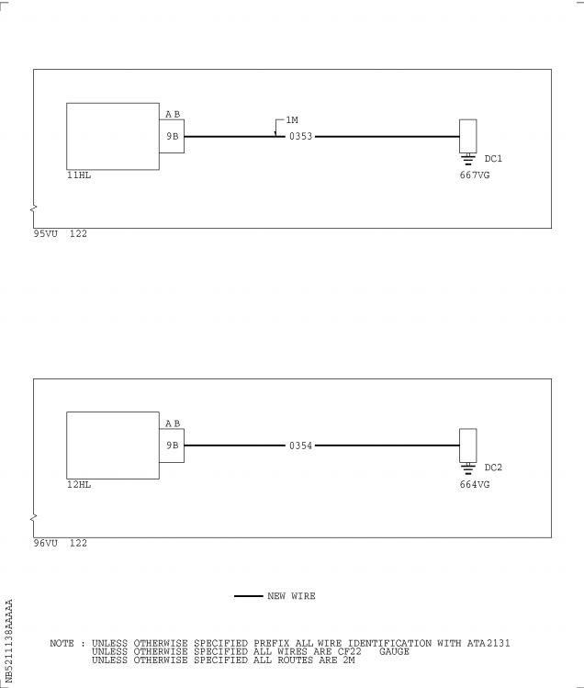

Figure 1 Sheet 1

Modification of the Wiring in 90VU

DATE : Sep 30/02 SERVICE BULLETIN No . : A320— 21— 1138

REVISION No . : 00 — Page : 13

Printed in FRANCE © AIRBUS INDUSTRIE, 2002 All rights reserved

@ A319/A320/A321

SERVICE BULLETIN

This Page Intentionally Left Blank

DATE : Sep 30/02 SERVICE BULLETIN No . : A320— 21— 1138

REVISION No . : 00 — Page : 14

Printed in FRANCE © AIRBUS INDUSTRIE, 2002 All rights reserved

@ A319/A320/A321

SERVICE BULLETIN

Figure 2 Sheet 1

Hook-up Chart(Goto A3 section)

DATE : Sep 30/02 SERVICE BULLETIN No . : A320— 21— 1138

REVISION No . : 00 — Page : 15

Printed in FRANCE © AIRBUS INDUSTRIE, 2002 All rights reserved

@ A319/A320/A321

SERVICE BULLETIN

REPORTING SHEET

TITLE : AIR CONDITIONING - PRESSURIZATION CONTROL - MODIFICATION OF PIN

PROGRAMMING TO DISABLE USE OF EXTERNAL MODE (RETRO SOLUTION)

MODIFICATION No . : 32221K7821

Please complete the appropriate item (A or B):

A - SB WILL BE embodied . . . . . . . . . . . . . YES/NO (if NO please comment)

If YES, aircraft concerned (as per SB effectivity by default) and planned dates

(month/year) of embodiment : . . . . . . . . . . . . . . . . . . . . . . . . . .

. . . . . . . . . . . . . . . . . . . . . . . . . . . . . . . . . . . . . . . .

. . . . . . . . . . . . . . . . . . . . . . . . . . . . . . . . . . . . . . . .

B - SB HAS BEEN embodied on aircraft : . . . . . . . . . . . . . . . . . . . . .

. . . . . . . . . . . . . . . . . . . . . . . . . . . . . . . . . . . . . . . .

. . . . . . . . . . . . . . . . . . . . . . . . . . . . . . . . . . . . . . . .

Operator comments : . . . . . . . . . . . . . . . . . . . . . . . . . . . . . .

. . . . . . . . . . . . . . . . . . . . . . . . . . . . . . . . . . . . . . .

. . . . . . . . . . . . . . . . . . . . . . . . . . . . . . . . . . . . . . .

From Airline : . . . . . . . . . . . . . . . . . . . . . . . . . . . . . . . . .

Name/Title : . . . . . . . . . . . . . . . . . . . . . . . . . . . . . . . . . .

Signature : . . . . . . . . . . . . . . Date : . . . . . . . . . . . . .

If operational documentation is affected (see Paragraph 1 .K of this SB): If information is needed prior to next normal revision or prior to SB embodiment, please indicate required service(s):

Either: Advance Data . . . . . . . . . . . . . . . . . . . . . YES/NO

Or : Intermediate/Temporary revision . . . . . . . . . . . . YES/NO

Important Information: This SB will only be incorporated in your maintenance and

operational documentation if this sheet is returned to Airbus Industrie and

signed by a duly authorised representative . With the next feasible revision,

this will result in

- updating of maintenance documentation to show pre and post SB data .

- updating of maintenance and operational documentation to show post SB data

after embodiment .

If this SB requires previous or simultaneous accomplishment of other SBs, Airbus

Industrie shall automatically include them in the manual revisions . Refer to SIL

00-037 for detailed information .

Please return this completed sheet to:

AIRBUS INDUSTRIE

CUSTOMER SERVICES DIRECTORATE

1 Rond Point Maurice Bellonte

31707 BLAGNAC CEDEX FRANCE

Attn: AI/SE-D32 Technical Data and Documentation Services

FAX: (+33) 5 61 93 28 06

or via your Resident Customer Support Office .

Alternatively, SB lists via letters or fax are also accepted .

6 DATE : Sep 30/02

REVISION No . : 00 —

SERVICE BULLETIN No . : A320— 21— 1138

Page : 1 of 1

Printed in FRANCE © AIRBUS INDUSTRIE, 2002 All rights reserved

@ A319/A320/A321

SERVICE BULLETIN

QUALITY PERCEPTION FORM

Use this form to tell us what is your perception of the quality of this Service Bulletin . The reported data that you provide us will be used to analyse areas of difficulties and to take corrective action to further improve the quality of our Service Bulletins .

We thank you for the time you have taken in completing this form .

(Please rate on a scale of 1 to 4, with 4 being the highest score)

|  |  |  |  |
| --- | --- | --- | --- |
| - Quality rating of this SB | 4 3 | 2 | 1 |
| - Quality rating of the Accomplishment Instructions | 4 3 | 2 | 1 |
| - Quality rating of the Illustrations | 4 3 | 2 | 1 |
| - Is this SB easy to understand ? | Y / N |  |  |

If you have had difficulties in the accomplishment of this SB please quote below

the area(s) and give a short description of the issue .

Planning

X Effectivity

X Reason

X Manpower

X References

X Publication

Comments :

Material

X Kit content

X List of Materials

Operator Supplied

X Re-identification

X Tooling

Instructions

X Preparation

X Mod/Inspection

X Test

X Close-Up

X Illustrations

Operator :

Date:

Name/Title :

Please return this form to :

AIRBUS INDUSTRIE

CUSTOMER SERVICES DIRECTORATE

1 Rond Point Maurice Bellonte

31707 BLAGNAC

Attn : AI/SE-T1 Service Bulletins Management

FAX : (33) 5 61 93 42 51

Or via your Resident Customer Support Office .

6 DATE : Sep 30/02

REVISION No . : 00 —

SERVICE BULLETIN No . : A320— 21— 1138

Page : 1 of 1

Printed in FRANCE © AIRBUS INDUSTRIE, 2002 All rights reserved

@ A319/A320/A321

SERVICE BULLETIN

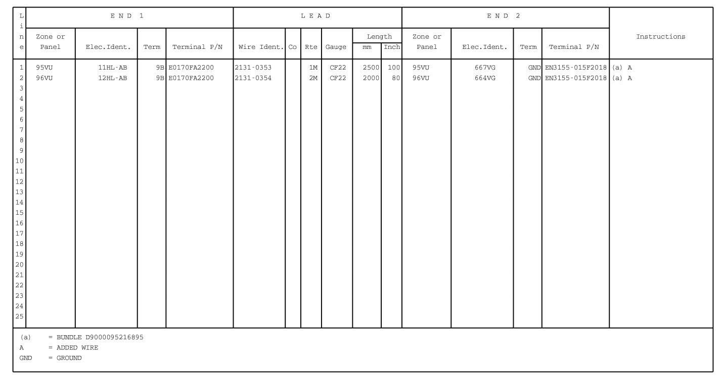

Figure 2 Sheet 1

Hook-up Chart

DATE : Sep 30/02

REVISION No . : 00 —

SERVICE BULLETIN No . : A320— 21— 1138

Page : 15/16

Printed in FRANCE © AIRBUS INDUSTRIE, 2002 All rights reserved