

SERVICE BULLETIN

REVISION TRANSMITTAL SHEET

**AIRBUS**

**CUSTOMER** **SERVICES** **DIRECTORATE**

**1** **Rond** **Point** **Maurice** **Bellonte**

**31707** **BLAGNAC** **CEDEX** **FRANCE**

**Tel** **:** **(33)** **5** **61** **93** **33** **33**

**Telex** **:** **AIRBU** **530526F**

**Fax** **:** **(33)** **5** **61** **93** **42** **51**

**ATA** **SYSTEM** **:** **21**

**TITLE** **:** **AIR** **CONDITIONING** **-** **PACK** **TEMPERATURE** **CONTROL** **-** **INSTALL** **PACK** **TEMPERATURE** **CONTROLLER** **PN** **759C0000-03**

**MODIFICATION** **No.** **:** 34732K9632

This page transmits Revision No. 01 of Service Bulletin No. A320-21- 1151.

ADDITIONAL WORK

Additional work is required by this revision for aircraft modified by Revision No. 00.

REASON

This Revision is issued to :

- delete aircraft MSN 0010, 0013, 0031, 0034, 0040, 0041 and 0177 from the effectivity and update the operators,

- add work steps to modify the wiring in the shelves 95VU and 96VUs,

- introduce a new kit,

- add the ADDITIONAL WORK for Config. 01.

CHANGES

SUMMARY :

- REASON/DESCRIPTION/OPERATIONAL CONSEQUENCES

. Sentence amended and MODIFICATION CLASSIFICATION table added.

- EFFECTIVITY

. Operators updated.

- MANPOWER

. Config. 01 and 02 values added. Manpower for ADDITIONAL WORK added.

- MATERIAL INFORMATION

. Material information added.

DATE : Jun 30/05

REVISION No. : 01 - Oct 09/09

SERVICE BULLETIN No. : A320-21- 1151

Page : 1 of 4



SERVICE BULLETIN

REVISION TRANSMITTAL SHEET

PLANNING INFORMATION :

- EFFECTIVITY

. 1.A. Aircraft MSN 0010, 0013,00031, 0034, 0040, 0041, 0177 deleted and operators updated.

NOTE for ADDITIONAL WORK added.

- REASON

- Objective/Action

. 1.C.(2) amended.

- DESCRIPTION

. 1.D. Config. 01, 02 and work steps added. ADDITIONAL WORK added.

- MANPOWER

. 1.G. Config. 01 and 02 added. Total Manhours and Elapsed Time due to additional work steps

updated. Manpower for ADDITIONAL WORK added.

- REFERENCES

. 1.J. References added.

- PUBLICATIONS AFFECTED

. 1.K. IPC and AWL references added.

MATERIAL INFORMATION :

- MATERIAL - PRICE AND AVAILABILITY

- Material

. 2.A.(1) Address added.

- Price and Availability

. 2.A.(2) Kit A01 added.

- INDUSTRIAL SUPPORT

. 2.B. VSB information added.

- LIST OF COMPONENTS

. 2.C. Kit A01 added.

- LIST OF MATERIALS - OPERATOR SUPPLIED

- Consumable Materials

DATE : Jun 30/05

REVISION No. : 01 - Oct 09/09

SERVICE BULLETIN No. : A320-21- 1151

Page : 2



SERVICE BULLETIN

REVISION TRANSMITTAL SHEET

. 2.D.(1) CML materials added.

ACCOMPLISHMENT INSTRUCTIONS :

- Preparation

. 3.A.(1) Config. 01, 02 and work steps added.

- Standard Practices

. 3.A.(2) Work steps added.

- MODIFICATION

. 3.B. Config. 01, 02 and work steps added.

. 3.B.(3) Work steps for ADDITIONAL WORK added.

- TESTS

. 3.C. Config. 01, 02 and work steps added.

- CLOSE-UP

. 3.D. Config. 01, 02 and work steps added.

- Figure 1

. Figure added.

- Figure 2

. Figure added.

- Figure 4

. Affected Pin changed from AA-6C to AB-6C.

- Figure 5

. Figure added.

- Figure 6

. Figure added.

- Figure 7

. Figure added.

- Figure 8

. Figure added.

DATE : Jun 30/05

REVISION No. : 01 - Oct 09/09

SERVICE BULLETIN No. : A320-21- 1151

Page : 3

Printed in France © AIRBUS 2008 All rights reserved



SERVICE BULLETIN

REVISION TRANSMITTAL SHEET

NOTE : Layout changes due to computerization of this revision are not identified.

FILING INSTRUCTIONS

This Service Bulletin has been generated electronically and is reissued as a complete document. Replace the complete document.

Put this Revision Transmittal Sheet in front of the Service Bulletin.

HISTORY OF PREVIOUS REVISIONS

No previous revisions.

REVISION SEQUENCE

ORIGINAL : Jun 30/05

REVISION No. : 01 - Oct 09/09

DATE : Jun 30/05

REVISION No. : 01 - Oct 09/09

SERVICE BULLETIN No. : A320-21- 1151

Page : 4

Printed in France © AIRBUS 2008 All rights reserved



SERVICE BULLETIN

SUMMARY

**AIRBUS**

**CUSTOMER** **SERVICES** **DIRECTORATE**

**1** **Rond** **Point** **Maurice** **Bellonte**

**31707** **BLAGNAC** **CEDEX** **FRANCE**

**Tel** **:** **(33)** **5** **61** **93** **33** **33**

**Telex** **:** **AIRBU** **530526F**

**Fax** **:** **(33)** **5** **61** **93** **42** **51**

This summary is for information only and is

not approved for modification of the aircraft

**ATA** **SYSTEM** **:** **21**

**TITLE** **:** **AIR** **CONDITIONING** **-** **PACK** **TEMPERATURE** **CONTROL** **-** **INSTALL** **PACK** **TEMPERATURE** **CONTROLLER** **PN** **759C0000-03**

**MODIFICATION** **No.** **:** 34732K9632

REASON/DESCRIPTION/OPERATIONAL CONSEQUENCES

On several in-service aircraft the Ram-Air Outlet Door has been deleted. As a result of the omission of the Ram-Air Outlet Actuator the corresponding Pack Controller has to be modified.

This Service Bulletin advises operators of the release of the LIEBHERR-AEROSPACE LINDENBERG Service Bulletin No. 759A-21-09 which introduces the improved pack temperature controller PN 759C0000-03.

This Service Bulletin permits the operator to install the improved pack temperature controller PN 759C0000-03 and to modify the wiring in the shelves 95VU and 96VU.

The accomplishment of this Service Bulletin will ensure proper function of the Environmental Control System (ECS) without Ram Air Outlet Actuator.

|  |  |  |  |
| --- | --- | --- | --- |
| EVALUATION TABLE | | | |
| COMPLIANCE | Desirable | CANCELS INSPECTION SB | No |
| POTENTIAL AD | No | A/C OPERATION AFFECTED | No |
| RELIABILITY AFFECTED | No | PAX COMFORT AFFECTED | No |
| COST SAVING | Yes | ETOPS AFFECTED | No |
| STRUCTURAL LIFE EXTN | No | VENDOR SB INVOLVED | Yes |
| KIT PRICE (USD) | See SB |  |  |

DATE : Jun 30/05 SERVICE BULLETIN No. : A320-21- 1151 REVISION No. : 01 - Oct 09/09 Page : 1 of 4



SERVICE BULLETIN

SUMMARY

|  |  |
| --- | --- |
| MODIFICATION CLASSIFICATION | |
| MAJOR | None |
| MINOR | 34732K9632 |

As per EASA IR 21, a minor change is one that has no appreciable effect on the mass, balance, structural strength, reliability, operational characteristics affecting the airworthiness of the product. All other changes are major changes.

**EFFECTIVITY**

This Service Bulletin is applicable to this (these) operator(s) :

31V 36V 47W 50X 86Z AAF AAN AAR ABQ ACA ADR AFR AHY AJM ALK AMU ANA ART ATC AUA AZA BAB BAW BEL BGH BIE BMA BST BTV CCA CCM CES CGL CIB CLI CQH CQN CSA CSC CSN CTN CYP D2F DLH EEZ EIN ETD F2I FHY G2X G8E GFA HDA HEJ HVN IAC IBE IRA ISR JAV JET KAC KKK LBT LBY LFO LVG MDL MLD MNJ MON MPD MSR MXA MYW NWA OHY P2G PAL RNV RYW RZO SDM SHY SSV STZ SVR SWR TAE TAM TAP TAR TAS TCW TCX THY TNA TOM TRK UAL UDC USA VBW VLK WZZ XLF

CONCURRENT REQUIREMENTS

This Service Bulletin can be done at the same time as :

Service Bulletin No. A320-21- 1150

Mod. No. 34651K9631

REFERENCES/REPERCUSSIONS

TFU

: None : None : None : None

: None

OEB

AOT

SIL

LIFE LIMIT

LINE MAINTENANCE AFFECTED : No

OTHERS : None

NATURE OF THE WORK

AIRCRAFT : NO

EQUIPMENT : YES

HARD : YES

SERVICE BULLETIN No. : A320-21- 1151 Page : 2

DATE : Jun 30/05

REVISION No. : 01 - Oct 09/09



SERVICE BULLETIN

SUMMARY

SOFT : YES

OBRM : NO

MANPOWER

Config. 01

**TOTAL** **MANHOURS**

**18.00**

**18.00**

**ELAPSED** **TIME** **(HOURS)**

NOTE : For modification of the pack controllers refer to LIEBHERR-AEROSPACE LINDENBERG Service Bulletin No. 759A-21-09.

Config. 01 ADDITIONAL WORK

**TOTAL** **MANHOURS**

**18.00**

**18.00**

**ELAPSED** **TIME** **(HOURS)**

Config. 02

**TOTAL** **MANHOURS** **3.00**

**ELAPSED** **TIME** **(HOURS)** **3.00**

NOTE : For modification of the pack controllers refer to LIEBHERR-AEROSPACE LINDENBERG Service Bulletin No. 759A-21-09.

MATERIAL INFORMATION

AIRCRAFT DATA

Config. 01

Electrical bundle and equipment

Config. 02

No Kit

APPENDICES

None

DATE : Jun 30/05

REVISION No. : 01 - Oct 09/09

SERVICE BULLETIN No. : A320-21- 1151

Page : 3



SERVICE BULLETIN

SUMMARY

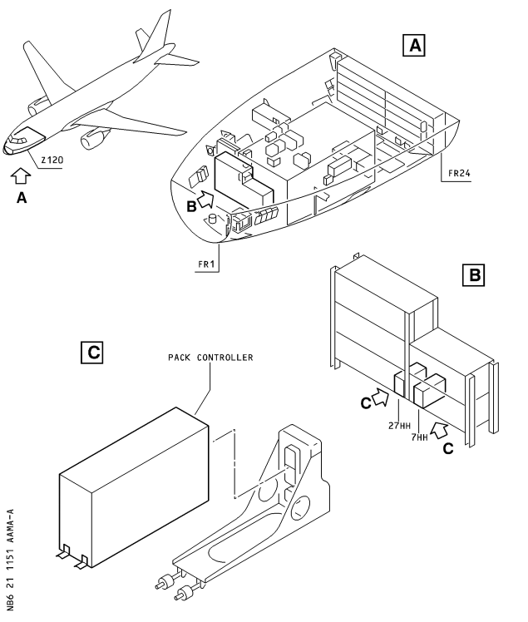

DATE : Jun 30/05

REVISION No. : 01 - Oct 09/09

SERVICE BULLETIN No. : A320-21- 1151

Page : 4



SERVICE BULLETIN

**AIRBUS**

**CUSTOMER** **SERVICES** **DIRECTORATE**

**1** **Rond** **Point** **Maurice** **Bellonte**

**31707** **BLAGNAC** **CEDEX** **FRANCE**

**Tel** **:** **(33)** **5** **61** **93** **33** **33**

**Telex** **:** **AIRBU** **530526F**

**Fax** **:** **(33)** **5** **61** **93** **42** **51**

**ATA** **SYSTEM** **:** **21**

**TITLE** **:** **AIR** **CONDITIONING** **-** **PACK** **TEMPERATURE** **CONTROL** **-** **INSTALL** **PACK** **TEMPERATURE** **CONTROLLER** **PN** **759C0000-03**

**MODIFICATION** **No.** **:** 34732K9632

This document contains AIRBUS PROPRIETARY INFORMATION and shall at all times remain the property of AIRBUS; no intellectual property right or licence is granted by AIRBUS in connection with any information contained in it. It is delivered on the express condition that the said document and the information contained

in it shall be treated as confidential, shall not be used for any purpose other than that for which it is hereby delivered. It shall not be disclosed in whole or in part to third parties and shall not be duplicated in any manner (except for the purposes of performing the tasks described hereunder and provided that any recipient of such document shall comply with the conditions herein), without AIRBUS prior written consent.

**1.** **PLANNING** **INFORMATION**

**A.** **EFFECTIVITY**

(1) Models

319- 111 319- 112 319- 113 319- 114 319- 131 320- 111 320-211 320-212 320-214 320-231

320-232 320-233 321- 111 321- 112 321- 131 321-211 321-212 321-231

(2) Aircraft

(a) Effectivity by MSN

This Service Bulletin is applicable to aircraft MSN :

0002 0003 0005 0007 0008 0012 0014 0016 0019-0021 0029 0037-0039 0042-0059

0061-0078 0080-0090 0093-0104 0108-0130 0132-0176 0178-0237 0239-0260

0262-0270 0272-0303 0305-0337 0339-0373 0375-0396 0398-0432 0434-0480

0482-0535 0537-0546 0548-0601 0603-0631 0633-0707 0709-0752 0754-0788

0790-0843 0845-0860 0862 0864-0867 0870 0871 0873-0875 0877 0879

(b) Effectivity by Operator

The Operator/MSN relationship is provided for information only and is correct at the time of issue in accordance with the information available to AIRBUS. Any future changes resulting from transfer of an aircraft from one operator to another will not be reflected in this list unless the Service Bulletin is revised for another reason.

DATE : Jun 30/05

REVISION No. : 01 - Oct 09/09

SERVICE BULLETIN No. : A320-21- 1151

Page : 1 of 38



SERVICE BULLETIN

OPERATOR

31V

36V

47W

50X

86Z

AAF

AAN

AAR

ABQ

ACA

ADR

AFR

AHY

AJM

ALK

AMU

ANA

ART

ATC

AUA

MSN

0313 0363 0438 0445

0134 0136

0764

0543 0661

0164 0179 0406 0461

0244 0558 0639 0808 0823

0430 0527 0565

0802

0394 0443 0760

0059 0068 0073 0084 0122 0126 0127 0141 0149 0150 0154 0159

0174 0175 0183 0210 0231 0232 0233 0242 0248 0253 0254 0255

0265 0277 0284 0290 0309 0324 0330 0341 0378 0403 0404 0546

0572 0634 0656 0670 0672 0682 0688 0691 0693 0695 0697 0711

0719 0721 0728 0732 0736 0740 0742 0752 0757 0769 0773 0779

0785 0800 0813 0817 0829 0831 0840 0845

0043 0113 0114

0002 0005 0007 0012 0014 0016 0019 0020 0021 0044 0061 0062

0063 0100 0101 0102 0108 0115 0128 0129 0130 0133 0144 0145

0155 0156 0184 0186 0187 0188 0214 0226 0227 0228 0235 0236

0237 0239 0270 0278 0285 0286 0287 0337 0352 0377 0491 0498

0509 0521 0529 0544 0598 0600 0608 0618 0625 0637 0777 0796

0331

0624 0626 0628

0169 0315

0557 0597 0620 0631 0805

0139 0151 0167 0170 0196 0212 0219 0245 0300 0328 0365 0383

0413 0482 0501 0507 0531 0534 0549 0554 0658 0669 0685

0142 0310 0311 0359 0446 0726

0630

0552 0570 0581 0768 0776 0797

DATE : Jun 30/05

REVISION No. : 01 - Oct 09/09

SERVICE BULLETIN No. : A320-21- 1151

Page : 2



SERVICE BULLETIN

OPERATOR AZA

BAB

BAW

BEL

BGH

BIE

BMA

BST

BTV

CCA

CCM

CES

CGL

CIB

CLI

CQH

CQN

CSA

CSC

CSN

CTN

CYP

D2F

MSN

0434 0477 0488 0494 0495 0513 0514 0515 0516 0524 0526 0532

0576 0583 0586 0593 0599 0765 0819 0848

0579 0645

0039 0042 0103 0109 0120

0644

0221 0294 0305 0349

0293 0517 0519 0535 0642 0827

0835

0604 0614

0168 0441 0449

0707 0724

0533 0548

0665 0754 0772 0799 0828 0838 0854

0234 0453

0774 0809

0146 0199 0240 0241 0264

0879

0696 0698 0704 0705

0674 0684

0540 0550 0551 0556 0573 0582 0591 0874

0709 0710 0712 0718 0720 0722 0849 0859

0258 0671 0767 0833

0037 0038 0180 0256 0295 0316

0211 0376

DATE : Jun 30/05

REVISION No. : 01 - Oct 09/09

SERVICE BULLETIN No. : A320-21- 1151

Page : 3



SERVICE BULLETIN

OPERATOR DLH

EEZ

EIN

ETD

F2I

FHY

G2X

G8E

GFA

HDA

HEJ

HVN

IAC

IBE

IRA

ISR

JAV

JET

KAC

KKK

LBT

DATE : Jun 30/05

REVISION No. : 01 - Oct 09/09

MSN

0069 0070 0071 0072 0078 0083 0086 0093 0094 0104 0110 0111

0116 0117 0135 0137 0147 0161 0162 0172 0200 0201 0202 0209

0216 0217 0218 0267 0268 0269 0346 0382 0401 0412 0458 0468

0473 0474 0484 0493 0502 0505 0518 0560 0563 0564 0567

0595 0609 0610 0616 0623 0627 0636 0641 0646 0651 0652

0654 0679 0689 0692 0694 0699 0700 0717 0723 0729 0738

0744 0794 0853 0860 0875

0737 0749

0815 0841

0350

0008

0132 0283 0288 0580 0771 0855

0190 0289

0003

0325 0375 0409 0419 0459 0466 0497 0537 0675 0761

0633 0756 0784 0812 0877

0087 0088

0590 0594 0601 0605 0607 0611 0617 0619 0648 0650

0045 0046 0047 0048 0049 0050 0051 0056 0057 0058 0074 0075

0080 0089 0090 0095 0096 0097 0225 0247 0257 0308 0314 0326

0327 0336 0344 0354 0362 0386 0396 0398 0411 0416 0423 0431

0432 0451 0469 0478 0480 0486 0490 0492 0499

0158 0173 0176 0207 0223 0224 0266 0274 0323 0356

0303 0312 0345 0530 0575 0857

0333 0384

0029

0163 0204 0215 0371 0421 0542 0647 0660 0816

0181 0182 0195

0460 0640 0676

0112 0222 0246 0299 0301 0348 0400 0793

SERVICE BULLETIN No. : A320-21- 1151

Page : 4



SERVICE BULLETIN

OPERATOR LBY

LFO

LVG

MDL

MLD

MNJ

MON

MPD

MSR

MXA

MYW

NWA

OHY

P2G

PAL

RNV

RYW

RZO

SDM

SHY

SSV

STZ

SVR

DATE : Jun 30/05

REVISION No. : 01 - Oct 09/09

MSN

0561

0659

0792

0279 0391

0249 0622 0741

0615

0379 0389 0392 0864

0342 0426 0662

0165 0166 0178 0194 0198 0322 0351 0366 0680 0687 0715 0725

0252 0259 0260 0275 0276 0280 0291 0292 0296 0320 0321

0332 0347 0353 0357 0361 0368 0369 0373 0405 0415 0428

0447 0467 0566

0143 0393 0414 0444 0814

0118 0121 0125 0152 0153 0160 0171 0192 0197 0206 0208 0213

0262 0263 0272 0273 0281 0282 0297 0298 0306 0307 0318

0319 0329 0339 0340 0355 0358 0360 0367 0372 0380 0381

0387 0388 0399 0408 0410 0417 0418 0766 0778 0786 0801

0807 0818 0830 0832 0846

0364 0385 0455 0471 0663 0668 0787

0302

0706 0745

0229

0569

0795

0427 0525 0649

0138 0148 0811

0496

0420 0436

0140 0157 0203 0220 0735

SERVICE BULLETIN No. : A320-21- 1151

Page : 5



SERVICE BULLETIN

OPERATOR SWR

TAE

TAM

TAP

TAR

TAS

TCW

TCX

THY

TNA

TOM

TRK

UAL

UDC

USA

VBW

VLK

WZZ

XLF

MSN

0520 0522 0541 0545 0553 0559 0562 0574 0577 0578 0585

0596 0603 0612 0621 0635 0643 0664 0673 0681 0701 0703

0713 0727 0734 0782

0657

0243 0250 0251 0334 0335 0440 0758

0185 0191 0395 0629 0750 0755 0763 0790 0821 0837 0870

0119 0123 0124 0205 0370 0390 0402 0511

0667 0739 0743

0425 0653

0193 0424 0429 0437 0476 0677 0716

0806 0810

0538 0555 0606 0731 0746 0791 0822

0781 0852

0666 0775

0435 0439 0442 0450 0452 0454 0456 0457 0462 0463 0464 0465

0470 0472 0475 0479 0483 0485 0487 0489 0500 0503 0504 0506

0508 0510 0512 0523 0539 0568 0571 0587 0589 0592 0613 0638

0655 0678 0683 0686 0690 0702 0748 0751 0759 0780 0783 0788

0798 0804 0820 0824 0825 0826 0834 0836 0842 0843 0847 0850

0851 0858 0862 0865 0867 0871 0873

0085 0230 0733 0747

0052 0053 0054 0055 0064 0065 0066 0067 0076 0077 0081 0082

0098 0099 0317 0448 0584 0762 0770 0803 0856 0866

0588

0422 0528 0714 0730

0839

0189 0343 0407

(c) Effectivity by MSN and Kit/Configuration

The Kits and configurations applicable to these MSNs are given at the end of this list

DATE : Jun 30/05

REVISION No. : 01 - Oct 09/09

SERVICE BULLETIN No. : A320-21- 1151

Page : 6



SERVICE BULLETIN

0002-0003 0005 0007-0008 0012 0014 0016 0019-0021 0029 0037-0039 0042-0059

0061-0078 0080-0090 0093-0104 0109-0130 0132-0144 0146-0176 0178-0210

0212-0237 0239-0242 0244-0248 0252-0260 0262-0270 0272-0303 0305-0312

0314-0324 0326-0333 0336-0337 0339-0344 0346-0352

KIT No. QTY PER A/C CONFIGURATION

None 02

211151A01 1 01

The Kits and configurations applicable to these MSNs are given at the end of this list

0108 0145 0211 0243 0249-0251 0313 0325 0334-0335 0345 0353-0373 0375-0396

0398-0432 0434-0480 0482-0535 0537-0546 0548-0601 0603-0631 0633-0707

0709-0752 0754-0788 0790-0843 0845-0860 0862 0864-0867 0870-0871

0873-0875 0877 0879

KIT No. QTY PER A/C CONFIGURATION

01

211151A01

1

NOTE : NOTE :

NOTE :

NOTE :

(3) Spares

None

Selection of Config. 01 or Config. 02 depends on the accomplishment of Service Bulletin No. A320-21- 1065.

Config. 01 is valid for aircraft on which the Anti-Ice Valve (AIV) PN 748A000-08 is installed (Mod. No. 23143K2664 (Service Bulletin No. A320-21- 1065) is embodied) or AIV PN 748B0000-01 is installed (Mod. No. 22010K2110 (ADAPT SYSTEM TO A321 DEFINITION) is embodied).

Config. 02 is valid for aircraft on which the AIV PN 748A000-08 is not installed (Mod. No. 23143K2664 (Service Bulletin No. A320-21- 1065) is not embodied) and AIV PN 748B0000-01 is not installed (Mod. No. 22010K2110 (ADAPT SYSTEM TO A321 DEFINITION) is not embodied).

ADDITIONAL WORK is required by this revision for aircraft modified by

Revision No. 00.

**B.** **CONCURRENT** **REQUIREMENTS**

This Service Bulletin can be done at the same time as :

Service Bulletin No. A320-21- 1150 Mod. No. 34651K9631

**C.** **REASON**

(1) History

DATE : Jun 30/05 SERVICE BULLETIN No. : A320-21- 1151

REVISION No. : 01 - Oct 09/09 Page : 7



SERVICE BULLETIN

On several in-service aircraft the Ram-Air Outlet Door has been deleted. As a result of

the omission of the Ram-Air Outlet Actuator the corresponding Pack Controller has to be modified.

This Service Bulletin advises operators of the release of the LIEBHERR-AEROSPACE LINDENBERG Service Bulletin No. 759A-21-09 which introduces the improved pack temperature controller PN 759C0000-03.

(2) Objective/Action

This Service Bulletin permits the operator to install the improved pack temperature controller PN 759C0000-03 and to modify the wiring in the shelves 95VU and 96VU.

(3) Advantages

The accomplishment of this Service Bulletin will ensure proper function of the Environmental Control System (ECS) without Ram Air Outlet Actuator.

(4) Operational/Maintenance Consequences

None

**D.** **DESCRIPTION**

To accomplish this Service Bulletin it is necessary to :

(1) Config. 01

(a) Remove and retain the pack controllers 7HH and 27HH from the avionics compartment.

(b) Remove the shelves 95VU and 96VU from the avionics compartment. (c) Modify the wiring in the shelves 95VU and 96VU.

(d) Install the shelves 95VU and 96VU in the avionics compartment. (e) Modify and replace the pack controllers 7HH and 27HH.

(f) Do the pack controller pin programming on the corresponding rack as necessary

(2) Config. 02

(a) Replace the pack controllers 7HH and 27HH.

(b) Do the pack controller pin programming on the corresponding rack as necessary

(3) Config. 01 ADDITIONAL WORK

(a) Preparation

(b) Modification

SERVICE BULLETIN No. : A320-21- 1151 Page : 8

DATE : Jun 30/05

REVISION No. : 01 - Oct 09/09



Test

Close

up

SERVICE BULLETIN

(c)

(d)

**E.** **COMPLIANCE**

(1) Classification

Desirable

(2) Accomplishment Timescale

In accordance with operators’ maintenance schedule.

**F.** **APPROVAL**

Approved under EASA Design Organisation Approval No. EASA.21J.031.

If an aircraft listed in the effectivity has a modification or repair embodied that is not of AIRBUS origin, and which affects the content of this Service Bulletin, the operator is responsible for obtaining approval by its airworthiness authority for any adaptation necessary before incorporation of the Service Bulletin.

**G.** **MANPOWER**

The manpower estimates given in this Service Bulletin are based on the direct labor cost to do the work. These estimates assume that the work will be done by experienced personnel, and may need to be revised upwards to suit operators’ circumstances. The estimates do not include the time to prepare, plan or inspect the work. Manufacture and procurement of parts and tools, drying time for paints, sealants, etc. and general administration work are also not included.

Config. 01

Get access 1.00 Removal of the shelves 95VU and 96VU 4.00 Modification of wiring in 95VU and 96VU 2.00 Installation of shelves 95VU and 96VU 6.00 Remove/install pack controller 7HH 0.50 Remove/install pack controller 27HH 0.50 Modify controllers (See NOTE)

Test 3.00

Close-up 1.00

**TOTAL** **MANHOURS** **18.00**

SERVICE BULLETIN No. : A320-21- 1151 Page : 9

DATE : Jun 30/05

REVISION No. : 01 - Oct 09/09



SERVICE BULLETIN

**ELAPSED** **TIME** **(HOURS)**

**18.00**

NOTE : For modification of the pack controllers refer to LIEBHERR-AEROSPACE LINDENBERG Service Bulletin No. 759A-21-09.

Config. 01 ADDITIONAL WORK

Get access 1.00 Removal of the shelves 95VU and 96VU 4.00 Modification of wiring in 95VU and 96VU 2.00 Installation of shelves 95VU and 96VU 6.00 Remove/install pack controller 7HH 0.50 Remove/install pack controller 27HH 0.50 Test 3.00

Close-up 1.00

**TOTAL** **MANHOURS** **18.00**

**ELAPSED** **TIME** **(HOURS)** **18.00**

Config. 02

Get Access 0.50 Remove/install pack controller 7HH 0.50 Remove/install pack controller 27HH 0.50 Modify controllers (See NOTE)

Test 1.00

Close-up 0.50

**TOTAL** **MANHOURS** **3.00**

**ELAPSED** **TIME** **(HOURS)** **3.00**

NOTE : For modification of the pack controllers refer to LIEBHERR-AEROSPACE LINDENBERG Service Bulletin No. 759A-21-09.

**H.** **WEIGHT** **AND** **BALANCE**

Not changed

DATE : Jun 30/05

REVISION No. : 01 - Oct 09/09

SERVICE BULLETIN No. : A320-21- 1151

Page : 10

Printed in France © AIRBUS 2008 All rights reserved



SERVICE BULLETIN

**I.** **ELECTRICAL** **LOAD** **DATA**

Not changed

**J.** **REFERENCES**

Aircraft Maintenance Manual (AMM) : 06-41-53 12-33-21 12-34-24 20-28-00 20-33-00 20-52-21 21-26-00 21-31-34 21-43-34 21-61-00 21-61-34 21-61-41 22-96-00 22-97-00 24-22-33 24-38-51 24-41-00 31-50-00 31-60-00 33- 13-00

33- 14-00 34-36-31 36- 11-34 52- 10-00

52-41-00 53-35- 13

Consumable Material List (CML)

Elec. Std. Practices Manual (ESPM) : 20-25-51 20-33-44 20-52- 10 20-55-00

Standards Manual (SM)

Service Bulletin No. A320-21- 1150

LIEBHERR-AEROSPACE LINDENBERG Service Bulletin No. 759A-21-09

**K.** **PUBLICATIONS** **AFFECTED**

Aircraft Wiring Manual (AWM) : 21-61-01

Illustrated Parts Catalog (IPC) : 21-61-08 21-61-34

Aircraft Wiring List (AWL)

**L.** **INTERCHANGEABILITY/MIXABILITY**

DESCRIPTION OLD PART No. NEW PART No. INT MIXABILITY

|  |  |  |  |  |
| --- | --- | --- | --- | --- |
| Pack temp. cont. | 759A0000- 10 | 759C0000-03 | 01 | NOTE (01) |
| Pack temp. cont. | 759A0000- 11 | 759C0000-03 | 01 | NOTE (01) |
| Pack temp. cont. | 759C0000-02 | 759C0000-03 | 01 | NOTE (01) |

NOTE :

For definitions of interchangeability codes in column INT. refer to ATA Common Support Data Dictionary (CSDD), Chapter 2.

NOTE(01) Pre MOD controller may be only installed if Ram Air Outlet (RAO) actuator is installed (Interchangeability code 02).

DATE : Jun 30/05

REVISION No. : 01 - Oct 09/09

SERVICE BULLETIN No. : A320-21- 1151

Page : 11



SERVICE BULLETIN

This Page Intentionally Left Blank

DATE : Jun 30/05

REVISION No. : 01 - Oct 09/09

SERVICE BULLETIN No. : A320-21- 1151

Page : 12

Printed in France © AIRBUS 2008 All rights reserved



SERVICE BULLETIN

**2.** **MATERIAL** **INFORMATION**

**A.** **MATERIAL** **-** **PRICE** **AND** **AVAILABILITY**

(1) Material

Customers with aircraft shown in the effectivity of this Service Bulletin should send a purchase order to AIRBUS. Quote the number of this Service Bulletin. The address is :

AIRBUS

Material, Logistics and Suppliers

Weg beim Jaeger 150

D-22335 HAMBURG

GERMANY

For ordering by internet:http://spares.airbus.com For SB Kits by fax : +49 40 50 76 25 90 For Spares by fax : +49 40 50 76 40 12

NOTE : Modification of removed equipment should be negotiated directly with LIEBHERR-AEROSPACE LINDENBERG as per instructions given in Service Bulletin No. 759A-21-09.

(2) Price and Availability

Kit 211151A01R00

Cost : 128 US dollars

Availability : 90 calendar days from receipt of order

The Kit availability given above is the standard lead time from the date of your purchase order. If you require the Kit(s) before this time, please include a retrofit planning schedule with your order so that we can try to comply with your requirements.

The sales terms (costs and availability) are estimated in relation to economic conditions at the issue date of the Service Bulletin.

Refer to LIEBHERR-AEROSPACE LINDENBERG Service Bulletin No. 759A-21-09 for the equipment modification sales terms

**B.** **INDUSTRY** **SUPPORT** **INFORMATION**

AIRBUS will not provide industry support for accomplishment of this Service Bulletin. Refer to the Vendor Service Bulletin (VSB) for the industry support terms.

**C.** **LIST** **OF** **COMPONENTS**

Kit 211151A01R00

ITEM NEW PART No. QTY UM KEYWORD ITEM OLD PART No. INT INST DISP

DATE : Jun 30/05 SERVICE BULLETIN No. : A320-21- 1151

REVISION No. : 01 - Oct 09/09 Page : 13



SERVICE BULLETIN

D9000095224395

1

50

50

Bundle Tie Tie

NSA935401-03

NSA935401-05

NOTE :

Refer to the AIRBUS Standards Manual (SM) if you find part numbers of hardware components in the related kit(s) which you cannot identify in the LIST OF

**D.** **LIST** **OF** **MATERIALS** **-** **OPERATOR** **SUPPLIED**

COMPONENTS of this Service Bulletin. The SM will give you the correct part number to part number relationship.

(1) Consumable Materials

DESCRIPTION

REFERENCE TO CML MAT No.

QTY PER A/C

INST/DISP

Pure Mineral Vaseline Or

As required

As required

Mat. No. 04-012

Mat. No. 07-001B

Petro-Latum

Electrical Bonding Coating (Blue

Color)

(2) Components

Refer to LIEBHERR-AEROSPACE LINDENBERG Service Bulletin No. 759A-21-09

**E.** **PARTS** **TO** **BE** **RE-IDENTIFIED** **BY** **THE** **OPERATOR**

ITEM NEW PART No. KEYWORD ITEM OLD PART No. INT

|  |  |  |  |  |  |
| --- | --- | --- | --- | --- | --- |
| 1 | 759C0000-03 | CONTROLR | 759A0000- 10 | 01 | NOTE (01) |
| 1 | 759C0000-03 | CONTROLR | 759A0000- 11 | 01 | NOTE (01) |
| 1 | 759C0000-03 | CONTROLR | 759C0000-02 | 01 | NOTE (01) |

NOTE :

For definitions of interchangeability codes in column INT. refer to ATA Common Support Data Dictionary (CSDD), Chapter 2.

NOTE(01) Pre MOD controller may be only installed if Ram Air Outlet (RAO) actuator is installed (Interchangeability code 02).

**F.** **TOOLING** **-** **PRICE** **AND** **AVAILABILITY**

None

**G.** **SPECIAL** **TOOLS**

None

DATE : Jun 30/05

REVISION No. : 01 - Oct 09/09

SERVICE BULLETIN No. : A320-21- 1151

Page : 14



SERVICE BULLETIN

**3.** **ACCOMPLISHMENT** **INSTRUCTIONS**

**A.** **GENERAL**

WARNING : MAKE SURE THAT YOU OBEY ALL THE WARNINGS AND CAUTIONS INCLUDED IN THE REFERENCED PROCEDURES.

CAUTION : ALWAYS OBEY THE PRECAUTIONS THAT FOLLOW TO KEEP ELECTRICAL WIRING IN A SATISFACTORY CONDITION (ELECTRICALLY AND MECHANICALLY SERVICEABLE).

WHEN YOU DO MAINTENANCE WORK, REPAIRS OR MODIFICATIONS, ALWAYS KEEP ELECTRICAL WIRING, COMPONENTS AND THE WORK AREA AS CLEAN AS POSSIBLE. TO DO THIS :

- PUT PROTECTION, SUCH AS PLASTIC SHEETING, CLOTHS, ETC. AS NECESSARY ON ELECTRICAL WIRING AND COMPONENTS.

- REGULARLY REMOVE ALL SHAVINGS, UNWANTED MATERIAL AND OTHER CONTAMINATION.

THESE PRECAUTIONS WILL DECREASE THE RISK OF CONTAMINATION AND DAMAGE TO THE ELECTRICAL WIRING INSTALLATION.

IF THERE IS CONTAMINATION REFER TO ESPM 20-55-00.

(1) Preparation

(a) Config. 01

1 Make sure that the aircraft is electrically grounded (Refer to AMM 12-34-24,

Page block 201).

2 Put the access platforms in position.

3 Open the access door 811 (Refer to AMM 52-41-00, Page block 201).

4 Open the passenger/crew door(s) (Refer to AMM 52- 10-00, Page block 201).

5 Make sure that the external connector(s) is (are) not connected to the aircraft

receptacle(s) EXT PW.

6 Make sure that there is (are) warning notice(s) on the external power receptacle

to tell persons not to connect an external power source.

7 Make sure that the EMER EXIT LT pushbutton switch on 25VU is on the

OFF position.

8 In the cockpit, on the overhead panel 35VU, release the BAT pushbutton

switches.

9 Put a warning notice on the refuel/defuel panel 800VU to tell persons not to

operate the NORMAL BATTERY switch.

DATE : Jun 30/05

REVISION No. : 01 - Oct 09/09

SERVICE BULLETIN No. : A320-21- 1151

Page : 15



SERVICE BULLETIN

10 Put a warning notice in the cockpit to tell persons not to start the Auxiliary

Power Unit (APU).

1 1 Put a warning notice in the cockpit to tell persons not to start the ENG1, 2. 12 Battery disconnection :

- For the job set-up, refer to the removal/installation of the batteries (Refer to AMM 24-38-51, Page block 401).

- Turn the knurled nut a quarter turn.

- Disconnect the connectors.

- Put blanking caps on the disconnected electrical connectors.

13 Open, safety and tag the circuit breaker(s) listed in the AMM 21-61-34, Page

block 401.

(b) Config. 02

1 Make sure that the aircraft is electrically grounded (Refer to AMM 12-34-24,

Page block 201).

2 Put the access platforms in position.

3 Open the access door 811 (Refer to AMM 52-41-00, Page block 201).

4 Open, safety and tag the circuit breaker(s) listed in the AMM 21-61-34, Page

block 401.

(2) Standard Practices

(a) For location of the access panels and partition panels, refer to AMM 06-41-53, Page block 001.

(b) For the specification of the material numbers (Mat No.), refer to the CML.

(c) Obey the instructions for the general installation of electrical wire harness (Refer to ESPM 20-33-00).

(d) Put blanking caps on the disconnected electrical connectors.

(e) To install new wires, cut them to the necessary length, crimp the terminals and connect them.

(f) Route the wires with the wires that are in the shelves. (g) Do a continuity test of the new wires (Refer to ESPM 20-52-21).

(h) For the cable tie application and tooling, refer to ESPM 20-33-44 and ESPM 20-25-51.

DATE : Jun 30/05 SERVICE BULLETIN No. : A320-21- 1151

REVISION No. : 01 - Oct 09/09 Page : 16

Printed in France © AIRBUS 2008 All rights reserved



SERVICE BULLETIN

(i) Do the electrical bonding (Refer to AMM 20-28-00, Page block 201) with Pure Mineral Vaseline Or Petro-Latum (Mat. No. 04-012) and Electrical Bonding Coating (Blue Color) (Mat. No. 07-001B).

**B.** **MODIFICATION**

(1) Config. 01

(a) Remove and retain the pack controllers 7HH and 27HH from the avionics compartment.

Refer to AMM 21-61-34, Page block 401

1 Remove and retain the pack controllers 7HH and 27HH from the avionics

compartment.

Refer to Figure 3

2 pack controller 759A0000- 10 Item (1) or

2 pack controller 759A0000- 11 Item (1) or

2 pack controller 759C0000-02 Item (1)

(b) Remove the shelves 95VU and 96VU from the avionics compartment.

Refer to AMM 21-31-34, Page block 401

Refer to AMM 21-43-34, Page block 401

Refer to AMM 24-22-33, Page block 401

Refer to AMM 34-36-31, Page block 401

Refer to AMM 34-36-31, Page block 401

Refer to AMM 36- 11-34, Page block 401

1 Remove and retain these computers installed on the shelves :

- Cabin pressure controllers 1 and 2, FINs 11HL and 12HL, if installed (Refer to AMM 21-31-34, Page block 401)

- Heat controller, FIN 10HC, if installed (Refer to AMM 21-43-34, Page block 401)

- Electrical Generation Interface Units (EGIU1 and 2), FINs 22XU1 and 22XU2, if installed (Refer to AMM 24-22-33, Page block 401)

- Multi-Mode Receivers (MMR1 and 2), FINs 40RT1 and 40RT2, if installed (Refer to AMM 34-36-31, Page block 401)

- Instrument Landing System receivers (ILS1 and 2), FINs 2RT1 and 2RT2, if installed (Refer to AMM 34-36-31, Page block 401)

DATE : Jun 30/05

REVISION No. : 01 - Oct 09/09

SERVICE BULLETIN No. : A320-21- 1151

Page : 17



SERVICE BULLETIN

- Bleed Monitoring Computers (BMC1 and 2), FINs 1HA1 and 1HA2, if installed (Refer to AMM 36- 11-34, Page block 401).

NOTE :

NOTE :

Removal of all the above mentioned computers has to be done in relation with the aircraft configuration.

You have to install these computers again after the modification.

2 Disconnect the shelves cut-off connectors and install blanking caps. 3 Disconnect the bonding braids.

4 Remove the attachment hardware from the shelves.

NOTE : Retain the hardware.

5 Remove the shelves and install them on the work bench.

(c) Modify the wiring in the shelves 95VU and 96VU. Refer to Kit 211151A01R00

Refer to Figure 1

Refer to Figure 2

1 Install the wires as shown on the wiring diagram, Figure 1, Sheet 1 and as given

in the hook-up chart lines :

- 1 and 2 (Refer to Figure 2, Sheet 1), supplied in :

Bundle D9000095224395

2 Attach the wires with :

50 Tie-Cable NSA935401-03

50 Tie-Cable NSA935401-05

(d) Install the shelves 95VU and 96VU in the avionics compartment.

Refer to AMM 21-31-34, Page block 401

Refer to AMM 21-43-34, Page block 401

Refer to AMM 24-22-33, Page block 401

Refer to AMM 34-36-31, Page block 401

Refer to AMM 34-36-31, Page block 401

Refer to AMM 36- 11-34, Page block 401

1 Put in position the shelves in the aircraft.

2 Do the electrical bonding on the shelves attachment.

3 Attach the shelves and connect the bonding braids with the hardware retained

at removal.

4 Connect the shelves cut-off connectors.

5 Install these computers on the shelves :

DATE : Jun 30/05 SERVICE BULLETIN No. : A320-21- 1151

REVISION No. : 01 - Oct 09/09 Page : 18



SERVICE BULLETIN

- Cabin pressure controllers 1 and 2, FINs 11HL and 12HL, if removed (Refer to AMM 21-31-34, Page block 401)

- Heat controller, FIN 10HC, if removed (Refer to AMM 21-43-34, Page block 401)

- EGIU1 and 2, FINs 22XU1 and 22XU2, if removed (Refer to AMM 24-22-33, Page block 401)

- Multi-Mode Receivers (MMR1 and 2), FINs 40RT1 and 40RT2, if installed (Refer to AMM 34-36-31, Page block 401)

- ILS1 and 2, FINs 2RT1 and 2RT2, if removed (Refer to AMM 34-36-31, Page block 401)

- BMC1 and 2, FINs 1HA1 and 1HA2, if removed (Refer to AMM 36- 11-34, Page block 401).

NOTE : These computers were retained at removal.

(e) Modify and replace the pack controllers 7HH and 27HH.

Refer to Figure 3

1 Do the modification to the retained pack controllers, Item (1), refer to

LIEBHERR-AEROSPACE LINDENBERG Service Bulletin No. 759A-21-09.

2 Reidentify the controllers 7HH and 27HH, refer to LIEBHERR-AEROSPACE

LINDENBERG Service Bulletin No. 759A-21-09.

3 Install the controllers 7HH and 27HH, refer to AMM 21-61-34, Page block 401.

Refer to AMM 21-61-34, Page block 401

2 pack controller 759C0000-03 Item 1

(f) Do the pack controller pin programming on the corresponding rack as necessary Refer to Figure 4

1 If no Ram Air Outlet-actuator (RAO) is installed on the aircraft the pin

programming discrete input at the ARINC connector pins AA-6B shall be connected to ground.

Refer to Service Bulletin No. A320-21- 1150

2 For interchangeability of the D-pack controller build standard the shop mode

indication for PC build will be spare discrete input pin AA-7A connected to ground.

NOTE : Aircraft configuration for pin AA-7A is open circuit.

3 Do the pin programming of the Anti Ice Valve (AIV) PN 748A0000-08 or

748B0000-01:

DATE : Jun 30/05

REVISION No. : 01 - Oct 09/09

SERVICE BULLETIN No. : A320-21- 1151

Page : 19



SERVICE BULLETIN

- the discrete input at the ARINC connector pin AB-6C shall be connected to ground.

Refer to para. 3.B.(1)(b)

Refer to Figure 1, Sheet 1

(2) Config. 02

(a) Replace the pack controllers 7HH and 27HH.

Refer to Figure 3

1 Remove the pack controllers 7HH and 27HH, refer to AMM 21-61-34, Page

block 401

2 pack controller 759A0000- 10 Item (1) or

2 pack controller 759A0000- 11 Item (1) or

2 pack controller 759C0000-02 Item (1)

2 Do the modification to the pack controllers, refer to LIEBHERR-AEROSPACE

LINDENBERG Service Bulletin No. 759A-21-09.

3 Reidentify the controllers 7HH and 27HH, refer to LIEBHERR-AEROSPACE

LINDENBERG Service Bulletin No. 759A-21-09.

4 Install the controllers 7HH and 27HH, refer to AMM 21-61-34, Page block 401.

2 pack controller 759C0000-03 Item 1

(b) Do the pack controller pin programming on the corresponding rack as necessary Refer to Figure 5

1 If no Ram Air Outlet-actuator (RAO) is installed on the aircraft the pin

programming discrete input at the ARINC connector pins AA-6B shall be connected to ground.

Refer to Service Bulletin No. A320-21- 1150

2 For interchangeability of the D-pack controller build standard the shop mode

indication for PC build will be spare discrete input pin AA-7A connected to ground.

NOTE : Aircraft configuration for pin AA-7A is open circuit.

(3) Config. 01 ADDITIONAL WORK

NOTE :

DATE : Jun 30/05

Additional work is required by this revision for aircraft modified by Revision

No. 00.

SERVICE BULLETIN No. : A320-21- 1151

Page : 20

REVISION No. : 01 - Oct 09/09

Printed in France © AIRBUS 2008 All rights reserved



SERVICE BULLETIN

(a) Preparation

1 Make sure that the aircraft is electrically grounded (Refer to AMM 12-34-24,

Page block 201).

2 Put the access platforms in position.

3 Open the access door 811 (Refer to AMM 52-41-00, Page block 201).

4 Open the passenger/crew door(s) (Refer to AMM 52- 10-00, Page block 201).

5 Make sure that the external connector(s) is (are) not connected to the aircraft

receptacle(s) EXT PW.

6 Make sure that there is (are) warning notice(s) on the external power receptacle

to tell persons not to connect an external power source.

7 Make sure that the EMER EXIT LT pushbutton switch on 25VU is on the

OFF position.

8 In the cockpit, on the overhead panel 35VU, release the BAT pushbutton

switches.

9 Put a warning notice on the refuel/defuel panel 800VU to tell persons not to

operate the NORMAL BATTERY switch.

10 Put a warning notice in the cockpit to tell persons not to start the Auxiliary

Power Unit (APU).

1 1 Put a warning notice in the cockpit to tell persons not to start the ENG1, 2. 12 Battery disconnection :

- For the job set-up, refer to the removal/installation of the batteries (Refer to AMM 24-38-51, Page block 401).

- Turn the knurled nut a quarter turn.

- Disconnect the connectors.

- Put blanking caps on the disconnected electrical connectors.

13 Open, safety and tag the circuit breaker(s) listed in the AMM 21-61-34, Page

block 401.

(b) Modification

1 Remove and retain the pack controllers 7HH and 27HH from the avionics

compartment.

Refer to AMM 21-61-34, Page block 401

a Remove and retain the pack controllers 7HH and 27HH from the avionics

compartment.

SERVICE BULLETIN No. : A320-21- 1151 Page : 21

DATE : Jun 30/05

REVISION No. : 01 - Oct 09/09



SERVICE BULLETIN

Refer to Figure 6

2 pack controller 759C0000-03 Item (1) Retain

2 Remove the shelves 95VU and 96VU from the avionics compartment.

Refer to AMM 21-31-34, Page block 401

Refer to AMM 21-43-34, Page block 401

Refer to AMM 24-22-33, Page block 401

Refer to AMM 34-36-31, Page block 401

Refer to AMM 34-36-31, Page block 401

Refer to AMM 36- 11-34, Page block 401

a Remove and retain these computers installed on the shelves :

- Cabin pressure controllers 1 and 2, FINs 11HL and 12HL, if installed (Refer to AMM 21-31-34, Page block 401)

- Heat controller, FIN 10HC, if installed (Refer to AMM 21-43-34, Page block 401)

- Electrical Generation Interface Units (EGIU1 and 2), FINs 22XU1 and 22XU2, if installed (Refer to AMM 24-22-33, Page block 401)

- Multi-Mode Receivers (MMR1 and 2), FINs 40RT1 and 40RT2, if installed (Refer to AMM 34-36-31, Page block 401)

- Instrument Landing System receivers (ILS1 and 2), FINs 2RT1 and 2RT2, if installed (Refer to AMM 34-36-31, Page block 401)

- Bleed Monitoring Computers (BMC1 and 2), FINs 1HA1 and 1HA2, if installed (Refer to AMM 36- 11-34, Page block 401).

NOTE : Removal of all the above mentioned computers has to be done in relation with the aircraft configuration.

NOTE : You have to install these computers again after the modification.

b Disconnect the shelves cut-off connectors and install blanking caps. c Disconnect the bonding braids.

d Remove the attachment hardware from the shelves.

NOTE : Retain the hardware.

e Remove the shelves and install them on the work bench.

3 Modify the wiring in the shelves 95VU and 96VU.

Refer to Kit 211151A01R00

Refer to Figure 7

Refer to Figure 8

DATE : Jun 30/05

REVISION No. : 01 - Oct 09/09

SERVICE BULLETIN No. : A320-21- 1151

Page : 22



SERVICE BULLETIN

a Install the wires as shown on the wiring diagram, Figure 7, Sheet 1 and as

given in the hook-up chart lines :

- 1 and 2 (Refer to Figure 8, Sheet 1), supplied in :

Bundle D9000095224395

b Attach the wires with :

50 Tie-Cable NSA935401-03

50 Tie-Cable NSA935401-05

4 Install the shelves 95VU and 96VU in the avionics compartment.

Refer to AMM 21-31-34, Page block 401

Refer to AMM 21-43-34, Page block 401

Refer to AMM 24-22-33, Page block 401

Refer to AMM 34-36-31, Page block 401

Refer to AMM 34-36-31, Page block 401

Refer to AMM 36- 11-34, Page block 401

a Put in position the shelves in the aircraft.

b Do the electrical bonding on the shelves attachment.

c Attach the shelves and connect the bonding braids with the hardware

retained at removal.

d Connect the shelves cut-off connectors.

e Install these computers on the shelves :

- Cabin pressure controllers 1 and 2, FINs 11HL and 12HL, if removed (Refer to AMM 21-31-34, Page block 401)

- Heat controller, FIN 10HC, if removed (Refer to AMM 21-43-34, Page block 401)

- EGIU1 and 2, FINs 22XU1 and 22XU2, if removed (Refer to AMM 24-22-33, Page block 401)

- Multi-Mode Receivers (MMR1 and 2), FINs 40RT1 and 40RT2, if installed (Refer to AMM 34-36-31, Page block 401)

- ILS1 and 2, FINs 2RT1 and 2RT2, if removed (Refer to AMM 34-36-31, Page block 401)

- BMC1 and 2, FINs 1HA1 and 1HA2, if removed (Refer to AMM 36- 11-34, Page block 401).

NOTE : These computers were retained at removal.

5 Install the pack controllers 7HH and 27HH to the avionics compartment.

SERVICE BULLETIN No. : A320-21- 1151 Page : 23

DATE : Jun 30/05

REVISION No. : 01 - Oct 09/09



SERVICE BULLETIN

a Install the pack controllers 7HH and 27HH to the avionics compartment.

Refer to Figure 6

2 pack controller 759C0000-03 Item (1) Retained

(c) Test

1 Remove the safety clips and the tags and close the circuit breaker(s) listed in

the AMM 21-61-34, Page block 401.

2 Preparation for the test

a Do the battery re-connection :

- For the job set-up, refer to the removal/installation of the batteries (Refer to AMM 24-38-51, Page block 401).

- Remove the blanking cap from the electrical connectors.

- Make sure that the electrical connectors are clean and in correct condition.

- Connect the connector on the battery.

- Turn the knurled nut a quarter turn.

b Remove all warning notices

c Restore the systems and the aircraft to normal operating condition

3 Preliminary Tests

NOTE : : If the aircraft is operated in CAT 3 conditions, you must also do the Land CAT 3 Capability Test (Refer to AMM 22-97-00, Page block 501).

a On each connectors which was disconnected, do the checks as defined

by ESPM 20-52- 10.

NOTE : The functional test and/or operational test requested by this ESPM procedure is (are) given hereafter.

b Do an operational test of the instrument and panel integral lighting (Refer to

AMM 33- 13-00, Page block 501).

c Do an operational test of the annunciator light test system in the cockpit

(Refer to AMM 33- 14-00, Page block 501).

d Do an operational check of the system via the Multipurpose Control and

Display Unit (MCDU) (Refer to AMM 21-26-00, Page block 501).

e Do an operational test of the Automatic Flight System (AFS) (Refer to

AMM 22-96-00, Page block 501).

SERVICE BULLETIN No. : A320-21- 1151

DATE : Jun 30/05

Page : 24

REVISION No. : 01 - Oct 09/09



SERVICE BULLETIN

f Do an operational test of the Electronic Instrument System (EIS) (Refer to

AMM 31-60-00, Page block 501).

g Do an operational test of the Electronic Centralized Aircraft Monitoring

(ECAM) control panel (Refer to AMM 31-50-00, Page block 501).

h Do an ground scanning of the central warning system (Refer to AMM

31-50-00, Page block 501).

4 Test of the equipment

a Test after removal/installation of the shelves 95VU and 96VU :

Do the test after removal/installation of the :

- Cabin pressure controllers 1 and 2, FINs 11HL and 12HL, if removed (Refer to AMM 21-31-34, Page block 401)

- Heat controller, FIN 10HC, if removed (Refer to AMM 21-43-34, Page block 401)

- Air conditioning system controllers 1 and 2, FINs 7HH and 27HH, if removed (Refer to AMM 21-61-34, Page block 401)

- EGIU1 and 2, FINs 22XU1 and 22XU2, if removed (Refer to AMM 24-22-33, Page block 401)

- Multi-Mode Receivers (MMR1 and 2), FINs 40RT1 and 40RT2, if installed (Refer to AMM 34-36-31, Page block 401)

- ILS1 and 2, FINs 2RT1 and 2RT2, if removed (Refer to AMM 34-36-31, Page block 401)

- BMC1 and 2, FINs 1HA1 and 1HA2, if removed (Refer to AMM 36- 11-34, Page block 401).

5 Do an operational test of the pack temperature control system :

Refer to AMM 21-61-00, Page block 501.

(d) Close up

1 Make sure that the work areas are clean and clear of tools and other items

of equipment.

2 Close the passenger/crew door(s) (Refer to AMM 52- 10-00, Page block 201). 3 Close the access door 811 (Refer to AMM 52-41-00, Page block 201).

4 Remove the access platforms.

5 Restore the systems and the aircraft to normal operating condition.

SERVICE BULLETIN No. : A320-21- 1151 Page : 25

DATE : Jun 30/05

REVISION No. : 01 - Oct 09/09



SERVICE BULLETIN

**C.** **TEST**

(1) Config. 01

(a) Remove the safety clips and the tags and close the circuit breaker(s) listed in

the AMM 21-61-34, Page block 401.

(b) Preparation for the test

1 Do the battery re-connection :

- For the job set-up, refer to the removal/installation of the batteries (Refer to AMM 24-38-51, Page block 401).

- Remove the blanking cap from the electrical connectors.

- Make sure that the electrical connectors are clean and in correct condition.

- Connect the connector on the battery.

- Turn the knurled nut a quarter turn.

2 Remove all warning notices

3 Restore the systems and the aircraft to normal operating condition (c) Preliminary Tests

NOTE : : If the aircraft is operated in CAT 3 conditions, you must also do the Land CAT 3 Capability Test (Refer to AMM 22-97-00, Page block 501).

1 On each connectors which was disconnected, do the checks as defined

by ESPM 20-52- 10.

NOTE : The functional test and/or operational test requested by this ESPM procedure is (are) given hereafter.

2 Do an operational test of the instrument and panel integral lighting (Refer

to AMM 33- 13-00, Page block 501).

3 Do an operational test of the annunciator light test system in the cockpit (Refer

to AMM 33- 14-00, Page block 501).

4 Do an operational check of the system via the Multipurpose Control and Display

Unit (MCDU) (Refer to AMM 21-26-00, Page block 501).

5 Do an operational test of the Automatic Flight System (AFS) (Refer to AMM

22-96-00, Page block 501).

6 Do an operational test of the Electronic Instrument System (EIS) (Refer to AMM

31-60-00, Page block 501).

DATE : Jun 30/05

REVISION No. : 01 - Oct 09/09

SERVICE BULLETIN No. : A320-21- 1151

Page : 26



SERVICE BULLETIN

7 Do an operational test of the Electronic Centralized Aircraft Monitoring (ECAM)

control panel (Refer to AMM 31-50-00, Page block 501).

8 Do an ground scanning of the central warning system (Refer to AMM 31-50-00,

Page block 501).

(d) Test of the equipment

1 Test after removal/installation of the shelves 95VU and 96VU :

a Do the test after removal/installation of the :

- Cabin pressure controllers 1 and 2, FINs 11HL and 12HL, if removed (Refer to AMM 21-31-34, Page block 401)

- Heat controller, FIN 10HC, if removed (Refer to AMM 21-43-34, Page block 401)

- Air conditioning system controllers 1 and 2, FINs 7HH and 27HH, if removed (Refer to AMM 21-61-34, Page block 401)

- EGIU1 and 2, FINs 22XU1 and 22XU2, if removed (Refer to AMM 24-22-33, Page block 401)

- Multi-Mode Receivers (MMR1 and 2), FINs 40RT1 and 40RT2, if installed (Refer to AMM 34-36-31, Page block 401)

- ILS1 and 2, FINs 2RT1 and 2RT2, if removed (Refer to AMM 34-36-31, Page block 401)

- BMC1 and 2, FINs 1HA1 and 1HA2, if removed (Refer to AMM 36- 11-34, Page block 401).

(e) Do an Anti Ice Valve (AIV) functional test if Anti Ice Valve (AIV) PN 748A0000-08 or 748B0000-01 is installed and the pin programming in accordance with Para. 3.B(2)(b) has been performed.

1 Make sure that the aircraft electrical circuits are energized :

- Refer to AMM 24-41-00, Page block 501.

2 Make sure that the access panel(s) 191KB and 192KB are removed :

- Refer to AMM 53-35- 13, Page block 401.

3 Do the pre-conditioning with the APU :

- Refer to AMM 12-33-21, Page block 201.

4 Open, safety and tag this (these) circuit breaker(s) for AIV 17HH :

DESIGNATION FIN LOCATION

PANEL

DATE : Jun 30/05

REVISION No. : 01 - Oct 09/09

SERVICE BULLETIN No. : A320-21- 1151

Page : 27



21HH

23HH

24HH

22HH

SERVICE BULLETIN

|  |  |  |  |
| --- | --- | --- | --- |
| 122VU | AIR COND/PACK TEMP/CTL 1HH 22 X  SYS1/1/115VAC | | |
| 122VU | AIR COND/PACK TEMP/CTL 3HH 21 X  SYS1/1/28VDC | | |
| 122VU | AIR COND/PACK TEMP CTL 4HH 19 Y  SYS2/1/28VDC | | |
| 122VU | AIR COND/PACK TEMP CTL 2HH 18 Y  SYS2/1/115VAC | | |
|  | 5 Open, safety and tag this (these) circuit breaker(s) for AIV 37HH : | | |
| PANEL | DESIGNATION | FIN | LOCATION |
| 122VU | AIR COND/PACK TEMP/CTL 21HH 22 W  SYS1/2/115VAC | | |
| 122VU | AIR COND/PACK TEMP/CTL 23HH 21 W  SYS1/2/28VDC | | |
| 122VU | AIR COND/PACK TEMP CTL 24HH 21 Y  SYS2/2/28VDC | | |
| 122VU | AIR COND/PACK TEMP CTL 22HH 20 Y  SYS2/2/115VAC  6 The air conditioning packs are now operating in pneumatic back-up mode.  Check that the AIVs are leaving their closed position for pack outlet temperature regulation.  7 Close this (these) circuit breaker(s) for AIV 17HH : | | |
| PANEL | DESIGNATION | FIN | LOCATION |
| 122VU | AIR COND/PACK TEMP/CTL 1HH 22 X  SYS1/1/115VAC | | |
| 122VU | AIR COND/PACK TEMP/CTL 3HH 21 X  SYS1/1/28VDC | | |
| 122VU | AIR COND/PACK TEMP CTL 4HH 19 Y  SYS2/1/28VDC | | |
| 122VU | AIR COND/PACK TEMP CTL 2HH 18 Y  SYS2/1/115VAC | | |
|  | 8 Close this (these) circuit breaker(s) for AIV 37HH : | | |
| PANEL | DESIGNATION | FIN | LOCATION |

AIR COND/PACK TEMP/CTL SYS1/2/115VAC

122VU

122VU

122VU

122VU

AIR COND/PACK TEMP/CTL SYS1/2/28VDC

AIR COND/PACK TEMP CTL SYS2/2/28VDC

AIR COND/PACK TEMP CTL SYS2/2/115VAC

DATE : Jun 30/05

REVISION No. : 01 - Oct 09/09

22 W

21 W

21 Y

20 Y

SERVICE BULLETIN No. : A320-21- 1151

Page : 28



SERVICE BULLETIN

9 On the panel 30VU :

- push the PACK 1 and the PACK 2 pushbutton switches to the off position (the OFF legends go on).

10 At the condensers of LH and RH pack (14) disconnect the sense line connector

(13) :

- Refer to AMM 21-61-41, Page block 401, Figure 402 or 402A.

1 1 On the panel 30VU :

- push the PACK 1 and the PACK 2 pushbutton switches to the on position (the OFF legends go off).

12 Check that the AIVs are leaving there closed position for Pack outlet temperature

regulation.

13 On the panel 30VU :

- push the PACK 1 and the PACK 2 pushbutton switches to the off position (the OFF legends go on).

14 At the condensers of LH and RH pack (14) connect the sense line connector

(13) :

- Refer to AMM 21-61-41, Page block 401, Figure 402 or 402A.

15 On the panel 30VU :

- push the PACK 1 and the PACK 2 pushbutton switches to the on position (the OFF legends go off).

16 Do a leak check of the anti-ice valve line connections at the condensers (7) :

- Refer to AMM 21-61-41, Page block 401, Figure 402 or 402A.

17 After approx. 15 minutes stop the pre-conditioning :

- Refer to AMM 12-33-21, Page block 201.

NOTE : Leaks are not permitted.

18 Close the removed access panel(s) 191KB and 192KB :

- Refer to AMM 53-35- 13, Page block 401.

(f) Do an operational test of the pack temperature control system :

Refer to AMM 21-61-00, Page block 501.

(2) Config. 02

SERVICE BULLETIN No. : A320-21- 1151 Page : 29

DATE : Jun 30/05

REVISION No. : 01 - Oct 09/09



SERVICE BULLETIN

(a) Remove the safety clips and the tags and close the circuit breaker(s) listed in the AMM 21-61-34, Page block 401.

(b) Do an operational test of the pack temperature control system :

Refer to AMM 21-61-00, Page block 501.

**D.** **CLOSE** **UP**

(1) Config. 01

(a) Make sure that the work areas are clean and clear of tools and other items of equipment.

(b) Close the passenger/crew door(s) (Refer to AMM 52- 10-00, Page block 201). (c) Close the access door 811 (Refer to AMM 52-41-00, Page block 201). (d) Remove the access platforms.

(e) Restore the systems and the aircraft to normal operating condition.

(2) Config. 02

(a) Make sure that the work areas are clean and clear of tools and other items of equipment.

(b) Close the passenger/crew door(s) (Refer to AMM 52- 10-00, Page block 201). (c) Close the access door 811 (Refer to AMM 52-41-00, Page block 201). (d) Remove the access platforms.

(e) Restore the systems and the aircraft to normal operating condition.

**E.** **DOCUMENTATION**

Write in the applicable aircraft records that you have done all the work given in this Service Bulletin.

DATE : Jun 30/05

REVISION No. : 01 - Oct 09/09

SERVICE BULLETIN No. : A320-21- 1151

Page : 30



SERVICE BULLETIN

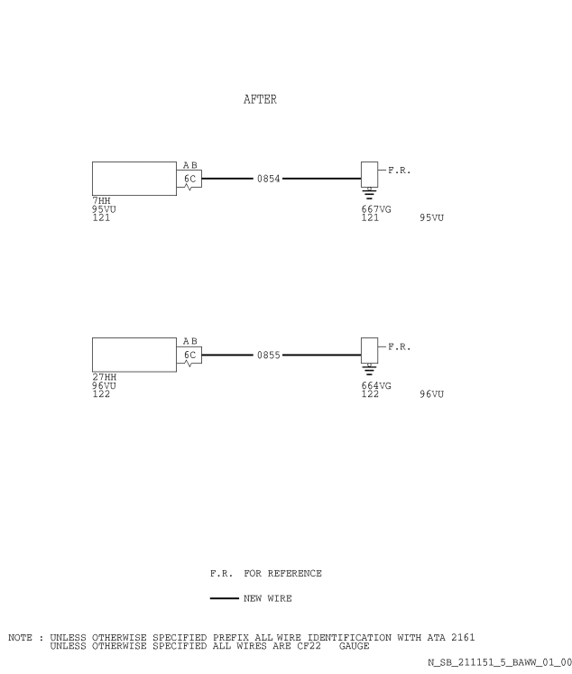

Figure 1, Sheet 1

Config. 01 : Modification of the Wiring in the Shelves 95VU and 96VU

DATE : Jun 30/05

REVISION No. : 01 - Oct 09/09

SERVICE BULLETIN No. : A320-21- 1151

Page : 31



SERVICE BULLETIN

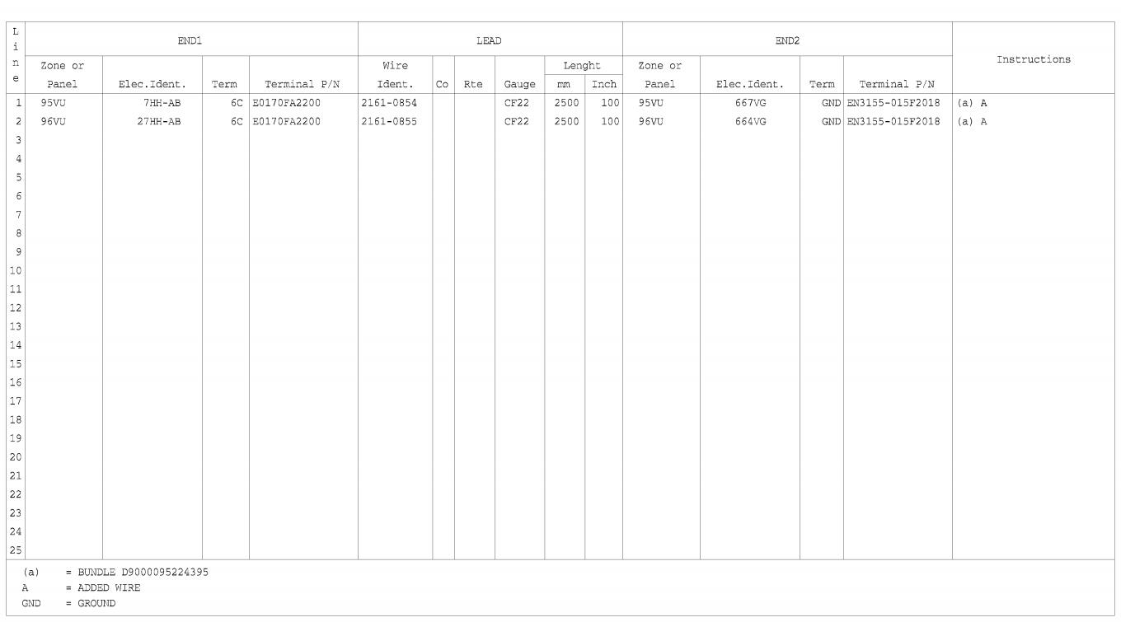

Figure 2, Sheet 1

Config. 01 : Hook-up Chart

SERVICE BULLETIN No. : A320-21- 1151

DATE : Jun 30/05

REVISION No. : 01 - Oct 09/09

Page : 32

Printed in France © AIRBUS 2008 All rights reserved



SERVICE BULLETIN

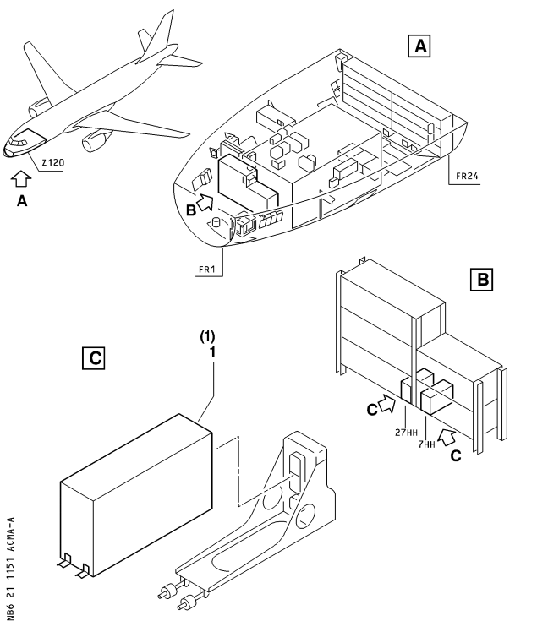

Figure 3, Sheet 1

Config. 01 thru 02 : Removal and Installation of Pack Temperature Controllers 7HH and 27HH

DATE : Jun 30/05

REVISION No. : 01 - Oct 09/09

SERVICE BULLETIN No. : A320-21- 1151

Page : 33



SERVICE BULLETIN

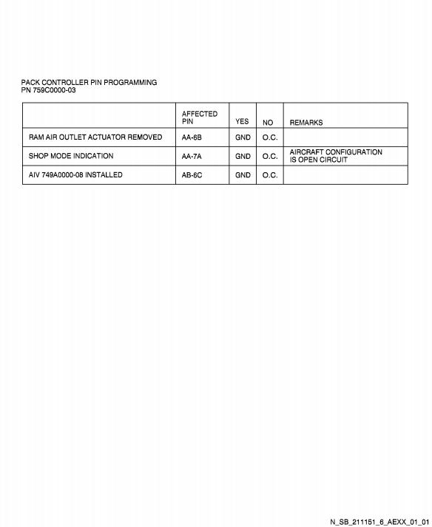

Figure 4, Sheet 1

Config. 01 : Pin Programming

DATE : Jun 30/05

REVISION No. : 01 - Oct 09/09

SERVICE BULLETIN No. : A320-21- 1151

Page : 34

Printed in France © AIRBUS 2008 All rights reserved



SERVICE BULLETIN

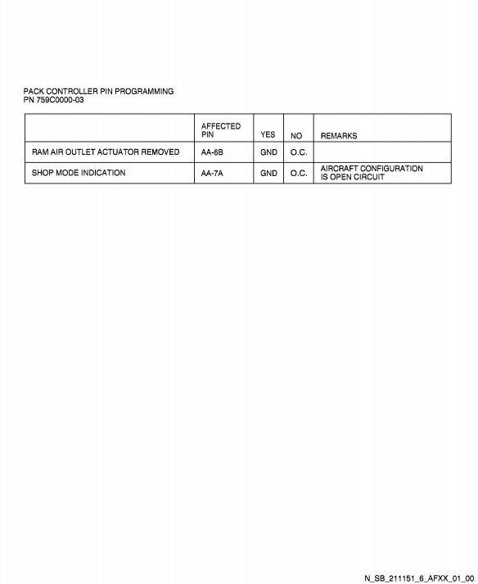

Figure 5, Sheet 1

Config. 02 : Pin Programming

DATE : Jun 30/05

REVISION No. : 01 - Oct 09/09

SERVICE BULLETIN No. : A320-21- 1151

Page : 35

Printed in France © AIRBUS 2008 All rights reserved



SERVICE BULLETIN

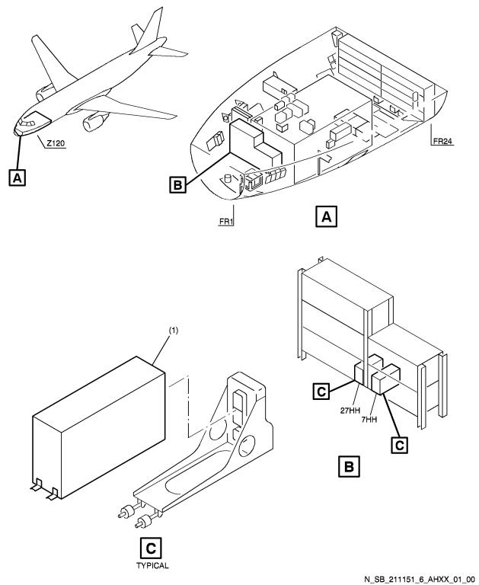

Figure 6, Sheet 1

Config. 01 : ADDITIONAL WORK : Removal and Installation of Pack Temperature Controllers 7HH and 27HH

SERVICE BULLETIN No. : A320-21- 1151 Page : 36

DATE : Jun 30/05

REVISION No. : 01 - Oct 09/09



SERVICE BULLETIN



Figure 7, Sheet 1

Config. 01 : ADDITIONAL WORK : Modification of the Wiring in the Shelves 95VU and 96VU

DATE : Jun 30/05

REVISION No. : 01 - Oct 09/09

SERVICE BULLETIN No. : A320-21- 1151

Page : 37

Printed in France © AIRBUS 2008 All rights reserved



SERVICE BULLETIN



Figure 8, Sheet 1

Config. 01 : ADDITIONAL WORK : Hook-up Chart

DATE : Jun 30/05

REVISION No. : 01 - Oct 09/09

SERVICE BULLETIN No. : A320-21- 1151

Page : 38

Printed in France © AIRBUS 2008 All rights reserved



SERVICE BULLETIN

REPORTING SHEET

**TITLE** **:** **AIR** **CONDITIONING** **-** **PACK** **TEMPERATURE** **CONTROL** **-** **INSTALL** **PACK** **TEMPERATURE** **CONTROLLER** **PN** **759C0000-03**

**MODIFICATION** **No.** **:** 34732K9632

Please complete the appropriate item (A or B):

A - SB WILL BE embodied .................................................................. YES/NO (if NO please comment)

If YES, aircraft concerned (as per SB effectivity by default) and planned dates (month/year) of embodiement:

.............................................................................................................................................................................

.............................................................................................................................................................................

B - SB HAS BEEN embodied on aircraft: ............................................................................................................

.............................................................................................................................................................................

.............................................................................................................................................................................

Operator comments: ............................................................................................................................................

.............................................................................................................................................................................

.............................................................................................................................................................................

From Airline: ........................................................................................................................................................

Name/Title: ..........................................................................................................................................................

Signature:..................... Date: .....................................................

If operational documentation is affected (see Paragraph 1.K of this SB): If information is needed prior to next normal revision or prior to SB embodiment, please indicate required service(s):

Either

Or

: Advance data ................................................................................... YES/NO

: Intermediate/Temporary revision ..................................................... YES/NO

Important Information: This SB will only be incorporated in your maintenance and operational documentation if this sheet is returned to Airbus and signed by a duly authorised representative. With the next feasible revision, this will result in

- updating of maintenance documentation to show pre and post SB data.

- updating of maintenance and operational documentation to show post SB data after embodiment.

If this SB requires previous or simultaneous accomplishment of other SBs, Airbus shall automatically include them in the manual revisions. Refer to SIL 00-037 for detailed information.

Please return th is completed sheet to:

**AIRBUS**

**CUSTOMER** **SERVICES** **DIRECTORATE**

**1** **Rond** **Point** **Maurice** **Bellonte**

**31707** **BLAGNAC** **CEDEX** **FRANCE**

Attn: SEDCC1 Technical Data and Documentation Services

FAX: (+33) 5 61 93 28 06

e-mail: sb.reporting@airbus.com

Or via your Resident Customer Support Office.

Alternatively, SB lists via letters or fax are also accepted.

DATE : Jun 30/05

REVISION No. : 01 - Oct 09/09

SERVICE BULLETIN No. : A320-21- 1151

Page : 1 of 1



SERVICE BULLETIN

REPORTING QUALITY

**TITLE** **:** **AIR** **CONDITIONING** **-** **PACK** **TEMPERATURE** **CONTROL** **-** **INSTALL** **PACK** **TEMPERATURE** **CONTROLLER** **PN** **759C0000-03**

**MODIFICATION** **No.** **:** 34732K9632

Use this form to tell us what is your perception of the quality of this Service Bulletin.The reported data that you provide us will be used to analyse areas of difficulties and to take corrective action to futher improve the quality of our Service Bulletins.

We thank you for the time you have taken in completing this form.

(Please rate on a scale of 1 to 4, with 4 being the highest score) -Quality rating of this SB

-Quality rating of the Accomplishment Instructions

-Quality rating of the Illustrations

-Is this SB easy to understand ?

4 3 2

4 3 2

4 3 2

Y / N

1

1

1

If you have had difficulties in the accomplishment of this SB please quote below the area(s) and give a short description of the issue.

Planning

X Effectivity

X Reason

X Manpower

X References

X Publication

Comments :

Material

X Kit Content

X List of Materials

Operator Supplied

X Re-identification

X Tooling

Instructions

X Preparation

X Mod/Inspection

X Test

X Close-up

X Illustrations

Operator :

Name/Title :

Date:

Please return this form to:

**AIRBUS**

**CUSTOMER** **SERVICES** **DIRECTORATE**

**1** **Rond** **Point** **Maurice** **Bellonte**

**31707** **BLAGNAC** **CEDEX** **FRANCE**

Attn: SEMB Service Bulletins Management

FAX: (+33) 5 61 93 42 51

Or via your Resident Customer Support Office.

DATE : Jun 30/05

REVISION No. : 01 - Oct 09/09

SERVICE BULLETIN No. : A320-21- 1151

Page : 1 of 1