@ Ac18/Ac16/Ac20/Ac21

SERVICE BULLETIN

SUMMARY

AIRBUS

CUSTOMER SERVICES DIRECTORATE

1 Rond Point Maurice Bellonte

31707 BLAGNAC CEDEX FRANCE

Tel : (33) 5 61 93 33 33

Telex : AIRBU 530526F

Fax : (33) 5 61 93 42 51

This summary is for information only

and is not approved for modification of the aircraft

ATA SYSTEM : 21

TITLE : AIR CONDITIONING - PRESSURE CONTROL AND MONITORING - FWC ACQUISITION

INTERFACE CONNECT FWC TO RPWS TO PREVENT DOOR OPENING WITH RESIDUAL

CABIN PRESSURE

MODIFICATION No . : 34673P8863

REASON/DESCRIPTION/OPERATIONAL CONSEQUENCES

Some cases of cabin door opening whilst residual cabin pressure was present have

been reported .

This Service Bulletin details the modification of the wiring to connect both

Flight Warning Computer (FWC) to the Cabin Pressure Detection Pressure Switch

(FIN 14WN) to provide the "CAB PR-EXCESS RESIDUAL PR" level 3 red warning .

The accomplishment of this Service Bulletin provides visual and audible warnings

to the flight crew in the case of excessive residual pressure in the cabin after

landing .

|  |  |  |  |
| --- | --- | --- | --- |
| EVALUATION TABLE | | | |
| COMPLIANCE | Desirable | CANCELS INSPECTION SB | No |
| POTENTIAL AD | No | A/C OPERATION AFFECTED | No |
| RELIABILITY AFFECTED | No | PAX COMFORT AFFECTED | No |
| COST SAVING | No | ETOPS AFFECTED | No |
| STRUCTURAL LIFE EXTN | No | VENDOR SB INVOLVED | No |
| KIT PRICE (USD) | See SB |  |  |

|  |  |
| --- | --- |
| MODIFICATION CLASSIFICATION | |
| MAJOR | none |
| MINOR | 34673P8863 |

6 DATE : Mar 30/07

REVISION No . : 00 —

SERVICE BULLETIN No . : A320— 21— 1164

Page : 1 of 4

Printed in FRANCE © AIRBUS, 2007 All rights reserved

@ Ac18/Ac16/Ac20/Ac21

SERVICE BULLETIN

SUMMARY

As per EASA IR 21, a minor change is one that has no appreciable effect on the mass, balance, structural strength, reliability, operational characteristics affecting the airworthiness of the product . All other changes are major changes .

EFFECTIVITY

This Service Bulletin is applicable to this (these) operator(s) :

03X 31X 39Z 53Z 57W 57Y 62X 73W 83Y 86Z AAF AAR ABQ ABY ACA ACI ADR AFL AFR AHY

AIJ AJM ALK AMC AMU ANA AUA AWE AZA BAW BER BES BGH BIE BKP BLM BMA BRS BST BWG

CCA CCM CEB CES CIB CLI CQH CSA CSC CSN CSZ CTN CYP D2F DAT DCS DGA DKN DLH DRK

EDW EEZ EIN EZY F2I FCA FFT FHY FIN FOM G4I GBL GFA GOW GWI GWY GXL HDA HVN I2L

IAC IBE INX IRM ISS IWD IZM JAV JBU JCS JET JKK JSA JST KAC KFR KKK KYV KZR LAJ

LAN LBT LFO LMJ LTC LTE LTU LVG MAU MDL MEA MLD MNJ MON MPD MPH MSR MXA MYT MYW

NKS NLY NVR NWA OHY PAL PTI QAF QTR R1T RAM RBA RJA RNV RZO SAA SAS SBI SHJ SLK

SSV SVR SWR SYR TAE TAI TAM TAP TAR TAS TCW TCX TGW THY TNA UAL UDC UEA USA VBW

VIM VKG VLE VLG VLK VLU VOI VUN WGT WZZ XLF

CONCURRENT REQUIREMENTS

Accomplishment of this Service Bulletin requires the prior or simultaneous accomplishment of the following Service Bulletin(s) or the equivalent production modification(s):

Service Bulletin No . A320-31-1267 Mod . No . 35220P9107

REFERENCES/REPERCUSSIONS

TFU

OEB

AOT

SIL

LIFE LIMIT

: None

: None

: None

: None

: None

LINE MAINTENANCE AFFECTED : No

OTHERS : None

NATURE OF THE WORK

Config . 01

AIRCRAFT : No

EQUIPMENT : Yes

HARD : No

SOFT : No

OBRM : No

MANPOWER

Config . 01

TOTAL MANHOURS 7 .0

ELAPSED TIME (HOURS) 6 . 5

DATE : Mar 30/07 SERVICE BULLETIN No . : A320— 21— 1164

REVISION No . : 00 — Page : 2

Printed in FRANCE © AIRBUS, 2007 All rights reserved

@ Ac18/Ac16/Ac20/Ac21

SERVICE BULLETIN

SUMMARY

MATERIAL INFORMATION

AIRCRAFT DATA

Config . 01

Kit 211164A01R00

Bundle, tie .

APPENDICES

None

DATE : Mar 30/07 SERVICE BULLETIN No . : A320— 21— 1164

REVISION No . : 00 — Page : 3

Printed in FRANCE © AIRBUS, 2007 All rights reserved

@ Ac18/Ac16/Ac20/Ac21

SERVICE BULLETIN

SUMMARY

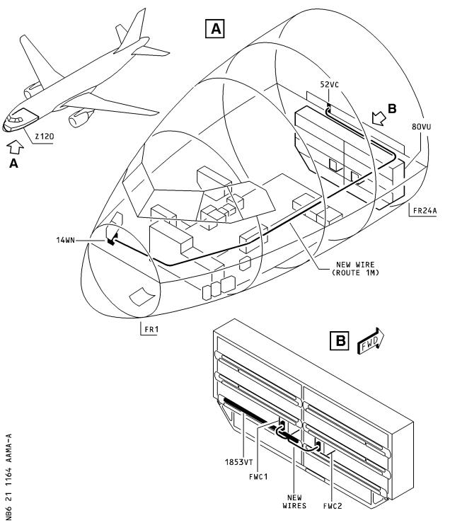

DATE : Mar 30/07 SERVICE BULLETIN No . : A320— 21— 1164

REVISION No . : 00 — Page : 4

Printed in FRANCE © AIRBUS, 2007 All rights reserved

@ Ac18/Ac16/Ac20/Ac21

SERVICE BULLETIN

AIRBUS

CUSTOMER SERVICES DIRECTORATE

1 Rond Point Maurice Bellonte

31707 BLAGNAC CEDEX FRANCE

Tel : (33) 5 61 93 33 33

Telex : AIRBU 530526F

Fax : (33) 5 61 93 42 51

ATA SYSTEM : 21

TITLE : AIR CONDITIONING - PRESSURE CONTROL AND MONITORING - FWC ACQUISITION

INTERFACE CONNECT FWC TO RPWS TO PREVENT DOOR OPENING WITH RESIDUAL

CABIN PRESSURE

MODIFICATION No . : 34673P8863

This document contains AIRBUS PROPRIETARY INFORMATION and shall at all times remain the property of AIRBUS; no intellectual property right or licence is granted by AIRBUS in connection with any information contained in it . It is delivered on the express condition that said document and the information contained in it shall be treated as confidential, shall not be used for any purpose other than that for which it is hereby delivered . It shall not be disclosed in whole or in part to third parties and shall not be duplicated in any manner (except for the purposes of performing the tasks described hereunder and provided that any recipient of such document shall comply with the conditions herein), without AIRBUS' prior written consent .

1. PLANNING INFORMATION

A . EFFECTIVITY

(1) Models

318-111 319-111 319-112 319-113 319-114 319-115 319-131 319-132

319-133 320-111 320-211 320-212 320-214 320-231 320-232 320-233

321-111 321-112 321-131 321-211 321-212 321-231 321-232

(2) Aircraft

(a) Effectivity by MSN

This Service Bulletin is applicable to aircraft MSN :

0002-0008 0010 0012-0014 0016-0021 0029 0031 0033-0059

0061-0078 0080-0091 0093-0104 0108-0237 0239-0270 0272-0373

0375-0396 0398-0432 0434-0480 0482-0535 0537-0546 0548-0601

0603-0631 0633-0707 0709-1185 1187-1277 1279-1598 1600-1812

1814-1821 1823-1829 1831-1918 1920-1929 1931-1984 1986-1991

1993-2024 2026-2110 2112-2508 2510 2512 2514-2516 2518-2521

2523 2525-2528 2530 2532 2534-2537 2544

NOTE : This modification is embodied before delivery on A319

aircraft MSN 2538 and subsequent, on A320 aircraft MSN

2509, MSN 2511, MSN 2513, MSN 2515, MSN 2522, MSN 2524,

MSN 2529, MSN 2531, MSN 2533, MSN 2539 and subsequent,

6 DATE : Mar 30/07

REVISION No . : 00 —

SERVICE BULLETIN No . : A320— 21— 1164

Page : 1 of 28

Printed in FRANCE © AIRBUS, 2007 All rights reserved

@ Ac18/Ac16/Ac20/Ac21

SERVICE BULLETIN

on A321 aircraft MSN 2543 and subsequent, on A318

aircraft MSN 1599, MSN 2552 and subsequent .

(b) Effectivity by Operator

The Operator/MSN relationship is provided for information only

and is correct at the time of issue in accordance with the

information available to AIRBUS . Any future changes resulting

from transfer of an aircraft from one operator to another will

not be reflected in this list unless the Service Bulletin is

revised for another reason .

|  |  |  |  |  |  |  |  |  |  |  |
| --- | --- | --- | --- | --- | --- | --- | --- | --- | --- | --- |
| OPERATOR  03X | MSN  2421 |  |  |  |  |  |  |  |  |  |
| 31X | 2192 |  |  |  |  |  |  |  |  |  |
| 39Z | 0956 |  |  |  |  |  |  |  |  |  |
| 53Z | 1468 |  |  |  |  |  |  |  |  |  |
| 57W | 1999 |  |  |  |  |  |  |  |  |  |
| 57Y | 1494 |  |  |  |  |  |  |  |  |  |
| 62X | 2403 |  |  |  |  |  |  |  |  |  |
| 73W | 0087 | 0088 |  |  |  |  |  |  |  |  |
| 83Y | 0913 | 1086 | 1124 | 1886 | 2165 |  |  |  |  |  |
| 86Z | 2431 |  |  |  |  |  |  |  |  |  |
| AAF | 0244 | 0558 | 0561 | 0808 | 0823 | 0888 | 1006 | 1846 | 2296 |  |
| AAR | 1356  2290 | 1511  2397 | 1636  2459 | 1670 | 1734 | 2041 | 2045 | 2110 | 2226 | 2247 |
| ABQ | 0394 | 0443 | 0760 | 1008 | 1199 | 1218 |  |  |  |  |
| ABY | 2158 | 2166 | 2278 | 2349 |  |  |  |  |  |  |
| ACA | 0059 | 0068 | 0073 | 0084 | 0122 | 0126 | 0127 | 0141 | 0149 | 0150 |
|  | 0154 | 0159 | 0174 | 0175 | 0183 | 0210 | 0231 | 0232 | 0233 | 0242 |
|  | 0248 | 0253 | 0254 | 0255 | 0265 | 0277 | 0284 | 0290 | 0302 | 0309 |
|  | 0310 | 0311 | 0324 | 0330 | 0341 | 0342 | 0350 | 0359 | 0378 | 0403 |
|  | 0404 | 0546 | 0572 | 0634 | 0639 | 0649 | 0656 | 0670 | 0672 | 0682 |
|  | 0688 | 0691 | 0693 | 0695 | 0697 | 0711 | 0719 | 0721 | 0728 | 0732 |
|  | 0736 | 0740 | 0742 | 0752 | 0757 | 0769 | 0773 | 0779 | 0785 | 0800 |
|  | 0813 | 0817 | 0829 | 0831 | 0840 | 0845 | 1562 | 1577 | 1602 | 1611 |
|  | 1623 | 1630 | 1632 | 1638 | 1673 | 1719 | 1726 | 1742 | 1748 | 1756 |
|  | 1765  2018 | 1772  2145 | 1783 | 1805 | 1811 | 1853 | 1864 | 1874 | 1940 | 1963 |
| ACI | 2152 |  |  |  |  |  |  |  |  |  |
| ADR | 0043 | 0113 | 0114 |  |  |  |  |  |  |  |
| AFL | 2052 | 2069 | 2072 | 2091 | 2093 | 2106 | 2116 | 2133 | 2144 | 2151 |
|  | 2163 | 2179 | 2222 | 2233 | 2243 | 2330 | 2337 | 2342 |  |  |

DATE : Mar 30/07 SERVICE BULLETIN No . : A320— 21— 1164

REVISION No . : 00 — Page : 2

Printed in FRANCE © AIRBUS, 2007 All rights reserved

@ Ac18/Ac16/Ac20/Ac21

SERVICE BULLETIN

|  |  |  |  |  |  |  |  |  |  |  |
| --- | --- | --- | --- | --- | --- | --- | --- | --- | --- | --- |
| OPERATOR | MSN |  |  |  |  |  |  |  |  |  |
| AFR | 0002 | 0003 | 0004 | 0005 | 0007 | 0010 | 0012 | 0013 | 0014 | 0016 |
|  | 0019 | 0020 | 0021 | 0033 | 0036 | 0044 | 0061 | 0062 | 0063 | 0100 |
|  | 0101 | 0102 | 0108 | 0115 | 0128 | 0129 | 0130 | 0131 | 0133 | 0144 |
|  | 0145 | 0155 | 0156 | 0184 | 0186 | 0187 | 0188 | 0203 | 0214 | 0220 |
|  | 0226 | 0227 | 0228 | 0235 | 0236 | 0237 | 0239 | 0270 | 0278 | 0285 |
|  | 0286 | 0287 | 0337 | 0352 | 0377 | 0491 | 0498 | 0509 | 0521 | 0529 |
|  | 0544 | 0598 | 0600 | 0608 | 0618 | 0625 | 0637 | 0644 | 0660 | 0777 |
|  | 0796 | 0938 | 0985 | 0998 | 1000 | 1020 | 1025 | 1036 | 1133 | 1151 |
|  | 1169 | 1176 | 1190 | 1201 | 1216 | 1267 | 1271 | 1299 | 1344 | 1404 |
|  | 1415 | 1444 | 1449 | 1471 | 1476 | 1502 | 1505 | 1524 | 1616 | 1622 |
|  | 1640 | 1645 | 1658 | 1677 | 1691 | 1699 | 1733 | 1859 | 1873 | 1879 |
|  | 1885 | 1894 | 1900 | 1924 | 1938 | 1949 | 2035 | 2059 | 2071 | 2081 |
|  | 2100 | 2109 | 2140 | 2213 | 2228 | 2279 | 2317 | 2344 | 2350 | 2456 |
| AHY | 0331 | 2487 | 2516 |  |  |  |  |  |  |  |
| AIJ | 1132 | 1162 | 1179 | 1244 | 1259 | 1308 | 1322 |  |  |  |
| AJM | 0422 | 0624 | 0626 | 0628 | 0630 | 0666 | 0775 | 1213 | 1390 | 1503 |
|  | 1747 | 1905 | 1966 | 1988 | 2048 |  |  |  |  |  |
| ALK | 0164 | 0169 | 0304 | 0315 | 0406 |  |  |  |  |  |
| AMC | 2113 | 2122 | 2142 | 2186 | 2189 | 2291 | 2332 | 2382 |  |  |
| AMU | 0557  1912 | 0597  1926 | 0620  1962 | 0631 | 0805 | 0908 | 1758 | 1790 | 1850 | 1893 |
| ANA | 0138 | 0139 | 0148 | 0151 | 0167 | 0170 | 0196 | 0212 | 0219 | 0245 |
|  | 0300 | 0328 | 0365 | 0383 | 0413 | 0482 | 0501 | 0507 | 0531 | 0534 |
|  | 0549  2061 | 0554 | 0658 | 0669 | 0685 | 0802 | 0811 | 1227 | 1973 | 2054 |
| AUA | 0552 | 0570 | 0581 | 0768 | 0776 | 0797 | 0920 | 0935 | 1137 | 1150 |
|  | 1189 | 1387 | 1458 | 1478 | 2131 | 2174 | 2262 | 2416 | 2494 |  |
| AWE | 0052 | 0053 | 0054 | 0055 | 0064 | 0065 | 0066 | 0067 | 0076 | 0077 |
|  | 0081 | 0082 | 0091 | 0098 | 0099 | 0317 | 0448 | 0527 | 0543 | 0565 |
|  | 0584 | 0661 | 0762 | 0770 | 0803 | 0856 | 0866 | 0889 | 0924 | 0931 |
|  | 0953 | 1003 | 1043 | 1049 | 1050 | 1056 | 1064 | 1075 | 1079 | 1083 |
|  | 1088 | 1110 | 1111 | 1116 | 1166 | 1178 | 1196 | 1223 | 1234 | 1274 |
|  | 1281 | 1284 | 1323 | 1350 | 1373 | 1375 | 1395 | 1397 | 1406 | 1410 |
|  | 1419 | 1463 | 1490 | 1527 | 1534 | 1547 | 1552 | 1563 | 1565 | 1576 |
|  | 1621 | 1643 | 1644 | 1710 | 1764 | 1792 | 1844 | 1935 | 2193 | 2302 |
|  | 2312 | 2359 | 2405 | 2422 | 2430 | 2458 | 2482 |  |  |  |
| AZA | 0434 | 0477 | 0488 | 0494 | 0495 | 0513 | 0514 | 0515 | 0516 | 0524 |
|  | 0526 | 0532 | 0576 | 0583 | 0586 | 0593 | 0599 | 0765 | 0819 | 0848 |
|  | 0940 | 0951 | 0959 | 0999 | 1138 | 1168 | 1217 | 1220 | 1226 | 1448 |
|  | 1457 | 1473 | 1480 | 1489 | 1722 | 1740 | 1745 | 1770 | 1779 | 2033 |
|  | 2057 | 2074 | 2083 | 2086 | 2101 | 2127 |  |  |  |  |
| BAW | 0006 | 0008 | 0017 | 0018 | 0039 | 0042 | 0103 | 0109 | 0120 | 1082 |
|  | 1115 | 1118 | 1142 | 1193 | 1197 | 1222 | 1225 | 1232 | 1236 | 1239 |
|  | 1258 | 1261 | 1279 | 1295 | 1329 | 1338 | 1380 | 1384 | 1423 | 1440 |
|  | 1445 | 1466 | 1510 | 1513 | 1529 | 1537 | 1558 | 1574 | 1590 | 1594 |
|  | 1604 | 1606 | 1661 | 1665 | 1689 | 1696 | 1708 | 1760 | 1782 | 1814 |
|  | 1829 | 1871 | 1883 | 1899 | 1907 | 1910 | 1958 | 2038 | 2040 | 2305 |
|  | 2320 | 2323 | 2324 | 2351 | 2363 | 2536 |  |  |  |  |

DATE : Mar 30/07 SERVICE BULLETIN No . : A320— 21— 1164

REVISION No . : 00 — Page : 3

Printed in FRANCE © AIRBUS, 2007 All rights reserved

@ Ac18/Ac16/Ac20/Ac21

SERVICE BULLETIN

|  |  |  |  |  |  |  |  |  |  |  |
| --- | --- | --- | --- | --- | --- | --- | --- | --- | --- | --- |
| OPERATOR | MSN |  |  |  |  |  |  |  |  |  |
| BER | 2335 | 2383 | 2467 | 2468 |  |  |  |  |  |  |
| BES | 1256 |  |  |  |  |  |  |  |  |  |
| BGH | 0221 | 0294 | 0305 | 0349 |  |  |  |  |  |  |
| BIE | 0293 | 0517 | 0519 | 0535 | 0642 | 0827 | 0891 |  |  |  |
| BKP | 2254 | 2310 |  |  |  |  |  |  |  |  |
| BLM | 0575 |  |  |  |  |  |  |  |  |  |
| BMA | 0835 | 0934 | 1014 | 1153 | 1174 | 1177 | 1183 | 1207 | 1383 | 1407 |
|  | 1418  2466 | 1424 | 1697 | 1732 | 1987 | 2098 | 2188 | 2194 | 2389 | 2429 |
| BRS | 2263 |  |  |  |  |  |  |  |  |  |
| BST | 0604 | 0614 |  |  |  |  |  |  |  |  |
| BWG | 0916 | 1240 | 1257 | 1546 | 1557 | 1650 |  |  |  |  |
| CCA | 0707 | 0724 | 0876 | 0921 | 1296 | 1654 | 1679 | 1753 | 2000 | 2007 |
|  | 2015  2499 | 2172  2508 | 2202  2525 | 2205  2532 | 2237 | 2269 | 2285 | 2293 | 2298 | 2454 |
| CCM | 0533 | 0548 | 1068 | 1145 |  |  |  |  |  |  |
| CEB | 2419 | 2439 |  |  |  |  |  |  |  |  |
| CES | 0665 | 0754 | 0772 | 0799 | 0828 | 0838 | 0854 | 0883 | 0897 | 0909 |
|  | 0914 | 0925 | 0939 | 0967 | 0984 | 0986 | 1005 | 1028 | 1030 | 1041 |
|  | 1070 | 1072 | 1093 | 1108 | 1285 | 1303 | 1312 | 1316 | 1330 | 1345 |
|  | 1357 | 1361 | 1377 | 1386 | 1532 | 1541 | 1542 | 1551 | 1601 | 1603 |
|  | 1639 | 1778 | 1786 | 1906 | 1911 | 1964 | 1981 | 2022 | 2034 | 2036 |
|  | 2049 | 2056 | 2068 | 2155 | 2171 | 2182 | 2199 | 2212 | 2219 | 2221 |
|  | 2235  2498 | 2239 | 2244 | 2274 | 2309 | 2315 | 2437 | 2451 | 2478 | 2493 |
| CIB | 0774  1416 | 0793  1437 | 0809  1929 | 0884  1968 | 0894 | 0905 | 0957 | 0971 | 1381 | 1402 |
| CLI | 0134 | 0136 | 0143 | 0146 | 0240 | 0241 | 0264 | 0312 | 0992 | 1396 |
| CQH | 0879 | 1286 | 1372 |  |  |  |  |  |  |  |
| CSA | 0674 | 0684 | 1439 | 1450 |  |  |  |  |  |  |
| CSC | 0540 | 0550 | 0551 | 0556 | 0573 | 0582 | 0591 | 0872 | 0874 | 0878 |
|  | 0902  2348 | 0912  2510 | 0915  2534 | 0919 | 1007 | 1013 | 1060 | 1293 | 1500 | 2313 |
| CSN | 0696 | 0698 | 0704 | 0705 | 0709 | 0710 | 0712 | 0718 | 0720 | 0722 |
|  | 0849 | 0859 | 0881 | 0895 | 0900 | 0950 | 0966 | 1035 | 1039 | 1057 |
|  | 1596 | 1614 | 1776 | 1788 | 1971 | 1974 | 1986 | 1995 | 2004 | 2008 |
|  | 2067 | 2080 | 2200 | 2203 | 2232 | 2273 | 2275 | 2334 | 2343 | 2345 |
|  | 2354  2521 | 2361  2530 | 2371 | 2408 | 2426 | 2435 | 2484 | 2505 | 2506 | 2519 |
| CSZ | 0994 |  |  |  |  |  |  |  |  |  |
| CTN | 0258 | 0671 | 0767 | 0833 | 1009 | 1029 | 1237 | 1252 |  |  |
| CYP | 0035 | 0037 | 0038 | 0180 | 0256 | 0295 | 0316 | 1729 | 1768 |  |
| D2F | 1204 |  |  |  |  |  |  |  |  |  |

DATE : Mar 30/07 SERVICE BULLETIN No . : A320— 21— 1164

REVISION No . : 00 — Page : 4

Printed in FRANCE © AIRBUS, 2007 All rights reserved

@ Ac18/Ac16/Ac20/Ac21

SERVICE BULLETIN

|  |  |  |  |  |  |  |  |  |  |  |
| --- | --- | --- | --- | --- | --- | --- | --- | --- | --- | --- |
| OPERATOR | MSN |  |  |  |  |  |  |  |  |  |
| DAT | 1160 | 1336 | 1388 |  |  |  |  |  |  |  |
| DCS | 1053 |  |  |  |  |  |  |  |  |  |
| DGA | 1485 | 1556 |  |  |  |  |  |  |  |  |
| DKN | 0932 | 0943 | 0977 | 2029 | 2077 | 2366 | 2376 |  |  |  |
| DLH | 0069 | 0070 | 0071 | 0072 | 0078 | 0083 | 0086 | 0093 | 0094 | 0104 |
|  | 0110 | 0111 | 0116 | 0117 | 0135 | 0137 | 0147 | 0161 | 0162 | 0172 |
|  | 0200 | 0201 | 0202 | 0209 | 0216 | 0217 | 0218 | 0267 | 0268 | 0269 |
|  | 0346 | 0382 | 0401 | 0412 | 0458 | 0468 | 0473 | 0474 | 0484 | 0493 |
|  | 0502 | 0505 | 0518 | 0560 | 0563 | 0564 | 0567 | 0595 | 0609 | 0610 |
|  | 0616 | 0623 | 0627 | 0636 | 0641 | 0651 | 0652 | 0689 | 0692 | 0694 |
|  | 0699 | 0717 | 0723 | 0729 | 0738 | 0744 | 0853 | 0860 | 0875 | 0887 |
|  | 0901 | 1080 | 1161 | 1188 | 1214 | 1260 | 1273 | 1337 | 1365 | 1367 |
| DRK | 2306 | 2346 |  |  |  |  |  |  |  |  |
| EDW | 0942 | 0947 | 1026 |  |  |  |  |  |  |  |
| EEZ | 0737 | 0749 | 1125 | 1852 | 1920 | 1937 | 1983 | 2001 | 2440 |  |
| EIN | 0815 | 0841 | 0926 | 0991 | 1023 | 1094 | 1242 | 1394 | 1443 | 1467 |
|  | 2191  2409 | 2206  2411 | 2217  2432 | 2250  2486 | 2256 | 2272 | 2294 | 2364 | 2374 | 2399 |
| EZY | 2037 | 2043 | 2050 | 2053 | 2062 | 2119 | 2120 | 2129 | 2170 | 2176 |
|  | 2181 | 2184 | 2196 | 2214 | 2224 | 2230 | 2245 | 2249 | 2251 | 2265 |
|  | 2271 | 2283 | 2289 | 2300 | 2319 | 2353 | 2360 | 2370 | 2378 | 2380 |
|  | 2385 | 2387 | 2398 | 2402 | 2412 | 2420 | 2427 | 2436 | 2442 | 2446 |
|  | 2450  2514 | 2460  2527 | 2463  2528 | 2471 | 2477 | 2481 | 2492 | 2495 | 2503 | 2512 |
| F2I | 0937 | 1129 | 1149 | 1164 | 1167 |  |  |  |  |  |
| FCA | 0677 | 0781 | 0852 | 1306 | 1320 | 1637 | 1720 | 1777 | 2180 |  |
| FFT | 1488 | 1515 | 1560 | 1579 | 1583 | 1660 | 1684 | 1743 | 1759 | 1761 |
|  | 1781 | 1803 | 1841 | 1851 | 1863 | 1876 | 1890 | 1939 | 1943 | 1980 |
|  | 1991 | 1997 | 2010 | 2012 | 2017 | 2019 | 2030 | 2051 | 2103 | 2198 |
|  | 2209 | 2218 | 2236 | 2240 | 2241 | 2253 | 2258 | 2260 | 2276 | 2287 |
|  | 2318 | 2392 | 2400 | 2406 | 2448 | 2465 | 2483 | 2497 | 2518 |  |
| FHY | 0132 | 0283 | 0288 | 0771 | 0855 |  |  |  |  |  |
| FIN | 0941 | 0961 | 1073 | 1107 | 1184 | 1185 | 1241 | 1309 | 1352 | 1364 |
|  | 1405 | 1470 | 1544 | 1588 | 1678 | 1712 | 1735 | 1791 | 1808 | 1913 |
|  | 1916 | 1978 | 1989 | 2065 | 2124 | 2146 | 2154 | 2208 | 2266 |  |
| FOM | 2085 | 2090 | 2112 | 2130 | 2148 | 2153 | 2173 | 2257 | 2297 |  |
| G4I | 1157 | 1795 | 2507 |  |  |  |  |  |  |  |
| GBL | 1215  1993 | 1428  2137 | 1433  2157 | 1687  2462 | 1715 | 1723 | 1754 | 1869 | 1918 | 1969 |
| GFA | 0289 | 0325 | 0375 | 0407 | 0409 | 0419 | 0459 | 0466 | 0497 | 0537 |
| GOW | 0455 | 0471 | 1482 | 1509 | 1597 | 1767 |  |  |  |  |
| GWI | 0525 | 0579 | 0645 | 0646 | 0654 | 0679 | 0700 | 0794 | 1016 | 1077 |
|  | 1084 | 1089 | 1136 | 1147 | 1155 | 1170 | 1172 | 1209 | 1277 |  |

DATE : Mar 30/07 SERVICE BULLETIN No . : A320— 21— 1164

REVISION No . : 00 — Page : 5

Printed in FRANCE © AIRBUS, 2007 All rights reserved

@ Ac18/Ac16/Ac20/Ac21

SERVICE BULLETIN

|  |  |  |  |  |  |  |  |  |  |  |
| --- | --- | --- | --- | --- | --- | --- | --- | --- | --- | --- |
| OPERATOR | MSN |  |  |  |  |  |  |  |  |  |
| GWY | 0427  2327 | 0730 | 1152 | 1198 | 1615 | 1725 | 1867 | 2175 | 2187 | 2325 |
| GXL | 1564 | 1860 | 2500 |  |  |  |  |  |  |  |
| HDA | 0633 | 0756 | 0784 | 0812 | 0877 | 0930 | 0993 | 1024 | 1253 | 1695 |
|  | 1721 | 1984 | 2021 | 2229 | 2238 | 2428 |  |  |  |  |
| HVN | 0590 | 0594 | 0601 | 0605 | 0607 | 0611 | 0617 | 0619 | 0648 | 0650 |
|  | 2255 | 2261 | 2267 | 2303 | 2480 |  |  |  |  |  |
| I2L | 2396 |  |  |  |  |  |  |  |  |  |
| IAC | 0045 | 0046 | 0047 | 0048 | 0049 | 0050 | 0051 | 0056 | 0057 | 0058 |
|  | 0074 | 0075 | 0080 | 0089 | 0090 | 0095 | 0096 | 0097 | 0168 | 0179 |
|  | 0225 | 0247 | 0257 | 0308 | 0314 | 0326 | 0327 | 0336 | 0344 | 0354 |
|  | 0362 | 0376 | 0386 | 0396 | 0398 | 0411 | 0416 | 0423 | 0431 | 0432 |
|  | 0451 | 0469 | 0478 | 0480 | 0486 | 0490 | 0492 | 0499 | 1668 | 1718 |
| IBE | 0158 | 0173 | 0176 | 0177 | 0199 | 0207 | 0223 | 0224 | 0246 | 0266 |
|  | 0274 | 0303 | 0323 | 0356 | 1021 | 1027 | 1047 | 1059 | 1067 | 1087 |
|  | 1099 | 1101 | 1119 | 1154 | 1180 | 1200 | 1208 | 1221 | 1247 | 1255 |
|  | 1262 | 1288 | 1292 | 1318 | 1347 | 1362 | 1379 | 1430 | 1454 | 1461 |
|  | 1484 | 1516 | 1530 | 1540 | 1550 | 1554 | 1572 | 1655 | 1674 | 1681 |
|  | 1694 | 1716 | 1736 | 1793 | 1809 | 1836 | 2104 | 2115 | 2143 | 2220 |
|  | 2225  2488 | 2242 | 2264 | 2270 | 2311 | 2357 | 2365 | 2381 | 2391 | 2472 |
| INX | 0963 | 0968 | 0974 |  |  |  |  |  |  |  |
| IRM | 0530 | 0857 | 1202 |  |  |  |  |  |  |  |
| ISS | 1048 | 1102 | 1283 | 1305 |  |  |  |  |  |  |
| IWD | 1130 | 1578 | 1657 | 2011 |  |  |  |  |  |  |
| IZM | 2404 | 2414 | 2452 |  |  |  |  |  |  |  |
| JAV | 0029 |  |  |  |  |  |  |  |  |  |
| JBU | 1123 | 1156 | 1173 | 1235 | 1270 | 1280 | 1302 | 1327 | 1398 | 1446 |
|  | 1452 | 1464 | 1506 | 1528 | 1591 | 1610 | 1652 | 1705 | 1739 | 1784 |
|  | 1785 | 1802 | 1823 | 1827 | 1835 | 1849 | 1861 | 1868 | 1891 | 1896 |
|  | 1898 | 1904 | 1915 | 1917 | 1927 | 1948 | 2006 | 2020 | 2031 | 2042 |
|  | 2063 | 2075 | 2099 | 2125 | 2132 | 2136 | 2141 | 2147 | 2149 | 2150 |
|  | 2159 | 2160 | 2177 | 2201 | 2215 | 2231 | 2246 | 2259 | 2280 | 2284 |
|  | 2286 | 2307 | 2314 | 2336 | 2352 | 2368 | 2384 | 2386 | 2415 | 2447 |
|  | 2449 | 2461 | 2489 | 2491 | 2504 | 2520 | 2535 |  |  |  |
| JCS | 0211 |  |  |  |  |  |  |  |  |  |
| JET | 0163  0816 | 0204 | 0215 | 0363 | 0371 | 0393 | 0414 | 0421 | 0542 | 0647 |
| JKK | 1276 | 1333 | 1349 | 1366 | 1497 | 1631 | 1682 | 1749 | 1843 | 1862 |
|  | 1914 | 1933 | 1946 | 1979 | 1998 | 2027 | 2168 | 2210 | 2223 | 2479 |
| JSA | 2316 | 2356 | 2395 | 2401 |  |  |  |  |  |  |
| JST | 2169  2515 | 2185  2526 | 2197  2537 | 2292 | 2299 | 2322 | 2329 | 2338 | 2455 | 2475 |
| KAC | 0181 | 0182 | 0195 | 2046 |  |  |  |  |  |  |

DATE : Mar 30/07 SERVICE BULLETIN No . : A320— 21— 1164

REVISION No . : 00 — Page : 6

Printed in FRANCE © AIRBUS, 2007 All rights reserved

@ Ac18/Ac16/Ac20/Ac21

SERVICE BULLETIN

|  |  |  |  |  |  |  |  |  |  |  |
| --- | --- | --- | --- | --- | --- | --- | --- | --- | --- | --- |
| OPERATOR | MSN |  |  |  |  |  |  |  |  |  |
| KFR | 2413 | 2443 | 2496 | 2502 |  |  |  |  |  |  |
| KKK | 0460 | 0461 | 0640 | 0676 | 0764 | 0978 | 2423 | 2453 | 2457 |  |
| KYV | 1012 | 1451 | 2117 |  |  |  |  |  |  |  |
| KZR | 1042 | 2016 | 2128 |  |  |  |  |  |  |  |
| LAJ | 1194 | 1690 | 1711 | 1922 | 2190 | 2441 |  |  |  |  |
| LAN | 0990 | 1304 | 1332 | 1351 | 1355 | 1491 | 1512 | 1526 | 1548 | 1568 |
|  | 1626 | 1854 | 1858 | 1877 | 1903 | 2089 | 2096 | 2295 | 2304 | 2321 |
| LBT | 0112  1175 | 0157  1744 | 0222 | 0299 | 0301 | 0348 | 0400 | 0970 | 0995 | 1121 |
| LFO | 0659 |  |  |  |  |  |  |  |  |  |
| LMJ | 1589 |  |  |  |  |  |  |  |  |  |
| LTC | 0142 | 0333 | 0384 | 0726 |  |  |  |  |  |  |
| LTE | 0438 | 0445 | 0496 | 0580 | 2123 |  |  |  |  |  |
| LTU | 1385 | 1441 | 1493 | 1504 | 1553 | 1607 | 1629 | 1762 | 1797 | 1806 |
|  | 1838 | 1931 | 1994 | 2005 | 2009 |  |  |  |  |  |
| LVG | 0792 | 1950 | 1970 |  |  |  |  |  |  |  |
| MAU | 1592 | 1936 |  |  |  |  |  |  |  |  |
| MDL | 0279 | 0391 |  |  |  |  |  |  |  |  |
| MEA | 1878 | 1953 | 1956 | 1967 | 1977 | 2055 |  |  |  |  |
| MLD | 0622 | 0662 |  |  |  |  |  |  |  |  |
| MNJ | 0615 |  |  |  |  |  |  |  |  |  |
| MON | 0379 | 0389 | 0392 | 0446 | 0864 | 0983 | 1015 | 1045 | 1081 | 1370 |
|  | 1707 | 1763 | 1941 | 2105 | 2234 |  |  |  |  |  |
| MPD | 0426 |  |  |  |  |  |  |  |  |  |
| MPH | 1944 | 1945 | 2167 |  |  |  |  |  |  |  |
| MSR | 0165 | 0166 | 0178 | 0194 | 0198 | 0322 | 0351 | 0366 | 0680 | 0687 |
|  | 0715 | 0725 | 2070 | 2073 | 2079 | 2088 | 2094 |  |  |  |
| MXA | 0252 | 0259 | 0260 | 0261 | 0275 | 0276 | 0280 | 0291 | 0292 | 0296 |
|  | 0320 | 0321 | 0332 | 0347 | 0353 | 0357 | 0361 | 0368 | 0369 | 0373 |
|  | 0405 | 0415 | 0428 | 0430 | 0447 | 0467 | 0566 | 1229 | 1429 | 1598 |
|  | 1612 | 1618 | 1625 | 1634 | 1706 | 1750 | 1866 | 1872 | 1882 | 1925 |
|  | 2066  2394 | 2078  2523 | 2126  2544 | 2248 | 2328 | 2333 | 2347 | 2358 | 2367 | 2377 |
| MYT | 0193 | 0424 | 0429 | 0449 | 0476 | 1238 | 1250 | 1972 |  |  |
| MYW | 0338 | 0444 | 0814 | 1757 |  |  |  |  |  |  |
| NKS | 1195  2490 | 1408 | 1438 | 1794 | 2424 | 2433 | 2470 | 2473 | 2476 | 2485 |
| NLY | 1487 |  |  |  |  |  |  |  |  |  |
| NVR | 2211 | 2216 | 2410 |  |  |  |  |  |  |  |

DATE : Mar 30/07 SERVICE BULLETIN No . : A320— 21— 1164

REVISION No . : 00 — Page : 7

Printed in FRANCE © AIRBUS, 2007 All rights reserved

@ Ac18/Ac16/Ac20/Ac21

SERVICE BULLETIN

|  |  |  |  |  |  |  |  |  |  |  |
| --- | --- | --- | --- | --- | --- | --- | --- | --- | --- | --- |
| OPERATOR | MSN |  |  |  |  |  |  |  |  |  |
| NWA | 0031 | 0034 | 0040 | 0041 | 0118 | 0121 | 0125 | 0152 | 0153 | 0160 |
|  | 0171 | 0192 | 0197 | 0206 | 0208 | 0213 | 0262 | 0263 | 0272 | 0273 |
|  | 0281 | 0282 | 0297 | 0298 | 0306 | 0307 | 0318 | 0319 | 0329 | 0339 |
|  | 0340 | 0355 | 0358 | 0360 | 0367 | 0372 | 0380 | 0381 | 0387 | 0388 |
|  | 0399 | 0408 | 0410 | 0417 | 0418 | 0766 | 0778 | 0786 | 0801 | 0807 |
|  | 0818 | 0830 | 0832 | 0846 | 0903 | 0907 | 0911 | 0923 | 0962 | 0964 |
|  | 0981 | 0988 | 0996 | 1011 | 1037 | 1058 | 1062 | 1191 | 1230 | 1249 |
|  | 1324 | 1325 | 1346 | 1392 | 1414 | 1434 | 1453 | 1456 | 1483 | 1498 |
|  | 1501 | 1520 | 1535 | 1543 | 1549 | 1567 | 1570 | 1582 | 1633 | 1641 |
|  | 1646 | 1659 | 1662 | 1683 | 1685 | 1693 | 1709 | 1714 | 1738 | 1746 |
|  | 1752 | 1766 | 1774 | 1789 | 1796 | 1800 | 1810 | 1812 | 1815 | 1819 |
|  | 1820 | 1824 | 1828 | 1833 | 1839 | 1870 | 1875 | 1897 | 1923 | 1959 |
|  | 1976 | 1982 | 1990 | 2002 | 2013 | 2026 | 2028 | 2039 | 2047 | 2082 |
|  | 2087 | 2092 | 2095 | 2369 | 2373 | 2464 | 2474 |  |  |  |
| OHY | 0313 | 0345 | 0364 | 0385 | 0663 | 0668 | 0787 | 0954 | 1004 | 1421 |
| PAL | 0706 | 0745 | 0753 | 0936 | 1063 | 1171 | 1210 | 2162 | 2183 |  |
| PTI | 1727 | 1880 | 1947 | 1955 |  |  |  |  |  |  |
| QAF | 0927 | 1335 |  |  |  |  |  |  |  |  |
| QTR | 0928 | 1566 | 1648 | 1656 | 1773 | 1895 | 1928 | 1957 | 2097 | 2107 |
|  | 2121 | 2138 | 2161 | 2288 | 2341 |  |  |  |  |  |
| R1T | 1908 |  |  |  |  |  |  |  |  |  |
| RAM | 2064 | 2076 |  |  |  |  |  |  |  |  |
| RBA | 2023 | 2032 | 2135 | 2139 |  |  |  |  |  |  |
| RJA | 0569 | 0675 | 0761 |  |  |  |  |  |  |  |
| RNV | 0229 | 2277 | 2362 |  |  |  |  |  |  |  |
| RZO | 0795 | 2390 | 2425 |  |  |  |  |  |  |  |
| SAA | 2268  2501 | 2281 | 2308 | 2326 | 2355 | 2375 | 2379 | 2418 | 2438 | 2469 |
| SAS | 1587 | 1619 | 1642 | 1675 | 1798 | 1807 | 1817 | 1848 |  |  |
| SBI | 1071 | 1078 | 1090 | 1091 | 1126 | 1131 |  |  |  |  |
| SHJ | 0910 |  |  |  |  |  |  |  |  |  |
| SLK | 0899 | 0969 | 1074 | 1098 | 1228 | 1422 | 1561 | 1698 | 2058 | 2252 |
| SSV | 0437  1965 | 1411  2003 | 1571 | 1605 | 1686 | 1780 | 1884 | 1901 | 1942 | 1961 |
| SVR | 0140 |  |  |  |  |  |  |  |  |  |
| SWR | 0520 | 0545 | 0577 | 0578 | 0585 | 0596 | 0603 | 0612 | 0621 | 0635 |
|  | 0643 | 0664 | 0673 | 0681 | 0701 | 0703 | 0713 | 0727 | 0734 | 0782 |
|  | 0987 | 1018 | 1144 | 1951 | 2024 | 2134 |  |  |  |  |
| SYR | 0886 | 0918 | 1032 | 1076 | 1085 | 1117 |  |  |  |  |
| TAE | 2014 | 2044 |  |  |  |  |  |  |  |  |
| TAI | 0733 | 0741 | 0747 | 1066 | 1113 | 1300 | 1334 | 1339 | 1353 | 1374 |
|  | 1400 | 1523 | 1624 | 1676 | 1730 | 1934 | 1952 | 2084 | 2102 | 2118 |
|  | 2282 | 2301 | 2339 | 2434 | 2444 |  |  |  |  |  |

DATE : Mar 30/07 SERVICE BULLETIN No . : A320— 21— 1164

REVISION No . : 00 — Page : 8

Printed in FRANCE © AIRBUS, 2007 All rights reserved

@ Ac18/Ac16/Ac20/Ac21

SERVICE BULLETIN

|  |  |  |  |  |  |  |  |  |  |  |
| --- | --- | --- | --- | --- | --- | --- | --- | --- | --- | --- |
| OPERATOR | MSN |  |  |  |  |  |  |  |  |  |
| TAM | 0243 | 0249 | 0250 | 0251 | 0334 | 0335 | 0440 | 0453 | 0758 | 0789 |
|  | 0976 | 1010 | 1092 | 1096 | 1103 | 1139 | 1143 | 1158 | 1246 | 1251 |
|  | 1368 | 1376 | 1459 | 1486 | 1518 | 1575 | 1580 | 1593 | 1595 | 1608 |
|  | 1613 | 1628 | 1663 | 1672 | 1692 | 1703 | 1717 | 1771 | 1775 | 1801 |
|  | 1804  2372 | 1818  2393 | 1825  2417 | 1826  2445 | 1831 | 1832 | 1837 | 1855 | 1857 | 1888 |
| TAP | 0185 | 0191 | 0234 | 0395 | 0629 | 0750 | 0755 | 0763 | 0790 | 0821 |
|  | 0837 | 0870 | 0906 | 0917 | 0933 | 0945 | 0960 | 0979 | 0982 | 1034 |
|  | 1100 | 1106 | 1120 | 1127 | 1165 | 1181 | 1206 | 1231 | 1307 | 1399 |
|  | 1667 | 1713 | 1799 | 1816 | 2178 |  |  |  |  |  |
| TAR | 0119 | 0123 | 0124 | 0205 | 0370 | 0390 | 0402 | 0511 | 0869 | 0880 |
|  | 0958 | 0975 | 1187 | 1479 | 1700 |  |  |  |  |  |
| TAS | 0667 | 0739 | 0743 |  |  |  |  |  |  |  |
| TCW | 0343 | 0420 | 0425 | 0436 | 1787 | 1975 |  |  |  |  |
| TCX | 0714 | 0716 | 0735 |  |  |  |  |  |  |  |
| TGW | 2195 | 2204 | 2331 | 2340 |  |  |  |  |  |  |
| THY | 0522 | 0541 | 0553 | 0559 | 0562 | 0574 | 0806 | 0810 | 1002 | 1054 |
|  | 1219 | 1233 | 1413 | 1856 | 1909 | 1996 | 2060 |  |  |  |
| TNA | 0441 | 0538 | 0555 | 0606 | 0731 | 0746 | 0791 | 0822 |  |  |
| UAL | 0435 | 0439 | 0442 | 0450 | 0452 | 0454 | 0456 | 0457 | 0462 | 0463 |
|  | 0464 | 0465 | 0470 | 0472 | 0475 | 0479 | 0483 | 0485 | 0487 | 0489 |
|  | 0500 | 0503 | 0504 | 0506 | 0508 | 0510 | 0512 | 0523 | 0539 | 0568 |
|  | 0571 | 0587 | 0589 | 0592 | 0613 | 0638 | 0655 | 0678 | 0683 | 0686 |
|  | 0690 | 0702 | 0748 | 0751 | 0759 | 0780 | 0783 | 0788 | 0798 | 0804 |
|  | 0820 | 0824 | 0825 | 0826 | 0834 | 0836 | 0842 | 0843 | 0847 | 0850 |
|  | 0851 | 0858 | 0862 | 0865 | 0867 | 0871 | 0873 | 0882 | 0893 | 0898 |
|  | 0944 | 0948 | 0952 | 0955 | 0965 | 0980 | 0989 | 1001 | 1022 | 1031 |
|  | 1104 | 1105 | 1128 | 1146 | 1163 | 1192 | 1211 | 1243 | 1248 | 1266 |
|  | 1272 | 1282 | 1290 | 1291 | 1321 | 1341 | 1343 | 1359 | 1363 | 1401 |
|  | 1409 | 1420 | 1426 | 1427 | 1432 | 1435 | 1460 | 1469 | 1474 | 1475 |
|  | 1477 | 1495 | 1507 | 1508 | 1514 | 1522 | 1533 | 1538 | 1545 | 1555 |
|  | 1559 | 1569 | 1573 | 1581 | 1584 | 1585 | 1586 | 1600 | 1609 | 1617 |
|  | 1620 | 1627 | 1647 | 1649 | 1653 | 1664 | 1669 | 1671 | 1680 | 1688 |
|  | 1702  1847 | 1728  1865 | 1731 | 1737 | 1741 | 1755 | 1821 | 1840 | 1842 | 1845 |
| UDC | 0085 | 0230 |  |  |  |  |  |  |  |  |
| UEA | 0946 | 0949 | 1263 | 1751 |  |  |  |  |  |  |

DATE : Mar 30/07 SERVICE BULLETIN No . : A320— 21— 1164

REVISION No . : 00 — Page : 9

Printed in FRANCE © AIRBUS, 2007 All rights reserved

@ Ac18/Ac16/Ac20/Ac21

SERVICE BULLETIN

|  |  |  |  |  |  |  |  |  |  |  |
| --- | --- | --- | --- | --- | --- | --- | --- | --- | --- | --- |
| OPERATOR | MSN |  |  |  |  |  |  |  |  |  |
| USA | 0844 | 0861 | 0863 | 0868 | 0885 | 0890 | 0896 | 0904 | 0922 | 0929 |
|  | 0972 | 0997 | 1019 | 1033 | 1038 | 1040 | 1044 | 1046 | 1051 | 1052 |
|  | 1055 | 1061 | 1065 | 1069 | 1095 | 1097 | 1109 | 1112 | 1114 | 1122 |
|  | 1134 | 1135 | 1141 | 1148 | 1182 | 1203 | 1205 | 1224 | 1245 | 1254 |
|  | 1264 | 1265 | 1268 | 1269 | 1275 | 1287 | 1289 | 1294 | 1297 | 1298 |
|  | 1301 | 1310 | 1311 | 1313 | 1314 | 1315 | 1317 | 1319 | 1326 | 1328 |
|  | 1331 | 1340 | 1342 | 1348 | 1354 | 1358 | 1360 | 1369 | 1371 | 1378 |
|  | 1382 | 1389 | 1391 | 1393 | 1403 | 1412 | 1417 | 1425 | 1431 | 1436 |
|  | 1442 | 1447 | 1455 | 1462 | 1465 | 1472 | 1481 | 1492 | 1496 | 1499 |
|  | 1517  1704 | 1519  1724 | 1521 | 1525 | 1531 | 1536 | 1539 | 1651 | 1666 | 1701 |
| VBW | 0588 |  |  |  |  |  |  |  |  |  |
| VIM | 2108 |  |  |  |  |  |  |  |  |  |
| VKG | 1881 | 1887 | 1889 | 1921 | 1932 | 1954 | 1960 |  |  |  |
| VLE | 0189 | 0190 |  |  |  |  |  |  |  |  |
| VLG | 1769 | 2114 | 2207 | 2227 | 2388 | 2407 |  |  |  |  |
| VLK | 0528 |  |  |  |  |  |  |  |  |  |
| VLU | 2156 | 2164 |  |  |  |  |  |  |  |  |
| VOI | 1140 | 1159 |  |  |  |  |  |  |  |  |
| VUN | 1017 |  |  |  |  |  |  |  |  |  |
| WGT | 1212 |  |  |  |  |  |  |  |  |  |
| WZZ | 0839 | 0892 | 1635 | 1834 | 1892 | 1902 |  |  |  |  |
| XLF | 0653 | 0657 | 0973 |  |  |  |  |  |  |  |

(c) Effectivity by MSN and Kit/Configuration

The kits and configurations applicable to these MSNs are given

at the end of this list:

0002-0008 0010 0012-0014 0016-0021 0029 0031 0033-0059

0061-0078 0080-0091 0093-0104 0108-0237 0239-0270 0272-0373

0375-0396 0398-0432 0434-0480 0482-0535 0537-0546 0548-0601

0603-0631 0633-0707 0709-1185 1187-1277 1279-1598 1600-1812

1814-1821 1823-1829 1831-1918 1920-1929 1931-1984 1986-1991

1993-2024 2026-2110 2112-2508 2510 2512 2514-2516 2518-2521

2523 2525-2528 2530 2532 2534-2537 2544

KIT No . QTY PER A/C CONFIGURATION

211164A01 1 01

NOTE : Config . 01 is valid for all aircraft given in the

effectivity of this Service Bulletin .

DATE : Mar 30/07 SERVICE BULLETIN No . : A320— 21— 1164

REVISION No . : 00 — Page : 10

Printed in FRANCE © AIRBUS, 2007 All rights reserved

@ Ac18/Ac16/Ac20/Ac21

SERVICE BULLETIN

(3) Spares

None

B . CONCURRENT REQUIREMENTS

Accomplishment of this Service Bulletin requires the prior or simultaneous accomplishment of the following Service Bulletin(s) or the equivalent production modification(s):

Service Bulletin No . A320-31-1267 Mod . No . 35220P9107

C . REASON

(1) History

Some cases of cabin door opening whilst residual cabin pressure was

present have been reported .

(2) Objective/Action

This Service Bulletin details the modification of the wiring to

connect both Flight Warning Computer (FWC) to the Cabin Pressure

Detection Pressure Switch (FIN 14WN) to provide the "CAB PR-EXCESS

RESIDUAL PR" level 3 red warning .

(3) Advantages

The accomplishment of this Service Bulletin provides visual and

audible warnings to the flight crew in the case of excessive

residual pressure in the cabin after landing .

(4) Operational/Maintenance Consequences

None

D . DESCRIPTION

To accomplish this Service Bulletin it is necessary to :

(1) Config . 01

(a) Modify the wiring in the Electronic Rack 80VU

(b) Modify the wiring in Avionics Compartment

E . COMPLIANCE

(1) Classification

Desirable

(2) Accomplishment Timescale

In accordance with operators' maintenance schedule .

DATE : Mar 30/07 SERVICE BULLETIN No . : A320— 21— 1164

REVISION No . : 00 — Page : 11

Printed in FRANCE © AIRBUS, 2007 All rights reserved

@ Ac18/Ac16/Ac20/Ac21

SERVICE BULLETIN

F . APPROVAL

Approved under EASA Design Organisation Approval No . EASA .21J .031 .

If an aircraft listed in the effectivity has a modification or repair

embodied that is not of AIRBUS origin, and which affects the content of

this Service Bulletin, the operator is responsible for obtaining

approval by its airworthiness authority for any adaptation necessary

before incorporation of the Service Bulletin .

G . MANPOWER

The manpower estimates given in this Service Bulletin are based on the

direct labor cost to do the work . These estimates assume that the work

will be done by experienced personnel, and may need to be revised

upwards to suit operator's circumstances . The estimates do not include

the time to prepare, plan or inspect the work . Manufacture and

procurement of parts and tools, drying times for paints, sealants, etc,

and general administration work are also not included .

Config . 01

Get access

Modify wiring in the 80VU

Modify wiring in Avionics

Compartment

Test

Close-up

TOTAL MANHOURS

ELAPSED TIME (HOURS)

H . WEIGHT AND BALANCE

Not changed

I . ELECTRICAL LOAD DATA

Not changed

J . REFERENCES

Aircraft Maintenance Manual (AMM)

Elec . Std . Practices Manual (ESPM)

Tool Equipment Manual (TEM)

Service Bulletin No . A320-31-1267

1 . 5

0 . 5

2.5

1 .0

1 . 5

7 .0

6 . 5

: 12-34-24 22-97-00 24-42-00

25- 54-11 31- 50-00 31- 53-34

52-10-00 52-11-00 52-22-00

52-31-00 52-41-00 52-73-12

: 20-30-00 20- 55-00

: 52-73-00

DATE : Mar 30/07 SERVICE BULLETIN No . : A320— 21— 1164

REVISION No . : 00 — Page : 12

Printed in FRANCE © AIRBUS, 2007 All rights reserved

@ Ac18/Ac16/Ac20/Ac21

SERVICE BULLETIN

K . PUBLICATIONS AFFECTED

Aircraft Schematic Manual (ASM) Aircraft Wiring Manual (AWM) Aircraft Wiring Lists (AWL)

L . INTERCHANGEABILITY/MIXABILITY

Not applicable

: 31- 52-02

: 31- 52-37

52-73-02

52-73-10

DATE : Mar 30/07 SERVICE BULLETIN No . : A320— 21— 1164

REVISION No . : 00 — Page : 13

Printed in FRANCE © AIRBUS, 2007 All rights reserved

@ Ac18/Ac16/Ac20/Ac21

SERVICE BULLETIN

This Page Intentionally Left Blank

DATE : Mar 30/07 SERVICE BULLETIN No . : A320— 21— 1164

REVISION No . : 00 — Page : 14

Printed in FRANCE © AIRBUS, 2007 All rights reserved

@ Ac18/Ac16/Ac20/Ac21

SERVICE BULLETIN

2. MATERIAL INFORMATION

A . MATERIAL — PRICE AND AVAILABILITY

(1) Material

Customers with aircraft shown in the effectivity of this Service

Bulletin should send a purchase order to AIRBUS . Quote the number

of this Service Bulletin . The address is :

AIRBUS

SPARES SUPPORT AND SERVICES

Weg beim Jaeger 150

D-22335 HAMBURG

GERMANY

For ordering by internet: http://spares .airbus .com

For ordering by fax: +49 40 50 76 25 90

(2) Price and Availability

Kit 211164A01R00

Cost : 252 US Dollars

Availability : 90 calendar days from receipt of order

The Kit availability given above is the standard lead time from the

date of your purchase order . If you require the Kit(s) before this

time, please include a retrofit planning schedule with your order

so that we can try to comply with your requirements .

The sales terms (costs and availability) are estimated in relation

to economic conditions at the issue date of the Service Bulletin .

B . INDUSTRY SUPPORT INFORMATION

Airbus will provide a 20 percent reduction to the applicable sales prices given in paragraph 2 .A . (2) for orders placed before 31 December 2013.

C . LIST OF COMPONENTS

Kit 211164A01R00

|  |  |  |  |  |  |  |  |  |  |  |
| --- | --- | --- | --- | --- | --- | --- | --- | --- | --- | --- |
| ITEM | NEW PART No . | QTY UM | KEYWORD | ITEM | OLD | PART | No . | INT | INST | DISP |

D9000095021495

NSA935401-05

NSA935401-13

1

50

50

Bundle

TIE

TIE

NOTE : Refer to the AIRBUS Standards Manual (SM) if you find part

numbers of hardware components in the related kit(s) which you

cannot identify in the LIST OF COMPONENTS of this Service

DATE : Mar 30/07 SERVICE BULLETIN No . : A320— 21— 1164

REVISION No . : 00 — Page : 15

Printed in FRANCE © AIRBUS, 2007 All rights reserved

@ Ac18/Ac16/Ac20/Ac21

SERVICE BULLETIN

Bulletin . The SM will give you the correct part number to part

number relationship .

D . LIST OF MATERIALS — OPERATOR SUPPLIED

None

E . PARTS TO BE RE— IDENTIFIED BY THE OPERATOR

None

F . TOOLING — PRICE AND AVAILABILITY

ITEM

PART NUMBER

QTY

DESCRIPTION

98D52703000000 1 CONNECTOR SHUNT

NOTE : The mentioned tool

Bulletin, which is

G . SPECIAL TOOLS

None

is required to accomplish this Service

listed in the TEM 52-73-00 Page block 001.

DATE : Mar 30/07 SERVICE BULLETIN No . : A320— 21— 1164

REVISION No . : 00 — Page : 16

Printed in FRANCE © AIRBUS, 2007 All rights reserved

@ Ac18/Ac16/Ac20/Ac21

SERVICE BULLETIN

3. ACCOMPLISHMENT INSTRUCTIONS

A . GENERAL

WARNING : MAKE SURE THAT YOU OBEY ALL THE WARNINGS AND ALL THE CAUTIONS

INCLUDED IN THE REFERENCED PROCEDURES .

CAUTION : ALWAYS OBEY THE PRECAUTIONS THAT FOLLOW TO KEEP ELECTRICAL WIRING IN A SATISFACTORY CONDITION (ELECTRICALLY AND MECHANICALLY SERVICEABLE) . WHEN YOU DO MAINTENANCE WORK, REPAIRS OR MODIFICATIONS, ALWAYS KEEP ELECTRICAL WIRING, COMPONENTS AND THE WORK AREA AS CLEAN AS POSSIBLE . TO DO THIS:

PUT PROTECTION, SUCH AS PLASTIC SHEETING, CLOTHS, ETC; AS

NECESSARY ON WIRING AND COMPONENTS .

REGULARLY REMOVE ALL SHAVINGS, UNWANTED MATERIAL AND OTHER

CONTAMINATION .

THESE PRECAUTIONS WILL DECREASE THE RISK OF CONTAMINATION AND

DAMAGE TO THE ELECTRICAL WIRING INSTALLATION .

IN CASE OF CONTAMINATION REFER TO ESPM 20- 55-00 .

(1) Preparation

(a) Config . 01

1 Make sure that the aircraft is electrically grounded (Refer

to AMM 12- 34-24 Page block 201) .

2 Put the access platform(s) in position in front of the FWD

passenger/crew door 841, the FWD Cargo Compartment door 825

and the FWD Avionics Compartment doors 811, 812.

3 Open the FWD passenger/crew door 841 (Refer to AMM 52-11-00

Page block 001) .

4 Open the FWD Cargo Compartment door 825 (Refer to AMM

52- 31-00 Page block 001) .

5 Open the FWD Avionics Compartment doors 811 and 812 (Refer

to AMM 52-41-00 Page block 001) .

6 Remove the FWD Cargo Compartment Partition FR24 (Refer to

AMM 25- 54-11 Page block 401) .

7 Open, safety and tag this (these) circuit breaker(s) :

PANEL DESIGNATION FIN LOCATION

121VU EIS/SLIDES/ARM AND WARN/FLT 15WN 11 P

121VU EIS/SLIDES/ARM AND WARN/GND 13WN 10 P

121VU EIS/FWC2/SPLY 2WW 07 Q

DATE : Mar 30/07 SERVICE BULLETIN No . : A320— 21— 1164

REVISION No . : 00 — Page : 17

Printed in FRANCE © AIRBUS, 2007 All rights reserved

@ Ac18/Ac16/Ac20/Ac21

SERVICE BULLETIN

PANEL

DESIGNATION

FIN

LOCATION

49VU

49VU

FWS/FWC1/SPLY

FWS/FWC1/SPLY

3WW

3WW

02 E

01 F

8 Do the preparation procedure as specified in the

removal/installation of the FWC 1 and 2 (Refer to AMM

31- 53- 34 Page block 401)

(2) Standard Practices

(a) Obey the instructions of the wiring installation (Refer to

ESPM 20-30-00) .

(b) Route the new wires with the wires that are in the aircraft .

(c) Do a continuity test of the new wires .

B . MODIFICATION

(1) Config . 01

(a) Modify the wiring in the Electronic Rack 80VU

Refer to Figure 1

Refer to Figure 3

Refer to Kit 211164A01R00

1 Install the wires as shown on the wiring diagram, Figure 1

, Sheet 1 and as given in the Hook-Up Chart lines :

— 2 thru 3, Refer to Figure 3 , Sheet 1

supplied in :

Bundle D9000095021495

2 Attach the new wires with :

10 Tie-Cable NSA935401-05

10 Tie-Cable NSA935401-13

(b) Modify the wiring in Avionics Compartment

Refer to Figure 2

Refer to Figure 3

Refer to Kit 211164A01R00

1 Remove the wire as shown on the wiring diagram, Figure 2 ,

Sheet 1 and as given in the Hook-Up Chart line :

DATE : Mar 30/07 SERVICE BULLETIN No . : A320— 21— 1164

REVISION No . : 00 — Page : 18

Printed in FRANCE © AIRBUS, 2007 All rights reserved

@ Ac18/Ac16/Ac20/Ac21

SERVICE BULLETIN

— 1, Refer to Figure 3 , Sheet 1

2 Install the wires as shown on the wiring diagram, Figure 2

, Sheet 2 , Sheet 3 and as given in the Hook -Up Chart

lines :

— 4 thru 7, Refer to Figure 3 , Sheet 1

supplied in :

Bundle D9000095021495

3 Attach the new wires with :

40 Tie-Cable NSA935401-05

40 Tie-Cable NSA935401-13

C . TEST

(1) Config . 01

(a) Remove the safety clip(s) and tag(s) and close this (these)

circuit breaker(s) :

PANEL

DESIGNATION

FIN

LOCATION

|  |  |  |  |  |
| --- | --- | --- | --- | --- |
| 121VU | EIS/SLIDES/ARM | AND WARN/FLT | 15WN | 11 P |
| 121VU | EIS/SLIDES/ARM | AND WARN/GND | 13WN | 10 P |
| 121VU | EIS/FWC2/SPLY |  | 2WW | 07 Q |
| 49VU | FWS/FWC1/SPLY |  | 3WW | 02 E |
| 49VU | FWS/FWC1/SPLY |  | 3WW | 01 F |

(b) Do the Ground Scanning of the Central Warning System (Refer to

AMM 31- 50-00 Page block 501) .

NOTE : As an alternative procedure, you can do the operational

test of the FWC without the CFDS (Refer to AMM 31- 50-00

Page block 501) .

NOTE : If the airline operates the aircraft in CAT3

conditions, do the LAND CAT3 capability test (Refer to

AMM 22-97-00 Page block 501) .

(c) Do the Operational Test of the Overpressure Warning System .

1 Job Set-up

a Energize the ground service network (Refer to AMM

24-42-00 Page block 201) .

b Aircraft Maintenance Configuration :

DATE : Mar 30/07 SERVICE BULLETIN No . : A320— 21— 1164

REVISION No . : 00 — Page : 19

Printed in FRANCE © AIRBUS, 2007 All rights reserved

@ Ac18/Ac16/Ac20/Ac21

SERVICE BULLETIN

— On the panel 115VU, make sure that the ENG MASTER 1

and MASTER 2 toggle switches are in the OFF position . c Disconnection of Component :

— Disconnect the electrical connector of the cabin

pressure detection pressure switch (14WN) (Refer to

AMM 52-73-12 Page block 401) .

d Aircraft Configuration

— Obey the special precautions before you start work on

the door or emergency exit (Refer to AMM 52-10-00 Page

block 201 and AMM 52-22-00 Page block 201) .

— Close all the doors (Refer to AMM 52-10-00 Page block

201 and AMM 52-22-00 Page block 201) .

e Make sure that these circuit breakers are closed :

DESIGNATION FIN LOCATION

PANEL

|  |  |  |  |
| --- | --- | --- | --- |
| 121VU | EIS/SLIDES/ARM AND WARN/FLT | 15WN | 11 P |
| 121VU | EIS/SLIDES/ARM AND WARN/GND | 13WN | 10 P |
| 121VU | ENGINE/ENG1/OIL/PRESS | 2EN1 | 40 N |
| 121VU | ENGINE/ENG1/OIL/PRESS | 2EN1 | 42 N |
| 121VU | ENGINE/ENG1/OIL/PRESS/AND REV  SNSR/CHAN A | 2EN1 | 40 N |
| 121VU | ENGINE/ENG1/OIL/PRESS/AND REV  SNSR/CHAN A | 2EN1 | 42 N |
| 121VU | ENGINE/ENG2/OIL/PRESS | 2EN2 | 42 N |
| 121VU | ENGINE/ENG2/OIL/PRESS | 2EN2 | 44 N |
| 121VU | ENGINE/ENG2/OIL/PRESS/AND REV  SNSR/CHAN A | 2EN2 | 42 N |
| 121VU | ENGINE/ENG2/OIL/PRESS/AND REV  SNSR/CHAN A | 2EN2 | 44 N |
| 49VU | FWS/FWC1/SPLY | 3WW | 02 E |
| 49VU | FWS/FWC1/SPLY | 3WW | 01 F |
| 121VU | EIS/FWC2/SPLY | 2WW | 07 Q |
|  | f Open, safety and tag | this (these) | circuit breaker(s) : |
| PANEL | DESIGNATION | FIN | LOCATION |

49VU

49VU

122VU

LIGHTING/EMER LT/CABIN

LIGHTING/EMER LT/CABIN

LIGHTING/CABIN/EMER/LT

2 Procedure

1WL

2WL

3WL

05 H

06 H

07 V

DATE : Mar 30/07 SERVICE BULLETIN No . : A320— 21— 1164

REVISION No . : 00 — Page : 20

Printed in FRANCE © AIRBUS, 2007 All rights reserved

@ Ac18/Ac16/Ac20/Ac21

SERVICE BULLETIN

a Do an operational test of the Overpressure Warning

System :

|  |  |
| --- | --- |
| ACTION | RESULT |
| Connect a connector shunt PN 98D52703000000 to the connector of the pressure switch 14WN | On all the passenger/crew door :  — The red CABIN PRESSURE warning light  panel flashes .  On all the emergency exit :  — The red CABIN PRESSURE warning light  panel flashes .  On the glareshield panels 130VU and  131VU :  — The MASTER WARN lights flash .  — The continuous repetitive chime is  heard .  On the ECAM upper display unit :  — "CAB PR EXCESS RESIDUAL PR" come on . |
| Disconnect the connector shunt PN  98D52703000000 from the connector of  the pressure switch 14WN | All warnings go off . |

3 Close-Up

a Installation of Component :

— Connect the electrical connector of the cabin pressure

detection pressure switch (14WN) (Refer to AMM

52-73-12 Page block 401) .

b Remove the safety clip(s) and tag(s) and close this

(these) circuit breaker(s) :

PANEL

DESIGNATION

FIN

LOCATION

49VU

49VU

122VU

LIGHTING/EMER LT/CABIN

LIGHTING/EMER LT/CABIN

LIGHTING/CABIN/EMER/LT

1WL

2WL

3WL

05 H

06 H

07 V

D . CLOSE UP

(1) Config . 01

(a) De-energize the ground service network (Refer to AMM 24-42-00

Page block 201) .

(b) Do the close-up procedure as specified in the

removal/installation of the FWC 1 and 2 (Refer to AMM 31- 53- 34

Page block 401) .

(c) Install the FWD Cargo Compartment Partition FR24 (Refer to AMM

25- 54-11 Page block 401) .

DATE : Mar 30/07 SERVICE BULLETIN No . : A320— 21— 1164

REVISION No . : 00 — Page : 21

Printed in FRANCE © AIRBUS, 2007 All rights reserved

@ Ac18/Ac16/Ac20/Ac21

SERVICE BULLETIN

(d) Obey the special precautions after the work on the door or

emergency exit (Refer to AMM 52-10-00 Page block 201 and AMM

52-22-00 Page block 201) .

(e) Close the FWD passenger/crew door 841 (Refer to AMM 52-11-00

Page block 001) .

(f) Close the FWD Cargo Compartment door 825 (Refer to AMM

52- 31-00 Page block 001) .

(g) Close the FWD Avionics Compartment doors 811 and 812 (Refer to

AMM 52-41-00 Page block 001) .

(h) Remove access platform(s) .

E . DOCUMENTATION

Write in the applicable aircraft records that you have done all the work

given in the Service Bulletin .

DATE : Mar 30/07 SERVICE BULLETIN No . : A320— 21— 1164

REVISION No . : 00 — Page : 22

Printed in FRANCE © AIRBUS, 2007 All rights reserved

@ Ac18/Ac16/Ac20/Ac21

SERVICE BULLETIN

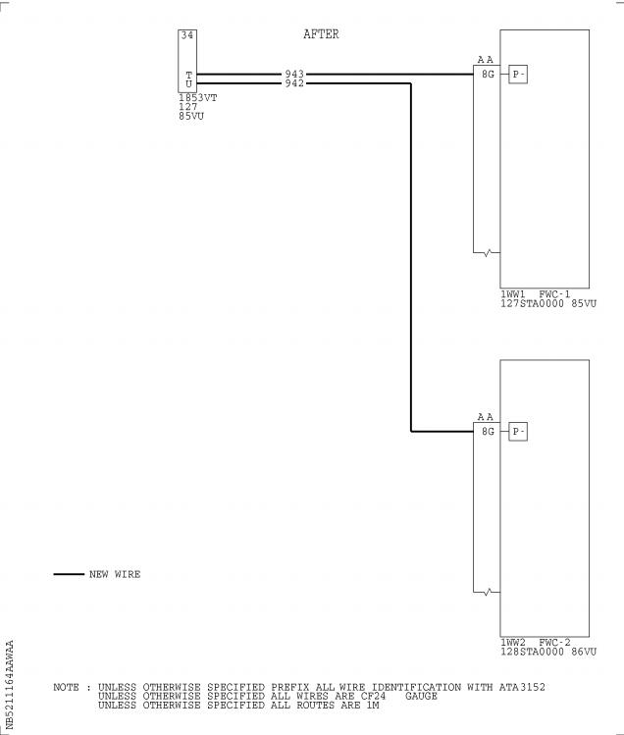

Figure 1 Sheet 1

Config . 01: Modification of the wiring in 80VU

DATE : Mar 30/07 SERVICE BULLETIN No . : A320— 21— 1164

REVISION No . : 00 — Page : 23

Printed in FRANCE © AIRBUS, 2007 All rights reserved

@ Ac18/Ac16/Ac20/Ac21

SERVICE BULLETIN

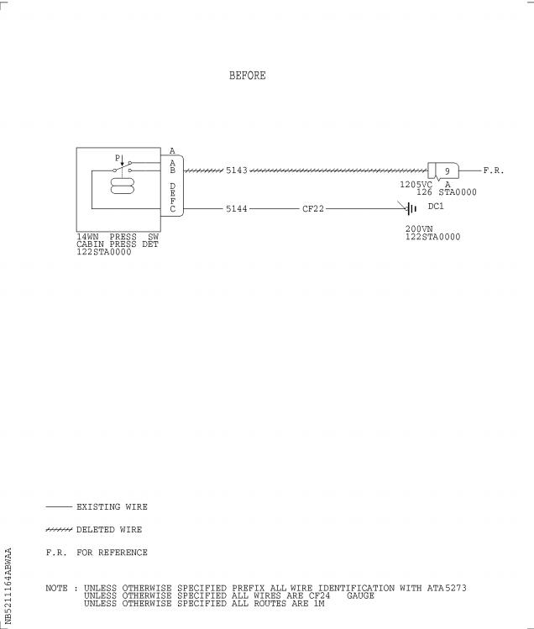

Figure 2 Sheet 1

Config . 01: Modification of the wiring in Avionics Compartment

DATE : Mar 30/07 SERVICE BULLETIN No . : A320— 21— 1164

REVISION No . : 00 — Page : 24

Printed in FRANCE © AIRBUS, 2007 All rights reserved

@ Ac18/Ac16/Ac20/Ac21

SERVICE BULLETIN

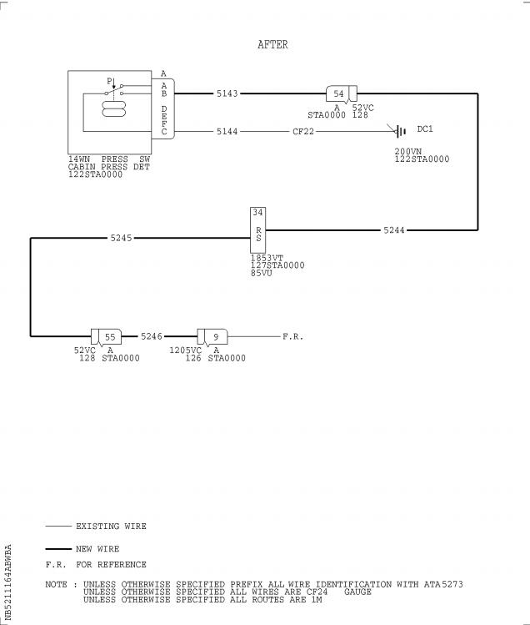

Figure 2 Sheet 2

Config . 01: Modification of the wiring in Avionics Compartment

DATE : Mar 30/07 SERVICE BULLETIN No . : A320— 21— 1164

REVISION No . : 00 — Page : 25

Printed in FRANCE © AIRBUS, 2007 All rights reserved

@ Ac18/Ac16/Ac20/Ac21

SERVICE BULLETIN

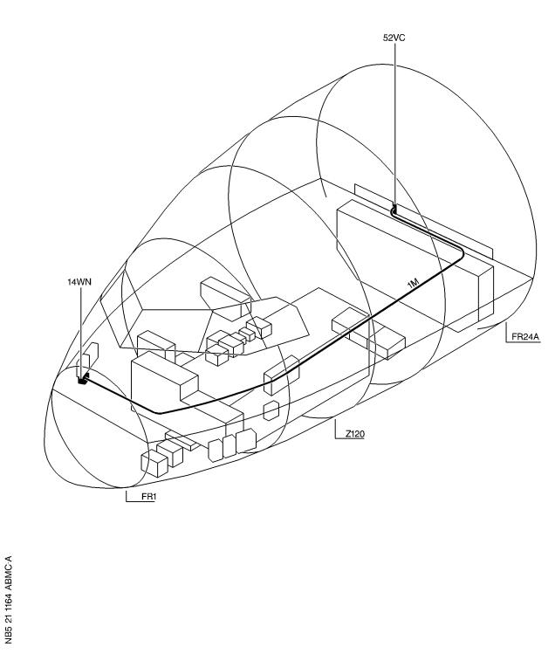

Figure 2 Sheet 3

Config . 01: Modification of the wiring in Avionics Compartment

DATE : Mar 30/07 SERVICE BULLETIN No . : A320— 21— 1164

REVISION No . : 00 — Page : 26

Printed in FRANCE © AIRBUS, 2007 All rights reserved

@ Ac18/Ac16/Ac20/Ac21

SERVICE BULLETIN

Figure 3 Sheet 1(Goto A3 section)

Config . 01: Hook-Up Chart

DATE : Mar 30/07 SERVICE BULLETIN No . : A320— 21— 1164

REVISION No . : 00 — Page : 27

Printed in FRANCE © AIRBUS, 2007 All rights reserved

@ Ac18/Ac16/Ac20/Ac21

SERVICE BULLETIN

REPORTING SHEET

TITLE : AIR CONDITIONING - PRESSURE CONTROL AND MONITORING - FWC ACQUISITION

INTERFACE CONNECT FWC TO RPWS TO PREVENT DOOR OPENING WITH RESIDUAL

CABIN PRESSURE

MODIFICATION No . : 34673P8863

Please complete the appropriate item (A or B):

A - SB WILL BE embodied . . . . . . . . . . . . . YES/NO (if NO please comment)

If YES, aircraft concerned (as per SB effectivity by default) and planned dates

(month/year) of embodiment : . . . . . . . . . . . . . . . . . . . . . . . . . .

. . . . . . . . . . . . . . . . . . . . . . . . . . . . . . . . . . . . . . . .

. . . . . . . . . . . . . . . . . . . . . . . . . . . . . . . . . . . . . . . .

B - SB HAS BEEN embodied on aircraft : . . . . . . . . . . . . . . . . . . . . .

. . . . . . . . . . . . . . . . . . . . . . . . . . . . . . . . . . . . . . . .

. . . . . . . . . . . . . . . . . . . . . . . . . . . . . . . . . . . . . . . .

Operator comments : . . . . . . . . . . . . . . . . . . . . . . . . . . . . . .

. . . . . . . . . . . . . . . . . . . . . . . . . . . . . . . . . . . . . . .

. . . . . . . . . . . . . . . . . . . . . . . . . . . . . . . . . . . . . . .

From Airline : . . . . . . . . . . . . . . . . . . . . . . . . . . . . . . . . .

Name/Title : . . . . . . . . . . . . . . . . . . . . . . . . . . . . . . . . . .

Signature : . . . . . . . . . . . . . . Date : . . . . . . . . . . . . .

If operational documentation is affected (see Paragraph 1 .K of this SB): If information is needed prior to next normal revision or prior to SB embodiment, please indicate required service:

Either: Modification Operational Impact (MOI), if available . . YES/NO

Or : Intermediate revision . . . . . . . . . . . . . . . . . YES/NO

Important Information: This SB will only be incorporated in your maintenance and

operational documentation if this sheet is returned to Airbus and signed by a

duly authorised representative . With the next feasible revision, this will

result in

- updating of maintenance documentation to show pre and post SB data .

- updating of maintenance and operational documentation to show post SB data

after embodiment .

If this SB requires previous or simultaneous accomplishment of other SBs,

Airbus shall automatically include them in the manual revisions . Refer to SIL

00-037 for detailed information .

Please return this completed sheet to:

AIRBUS

CUSTOMER SERVICES DIRECTORATE

1 Rond Point Maurice Bellonte

31707 BLAGNAC CEDEX FRANCE

Attn: SDC32 Technical Data and Documentation Services

FAX: (+33) 5 61 93 28 06

e -mail: sb . reporting@airbus .com

or via your Resident Customer Support Office .

Alternatively, SB lists via letters or fax are also accepted .

6 DATE : Mar 30/07

REVISION No . : 00 —

SERVICE BULLETIN No . : A320— 21— 1164

Page : 1 of 1

Printed in FRANCE © AIRBUS, 2007 All rights reserved

@ Ac18/Ac16/Ac20/Ac21

SERVICE BULLETIN

QUALITY PERCEPTION FORM

Use this form to tell us what is your perception of the quality of this Service Bulletin . The reported data that you provide us will be used to analyse areas of difficulties and to take corrective action to further improve the quality of our Service Bulletins .

We thank you for the time you have taken in completing this form .

(Please rate on a scale of 1 to 4, with 4 being the highest score)

|  |  |  |  |
| --- | --- | --- | --- |
| - Quality rating of this SB | 4 3 | 2 | 1 |
| - Quality rating of the Accomplishment Instructions | 4 3 | 2 | 1 |
| - Quality rating of the Illustrations | 4 3 | 2 | 1 |
| - Is this SB easy to understand ? | Y / N |  |  |

If you have had difficulties in the accomplishment of this SB please quote below

the area(s) and give a short description of the issue .

Planning

X Effectivity

X Reason

X Manpower

X References

X Publication

Comments :

Material

X Kit content

X List of Materials

Operator Supplied

X Re-identification

X Tooling

Instructions

X Preparation

X Mod/Inspection

X Test

X Close-Up

X Illustrations

Operator :

Date:

Name/Title :

Please return this form to :

AIRBUS

CUSTOMER SERVICES DIRECTORATE

1 Rond Point Maurice Bellonte

31707 BLAGNAC

Attn : SEM4 Service Bulletins Management

FAX : (33) 5 61 93 42 51

Or via your Resident Customer Support Office .

6 DATE : Mar 30/07

REVISION No . : 00 —

SERVICE BULLETIN No . : A320— 21— 1164

Page : 1 of 1

Printed in FRANCE © AIRBUS, 2007 All rights reserved

@ Ac18/Ac16/Ac20/Ac21

SERVICE BULLETIN

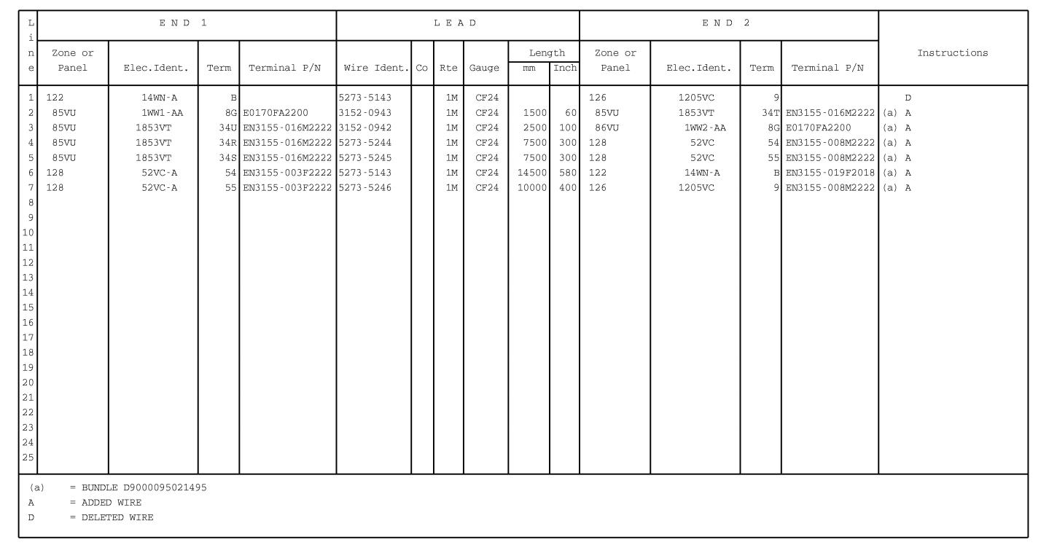

Figure 3 Sheet 1

Config . 01: Hook-Up Chart

DATE : Mar 30/07

REVISION No . : 00 —

SERVICE BULLETIN No . : A320— 21— 1164

Page : 27/28

Printed in FRANCE © AIRBUS, 2007 All rights reserved