AIRBUS INDUSTRIE

PRODUCT SUPPORT DIRECTORATE

1 Rond Point Maurice Bellonte 31707 BLAGNAC CEDEX FRANCE SERVICE BULLETIN Tel : (33) 61-93-33-33

Telex : AIRBU 530526 F REVISION TRANSMITTAL SHEET

MODIFICATION No. None ATA SYSTEM : 21

TITLE : AIR CONDITIONING - INTRODUCE SOME IMPROVEMENTS TO AVOID WATER CONDENSATION IN THE COCKPIT.

This page transnits Revision No. 1 of Service Bulletin No. A320-21-1902. No additional work is required by this Revision.

REASON

This Revision is issued to inform the operators of an updating of the effectivity paragraph.

SUMMARY

Page 1 of 2 - Para. REASON and EFFECTIVITY modified.

SERVICE BULLETIN

Page 1 of 19 - Para. 1.A.(2) and 1.B.(2) nodified.

FILING INSTRUCTIONS

Replace pages SUMMARY 1 of 2

SERVICE BULLETIN 1 of 19

FiLe this Revision Transmittal Sheet in front of the Service Bulletin.

REVISION SEQUENCES

ORIGINAL : Jun 14/91

REVISION No. : 1 - Feb 18/92

PRODUCT SUPPORT DIRECTORATE 1 Rond Point Maurice BeLlonte

AIRBUS INDUSTRIE

BLAGNAC CEDEX FRANCE (33) 61-93-33-33 :AIRBU 530526 F

31707 Tel : Telex

This sumnary is for infornation only and is not DGAC approved for  
Modification of the aircraft.

®A320

SERVICE BULLETIN SUMMARY

MODIFICATION No. None (evaluation)

ATA SYSTEM : 21

TITLE : AIR CONDITIONING - INTRODUCE SOME IMPROVEMENTS TO AVOID WATER CONDENSATION IN THE COCKPIT.

REASON/DESCRIPTION/OPERATIONAL CONSEQUENCES

Operators report danage and nuisance due to condensed water ； several Locations have been identified mainly on the front panel and side walls of the cockpit. This is experienced during long flights (4 hours and none).

This Service Bulletin proposes to apply adhesive foan on left lining in cockpit and to seal gaps on lower and upper left lateral frames in the cockpit夕 for an evaluation for 3 nonths on one AIR MALTA aircraft and on one CONAIR A/S aircraft.

EFFECTIVITY

This Service Bulletin is applicable on one A/C of each fleet : AMCZ OYC.

SERVICE BULLETIN/HODIFICATION TO BE ACCOMPLISHED PREVIOUSLY OR SIMULTANEOUSLY

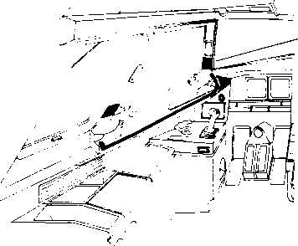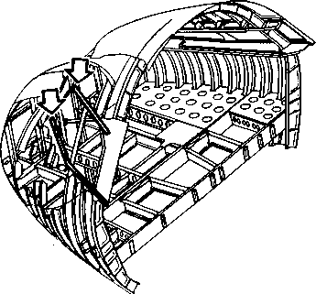None.

^A320

SERVICE BULLETIN SUMMARY

REFERENCES/REPERCUSSIONS

|  |  |  |  |
| --- | --- | --- | --- |
| TFU | 21000005 | LIFE LIMIT | None |
| OEB | None | LINE MAINTENANCE AFFECTED | |
|  |  | NO |  |
| AOT | None |  |  |
| SIL | None | OTHERS | None |

|  |  |  |
| --- | --- | --- |
| NATURE OF THE | MODIFICATION |  |
| AIRCRAFT | YES |  |
| EQUIPMENT | NO |  |
| COMPLIANCE |  |  |
| Optional. |  |  |
| MANPOWER |  |  |
| Manhours |  | 8.0 |
| Elapsed time | (Hours) | 7.0 |

MATERIAL INFORMATION

Aircraft Data

Quantity per A/C

1 self-adhesive foam sheet

Eauiment Data

None.

APPENDICES

None.

AIRBUS INDUSTRIE

PRODUCT SUPPORT DIRECTORATE

1 Rond Point Maurice Bellonte 31707 BLAGNAC CEDEX FRANCE TeL : (33) 61-93-33-33

Telex : AIRBU 530526 F

MODIFICATION No. None (evaluation)

5320

SERVICE BULLETIN

ATA SYSTEM : 21

TITLE : AIR CONDITIONING ・ INTRODUCE SOME IMPROVEMENTS TO AVOID WATER CONDENSATION IN THE COCKPIT.

1. PLANNING INFORMATION

A. EFFECTIVE

1. Aircraft models : A320T1，A320-211.
2. Aircraft

|  |  |  |  |
| --- | --- | --- | --- |
| Customer and Fleet No. | MSN | Kit No. 211902 | Qty of Kits |
| AMC | TBD | A01 | 01 |
| OYC | TBD | A01 | 01 |

Evaluation applicable on 1 AIR MALTA aircraft and on 1 CONAIR A/S aircraft for 3 months.

1. Spares

None.

B. REASON

(1) History

Operators report danage and nuisance due to condensed water ; several Locations have been identified Mainly on the front panel and side walls of the cockpit. This is experienced during long flights (4 hours and nore).

(2) Objective/Action

This Service Bulletin proposes to apply adhesive foa* on left lining in cockpit and to seal gaps on lower and upper left lateral frames in the cockpit^ for an evaluation for 3 Months on one AIR MALTA aircraft and on one CONAIR A/S aircraft.

®A320

SERVICE BULLETIN

1. Advantages

To reduce condensed water in the cockpit.

1. Acconplishment Timescale

In accordance with operators experience.

1. DESCRIPTION

Accomplisment of this Service Bulletin consists in carrying out the following jobs on the aircraft :

1. Apply adhesive foam on Left Lining in cockpit.
2. Seal gaps on Lower and upper left lateral frames in the cockpit.
3. APPROVAL

This Service Bulletin is approved by Direction Generate de I'Aviation Civile - FRANCE (D.G.A.C.).

1. MANPOWER

Manhours

Gain access 2.0

Modification on the cockpit panel 1.0

Modification on Lateral frames 2.0

Close up 3.0

TOTAL MANHOURS 8.0

ELAPSED TIME (HOURS) 7.0

NOTE : This Service Bulletin assumes that the aircraft has been placed in a Maintenance status. The «anhours/elapsed tine estimates do not include preparation for the nodificationz non-productive elapsed tinez or administrative functions.

®4320

SERVICE BULLETIN

1. MATERIAL ・ COST AND AVAILABILITY

Refer to Paragraph 3夕 MATERIAL INFORMATION.

1. TOOLING - PRICE AND AVAILABILITY

None.

1. HEIGHT AND BALANCE

None.

I.

REFERENCES

Aircraft Maintenance Manual

:06-41-52, 31-53-21, 56-12-12.

12-34-24, 24-41-00, 25-13-41,

56-11-11, 56-11-12z 56-12-11,

Consumable Material List

Shop sketch

:C 000075,

C 000076, C 000077

J. PUBLICATIONS AFFECTED

None.

®A320

SERVICE BULLETIN

2. ACCOMPLISHMENT INSTRUCTIONS

1. GENERAL
2. Preparation
3. De-energize the aircraft electrical circuits

(Ref. AMM 24-41-00, P. Block 201) and electrically ground the aircraft (Ref. AMM 12-34-24, P. Block 201).

1. Install access platforms.
2. Open access door 831 (Ref. AMM 06-41-52)
3. Remove inner Lining of fixed window 7DG1 (Ref. AMM 56-11-12)
4. Remove access panel 211KC and Iining of siiding window 8DG1 (Ref. AMM 56-12-11).
5. Remove access panels 211PWZ 211DW and 211GW

(Ref. AHM 56-12-12).

1. Remove access panels 211LC, 211MC, 211NW (Ref. AMM 56-11-11).
2. Remove access panels 211AC, 211BC, 211DCZ 211FC (Ref. AMM 25-13-41).
3. Remove instrument panel 2VU (AMM 31-53-21).
4. Standard procedures
5. Clean surfaces to be sealed using solvent Mat. No. 11-003 (Ref. CML).
6. MODIFICATION

(1) Apply self adhesive foam pieces on left Iining in cockpit

Refer to figure 1 sheet 1 of 3Z 2 and 3

1. Cut-out 6 pieces of self-adhesive foam as per shop sketches No. C 000075z C 000076z C 000077 and figure 1 sheet 3.

1 self-adhesive foam sheet ASNA5002-5206 Iteml

1. On Iining panels 211NWZ 211PWZ 8DG1 and 2VU apply self-adhesive foam pieces as per shop sketches No. C 000075, C 000076z

C 000077 and figure 1 sheet 3.

SERVICE BULLETIN

(2) Seal gaps on lower and upper Left lateral frames in the cockpit Refer to figure 2 sheet 1 of 3Z 2 and 3.

1. Before sealing gapsz blank off bottom gaps using adhesive tape Mat. No. 05-015.
2. With a brush# apply a coat of release agent Mat. No. 05-013 and let dry.
3. Seal gaps using sealing compound Mat. No. 09-019.
4. After drying *oi* sealing compound夕 remove the adhesive tape.
5. TESTS

None.

1. CLOSE-UP
2. Make sure that the work area is clean and clear of tools and miscellaneous items of equipment.
3. Install instrument panel 2VU (AMM 31-53-21).
4. Install access panels 211ACZ 211BC, 211DC, 211FC (Ref. AMM 25-13-41).
5. Install access panels 211LC, 211MCZ 211NW (Ref. AMM 56-11-11).
6. Install access panels 211PW, 211DW and 211GW (Ref. AMM 56-12-12).
7. Install access panel 211KC and lining of sliding window 8DG1 (Ref. AMM 56-12-11).
8. Install inner lining of fixed window 7DG1 (Ref. AMM 56-11-12).
9. Close access door 831 (Ref. AMM 06-41-52).
10. Remove access platforms.
11. Disconnect the aircraft electrical ground connection (Ref. AMM 24-41-00z P. Block 201).

^A320

SERVICE BULLETIN

Apply Self-Adhesive Foan Pieces on Left Lining in Cockpit

Figure 1 Sheet 1 of 3

DATE : Jun 14/91

SERVICE BULLETIN No. : A320-21-1902

REVISION NO.:

PAGE : 7-8

SECTION AA

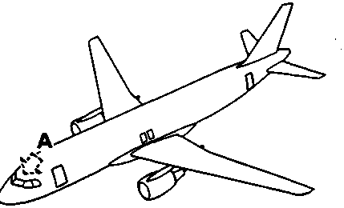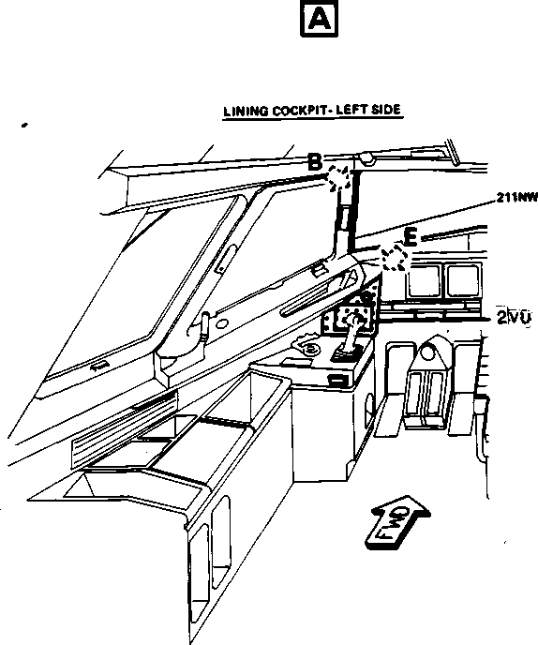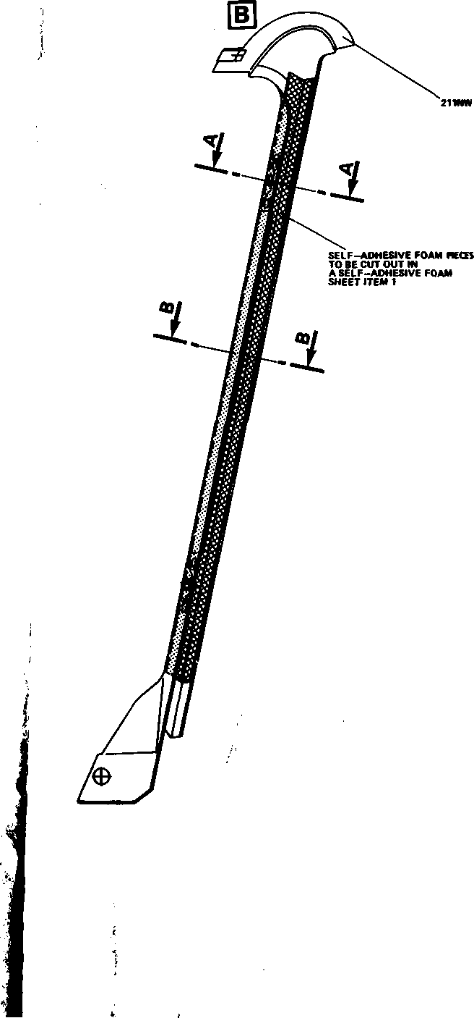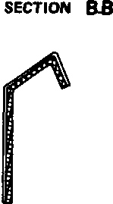

回

jun

RgSlQN HO-.

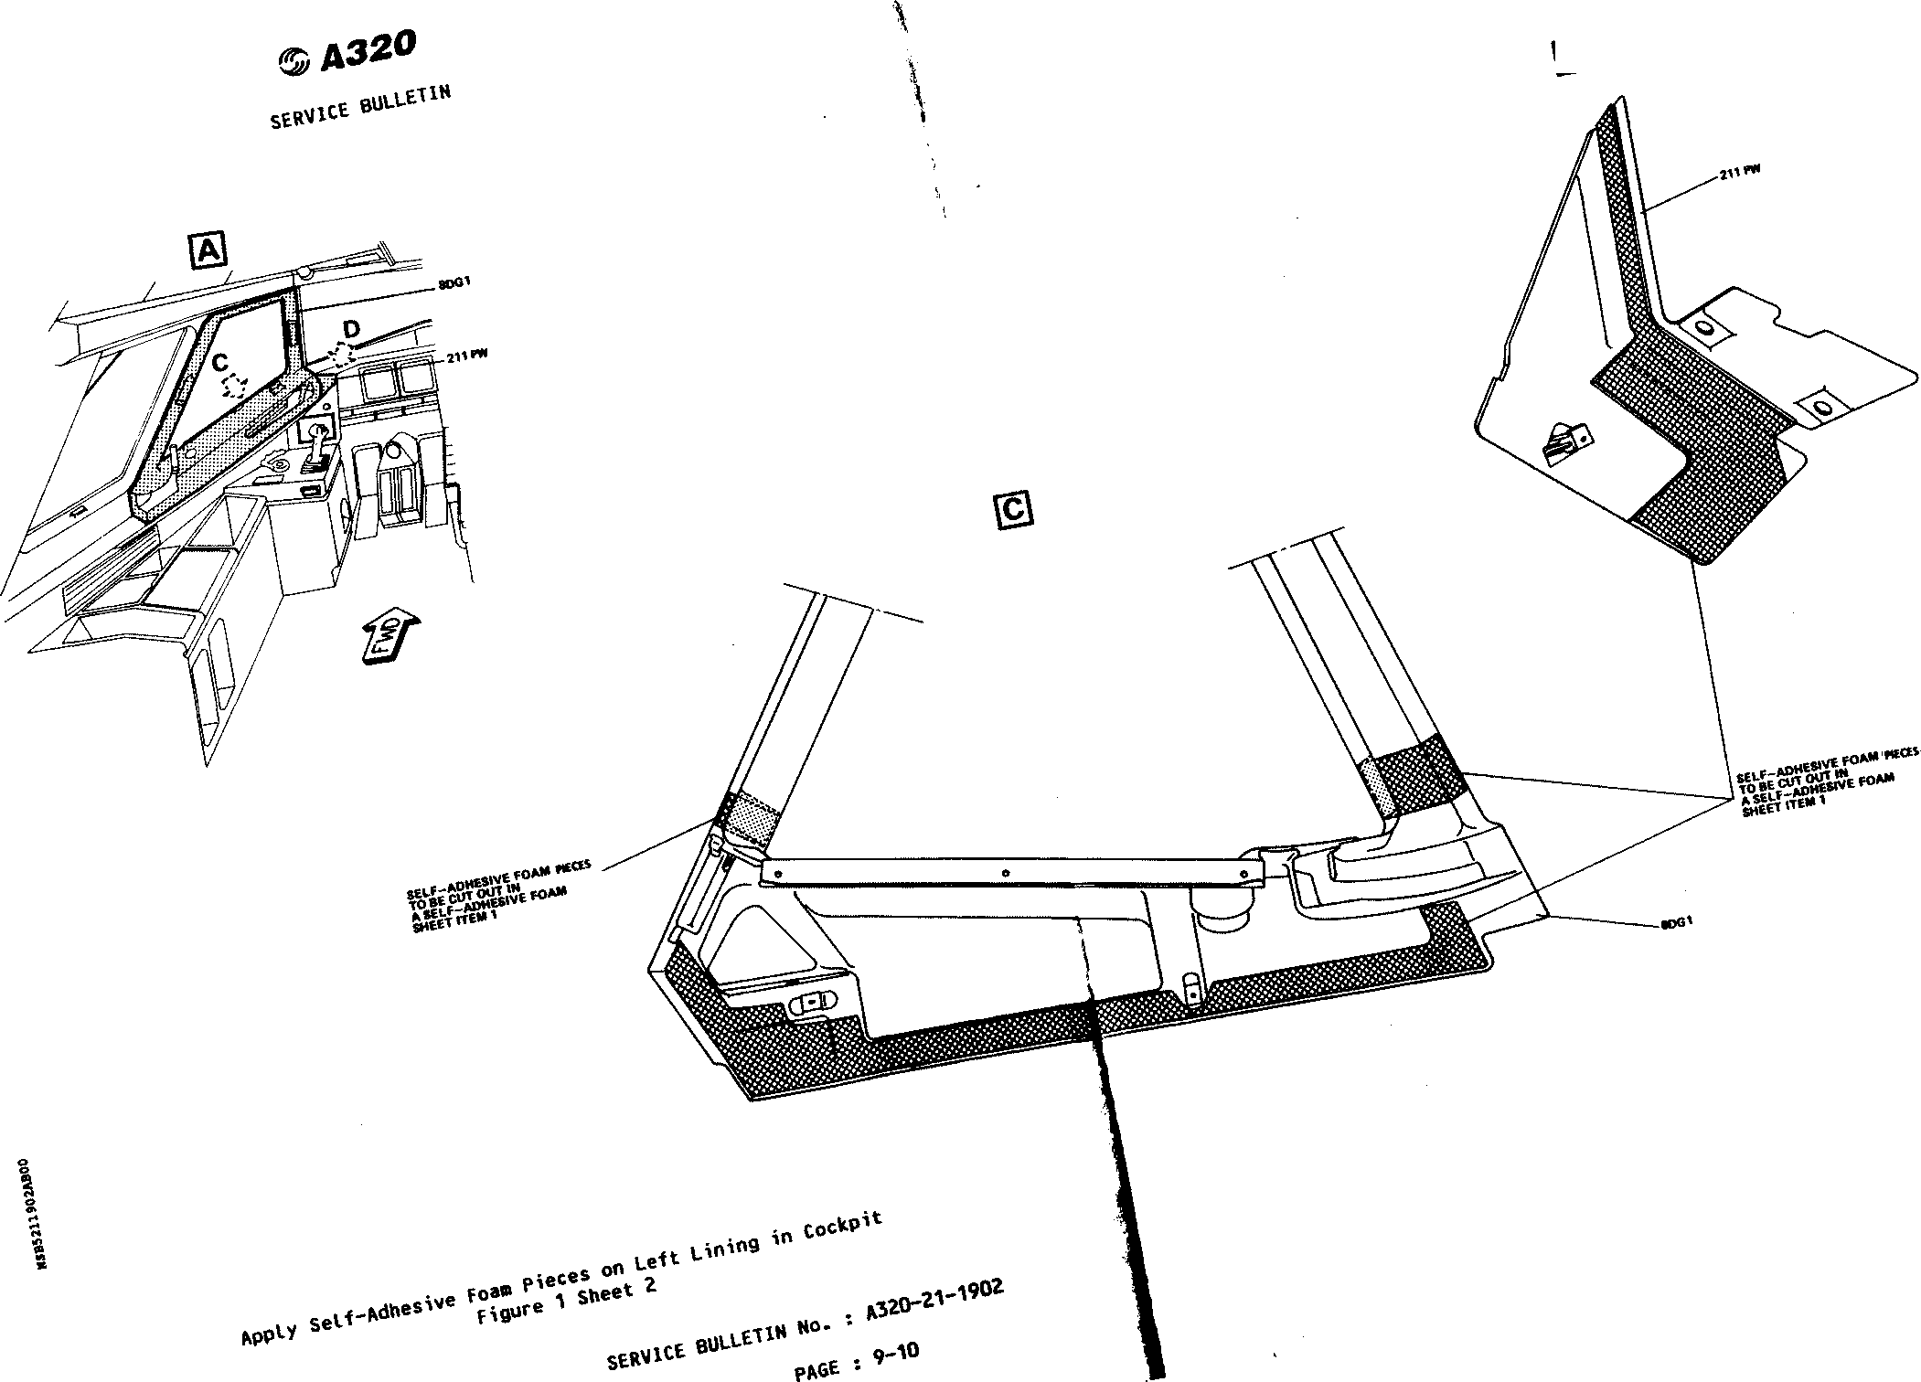

fQ

^A320

SERVICE BULLETIN

SELFADMESWE FOAM PIECE DEVELOPED

(3.937m.)

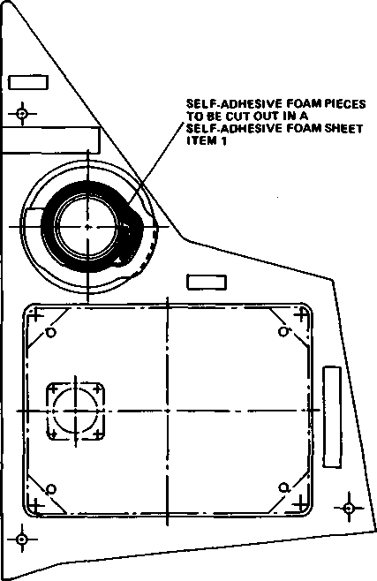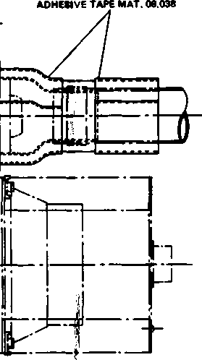

Apply Self-Adhesive Foa« Pieces on Left Lining in Cockpit  
Figure 1 Sheet 3

SERVICE BULLETIN

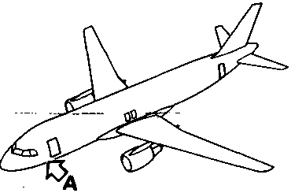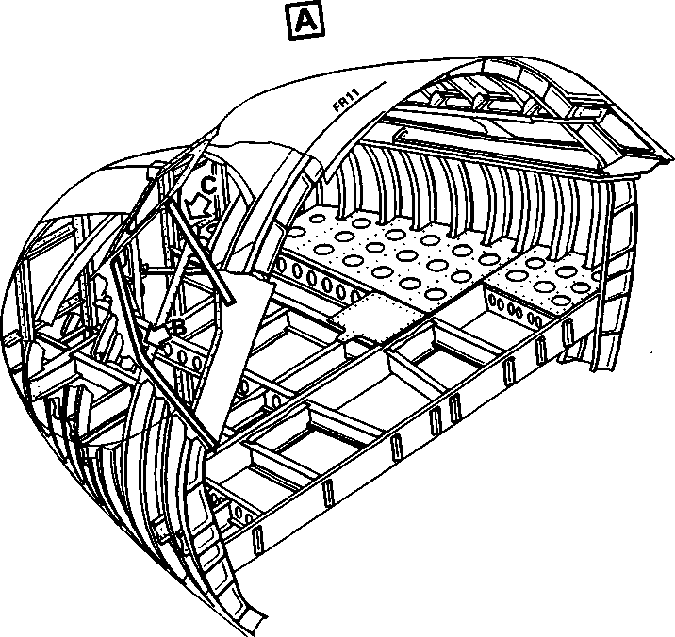

Gaps to be Sealed on Lower and Upper Left Lateral Franes in the Cockpit

Figure 2 Sheet 1 of 3

DATE : Jun 14/91

SERVICE BULLETIN No. : A320-21-1902

⑤ A320

SERVICE BULLETIN

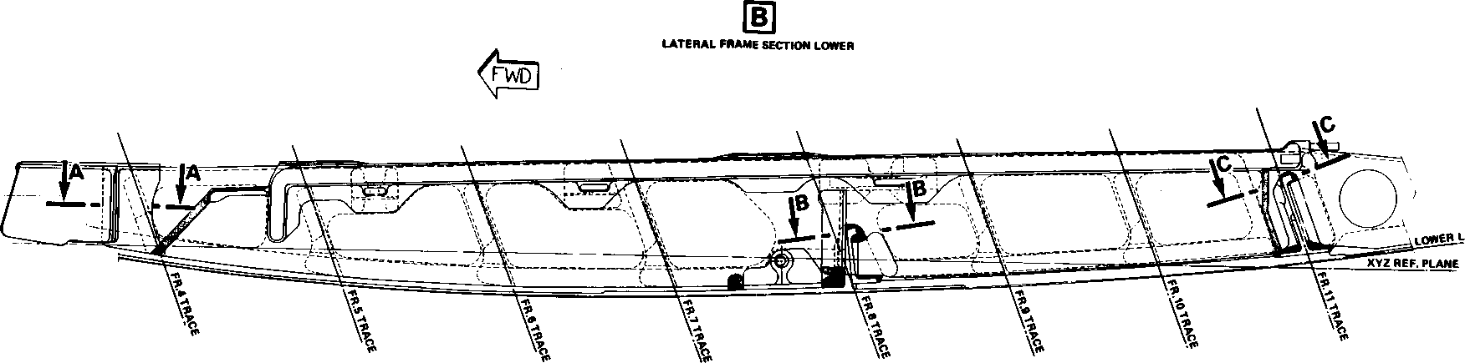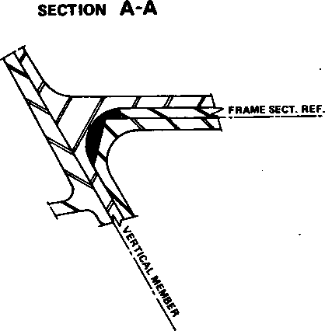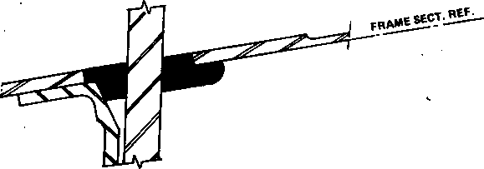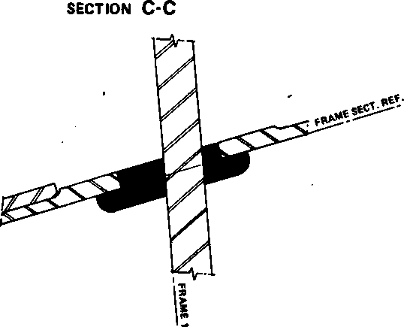

SECTION B・B

GAPS TO BE SEALED WITH MAT. No. 09 - 019

AND MAT. No. 05 -013

Gaps to be Sealed on Lower and Upper Left Lateral Frames in the Cockpit  
Figure 2 Sheet 2

SERVICE BULLETIN No. : A320-21-1902

DATE : Jun 14/91

回

LymAL FRAME SECTION UPPER

SECTION B-B

Gaps to be Sealed on Lower

and Upper Left Lateral Frames in the Cockpit Figure 2 Sheet 3

DATE : Jun 14/91

REVISION No.:

SERVICE BULLETIN No. : A320-21-1902

*PAGE :* 17-18

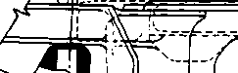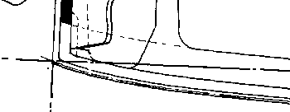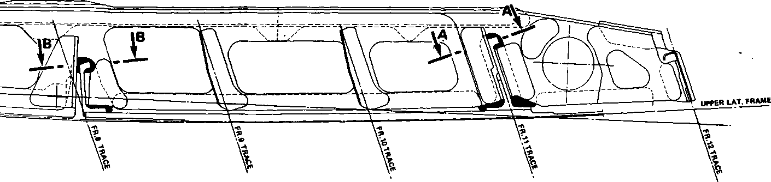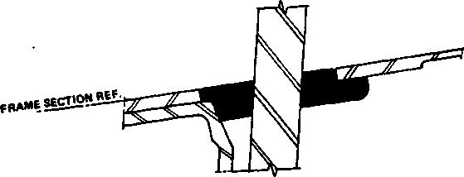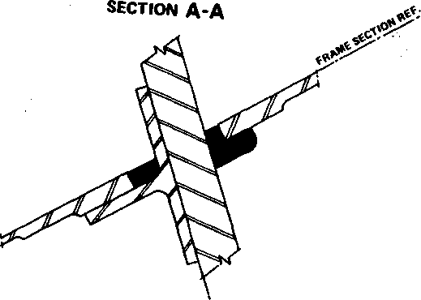

^A320

SERVICE BULLETIN

3. MATERIAL INFORMATION



A item

LIST OF COMPONENTS

NEW PART No.

QTY

DESCRIPTION

OLD PART No.

INT

DISPOS .

INSTRUC

Kit No, 211902

A01

1 ASNA5002-5206

1 Foam-seLf*adhesive

* Material required for acconplishnent of this Service Bulletin shall be procured by means of a spares purchase order.

1. SPECIAL TOOLS

None.

1. LIST OF MATERIALS ・ OPERATOR SUPPLIED

DESCRIPTION REFERENCE

QTY PER A/C

CHL

|  |  |  |  |
| --- | --- | --- | --- |
| Release agent | Mat. | No. 05-013 | AS required |
| Adhesive tape | Mat. | No. 05-015 | AS required |
| Adhesive tape | Mat. | No. 08-038 | AS required |
| PR1403 | Mat. | No. 09-019 | AS required |
| Solvent | Mat. | No. 11-003 | AS required |

1. PARTS TO BE RE-IDENTIFIED BY OPERATOR

None.

AIRBUS INDUSTRIE

PRODUCT SUPPORT DIRECTORATE

1 Rond Point Maurice BELLONTE 31707 BLAGNAC CEDEX FRANCE Tel : (33) 61-93-33-33

Telex : AIRBU 530526 F

MODIFICATION No. None (evaluation) ATA SYSTEM : 21

TITLE : AIR CONDITIONING - INTRODUCE SOME IMPROVEMENTS TO AVOID WATER CONDENSATION IN THE COCKPIT.

IS BEING HEREWITH SUBMITTED TO YOU FOR REVIEW

Please fill : ... REJECTED

... WILL BE EMBODIED

... EFFECTIVITY

This SB can only be incorporated in your "customized" documentation within the agreed time schedule in so far as this sheet is returned to us on purchase date and signed by a duly authorized and empowered officer or representative.

|  |  |  |
| --- | --- | --- |
| FROM : |  | Please return to : |
| AIRLINE : |  | AIRBUS INDUSTRIE PRODUCT SUPPORT DIRECTORATE |
| NAME : |  | 1 Rond Point Maurice BELLONTE 31707 BLAGNAC CEDEX FRANCE |
|  |  | Att. : AI/SP - Technical Publications |
| DATE : |  | Department |

19