***A319/A320/A321***

|  |
| --- |
|  |

SERVICE BULLETIN

SUMMARY

AIRBUS INDUSTRIE

CUSTOMER SERVICES DIRECTORATE

1 Rond Point Maurice BELLONTE

31707 BLAGNAC CEDEX FRANCE

Tel: (33) 5 61-93-33-33

Telex: AIRBU 530526 F

TITLE : AIR

AIR

This summary is for information only

and is not approved for modification of the aircraft

CONDITIONING - FLOW CONTROL AND INDICATING - INTRODUCE MODIFIED

CONDITIONING FOR EVALUATION

MODIFICATION No. : 26249K04574 26792K05213 ATA SYSTEM : 21

REASON/DESCRIPTION/OPERATIONAL CONSEQUENCES

To gain potential for improvements on system level, the Environmental

Control System (ECS) has been investigated. The objectives for such

improvements are higher reliability by improved Mean Time Between

Unscheduled Removal Guaranteed (MTBURG), better maintainability with

lower maintenance costs and greater commonality with other aircraft

types.

This Service Bulletin introduces an improved pack temperature controller

in the avionics compartment, a new flow control valve, pressure sensor

and pack inlet pressure sensor.

The MTBURG for the new flow control valve is increased from 4,800 to

7,000 flight hours.

The modification is to be installed for evaluation purposes on LH or RH

side only.

EFFECTIVITY

This Service Bulletin is applicable to these customer(s) :

AFR, SWR.

SERVICE BULLETIN TO BE ACCOMPLISHED

PREVIOUSLY OR SIMULTANEOUSLY

Service Bulletin No. A320-21-1082 (Mod. No. 24094K3554

REFERENCES/REPERCUSSIONS

TFU : None

OEB : None

AOT : None

SIL : None

LIFE LIMIT : None

LINE MAINTENANCE AFFECTED : None

OTHER : None

6 DATE : Feb 24/98 SERVICE BULLETIN No. : A320-21-1906

REVISION No. : 00 -

PAGE : 1 of 3

Printed in France

|  |
| --- |
|  |

NATURE OF THE WORK

***A319/A320/A321***

SERVICE BULLETIN

SUMMARY

Kit No. 211 0A01

AIRCRAFT

EQUIPMENT

HARD

SOFT

OBRM COMPLIANCE Optional

MANPOWER

:

:

:

:

:

YES

NO

NO

NO

NO

Kit No. 211 0A01

TOTAL MANHOURS

8.00

8.00

ELAPSED TIME (HOURS)

MATERIAL INFORMATION

AIRCRAFT DATA

Kit No. 211 0A01

2 hoses, clamps and associated hardware.

EQUIPMENT DATA

Kit No. 211 0A01

Designation : Flow Control Valve (8HB and 11HB)

Supplier : LIEBHERR AERO TECHNIK GmbH

Service Bulletin No. None

Old

New

Part

Part

Number

Number

751A0000-07 751B0000-02

1303A0000-01

Interchangeability code 03 (Refer to ATA 200 Chapter 1A-2)

Mixability : NO

Designation : Pressure Sensor (9HB and 10HB)

Supplier : LIEBHERR AERO TECHNIK GmbH

Service Bulletin No. None

Old

New

Part

Part

Number

Number

9104A0003-01

9106A0005-01

Interchangeability code 03 (Refer to ATA 200 Chapter 1A-2)

Mixability : NO

Designation : Pressure Sensor (16HH and 36HH)

Supplier : LIEBHERR AERO TECHNIK GmbH

Service Bulletin No. None

Old

New

Part

Part

Number

Number

768A0000-03

9104A0006-01

Interchangeability code 03 (Refer to ATA 200 Chapter 1A-2)

DATE : Feb 24/98 SERVICE BULLETIN No. : A320-21-1906

REVISION No. : 00 -

PAGE : 2

Printed in France

***A319/A320/A321***

|  |
| --- |
|  |

SERVICE BULLETIN

SUMMARY

Mixability : NO

Designation : Pack Controller (7HH and 27HH)

Supplier : LIEBHERR AERO TECHNIK GmbH

Service Bulletin No. None

Old

New

Part

Part

Number

Number

759A0000-10 759C0000-02

759D0000-01

Interchangeability code 03 (Refer to ATA 200 Chapter 1A-2)

Mixability : YES

NOTE : Flow Control Valve (8HB and 11HB) old part number

751A0000-07 or 751B0000-02 can be installed.

Pack Controller (7HH and 27HH) old part number 759A0000-10

or 759C0000-02 can be installed.

APPENDICES

None

DATE : Feb 24/98 SERVICE BULLETIN No. : A320-21-1906

REVISION No. : 00 -

PAGE : 3

Printed in France

***A319/A320/A321***

|  |
| --- |
|  |

SERVICE BULLETIN

AIRBUS INDUSTRIE

CUSTOMER SERVICES DIRECTORATE

1 Rond Point Maurice BELLONTE

31707 BLAGNAC CEDEX FRANCE

Tel: (33) 5 61-93-33-33

Telex: AIRBU 530526 F

TITLE : AIR CONDITIONING - FLOW CONTROL AND INDICATING - INTRODUCE MODIFIED

AIR CONDITIONING FOR EVALUATION

MODIFICATION No. : 26249K04574 26792K05213 ATA SYSTEM : 21

1. PLANNING INFORMATION

A. EFFECTIVITY

(1) Aircraft models : 319-112, 319-113, 320-111, 320-211, 320-212, 320-214, 321-111, 321-211

(2) Aircraft

Customer and MSN Kit No. Qty Config

Fleet No. 211906 of kits No.

AFR001, 002 005,007 A01

004-009 014,019,020,021,002,004 A01

010-013 003,010,012,013 A01

015 016 A01

031-036 061,062,063,100,101,102 A01

037-042 128,129,133,186,187,188 A01

043-048 226,227,228,285,286,287 A01

066-068 033,036,044 A01

071-076 108,115,130,155,156,184 A01

077-078 214,239 A01

080-085 278,337,352,236,237,377 A01

101-105 498,509,521,529,544 A01

131, 132 777,796 A01

201, 202 144,145 A01

211, 212 420,436 A01

226, 227 131,132 A01

231, 332 203,220 A01

301, 302 204,211 A01

305 085 A01

401-403 215,244,270 A01

411, 412 491,525 A01

6 DATE : Feb 24/98 SERVICE BULLETIN No. : A320-21-1906

REVISION No. : 00 -

PAGE : 1 of 38

Printed in France

***A319/A320/A321***

|  |
| --- |
|  |

SERVICE BULLETIN

Customer and

Fleet No.

MSN

Kit No.

211906

Qty

of kits

Config

No.

|  |  |  |
| --- | --- | --- |
| 501-503 | 674,675,684 | A01 |
| 901-906 | 598,600,608,618,625,637 | A01 |
| 947-949 | 644,647,660 | A01 |
| SWR201-206 | 578,588,612,621,629,713 | A01 |
| 207-208 | 727,734 | A01 |
| 226-231 | 533,545,548,553,559,562 | A01 |
| 232-237 | 566,574,577,585,596,603 | A01 |
| 238-243 | 635,643,673,681,701,703 | A01 |
| 276-281 | 517,519,520,522,535,541 | A01 |
| 282-283 | 642,664 | A01 |

This Evaluation Service Bulletin is only applicable on one aircraft

from each fleet among those listed above. The MSN of this aircraft

will be given to Airbus Industrie.

To do this Service Bulletin you must do Service Bulletin No.

A320-21-1082 (Mod. No. 24094K3554) before or at the same time.

This document contains Airbus Industrie PROPRIETARY INFORMATION and

shall at all times remain the property of Airbus Industrie; no

intellectual property right or licence is granted by Airbus

Industrie in connection with any information contained in it. It is

delivered on the express condition that said document and the

information contained in it shall be treated as confidential, shall

not be used for any purpose other than that for which it is hereby

delivered. It shall not be disclosed in whole or in part to third

parties and shall not be duplicated in any manner (except for the

purposes of performing the tasks described hereunder and provided

that any recipient of such document shall comply with the

conditions herein), without Airbus Industrie‘s prior written

consent.

(3) Spares

None

B. REASON

(1) History

To gain potential for improvements on system level, the

Environmental Control System (ECS) has been investigated. The

objectives for such improvements are higher reliability by improved

Mean Time Between Unscheduled Removal Guaranteed (MTBURG), better

maintainability with lower maintenance costs and greater

commonality with other aircraft types.

DATE : Feb 24/98 SERVICE BULLETIN No. : A320-21-1906

REVISION No. : 00 -

PAGE : 2

Printed in France

***A319/A320/A321***

|  |
| --- |
|  |

SERVICE BULLETIN

(2) Objective/Action

This Service Bulletin introduces an improved pack temperature

controller in the avionics compartment, a new flow control valve,

pressure sensor and pack inlet pressure sensor.

The modification is to be installed for evaluation purposes. The

evaluation should be accomplished for three months on LH or RH side

only.

(3) Advantages

The MTBURG for the new flow control valve is increased from 4,800

to 7,000 flight hours.

(4) Operational/Maintenance Consequences

None

(5) Accomplishment Timescale

In accordance with operators’ maintenance schedule.

C. DESCRIPTION

To accomplish this Service Bulletin it is necessary to :

(1) Remove the pack controller in the electronics rack 90VU.

(2) Modify the wiring and the equipment in the shelves 95VU and 90VU.

(3) Install the new pack controller in the electronics rack 90VU.

(4) Remove the flow control valve in the zone 191 or 192.

(5) Remove the pressure sensor in the zone 191 or 192.

(6) Install the new pressure sensor in the zone 191 or 192.

(7) Install the new hose on LH side, zone 191 or on RH side, zone 192.

(8) Install the new flow control valve in the zone 191 or 192.

D. APPROVAL

The technical information including design data contained in this Service Bulletin has been approved under the authority of DGAC Design Organisation Approval No F.JA.02. The changes specified in this Service Bulletin have been approved by the DGAC when they are major, or under the authority of DGAC Design Organisation Approval No. F.JA.02, when they are minor.

E. MANPOWER

This Service Bulletin is written for an aircraft in a maintenance

condition. The manhours/elapsed time estimates do not include the time

to prepare for the modification, non-productive elapsed times or

administration.

On aircraft

Get access 1.50

DATE : Feb 24/98 SERVICE BULLETIN No. : A320-21-1906

REVISION No. : 00 -

PAGE : 3

Printed in France

***A319/A320/A321***

|  |
| --- |
|  |

SERVICE BULLETIN

Removal of controller pack

Modification of the wiring

Installation of controller packs

Removal of the control valve and sensors

Installation of the control valve and sensors

Test

Close-up

TOTAL MANHOURS

ELAPSED TIME (HOURS)

After evaluation

Restoration of the aircraft to its initial config.

TOTAL MANHOURS

ELAPSED TIME (HOURS)

F. MATERIAL - COST AND AVAILABILITY

0.50

1.00

0.50

0.75

0.75

1.50

1.50

8.00

8.00

8.00

8.00

8.00

|  |  |  |
| --- | --- | --- |
| (1) | Material  Contact the following address for Kit management  Daimler-Benz Aerospace Airbus  Dept. ESD  ATTN: R. Schmidt  Kreetslag 10  21129 HAMBURG  Tel.: 040/7437-3855  Fax : 040/7437-3787 | : |

(2) Cost and availability

Kit No.

211 0A01

Cost

(US Dollars)

FOC

Availability :

days from receipt

Calendar of order

G. TOOLING - PRICE AND AVAILABILITY

None

H. WEIGHT AND BALANCE Not changed

I. REFERENCES

Aircraft Maintenance Manual (AMM)

Service Bulletin (SB)

: 21-51-11, 21-51-51, 21-61-16,

21-61-34

: A320-21-1082

DATE : Feb 24/98 SERVICE BULLETIN No. : A320-21-1906

REVISION No. : 00 -

PAGE : 4

Printed in France

***A319/A320/A321***

|  |
| --- |
|  |

SERVICE BULLETIN

J. PUBLICATIONS AFFECTED

Illustrated Parts Catalog (IPC)

Aircraft Wiring Manual (AWM)

: 21-61-08

: 21-61-01, 21-61-06

DATE : Feb 24/98 SERVICE BULLETIN No. : A320-21-1906

REVISION No. : 00 -

PAGE : 5

Printed in France

***A319/A320/A321***

|  |
| --- |
|  |

SERVICE BULLETIN

This Page Intentionally Left Blank

DATE : Feb 24/98 SERVICE BULLETIN No. : A320-21-1906

REVISION No. : 00 -

PAGE : 6

Printed in France

***A319/A320/A321***

|  |
| --- |
|  |

SERVICE BULLETIN

2. ACCOMPLISHMENT INSTRUCTIONS

A. GENERAL

WARNING : MAKE SURE THAT YOU OBEY ALL THE WARNINGS AND ALL THE

CAUTIONS INCLUDED IN THE REFERENCED PROCEDURES.

WARNING : MAKE SURE THAT THE GROUND SAFETY-LOCKS ARE IN POSITION ON

THE LANDING GEAR AND THE WHEEL CHOCKS ARE IN POSITION.

WARNING : MAKE SURE THAT NO AIR IS SUPPLIED TO THE AIR CONDITIONING

SYSTEM FROM THE MAIN ENGINE, THE APU OR A GROUND SOURCE. HOT

COMPRESSED AIR CAN CAUSE INJURY TO PERSONNEL.

(1) Preparation

(a) Refer to AMM: 21-51-11, P. Block 401 .

(b) Refer to AMM: 21-51-51, P. Block 401 .

(c) Refer to AMM: 21-61-16, P. Block 401 .

(d) Refer to AMM: 21-61-34, P. Block 401 .

(2) Standard Practices

None

B. MODIFICATION

NOTE: This modification should be accomplished on LH or RH side only.

(1) Remove the pack controller in the electronics rack 90VU

Refer to Figure 1

Refer to AMM: 21-61-34, P. Block 401

1 pack controller 7HH 759A0000-10 Item (1) Retain

or

1 pack controller 7HH 759C0000-02 Item (1) Retain

and

1 pack controller 27HH 759A0000-10 Item (1) Retain

or

1 pack controller 27HH 759C0000-02 Item (1) Retain

(2) Modify the wiring and the equipment in the shelves 95VU and 96VU

Refer to Figure 2 , 3 and 4

(a) Install except for aircraft MSN 588, 612, 621, 629, 713, 727

and 734, in the shelf 96VU :

DATE : Feb 24/98 SERVICE BULLETIN No. : A320-21-1906

REVISION No. : 00 - PAGE : 7

Printed in France

***A319/A320/A321***

|  |
| --- |
|  |

SERVICE BULLETIN

Refer to Figure 3

1 module 672VG E0425A2001 Item 2

(b) Install the wires shown on the lines 1 and 2 (Refer to Figure 4

), supplied in :

1 bundle D9000095209695

route them with the wires that

(c) Cut the wires to the necessary

connect them.

(d) Attach the wires with :

are in the panel.

length. crimp the terminals and

10 cable ties NSA935401-05

(e) Do a continuity test of the new wires.

(3) Install the new pack controller in the electronics rack 90VU :

Refer to AMM: 21-61-34, P. Block 401

1 pack controller 7HH 759D0000-01 Item 1

or

1 pack controller 27HH 759D0000-01 Item 1

(4) Remove the flow control valves in the zones 191 or 192

Refer to Figure 5

Refer to AMM: 21-51-51, P. Block 401

|  |  |  |  |  |  |  |  |
| --- | --- | --- | --- | --- | --- | --- | --- |
| 1 | flow  or | ctr | valve | 8HB | 751A0000-07 | Item (3) | Retain |
| 1 | flow  and | ctr | valve | 8HB | 751B0000-02 | Item (3) | Retain |
| 1 | flow  or | ctr | valve | 11HB | 751A0000-07 | Item (3) | Retain |

DATE : Feb 24/98 SERVICE BULLETIN No. : A320-21-1906

REVISION No. : 00 -

PAGE : 8

Printed in France

***A319/A320/A321***

|  |
| --- |
|  |

SERVICE BULLETIN

1 flow ctr valve 11HB 751B0000-02 Item (3) Retain

NOTE : Identify the hoses with the items given in the figure to

facilitate the later connection.

(5) Remove the pressure sensors in the zones 191 or 192

Refer to Figure 5

Refer to AMM: 21-51-11, P. Block 401

1

pressure sensor

or

9HB

9104A0003-01

Item (6)

Retain

1 pressure sensor 10HB 9104A0003-01 Item (6) Retain Refer to AMM: 21-61-16, P. Block 401

1

pressure sensor

or

16HH

768A0000-03

Item (7)

Retain

1 pressure sensor 36HH 768A0000-03 Item (7) Retain

(6) Install the new pressure sensors in the zones 191 or 192

Refer to Figure 6

Refer to AMM: 21-51-11, P. Block 401

1 pressure sensor 9HB 9106A0005-01 Item 6

or

1 pressure sensor 10HB 9106A0005-01 Item 6

Refer to AMM: 21-61-16, P. Block 401

1 pressure sensor 16HH 9104A0006-01 Item 7

or

1 pressure sensor 36HH 9104A0006-01 Item 7

(7) Install the new hose on LH side, zone 191

DATE : Feb 24/98 SERVICE BULLETIN No. : A320-21-1906

REVISION No. : 00 -

PAGE : 9

Printed in France

***A319/A320/A321***

|  |
| --- |
|  |

SERVICE BULLETIN

Refer to Figure 6

(a) Put the hose in position and connect to the pressure sensor

10HB, item 6:

1 hose D2157147104000 Item 30 (b) Install the Hose, item 30, as shown section G-G with:

1

clamp

MS21919WCJ6

Item 21

(8) Install the new hose on RH side, zone 192

Refer to Figure 6

(a) Put the hose in position and connect to the pressure sensor

9HB, item 6:

1 hose D2157147104200 Item 20 (b) Install the Hose, item 20, as shown section E-E with:

2 clamps MS21919WCJ6 Item 21

2 washers NAS1149C0332R Item 22

2 nuts MS21043-3 Item 23

2 screws A104-1/2D Item 24

1 clamp MS21919WCJ8 Item 25

1 clamp NSA5516-15NJ Item 26

(9) Install the new flow control valves in the zone 191 or 192 Refer to Figure 6

Refer to AMM: 21-51-51, P. Block 401

1 flow ctr valve 8HB 1303A0000-01 Item 3 or

1 flow ctr valve 11HB 1303A0000-01 Item 3

NOTE : Connect the hoses as shown in the figure.

DATE : Feb 24/98 SERVICE BULLETIN No. : A320-21-1906

REVISION No. : 00 -

PAGE : 10

Printed in France

***A319/A320/A321***

|  |
| --- |
|  |

SERVICE BULLETIN

C. TEST

(1) Do the test after the removal/installation of the controller packs

(Refer to AMM: 21-61-34, P. Block 401 ).

(2) Do the leak check and operational test of the flow control and

indicating system (Refer to AMM: 21-51-51, P. Block 401 ).

D. CLOSE-UP

(1) Refer to AMM: 21-61-34, P. Block 401 .

(2) Refer to AMM: 21-51-51, P. Block 401 .

(3) Refer to AMM: 21-61-16, P. Block 401 .

(4) Refer to AMM: 21-61-34, P. Block 401 .

E. DOCUMENTATION

Write in the applicable aircraft records that you have done all the work

given in this Service Bulletin.

F. EVALUATION

During the evaluation do a visual inspection, a leakage test and a system

test via MCDU every two weeks or 150 FH.

The restoration has to be done three months after accomplishment of this

Service Bulletin.

G. RESTORATION OF AIRCRAFT TO ITS INITIAL CONFIGURATION Put the aircraft back to the initial configuration.

H. TEST

(1) Do the test after the removal/installation of the controller packs

(Refer to AMM: 21-61-34, P. Block 401 ).

(2) Do the leak check and operational test of the flow control and

indicating system (Refer to AMM: 21-51-51, P. Block 401 ).

I. CLOSE-UP

(1) Refer to AMM: 21-61-34, P. Block 401 .

(2) Refer to AMM: 21-51-51, P. Block 401 .

(3) Refer to AMM: 21-61-16, P. Block 401 .

(4) Refer to AMM: 21-61-34, P. Block 401 .

J. DOCUMENTATION

Write in the applicable aircraft record that you have done all the work

given in this Service Bulletin.

DATE : Feb 24/98 SERVICE BULLETIN No. : A320-21-1906

REVISION No. : 00 -

PAGE : 11

Printed in France

***A319/A320/A321***

|  |
| --- |
|  |

SERVICE BULLETIN

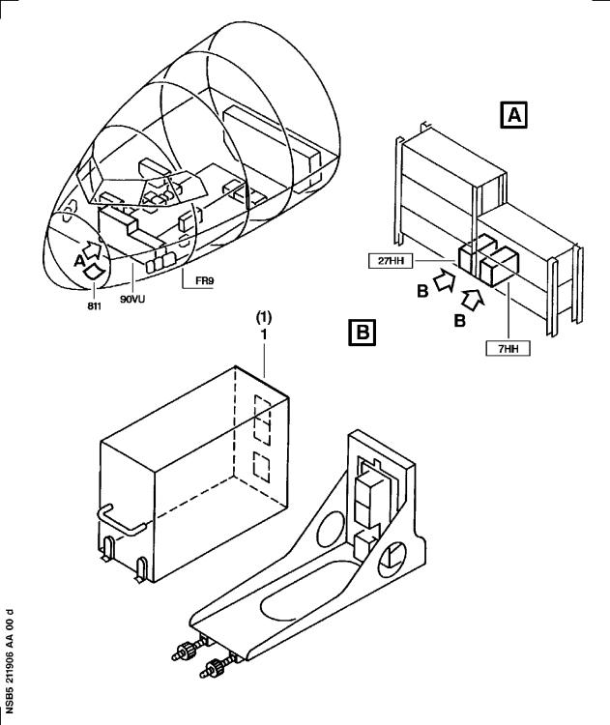

Removal/Installation of the Pack Controller

Figure 1 Sheet 1

DATE : Feb 24/98 SERVICE BULLETIN No. : A320-21-1906

REVISION No. : 00 -

PAGE : 12

Printed in France

***A319/A320/A321***

|  |
| --- |
|  |

SERVICE BULLETIN

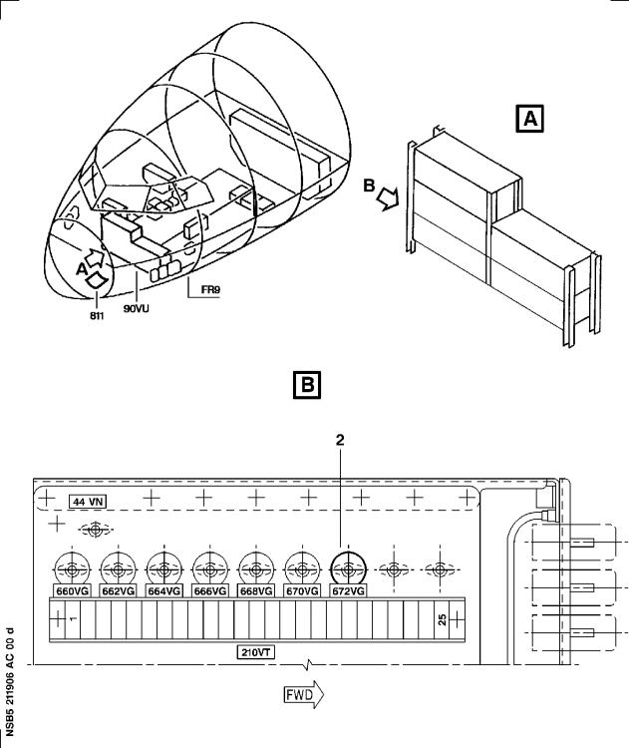

Modification of the Equipment in the Shelf 96VU

Figure 2 Sheet 1

DATE : Feb 24/98 SERVICE BULLETIN No. : A320-21-1906

REVISION No. : 00 -

PAGE : 13

Printed in France

***A319/A320/A321***

|  |
| --- |
|  |

SERVICE BULLETIN

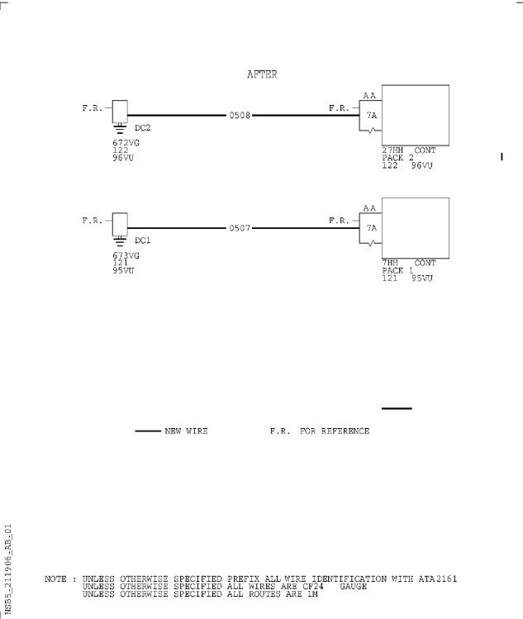

Modification of the Wiring in the Shelves 95VU and 96VU

Figure 3 Sheet 1

DATE : Feb 24/98 SERVICE BULLETIN No. : A320-21-1906

REVISION No. : 00 -

PAGE : 14

Printed in France

***A319/A320/A321***

|  |
| --- |
|  |

SERVICE BULLETIN

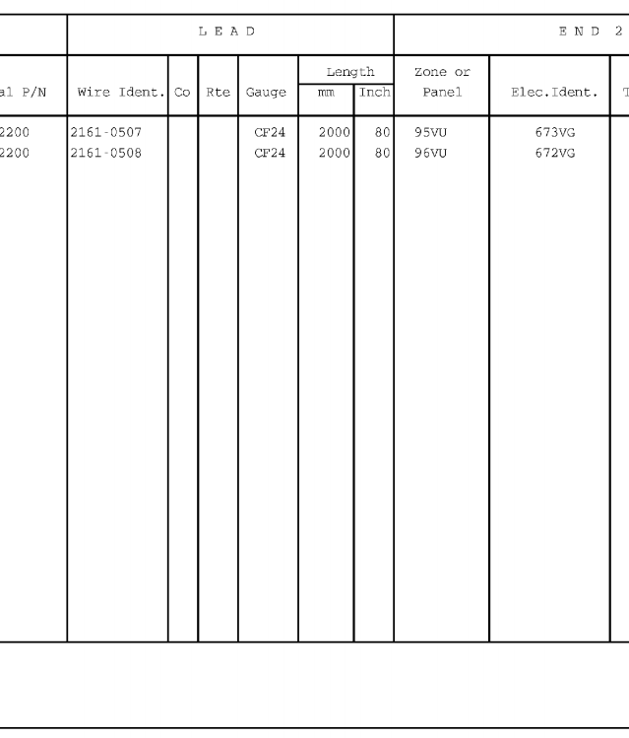

Hookup Chart

Figure 4 Sheet 1

DATE : Feb 24/98 SERVICE BULLETIN No. : A320-21-1906

REVISION No. : 00 -

PAGE : 16

Printed in France

***A319/A320/A321***

|  |
| --- |
|  |

SERVICE BULLETIN

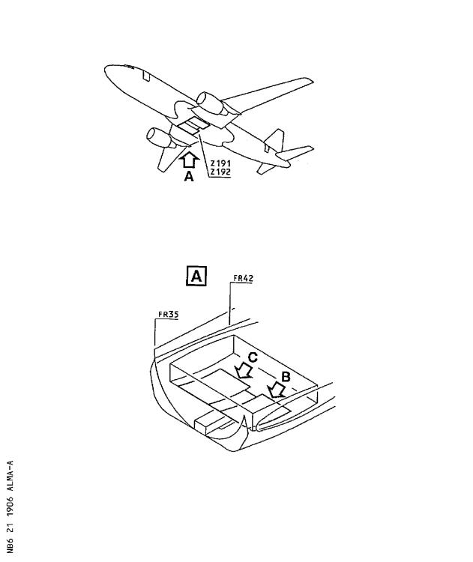

Removal of the Flow Control Valves and Pressure Sensors

Figure 5 Sheet 1

DATE : Feb 24/98 SERVICE BULLETIN No. : A320-21-1906

REVISION No. : 00 -

PAGE : 17

Printed in France

***A319/A320/A321***

|  |
| --- |
|  |

SERVICE BULLETIN

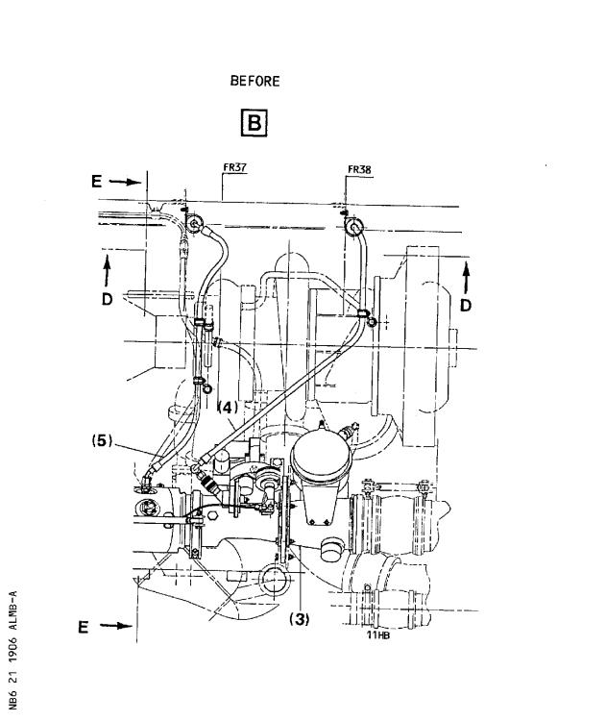

Removal of the Flow Control Valves and Pressure Sensors

Figure 5 Sheet 2

DATE : Feb 24/98 SERVICE BULLETIN No. : A320-21-1906

REVISION No. : 00 -

PAGE : 18

Printed in France

***A319/A320/A321***

|  |
| --- |
|  |

SERVICE BULLETIN

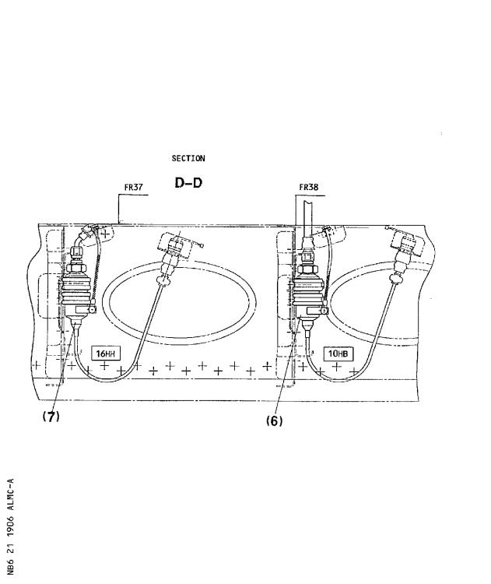

Removal of the Flow Control Valves and Pressure Sensors

Figure 5 Sheet 3

DATE : Feb 24/98 SERVICE BULLETIN No. : A320-21-1906

REVISION No. : 00 -

PAGE : 19

Printed in France

***A319/A320/A321***

|  |
| --- |
|  |

SERVICE BULLETIN

This Page Intentionally Left Blank

DATE : Feb 24/98 SERVICE BULLETIN No. : A320-21-1906

REVISION No. : 00 -

PAGE : 20

Printed in France

***A319/A320/A321***

|  |
| --- |
|  |

SERVICE BULLETIN

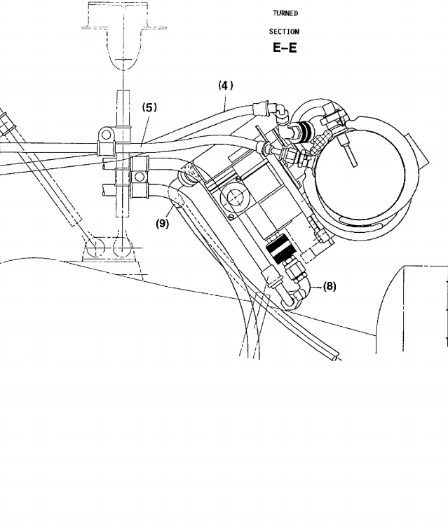

Removal of the Flow Control Valves and Pressure Sensors

Figure 5 Sheet 4

DATE : Feb 24/98 SERVICE BULLETIN No. : A320-21-1906

REVISION No. : 00 -

PAGE : 22

Printed in France

***A319/A320/A321***

|  |
| --- |
|  |

SERVICE BULLETIN

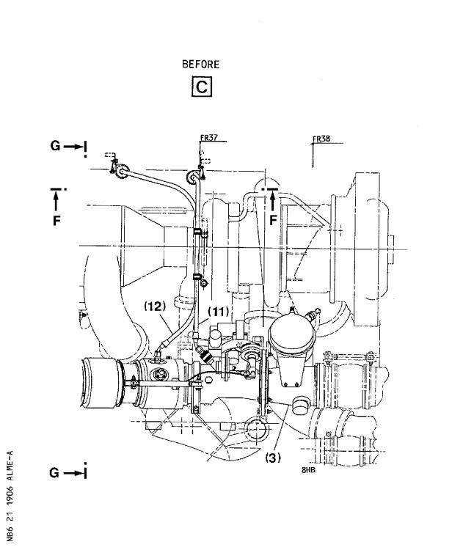

Removal of the Flow Control Valves and Pressure Sensors

Figure 5 Sheet 5

DATE : Feb 24/98 SERVICE BULLETIN No. : A320-21-1906

REVISION No. : 00 -

PAGE : 23

Printed in France

***A319/A320/A321***

|  |
| --- |
|  |

SERVICE BULLETIN

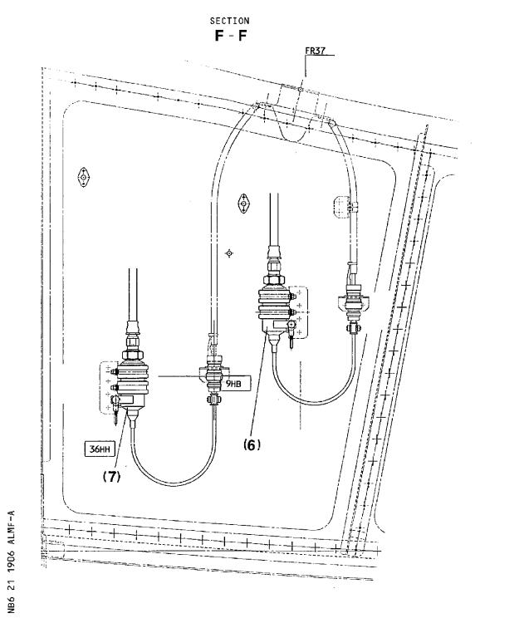

Removal of the Flow Control Valves and Pressure Sensors

Figure 5 Sheet 6

DATE : Feb 24/98 SERVICE BULLETIN No. : A320-21-1906

REVISION No. : 00 -

PAGE : 24

Printed in France

***A319/A320/A321***

|  |
| --- |
|  |

SERVICE BULLETIN

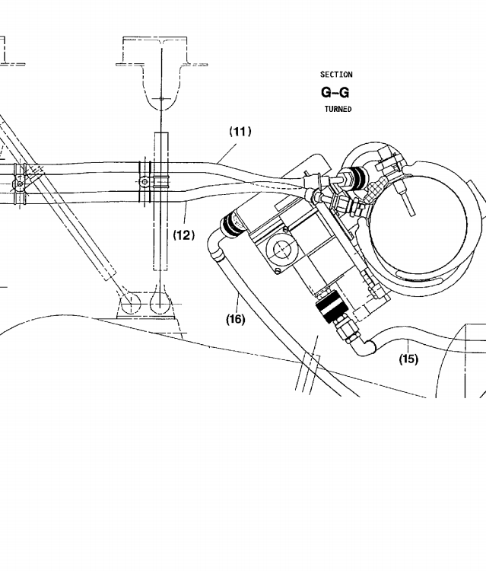

Removal of the Flow Control Valves and Pressure Sensors

Figure 5 Sheet 7

DATE : Feb 24/98 SERVICE BULLETIN No. : A320-21-1906

REVISION No. : 00 -

PAGE : 26

Printed in France

***A319/A320/A321***

|  |
| --- |
|  |

SERVICE BULLETIN

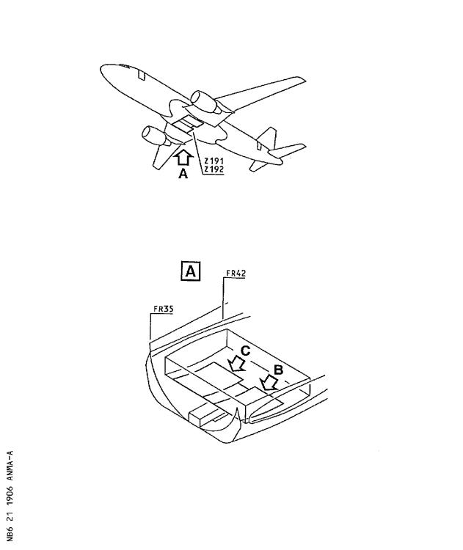

Installation of the Flow Control Valves and Pressure Sensors

Figure 6 Sheet 1

DATE : Feb 24/98 SERVICE BULLETIN No. : A320-21-1906

REVISION No. : 00 -

PAGE : 27

Printed in France

***A319/A320/A321***

|  |
| --- |
|  |

SERVICE BULLETIN

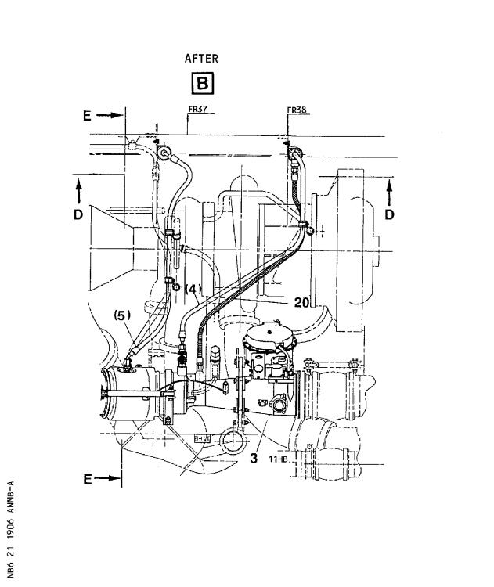

Installation of the Flow Control Valves and Pressure Sensors

Figure 6 Sheet 2

DATE : Feb 24/98 SERVICE BULLETIN No. : A320-21-1906

REVISION No. : 00 -

PAGE : 28

Printed in France

***A319/A320/A321***

|  |
| --- |
|  |

SERVICE BULLETIN

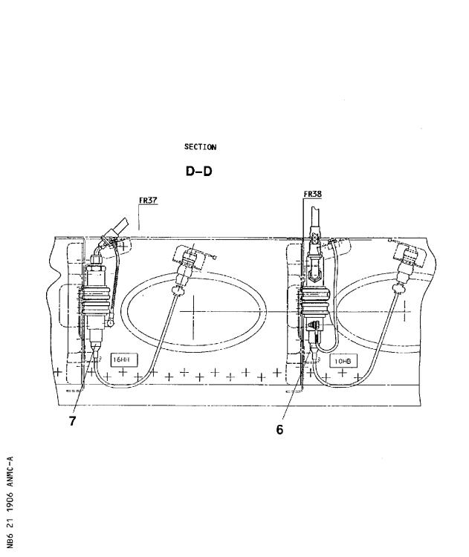

Installation of the Flow Control Valves and Pressure Sensors

Figure 6 Sheet 3

DATE : Feb 24/98 SERVICE BULLETIN No. : A320-21-1906

REVISION No. : 00 -

PAGE : 29

Printed in France

***A319/A320/A321***

|  |
| --- |
|  |

SERVICE BULLETIN

This Page Intentionally Left Blank

DATE : Feb 24/98 SERVICE BULLETIN No. : A320-21-1906

REVISION No. : 00 -

PAGE : 30

Printed in France

***A319/A320/A321***

|  |
| --- |
|  |

SERVICE BULLETIN

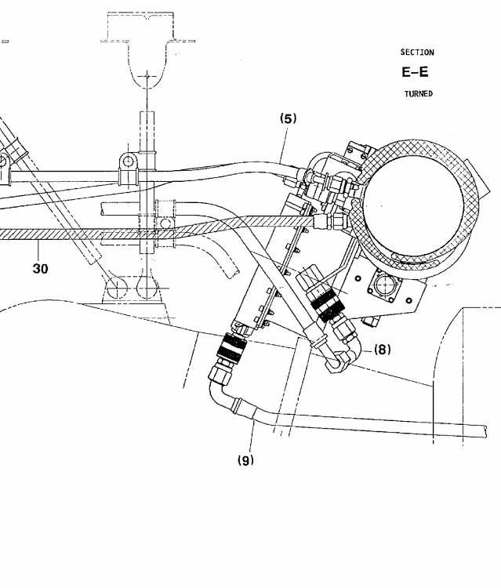

Installation of the Flow Control Valves and Pressure Sensors

Figure 6 Sheet 4

DATE : Feb 24/98 SERVICE BULLETIN No. : A320-21-1906

REVISION No. : 00 -

PAGE : 32

Printed in France

***A319/A320/A321***

|  |
| --- |
|  |

SERVICE BULLETIN

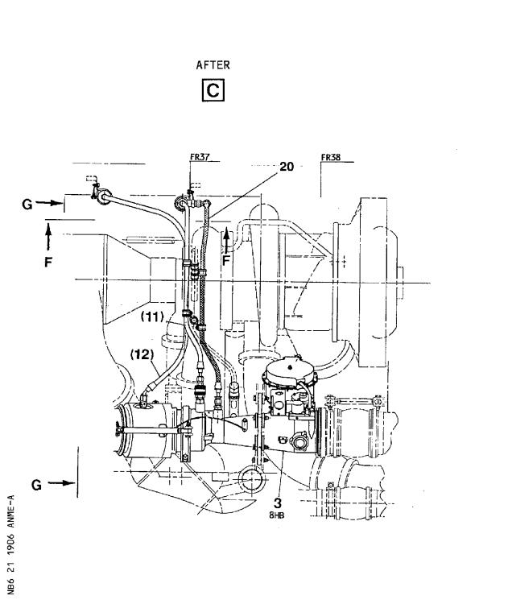

Installation of the Flow Control Valves and Pressure Sensors

Figure 6 Sheet 5

DATE : Feb 24/98 SERVICE BULLETIN No. : A320-21-1906

REVISION No. : 00 -

PAGE : 33

Printed in France

***A319/A320/A321***

|  |
| --- |
|  |

SERVICE BULLETIN

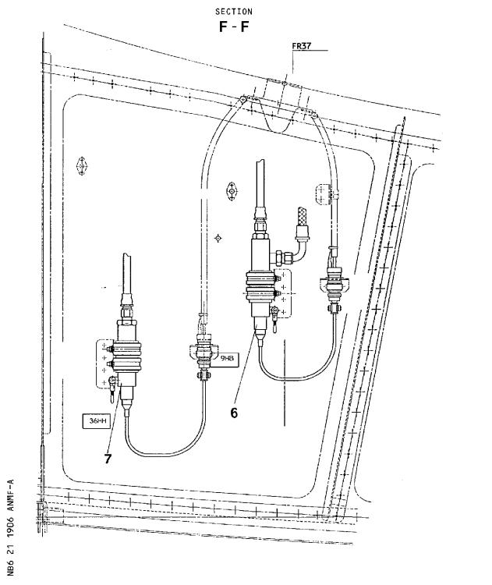

Installation of the Flow Control Valves and Pressure Sensors

Figure 6 Sheet 6

DATE : Feb 24/98 SERVICE BULLETIN No. : A320-21-1906

REVISION No. : 00 -

PAGE : 34

Printed in France

***A319/A320/A321***

|  |
| --- |
|  |

SERVICE BULLETIN

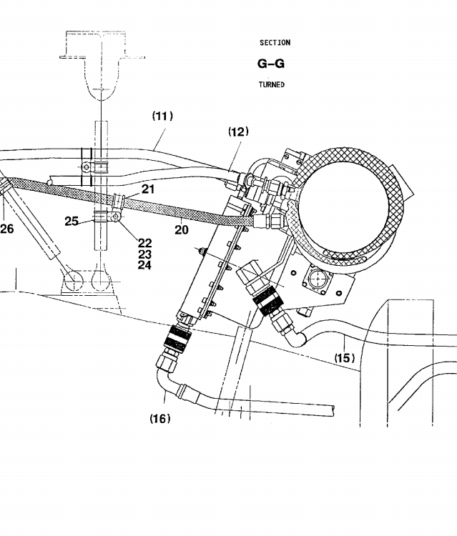

Installation of the Flow Control Valves and Pressure Sensors

Figure 6 Sheet 7

DATE : Feb 24/98 SERVICE BULLETIN No. : A320-21-1906

REVISION No. : 00 -

PAGE : 36

Printed in France

***A319/A320/A321***

|  |
| --- |
|  |

SERVICE BULLETIN

3. MATERIAL INFORMATION

A. LIST OF COMPONENTS

ITEM NEW PART NO. QTY KEYWORD ITEM OLD PART NO. INT INST

DISP

Kit No. 211 0A01

1 759D0000-01 1 Pack ctr (1) E

2 E0425A2001 1 Module

D9000095209695 1 Bundle

NSA935401 10 Tie

3 1303A0000-01 1 Valve (3) F

6 9106A0005-01 1 Sensor (6) 9104A0003-01 A

7 9104A0006-01 1 Sensor (7) 768A0000-03 A

20 D2157147104200 1 Hose B

21 MS21919WCJ6 2 Clamp C

22 NAS1149C0332R 2 Washer B

23 MS21043-3 2 Nut B

24 A104-1/2D 2 Screw B

25 MS21919WCJ8 1 Clamp B

26 NSA5516-15NJ 1 Clamp B

30 D2157147104000 1 Hose D

(A) Retain

(B) RH only.

(C) One on LH, two on RH.

(D) LH only.

(E) OLD PART NO. 759A0000-10 or 759C0000-02 can be installed. Retain

old part.

(F) OLD PART NO. 751A0000-07 or 751B0000-02 can be installed. Retain

old part.

NOTE 1 : Only flow control valve PN 1303A0000-01 with serial numbers 0101, 0102, 0103 and 0104 can be embodied.

NOTE 2 : The kit should be installed on LH or RH. The kit contains the parts for both sides.

B. SPECIAL TOOLS

None

DATE : Feb 24/98 SERVICE BULLETIN No. : A320-21-1906

REVISION No. : 00 - PAGE : 37

Printed in France

***A319/A320/A321***

|  |
| --- |
|  |

SERVICE BULLETIN

C. LIST OF MATERIAL - OPERATOR SUPPLIED

None

D. PARTS TO BE RE-IDENTIFIED BY OPERATOR

None

DATE : Feb 24/98 SERVICE BULLETIN No. : A320-21-1906

REVISION No. : 00 -

PAGE : 38

Printed in France

***A319/A320/A321***

|  |
| --- |
|  |

SERVICE BULLETIN

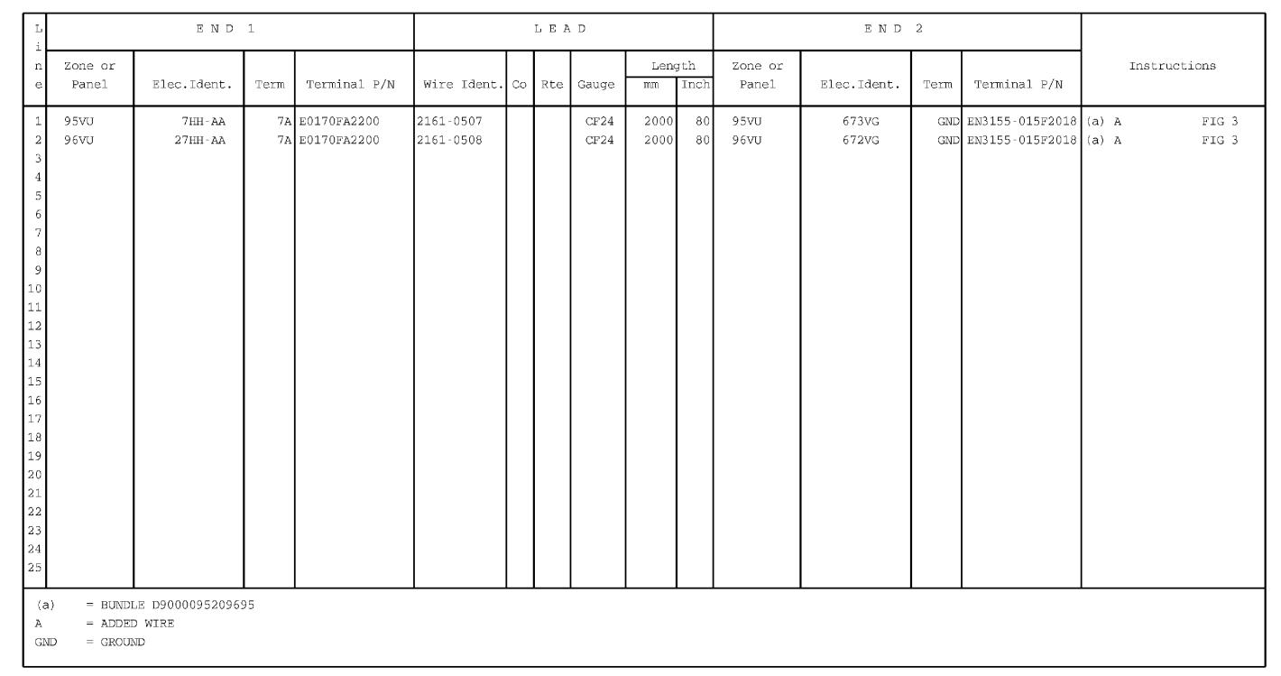

Hookup Chart

Figure 4 Sheet 1

DATE : Feb 24/98 SERVICE BULLETIN No. : A320-21-1906

REVISION No. : 00 -

PAGE : 15 - 16

***A319/A320/A321***

|  |
| --- |
|  |

SERVICE BULLETIN

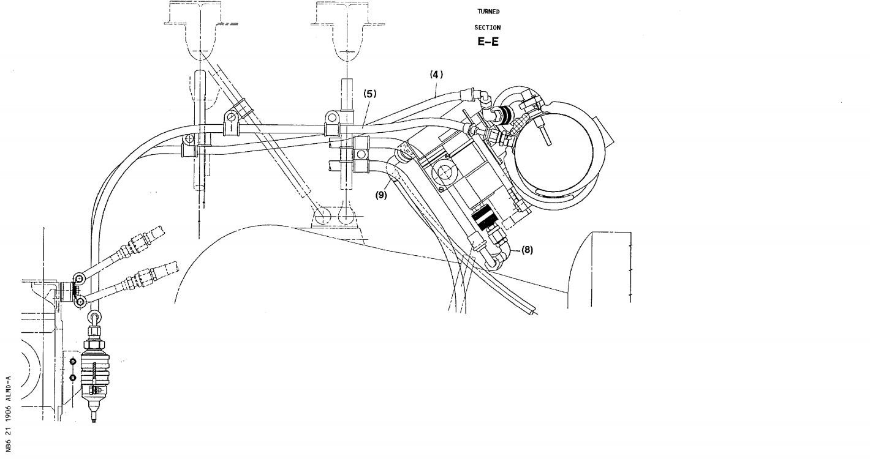

Removal of the Flow Control Valves and Pressure Sensors

Figure 5 Sheet 4

DATE : Feb 24/98 SERVICE BULLETIN No. : A320-21-1906

REVISION No. : 00 -

PAGE : 21 - 22

***A319/A320/A321***

|  |
| --- |
|  |

SERVICE BULLETIN

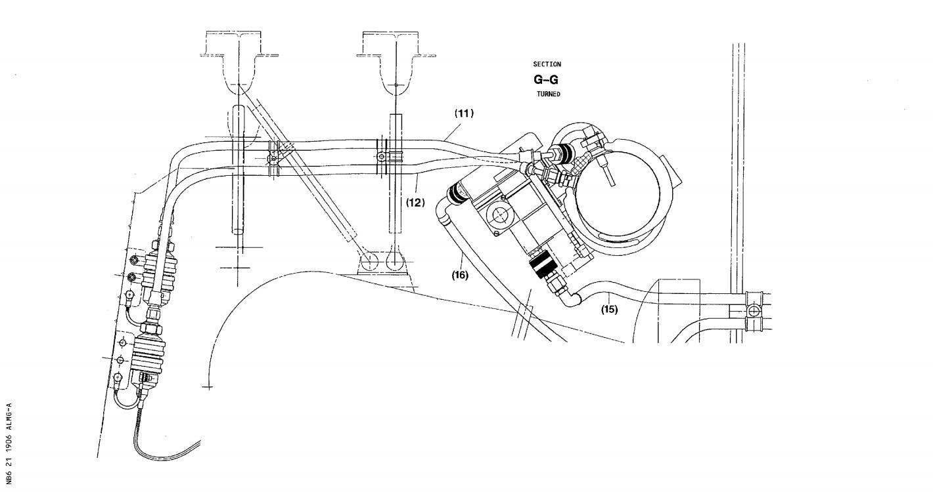

Removal of the Flow Control Valves and Pressure Sensors

Figure 5 Sheet 7

DATE : Feb 24/98 SERVICE BULLETIN No. : A320-21-1906

REVISION No. : 00 -

PAGE : 25 - 26

***A319/A320/A321***

|  |
| --- |
|  |

SERVICE BULLETIN

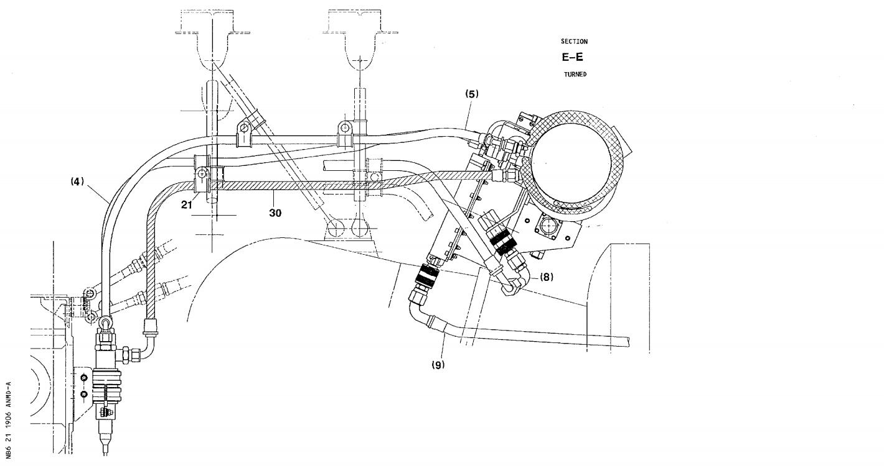

Installation of the Flow Control Valves and Pressure Sensors

Figure 6 Sheet 4

DATE : Feb 24/98 SERVICE BULLETIN No. : A320-21-1906

REVISION No. : 00 -

PAGE : 31 - 32

***A319/A320/A321***

|  |
| --- |
|  |

SERVICE BULLETIN

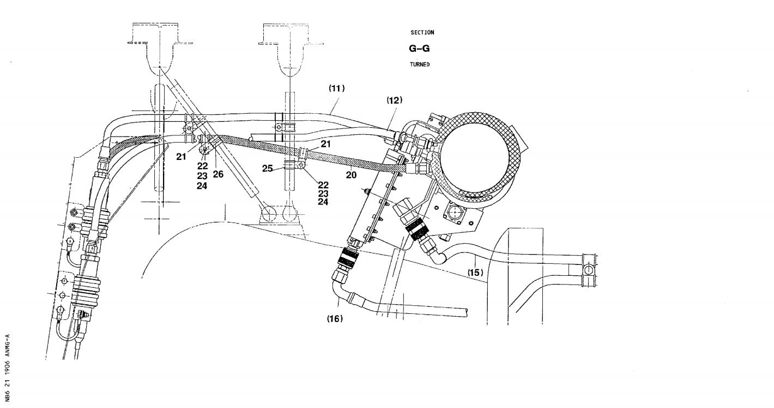

Installation of the Flow Control Valves and Pressure Sensors

Figure 6 Sheet 7

DATE : Feb 24/98 SERVICE BULLETIN No. : A320-21-1906

REVISION No. : 00 -

PAGE : 35 - 36

***A319/A320/A321***

|  |
| --- |
|  |

|  |  |  |
| --- | --- | --- |
| FROM :  AIRLINE :   |  | | --- | | NAME : | | DATE : | |

SERVICE BULLETIN

ACCEPTANCE/REJECTION SHEET

AIRBUS INDUSTRIE

CUSTOMER SERVICES DIRECTORATE

1 Rond Point Maurice BELLONTE

31707 BLAGNAC CEDEX FRANCE

Tel: (33) 5 61-93-33-33

Telex: AIRBU 530526 F

TITLE : AIR CONDITIONING - FLOW CONTROL AND INDICATING - INTRODUCE MODIFIED

AIR CONDITIONING FOR EVALUATION

MODIFICATION No. : 26249K04574 26792K05213 ATA SYSTEM : 21

|  |  |
| --- | --- |
| IS BEING HEREWITH  Please fill : | SUBMITTED TO YOU FOR REVIEW  ...REJECTED  ...WILL BE EMBODIED  ...EFFECTIVITY |

|  |
| --- |
| This SB can only be incorporated in your "customized" documentation within the agreed time schedule in so far as this sheet returned to us on purchase date and signed by a duly authorized and empowered officer or representative. |

|  |
| --- |
| Please return to :  AIRBUS INDUSTRIE  CUSTOMER SERVICES DIRECTORATE  1 Rond Point Maurice Bellonte  31707 BLAGNAC CEDEX FRANCE  Attn : AI/SE-D32 Technical Data  and Documentation Services  FAX : (+33) 5 61 93 28 06 |

6 DATE : Feb 24/98 SERVICE BULLETIN No. : A320-21-1906

REVISION No. : 00 -

PAGE : 1 of 1

Printed in France