***A319/A320/A321***

|  |
| --- |
|  |

SERVICE BULLETIN

REVISION TRANSMITTAL SHEET

AIRBUS INDUSTRIE

CUSTOMER SERVICES DIRECTORATE

1 Rond Point Maurice BELLONTE

31707 BLAGNAC CEDEX FRANCE

Tel: (33) 5 61-93-33-33

Telex: AIRBU 530526 F

TITLE : AIR CONDITIONING - PRESSURE CONTROL AND MONITORING - INTRODUCE

MODIFIED CABIN PRESSURE CONTROLLER PN 20791

MODIFICATION No. :

27570K5548

ATA SYSTEM : 21

This page transmits Revision No. 01 of Service Bulletin No. A320-21-1907.

ADDITIONAL WORK

No additional work is required by this revision for aircraft modified by

any previous revision.

REASON

This Revision has been issued to change the TA number from 5958/98 to

5967/98.

CHANGES

SUMMARY

- Nature of the Work, Aircraft changed to NO and Equipment changed to YES.

- Material Information, TA number changed from 5958/98 to 5967/98.

SERVICE BULLETIN

Accomplishment Instructions

- Para. B.(2), TA number changed from 5958/98 to 5967/98.

Layout changes due to computerization of this revision are not identified.

FILING INSTRUCTIONS

This Service Bulletin has been generated electronically and is reissued as

a complete document. Replace the complete document.

Put this Revision Transmittal Sheet in front of the Service

Bulletin.

HISTORY OF PREVIOUS REVISIONS

No previous Revisions.

REVISION SEQUENCE

ORIGINAL : Jul 29/98

REVISION No. : 01 - Jan 06/99

6 DATE : Jul 29/98 SERVICE BULLETIN No. : A320-21-1907

REVISION No. :

010 Jan 06/99

Printed in France

PAGE : 1 of 1

***A319/A320/A321***

|  |
| --- |
|  |

SERVICE BULLETIN

SUMMARY

AIRBUS INDUSTRIE

CUSTOMER SERVICES DIRECTORATE

1 Rond Point Maurice BELLONTE

31707 BLAGNAC CEDEX FRANCE

Tel: (33) 5 61-93-33-33

Telex: AIRBU 530526 F

This summary is for information only

and is not approved for modification of the aircraft

TITLE : AIR CONDITIONING - PRESSURE CONTROL AND MONITORING - INTRODUCE

MODIFIED CABIN PRESSURE CONTROLLER PN 20791

MODIFICATION No. :

27570K5548

ATA SYSTEM : 21

REASON/DESCRIPTION/OPERATIONAL CONSEQUENCES

This Service Bulletin introduces an improved cabin pressure controller in

the avionics compartment. This controller has been developed in the frame

of the enhanced maintainability and manufacturing program.

The modification is to be installed on 10 aircraft for evaluation

purposes. The evaluation should be accomplished for three months only.

EFFECTIVITY

This Service Bulletin is applicable to these customer(s) :

DLH.

SERVICE BULLETIN TO BE ACCOMPLISHED

PREVIOUSLY OR SIMULTANEOUSLY

None

REFERENCES/REPERCUSSIONS

TFU

OEB

AOT

SIL

LIFE LIMIT

LINE MAINTENANCE AFFECTED

OTHER

NATURE OF THE WORK

:

AIRCRAFT

EQUIPMENT

HARD

SOFT

OBRM

:

:

:

:

: None

: None

: None

: None

: None

: None

: None

NO

YES

YES

YES

NO

6 DATE : Jul 29/98 SERVICE BULLETIN No. : A320-21-1907

REVISION No. :

010 Jan 06/99

Printed in France

PAGE : 1 of 3

***A319/A320/A321***

|  |
| --- |
|  |

SERVICE BULLETIN

SUMMARY

COMPLIANCE

Optional

MANPOWER

On aircraft

TOTAL MANHOURS

ELAPSED TIME (HOURS)

MATERIAL INFORMATION

AIRCRAFT DATA

1 Cabin Pressure Controller

1.25

1.25

EQUIPMENT DATA

Designation : Cabin Pressure Controller

Supplier : NORD-MICRO ELEKTRONIK

Service Bulletin No. None

Old

New

Part

Part

Number

Number

9022-15702-9

20791-01AA (according to TA 5967/98)

Interchangeability code 02 (Refer to ATA 200 Chapter 1A-2)

Mixability : Yes

APPENDICES

None

DATE : Jul 29/98 SERVICE BULLETIN No. : A320-21-1907

REVISION No. :

010 Jan 06/99

Printed in France

PAGE : 2

***A319/A320/A321***

|  |
| --- |
|  |

SERVICE BULLETIN

SUMMARY

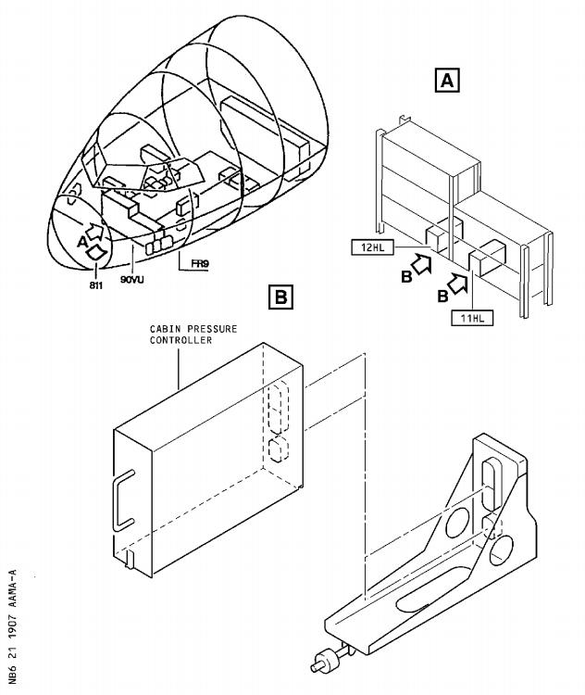

DATE : Jul 29/98 SERVICE BULLETIN No. : A320-21-1907

REVISION No. :

010 Jan 06/99

Printed in France

PAGE : 3

***A319/A320/A321***

|  |
| --- |
|  |

SERVICE BULLETIN

AIRBUS INDUSTRIE

CUSTOMER SERVICES DIRECTORATE

1 Rond Point Maurice BELLONTE

31707 BLAGNAC CEDEX FRANCE

Tel: (33) 5 61-93-33-33

Telex: AIRBU 530526 F

TITLE : AIR CONDITIONING - PRESSURE CONTROL AND MONITORING - INTRODUCE

MODIFIED CABIN PRESSURE CONTROLLER PN 20791

MODIFICATION No. : 27570K5548 ATA SYSTEM : 21

1. PLANNING INFORMATION

A. EFFECTIVITY

(1) Aircraft models : 319-114, 320-211, 321-131

(2) Aircraft

Customer and MSN Kit No. Qty Config

Fleet No. none of kits No.

 DLH001-006 069,070,071,072,078,083

007-010 086,093,094,104

012-017 110,111,116,117,135,137

018-023 147,161,162,172,200,201

024-029 202,209,216,217,218,267

030-034 268,269,346,382,401

101-106 458,468,473,474,484,493

107-112 412,502,505,518,560,563

113-118 564,567,595,652,692,699

119-120 887,901

201-206 609,610,616,623,627,636

207-212 641,651,679,689,694,700

213-218 717,723,729,738,744,853

219-220 860,875

This Evaluation Service Bulletin is only applicable on ten aircraft

from among those listed above. The MSN of these aircraft will be

given to Airbus Industrie.

This document contains Airbus Industrie PROPRIETARY INFORMATION and

shall at all times remain the property of Airbus Industrie; no

intellectual property right or licence is granted by Airbus

Industrie in connection with any information contained in it. It is

delivered on the express condition that the said document and the

information contained in it shall be treated as confidential and

shall not be used for any purpose other than that for which it is

hereby delivered. It shall not be disclosed in whole or in part to

6 DATE : Jul 29/98 SERVICE BULLETIN No. : A320-21-1907

REVISION No. :

010 Jan 06/99

Printed in France

PAGE : 1 of 9

***A319/A320/A321***

|  |
| --- |
|  |

SERVICE BULLETIN

third parties and shall not be duplicated in any manner (except for

the purposes of performing the tasks described hereunder and

provided that any recipient of such document shall comply with the

conditions herein), without Airbus Industrie’s prior written

consent.

(3) Spares

None

B. REASON

(1) History

A new cabin pressure controller has been developed in the frame of

the enhanced maintainability and manufacturing program.

(2) Objective/Action

This Service Bulletin introduces an improved cabin pressure

controller in the avionics compartment.

The modification is to be installed on 10 aircraft for evaluation

purposes. The evaluation should be accomplished for three months

only.

(3) Advantages

The statistical data obtained during the three month period will

assist in evaluating this product improvement.

(4) Operational/Maintenance Consequences

None

(5) Accomplishment Timescale

In accordance with operators’ maintenance schedule.

C. DESCRIPTION

To accomplish this Service Bulletin it is necessary to :

(1) Remove the existing cabin pressure controller from the electronics

rack 90VU.

(2) Install the new cabin pressure controller to the electronics rack

90VU for evaluation.

D. APPROVAL

The technical content of this Service Bulletin has been approved under

the authority of the DGAC Design Organisation Approval No. F.JA.02.

E. MANPOWER

This Service Bulletin is written for an aircraft in a maintenance

status. The manhours/elapsed time estimates do not include the time to

prepare for the modification, non-productive elapsed times or

administration.

On aircraft

DATE : Jul 29/98 SERVICE BULLETIN No. : A320-21-1907

REVISION No. :

010 Jan 06/99

Printed in France

PAGE : 2

***A319/A320/A321***

|  |
| --- |
|  |

SERVICE BULLETIN

Get access

Removal/Installation of controller pack

Test

Close-up

TOTAL MANHOURS

ELAPSED TIME (HOURS)

After evaluation

Get access

Removal/Installation of controller pack

Test

Close-up

TOTAL MANHOURS

ELAPSED TIME (HOURS)

F. MATERIAL - COST AND AVAILABILITY

0.25

0.25

0.50

0.25

1.25

1.25

0.25

0.25

0.50

0.25

1.25

1.25

(1) Material

Vendor parts are to be purchased from

NORD-MICRO ELECTRONIK

Product Support

Attn.: Gerd A. Volkmann

60388 Frankfurt

Tel.: (49) 6109 303 230

Fax.: (49) 6109 303 412

(2) Cost and availability

Kit No.

FOC

Cost

(US Dollars)

Availability :

days from receipt

Calendar of order

G. TOOLING - PRICE AND AVAILABILITY

None

H. WEIGHT AND BALANCE

None

I. REFERENCES

Aircraft Maintenance Manual (AMM) : 21-31-34

J. PUBLICATIONS AFFECTED

None

DATE : Jul 29/98 SERVICE BULLETIN No. : A320-21-1907

REVISION No. :

010 Jan 06/99

Printed in France

PAGE : 3

***A319/A320/A321***

|  |
| --- |
|  |

SERVICE BULLETIN

This Page Intentionally Left Blank

DATE : Jul 29/98 SERVICE BULLETIN No. : A320-21-1907

REVISION No. :

010  Jan 06/99

Printed in France

PAGE : 4

***A319/A320/A321***

|  |
| --- |
|  |

SERVICE BULLETIN

2. ACCOMPLISHMENT INSTRUCTIONS

A. GENERAL

WARNING : MAKE SURE THAT YOU OBEY ALL THE WARNINGS AND ALL THE

CAUTIONS INCLUDED IN THE REFERENCED PROCEDURES.

WARNING : MAKE SURE THAT THE GROUND SAFETY-LOOKS ARE IN POSITION ON

THE LANDING GEAR AND THE WHEEL CHOCKS ARE IN POSITION.

WARNING : MAKE SURE THAT NO AIR IS SUPPLIED TO THE AIR CONDITIONING

SYSTEM FROM THE MAIN ENGINE, THE APU OR A GROUND SOURCE. HOT

COMPRESSED AIR CAN CAUSE INJURY TO PERSONNEL.

(1) Preparation

(a) Refer to AMM: 21-31-34, P. Block 401 .

(2) Standard Practices

None

B. MODIFICATION

Refer to Figure 1

(1) Remove the Cabin Pressure Controller, item (1), 11HL or 12HL (Refer

to AMM: 21-31-34, P. Block 401 ).

(2) Install the Cabin Pressure Controller 20791-01AA (according to TA

5967/98), item 1, 11HL or 12HL (Refer to AMM: 21-31-34, P. Block

401 ).

C. TEST

(1) Do the test after the removal/installation of the Cabin Pressure

Controller 11HL or 12HL (Refer to AMM: 21-31-34, P. Block 401 ).

D. CLOSE-UP

(1) Refer to AMM: 21-31-34, P. Block 401 .

E. DOCUMENTATION

Write in the applicable aircraft records that you have done all the work

given in this Service Bulletin.

F. EVALUATION

During the evaluation do a print of last leg report, previous legs report, class III report, system ID of CPC 1+2 every week. Send the reports to:

AIRBUS INDUSTRIE

CUSTOMER SERVICE DIRECTORATE

1 Rond Point Maurice Bellonte

31707 BLAGNAC CEDEX FRANCE

AI/SE-E22 Gilles Juan

FAX: (33) 5 61-93-44-38

TEL: (33) 5 62-11-02-90

DATE : Jul 29/98 SERVICE BULLETIN No. : A320-21-1907

REVISION No. :

010  Jan 06/99

Printed in France

PAGE : 5

***A319/A320/A321***

|  |
| --- |
|  |

SERVICE BULLETIN

The restoration to the initial configuration has to be

after accomplishment of this Service Bulletin.

G. RESTORATION OF AIRCRAFT TO ITS INITIAL CONFIGURATION Put the aircraft back to the initial configuration.

H. TEST

(1) Do the test after the removal/installation of the

Controller 11HL or 12HL (Refer to AMM: 21-31-34,

I. CLOSE-UP

(1) Refer to AMM: 21-31-34, P. Block 401 .

J. DOCUMENTATION

Write in the applicable aircraft records that you have

given in this Service Bulletin.

done three months

Cabin Pressure P. Block 401 ).

done all the work

DATE : Jul 29/98 SERVICE BULLETIN No. : A320-21-1907

REVISION No. :

010 Jan 06/99

Printed in France

PAGE : 6

***A319/A320/A321***

|  |
| --- |
|  |

SERVICE BULLETIN

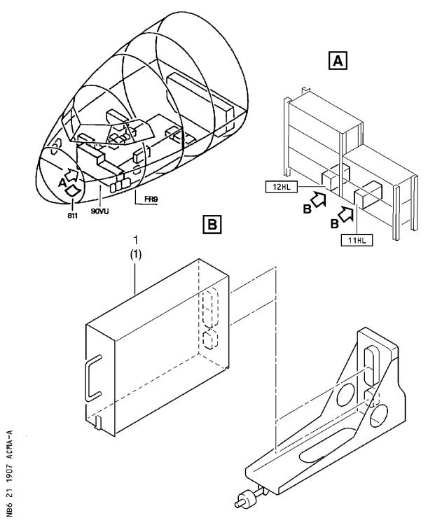

Removal/Installation of the Cabin Pressure Controller

Figure 1 Sheet 1

DATE : Jul 29/98 SERVICE BULLETIN No. : A320-21-1907

REVISION No. :

010  Jan 06/99

Printed in France

PAGE : 7

***A319/A320/A321***

|  |
| --- |
|  |

SERVICE BULLETIN

This Page Intentionally Left Blank

DATE : Jul 29/98 SERVICE BULLETIN No. : A320-21-1907

REVISION No. :

010  Jan 06/99

Printed in France

PAGE : 8

***A319/A320/A321***

|  |
| --- |
|  |

SERVICE BULLETIN

3. MATERIAL INFORMATION

A. LIST OF COMPONENTS

ITEM NEW PART NO. QTY KEYWORD ITEM OLD PART NO. INT INST

DISP

1 20791-01AA 1 Control. (1) 9022-15702-9 A

(A) Retain the controller PN 9022-15702-9 for later installation.

B. SPECIAL TOOLS

None

C. LIST OF MATERIAL - OPERATOR SUPPLIED

None

D. PARTS TO BE RE-IDENTIFIED BY OPERATOR

None

DATE : Jul 29/98 SERVICE BULLETIN No. : A320-21-1907

REVISION No. : 010  Jan 06/99 PAGE : 9

Printed in France

***A319/A320/A321***

|  |
| --- |
|  |

|  |  |  |
| --- | --- | --- |
| FROM :  AIRLINE :   |  | | --- | | NAME : | | DATE : | |

SERVICE BULLETIN

ACCEPTANCE/REJECTION SHEET

AIRBUS INDUSTRIE

CUSTOMER SERVICES DIRECTORATE

1 Rond Point Maurice BELLONTE

31707 BLAGNAC CEDEX FRANCE

Tel: (33) 5 61-93-33-33

Telex: AIRBU 530526 F

TITLE : AIR CONDITIONING - PRESSURE CONTROL AND MONITORING - INTRODUCE

MODIFIED CABIN PRESSURE CONTROLLER PN 20791

MODIFICATION No. :

27570K5548

ATA SYSTEM : 21

|  |  |
| --- | --- |
| IS BEING HEREWITH  Please fill : | SUBMITTED TO YOU FOR REVIEW  ...REJECTED  ...WILL BE EMBODIED  ...EFFECTIVITY |

|  |
| --- |
| This SB can only be incorporated in your "customized" documentation within the agreed time schedule in so far as this sheet returned to us on purchase date and signed by a duly authorized and empowered officer or representative. |

|  |
| --- |
| Please return to :  AIRBUS INDUSTRIE  CUSTOMER SERVICES DIRECTORATE  1 Rond Point Maurice Bellonte  31707 BLAGNAC CEDEX FRANCE  Attn : AI/SE-D32 Technical Data  and Documentation Services  FAX : (+33) 5 61 93 28 06 |

6 DATE : Jul 29/98 SERVICE BULLETIN No. : A320-21-1907

REVISION No. :

010 Jan 06/99

Printed in France

PAGE : 1 of 1