@ Ac18/Ac16/Ac20/Ac21

SERVICE BULLETIN

REVISION TRANSMITTAL SHEET

AIRBUS

CUSTOMER SERVICES DIRECTORATE

1 Rond Point Maurice Bellonte

31707 BLAGNAC CEDEX FRANCE

Tel : (33) 5 61 93 33 33

Telex : AIRBU 530526F

Fax : (33) 5 61 93 42 51

ATA SYSTEM : 21

TITLE : AIR CONDITIONING - COCKPIT AIR HEATING - IMPROVE FOOT WARMER EFFICIENCY .

MODIFICATION No . : 35861P9435 35861P9449

This page transmits Revision No . 01 of Service Bulletin No . A320-21-1908 . ADDITIONAL WORK

No additional work is required by this revision for aircraft modified by any

previous issue .

REASON

Revision No . 01 issued to add aircraft MSN 2233 and MSN 2243, to include design office changes and to include modifications after the validation on A321-211 aircraft MSN 2342.

CHANGES

SUMMARY :

— REASON/DESCRIPTION/OPERATIONAL CONSEQUENCES

. Kit 211908A05R01 price added in evaluation table .

— EFFECTIVITY

. Sentence added .

— MANPOWER

. Config . 01 : 3.0 TOTAL MANHOURS become 10.0 and 1.5 ELAPSED TIME hours

become 6.0. Config . 02 : 108.0 TOTAL MANHOURS become 109.0 and 57.0

ELAPSED TIME hours become 58.0. Config . 03 : manpower added .

— MATERIAL INFORMATION

. Material information added for kit 211908A05R01 .

PLANNING INFORMATION :

— EFFECTIVITY

. Para . 1 .A . Aircraft MSN 2233 and MSN 2243 added for operator AFL . Note

Config . 03 added .

5 DATE : Mar 08/06

REVISION No . : 01 — Mar 30/07

SERVICE BULLETIN No . : A320— 21— 1908

Page : 1 of 4

Printed in FRANCE © AIRBUS, 2007 All rights reserved

@ Ac18/Ac16/Ac20/Ac21

SERVICE BULLETIN

REVISION TRANSMITTAL SHEET

— DESCRIPTION

. Para . 1 .D . Config . 01 modified . Config . 03 added .

— MANPOWER

. Para . 1 .G . Config . 01 : 3.0 TOTAL MANHOURS become 10.0 and 1.5 ELAPSED

TIME hours become 6.0. 1.0 added for tests . Config . 02 : 108.0 TOTAL

MANHOURS become 109.0 and 57.0 ELAPSED TIME hours become 58.0. 6.0 for

test become 7.0. Config . 03 : manpower added .

— WEIGHT AND BALANCE

. Para . 1 .H . Paragraph updated for config . 03.

— ELECTRICAL LOAD DATA

. Para . 1 .I . Paragraph updated for config . 03.

— REFERENCES

. Para . 1 .J . Reference to AMM 23-71-00 added .

— INTERCHANGEABILITY/MIXABILITY

. Para . 1 .L . PN and note added for config . 03.

MATERIAL INFORMATION :

— MATERIAL - PRICE AND AVAILABILITY

. Para . 2 .A . Price added for kit 211908A05R01 .

— LIST OF COMPONENTS

. Para . 2 .C . In kit 211908A02R08 : PN D9550003000196 becomes

D9550003000197, PN D9000095220396 becomes D9000095220397, PN

D11311898A00 becomes D11311898B00, D33110306A00 becomes D33110306C00, PN

ASNA2080G01 becomes ASNA2080G04, PN NSA931320-050A becomes

NSA931320-050 . Kit 211908A05R01 added .

— LIST OF MATERIALS - OPERATOR SUPPLIED

. Para . 2 .D . Rivets PN ASNA2080G01 added .

ACCOMPLISHMENT INSTRUCTIONS :

— GENERAL

. Para . 3 .A . Config . 03 and Config . 01 added in paragraph Preparation .

— MODIFICATION

. Para . 3 .B . Installation of the panels assy added in Config . 01. Text

added or modified in Config . 02. Config . 03 added .

DATE : Mar 08/06 SERVICE BULLETIN No . : A320— 21— 1908

REVISION No . : 01 — Mar 30/07 Page : 2

Printed in FRANCE © AIRBUS, 2007 All rights reserved

@ Ac18/Ac16/Ac20/Ac21

SERVICE BULLETIN

REVISION TRANSMITTAL SHEET

— TESTS

. Para . 3 .C . Tests added for Config . 01 and for Config . 03.

— CLOSE-UP

. Para . 3 .D . Config . 01 Tests added .

— RESTORATION OF AIRCRAFT TO ITS INITIAL CONFIGURATION

. Para . 3 .G . Config . 01 : preparation added . Config . 03 added for

restoration .

— TESTS

. Para . 3 .H . Test added for config . 01 and Config . 03.

— CLOSE-UP

. Para . 3 .I . Config . 01 : close-up added . Config . 03 added .

ILLUSTRATIONS :

|  |  |
| --- | --- |
| — Figure | 1 added . |
| — Figure | 4 added . |
| — Figure | 6 sheet 3 updated and sheet 4 added . |
| — Figure | 8, sheet 1 modified . |
| — Figure | 9, sheet 1 modified . |
| — Figure | 11, sheet 1 modified . |
| — Figure | 14, sheet 1 and sheet 2 added . |
| — Figure | 18, sheet 1 modified . |
| — Figure | 21, sheet 1 modified . |
| — Figure | 23, sheet 1 modified . |
| — Figure | 24, sheet 1 modified . |
| — Figure | 25, sheet 1 modified . |
| — Figure | 26, sheet 1 modified . |

FILING INSTRUCTIONS

This Service Bulletin has been generated electronically and is reissued as a

complete document . Replace the complete document .

Put this Revision Transmittal Sheet in front of the Service Bulletin .

DATE : Mar 08/06 SERVICE BULLETIN No . : A320— 21— 1908

REVISION No . : 01 — Mar 30/07 Page : 3

Printed in FRANCE © AIRBUS, 2007 All rights reserved

@ Ac18/Ac16/Ac20/Ac21

SERVICE BULLETIN

REVISION TRANSMITTAL SHEET

HISTORY OF PREVIOUS REVISIONS

No previous revisions .

REVISION SEQUENCE

ORIGINAL : Mar 08/06

REVISION No . : 01 — Mar 30/07

DATE : Mar 08/06 SERVICE BULLETIN No . : A320— 21— 1908

REVISION No . : 01 — Mar 30/07 Page : 4

Printed in FRANCE © AIRBUS, 2007 All rights reserved

@ Ac18/Ac16/Ac20/Ac21

SERVICE BULLETIN

SUMMARY

AIRBUS

CUSTOMER SERVICES DIRECTORATE

1 Rond Point Maurice Bellonte

31707 BLAGNAC CEDEX FRANCE

Tel : (33) 5 61 93 33 33

Telex : AIRBU 530526F

Fax : (33) 5 61 93 42 51

This summary is for information only

and is not approved for modification of the aircraft

ATA SYSTEM : 21

TITLE : AIR CONDITIONING - COCKPIT AIR HEATING - IMPROVE FOOT WARMER EFFICIENCY .

MODIFICATION No . : 35861P9435 35861P9449

REASON/DESCRIPTION/OPERATIONAL CONSEQUENCES

On longer flight on A320 family aircraft, low temperatures are being experienced

at pilot foot level . The temperature drop is proportional to the length of the

flight, and pilot reports indicate that it becomes uncomfortable after

approximately 3/3 . 5 hours of flight . The temperature drop appears to be most

noticeable on newer aircraft, and the majority of pilot reports refer to "moving

air" .

Several flight tests have been conducted and the cold feet sensation reported by

the airlines has been reported on all flights, with surface and air temperatures

dropping steadily as the flight length increases . The cockpit airflow pattern

and distribution system have an influence on the low temperatures at pilot foot

level . This is compounded by cooler air entering the cockpit from the avionics

bay and by temperature losses across the cockpit distribution ducting from one

air outlet to another . Cockpit foot warmers improve the situation as per their

basic function .

To improve the situation a package of modifications have been developed which

are proposed by this Service Bulletin .

This evaluation Service Bulletin installs :

— On aircraft MSN 2342 only : Thermal

eliminate cold surfaces which could

convection .

insulation around the forward pedestal to

cool the air in the pedestal area by

— On all aircraft :

A new duct routing which will drive the air to a better location to ensure a

good comfort of the pilot's feet .

— A heater in the cockpit distribution ducting just before the foot level outlet

(last outlet in the circuit) to allow the increase of the outlet temperature

at this level .

5 DATE : Mar 08/06

REVISION No . : 01 — Mar 30/07

SERVICE BULLETIN No . : A320— 21— 1908

Page : 1 of 4

Printed in FRANCE © AIRBUS, 2007 All rights reserved

@ Ac18/Ac16/Ac20/Ac21

SERVICE BULLETIN

SUMMARY

Accomplishment of this evaluation Service Bulletin will provide information of all evolution (the cockpit air heating, thermal insulation, foot warmer) efficiency in operational conditions for a six months period .

|  |  |  |  |
| --- | --- | --- | --- |
| EVALUATION TABLE | | | |
| COMPLIANCE | Desirable | CANCELS INSPECTION SB | No |
| POTENTIAL AD | No | A/C OPERATION AFFECTED | No |
| RELIABILITY AFFECTED | No | PAX COMFORT AFFECTED | No |
| COST SAVING | No | ETOPS AFFECTED | No |
| STRUCTURAL LIFE EXTN | No | VENDOR SB INVOLVED | No |
| KIT PRICE (USD)  A02R08 | 15,230 | KIT PRICE (USD) A03R03 | 6,010 |
| KIT PRICE (USD)  A04R00 | 37,410 | KIT PRICE (USD) A05R01 | 15,170 |

EFFECTIVITY

This Service Bulletin is

AFL

NOTE : This modification

applicable to this operator :

is applicable by Service Bulletin only .

NOTE : This Service Bulletin has been accomplished at Revision No . 00 on

aircraft MSN 2342 to validate its content .

CONCURRENT REQUIREMENTS

This Service Bulletin cannot be accomplished if the following Service Bulletin

has been accomplished:

Service Bulletin No . A320-21-1909 Mod . No . 35861P9430

REFERENCES/REPERCUSSIONS

TFU

OEB

AOT

SIL

LIFE LIMIT

: 21 .21 .00 .022

: None

: None

: None

: None

LINE MAINTENANCE AFFECTED : No

OTHERS : None

NATURE OF THE WORK

AIRCRAFT : YES

EQUIPMENT : NO

HARD : NO

DATE : Mar 08/06 SERVICE BULLETIN No . : A320— 21— 1908

REVISION No . : 01 — Mar 30/07 Page : 2

Printed in FRANCE © AIRBUS, 2007 All rights reserved

@ Ac18/Ac16/Ac20/Ac21

SERVICE BULLETIN

SUMMARY

SOFT : NO

OBRM : NO

MANPOWER

For Config . 01

TOTAL MANHOURS 10 .0

ELAPSED TIME (HOURS) 6 .0

For Config . 02 thru Config . 03

TOTAL MANHOURS 109 .0

ELAPSED TIME (HOURS) 58 .0

For Config . 01 , restoration of the aircraft

TOTAL MANHOURS 10 .0

ELAPSED TIME (HOURS) 6 .0

For Config . 02 thru Config . 03 , restoration of the aircraft

TOTAL MANHOURS 109 .0

ELAPSED TIME (HOURS) 58 .0 MATERIAL INFORMATION

AIRCRAFT DATA

Kit 211908A02R08

Ducts, brackets, bundle, panel, placard

Kit 211908A05R01

Ducts, brackets, bundle, panel, placard

Kit 211908A03R03

Lateral panels

Kit 211908A04R00

Heaters

APPENDICES

None

DATE : Mar 08/06 SERVICE BULLETIN No . : A320— 21— 1908

REVISION No . : 01 — Mar 30/07 Page : 3

Printed in FRANCE © AIRBUS, 2007 All rights reserved

@ Ac18/Ac16/Ac20/Ac21

SERVICE BULLETIN

SUMMARY

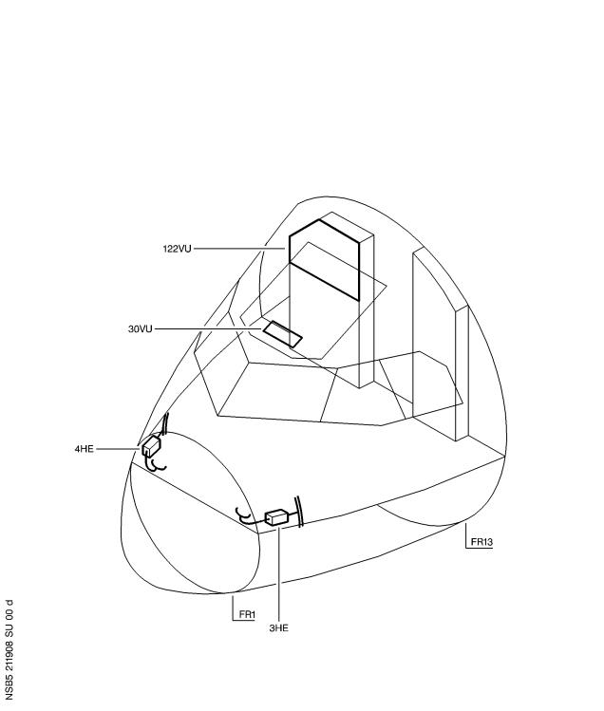

DATE : Mar 08/06 SERVICE BULLETIN No . : A320— 21— 1908

REVISION No . : 01 — Mar 30/07 Page : 4

Printed in FRANCE © AIRBUS, 2007 All rights reserved

@ Ac18/Ac16/Ac20/Ac21

SERVICE BULLETIN

AIRBUS

CUSTOMER SERVICES DIRECTORATE

1 Rond Point Maurice Bellonte

31707 BLAGNAC CEDEX FRANCE

Tel : (33) 5 61 93 33 33

Telex : AIRBU 530526F

Fax : (33) 5 61 93 42 51

ATA SYSTEM : 21

TITLE : AIR CONDITIONING - COCKPIT AIR HEATING - IMPROVE FOOT WARMER EFFICIENCY .

MODIFICATION No . : 35861P9435 35861P9449

This document contains AIRBUS PROPRIETARY INFORMATION and shall at all times remain the property of AIRBUS; no intellectual property right or licence is granted by AIRBUS in connection with any information contained in it . It is delivered on the express condition that said document and the information contained in it shall be treated as confidential, shall not be used for any purpose other than that for which it is hereby delivered . It shall not be disclosed in whole or in part to third parties and shall not be duplicated in any manner (except for the purposes of performing the tasks described hereunder and provided that any recipient of such document shall comply with the conditions herein), without AIRBUS' prior written consent .

1. PLANNING INFORMATION

A . EFFECTIVITY

(1) Models

319-111 320-214 321-211

(2) Aircraft

(a) Effectivity by MSN

This Service Bulletin is applicable to aircraft MSN :

2233 2243 2330 2337 2342

NOTE : This Service Bulletin has been accomplished at Revision

No . 00 on aircraft MSN 2342 to validate its content .

(b) Effectivity by Operator

The Operator/MSN relationship is provided for information only and is correct at the time of issue in accordance with the information available to AIRBUS . Any future changes resulting from transfer of an aircraft from one operator to another will not be reflected in this list unless the Service Bulletin is revised for another reason .

5 DATE : Mar 08/06

REVISION No . : 01 — Mar 30/07

SERVICE BULLETIN No . : A320— 21— 1908

Page : 1 of 134

Printed in FRANCE © AIRBUS, 2007 All rights reserved

@ Ac18/Ac16/Ac20/Ac21

SERVICE BULLETIN

OPERATOR MSN

 AFL

2233 2243 2330 2337 2342

(c) Effectivity by MSN and Kit/Configuration

The kits and configurations applicable to these MSNs are given

at the end of this list:

2330 2337 2342

KIT No .

211908A02R08

211908A03R03

211908A04R00

QTY PER A/C

1

1

1

CONFIGURATION

02

01

02

NOTE (01) Config . 01 concerns the modification No . 35861P9435

which replaces the lateral panels on the center

pedestal (only for aircraft MSN 2342) .

NOTE (02) Config . 02 concerns the modification No . 35861P9449 which installs the equipment and the associated wiring on the foot air outlet in the cockpit and concerns aircraft with panel 30VU equipped with FIN 5HB PN ABS0951C3LM007 .

The kits and configurations applicable to these MSNs are given

at the end of this list:

2233 2243

KIT No . QTY PER A/C CONFIGURATION

211908A04R00

211908A05R01

1

1

03

03

NOTE : Config . 03 concerns the modification No . 35861P9449

which installs the equipment and the associated wiring

on the foot air outlet in the cockpit and concerns

aircraft with panel 30VU equipped with FIN 5HB PN

058-003-00 .

(3) Spares

Placard

Placard

Placard

D11311478A00

723-4071-03

723-4207-01

DATE : Mar 08/06 SERVICE BULLETIN No . : A320— 21— 1908

REVISION No . : 01 — Mar 30/07 Page : 2

Printed in FRANCE © AIRBUS, 2007 All rights reserved

@ Ac18/Ac16/Ac20/Ac21

SERVICE BULLETIN

B . CONCURRENT REQUIREMENTS

This Service Bulletin cannot be accomplished if the following Service

Bulletin has been accomplished:

Service Bulletin No . A320-21-1909 Mod . No . 35861P9430

C . REASON

(1) History

On longer flight on A320 family aircraft, low temperatures are

being experienced at pilot foot level . The temperature drop is

proportional to the length of the flight, and pilot reports

indicate that it becomes uncomfortable after approximately 3/3 . 5

hours of flight . The temperature drop appears to be most noticeable

on newer aircraft, and the majority of pilot reports refer to

"moving air" .

Several flight tests have been conducted and the cold feet

sensation reported by the airlines has been reported on all

flights, with surface and air temperatures dropping steadily as the

flight length increases . The cockpit airflow pattern and

distribution system have an influence on the low temperatures at

pilot foot level . This is compounded by cooler air entering the

cockpit from the avionics bay and by temperature losses across the

cockpit distribution ducting from one air outlet to another .

Cockpit foot warmers improve the situation as per their basic

function .

To improve the situation a package of modifications have been

developed which are proposed by this Service Bulletin .

(2) Objective/Action

This evaluation Service Bulletin installs :

— On aircraft MSN 2342 only : Thermal insulation around the forward

pedestal to eliminate cold surfaces which could cool the air in

the pedestal area by convection .

— On all aircraft :

A new duct routing which will drive the air to a better location

to ensure a good comfort of the pilot's feet .

— A heater in the cockpit distribution ducting just before the foot

level outlet (last outlet in the circuit) to allow the increase

of the outlet temperature at this level .

(3) Advantages

Accomplishment of this evaluation Service Bulletin will provide

information of all evolution (the cockpit air heating, thermal

insulation, foot warmer) efficiency in operational conditions for a

six months period .

DATE : Mar 08/06 SERVICE BULLETIN No . : A320— 21— 1908

REVISION No . : 01 — Mar 30/07 Page : 3

Printed in FRANCE © AIRBUS, 2007 All rights reserved

@ Ac18/Ac16/Ac20/Ac21

SERVICE BULLETIN

(4) Operational/Maintenance Consequences

None

D . DESCRIPTION

To accomplish this Service Bulletin it is necessary to :

(1) Config . 01

(a) Remove the equipment for access .

(b) Replace the lateral panels at LH side .

(c) Replace the lateral panels at RH side .

(d) Replace the panels assy at LH side .

(e) Replace the panels assy at RH side .

(f) Install the removed equipment for access .

(2) Config . 02

(a) In the cockpit, remove the equipment for access .

(b) Install the heater 3HE at LH side .

(c) Install the heater 4HE at RH side .

(d) Modify the equipment and the wiring in the rear panel 120VU .

(e) Modify the equipment and the wiring between the cockpit and

the avionics compartment .

(f) In the RH side, modify the routing between FR2 and FR3 .

(g) In the LH side, modify the routing between FR2 and FR3 .

(h) In the avionics compartment, modify the equipment .

(i) Modify the wiring between the equipment (FINs 3HE and 4HE) and

the avionics compartment .

(j) Modify the wiring in the relay box 103VU .

(k) In the cockpit, install the equipment removed for access .

(3) Config . 03

(a) In the cockpit, remove the equipment for access .

(b) Install the heater 3HE at LH side .

(c) Install the heater 4HE at RH side .

DATE : Mar 08/06 SERVICE BULLETIN No . : A320— 21— 1908

REVISION No . : 01 — Mar 30/07 Page : 4

Printed in FRANCE © AIRBUS, 2007 All rights reserved

@ Ac18/Ac16/Ac20/Ac21

SERVICE BULLETIN

(d) Modify the equipment and the wiring in the rear panel 120VU .

(e) Modify the equipment and the wiring between the cockpit and

the avionics compartment .

(f) In the RH side, modify the routing between FR2 and FR3 .

(g) In the LH side, modify the routing between FR2 and FR3 .

(h) In the avionics compartment, modify the equipment .

(i) Modify the wiring between the equipment (FINs 3HE and 4HE) and

the avionics compartment .

(j) Modify the wiring in the relay box 103VU .

(k) In the cockpit, install the equipment removed for access .

E . COMPLIANCE

(1) Classification

Desirable

(2) Accomplishment Timescale

In accordance with operators' maintenance schedule .

F . APPROVAL

Approved under EASA Design Organisation Approval No . EASA .21J .031 .

If an aircraft listed in the effectivity has a modification or repair

embodied that is not of AIRBUS origin, and which affects the content of

this Service Bulletin, the operator is responsible for obtaining

approval by its airworthiness authority for any adaptation necessary

before incorporation of the Service Bulletin .

G . MANPOWER

The manpower estimates given in this Service Bulletin are based on the

direct labor cost to do the work . These estimates assume that the work

will be done by experienced personnel, and may need to be revised

upwards to suit operator's circumstances . The estimates do not include

the time to prepare, plan or inspect the work . Manufacture and

procurement of parts and tools, drying times for paints, sealants, etc,

and general administration work are also not included .

For Config . 01

Get access 3 .0

Replacement of the panels 1.5

at LH side

DATE : Mar 08/06 SERVICE BULLETIN No . : A320— 21— 1908

REVISION No . : 01 — Mar 30/07 Page : 5

Printed in FRANCE © AIRBUS, 2007 All rights reserved

@ Ac18/Ac16/Ac20/Ac21

SERVICE BULLETIN

Replacement of the panels

1.5

1.5

1.5

1 .0

10 .0

6 .0

at RH side

Replacement of panels assy

at LH side

Replacement of panels assy

at RH side

Test

TOTAL MANHOURS

ELAPSED TIME (HOURS)

For Config . 02 thru Config . 03

Get access

4 .0

16 .0

20.5

20.5

3.0

6.0

2.0

2.0

1.0

6.0

1.0

16.0

7 .0

4 .0

109 .0

58 .0

Removal of the equipment

Installation of the heater

at LH side

Installation of the heater

at RH side

Modif . equipment and

wiring in 120VU

Modif . equipment and

wiring CKPT/AVNCS

Modification of the

routing in RH side

Modification of the

routing in LH side

Modification of equipment

in AVNCS

Modif . wiring between

equipment/AVNCS

Modification of the wiring

in 103VU

Installation of the

removed equipment

Test

Close-up

TOTAL MANHOURS

ELAPSED TIME (HOURS)

For Config . 01 , restoration of the aircraft

Restoration to initial

10.0

10 .0

6 .0

conditions

TOTAL MANHOURS

ELAPSED TIME (HOURS)

DATE : Mar 08/06 SERVICE BULLETIN No . : A320— 21— 1908

REVISION No . : 01 — Mar 30/07 Page : 6

Printed in FRANCE © AIRBUS, 2007 All rights reserved

@ Ac18/Ac16/Ac20/Ac21

SERVICE BULLETIN

For Config . 02 thru Config . 03 , restoration of the aircraft

Restoration to initial 109.0

conditions

TOTAL MANHOURS 109 .0

ELAPSED TIME (HOURS) 58 .0

H . WEIGHT AND BALANCE

Config . 01

Manufacturers Empty Weight : -0 .86 kg (-1 .90 lb)

Effect on Balance : -3 .87 kgm (-27 .99 lb .ft)

Config . 02 thru Config . 03

Manufacturers Empty Weight : +4 .00 kg (+8 .82 lb)

Effect on Balance : +18 .00 kgm (+130 .19 lb .ft)

I . ELECTRICAL LOAD DATA

(1) Direct Current (DC) Load Changes

Not changed

(2) Alternating Current (AC) Load Changes

(a) Config . 02 , Kit 211908A02R08 and Config . 03 , Kit

211908A05R01

Circuit Breaker : 1HE (New)

Designation : CKPT FOOT HEATERS

Busbar : 204XP-C

Nominal Power : 288 VA

Electrical Load Data : + 288 VA

DATE : Mar 08/06 SERVICE BULLETIN No . : A320— 21— 1908

REVISION No . : 01 — Mar 30/07 Page : 7

Printed in FRANCE © AIRBUS, 2007 All rights reserved

@ Ac18/Ac16/Ac20/Ac21

SERVICE BULLETIN

J . REFERENCES

: 06-41- 53 11-00-00 12-34-24

Aircraft Maintenance Manual (AMM)

20-28-00 21-26-00 21- 51-00

21- 55-00 21-63-00 22-82-12

22-96-00 22-97-00 23-13-00

23-13-13 23- 51-00 23- 51-12

23-71-00 24-38- 51 24-41-00

25-11- 51 25-13-14 25-13-44

25-15- 51 26-12-00 26-12-12

27-21-42 31-10-00 31- 50-00

31-60-00 32-45-00 33-12-00

33-13-00 33-14-00 34-41-00

34-41-12 34- 52-00 34- 52-12

36-11-00 49-00-00 52-41-00

52- 51-00

Consumable Material List (CML)

: 20-25- 51 20-30-00 20-33-44

Elec . Std . Practices Manual (ESPM)

Structural Repair Manual (SRM)

20- 52-10 20- 55-00

: 51-42-00 51-43-00 51-44-00

51-46-00 51-49-00

Standards Manual (SM)

Service Bulletin No . A320-21-1909

K . PUBLICATIONS AFFECTED

Aircraft Wiring List (AWL)

L . INTERCHANGEABILITY/MIXABILITY

Config . 02

DESCRIPTION OLD PART No . NEW PART No . INT MIXABILITY

Placard

Not applicable

Not applicable

D11311478A00

723-4071-03

D11311898B00

D33110306C00

03

03

Placard

NOTE : For definitions of interchangeability codes in column INT . refer

to ATA Common Support Data Dictionary (CSDD), Chapter 2.

Config . 03

INT MIXABILITY

OLD

PART No .

NEW

PART

No .

DESCRIPTION

Not applicable

Placard

Placard

D11311478A00

723-4207-01

D11311898B00

D33110305B00

03

03

Not applicable

NOTE : For definitions of interchangeability codes in column INT . refer

to ATA Common Support Data Dictionary (CSDD), Chapter 2.

DATE : Mar 08/06 SERVICE BULLETIN No . : A320— 21— 1908

REVISION No . : 01 — Mar 30/07 Page : 8

Printed in FRANCE © AIRBUS, 2007 All rights reserved

@ Ac18/Ac16/Ac20/Ac21

SERVICE BULLETIN

2. MATERIAL INFORMATION

A . MATERIAL — PRICE AND AVAILABILITY

(1) Material

Customers with aircraft shown in the effectivity of this Service

Bulletin should send a purchase order to AIRBUS . Quote the number

of this Service Bulletin . The address is :

AIRBUS

SPARES SUPPORT AND SERVICES

Weg bein Jaeger 150

D-22335 HAMBURG

GERMANY

For ordering by internet: http://spares .airbus .com

For ordering by fax: +49 40 50 76 25 90

(2) Price and Availability

Kit 211908A02R08

 Cost : 15,230 .00US Dollars

Availability : 120 calendar days from receipt of order

The Kit availability given above is the standard lead time from the date of your purchase order . If you require the Kit(s) before this time, please include a retrofit planning schedule with your order so that we can try to comply with your requirements .

Kit 211908A03R03

 Cost : 6,010 .00 US Dollars

Availability : 90 calendar days from receipt of order

The Kit availability given above is the standard lead time from the date of your purchase order . If you require the Kit(s) before this time, please include a retrofit planning schedule with your order so that we can try to comply with your requirements .

Kit 211908A04R00

Cost : 37,140 .00US Dollars

Availability : 90 calendar days from receipt of order The Kit availability given above is the standard lead time from the date of your purchase order . If you require the Kit(s) before this time, please include a retrofit planning schedule with your order so that we can try to comply with your requirements . Kit 211908A05R01

DATE : Mar 08/06 SERVICE BULLETIN No . : A320— 21— 1908

REVISION No . : 01 — Mar 30/07 Page : 9

Printed in FRANCE © AIRBUS, 2007 All rights reserved

@ Ac18/Ac16/Ac20/Ac21

SERVICE BULLETIN

Cost : 15,170 .00US Dollars

Availability : 120 calendar days from receipt of order

The Kit availability given above is the standard lead time from the

date of your purchase order . If you require the Kit(s) before this

time, please include a retrofit planning schedule with your order

so that we can try to comply with your requirements .

B . INDUSTRY SUPPORT INFORMATION

AIRBUS will provide the material at no charge for the aircraft selected for evaluation only and will credit the manhours indicated in this Service Bulletin at the operator's agreed in-house warranty labor rate upon receipt of a warranty claim .

C . LIST OF COMPONENTS

Kit 211908A02R08

 ITEM NEW PART No . QTY UM KEYWORD ITEM OLD PART No . INT INST DISP

1

2

3

4

5

6

7

8

9

10

11

12

13

14

15

18

19

20

21

22

23

34

35

36

37

38

D2122872600000

D2122872700000

D2122872700100

D2122872800000

D2122872800100

D2122872900000

D2122873020000

D2122873100000

D2122873100100

D0003005501000

D2122875620000

F2121008920000

ASNA3323-203

F0003078400000

F0003078400100

D5361107200000

D5361107200100

D5392514820000

D5392514820100

D5392514920000

D5391828200000

ABS1114B028D350

ABS1114B028D640

NAS1801-3-7

NAS1801-3-8

MS21042-3

2

1

1

1

1

4

5

1

1

2

9

2

2

1

1

1

1

1

1

2

4

2

2

16

16

16

Tee

Mouthpic

Mouthpic

Outlet

Outlet

Cap

Holder

Support

Support

Cable

Shim

Bolt

Sleeve

Valve

Valve

Panel

Panel

Bracket

Bracket

Bracket

Bracket

Hose

Hose

Screw

Screw

Nut

DATE : Mar 08/06 SERVICE BULLETIN No . : A320— 21— 1908

REVISION No . : 01 — Mar 30/07 Page : 10

Printed in FRANCE © AIRBUS, 2007 All rights reserved

@ Ac18/Ac16/Ac20/Ac21

SERVICE BULLETIN

|  |  |  |  |  |  |  |  |  |  |  |
| --- | --- | --- | --- | --- | --- | --- | --- | --- | --- | --- |
| ITEM | NEW PART No . | QTY UM | KEYWORD | ITEM | OLD | PART | No . | INT | INST | DISP |

39 ASNA2397-10L

40 NAS1801-3-6

41 NSA5516CA54NJ

42 ABS0901-045

43 NSA5516A06NJ

44 NSA5516A07NJ

45 ABS0901-050

46 NSA5527-03-05

47 ASNA2397-416

48 MS21042-4

49 NAS1801-3-12

50 ABS0901-035

51 ABS1114B020D350

52 NAS1801-3-9

54 D9251587500000

55 D9251587600000

56 ASNA2050DCJ3215

61 ABS5006-2G

81 MS21071L3

82 ASNA2051DCJ2412

100 NSA931320-050

107 D11311898B00

108 ASNA2080G04

115 E0432A06

116 E0343-01

118 NSA5050-3

119 NSA935504-01

120 NSA5527-03-08

121 NAS1801-3-24

122 NSA937901MA2011

123 EN3646A61006BN

124 E0080-02-10C

125 D33110306C00

127 D9550003000197

128 EN3646A61626BZ

129 E0080-01-16C

130 NAS1149F0332P

131 D2122878020000

132 D2122875620200

133 D2122875620400

134 NAS1801-3-13

135 NAS1801-3-15 D9000095220397

46

2

2

8

8

2

10

2

4

2

2

8

2

12

2

2

28

4 M

2

4

1

1

4

2 M

4

8

4

2

2

1

2

2

1

1

1

1

12

1

3

1

2

6

1

Washer

Screw

Clamp

Clamp

Clamp

Clamp

Clamp

Spacer

Washer

Nut

Screw

Clamp

Hose

Screw

Bracket

Bracket

Rivet

Tape

Nut

Rivet

CB

Placard (107) D11311478A00

Button

Conduit

Mount

Nut

Mount

Spacer

Screw

Module

CNCTR

BACKSHLL

Placard (125) 723-4071-03

Panel

CNCTR

BACKSHLL

Washer

Holder

Shim

Shim

Screw

Screw

Bundle

03 *

03 *

DATE : Mar 08/06 SERVICE BULLETIN No . : A320— 21— 1908

REVISION No . : 01 — Mar 30/07 Page : 11

Printed in FRANCE © AIRBUS, 2007 All rights reserved

@ Ac18/Ac16/Ac20/Ac21

SERVICE BULLETIN

ITEM NEW PART No . QTY UM KEYWORD ITEM OLD PART No . INT INST DISP

D9100095212195

Set

Tie

Tie

Tie

Tie

Module

Module

1

900

900

904

900

1

1

NSA935401-03

NSA935401-04

NSA935401-05

NSA935401-08

NSA937901E1

NSA937901E7

NOTE : For definitions of interchangeability codes in column INT . refer

to ATA Common Support Data Dictionary (CSDD), Chapter 2.

NOTE (*) Discard

NOTE : Refer to the AIRBUS Standards Manual (SM) if you find part

numbers of hardware components in the related kit(s) which you

cannot identify in the LIST OF COMPONENTS of this Service

Bulletin . The SM will give you the correct part number to part

number relationship .

Kit 211908A03R03

NEW PART No .

OLD

KEYWORD

INST

DISP

ITEM

PART

No .

INT

ITEM

QTY UM

D2701014600000

16

17

70

Panel

Panel

Washer

1

1

26

D2701014600100

ASNA2397JD10L

NOTE : Refer to the AIRBUS Standards Manual (SM) if you find part

numbers of hardware components in the related kit(s) which you

cannot identify in the LIST OF COMPONENTS of this Service

Bulletin . The SM will give you the correct part number to part

number relationship .

Kit 211908A04R00

NEW PART No .

KEYWORD

OLD

INST

DISP

ITEM

PART

No .

INT

QTY UM

ITEM

53

RC0200A00

2 Heater

Kit 211908A05R01

 ITEM NEW PART No . QTY UM KEYWORD ITEM OLD PART No . INT INST DISP

1

2

3

4

5

6

D2122872600000

D2122872700000

D2122872700100

D2122872800000

D2122872800100

D2122872900000

2

1

1

1

1

4

Tee

Mouthpic

Mouthpic

Outlet

Outlet

Cap

DATE : Mar 08/06 SERVICE BULLETIN No . : A320— 21— 1908

REVISION No . : 01 — Mar 30/07 Page : 12

Printed in FRANCE © AIRBUS, 2007 All rights reserved

@ Ac18/Ac16/Ac20/Ac21

SERVICE BULLETIN

|  |  |  |  |  |  |  |  |  |  |  |
| --- | --- | --- | --- | --- | --- | --- | --- | --- | --- | --- |
| ITEM | NEW PART No . | QTY UM | KEYWORD | ITEM | OLD | PART | No . | INT | INST | DISP |

7

8

9

10

11

12

13

14

15

18

19

20

21

22

23

34

35

36

37

38

39

40

41

42

43

44

45

46

47

48

49

50

51

52

54

55

56

61

81

82

100

107

108

D2122873020000

D2122873100000

D2122873100100

D0003005501000

D2122875620000

F2121008920000

ASNA3323-203

F0003078400000

F0003078400100

D5361107200000

D5361107200100

D5392514820000

D5392514820100

D5392514920000

D5391828200000

ABS1114B028D350

ABS1114B028D640

NAS1801-3-7

NAS1801-3-8

MS21042-3

ASNA2397-10L

NAS1801-3-6

NSA5516CA54NJ

ABS0901-045

NSA5516A06NJ

NSA5516A07NJ

ABS0901-050

NSA5527-03-05

ASNA2397-416

MS21042-4

NAS1801-3-12

ABS0901-035

ABS1114B020D350

NAS1801-3-9

D9251587500000

D9251587600000

ASNA2050DCJ3215

ABS5006-2G

MS21071L3

ASNA2051DCJ2412

NSA931320-050

D11311898B00

ASNA2080G04

5

1

1

2

9

2

2

1

1

1

1

1

1

2

4

2

2

16

16

16

46

2

2

8

8

2

10

2

4

2

2

8

2

12

2

2

28

4 M

2

4

1

1

4

Holder

Support

Support

Cable

Shim

Bolt

Sleeve

Valve

Valve

Panel

Panel

Bracket

Bracket

Bracket

Bracket

Hose

Hose

Screw

Screw

Nut

Washer

Screw

Clamp

Clamp

Clamp

Clamp

Clamp

Spacer

Washer

Nut

Screw

Clamp

Hose

Screw

Bracket

Bracket

Rivet

Tape

Nut

Rivet

CB

Placard

(107) D11311478A00

Button

03 *

DATE : Mar 08/06 SERVICE BULLETIN No . : A320— 21— 1908

REVISION No . : 01 — Mar 30/07 Page : 13

Printed in FRANCE © AIRBUS, 2007 All rights reserved

@ Ac18/Ac16/Ac20/Ac21

Conduit

Mount

Nut

Mount

Spacer

Screw

Module

CNCTR

BACKSHLL

Placard (125) 723-4207-01

Panel

CNCTR

BACKSHLL

Washer

Holder

Shim

Shim

Screw

Screw

Bundle

Set

Tie

Tie

Tie

Tie

Module

Module

2 M

4

8

4

2

2

1

2

2

1

1

1

1

12

1

3

1

2

6

1

1

900

900

904

900

1

1

03 *

SERVICE BULLETIN

NEW PART No .

KEYWORD

DISP

OLD

INST

ITEM

QTY UM

PART

No .

INT

ITEM

115 E0432A06

116 E0343-01

118 NSA5050-3

119 NSA935504-01

120 NSA5527-03-08

121 NAS1801-3-24

122 NSA937901MA2011

123 EN3646A61006BN

124 E0080-02-10C

125 D33110305B00

127 D9550003000295

128 EN3646A61626BZ

129 E0080-01-16C

130 NAS1149F0332P

131 D2122878020000

132 D2122875620200

133 D2122875620400

134 NAS1801-3-13

135 NAS1801-3-15 D9000095220397 D9100095212195 NSA935401-03 NSA935401-04 NSA935401-05 NSA935401-08 NSA937901E1 NSA937901E7

NOTE : For definitions of interchangeability codes in column INT . refer

to ATA Common Support Data Dictionary (CSDD), Chapter 2.

NOTE (*) Discard

NOTE : Refer to the AIRBUS Standards Manual (SM) if you find part

numbers of hardware components in the related kit(s) which you

cannot identify in the LIST OF COMPONENTS of this Service

Bulletin . The SM will give you the correct part number to part

number relationship .

DATE : Mar 08/06 SERVICE BULLETIN No . : A320— 21— 1908

REVISION No . : 01 — Mar 30/07 Page : 14

Printed in FRANCE © AIRBUS, 2007 All rights reserved

@ Ac18/Ac16/Ac20/Ac21

SERVICE BULLETIN

D . LIST OF MATERIALS — OPERATOR SUPPLIED

(1) Consumable Materials

|  |  |  |  |  |  |  |
| --- | --- | --- | --- | --- | --- | --- |
| DESCRIPTION | REFERENCE TO CML  MAT . No . | QTY | PER | A/C | INST | DISP |

Pure Mineral Vaseline Or

Petro-Latum

Electrical Bonding Coating

(Blue Color)

Dry Cleaning Solvent

|  |  |
| --- | --- |
| (Varsol/White  Tape Hook and  ABS1133A025  Self Adhesive | Spirit)  Loop  ABS1133D025 |

rivet ASNA2050DCJ3215

rivet ASNA2050DCJ4828

Rivet ASNA2051DCJ2412

Button Rivet Plastic

ASNA2080G01

04-012

07-001

11-002

None

None

None

None

None

None

As

As

As

As

As

required

required

required

required

required

68

12

8

4

(2) Components

None

E . PARTS TO BE RE— IDENTIFIED BY THE OPERATOR

None

F . TOOLING — PRICE AND AVAILABILITY

None

G . SPECIAL TOOLS

None

DATE : Mar 08/06 SERVICE BULLETIN No . : A320— 21— 1908

REVISION No . : 01 — Mar 30/07 Page : 15

Printed in FRANCE © AIRBUS, 2007 All rights reserved

@ Ac18/Ac16/Ac20/Ac21

SERVICE BULLETIN

This Page Intentionally Left Blank

DATE : Mar 08/06 SERVICE BULLETIN No . : A320— 21— 1908

REVISION No . : 01 — Mar 30/07 Page : 16

Printed in FRANCE © AIRBUS, 2007 All rights reserved

@ Ac18/Ac16/Ac20/Ac21

SERVICE BULLETIN

3. ACCOMPLISHMENT INSTRUCTIONS

A . GENERAL

WARNING : MAKE SURE THAT YOU OBEY ALL THE WARNINGS AND ALL THE CAUTIONS

INCLUDED IN THE REFERENCED PROCEDURES .

CAUTION : ALWAYS OBEY THE PRECAUTIONS THAT FOLLOW TO KEEP ELECTRICAL

WIRING IN A SATISFACTORY CONDITION (ELECTRICALLY AND

MECHANICALLY SERVICEABLE) . WHEN YOU DO MAINTENANCE WORK,

REPAIRS OR MODIFICATIONS, ALWAYS KEEP ELECTRICAL WIRING,

COMPONENTS AND THE WORK AREA AS CLEAN AS POSSIBLE, TO DO THIS

:

— PUT PROTECTION, SUCH AS PLASTIC SHEETING, CLOTHS, ETC; AS

NECESSARY ON WIRING AND COMPONENTS .

— REGULARLY REMOVE ALL SHAVINGS, UNWANTED MATERIAL AND OTHER

CONTAMINATION .

THESE PRECAUTIONS WILL DECREASE THE RISK OF CONTAMINATION AND

DAMAGE TO THE ELECTRICAL WIRING INSTALLATION .

IF THERE IS CONTAMINATION REFER TO ESPM 20- 55-00 .

(1) Preparation

(a) Config . 01

1 Do the preparation procedure as specified in the

removal/installation of the Multipurpose Control & Display Unit (MCDU) (3CA1,3CA2 and 3CA3) (Refer to AMM 22-82-12 Page block 401) .

2 Do the preparation procedure as specified in the

removal/installation of the Radio Management Panel (RMP) (1RG1, 1RG2 and 1RG3) (Refer to AMM 23-13-13 Page block 401) .

3 Do the preparation procedure as specified in the

removal/installation of the Audio Control Panel (ACP) (2RN1, 2RN2, 2RN3, 2RN4 and 2RN5) (Refer to AMM 23- 51-12 Page block 401) .

4 Do the preparation procedure as specified in the

removal/installation of the Weather Radar control unit

(WXR) (3SQ) (Refer to AMM 34-41-12 Page block 401) .

5 Do the preparation procedure as specified in the

removal/installation of the Air Traffic Control/ Traffic Alert and Collision Avoidance System (ATC/TCAS) control unit (3SH) (Refer to AMM 34- 52-12 Page block 401) .

6 Open, safety and tag these circuit breakers :

DATE : Mar 08/06 SERVICE BULLETIN No . : A320— 21— 1908

REVISION No . : 01 — Mar 30/07 Page : 17

Printed in FRANCE © AIRBUS, 2007 All rights reserved

@ Ac18/Ac16/Ac20/Ac21

SERVICE BULLETIN

DESIGNATION

LOCATION

PANEL

FIN

LIGHTING/EMER LT/CKPT/DOME

49VU

122VU

122VU

121VU

1LE

2LE

4LF

5TV

08 H

04 Z

04 Y

15 K

LIGHTING/FLOOD/CTR INST/PNL

LIGHTING/INSTL LT/MAIN INST/PNL

AND/PED

AIDS & RCDR/FDIMU

(b) Config . 02 thru Config . 03

1 Make sure that the aircraft is electrically grounded (Refer

to AMM 12- 34-24 Page block 201) .

2 Put the access platform(s) in position .

3 Open the access doors 811 and 822 (Refer to AMM 52-41-00

Page block 001) .

4 In the cockpit, remove the sidewall and ceiling panels

211BW, 212BW, 211HC, 212FC, 212KC, 212JW and 212HW (Refer

to AMM 06-41- 53 Page block 001) .

5 Remove the textile floor covering (Refer to AMM 25-13-44

Page block 401) .

6 Remove the panel Item (141) on the left of the panel 120VU

(Refer to Figure 11 , Sheet 1) for access .

7 Make sure that the external connector(s) is (are) not

connected to the aircraft receptacle(s) EXT PW .

8 Make sure that there is (are) warning notice(s) on external

power receptacle to tell persons not to connect an external

power source .

9 Make sure that the EMER EXIT LT pushbutton switch on 25VU

is on OFF position .

10 In the cocpkit, on the overhead panel 35VU release BAT

pushbutton switches .

11 Put a warning notice on refuel/defuel panel 800VU to tell

persons no to operate the NORMAL BATTERY switch .

12 Put a warning notice in the cockpit to tell persons not to

start the Auxiliary Power Unit (APU) .

13 Put a warning notice in the cockpit to tell persons not to

start the ENG 1, 2.

14 Battery disconnection :

DATE : Mar 08/06 SERVICE BULLETIN No . : A320— 21— 1908

REVISION No . : 01 — Mar 30/07 Page : 18

Printed in FRANCE © AIRBUS, 2007 All rights reserved

@ Ac18/Ac16/Ac20/Ac21

SERVICE BULLETIN

— For job set-up, refer to the removal/installation of the

batteries (Refer to AMM 24- 38- 51 Page block 401) .

— Turn the knurled nut a quarter turn .

— Disconnect the connectors .

— Put blanking caps on the disconnected electrical

connectors .

(2) Standard Practices

(a) For the specification of the material numbers (Mat . No .),

refer to CML .

(b) Torque the standard threaded fasteners (Refer to SRM

51-49-00) .

(c) For alternative and substitute fasteners, refer to SRM

51-43-00 .

(d) Drill and deburr the holes (Refer to SRM 51-44-00) .

(e) To countersink the holes, refer to SRM 51-46-00 .

(f) Remove/install the fasteners (Refer to SRM 51-42-00) .

(g) Do the electrical bonding (Refer to AMM 20-28-00 Page block

201) with Pure Mineral Vaseline Or Petro-Latum (Mat No .

04-012) and Electrical Bonding Coating (Blue Color) (Mat No .

07-001) .

(h) Obey the instructions for the general wiring installation

(Refer to ESPM 20- 30-00) .

(i) To install new wires, cut them to the necessary length, crimp

the terminals and connect them .

(j) Route the wires with the wires that are in the aircraft .

(k) Use existing spare conduits to route wires in locations

difficult to get access to .

(l) Do a continuity test of the modified and new wires .

(m) For the cable tie application and tooling, refer to ESPM

20- 33-44 and ESPM 20-25- 51 .

(n) Clean the surfaces at location of the placards with Dry

Cleaning Solvent (Varsol/White Spirit) (Mat No . 11-002) .

(o) Bond the placards (Refer to AMM 11-00-00 Page block 201) .

DATE : Mar 08/06 SERVICE BULLETIN No . : A320— 21— 1908

REVISION No . : 01 — Mar 30/07 Page : 19

Printed in FRANCE © AIRBUS, 2007 All rights reserved

@ Ac18/Ac16/Ac20/Ac21

SERVICE BULLETIN

B . MODIFICATION

(1) Config . 01

(a) Remove the equipment for access .

Refer to AMM 22-82-12 Page block 401

Refer to AMM 23-13-13 Page block 401

Refer to AMM 23- 51-12 Page block 401

Refer to AMM 34-41-12 Page block 401

1 Remove the MCDU (3CA1 and 3CA2) (Refer to AMM 22-82-12 Page

block 401) .

2 Remove the RMP (1RG1 and 1RG2) (Refer to AMM 23-13-13 Page

block 401) .

3 Remove the ACP (2RN1 and 2RN2) (Refer to AMM 23- 51-12 Page

block 401) .

4 Remove the weather radar CTL unit (Refer to AMM 34-41-12

Page block 401) .

5 Remove the panel 111VU .

6 Remove the panel 112VU .

(b) Replace the lateral panels at LH side .

Refer to Figure 3 , Sheets 1 and 2

Refer to Kit 211908A03R03

1 Remove :

1 Panel foam

1 Strip board

machined

1 Strip board

machined

attached with :

3 Screw

6 Screw

2 Screw

9 Washer

and

1 Strip board

machined

Item (86) Retain

Item (63) Retain

Item (67) Retain

Item (88) Retain

Item (71) Retain

Item (89) Retain

Item (70) Discard

Item (65) Retain

DATE : Mar 08/06 SERVICE BULLETIN No . : A320— 21— 1908

REVISION No . : 01 — Mar 30/07 Page : 20

Printed in FRANCE © AIRBUS, 2007 All rights reserved

@ Ac18/Ac16/Ac20/Ac21

SERVICE BULLETIN

attached with :

4

4

Screw

Washer

Item (69) Retain

Item (70) Discard

2 Install :

1 Lateral panel D2701014600000 Item 16

assy

1 Panel foam Item (86)

with :

3 Screw Item (88)

6 Screw Item (71)

4 Screw Item (69)

2 Screw Item (89)

13 Washer ASNA2397JD10L Item 70

NOTE : Items (69), (71), (86), (88) and (89) were retained

at removal .

(c) Replace the lateral panels at RH side .

Refer to Figure 3 , Sheets 1 and 2

1 Remove :

1 Panel foam

1 Strip board

machined

1 Strip board

machined

attached with :

3 Screw

6 Screw

2 Screw

9 Washer

and

1 Strip board

machined

attached with :

4 Screw

4 Washer

2 Install :

Item (87) Retain

Item (64) Retain

Item (68) Retain

Item (88) Reatin

Item (71) Retain

Item (89) Retain

Item (70) Discard

Item (66) Retain

Item (69) Retain

Item (70) Discard

DATE : Mar 08/06 SERVICE BULLETIN No . : A320— 21— 1908

REVISION No . : 01 — Mar 30/07 Page : 21

Printed in FRANCE © AIRBUS, 2007 All rights reserved

@ Ac18/Ac16/Ac20/Ac21

SERVICE BULLETIN

1 Panel foam Item (87)

1 Lateral panel D2701014600100 Item 17

assy

with :

3 Screw Item (88)

6 Screw Item (71)

4 Screw Item (69)

2 Screw Item (89)

13 Washer ASNA2397JD10L Item 70

NOTE : Items (69), (71), (87), (88) and (89) were retained

at removal .

(d) Install the removed equipment for access .

Refer to AMM 22-82-12 Page block 401

Refer to AMM 23-13-13 Page block 401

Refer to AMM 23- 51-12 Page block 401

Refer to AMM 34-41-12 Page block 401

1 Install the MCDU (3CA1 and 3CA2) (Refer to AMM 22-82-12

Page block 401) .

2 Install the RMP (1RG1 and 1RG2) (Refer to AMM 23-13-13 Page

block 401) .

3 Install the ACP (2RN1 and 2RN2) (Refer to AMM 23- 51-12 Page

block 401) .

4 Install the weather radar CTL unit (Refer to AMM 34-41-12

Page block 401) .

5 Install the panel 111VU .

6 Install the panel 112VU .

(2) Config . 02

(a) In the cockpit, remove the equipment for access .

Refer to AMM 25-11- 51

Refer to AMM 27-21-42

refer to AMM 25-13-14

Refer to AMM 25-15- 51

DATE : Mar 08/06 SERVICE BULLETIN No . : A320— 21— 1908

REVISION No . : 01 — Mar 30/07 Page : 22

Printed in FRANCE © AIRBUS, 2007 All rights reserved

@ Ac18/Ac16/Ac20/Ac21

SERVICE BULLETIN

1 Remove the captain and first officer seats (3MS and 4MS)

(Refer to AMM 25-11- 51 Page block 401) .

2 Remove the captain and first officer pedals (Refer to AMM

27-21-42 Page block 401) .

3 Remove the foot rest assembly (Refer to AMM 25-13-14 Page

block 401) .

4 Remove the captain and first officer foot warmers (2DR1,

2DR2, 2DR3 and 2DR4) (Refer to AMM 25-15- 51 Page block

401) .

5 Remove the duct Item (90) for access .

Refer to Figure 1 , Sheet 1

a Remove :

1 Duct Item (90) Retain

attached with :

1 Clamp Item (91) Retain

1 Clamp Item (92) Retain

2 Clamp Item (95) Retain

1 Sleeve Item (96) Retain

2 Clamp Item (93) Retain

1 Sleeve Item (94) Retain

(b) Install the tape adhesive Item 61 on the panel assy at LH

side .

Refer to Figure 4 , Sheets 1 and 2

— Install :

1 M Tape-Adhesive ABS5006-2G Item 61

NOTE : The tape-adhesive is installed to close the air

outlet .

(c) Install the tape adhesive Item 61 on the panel assy at RH

side .

Refer to Figure 4 , Sheets 1 and 2

— Install :

1 M Tape-Adhesive ABS5006-2G Item 61

NOTE : The tape-adhesive is installed to close the air

outlet .

DATE : Mar 08/06 SERVICE BULLETIN No . : A320— 21— 1908

REVISION No . : 01 — Mar 30/07 Page : 23

Printed in FRANCE © AIRBUS, 2007 All rights reserved

@ Ac18/Ac16/Ac20/Ac21

SERVICE BULLETIN

(d) Install the heater 3HE at LH side .

Refer to Figure 5 , Sheet 1

Refer to Figure 6 , Sheets 1 thru 5

Refer to Figure 7 , Sheets 1 thru 4

Refer to Figure 8 , Sheets 1 and 2

Refer to Kit 211908A02R08

1 Replace the cabin floor panel .

Refer to Figure 5 , Sheet 1

a Remove the cabin floor Item (18) .

— Disconnect the connector 1025VC for access .

— Remove :

1 Cabin floor Item (18) Retain

attached with :

6 Screw Item (29) Retain

b Install the cabin floor Item 18.

— Install :

1 Panel - floor D5361107200000 Item 18

with :

6 Screw Item (29)

NOTE : The screw Item (29) was retained at removal .

— Connect the connector 1025VC already disconnected for

access .

2 Install the ducts and the heater 3HE .

|  |  |  |  |
| --- | --- | --- | --- |
| Refer  Refer  Refer  Refer  Refer | to  to  to  to  to | Figure  Figure  Figure  Figure  Figure | 1 , Sheet 1  2 , Sheets 1 and 2  6 , Sheets 1 thru 5  7 , Sheets 1 thru 4  8 , Sheets 1 and 2 |

DATE : Mar 08/06 SERVICE BULLETIN No . : A320— 21— 1908

REVISION No . : 01 — Mar 30/07 Page : 24

Printed in FRANCE © AIRBUS, 2007 All rights reserved

@ Ac18/Ac16/Ac20/Ac21

SERVICE BULLETIN

a Remove the duct Item (74) .

Refer to Figure 6 , Sheet 1

— Remove :

1 Duct Item (74) Retain

attached with :

2 Clamp Item (73) Retain

and

1 Base assy Item (83) Retain

mounting

1 Outlet air Item (84) Retain

attached with :

4 Screw Item (85) Retain

 b Disconnect the cable Item (80) .

Refer to Figure 6 , Sheet 1

— Disconnect :

1 Cable Item (80) Retain

attached with :

1 Bolt Item (75) Retain

1 Clamp Item (77) Retain

1 Screw Item (79) Retain

1 Washer Item (78) Discard

1 Nut Item (76) Discard

— Attach temporarily the cable Item (80) on the

structure with :

1 Tie-Cable NSA935401-05

c Install a tie-cable on the flap of the air outlet (only

on 2342 ) .

Refer to Figure 2 , Sheets 1 and 2

— Install :

1 Tie-Cable NSA935401-05

NOTE : The tie-cable is installed to lock the flap of

the air outlet in close position .

DATE : Mar 08/06 SERVICE BULLETIN No . : A320— 21— 1908

REVISION No . : 01 — Mar 30/07 Page : 25

Printed in FRANCE © AIRBUS, 2007 All rights reserved

Ac18/Ac16/Ac20/Ac21

@

SERVICE BULLETIN

d Install the tape-adhesive Item 61.

Refer to Figure 2 , Sheets 1 and 2

— Install :

1 M Tape-Adhesive ABS5006-2G Item 61

NOTE : The tape-adhesive is installed to close the air

outlet .

e Install the brackets Item 54,

the structure .

Refer to Figure 6 , Sheets 2

Refer to Figure 7 , Sheets 1

Refer to Figure 8 , Sheets 1

— Install the bracket Item 54

55, 20, 22, 23, 7 and 8 on

thru 5

thru 4

and 2

on the structure .

Refer to Figure 7 , Sheets 1 and 2

. Temporarily put in position the bracket Item 54 PN

D9251587500000 on the structure as shown on Figure 7

, Sheet 2 , detail B .

. Drill and deburr two holes on the structure to the

dimensions given in Figure 7 , Sheet 2 .

. Install :

1 Bracket D9251587500000 Item 54

with :

2 Rivet ASNA2050DCJ3215 Item 56

— Install the bracket Item 55 on the structure .

Refer to Figure 7 , Sheets 1 and 2

. Temporarily put in position the bracket Item 55 PN

D9251587600000 on the structure as shown on Figure 7

, Sheet 2 detail C .

. Drill and deburr two holes on the structure to the

dimensions given in Figure 6, Sheet 2.

. Install :

1 Bracket D9251587600000 Item 55 with :

DATE : Mar 08/06 SERVICE BULLETIN No . : A320— 21— 1908

REVISION No . : 01 — Mar 30/07 Page : 26

Printed in FRANCE © AIRBUS, 2007 All rights reserved

@ Ac18/Ac16/Ac20/Ac21

SERVICE BULLETIN

2 Rivet ASNA2050DCJ3215 Item 56

— Install the bracket Item 20, Item 22 and Item 23 on

the cabin floor .

Refer to Figure 7 , Sheets 1 and 3

. Temporarily put in position the brackets Item 20 PN

D5392514820000, Item 22 PN D5392514920000, Item 23

PN D5391828200000 on the structure as shown on

Figure 7 , Sheet 3 , detail D .

. Drill and deburr eight holes on the structure to the

dimensions given in Figure 7 , Sheet 3 , detail D .

. Install :

1 Bracket D5392514820000 Item 20

with :

3 Rivet ASNA2050DCJ3215 Item 56

and

1 Bracket D5392514920000 Item 22

with :

3 Rivet ASNA2050DCJ3215 Item 56

and

1 Bracket D5391828200000 Item 23

with :

2 Rivet ASNA2050DCJ3215 Item 56

— Install the bracket Item 23 between FR2 and FR3 on the

under floor .

Refer to Figure 7 , Sheets 1 and 4

. Temporarily put in position the bracket Item 23 PN

D5391828200000 on the structure as shown on Figure 7

, Sheet 4 , detail F .

. Drill and deburr two holes on the structure to the

dimensions given in Figure 7 , Sheet 4 .

. Install :

1 Bracket D5391828200000 Item 23

DATE : Mar 08/06 SERVICE BULLETIN No . : A320— 21— 1908

REVISION No . : 01 — Mar 30/07 Page : 27

Printed in FRANCE © AIRBUS, 2007 All rights reserved

@ Ac18/Ac16/Ac20/Ac21

SERVICE BULLETIN

2

3

6

6

6

1

2

2

1

2

with :

Rivet ASNA2050DCJ3215 Item 56

— Install the brackets Item 7, Item 8 and their related

shims on the floor panel .

Refer to Figure 6 , Sheets 2 thru 5

. Install :

Holder D2122873020000 Item 7

Shim D2122875620000 Item 11

with :

|  |  |
| --- | --- |
| Screw  Washer  and  Support assy  with :  Screw  Washer  — Install the | NAS1801-3-8 Item 37  ASNA2397-10L Item 39  D2122873100000 Item 8  NAS1801-3-6 Item 40  ASNA2397-10L Item 39  nut Item 81 on the cabin floor . |

Refer to Figure 7 , Sheets 1 and 3

. Drill and deburr one hole on the cabin floor to the

dimensions given in Figure 7 , Sheet 3 , detail D .

. Temporarily put in position the nut Item 81 PN

MS21071L3 on the cabin floor as shown on Figure 7 ,

Sheet 3 , detail D .

. Drill and deburr two holes on the cabin floor to the

dimensions given in Figure 7 , Sheet 3 , detail D .

. Install :

Nut MS21071L3 Item 81

with :

Rivet-Solid ASNA2051DCJ2412 Item 82

— As shown on Figure 5, Sheet 4, detail G, bond the

placard HEATER 3HE supplied in

Placard set D9100095212195

DATE : Mar 08/06 SERVICE BULLETIN No . : A320— 21— 1908

REVISION No . : 01 — Mar 30/07 Page : 28

Printed in FRANCE © AIRBUS, 2007 All rights reserved

@ Ac18/Ac16/Ac20/Ac21

SERVICE BULLETIN

f Install the grounding points and the placards 203VN,

205VN, 207VN .

Refer to Figure 8 , Sheets 1 and 2

— Drill three holes on the structure to a diameter of

5 .2mm (0 .204in .) as shown on Figure 7, Sheet 1.

— On the structure, do a stripping to the dimension

given in Figure 7, Sheet 1.

— As shown on Figure 7, Sheet 2, detail A, bond the

placards 203VN, 205VN, 207VN, supplied in :

Placard set D9100095212195

Install the ducts and the heater 3HE .

g

Refer to Figure 6 , Sheets 2 thru 5

— Install :

|  |  |  |  |  |
| --- | --- | --- | --- | --- |
| 1 | Hose  with : | ABS1114B020D350 | Item | 51 |
| 1 | Clamp  and | ABS0901-035 | Item | 50 |
| 1 | Tee - Helded | D2122872600000 | Item | 1 |
| 1 | Sleeve  with : | ASNA3323-203 | Item | 13 |
| 3 | Clamp  and | ABS0901-035 | Item | 50 |
| 1 | Heater | RC0200A00 | Item | 53 |
| 1 | Valve 3 ways | F0003078400000 | Item | 14 |
| 1 | Valve  with : | D2122872700000 | Item | 2 |
| 4 | Screw | NAS1801-3-9 | Item | 52 |
| 4 | Screw | NAS1801-3-7 | Item | 36 |
| 8 | Washer | ASNA2397-10L | Item | 39 |
| 8 | Nut  and | MS21042-3 | Item | 38 |
| 1 | Hose | ABS1114B028D640 | Item | 35 |

DATE : Mar 08/06 SERVICE BULLETIN No . : A320— 21— 1908

REVISION No . : 01 — Mar 30/07 Page : 29

Printed in FRANCE © AIRBUS, 2007 All rights reserved

@ Ac18/Ac16/Ac20/Ac21

SERVICE BULLETIN

with :

2 Clamp ABS0901-045 Item 42

NOTE : Attach the hose Item 35 on the existing duct

with Tape Hook and Loop ABS1133A025 and Self

Adhesive ABS1133D025 .

and

1 Outlet - blowing D2122872800000 Item 4

with :

3 Clamp ABS0901-050 Item 45

and

2 Cap by pass D2122872900000 Item 6

with :

2 Clamp ABS0901-050 Item 45

and

1 Hose ABS1114B028D350 Item 34

with :

2 Clamp ABS0901-045 Item 42

1 Clamp NSA5516CA54NJ Item 41

2 Screw NAS1801-3-7 Item 36

2 Washer ASNA2397-10L Item 39

h Install the cable Item 10.

Refer to Figure 6 , Sheets 2 and 3

— Install :

1 Cable D0003005501000 Item 10

with :

2

1

2

1

1

5

4

1

Screw

Screw

Screw

Bolt

Spacer

Washer

Clamp

Clamp

NAS1801-3-7

NAS1801-3-12

NAS1801-3-8

F2121008920000

NSA5527-03-05

ASNA2397-10L

NSA5516A06NJ

NSA5516A07NJ

Item

Item

Item

Item

Item

Item

Item

Item

36

49

37

12

46

39

43

44

DATE : Mar 08/06 SERVICE BULLETIN No . : A320— 21— 1908

REVISION No . : 01 — Mar 30/07 Page : 30

Printed in FRANCE © AIRBUS, 2007 All rights reserved

@ Ac18/Ac16/Ac20/Ac21

SERVICE BULLETIN

2

1

Washer

Nut

ASNA2397-416

MS21042-4

Item 47

Item 48

(e) Install the heater 4HE at RH side .

Refer to Figure 5 , Sheet 1

Refer to Figure 6 , Sheets 1 thru 5

Refer to Figure 7 , Sheets 1 thru 4

Refer to Figure 9 , Sheets 1 and 2

Refer to Kit 211908A02R08

Refer to Kit 211908A03R03

1 Replace the cabin floors panel .

Refer to Figure 5 , Sheet 1

a Remove the cabin floor Item (19) .

— Remove :

1 Cabin floor Item (19) Retain

attached with :

6 Screw Item (29) Retain

b Install the cabin floor Item 19.

— Install :

1 Panel - floor D5361107200100 Item 19

with :

6 Screw Item (29)

NOTE : The screw Item (29) was retained at removal .

2 Install the ducts and the heater 4HE .

Refer to Figure 2 , Sheets 1 Refer to Figure 6 , Sheets 1 Refer to Figure 7 , Sheets 1 Refer to Figure 9 , Sheets 1

a Remove the duct Item (74) .

and 2

thru 5

thru 4

and 2

DATE : Mar 08/06 SERVICE BULLETIN No . : A320— 21— 1908

REVISION No . : 01 — Mar 30/07 Page : 31

Printed in FRANCE © AIRBUS, 2007 All rights reserved

@ Ac18/Ac16/Ac20/Ac21

SERVICE BULLETIN

Refer to Figure 6 , Sheet 1

— Remove :

1 Duct

attached with :

2 Clamp

and

1 Base assy

mounting

1 Outlet air

attached with :

4 Screw

b Disconnect the cable Item (80) .

Refer to Figure 6 , Sheet 1

— Disconnect :

1 Cable

attached with :

1 Bolt

1 Clamp

1 Screw

1 Washer

1 Nut

Item (74) Retain

Item (73) Retain

Item (83) Retain

Item (84) Retain

Item (85) Retain

Item (80) Retain

Item (75) Retain

Item (77) Retain

Item (79) Retain

Item (78) Discard

Item (76) Discard

— Attach temporarily the cable Item (80) on the

structure with :

1 Tie-Cable NSA935401-05

c Install a tie-cable on the flap of the air outlet .

Refer to Figure 2 , Sheets 1 and 2

— Install :

1 Tie-Cable NSA935401-05

NOTE : The tie-cable is installed to lock the flap of

the air outlet in close position .

d Install the tape-adhesive Item 61 (only on the 2342 ) .

DATE : Mar 08/06 SERVICE BULLETIN No . : A320— 21— 1908

REVISION No . : 01 — Mar 30/07 Page : 32

Printed in FRANCE © AIRBUS, 2007 All rights reserved

Ac18/Ac16/Ac20/Ac21

@

SERVICE BULLETIN

Refer to Figure 2 , Sheets 1 and 2

— Install :

1 M Tape-Adhesive ABS5006-2G Item 61

NOTE : The tape-adhesive is installed to close the air

outlet .

e Install the brackets Item 54,

the structure .

Refer to Figure 6 , Sheets 1

Refer to Figure 7 , Sheets 1

Refer to Figure 9 , Sheets 1

— Install the bracket Item 54

55, 21, 22, 23, 7 and 9 on

thru 5

thru 4

and 2

on the structure .

Refer to Figure 7 , Sheets 1 and 2

. Temporarily put in position the bracket Item 54 PN

D9251587500000 on the structure as shown on Figure

6, Sheet 2 on detail B .

. Drill and deburr two holes on the structure to the

dimensions given in Figure 6, Sheet 2.

. Install :

1 Bracket D9251587500000 Item 54

with :

2 Rivet ASNA2050DCJ3215 Item 56

— Install the bracket Item 55 on the structure .

Refer to Figure 7 , Sheets 1 and 2

. Temporarily put in position the bracket Item 55 PN

D9251587600000 on the structure as shown on Figure

6, Sheet 2 on detail C .

. Drill and deburr two holes on the structure to the

dimensions given in Figure 6, Sheet 2.

. Install :

1 Bracket D9251587600000 Item 55

with :

2 Rivet ASNA2050DCJ3215 Item 56

DATE : Mar 08/06 SERVICE BULLETIN No . : A320— 21— 1908

REVISION No . : 01 — Mar 30/07 Page : 33

Printed in FRANCE © AIRBUS, 2007 All rights reserved

@ Ac18/Ac16/Ac20/Ac21

SERVICE BULLETIN

— Install the bracket Item 21, Item 22, Item 23 on the

cabin floor .

Refer to Figure 7 , Sheets 1 and 3

. Temporarily put in position the brackets Item 21 PN

D5392514820100, Item 22 PN D5392514920000, Item 23

PN D5391828200000 on the structure as shown on

Figure 6, Sheet 3 on detail D .

. Drill and deburr eight holes on the structure to the

dimensions given in Figure 6, Sheet 3.

1

3

1

3

1

2

1

. Install :

Bracket D5392514820100 Item 21

with :

Rivet ASNA2050DCJ3215 Item 56

and

Bracket D5392514920000 Item 22

with :

Rivet ASNA2050DCJ3215 Item 56

and

Bracket D5391828200000 Item 23

with :

Rivet ASNA2050DCJ3215 Item 56

— Install the bracket Item 23 between FR2 and FR3 on the

under floor .

Refer to Figure 7 , Sheets 1 and 4

. Temporarily put in position the bracket Item 23 PN

D5391828200000 on the structure as shown on Figure

6, Sheet 4 on detail F .

. Drill and deburr two holes on the structure to the

dimensions given in Figure 6, Sheet 4.

. Install :

Bracket D5391828200000 Item 23

with :

DATE : Mar 08/06 SERVICE BULLETIN No . : A320— 21— 1908

REVISION No . : 01 — Mar 30/07 Page : 34

Printed in FRANCE © AIRBUS, 2007 All rights reserved

@ Ac18/Ac16/Ac20/Ac21

SERVICE BULLETIN

2 Rivet ASNA2050DCJ3215 Item 56

— Install the brackets Item 7, Item 9 , Item 131 and

their related shims on the floor panel .

Refer to Figure 6 , Sheets 2 thru 5

. Install :

D2122873020000

2

1

3

3

Holder

Holder

Shim

Shim

7

131

11

132

Item

Item

Item

Item

D2122878020000

D2122875620000

D2122875620200

with :

NAS1801-3-15

Screw

Washer

6

6

135

39

Item

Item

ASNA2397-10L

and

Support assy

D2122873100100

D2122875620400

1

1

9

133

Item

Item

Shim

with :

NAS1801-3-13

Screw

Washer

2

2

134

39

Item

Item

ASNA2397-10L

— Install the nut Item 81 on the cabin floor .

Refer to Figure 7 , Sheets 1 and 3

. Drill and deburr one hole on the cabin floor to the

dimensions given in Figure 6, Sheet 3, detail D .

. Temporarily put in position the nut Item 81 PN

MS21071L3 on the cabin floor as shown on Figure 6,

Sheet 3, detail D .

. Drill and deburr two holes on the cabin floor to the

dimensions given in Figure 6, Sheet 3, detail D .

. Install :

1 Nut MS21071L3 Item 81

with :

2 Rivet-Solid ASNA2051DCJ2412 Item 82

— As shown on Figure 5, Sheet 4, detail G, bond the

placard HEATER 4HE supplied in :

DATE : Mar 08/06 SERVICE BULLETIN No . : A320— 21— 1908

REVISION No . : 01 — Mar 30/07 Page : 35

Printed in FRANCE © AIRBUS, 2007 All rights reserved

@ Ac18/Ac16/Ac20/Ac21

SERVICE BULLETIN

Placard set D9100095212195

f Install the grounding points and the placards 204VN,

206VN, 208VN .

Refer to Figure 9 , Sheets 1 and 2

— Drill three holes on the structure to a diameter of

5 .2mm (0 .204in .) as shown on Figure 8, Sheet 1.

— On the structure, do a stripping to the dimension

given in Figure 8, Sheet 1.

— As shown on Figure 8, Sheet 2, detail A, bond the

placards 204VN, 206VN, 208VN, supplied in :

Placard set D9100095212195

Install the ducts and the heater 4HE .

g

Refer to Figure 6 , Sheets 2 thru 5

— Install :

1 Hose ABS1114B020D350 Item 51

with :

1 Clamp ABS0901-035 Item 50

and

1 Tee - Helded D2122872600000 Item 1

1 Sleeve ASNA3323-203 Item 13

with :

3 Clamp ABS0901-035 Item 50

and

1 Heater RC0200A00 Item 53

1 Valve 3 ways F0003078400100 Item 15

1 Valve D2122872700100 Item 3

with :

4 Screw NAS1801-3-9 Item 52

4 Screw NAS1801-3-7 Item 36

8 Washer ASNA2397-10L Item 39

8 Nut MS21042-3 Item 38

and

DATE : Mar 08/06 SERVICE BULLETIN No . : A320— 21— 1908

REVISION No . : 01 — Mar 30/07 Page : 36

Printed in FRANCE © AIRBUS, 2007 All rights reserved

@ Ac18/Ac16/Ac20/Ac21

SERVICE BULLETIN

1 Hose ABS1114B028D640 Item 35

with :

2 Clamp ABS0901-045 Item 42

NOTE : Attach the hose Item 35 on the existing duct

with Tape Hook and Loop ABS1133A025 and Self

Adhesive ABS1133D025 .

and

1 Outlet - blowing D2122872800100 Item 5

with :

3 Clamp ABS0901-050 Item 45

and

2 Cap by pass D2122872900000 Item 6

with :

2 Clamp ABS0901-050 Item 45

and

1 Hose ABS1114B028D350 Item 34

with :

2 Clamp ABS0901-045 Item 42

1 Clamp NSA5516CA54NJ Item 41

2 Screw NAS1801-3-7 Item 36

2 Washer ASNA2397-10L Item 39

h Install the cable Item 10.

Refer to Figure 6 , Sheets 2 and Sheet 3

— Install :

1 Cable D0003005501000 Item 10

with :

2

1

2

1

1

5

Screw

Screw

Screw

Bolt

Spacer

Washer

NAS1801-3-7

NAS1801-3-12

NAS1801-3-8

F2121008920000

NSA5527-03-05

ASNA2397-10L

Item

Item

Item

Item

Item

Item

36

49

37

12

46

39

DATE : Mar 08/06 SERVICE BULLETIN No . : A320— 21— 1908

REVISION No . : 01 — Mar 30/07 Page : 37

Printed in FRANCE © AIRBUS, 2007 All rights reserved

@ Ac18/Ac16/Ac20/Ac21

SERVICE BULLETIN

4 Clamp

1 Clamp

2 Washer

1 Nut

(f) Modify the equipment

Refer to Figure 11 ,

Refer to Figure 18

Refer to Figure 23

NSA5516A06NJ

NSA5516A07NJ

ASNA2397-416

MS21042-4

and the wiring in

Sheets 1 and 2

Item 43

Item 44

Item 47

Item 48

the rear panel 120VU .

Refer to Kit 211908A02R08

1 Install the circuit breaker 1HE and the related placard

44LM .

Refer to Figure 11 , Sheets 1 and 2

a From the rear C/B panel 122VU, remove :

FIN 44LM

1 Placard D11311478A00 Item (107) Discard

attached with :

4 Button Rivet Item (108) Discard

Plastic

b On the rear C/B panel 122VU, install :

FIN 44LM

 1

4

Placard

with :

Button Rivet

Plastic

D11311898B00

ASNA2080G04

Item 107

Item 108

or with : Button Rivet Plastic ASNA2080G01

c In the rear C/B panel 122VU, install at the location V23

:

FIN 1HE

 1 Circuit Breaker NSA931320-050 Item 100

eqipped with :

DATE : Mar 08/06 SERVICE BULLETIN No . : A320— 21— 1908

REVISION No . : 01 — Mar 30/07 Page : 38

Printed in FRANCE © AIRBUS, 2007 All rights reserved

@ Ac18/Ac16/Ac20/Ac21

SERVICE BULLETIN

2

2

Screw

Washer-Locking

E0736N08-01

ASNA2553-0401

Item 109

Item 110

d Near the circuit breaker, bond the placard 1HE, supplied

in :

Placard set D9100095212195

2 Modify the wiring in the rear panel 120VU .

Refer to Figure 18

Refer to Figure 23

a Install the wires as shown on the wiring diagram, Figure 18 , Sheet 1 and as given in the Hook-up Chart lines :

— 1 and 2 (Refer to Figure 23 , Sheet 1) supplied in :

 Bundle D9000095220397

b Attach the wires with :

150 Tie-Cable NSA935401-03

150 Tie-Cable NSA935401-04

150 Tie-Cable NSA935401-05

150 Tie-Cable NSA935401-08

(g) Modify the equipment and the wiring between the cockpit and

the avionics compartment .

Refer to Figure 10

Refer to Figure 12

Refer to Figure 13 , Sheets 1 and 2

Refer to Figure 19

Refer to Figure 20

Refer to Figure 24

Refer to Kit 211908A02R08

1 In the overhead panel 20VU, remove the equipment for

access .

Refer to Figure 12

Refer to Figure 13 , Sheets 1 and 2

a Remove :

DATE : Mar 08/06 SERVICE BULLETIN No . : A320— 21— 1908

REVISION No . : 01 — Mar 30/07 Page : 39

Printed in FRANCE © AIRBUS, 2007 All rights reserved

@ Ac18/Ac16/Ac20/Ac21

SERVICE BULLETIN

FIN 30VU

1 Panel Item (127) Discard

FIN 12LF

1 Plate 723-4071-03 Item (125) Discard

attached with :

5 Screw Item (126) Retain

b Remove and retain the ELEC PNL 35VU, the HYD/FUEL PNL

40VU and the OVERHEAD CTL&IND PNL 48VU .

c Remove the ENG/APU fire panel (1WD) (Refer to AMM

26-12-12 Page block 401) .

d Open without disconnect the OVERHEAD C/B PNL 49VU .

2 Install the wires as shown on the wiring diagram, Figure 20

, Sheet 1 and as given in the Hook-up Chart lines :

— 1 thru 6 (Refer to Figure 24 , Sheet 1) supplied in :

 Bundle

D9000095220397

3 Attach the wires with :

400 Tie-Cable NSA935401-03

400 Tie-Cable NSA935401-04

400 Tie-Cable NSA935401-05

400 Tie-Cable NSA935401-08

4 With the wires, install :

Refer to Figure 13 , Sheet 1

FIN 2432VC-A

1 Connector-Plug EN3646A61626BZ Item 128

FIN 2432VC-A1

1 Backshell E0080-01-16C Item 129

5 Install the identification plate 2432VC-A supplied in :

 Bundle D9000095220397

6 In the overhead panel 20VU, install the equipment .

Refer to Figure 12

DATE : Mar 08/06 SERVICE BULLETIN No . : A320— 21— 1908

REVISION No . : 01 — Mar 30/07 Page : 40

Printed in FRANCE © AIRBUS, 2007 All rights reserved

@ Ac18/Ac16/Ac20/Ac21

SERVICE BULLETIN

Refer to Figure 13 , Sheets 1 and 2

a Install :

Refer to Figure 13 , Sheets 1 and 2

FIN 30VU

|  |  |  |  |
| --- | --- | --- | --- |
| 1 | Panel  FIN 12LF | D9550003000197 | Item 127 |
| 1 | Placard  with : | D33110306C00 | Item 125 |
| 5 | Screw |  | Item (126) |

NOTE : Screw, Item (126) was retained at removal .

b Install the ELEC PNL 35VU, the HYD/FUEL PNL 40VU and the

OVERHEAD CTL&IND PNL 48VU .

c Install the ENG/APU fire panel (1WD) (Refer to AMM

26-12-12 Page block 401) .

d Close the OVERHEAD C/B PNL 49VU .

(h) In the RH side, modify the routing between FR2 and FR3 .

Refer to Figure 15 , Sheets 1 and 2

1 Install as shown in section B-B :

1 Mount-Cable E0343-01

with :

1 Screw NAS1801-3-9

1 Washer NAS1149F0332P

2 Install as shown in section C-C :

1 Mount-Cable E0343-01

with :

1 Screw NAS1801-3-9

1 Washer NAS1149F0332P

3 Remove as shown in section D-D :

1 Mount-Cable

Item

Item

Item

Item

Item

Item

Item

116

52

130

116

52

130

(119) Discard

DATE : Mar 08/06 SERVICE BULLETIN No . : A320— 21— 1908

REVISION No . : 01 — Mar 30/07 Page : 41

Printed in FRANCE © AIRBUS, 2007 All rights reserved

@ Ac18/Ac16/Ac20/Ac21

SERVICE BULLETIN

with its hardware .

4 Install as shown in 2 Mount

with :

1 Spacer

1 Nut

1 Screw

1 Washer

5 Install as shown in

section D-D : NSA935504-01

NSA5527-03-08

NSA5050-3

NAS1801-3-24

NAS1149F0332P

view A :

Item

Item

Item

Item

Item

119

120

118

121

130

1 M Conduit E0432A06 Item 115

(i) In the LH side, modify the routing between FR2 and FR3 . Refer to Figure 16 , Sheets 1 and 2

1 Install as shown in section B-B :

1 Mount-Cable E0343-01 Item 116

with :

1 Screw NAS1801-3-9 Item 52

1 Washer NAS1149F0332P Item 130

2 Install as shown in section C-C :

1 Mount-Cable E0343-01 Item 116

with :

1 Screw NAS1801-3-9 Item 52

1 Washer NAS1149F0332P Item 130

3 Remove as shown in section D-D :

1 Mount-Cable Item (119) Discard

with its hardware .

4 Install as shown in section D-D :

2 Mount NSA935504-01 Item 119

with :

1 Spacer NSA5527-03-08 Item 120

1 Nut NSA5050-3 Item 118

DATE : Mar 08/06 SERVICE BULLETIN No . : A320— 21— 1908

REVISION No . : 01 — Mar 30/07 Page : 42

Printed in FRANCE © AIRBUS, 2007 All rights reserved

@ Ac18/Ac16/Ac20/Ac21

SERVICE BULLETIN

1 Screw NAS1801-3-24 Item 121

1 Washer NAS1149F0332P Item 130 5 Install as shown in view A :

1 M Conduit E0432A06 Item 115

(j) In the avionics compartment, modify the equipment .

Refer to Figure 17

1 Modify the terminal block 1102VT .

a From the position 17, remove (if installed) :

1 Module- False Retain

or

1 Clamp-End Retain b At the position 17, install :

1 Module NSA937901MA2011 Item 122

with :

1 Module NSA937901E1

Identification

1 Module NSA937901E7

Identification

c At the position 18, install as required :

1 Module- False

or

1 Clamp-End

NOTE : The false-module or end-clamp were retained at

removal .

(k) Modify the wiring between the equipment (FINs 3HE and 4HE) and

the avionics compartment .

Refer to Figure 6 , Sheet 5

Refer to Figure 15 , Sheets 1 and 2

Refer to Figure 16 , Sheets 1 and 2

Refer to Figure 21

DATE : Mar 08/06 SERVICE BULLETIN No . : A320— 21— 1908

REVISION No . : 01 — Mar 30/07 Page : 43

Printed in FRANCE © AIRBUS, 2007 All rights reserved

@ Ac18/Ac16/Ac20/Ac21

SERVICE BULLETIN

Refer to Figure 25

1 Install the wires as shown on the wiring diagram, Figure 21

, Sheet 1 and as given in the Hook-up Chart lines :

— 1 thru 13 (Refer to Figure 25 , Sheet 1) supplied in :

 Bundle

D9000095220397

2 Attach the wires with :

300 Tie-Cable NSA935401-03

300 Tie-Cable NSA935401-04

300 Tie-Cable NSA935401-05

300 Tie-Cable NSA935401-08

3 In the cockpit, at the end of the wires, install :

Refer to Figure 6 , Sheet 5

FINs 3HE-A and 4HE-A

2 Connector-Plug EN3646A61006BN Item 123

FINs 3HE-A1 and 4HE-A1

2 Backshell E0080-02-10C Item 124

4 Install the identification plates 3HE-A and 4HE-A supplied

in :

 Bundle

D9000095220397

5 In the RH and LH sides, connect the grounding points 203VN,

204VN, 205VN, 206VN, 207VN and 208VN with :

6 Screw NAS1801-3-8 Item 37

6 Nut NSA5050-3 Item 118

6 Washer NAS1149F0332P Item 130

(l) Modify the wiring in the relay box 103VU .

Refer to Figure 22

Refer to Figure 26

1 Install the wire as shown on the wiring diagram, Figure 22

, Sheet 1 and as given in the Hook-up Chart line :

— 1 (Refer to Figure 26 , Sheet 1) supplied in :

 Bundle D9000095220397

2 Attach the wire with :

DATE : Mar 08/06 SERVICE BULLETIN No . : A320— 21— 1908

REVISION No . : 01 — Mar 30/07 Page : 44

Printed in FRANCE © AIRBUS, 2007 All rights reserved

@ Ac18/Ac16/Ac20/Ac21

SERVICE BULLETIN

50 Tie-Cable NSA935401-03

50 Tie-Cable NSA935401-04

50 Tie-Cable NSA935401-05

50 Tie-Cable NSA935401-08

(m) Install the duct Item (90) .

Refer to Figure 1 , Sheet 1

1 Install :

1 Duct Item (90) Retain

attach with :

Clamp

Item (91) Retain

Item (92) Retain

Item (95) Retain

Item (96) Retain

Item (93) Retain

Item (94) Retain

1

1

2

1

2

1

Clamp

Clamp

Sleeve

Clamp

Sleeve

NOTE : The duct Item (90), the sleeves Item (94) and Item

(96) and the clamps Item (91), Item (92), Item (93)

and Item (95) .

(n) In the cockpit, install the equipment removed for access .

1 Install the captain and first officer foot warmers (2DR1,

2DR2, 2DR3 and 2DR4) (Refer to AMM 25-15- 51 Page block

401) .

2 Install the foot rest assembly (Refer to AMM 25-13-14 Page

block 401) .

3 Install the captain and first officer pedals (Refer to AMM

27-21-42 Page block 401) .

4 Install the captain and first officer seats (3MS and 4MS)

(Refer to AMM 25-11- 51 Page block 401) .

(3) Config . 03

(a) In the cockpit, remove the equipment for access .

Refer to AMM 25-11- 51

Refer to AMM 27-21-42

refer to AMM 25-13-14

Refer to AMM 25-15- 51

DATE : Mar 08/06 SERVICE BULLETIN No . : A320— 21— 1908

REVISION No . : 01 — Mar 30/07 Page : 45

Printed in FRANCE © AIRBUS, 2007 All rights reserved

@ Ac18/Ac16/Ac20/Ac21

SERVICE BULLETIN

1 Remove the captain and first officer seats (3MS and 4MS)

(Refer to AMM 25-11- 51 Page block 401) .

2 Remove the captain and first officer pedals (Refer to AMM

27-21-42 Page block 401) .

3 Remove the foot rest assembly (Refer to AMM 25-13-14 Page

block 401) .

4 Remove the captain and first officer foot warmers (2DR1,

2DR2, 2DR3 and 2DR4) (Refer to AMM 25-15- 51 Page block

401) .

5 Remove the duct Item (90) for access .

Refer to Figure 1 , Sheet 1

a Remove :

1 Duct Item (90) Retain

attached with :

1 Clamp Item (91) Retain

1 Clamp Item (92) Retain

2 Clamp Item (95) Retain

1 Sleeve Item (96) Retain

2 Clamp Item (93) Retain

1 Sleeve Item (94) Retain

(b) Install the tape adhesive Item 61 on the panel assy at LH

side .

Refer to Figure 4 , Sheets 1 and 2

— Install :

1 M Tape-Adhesive ABS5006-2G Item 61

NOTE : The tape-adhesive is installed to close the air

outlet .

(c) Install the tape adhesive Item 61 on the panel assy at RH

side .

Refer to Figure 4 , Sheets 1 and 2

— Install :

1 M Tape-Adhesive ABS5006-2G Item 61

NOTE : The tape-adhesive is installed to close the air

outlet .

DATE : Mar 08/06 SERVICE BULLETIN No . : A320— 21— 1908

REVISION No . : 01 — Mar 30/07 Page : 46

Printed in FRANCE © AIRBUS, 2007 All rights reserved

@ Ac18/Ac16/Ac20/Ac21

SERVICE BULLETIN

(d) Install the heater 3HE at LH side .

Refer to Figure 5 , Sheet 1

Refer to Figure 6 , Sheets 1 thru 5

Refer to Figure 7 , Sheets 1 thru 4

Refer to Figure 8 , Sheets 1 and 2

Refer to Kit 211908A02R08

1 Replace the cabin floor panel .

Refer to Figure 5 , Sheet 1

a Remove the cabin floor Item (18) .

— Disconnect the connector 1025VC for access .

— Remove :

1 Cabin floor Item (18) Retain

attached with :

6 Screw Item (29) Retain

b Install the cabin floor Item 18.

— Install :

1 Panel - floor D5361107200000 Item 18

with :

6 Screw Item (29)

NOTE : The screw Item (29) was retained at removal .

— Connect the connector 1025VC already disconnected for

access .

2 Install the ducts and the heater 3HE .

Refer to Figure 2 , Sheets 1 Refer to Figure 6 , Sheets 1 Refer to Figure 7 , Sheets 1 Refer to Figure 8 , Sheets 1

a Remove the duct Item (74) .

and 2

thru 5

thru 4

and 2

DATE : Mar 08/06 SERVICE BULLETIN No . : A320— 21— 1908

REVISION No . : 01 — Mar 30/07 Page : 47

Printed in FRANCE © AIRBUS, 2007 All rights reserved

@ Ac18/Ac16/Ac20/Ac21

SERVICE BULLETIN

Refer to Figure 6 , Sheet 1

— Remove :

1 Duct

attached with :

2 Clamp

and

1 Base assy

mounting

1 Outlet air

attached with :

4 Screw

b Disconnect the cable Item (80) .

Refer to Figure 6 , Sheet 1

— Disconnect :

1 Cable

attached with :

1 Bolt

1 Clamp

1 Screw

1 Washer

1 Nut

Item (74) Retain

Item (73) Retain

Item (83) Retain

Item (84) Retain

Item (85) Retain

Item (80) Retain

Item (75) Retain

Item (77) Retain

Item (79) Retain

Item (78) Discard

Item (76) Discard

— Attach temporarily the cable Item (80) on the

structure with :

1 Tie-Cable NSA935401-05

c Install a tie-cable on the flap of the air outlet .

Refer to Figure 2 , Sheets 1 and 2

— Install :

1 Tie-Cable NSA935401-05

NOTE : The tie-cable is installed to lock the flap of

the air outlet in close position .

d Install the tape-adhesive Item 61 (only on the 2342 ) .

DATE : Mar 08/06 SERVICE BULLETIN No . : A320— 21— 1908

REVISION No . : 01 — Mar 30/07 Page : 48

Printed in FRANCE © AIRBUS, 2007 All rights reserved

Ac18/Ac16/Ac20/Ac21

@

SERVICE BULLETIN

Refer to Figure 2 , Sheets 1 and 2

— Install :

1 M Tape-Adhesive ABS5006-2G Item 61

NOTE : The tape-adhesive is installed to close the air

outlet .

e Install the brackets Item 54,

the structure .

Refer to Figure 6 , Sheets 2

Refer to Figure 7 , Sheets 1

Refer to Figure 8 , Sheets 1

— Install the bracket Item 54

55, 20, 22, 23, 7 and 8 on

thru 5

thru 4

and 2

on the structure .

Refer to Figure 7 , Sheets 1 and 2

. Temporarily put in position the bracket Item 54 PN

D9251587500000 on the structure as shown on Figure

6, Sheet 2.

. Drill and deburr two holes on the structure to the

dimensions given in Figure 6, Sheet 2.

. Install :

1 Bracket D9251587500000 Item 54

with :

2 Rivet ASNA2050DCJ3215 Item 56

— Install the bracket Item 55 on the structure .

Refer to Figure 7 , Sheets 1 and 2

. Temporarily put in position the bracket Item 55 PN

D9251587600000 on the structure as shown on Figure

6, Sheet 2 on detail C .

. Drill and deburr two holes on the structure to the

dimensions given in Figure 6, Sheet 2.

. Install :

1 Bracket D9251587600000 Item 55

with :

2 Rivet ASNA2050DCJ3215 Item 56

DATE : Mar 08/06 SERVICE BULLETIN No . : A320— 21— 1908

REVISION No . : 01 — Mar 30/07 Page : 49

Printed in FRANCE © AIRBUS, 2007 All rights reserved

@ Ac18/Ac16/Ac20/Ac21

SERVICE BULLETIN

— Install the bracket Item 20, Item 22, Item 23 on the

cabin floor .

Refer to Figure 7 , Sheets 1 and 3

. Temporarily put in position the brackets Item 20 PN

D5392514820000, Item 22 PN D5392514920000, Item 23

PN D5391828200000 on the structure as shown on

Figure 6, Sheet 3 on detail D .

. Drill and deburr eight holes on the structure to the

dimensions given in Figure 6, Sheet 3 detail D .

1

3

1

3

1

2

1

. Install :

Bracket D5392514820000 Item 20

with :

Rivet ASNA2050DCJ3215 Item 56

and

Bracket D5392514920000 Item 22

with :

Rivet ASNA2050DCJ3215 Item 56

and

Bracket D5391828200000 Item 23

with :

Rivet ASNA2050DCJ3215 Item 56

— Install the bracket Item 23 between FR2 and FR3 on the

under floor .

Refer to Figure 7 , Sheets 1 and 4

. Temporarily put in position the bracket Item 23 PN

D5391828200000 on the structure as shown on Figure

6, Sheet 4 on detail F .

. Drill and deburr two holes on the structure to the

dimensions given in Figure 6, Sheet 4.

. Install :

Bracket D5391828200000 Item 23

with :

DATE : Mar 08/06 SERVICE BULLETIN No . : A320— 21— 1908

REVISION No . : 01 — Mar 30/07 Page : 50

Printed in FRANCE © AIRBUS, 2007 All rights reserved

@ Ac18/Ac16/Ac20/Ac21

SERVICE BULLETIN

2 Rivet ASNA2050DCJ3215 Item 56

3

6

6

6

1

2

2

1

2

— Install the brackets Item 7, Item 8 and their related

shims on the floor panel .

Refer to Figure 6 , Sheets 2 thru 5

. Install :

Holder D2122873020000 Item 7

Shim D2122875620000 Item 11

with :

|  |  |
| --- | --- |
| Screw  Washer  and  Support assy  with :  Screw  Washer  — Install the | NAS1801-3-8 Item 37  ASNA2397-10L Item 39  D2122873100000 Item 8  NAS1801-3-6 Item 40  ASNA2397-10L Item 39  nut Item 81 on the cabin floor . |

Refer to Figure 7 , Sheets 1 and 3

. Drill and deburr one hole on the cabin floor to the

dimensions given in Figure 6, Sheet 3, detail D .

. Temporarily put in position the nut Item 81 PN

MS21071L3 on the cabin floor as shown on Figure 6,

Sheet 3, detail D .

. Drill and deburr two holes on the cabin floor to the

dimensions given in Figure 6, Sheet 3, detail D .

. Install :

Nut MS21071L3 Item 81

with :

Rivet-Solid ASNA2051DCJ2412 Item 82

— As shown on Figure 5, Sheet 4, detail G, bond the

placard HEATER 4HE supplied in

Placard set D9100095212195

DATE : Mar 08/06 SERVICE BULLETIN No . : A320— 21— 1908

REVISION No . : 01 — Mar 30/07 Page : 51

Printed in FRANCE © AIRBUS, 2007 All rights reserved

@ Ac18/Ac16/Ac20/Ac21

SERVICE BULLETIN

f Install the grounding points and the placards 203VN,

205VN, 207VN .

Refer to Figure 8 , Sheets 1 and 2

— Drill three holes on the structure to a diameter of

5 .2mm (0 .204in .) as shown on Figure 8, Sheet 1.

— On the structure, do a stripping to the dimension

given in Refer to Figure 7, Sheet 1.

— As shown on Figure 7, Sheet 2, detail A, bond the

placards 203VN, 205VN, 207VN, supplied in :

Placard set D9100095212195

Install the ducts and the heater 3HE .

g

Refer to Figure 6 , Sheets 2 thru 5

— Install :

|  |  |  |  |  |
| --- | --- | --- | --- | --- |
| 1 | Hose  with : | ABS1114B020D350 | Item | 51 |
| 1 | Clamp  and | ABS0901-035 | Item | 50 |
| 1 | Tee - Helded | D2122872600000 | Item | 1 |
| 1 | Sleeve  with : | ASNA3323-203 | Item | 13 |
| 3 | Clamp  and | ABS0901-035 | Item | 50 |
| 1 | Heater | RC0200A00 | Item | 53 |
| 1 | Valve 3 ways | F0003078400000 | Item | 14 |
| 1 | Valve  with : | D2122872700000 | Item | 2 |
| 4 | Screw | NAS1801-3-9 | Item | 52 |
| 4 | Screw | NAS1801-3-7 | Item | 36 |
| 8 | Washer | ASNA2397-10L | Item | 39 |
| 8 | Nut  and | MS21042-3 | Item | 38 |
| 1 | Hose | ABS1114B028D640 | Item | 35 |

DATE : Mar 08/06 SERVICE BULLETIN No . : A320— 21— 1908

REVISION No . : 01 — Mar 30/07 Page : 52

Printed in FRANCE © AIRBUS, 2007 All rights reserved

@ Ac18/Ac16/Ac20/Ac21

SERVICE BULLETIN

with :

2 Clamp ABS0901-045 Item 42

NOTE : Attach the hose Item 35 on the existing duct

with Tape Hook and Loop ABS1133A025 and Self

Adhesive ABS1133D025 .

and

1 Outlet - blowing D2122872800000 Item 4

with :

3 Clamp ABS0901-050 Item 45

and

2 Cap by pass D2122872900000 Item 6

with :

2 Clamp ABS0901-050 Item 45

and

1 Hose ABS1114B028D350 Item 34

with :

2 Clamp ABS0901-045 Item 42

1 Clamp NSA5516CA54NJ Item 41

2 Screw NAS1801-3-7 Item 36

2 Washer ASNA2397-10L Item 39

h Install the cable Item 10.

Refer to Figure 6 , Sheets 2 and Sheet 3

— Install :

1 Cable D0003005501000 Item 10

with :

2

1

2

1

1

5

4

1

Screw

Screw

Screw

Bolt

Spacer

Washer

Clamp

Clamp

NAS1801-3-7

NAS1801-3-12

NAS1801-3-8

F2121008920000

NSA5527-03-05

ASNA2397-10L

NSA5516A06NJ

NSA5516A07NJ

Item

Item

Item

Item

Item

Item

Item

Item

36

49

37

12

46

39

43

44

DATE : Mar 08/06 SERVICE BULLETIN No . : A320— 21— 1908

REVISION No . : 01 — Mar 30/07 Page : 53

Printed in FRANCE © AIRBUS, 2007 All rights reserved

@ Ac18/Ac16/Ac20/Ac21

SERVICE BULLETIN

2

1

Washer

Nut

ASNA2397-416

MS21042-4

Item 47

Item 48

(e) Install the heater 4HE at RH side .

Refer to Figure 5 , Sheet 1

Refer to Figure 6 , Sheets 1 , thru 5

Refer to Figure 7 , Sheets 1 thru 4

Refer to Figure 9 , Sheets 1 and 2

Refer to Kit 211908A02R08

Refer to Kit 211908A03R03

1 Replace the cabin floors panel .

Refer to Figure 5 , Sheet 1

a Remove the cabin floor Item (19) .

— Remove :

1 Cabin floor Item (19) Retain

attached with :

6 Screw Item (29) Retain

b Install the cabin floor Item 19.

— Install :

1 Panel - floor D5361107200100 Item 19

with :

6 Screw Item (29)

NOTE : The screw Item (29) was retained at removal .

2 Install the ducts and the heater 4HE .

Refer to Figure 2 , Sheets 1 Refer to Figure 6 , Sheets 1 Refer to Figure 7 , Sheets 1 Refer to Figure 9 , Sheets 1

a Remove the duct Item (74) .

and 2

thru 5

thru 4

and 2

DATE : Mar 08/06 SERVICE BULLETIN No . : A320— 21— 1908

REVISION No . : 01 — Mar 30/07 Page : 54

Printed in FRANCE © AIRBUS, 2007 All rights reserved

@ Ac18/Ac16/Ac20/Ac21

SERVICE BULLETIN

Refer to Figure 6 , Sheet 1

— Remove :

1 Duct

attached with :

2 Clamp

and

1 Base assy

mounting

1 Outlet air

attached with :

4 Screw

b Disconnect the cable Item (80) .

Refer to Figure 6 , Sheet 1

— Disconnect :

1 Cable

attached with :

1 Bolt

1 Clamp

1 Screw

1 Washer

1 Nut

Item (74) Retain

Item (73) Retain

Item (83) Retain

Item (84) Retain

Item (85) Retain

Item (80) Retain

Item (75) Retain

Item (77) Retain

Item (79) Retain

Item (78) Discard

Item (76) Discard

— Attach temporarily the cable Item (80) on the

structure with :

1 Tie-Cable NSA935401-05

c Install a tie-cable on the flap of the air outlet .

Refer to Figure 2 , Sheets 1 and 2

— Install :

1 Tie-Cable NSA935401-05

NOTE : The tie-cable is installed to lock the flap of

the air outlet in close position .

d Install the tape-adhesive Item 61 (only on the 2342 ) .

DATE : Mar 08/06 SERVICE BULLETIN No . : A320— 21— 1908

REVISION No . : 01 — Mar 30/07 Page : 55

Printed in FRANCE © AIRBUS, 2007 All rights reserved

Ac18/Ac16/Ac20/Ac21

@

SERVICE BULLETIN

Refer to Figure 2 , Sheets 1 and 2

— Install :

1 M Tape-Adhesive ABS5006-2G Item 61

NOTE : The tape-adhesive is installed to close the air

outlet .

e Install the brackets Item 54,

the structure .

Refer to Figure 6 , Sheets 1

Refer to Figure 7 , Sheets 1

Refer to Figure 9 , Sheets 1

— Install the bracket Item 54

55, 21, 22, 23, 7 and 9 on

thru 5

thru 4

and 2

on the structure .

Refer to Figure 7 , Sheets 1 and 2

. Temporarily put in position the bracket Item 54 PN

D9251587500000 on the structure as shown on Figure

6, Sheet 2 on detail B .

. Drill and deburr two holes on the structure to the

dimensions given in Figure 6, Sheet 2.

. Install :

1 Bracket D9251587500000 Item 54

with :

2 Rivet ASNA2050DCJ3215 Item 56

— Install the bracket Item 55 on the structure .

Refer to Figure 7 , Sheets 1 and 2

. Temporarily put in position the bracket Item 55 PN

D9251587600000 on the structure as shown on Figure

6, Sheet 2 on detail C .

. Drill and deburr two holes on the structure to the

dimensions given in Figure 6, Sheet 2.

. Install :

1 Bracket D9251587600000 Item 55

with :

2 Rivet ASNA2050DCJ3215 Item 56

DATE : Mar 08/06 SERVICE BULLETIN No . : A320— 21— 1908

REVISION No . : 01 — Mar 30/07 Page : 56

Printed in FRANCE © AIRBUS, 2007 All rights reserved

@ Ac18/Ac16/Ac20/Ac21

SERVICE BULLETIN

— Install the bracket Item 21, Item 22, Item 23 on the

cabin floor .

Refer to Figure 7 , Sheets 1 and 3

. Temporarily put in position the brackets Item 21 PN

D5392514820100, Item 22 PN D5392514920000, Item 23

PN D5391828200000 on the structure as shown on

Figure 6, Sheet 3 on detail D .

. Drill and deburr eight holes on the structure to the

dimensions given in Figure 6, Sheet 3.

1

3

1

3

1

2

1

. Install :

Bracket D5392514820100 Item 21

with :

Rivet ASNA2050DCJ3215 Item 56

and

Bracket D5392514920000 Item 22

with :

Rivet ASNA2050DCJ3215 Item 56

and

Bracket D5391828200000 Item 23

with :

Rivet ASNA2050DCJ3215 Item 56

— Install the bracket Item 23 between FR2 and FR3 on the

under floor .

Refer to Figure 7 , Sheets 1 and 4

. Temporarily put in position the bracket Item 23 PN

D5391828200000 on the structure as shown on Figure

6, Sheet 4 on detail F .

. Drill and deburr two holes on the structure to the

dimensions given in Figure 6, Sheet 4.

. Install :

Bracket D5391828200000 Item 23

with :

DATE : Mar 08/06 SERVICE BULLETIN No . : A320— 21— 1908

REVISION No . : 01 — Mar 30/07 Page : 57

Printed in FRANCE © AIRBUS, 2007 All rights reserved

@ Ac18/Ac16/Ac20/Ac21

SERVICE BULLETIN

2 Rivet ASNA2050DCJ3215 Item 56

— Install the brackets Item 7, Item 9 and their related

shims on the floor panel .

Refer to Figure 6 , Sheets 2 thru 5

2

1

3

3

6

6

1

1

2

2

. Install :

Holder

Holder

Shim

Shim

with :

Screw

Washer

and

Support assy

Shim

with :

Screw

Washer

D2122873020000

D2122878020000

D2122875620000

D2122875620200

NAS1801-3-15

ASNA2397-10L

D2122873100100

D2122875620400

NAS1801-3-13

ASNA2397-10L

Item

Item

Item

Item

Item

Item

Item

Item

Item

Item

7

131

11

132

135

39

9

133

134

39

— Install the nut Item 81 on the cabin floor .

Refer to Figure 7 , Sheets 1 and 3

. Drill and deburr one hole on the cabin floor to the

dimensions given in Figure 6, Sheet 3, detail D .

. Temporarily put in position the nut Item 81 PN

MS21071L3 on the cabin floor as shown on Figure 6,

Sheet 3, detail D .

. Drill and deburr two holes on the cabin floor to the

dimensions given in Figure 6, Sheet 3, detail D .

. Install :

1 Nut MS21071L3 Item 81

with :

2 Rivet-Solid ASNA2051DCJ2412 Item 82

— As shown on Figure 5, Sheet 4, detail G, bond the

placard HEATER 4HE supplied in

DATE : Mar 08/06 SERVICE BULLETIN No . : A320— 21— 1908

REVISION No . : 01 — Mar 30/07 Page : 58

Printed in FRANCE © AIRBUS, 2007 All rights reserved

@ Ac18/Ac16/Ac20/Ac21

SERVICE BULLETIN

Placard set D9100095212195

f Install the grounding points and the placards 204VN,

206VN, 208VN .

Refer to Figure 9 , Sheets 1 and 2

— Drill three holes on the structure to a diameter of

5 .2mm (0 .204in .) as shown on Figure 8, Sheet 1.

— On the structure, do a stripping to the dimension

given in Figure 8, Sheet 1.

— As shown on Figure 8, Sheet 2, detail A, bond the

placards 204VN, 206VN, 208VN, supplied in :

Placard set D9100095212195

Install the ducts and the heater 4HE .

g

Refer to Figure 6 , Sheets 2 thru 5

— Install :

1 Hose ABS1114B020D350 Item 51

with :

1 Clamp ABS0901-035 Item 50

and

1 Tee - Helded D2122872600000 Item 1

1 Sleeve ASNA3323-203 Item 13

with :

3 Clamp ABS0901-035 Item 50

and

1 Heater RC0200A00 Item 53

1 Valve 3 ways F0003078400100 Item 15

1 Valve D2122872700100 Item 3

with :

4 Screw NAS1801-3-9 Item 52

4 Screw NAS1801-3-7 Item 36

8 Washer ASNA2397-10L Item 39

8 Nut MS21042-3 Item 38

and

DATE : Mar 08/06 SERVICE BULLETIN No . : A320— 21— 1908

REVISION No . : 01 — Mar 30/07 Page : 59

Printed in FRANCE © AIRBUS, 2007 All rights reserved

@ Ac18/Ac16/Ac20/Ac21

SERVICE BULLETIN

1 Hose ABS1114B028D640 Item 35

with :

2 Clamp ABS0901-045 Item 42

NOTE : Attach the hose Item 35 on the existing duct

with Tape Hook and Loop ABS1133A025 and Self

Adhesive ABS1133D025 .

and

1 Outlet - blowing D2122872800100 Item 5

with :

3 Clamp ABS0901-050 Item 45

and

2 Cap by pass D2122872900000 Item 6

with :

2 Clamp ABS0901-050 Item 45

and

1 Hose ABS1114B028D350 Item 34

with :

2 Clamp ABS0901-045 Item 42

1 Clamp NSA5516CA54NJ Item 41

2 Screw NAS1801-3-7 Item 36

2 Washer ASNA2397-10L Item 39

h Install the cable Item 10.

Refer to Figure 6 , Sheets 2 and Sheet 3

— Install :

1 Cable D0003005501000 Item 10

with :

2

1

2

1

1

5

Screw

Screw

Screw

Bolt

Spacer

Washer

NAS1801-3-7

NAS1801-3-12

NAS1801-3-8

F2121008920000

NSA5527-03-05

ASNA2397-10L

Item

Item

Item

Item

Item

Item

36

49

37

12

46

39

DATE : Mar 08/06 SERVICE BULLETIN No . : A320— 21— 1908

REVISION No . : 01 — Mar 30/07 Page : 60

Printed in FRANCE © AIRBUS, 2007 All rights reserved

@ Ac18/Ac16/Ac20/Ac21

SERVICE BULLETIN

4 Clamp

1 Clamp

2 Washer

1 Nut

(f) Modify the equipment

Refer to Figure 11 ,

Refer to Figure 18

Refer to Figure 23

NSA5516A06NJ

NSA5516A07NJ

ASNA2397-416

MS21042-4

and the wiring in

Sheets 1 and 2

Item 43

Item 44

Item 47

Item 48

the rear panel 120VU .

Refer to Kit 211908A05R01

1 Install the circuit breaker 1HE and the related placard

44LM .

Refer to Figure 11 , Sheets 1 and 2

a From the rear C/B panel 122VU, remove :

FIN 44LM

1 Placard D11311478A00 Item (107) Discard

attached with :

4 Button Rivet Item (108) Discard

Plastic

b On the rear C/B panel 122VU, install :

FIN 44LM

1 Placard D11311898B00 Item 107

with :

4 Button Rivet ASNA2080G04 Item 108

Plastic

c In the rear C/B panel 122VU, install at the location V23

:

FIN 1HE

1 Circuit Breaker NSA931320-050 Item 100

equipped with :

2

2

Screw

Washer-Locking

E0736N08-01

ASNA2553-0401

Item 109

Item 110

DATE : Mar 08/06 SERVICE BULLETIN No . : A320— 21— 1908

REVISION No . : 01 — Mar 30/07 Page : 61

Printed in FRANCE © AIRBUS, 2007 All rights reserved

@ Ac18/Ac16/Ac20/Ac21

SERVICE BULLETIN

d Near the circuit breaker, bond the placard 1HE, supplied

in :

Placard set D9100095212195

2 Modify the wiring in the rear panel 120VU .

Refer to Figure 11 , Sheets 1 and 2

Refer to Figure 18

Refer to Figure 23

a Install the wires as shown on the wiring diagram, Figure

18 , Sheet 1 and as given in the Hook-up Chart lines :

— 1 and 2 (Refer to Figure 23 Sheet 1) supplied in :

Bundle D9000095220397

b Attach the wires with :

150 Tie-Cable NSA935401-03

150 Tie-Cable NSA935401-04

150 Tie-Cable NSA935401-05

150 Tie-Cable NSA935401-08

(g) Modify the equipment and the wiring between the cockpit and

the avionics compartment .

Refer to Figure 10

Refer to Figure 12

Refer to Figure 14 , Sheets 1 and 2

Refer to Figure 19

Refer to Figure 20

Refer to Figure 24

Refer to Kit 211908A05R01

1 In the overhead panel 20VU, remove the equipment for

access .

Refer to Figure 12

Refer to Figure 14 , Sheets 1 and 2

a Remove :

FIN 30VU

DATE : Mar 08/06 SERVICE BULLETIN No . : A320— 21— 1908

REVISION No . : 01 — Mar 30/07 Page : 62

Printed in FRANCE © AIRBUS, 2007 All rights reserved

@ Ac18/Ac16/Ac20/Ac21

SERVICE BULLETIN

1 Panel Item (127) Discard

FIN 12LF

1 Plate-Integrally 723-4207-01 Item (125) Discard

Lighted

attached with :

5 Screw Item (126) Retain

b Remove and retain the ELEC PNL 35VU, the HYD/FUEL PNL

40VU and the OVERHEAD CTL&IND PNL 48VU .

c Remove the ENG/APU fire panel (1WD) (Refer to AMM

26-12-12 Page block 401) .

d Open without disconnect the OVERHEAD C/B PNL 49VU .

2 Install the wires as shown on the wiring diagram, Figure 20

, Sheets 1 and as given in the Hook-up Chart lines :

— 1 thru 6 (Refer to Figure 24 , Sheet 1) supplied in :

Bundle D9000095220397

3 Attach the wires with :

400 Tie-Cable NSA935401-03

400 Tie-Cable NSA935401-04

400 Tie-Cable NSA935401-05

400 Tie-Cable NSA935401-08

4 With the wires, install :

Refer to Figure 14 , Sheets 1 and 2

FIN 2432VC-A

1 Connector-Plug EN3646A61626BZ Item 128

FIN 2432VC-A1

1 Backshell E0080-01-16C Item 129

5 Install the identification plate 2432VC-A supplied in : Bundle D9000095220397

6 In the overhead panel 20VU, install the equipment .

Refer to Figure 12

DATE : Mar 08/06 SERVICE BULLETIN No . : A320— 21— 1908

REVISION No . : 01 — Mar 30/07 Page : 63

Printed in FRANCE © AIRBUS, 2007 All rights reserved

Ac18/Ac16/Ac20/Ac21

@

SERVICE BULLETIN

Refer to Figure 14 , Sheets 1 and 2

a Install :

Refer to Figure 14 , Sheets 1 and 2

FIN 30VU

1 Panel D9550003000295 Item 127

FIN 12LF

1 Placard D33110305B00 Item 125

with :

5 Screw Item (126)

NOTE : Screw, Item (126) was retained at removal .

b Install the ELEC PNL 35VU, the HYD/FUEL PNL 40VU and the

OVERHEAD CTL&IND PNL 48VU .

c Install the ENG/APU fire panel (1WD) (Refer to AMM

26-12-12 Page block 401) .

d Close the OVERHEAD C/B PNL 49VU .

(h) In the RH side, modify the routing between FR2 and FR3 .

Refer to Figure 15 , Sheets 1 and 2

1 Install as shown in section B-B :

1 Mount-Cable E0343-01

with :

1 Screw NAS1801-3-9

1 Washer NAS1149F0332P

2 Install as shown in section C-C :

1 Mount-Cable E0343-01

with :

1 Screw NAS1801-3-9

1 Washer NAS1149F0332P

3 Remove as shown in section D-D :

1 Mount-Cable

Item

Item

Item

Item

Item

Item

Item

116

52

130

116

52

130

(119) Discard

DATE : Mar 08/06 SERVICE BULLETIN No . : A320— 21— 1908

REVISION No . : 01 — Mar 30/07 Page : 64

Printed in FRANCE © AIRBUS, 2007 All rights reserved

@ Ac18/Ac16/Ac20/Ac21

SERVICE BULLETIN

with its hardware .

4 Install as shown in 2 Mount

with :

1 Spacer

1 Nut

1 Screw

1 Washer

5 Install as shown in

section D-D : NSA935504-01

NSA5527-03-08

NSA5050-3

NAS1801-3-24

NAS1149F0332P

view A :

Item

Item

Item

Item

Item

119

120

118

121

130

1 M Conduit E0432A06 Item 115

(i) In the LH side, modify the routing between FR2 and FR3 . Refer to Figure 16 , Sheets 1 and 2

1 Install as shown in section B-B :

1 Mount-Cable E0343-01 Item 116

with :

1 Screw NAS1801-3-9 Item 52

1 Washer NAS1149F0332P Item 130

2 Install as shown in section C-C :

1 Mount-Cable E0343-01 Item 116

with :

1 Screw NAS1801-3-9 Item 52

1 Washer NAS1149F0332P Item 130

3 Remove as shown in section D-D :

1 Mount-Cable Item (119) Discard

with its hardware .

4 Install as shown in section D-D :

2 Mount NSA935504-01 Item 119

with :

1 Spacer NSA5527-03-08 Item 120

1 Nut NSA5050-3 Item 118

DATE : Mar 08/06 SERVICE BULLETIN No . : A320— 21— 1908

REVISION No . : 01 — Mar 30/07 Page : 65

Printed in FRANCE © AIRBUS, 2007 All rights reserved

@ Ac18/Ac16/Ac20/Ac21

SERVICE BULLETIN

1 Screw NAS1801-3-24 Item 121

1 Washer NAS1149F0332P Item 130 5 Install as shown in view A :

1 M Conduit E0432A06 Item 115

(j) In the avionics compartment, modify the equipment .

Refer to Figure 17

1 Modify the terminal block 1102VT .

a From the position 17, remove (if installed) :

1 Module- False Retain

or

1 Clamp-End Retain b At the position 17, install :

1 Module NSA937901MA2011 Item 122

with :

1 Module NSA937901E1

Identification

1 Module NSA937901E7

Identification

c At the position 18, install as required :

1 Module- False

or

1 Clamp-End

NOTE : The false-module or end-clamp were retained at

removal .

(k) Modify the wiring between the equipment (FINs 3HE and 4HE) and

the avionics compartment .

Refer to Figure 6 , Sheet 5

Refer to Figure 15 , Sheets 1 and 2

Refer to Figure 16 , Sheets 1 and 2

Refer to Figure 21

DATE : Mar 08/06 SERVICE BULLETIN No . : A320— 21— 1908

REVISION No . : 01 — Mar 30/07 Page : 66

Printed in FRANCE © AIRBUS, 2007 All rights reserved

@ Ac18/Ac16/Ac20/Ac21

SERVICE BULLETIN

Refer to Figure 25

1 Install the wires as shown on the wiring diagram, Figure 21

, Sheets 1 and as given in the Hook-up Chart lines :

— 1 thru 13 (Refer to Figure 25 , Sheet 1) supplied in :

Bundle D9000095220397

2 Attach the wires with :

300 Tie-Cable NSA935401-03

300 Tie-Cable NSA935401-04

300 Tie-Cable NSA935401-05

300 Tie-Cable NSA935401-08

3 In the cockpit, at the end of the wires, install :

Refer to Figure 6 , Sheet 5

FINs 3HE-A and 4HE-A

2 Connector-Plug EN3646A61006BN Item 123

FINs 3HE-A1 and 4HE-A1

2 Backshell E0080-02-10C Item 124

4 Install the identification plates 3HE-A and 4HE-A supplied

in :

Bundle D9000095220397

5 In the RH and LH sides, connect the grounding points 203VN,

204VN, 205VN, 206VN, 207VN and 208VN with :

6 Screw NAS1801-3-8 Item 37

6 Nut NSA5050-3 Item 118

6 Washer NAS1149F0332P Item 130

(l) Modify the wiring in the relay box 103VU .

Refer to Figure 22

Refer to Figure 26

1 Install the wires as shown on the wiring diagram, Figure 22

, Sheets 1 and as given in the Hook-up Chart line :

— 1 (Refer to Figure 26 , Sheet 1) supplied in :

Bundle D9000095220397

2 Attach the wire with :

DATE : Mar 08/06 SERVICE BULLETIN No . : A320— 21— 1908

REVISION No . : 01 — Mar 30/07 Page : 67

Printed in FRANCE © AIRBUS, 2007 All rights reserved

@ Ac18/Ac16/Ac20/Ac21

SERVICE BULLETIN

50 Tie-Cable NSA935401-03

50 Tie-Cable NSA935401-04

50 Tie-Cable NSA935401-05

50 Tie-Cable NSA935401-08

(m) In the cockpit, install the equipment removed for access .

1 Install the captain and first officer foot warmers (2DR1,

2DR2, 2DR3 and 2DR4) (Refer to AMM 25-15- 51 Page block

401) .

2 Install the foot rest assembly (Refer to AMM 25-13-14 Page

block 401) .

3 Install the captain and first officer pedals (Refer to AMM

27-21-42 Page block 401) .

4 Install the captain and first officer seats (3MS and 4MS)

(Refer to AMM 25-11- 51 Page block 401) .

(n) Install the duct Item (90) .

Refer to Figure 1 , Sheet 1

1 Install :

1 Duct Item (90) Retain

attach with :

Clamp

Item (91) Retain

Item (92) Retain

Item (95) Retain

Item (96) Retain

Item (93) Retain

Item (94) Retain

1

1

2

1

2

1

Clamp

Clamp

Sleeve

Clamp

Sleeve

NOTE : The duct Item (90),

(96) and the clamps

and Item (95) .

the sleeves Item (94) and Item

Item (91), Item (92), Item (93)

C . TEST

(1) Config . 01

(a) Remove the safety clips and tags and close these circuit

breakers :

DESIGNATION

LOCATION

PANEL

FIN

LIGHTING/EMER LT/CKPT/DOME

49VU

122VU

1LE

2LE

08 H

04 Z

LIGHTING/FLOOD/CTR INST/PNL

DATE : Mar 08/06 SERVICE BULLETIN No . : A320— 21— 1908

REVISION No . : 01 — Mar 30/07 Page : 68

Printed in FRANCE © AIRBUS, 2007 All rights reserved

@ Ac18/Ac16/Ac20/Ac21

SERVICE BULLETIN

DESIGNATION

LOCATION

PANEL

FIN

LIGHTING/INSTL LT/MAIN INST/PNL

122VU

121VU

04 Y

15 K

4LF

5TV

AND/PED

AIDS & RCDR/FDIMU

(b) Do the tests after removal/installation of the MCDU (3CA1

,3CA2 and 3CA3) (Refer to AMM 22-82-12 Page block 401) .

(c) Do the tests after removal/installation of the RMP (1RG1, 1RG2

and 1RG3) (Refer to AMM 23-13-13 Page block 401) .

(d) Do the tests after removal/installation of the ACP (2RN1,

2RN2, 2RN3, 2RN4 and 2RN5) (Refer to AMM 23- 51-12 Page block

401) .

(e) Do the tests after removal/installation of the Weather Radar

control unit (3SQ) (Refer to AMM 34-41-12 Page block 401) .

(f) Do the tests after removal/installation of the ATC/TCAS

control unit (3SH) (Refer to AMM 34- 52-12 Page block 401) .

(g) For the panel 111VU, do an operational test of the general

illumination (Refer to AMM 33-12-00 Page block 501),

(h) Do an operational test of the instrument and panel integral

lighting (Refer to AMM 33-13-00 Page block 501)

(i) Do an operational test of the Cockpit Door Lock System (CDLS)

(Refer to AMM 52- 51-00 Page block 501) .

(2) Config . 02 thru Config . 03 (a) Job set-up :

1 Re-connect the battery :

— For job set-up, refer to the removal/installation of the

batteries (Refer to AMM 24- 38- 51 Page block 401) .

— Remove the blanking cap from the electrical connectors .

— Make sure that the electrical connectors are clean and in

correct condition .

— Connect the connector of the batteries .

— Turn the knurled nut a quarter turn .

2 Remove all the warning notices .

3 Restore the systems and the aircraft to the normal

operating condition .

(b) Preliminary test

DATE : Mar 08/06 SERVICE BULLETIN No . : A320— 21— 1908

REVISION No . : 01 — Mar 30/07 Page : 69

Printed in FRANCE © AIRBUS, 2007 All rights reserved

@ Ac18/Ac16/Ac20/Ac21

SERVICE BULLETIN

1 Initial conditions :

a On each connectors that you disconnected, do a visual

check as defined by ESPM 20- 52-10, to make sure that :

— The label of the plug is the same as the label on the

receptacle .

— The plug is correctly locked .

2 Preliminary test :

NOTE : If the aircraft is operated in CAT 3 conditions, you

must also do this test : land CAT 3 capability test

(Refer to AMM 22-97-00 Page block 501) .

a Do an operational test of the instrument and panel

integral lighting (Refer to AMM 33-13-00 Page block

501) .

b Do an operational test of the annunciator light test

system in the cockpit (Refer to AMM 33-14-00 Page block

501) .

c Do an operational test of the avionics equipment

ventilation system (Refer to AMM 21-26-00 Page block

501) .

d Do an operational test of the Automatic Flight System

(AFS) (Refer to AMM 22-96-00 Page block 501) .

e Do an operational test of the Electronic Instrument

System (EIS) (Refer to AMM 31-60-00 Page block 501) .

f Do an operational test of the Electronic Centralized

Aircraft Monitoring (ECAM) (Refer to AMM 31- 50-00 Page

block 501) .

g Do the ground scanning of the central warning system

(Refer to AMM 31- 50-00 Page block 501) .

(c) Tests after disconnection/connection of the plug 1180VC :

1 Do an operational test of the Ground Power Control Unit

(GPCU) with the Centralized Fault Display System (CFDS)

(Refer to AMM 24-41-00 Page block 501) .

(d) Tests after disconnection/connection of the plug 1025VC :

1 Do an operational test of the Cockpit Voice Recorder (CVR)

and of the CVR channel recording (Refer to AMM 23-71-00

Page block 501) .

(e) Tests after disconnection/connection of the plug 1200VC :

DATE : Mar 08/06 SERVICE BULLETIN No . : A320— 21— 1908

REVISION No . : 01 — Mar 30/07 Page : 70

Printed in FRANCE © AIRBUS, 2007 All rights reserved

@ Ac18/Ac16/Ac20/Ac21

SERVICE BULLETIN

1 Do an operational test of the parking brake system (Refer

to AMM 32-45-00 Page block 501) .

(f) Tests after disconnection/connection of the plug 2252VC :

1 Do an operational test of the engine fire and overheat

detection (Refer to AMM 26-12-00 Page block 501) .

(g) Test after removal/installation of the equipment :

1 Do the test after removal/installation of the captain and

first officer seats (Refer to AMM 25-11- 51 Page block 401) .

2 Do the test after removal/installation of the captain and

first officer pedals (Refer to AMM 27-21-42 Page block

401) .

3 Do the test after removal/installation of the captain and

first officer foot warmer (Refer to AMM 25-15- 51 Page block

401) .

(h) Test after removal/installation of the panels :

1 Do the test after removal/installation of the panel 35VU

(Refer to AMM 31-10-00 Page block 201) .

2 Do the test after removal/installation of the panel 40VU

(Refer to AMM 31-10-00 Page block 201) .

3 Do the test after removal/installation of the panel 48VU

(Refer to AMM 31-10-00 Page block 201) .

4 Do the test after removal/installation of the ENG/APU fire

panel (Refer to AMM 26-12-12 Page block 401) .

(i) Test after removal/installation of the 30VU panel :

1 Do an operational test of the flow control and indicating

system (Refer to AMM 21- 51-00 Page block 501) .

2 Do an operational test of the flow control valves closing

(Refer to AMM 21- 51-00 Page block 501) .

3 Do an operational test of the ram-air inlet (Refer to AMM

21- 55-00 Page block 501) .

4 Do a functional test of the cockpit and cabin temperature

control without Centralized Fault Display System (CFDS) / Multipurpose Control and Display Unit (MCDU) (Refer to AMM 21-63-00 Page block 501) .

5 Do an operational test of the bleed air system (Refer to

AMM 36-11-00 Page block 501) .

DATE : Mar 08/06 SERVICE BULLETIN No . : A320— 21— 1908

REVISION No . : 01 — Mar 30/07 Page : 71

Printed in FRANCE © AIRBUS, 2007 All rights reserved

@ Ac18/Ac16/Ac20/Ac21

SERVICE BULLETIN

6 Do a functional test of the foot air outlet heater (refer

to paragraph C . (2) . (h))

(j) Do a voltage check at pin 2 of each following circuit breakers

to make sure that there is 115VAC :

— 122VU : 1HE and 1LC2 .

(k) Do an operational test of the Circuit Breaker Monitoring

System (CBMS) (Refer to AMM 31- 50-00 Page block 501) .

(l) Functional test of the foot air outlet heater : 1 Job set-up :

a Energize the aircraft electrical circuit (Refer to AMM

24-41-00 Page block 201) .

b Do the EIS start procedure (System Display (SD) Display

Unit (DU) only) (Refer to AMM 31-60-00 Page block 201) .

c Make sure that this circuit breaker is closed :

DESIGNATION FIN LOCATION

PANEL

122VU CKPT FOOT HTR/SPLY 1HE V23

d Start the APU (Refer to AMM 49-00-00 Page block 501) . e On the AIR COND PNL 30VU :

— Push the PACK 1 and PACK 2 pushbutton switches (OFF

and FAULT legends off),

— Make sure that the PACK FLOW selector is at NORM,

— Make sure that the COCKPIT and the CABIN temperature

selectors are in the 12 o'clock position .

— Make sure that the cabin fans operate .

f Make sure that all the air outlets in the cockpit are

open .

g Make sure that the cockpit door is closed .

2 Procedure :

NOTE : For this test, the cockpit ambient temperature must

be between 20 degrees C (68 degrees F) and 28

degrees C (82 .40 degrees F) .

NOTE : The temperature is shown on the AIR COND page of the

SD .

DATE : Mar 08/06 SERVICE BULLETIN No . : A320— 21— 1908

REVISION No . : 01 — Mar 30/07 Page : 72

Printed in FRANCE © AIRBUS, 2007 All rights reserved

@ Ac18/Ac16/Ac20/Ac21

SERVICE BULLETIN

NOTE : Use a portable thermometer to measure the

temperature at the individual air outlet .

a Check of RH and LH side valve 3 ways closing/opening

actuation :

— Turn the CAPT and F/O air outlet actuator to closed

position :

. On CAPT and F/O foot air outlet, check there is no

air flow .

— Turn the CAPT and F/O air outlet actuator to opened

position :

. On CAPT and F/O foot air outlet, check there is a

constant air flow .

b When the blown air temperature is stable :

— On the AIR COND PNL 30VU, set the HEATER CAPT selector

switch to LO .

c Measure the blown air temperature at the left foot

air-outlet .

NOTE : Measure the temperature at the outlet .

NOTE : Make sure that the blown-air stable temperature

is 12 . 5 degrees C (54 . 5 degrees F) (+/- 7 degrees

C) higher than the temperature shown on the AIR

COND page of the SD .

d Set the HEATER CAPT selector switch to HI .

e Measure the blown air temperature at the LH foot

air-outlet .

NOTE : Measure the temperature at the outlet .

NOTE : Make sure that the blown-air stable temperature

is 25 degrees C (77 degrees F) (+/- 7 degrees C)

higher than the temperature shown on the AIR COND

page of the SD .

f g

Set the HEATER F/O selector switch to LO .

Measure the blown air temperature at the RH foot

air-outlet .

NOTE : Measure the temperature at the outlet .

NOTE : Make sure that the blown-air stable temperature

is 12 . 5 degrees C (54 . 5 degrees F) (+/- 7 degrees

DATE : Mar 08/06 SERVICE BULLETIN No . : A320— 21— 1908

REVISION No . : 01 — Mar 30/07 Page : 73

Printed in FRANCE © AIRBUS, 2007 All rights reserved

@ Ac18/Ac16/Ac20/Ac21

SERVICE BULLETIN

C) higher than the temperature shown on the AIR COND page of the SD .

h Set the HEATER F/O selector switch to HI .

i Measure the blown air temperature at the right foot

air-outlet .

NOTE : Measure the temperature at the outlet .

NOTE : Make sure that the blown-air stable temperature

is 25 degrees C (77 degrees F) (+/- 7 degrees C)

higher than the temperature shown on the AIR COND

page of the SD .

j Switch off cabin recirculation fans (pushbutton on the

30VU panel) and keep the HEATER CAPT selector switch to

HI .

NOTE : Measure the temperature at the outlet .

NOTE : Make sure that the blown-air stable temperature

is the same as the value shown on the AIR COND

page of the SD (+/- 7 degrees C) 3 Close-up :

a On the AIR COND PNL 30VU :

— Release the PACK 1 and the PACK 2 pushbutton switches

(OFF legends on) .

— Set the COCKPIT and CABIN temperature selectors to the

12 o'clock position .

— Set the HEATER CAPT and HEATER F/O selector switches

to OFF .

b Stop the APU (Refer to AMM 49-00-00 Page block 201) .

c Do the EIS stop procedure (Refer to AMM 31-60-00 Page

block 201) .

d De-energize the aircraft electrical circuits (Refer to

AMM 24-41-00 Page block 201) .

D . CLOSE UP

(1) Config . 01

(a) Do the close-up procedure as specified in the

removal/installation of the Multipurpose Control & Display

Unit (MCDU) (3CA1,3CA2 and 3CA3) (Refer to AMM 22-82-12 Page

block 401) .

DATE : Mar 08/06 SERVICE BULLETIN No . : A320— 21— 1908

REVISION No . : 01 — Mar 30/07 Page : 74

Printed in FRANCE © AIRBUS, 2007 All rights reserved

@ Ac18/Ac16/Ac20/Ac21

SERVICE BULLETIN

(b) Do the close-up procedure as specified in the

removal/installation of the Radio Management Panel (RMP)

(1RG1, 1RG2 and 1RG3) (Refer to AMM 23-13-13 Page block 401) .

(c) Do the close-up procedure as specified in the

removal/installation of the Audio Control Panel (ACP) (2RN1,

2RN2, 2RN3, 2RN4 and 2RN5) (Refer to AMM 23- 51-12 Page block

401) .

(d) Do the close-up procedure as specified in the

removal/installation of the Air Traffic Control/ Traffic Alert

and Collision Avoidance System (ATC/TCAS) control unit (Refer

to AMM 34- 52-12 Page block 401) .

(e) Do the close-up procedure as specified in the

removal/installation of the Weather Radar control unit (WXR)

(Refer to AMM 34-41-12 Page block 401) .

(2) Config . 02 thru Config . 03

(a) Make sure that the work areas are clean and clear of tools and

other items of equipment .

(b) Install the textile floor covering (Refer to AMM 25-13-44 Page

block 401) .

(c) In the cockpit, install the sidewall and ceiling panels 211BW,

212BW, 211HC, 212FC, 212KC, 212JW and 212HW (Refer to AMM

06-41- 53 Page block 001) .

(d) Install panel Item 141 on the left side of the panel 120VU

(Refer to Figure 11 Sheet 1) .

(e) Close the access doors 811 and 822 (Refer to AMM 52-41-00 Page

block 001) .

(f) Remove the access platform(s) .

(g) Restore the systems and the aircraft to normal operating

conditions .

E . DOCUMENTATION

Write in the applicable aircraft records that you have done all the work

given in the Service Bulletin .

F . EVALUATION

The evaluation period must be done for six months .

G . RESTORATION OF AIRCRAFT TO ITS ORIGINAL CONDITION

(1) Config . 01 (Only for aircraft MSN 2342)

DATE : Mar 08/06 SERVICE BULLETIN No . : A320— 21— 1908

REVISION No . : 01 — Mar 30/07 Page : 75

Printed in FRANCE © AIRBUS, 2007 All rights reserved

@ Ac18/Ac16/Ac20/Ac21

SERVICE BULLETIN

(a) After the evaluation period, put the aircraft back to the

initial configuration .

1 Preparation :

a Do the preparation procedure as specified in the

removal/installation of the Multipurpose Control & Display Unit (MCDU) (3CA1,3CA2 and 3CA3) (Refer to AMM 22-82-12 Page block 401) .

b Do the preparation procedure as specified in the

removal/installation of the Radio Management Panel (RMP)

(1RG1, 1RG2 and 1RG3) (Refer to AMM 23-13-13 Page block

401) .

c Do the preparation procedure as specified in the

removal/installation of the Audio Control Panel (ACP) (2RN1, 2RN2, 2RN3, 2RN4 and 2RN5) (Refer to AMM 23- 51-12 Page block 401) .

d Do the preparation procedure as specified in the

removal/installation of the Weather Radar control unit

(WXR) (3SQ) (Refer to AMM 34-41-12 Page block 401) .

e Do the preparation procedure as specified in the

removal/installation of the Air Traffic Control/ Traffic

Alert and Collision Avoidance System (ATC/TCAS) control

unit (3SH) (Refer to AMM 34- 52-12 Page block 401) .

f Open, safety and tag these circuit breakers :

LOCATION

DESIGNATION

PANEL

FIN

49VU

122VU

122VU

121VU

LIGHTING/EMER LT/CKPT/DOME

LIGHTING/FLOOD/CTR INST/PNL

LIGHTING/INSTL LT/MAIN INST/PNL

AND/PED

AIDS & RCDR/FDIMU

2 Modification :

1LE

2LE

4LF

5TV

08 H

04 Z

04 Y

15 K

|  |  |  |
| --- | --- | --- |
| a | Replace the panels  B . (1) (a) . | modified at LH side in paragraph 3. |
| b | Replace the panels  B . (1) (b) . | modified at RH side in paragraph 3. |
| c | Replace the panels  3. B . (1) (c) . | assy modified at LH side in paragraph |
| d | Replace the panels  3. B . (1) (d) . | assy modified at RH side in paragraph |
| (2) Config . 02 |  |  |

DATE : Mar 08/06 SERVICE BULLETIN No . : A320— 21— 1908

REVISION No . : 01 — Mar 30/07 Page : 76

Printed in FRANCE © AIRBUS, 2007 All rights reserved

@ Ac18/Ac16/Ac20/Ac21

SERVICE BULLETIN

(a) After the evaluation period, put the aircraft back to the

initial configuration .

1 Preparation :

a Make sure that the aircraft is electrically grounded

(Refer to AMM 12- 34-24 Page block 201) .

b Put the access platform(s) in position .

c Open the access doors 811 and 822 (Refer to AMM 52-41-00

Page block 001) .

d In the cockpit, remove the sidewall and ceiling panels

211BW, 212BW, 211HC, 212FC, 212KC, 212JW and 212HW

(Refer to AMM 06-41- 53 Page block 001) .

e Remove the panel Item (141) on the left of panel 120VU

(Refer to Figure 11 Sheet 1) for access .

f Remove the textile floor covering (Refer to AMM 25-13-44

Page block 401) .

g Make sure that the external connector(s) is (are) not

connected to the aircraft receptacle(s) EXT PW .

h Make sure that there is (are) warning notice(s) on

external power receptacle to tell persons not to connect

an external power source .

i Make sure that the EMER EXIT LT pushbutton switch on

25VU is on OFF position .

j In the cocpkit, on the overhead panel

pushbutton switches .

k Put a warning notice on refuel/defuel

tell persons no to operate the NORMAL

35VU release BAT

panel 800VU to

BATTERY switch .

l Put a warning notice in the cockpit to tell persons not

to start the Auxiliary Power Unit (APU) .

m Put a warning notice in the cockpit to tell persons not

to start the ENG 1, 2.

n Battery disconnection :

— For job set-up, refer to the removal/installation of

the batteries (Refer to AMM 24- 38- 51 Page block 401) .

— Turn the knurled nut a quarter turn .

— Disconnect the connectors .

DATE : Mar 08/06 SERVICE BULLETIN No . : A320— 21— 1908

REVISION No . : 01 — Mar 30/07 Page : 77

Printed in FRANCE © AIRBUS, 2007 All rights reserved

@ Ac18/Ac16/Ac20/Ac21

SERVICE BULLETIN

— Put blanking caps on the disconnected electrical

connectors .

2 Modification :

a In the cockpit, remove the equipment for access as

described in paragraph 3. B . (2) (a) .

b Remove the heater 3HE at LH side as described in

paragraph 3. B . (2) (b) .

NOTE : After the removal of the brackets, install rivets

ASNA2050DCJ3215 and Rivet ASNA2051DCJ2412 in

the empty holes .

NOTE : After the removal of the grounding points,

install rivets ASNA2050DCJ4828 in the empty

holes .

c Remove the heater 4HE at RH side as described in

paragraph 3. B . (2) (c) .

NOTE : After the removal of the brackets, install rivets

ASNA2050DCJ3215 and Rivet ASNA2051DCJ2412 in

the empty holes .

NOTE : After the removal of the grounding points,

installrivets ASNA2050DCJ4828 in the empty

holes .

d Remove the circuit breaker and the wires in the 120VU

installed in paragraph 3. B . (2) (d) .

e Modify the equipment and remove the wires between the

cockpit and the avionics compartment installed in

paragraph 3. B . (2) (e) .

f In the RH side, remove the mounts between FR2 and FR3

installed in paragraph 3. B . (2) (f) .

g In the LH side, remove the mounts between FR2 and FR3

installed in paragraph 3. B . (2) (g) .

h In the avionics compartment, remove the module installed

in paragraph 3. B . (2) (h) .

i Remove the wires and connectors between the equipment

(FINs 3HE and 4HE) and the avionics compartment

installed in paragraph 3. B . (2) (i) .

j Remove the wire installed in paragraph 3. B . (2) (j) .

k In the cockpit, install the equipment removed for access

as described in paragraph 3. B . (2) (k) .

DATE : Mar 08/06 SERVICE BULLETIN No . : A320— 21— 1908

REVISION No . : 01 — Mar 30/07 Page : 78

Printed in FRANCE © AIRBUS, 2007 All rights reserved

@ Ac18/Ac16/Ac20/Ac21

SERVICE BULLETIN

(3) Config . 03

(a) After the evaluation period, put the aircraft back to the

initial configuration .

1 Preparation :

a Make sure that the aircraft is electrically grounded

(Refer to AMM 12- 34-24 Page block 201) .

b Put the access platform(s) in position .

c Open the access doors 811 and 822 (Refer to AMM 52-41-00

Page block 001) .

d In the cockpit, remove the sidewall and ceiling panels

211BW, 212BW, 211HC, 212FC, 212KC, 212JW and 212HW

(Refer to AMM 06-41- 53 Page block 001) .

e Remove the panel Item (141) on the left of panel 120VU

(Refer to Figure 11 Sheet 1) for access .

f Remove the textile floor covering (Refer to AMM 25-13-44

Page block 401) .

g Make sure that the external connector(s) is (are) not

connected to the aircraft receptacle(s) EXT PW .

h Make sure that there is (are) warning notice(s) on

external power receptacle to tell persons not to connect

an external power source .

i Make sure that the EMER EXIT LT pushbutton switch on

25VU is on OFF position .

j In the cocpkit, on the overhead panel

pushbutton switches .

k Put a warning notice on refuel/defuel

tell persons no to operate the NORMAL

35VU release BAT

panel 800VU to

BATTERY switch .

l Put a warning notice in the cockpit to tell persons not

to start the Auxiliary Power Unit (APU) .

m Put a warning notice in the cockpit to tell persons not

to start the ENG 1, 2.

n Battery disconnection :

— For job set-up, refer to the removal/installation of

the batteries (Refer to AMM 24- 38- 51 Page block 401) .

— Turn the knurled nut a quarter turn .

— Disconnect the connectors .

DATE : Mar 08/06 SERVICE BULLETIN No . : A320— 21— 1908

REVISION No . : 01 — Mar 30/07 Page : 79

Printed in FRANCE © AIRBUS, 2007 All rights reserved

@ Ac18/Ac16/Ac20/Ac21

SERVICE BULLETIN

— Put blanking caps on the disconnected electrical

connectors .

2 Modification :

a In the cockpit, remove the equipment for access as

described in paragraph 3. B . (3) (a) .

b Remove the heater 3HE at LH side as described in

paragraph 3. B . (3) (b) .

NOTE : After the removal of the brackets, install rivets

ASNA2050DCJ3215 and Rivet ASNA2051DCJ2412 in

the empty holes .

NOTE : After the removal of the grounding points,

install rivets ASNA2050DCJ4828 in the empty

holes .

c Remove the heater 4HE at RH side as described in

paragraph 3. B . (3) (c) .

NOTE : After the removal of the brackets, install rivets

ASNA2050DCJ3215 and Rivet ASNA2051DCJ2412 in

the empty holes .

NOTE : After the removal of the grounding points,

installrivets ASNA2050DCJ4828 in the empty

holes .

d Remove the circuit breaker and the wires in the 120VU

installed in paragraph 3. B . (3) (d) .

e Modify the equipment and remove the wires between the

cockpit and the avionics compartment installed in

paragraph 3. B . (3) (e) .

f In the RH side, remove the mounts between FR2 and FR3

installed in paragraph 3. B . (3) (f) .

g In the LH side, remove the mounts between FR2 and FR3

installed in paragraph 3. B . (3) (g) .

h In the avionics compartment, remove the module installed

in paragraph 3. B . (3) (h) .

i Remove the wires and connectors between the equipment

(FINs 3HE and 4HE) and the avionics compartment

installed in paragraph 3. B . (3) (i) .

j Remove the wire installed in paragraph 3. B . (3) (j) .

k In the cockpit, install the equipment removed for access

as described in paragraph 3. B . (3) (k) .

DATE : Mar 08/06 SERVICE BULLETIN No . : A320— 21— 1908

REVISION No . : 01 — Mar 30/07 Page : 80

Printed in FRANCE © AIRBUS, 2007 All rights reserved

@ Ac18/Ac16/Ac20/Ac21

SERVICE BULLETIN

H . TEST

(1)

PANEL

Config . 01

(a) Remove the

breakers :

DESIGNATION

safety clips and tags and close these circuit

LOCATION

FIN

LIGHTING/EMER LT/CKPT/DOME

49VU

122VU

122VU

121VU

1LE

2LE

4LF

5TV

08 H

04 Z

04 Y

15 K

LIGHTING/FLOOD/CTR INST/PNL

LIGHTING/INSTL LT/MAIN INST/PNL

AND/PED

AIDS & RCDR/FDIMU

(b) Do the tests after removal/installation of the MCDU (3CA1

,3CA2 and 3CA3) (Refer to AMM 22-82-12 Page block 401) .

(c) Do the tests after removal/installation of the RMP (1RG1, 1RG2

and 1RG3) (Refer to AMM 23-13-13 Page block 401) .

(d) Do the tests after removal/installation of the ACP (2RN1,

2RN2, 2RN3, 2RN4 and 2RN5) (Refer to AMM 23- 51-12 Page block

401) .

(e) Do the tests after removal/installation of the Weather Radar

control unit (3SQ) (Refer to AMM 34-41-12 Page block 401) .

(f) Do the tests after removal/installation of the ATC/TCAS

control unit (3SH) (Refer to AMM 34- 52-12 Page block 401) .

(g) For the panel 111VU, do an operational test of the general

illumination (Refer to AMM 33-12-00 Page block 501),

(h) Do an operational test of the instrument and panel integral

lighting (Refer to AMM 33-13-00 Page block 501)

(i) Do an operational test of the Cockpit Door Lock System (CDLS)

(Refer to AMM 52- 51-00 Page block 501) .

(2) Config . 02 thru Config . 03

(a) Job set-up :

1 Re-connect the battery :

— For job set-up, refer to the removal/installation of the

batteries (Refer to AMM 24- 38- 51 Page block 401) .

— Remove the blanking cap from the electrical connectors .

— Make sure that the electrical connectors are clean and in

correct condition .

DATE : Mar 08/06 SERVICE BULLETIN No . : A320— 21— 1908

REVISION No . : 01 — Mar 30/07 Page : 81

Printed in FRANCE © AIRBUS, 2007 All rights reserved

@ Ac18/Ac16/Ac20/Ac21

SERVICE BULLETIN

— Connect the connector of the batteries .

— Turn the knurled nut a quarter turn .

2 Remove all the warning notices .

3 Restore the systems and the aircraft to the normal

operating condition .

(b) Preliminary test

1 Initial conditions :

a On each connectors that you disconnected, do a visual

check as defined by ESPM 20- 52-10, to make sure that :

— The label of the plug is the same as the label on the

receptacle .

— The plug is correctly locked .

2 Preliminary test :

NOTE : If the aircraft is operated in CAT 3 conditions, you

must also do this test : land CAT 3 capability test

(Refer to AMM 22-97-00 Page block 501) .

a Do an operational test of the instrument and panel

integral lighting (Refer to AMM 33-13-00 Page block

501) .

b Do an operational test of the annunciator light test

system in the cockpit (Refer to AMM 33-14-00 Page block

501) .

c Do an operational test of the avionics equipment

ventilation system (Refer to AMM 21-26-00 Page block

501) .

d Do an operational test of the Automatic Flight System

(AFS) (Refer to AMM 22-96-00 Page block 501) .

e Do an operational test of the Electronic Instrument

System (EIS) (Refer to AMM 31-60-00 Page block 501) .

f Do an operational test of the Electronic Centralized

Aircraft Monitoring (ECAM) (Refer to AMM 31- 50-00 Page

block 501) .

g Do the ground scanning of the central warning system

(Refer to AMM 31- 50-00 Page block 501) .

(c) Tests after disconnection/connection of the plug 1180VC :

DATE : Mar 08/06 SERVICE BULLETIN No . : A320— 21— 1908

REVISION No . : 01 — Mar 30/07 Page : 82

Printed in FRANCE © AIRBUS, 2007 All rights reserved

@ Ac18/Ac16/Ac20/Ac21

SERVICE BULLETIN

1 Do an operational test of the Ground Power Control Unit

(GPCU) with the Centralized Fault Display System (CFDS)

(Refer to AMM 24-41-00 Page block 501) .

(d) Tests after disconnection/connection of the plug 1025VC :

1 Do an operational test of the Cockpit Voice Recorder (CVR)

and of the CVR channel recording (Refer to AMM 23-71-00

Page block 501) .

(e) Tests after disconnection/connection of the plug 1200VC :

1 Do an operational test of the parking brake system (Refer

to AMM 32-45-00 Page block 501) .

(f) Tests after disconnection/connection of the plug 2252VC :

1 Do an operational test of the engine fire and overheat

detection (Refer to AMM 26-12-00 Page block 501) .

(g) Test after removal/installation of the equipment :

1 Do the test after removal/installation of the captain and

first officer seats (Refer to AMM 25-11- 51 Page block 401) .

2 Do the test after removal/installation of the captain and

first officer pedals (Refer to AMM 27-21-42 Page block

401) .

3 Do the test after removal/installation of the captain and

first officer foot warmer (Refer to AMM 25-15- 51 Page block

401) .

(h) Test after removal/installation of the panels :

1 Do the test after removal/installation of the panel 35VU

(Refer to AMM 31-10-00 Page block 201) .

2 Do the test after removal/installation of the panel 40VU

(Refer to AMM 31-10-00 Page block 201) .

3 Do the test after removal/installation of the panel 48VU

(Refer to AMM 31-10-00 Page block 201) .

4 Do the test after removal/installation of the ENG/APU fire

panel (Refer to AMM 26-12-12 Page block 401) .

(i) Test after removal/installation of the 30VU panel :

1 Do an operational test of the flow control and indicating

system (Refer to AMM 21- 51-00 Page block 501) .

2 Do an operational test of the flow control valves closing

(Refer to AMM 21- 51-00 Page block 501) .

DATE : Mar 08/06 SERVICE BULLETIN No . : A320— 21— 1908

REVISION No . : 01 — Mar 30/07 Page : 83

Printed in FRANCE © AIRBUS, 2007 All rights reserved

@ Ac18/Ac16/Ac20/Ac21

SERVICE BULLETIN

3 Do an operational test of the ram-air inlet (Refer to AMM

21- 55-00 Page block 501) .

4 Do a functional test of the cockpit and cabin temperature

control without Centralized Fault Display System (CFDS) / Multipurpose Control and Display Unit (MCDU) (Refer to AMM 21-63-00 Page block 501) .

5 Do an operational test of the bleed air system (Refer to

AMM 36-11-00 Page block 501) .

(j) Do a voltage check at pin 2 of each following circuit breakers

to make sure that there is 115VAC :

— 122VU : 1LC2 .

(k) Do an operational test of the Circuit Breaker Monitoring

System (CBMS) (Refer to AMM 31- 50-00 Page block 501) .

I . CLOSE UP

(1) Config . 01

(a) Do the close-up procedure as specified in the

removal/installation of the Multipurpose Control & Display

Unit (MCDU) (3CA1,3CA2 and 3CA3) (Refer to AMM 22-82-12 Page

block 401) .

(b) Do the close-up procedure as specified in the

removal/installation of the Radio Management Panel (RMP)

(1RG1, 1RG2 and 1RG3) (Refer to AMM 23-13-13 Page block 401) .

(c) Do the close-up procedure as specified in the

removal/installation of the Audio Control Panel (ACP) (2RN1,

2RN2, 2RN3, 2RN4 and 2RN5) (Refer to AMM 23- 51-12 Page block

401) .

(d) Do the close-up procedure as specified in the

removal/installation of the Air Traffic Control/ Traffic Alert

and Collision Avoidance System (ATC/TCAS) control unit (Refer

to AMM 34- 52-12 Page block 401) .

(e) Do the close-up procedure as specified in the

removal/installation of the Weather Radar control unit (WXR)

(Refer to AMM 34-41-12 Page block 401) .

(2) Config . 02 thru Config . 03

(a) Make sure that the work areas are clean and clear of tools and

other items of equipment .

(b) Install the textile floor covering (Refer to AMM 25-13-44 Page

block 401) .

DATE : Mar 08/06 SERVICE BULLETIN No . : A320— 21— 1908

REVISION No . : 01 — Mar 30/07 Page : 84

Printed in FRANCE © AIRBUS, 2007 All rights reserved

@ Ac18/Ac16/Ac20/Ac21

SERVICE BULLETIN

(c) In the cockpit, install the sidewall and ceiling panels 211BW,

212BW, 211HC, 212FC, 212KC, 212JW and 212HW (Refer to AMM

06-41- 53 Page block 001) .

(d) Install the panel Item (141) on the left of the panel 120VU

(Refer to Figure 11 Sheet 1) for access .

(e) Close the access doors 811 and 822 (Refer to AMM 52-41-00 Page

block 001) .

(f) Remove the access platform(s) .

(g) Restore the systems and the aircraft to normal operating

conditions .

J . DOCUMENTATION

Write in the applicable aircraft records that you have done all the work

given in the Service Bulletin .

DATE : Mar 08/06 SERVICE BULLETIN No . : A320— 21— 1908

REVISION No . : 01 — Mar 30/07 Page : 85

Printed in FRANCE © AIRBUS, 2007 All rights reserved

@ Ac18/Ac16/Ac20/Ac21

SERVICE BULLETIN

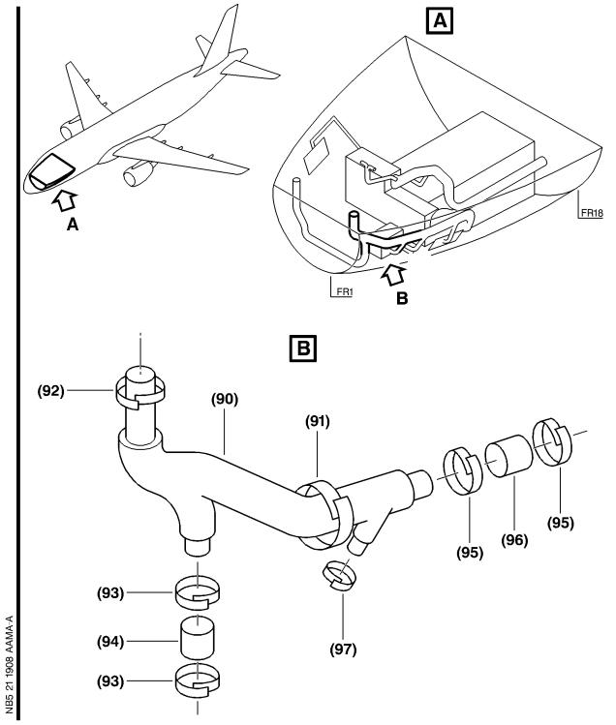

Figure 1 Sheet 1

Config . 01 thru 03 : Removal of the Duct for Access .

DATE : Mar 08/06 SERVICE BULLETIN No . : A320— 21— 1908

REVISION No . : 01 — Mar 30/07 Page : 86

Printed in FRANCE © AIRBUS, 2007 All rights reserved

@ Ac18/Ac16/Ac20/Ac21

SERVICE BULLETIN

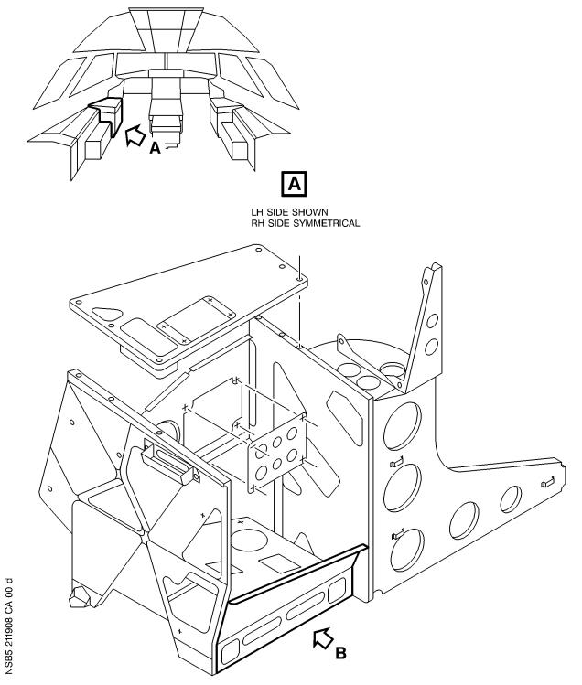

Figure 2 Sheet 1

Config . 02 thru 03 : Installation of the Seal

DATE : Mar 08/06 SERVICE BULLETIN No . : A320— 21— 1908

REVISION No . : 01 — Mar 30/07 Page : 87

Printed in FRANCE © AIRBUS, 2007 All rights reserved

@ Ac18/Ac16/Ac20/Ac21

SERVICE BULLETIN

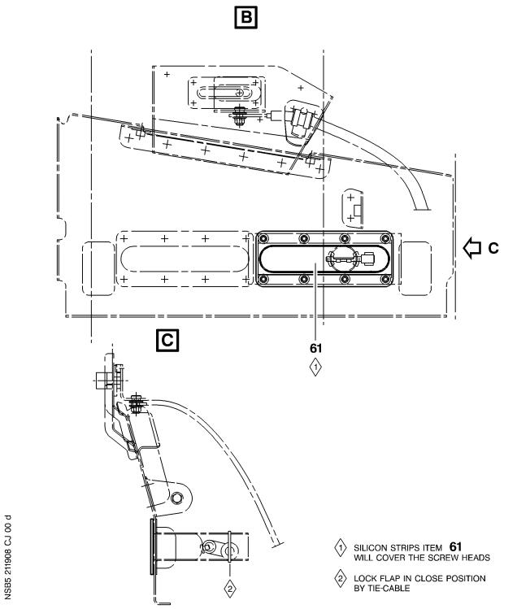

Figure 2 Sheet 2

Config . 02 thru 03 : Installation of the Seal

DATE : Mar 08/06 SERVICE BULLETIN No . : A320— 21— 1908

REVISION No . : 01 — Mar 30/07 Page : 88

Printed in FRANCE © AIRBUS, 2007 All rights reserved

@ Ac18/Ac16/Ac20/Ac21

SERVICE BULLETIN

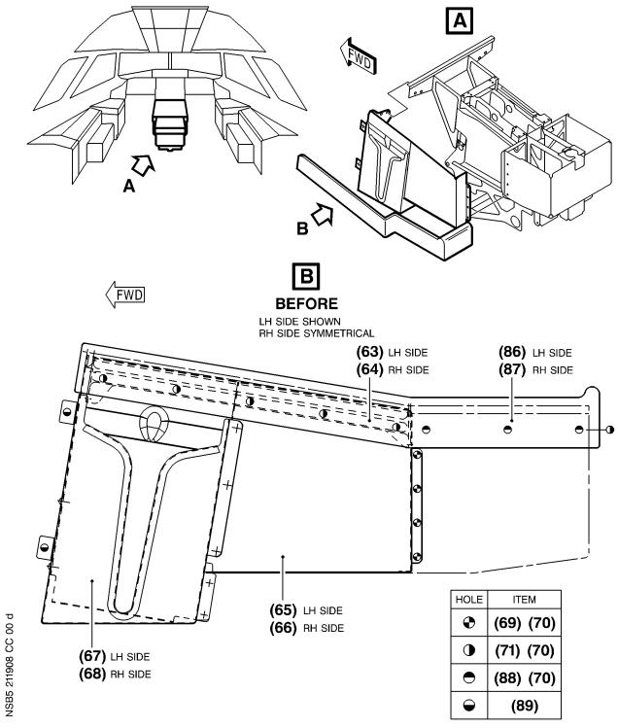

Figure 3 Sheet 1

Config . 01 : Replacement of the Pylon Panels

DATE : Mar 08/06 SERVICE BULLETIN No . : A320— 21— 1908

REVISION No . : 01 — Mar 30/07 Page : 89

Printed in FRANCE © AIRBUS, 2007 All rights reserved

@ Ac18/Ac16/Ac20/Ac21

SERVICE BULLETIN

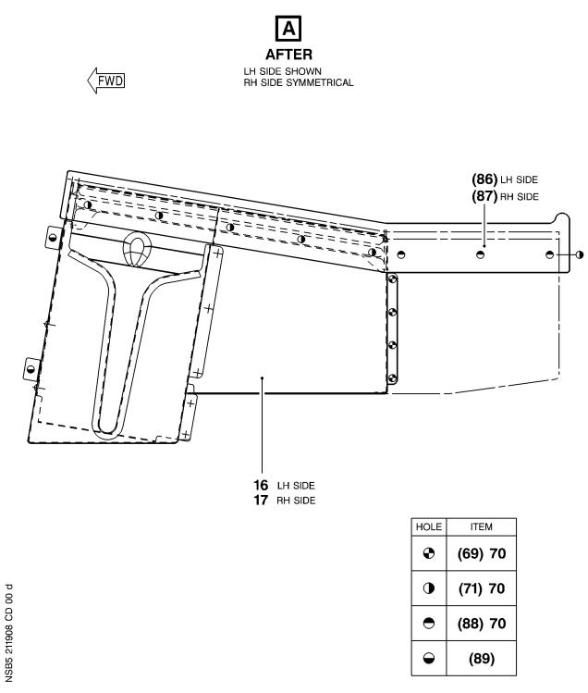

Figure 3 Sheet 2

Config . 01 : Replacement of the Pylon Panels

DATE : Mar 08/06 SERVICE BULLETIN No . : A320— 21— 1908

REVISION No . : 01 — Mar 30/07 Page : 90

Printed in FRANCE © AIRBUS, 2007 All rights reserved

@ Ac18/Ac16/Ac20/Ac21

SERVICE BULLETIN

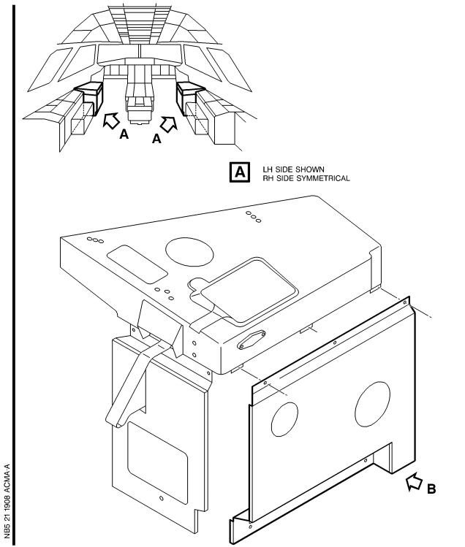

Figure 4 Sheet 1

Config . 02 thru 03 : Installation of the Seal on the Panels Assy

DATE : Mar 08/06 SERVICE BULLETIN No . : A320— 21— 1908

REVISION No . : 01 — Mar 30/07 Page : 91

Printed in FRANCE © AIRBUS, 2007 All rights reserved

@ Ac18/Ac16/Ac20/Ac21

SERVICE BULLETIN

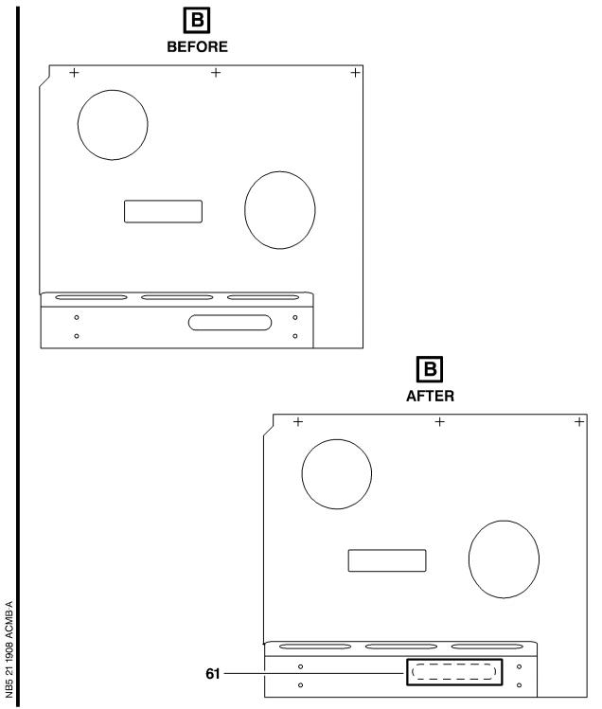

Figure 4 Sheet 2

Config . 02 thru 03 : Installation of the Seal on the Panels Assy

DATE : Mar 08/06 SERVICE BULLETIN No . : A320— 21— 1908

REVISION No . : 01 — Mar 30/07 Page : 92

Printed in FRANCE © AIRBUS, 2007 All rights reserved

@ Ac18/Ac16/Ac20/Ac21

SERVICE BULLETIN

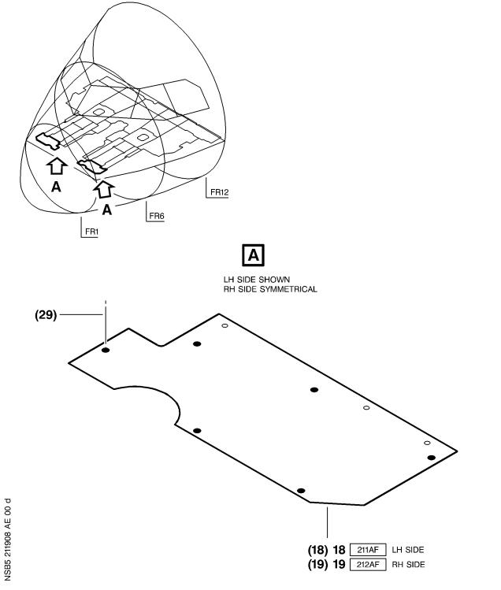

Figure 5 Sheet 1

Config . 02 thru 03 : Replacement of the Cabin Floors

DATE : Mar 08/06 SERVICE BULLETIN No . : A320— 21— 1908

REVISION No . : 01 — Mar 30/07 Page : 93

Printed in FRANCE © AIRBUS, 2007 All rights reserved

@ Ac18/Ac16/Ac20/Ac21

SERVICE BULLETIN

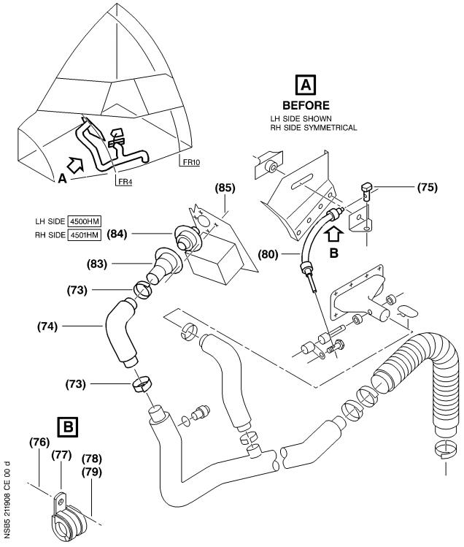

Figure 6 Sheet 1

Config . 02 thru 03 : Installation of the Ducts and the Heaters 3HE and 4HE

DATE : Mar 08/06 SERVICE BULLETIN No . : A320— 21— 1908

REVISION No . : 01 — Mar 30/07 Page : 94

Printed in FRANCE © AIRBUS, 2007 All rights reserved

@ Ac18/Ac16/Ac20/Ac21

SERVICE BULLETIN

Figure 6 Sheet 2(Goto A3 section)

Config . 02 thru 03 : Installation of the Ducts and the Heaters 3HE and 4HE

DATE : Mar 08/06 SERVICE BULLETIN No . : A320— 21— 1908

REVISION No . : 01 — Mar 30/07 Page : 95

Printed in FRANCE © AIRBUS, 2007 All rights reserved

@ Ac18/Ac16/Ac20/Ac21

SERVICE BULLETIN

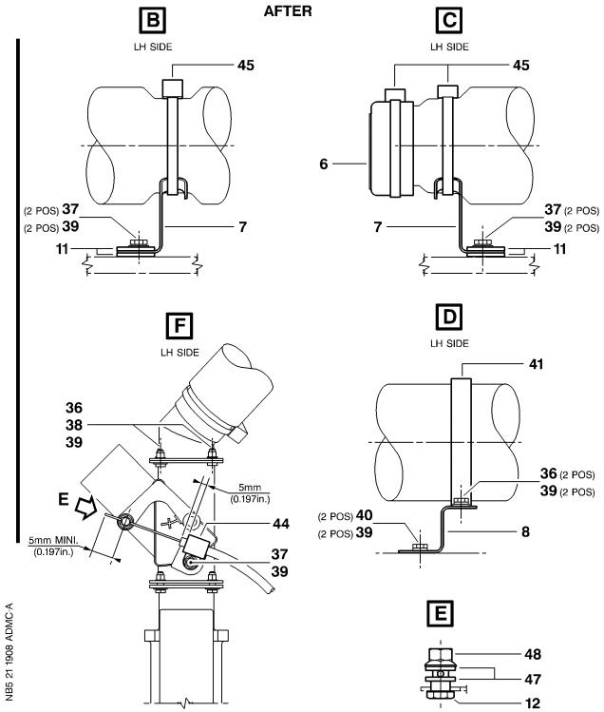

Figure 6 Sheet 3

Config . 02 thru 03 : Installation of the Ducts and the Heaters 3HE and 4HE

DATE : Mar 08/06 SERVICE BULLETIN No . : A320— 21— 1908

REVISION No . : 01 — Mar 30/07 Page : 97

Printed in FRANCE © AIRBUS, 2007 All rights reserved

@ Ac18/Ac16/Ac20/Ac21

SERVICE BULLETIN

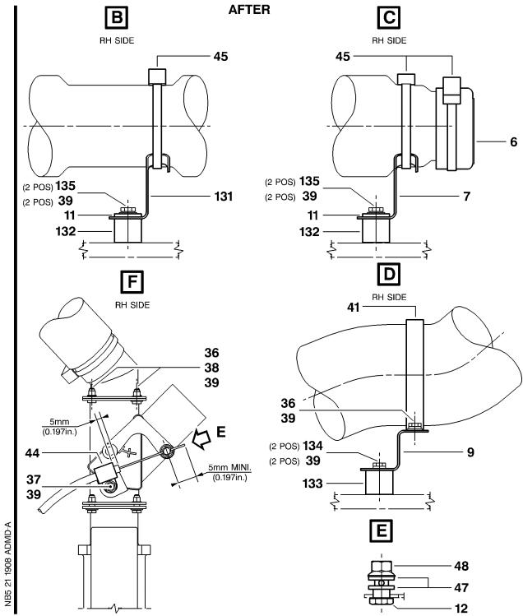

Figure 6 Sheet 4

Config . 02 thru 03 : Installation of the Ducts and the Heaters 3HE and 4HE

DATE : Mar 08/06 SERVICE BULLETIN No . : A320— 21— 1908

REVISION No . : 01 — Mar 30/07 Page : 98

Printed in FRANCE © AIRBUS, 2007 All rights reserved

@ Ac18/Ac16/Ac20/Ac21

SERVICE BULLETIN

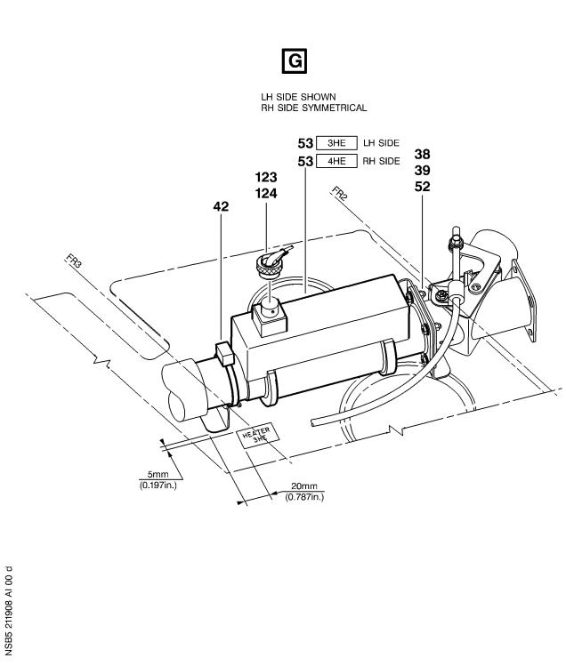

Figure 6 Sheet 5

Config . 02 thru 03 : Installation of the Ducts and the Heaters 3HE and 4HE

DATE : Mar 08/06 SERVICE BULLETIN No . : A320— 21— 1908

REVISION No . : 01 — Mar 30/07 Page : 99

Printed in FRANCE © AIRBUS, 2007 All rights reserved

@ Ac18/Ac16/Ac20/Ac21

SERVICE BULLETIN

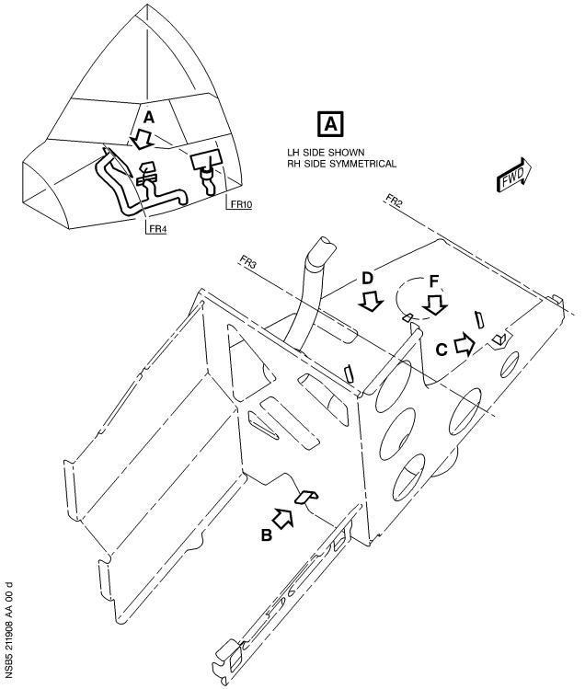

Figure 7 Sheet 1

Config . 02 thru 03 : Installation of the Brackets

DATE : Mar 08/06 SERVICE BULLETIN No . : A320— 21— 1908

REVISION No . : 01 — Mar 30/07 Page : 100

Printed in FRANCE © AIRBUS, 2007 All rights reserved

@ Ac18/Ac16/Ac20/Ac21

SERVICE BULLETIN

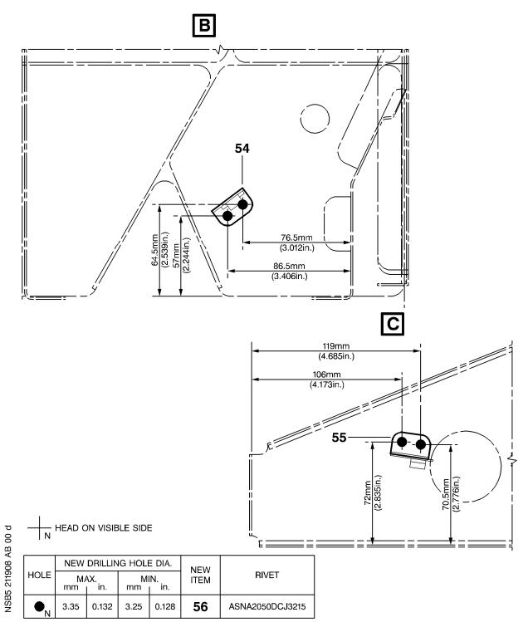

Figure 7 Sheet 2

Config . 02 thru 03 : Installation of the Brackets

DATE : Mar 08/06 SERVICE BULLETIN No . : A320— 21— 1908

REVISION No . : 01 — Mar 30/07 Page : 101

Printed in FRANCE © AIRBUS, 2007 All rights reserved

@ Ac18/Ac16/Ac20/Ac21

SERVICE BULLETIN

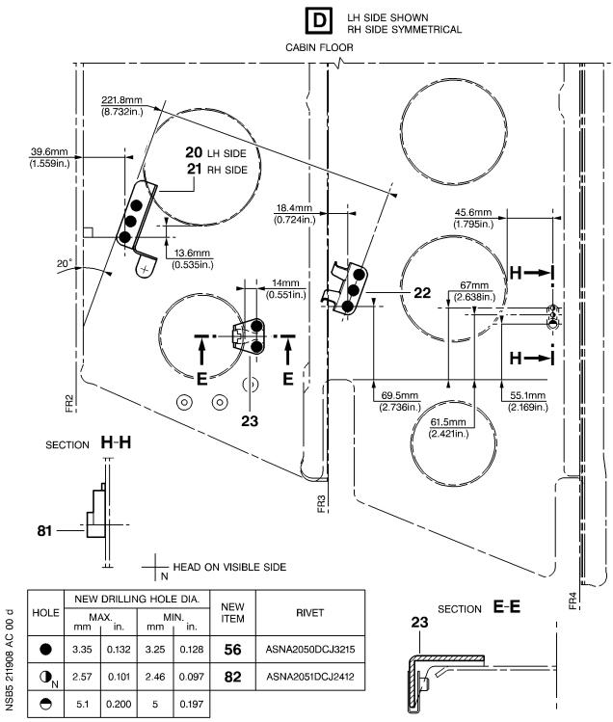

Figure 7 Sheet 3

Config . 02 thru 03 : Installation of the Brackets

DATE : Mar 08/06 SERVICE BULLETIN No . : A320— 21— 1908

REVISION No . : 01 — Mar 30/07 Page : 102

Printed in FRANCE © AIRBUS, 2007 All rights reserved

@ Ac18/Ac16/Ac20/Ac21

SERVICE BULLETIN

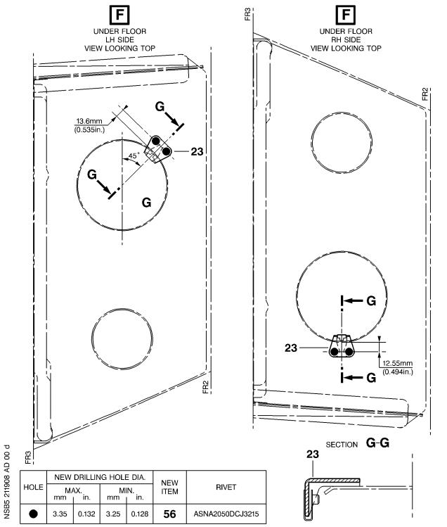

Figure 7 Sheet 4

Config . 02 thru 03 : Installation of the Brackets

DATE : Mar 08/06 SERVICE BULLETIN No . : A320— 21— 1908

REVISION No . : 01 — Mar 30/07 Page : 103

Printed in FRANCE © AIRBUS, 2007 All rights reserved

@ Ac18/Ac16/Ac20/Ac21

SERVICE BULLETIN

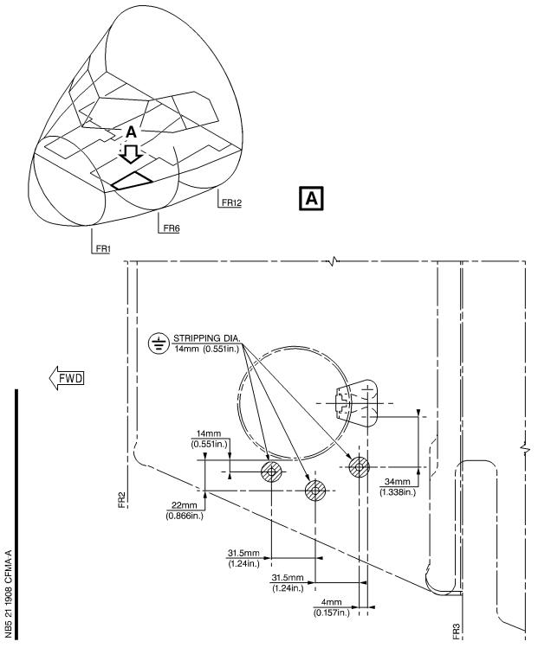

Figure 8 Sheet 1

Config . 02 thru 03 : Installation of the Ground Points and of their Placards at

LH side

DATE : Mar 08/06 SERVICE BULLETIN No . : A320— 21— 1908

REVISION No . : 01 — Mar 30/07 Page : 104

Printed in FRANCE © AIRBUS, 2007 All rights reserved

@ Ac18/Ac16/Ac20/Ac21

SERVICE BULLETIN

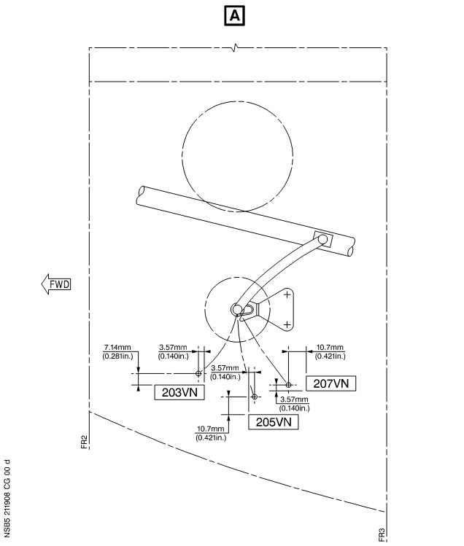

Figure 8 Sheet 2

Config . 02 thru 03 : Installation of the Ground Points and of their Placards at

LH side

DATE : Mar 08/06 SERVICE BULLETIN No . : A320— 21— 1908

REVISION No . : 01 — Mar 30/07 Page : 105

Printed in FRANCE © AIRBUS, 2007 All rights reserved

@ Ac18/Ac16/Ac20/Ac21

SERVICE BULLETIN

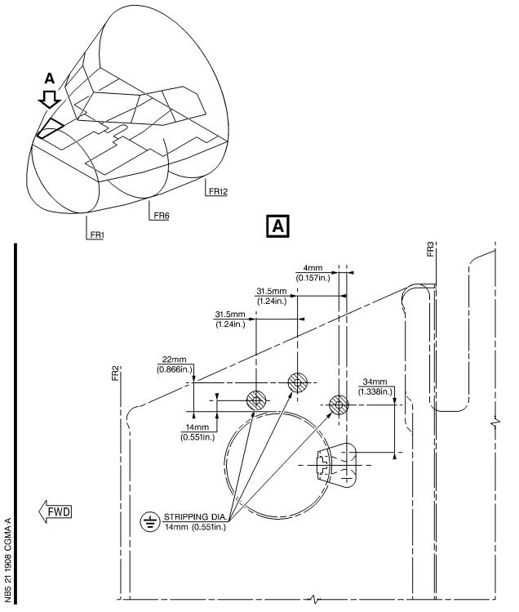

Figure 9 Sheet 1

Config . 02 thru 03 : Installation of the Ground Points and of their Placards at

RH side

DATE : Mar 08/06 SERVICE BULLETIN No . : A320— 21— 1908

REVISION No . : 01 — Mar 30/07 Page : 106

Printed in FRANCE © AIRBUS, 2007 All rights reserved

@ Ac18/Ac16/Ac20/Ac21

SERVICE BULLETIN

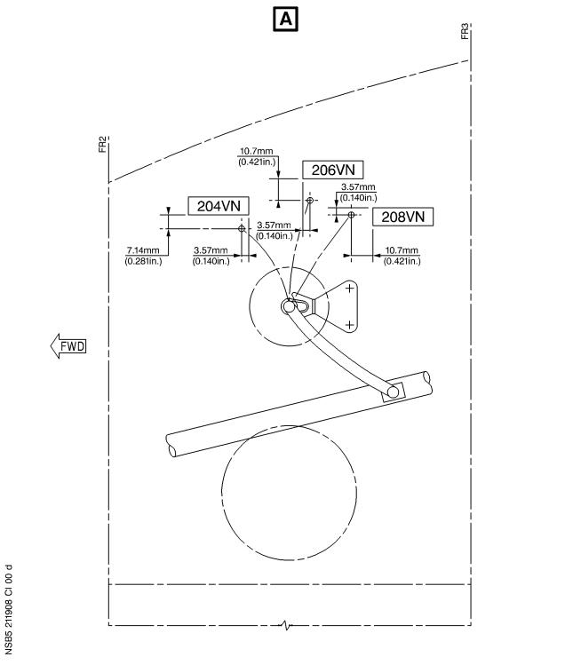

Figure 9 Sheet 2

Config . 02 thru 03 : Installation of the Ground Points and of their Placards at

RH side

DATE : Mar 08/06 SERVICE BULLETIN No . : A320— 21— 1908

REVISION No . : 01 — Mar 30/07 Page : 107

Printed in FRANCE © AIRBUS, 2007 All rights reserved

@ Ac18/Ac16/Ac20/Ac21

SERVICE BULLETIN

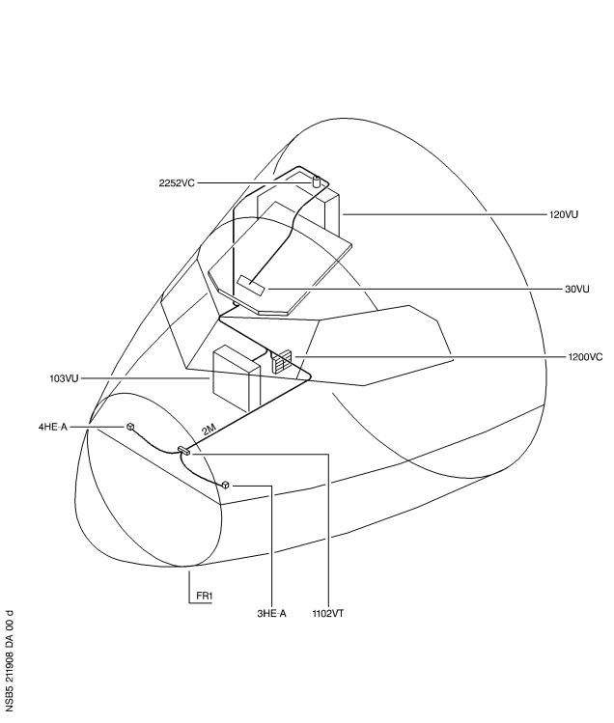

Figure 10 Sheet 1

Config . 02 thru 03 : Location of the Work Area

DATE : Mar 08/06 SERVICE BULLETIN No . : A320— 21— 1908

REVISION No . : 01 — Mar 30/07 Page : 108

Printed in FRANCE © AIRBUS, 2007 All rights reserved

@ Ac18/Ac16/Ac20/Ac21

SERVICE BULLETIN

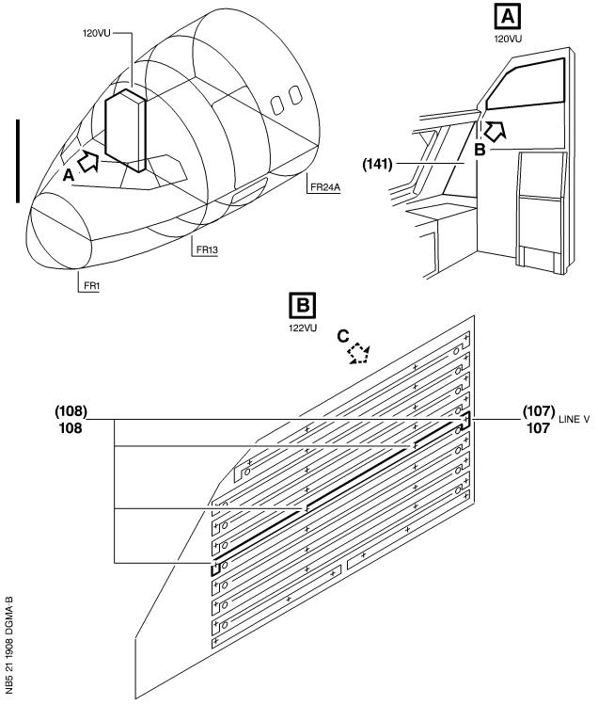

Figure 11 Sheet 1

Config . 02 thru 03 : Modification of the Equipment in the Rear C/B Panel 122VU

DATE : Mar 08/06 SERVICE BULLETIN No . : A320— 21— 1908

REVISION No . : 01 — Mar 30/07 Page : 109

Printed in FRANCE © AIRBUS, 2007 All rights reserved

@ Ac18/Ac16/Ac20/Ac21

SERVICE BULLETIN

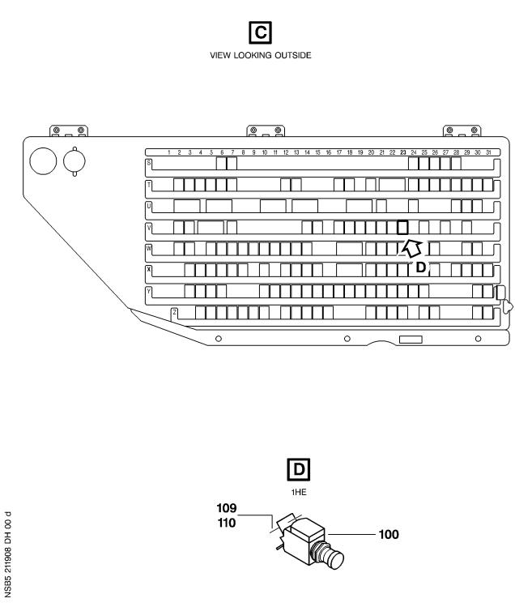

Figure 11 Sheet 2

Config . 02 thru 03 : Modification of the Equipment in the Rear C/B Panel 122VU

DATE : Mar 08/06 SERVICE BULLETIN No . : A320— 21— 1908

REVISION No . : 01 — Mar 30/07 Page : 110

Printed in FRANCE © AIRBUS, 2007 All rights reserved

@ Ac18/Ac16/Ac20/Ac21

SERVICE BULLETIN

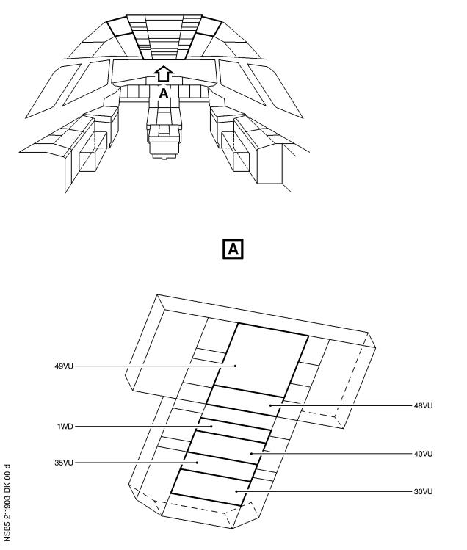

Figure 12 Sheet 1

Config . 02 thru 03 : Location of the Equipment for Access

DATE : Mar 08/06 SERVICE BULLETIN No . : A320— 21— 1908

REVISION No . : 01 — Mar 30/07 Page : 111

Printed in FRANCE © AIRBUS, 2007 All rights reserved

@ Ac18/Ac16/Ac20/Ac21

SERVICE BULLETIN

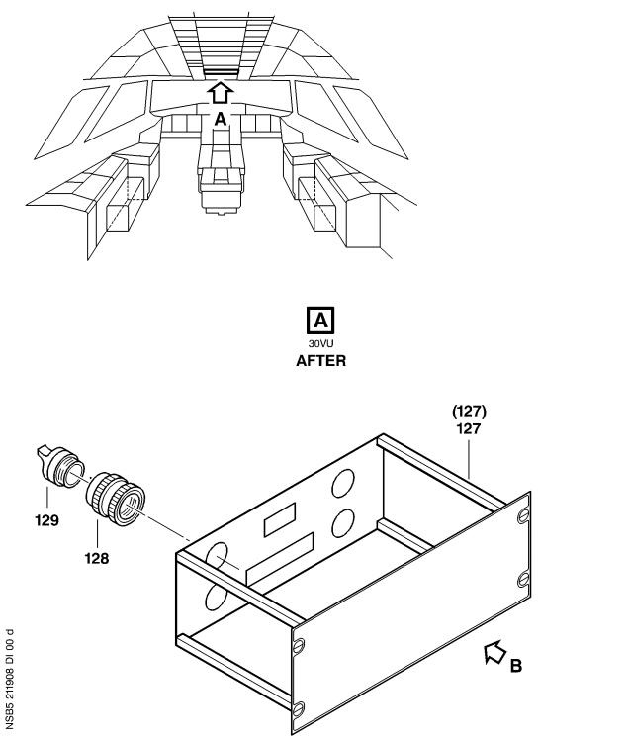

Figure 13 Sheet 1

Config . 02 : Modification of the Equipment in the Overhead Panel 20VU

DATE : Mar 08/06 SERVICE BULLETIN No . : A320— 21— 1908

REVISION No . : 01 — Mar 30/07 Page : 112

Printed in FRANCE © AIRBUS, 2007 All rights reserved

@ Ac18/Ac16/Ac20/Ac21

SERVICE BULLETIN

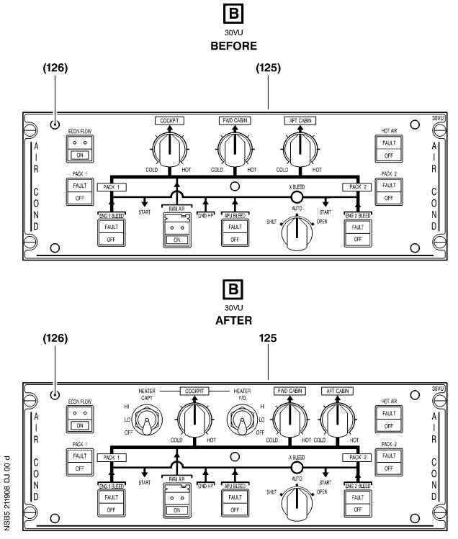

Figure 13 Sheet 2

Config . 02 : Modification of the Equipment in the Overhead Panel 20VU

DATE : Mar 08/06 SERVICE BULLETIN No . : A320— 21— 1908

REVISION No . : 01 — Mar 30/07 Page : 113

Printed in FRANCE © AIRBUS, 2007 All rights reserved

@ Ac18/Ac16/Ac20/Ac21

SERVICE BULLETIN

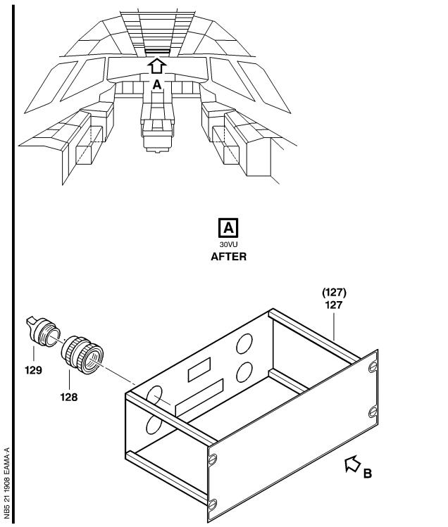

Figure 14 Sheet 1

Config . 03 : Modification of the Equipment in the Overhead Panel 20VU

DATE : Mar 08/06 SERVICE BULLETIN No . : A320— 21— 1908

REVISION No . : 01 — Mar 30/07 Page : 114

Printed in FRANCE © AIRBUS, 2007 All rights reserved

@ Ac18/Ac16/Ac20/Ac21

SERVICE BULLETIN

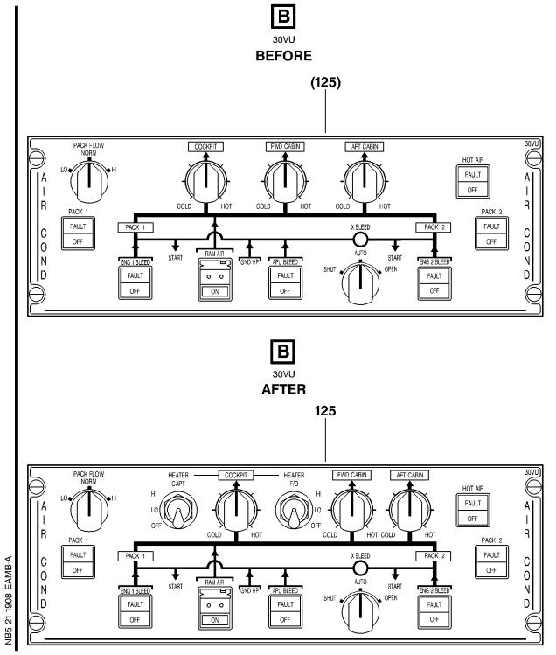

Figure 14 Sheet 2

Config . 03 : Modification of the Equipment in the Overhead Panel 20VU

DATE : Mar 08/06 SERVICE BULLETIN No . : A320— 21— 1908

REVISION No . : 01 — Mar 30/07 Page : 115

Printed in FRANCE © AIRBUS, 2007 All rights reserved

@ Ac18/Ac16/Ac20/Ac21

SERVICE BULLETIN

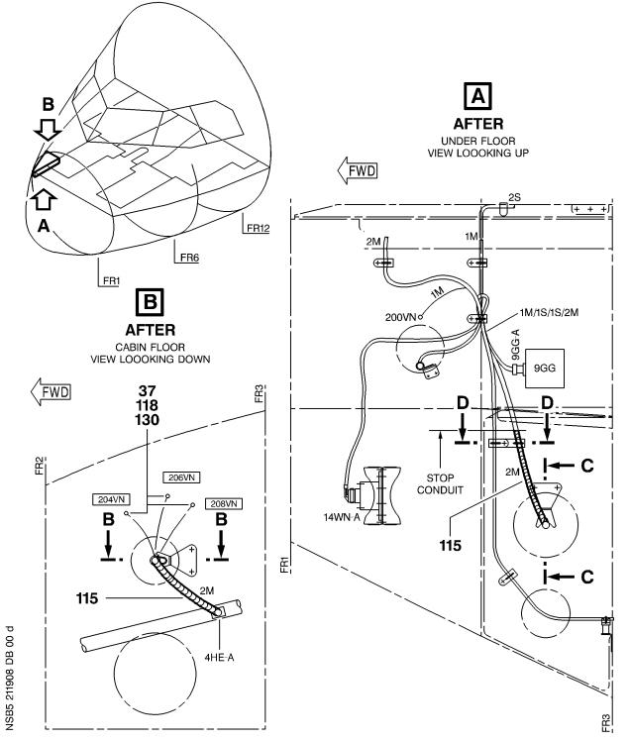

Figure 15 Sheet 1

Config . 02 thru 03 : Modification of the Routing in the RH Side between FR2 and

FR3

DATE : Mar 08/06 SERVICE BULLETIN No . : A320— 21— 1908

REVISION No . : 01 — Mar 30/07 Page : 116

Printed in FRANCE © AIRBUS, 2007 All rights reserved

@ Ac18/Ac16/Ac20/Ac21

SERVICE BULLETIN

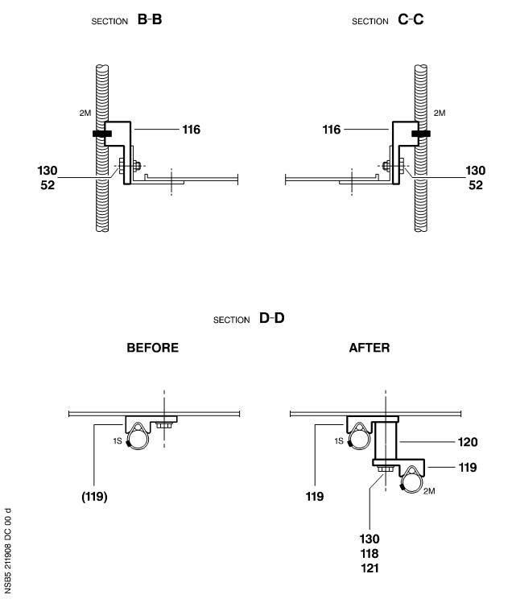

Figure 15 Sheet 2

Config . 02 thru 03 : Modification of the Routing in the RH Side between FR2 and

FR3

DATE : Mar 08/06 SERVICE BULLETIN No . : A320— 21— 1908

REVISION No . : 01 — Mar 30/07 Page : 117

Printed in FRANCE © AIRBUS, 2007 All rights reserved

@ Ac18/Ac16/Ac20/Ac21

SERVICE BULLETIN

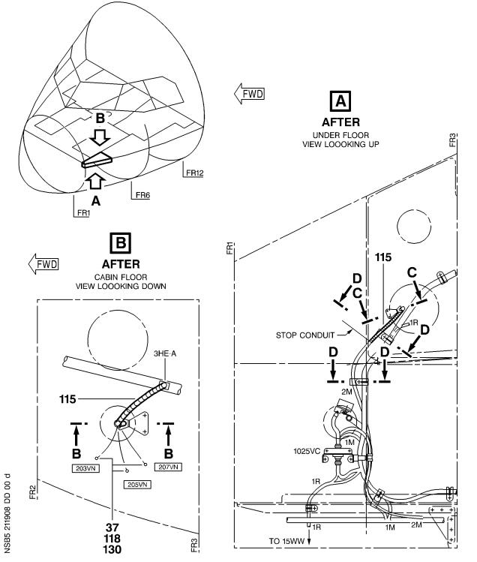

Figure 16 Sheet 1

Config . 02 thru 03 : Modification of the Routing in the LH Side between FR2 and

FR3

DATE : Mar 08/06 SERVICE BULLETIN No . : A320— 21— 1908

REVISION No . : 01 — Mar 30/07 Page : 118

Printed in FRANCE © AIRBUS, 2007 All rights reserved

@ Ac18/Ac16/Ac20/Ac21

SERVICE BULLETIN

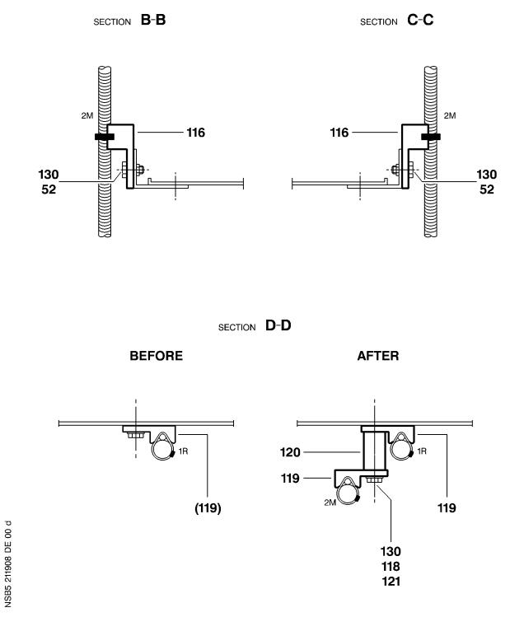

Figure 16 Sheet 2

Config . 02 thru 03 : Modification of the Routing in the LH Side between FR2 and

FR3

DATE : Mar 08/06 SERVICE BULLETIN No . : A320— 21— 1908

REVISION No . : 01 — Mar 30/07 Page : 119

Printed in FRANCE © AIRBUS, 2007 All rights reserved

@ Ac18/Ac16/Ac20/Ac21

SERVICE BULLETIN

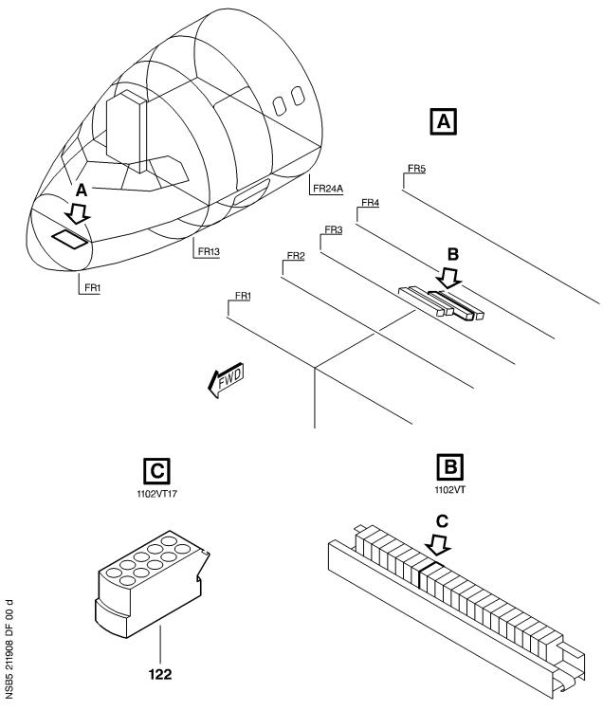

Figure 17 Sheet 1

Config . 02 thru 03 : Modification of the Equipment in the Avionics Compartment

DATE : Mar 08/06 SERVICE BULLETIN No . : A320— 21— 1908

REVISION No . : 01 — Mar 30/07 Page : 120

Printed in FRANCE © AIRBUS, 2007 All rights reserved

@ Ac18/Ac16/Ac20/Ac21

SERVICE BULLETIN

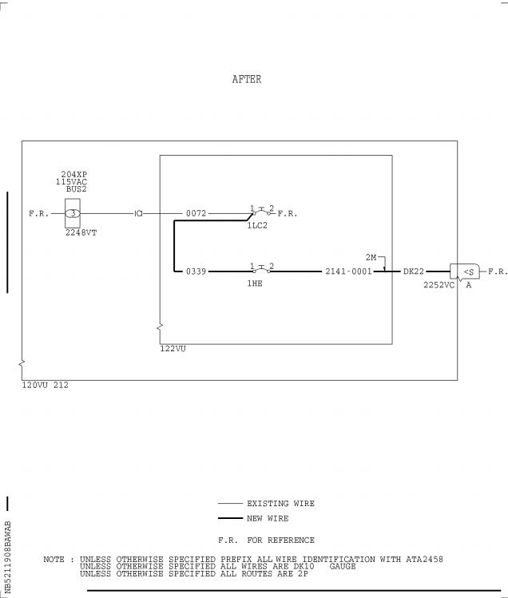

Figure 18 Sheet 1

Config . 02 thru 03 : Modification of the Wiring in the Rear Panel 120VU

DATE : Mar 08/06 SERVICE BULLETIN No . : A320— 21— 1908

REVISION No . : 01 — Mar 30/07 Page : 121

Printed in FRANCE © AIRBUS, 2007 All rights reserved

@ Ac18/Ac16/Ac20/Ac21

SERVICE BULLETIN

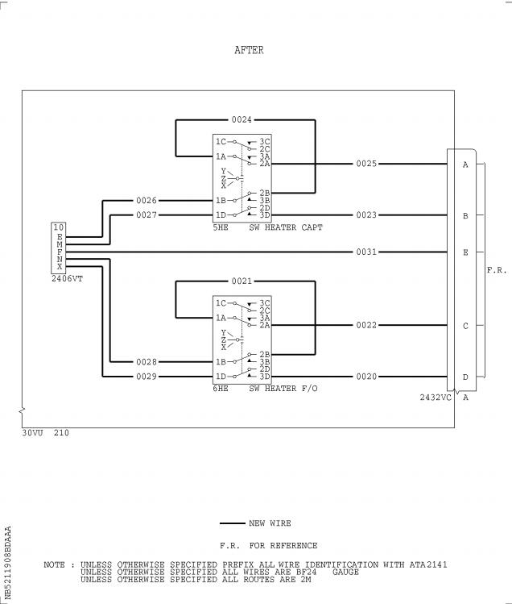

Figure 19 Sheet 1

Config . 02 thru 03 : 30VU Wiring Diagram - For Information Only

DATE : Mar 08/06 SERVICE BULLETIN No . : A320— 21— 1908

REVISION No . : 01 — Mar 30/07 Page : 122

Printed in FRANCE © AIRBUS, 2007 All rights reserved

@ Ac18/Ac16/Ac20/Ac21

SERVICE BULLETIN

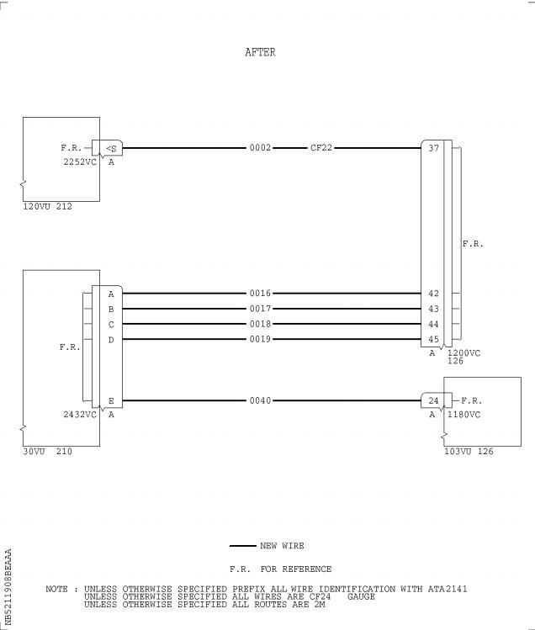

Figure 20 Sheet 1

Config . 02 thru 03 : Modification of the Wiring between the Cockpit and the

Avionics Compartment

DATE : Mar 08/06 SERVICE BULLETIN No . : A320— 21— 1908

REVISION No . : 01 — Mar 30/07 Page : 123

Printed in FRANCE © AIRBUS, 2007 All rights reserved

@ Ac18/Ac16/Ac20/Ac21

SERVICE BULLETIN

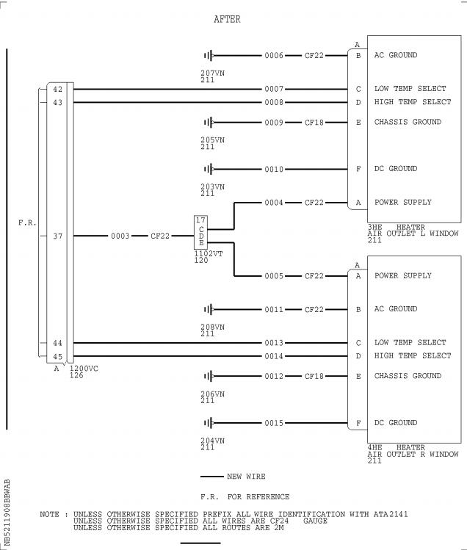

Figure 21 Sheet 1

Config . 02 thru 03 : Modification of the Wiring between the Equipment and the

Avionics Compartment

DATE : Mar 08/06 SERVICE BULLETIN No . : A320— 21— 1908

REVISION No . : 01 — Mar 30/07 Page : 124

Printed in FRANCE © AIRBUS, 2007 All rights reserved

@ Ac18/Ac16/Ac20/Ac21

SERVICE BULLETIN

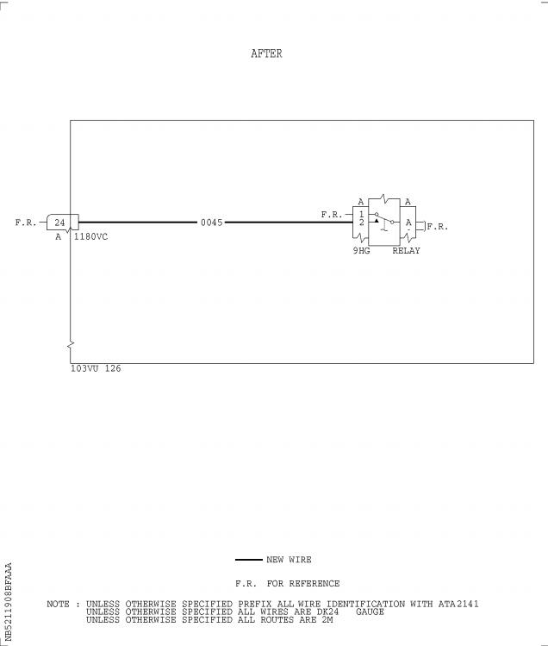

Figure 22 Sheet 1

Config . 02 thru 03 : Modification of the Wiring in the Relay Box 103VU

DATE : Mar 08/06 SERVICE BULLETIN No . : A320— 21— 1908

REVISION No . : 01 — Mar 30/07 Page : 125

Printed in FRANCE © AIRBUS, 2007 All rights reserved

@ Ac18/Ac16/Ac20/Ac21

SERVICE BULLETIN

This Page Intentionally Left Blank

DATE : Mar 08/06 SERVICE BULLETIN No . : A320— 21— 1908

REVISION No . : 01 — Mar 30/07 Page : 126

Printed in FRANCE © AIRBUS, 2007 All rights reserved

@ Ac18/Ac16/Ac20/Ac21

SERVICE BULLETIN

Figure 23 Sheet 1(Goto A3 section)

Config . 02 thru 03 : Hook-up Chart

DATE : Mar 08/06 SERVICE BULLETIN No . : A320— 21— 1908

REVISION No . : 01 — Mar 30/07 Page : 127

Printed in FRANCE © AIRBUS, 2007 All rights reserved

@ Ac18/Ac16/Ac20/Ac21

SERVICE BULLETIN

Figure 24 Sheet 1(Goto A3 section)

Config . 02 thru 03 : Hook-up Chart

DATE : Mar 08/06 SERVICE BULLETIN No . : A320— 21— 1908

REVISION No . : 01 — Mar 30/07 Page : 129

Printed in FRANCE © AIRBUS, 2007 All rights reserved

@ Ac18/Ac16/Ac20/Ac21

SERVICE BULLETIN

Figure 25 Sheet 1(Goto A3 section)

Config . 02 thru 03 : Hook-up Chart

DATE : Mar 08/06 SERVICE BULLETIN No . : A320— 21— 1908

REVISION No . : 01 — Mar 30/07 Page : 131

Printed in FRANCE © AIRBUS, 2007 All rights reserved

@ Ac18/Ac16/Ac20/Ac21

SERVICE BULLETIN

Figure 26 Sheet 1(Goto A3 section)

Config . 02 thru 03 : Hook-up Chart

DATE : Mar 08/06 SERVICE BULLETIN No . : A320— 21— 1908

REVISION No . : 01 — Mar 30/07 Page : 133

Printed in FRANCE © AIRBUS, 2007 All rights reserved

@ Ac18/Ac16/Ac20/Ac21

SERVICE BULLETIN

REPORTING SHEET

TITLE : AIR CONDITIONING - COCKPIT AIR HEATING - IMPROVE FOOT WARMER EFFICIENCY .

MODIFICATION No . : 35861P9435 35861P9449

Please complete the appropriate item (A or B):

A - SB WILL BE embodied . . . . . . . . . . . . . YES/NO (if NO please comment)

If YES, aircraft concerned (as per SB effectivity by default) and planned dates

(month/year) of embodiment : . . . . . . . . . . . . . . . . . . . . . . . . . .

. . . . . . . . . . . . . . . . . . . . . . . . . . . . . . . . . . . . . . . .

. . . . . . . . . . . . . . . . . . . . . . . . . . . . . . . . . . . . . . . .

B - SB HAS BEEN embodied on aircraft : . . . . . . . . . . . . . . . . . . . . .

. . . . . . . . . . . . . . . . . . . . . . . . . . . . . . . . . . . . . . . .

. . . . . . . . . . . . . . . . . . . . . . . . . . . . . . . . . . . . . . . .

Operator comments : . . . . . . . . . . . . . . . . . . . . . . . . . . . . . .

. . . . . . . . . . . . . . . . . . . . . . . . . . . . . . . . . . . . . . .

. . . . . . . . . . . . . . . . . . . . . . . . . . . . . . . . . . . . . . .

From Airline : . . . . . . . . . . . . . . . . . . . . . . . . . . . . . . . . .

Name/Title : . . . . . . . . . . . . . . . . . . . . . . . . . . . . . . . . . .

Signature : . . . . . . . . . . . . . . Date : . . . . . . . . . . . . .

If operational documentation is affected (see Paragraph 1 .K of this SB): If information is needed prior to next normal revision or prior to SB embodiment, please indicate required service:

Either: Modification Operational Impact (MOI), if available . . YES/NO

Or : Intermediate revision . . . . . . . . . . . . . . . . . YES/NO

Important Information: This SB will only be incorporated in your maintenance and

operational documentation if this sheet is returned to Airbus and signed by a

duly authorised representative . With the next feasible revision, this will

result in

- updating of maintenance documentation to show pre and post SB data .

- updating of maintenance and operational documentation to show post SB data

after embodiment .

If this SB requires previous or simultaneous accomplishment of other SBs,

Airbus shall automatically include them in the manual revisions . Refer to SIL

00-037 for detailed information .

Please return this completed sheet to:

AIRBUS

CUSTOMER SERVICES DIRECTORATE

1 Rond Point Maurice Bellonte

31707 BLAGNAC CEDEX FRANCE

Attn: SDC32 Technical Data and Documentation Services

FAX: (+33) 5 61 93 28 06

e -mail: sb . reporting@airbus .com

or via your Resident Customer Support Office .

Alternatively, SB lists via letters or fax are also accepted .

5 DATE : Mar 08/06

REVISION No . : 01 — Mar 30/07

SERVICE BULLETIN No . : A320— 21— 1908

Page : 1 of 1

Printed in FRANCE © AIRBUS, 2007 All rights reserved

@ Ac18/Ac16/Ac20/Ac21

SERVICE BULLETIN

QUALITY PERCEPTION FORM

Use this form to tell us what is your perception of the quality of this Service Bulletin . The reported data that you provide us will be used to analyse areas of difficulties and to take corrective action to further improve the quality of our Service Bulletins .

We thank you for the time you have taken in completing this form .

(Please rate on a scale of 1 to 4, with 4 being the highest score)

|  |  |  |  |
| --- | --- | --- | --- |
| - Quality rating of this SB | 4 3 | 2 | 1 |
| - Quality rating of the Accomplishment Instructions | 4 3 | 2 | 1 |
| - Quality rating of the Illustrations | 4 3 | 2 | 1 |
| - Is this SB easy to understand ? | Y / N |  |  |

If you have had difficulties in the accomplishment of this SB please quote below

the area(s) and give a short description of the issue .

Planning

X Effectivity

X Reason

X Manpower

X References

X Publication

Comments :

Material

X Kit content

X List of Materials

Operator Supplied

X Re-identification

X Tooling

Instructions

X Preparation

X Mod/Inspection

X Test

X Close-Up

X Illustrations

Operator :

Date:

Name/Title :

Please return this form to :

AIRBUS

CUSTOMER SERVICES DIRECTORATE

1 Rond Point Maurice Bellonte

31707 BLAGNAC

Attn : SEM4 Service Bulletins Management

FAX : (33) 5 61 93 42 51

Or via your Resident Customer Support Office .

5 DATE : Mar 08/06

REVISION No . : 01 — Mar 30/07

SERVICE BULLETIN No . : A320— 21— 1908

Page : 1 of 1

Printed in FRANCE © AIRBUS, 2007 All rights reserved

@ Ac18/Ac16/Ac20/Ac21

SERVICE BULLETIN

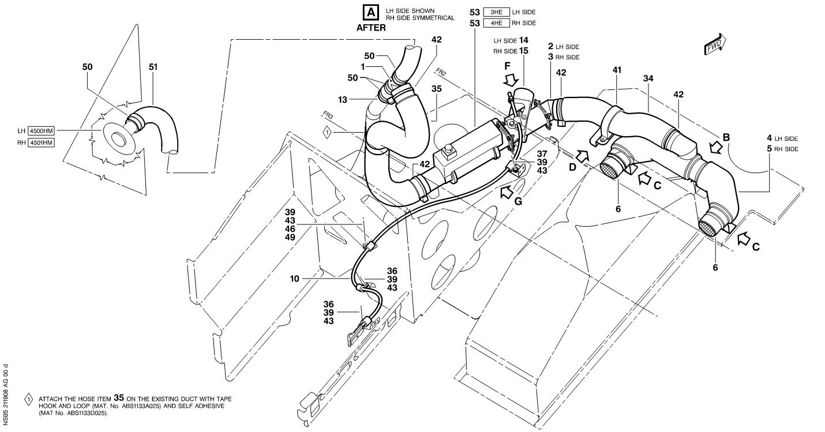

Figure 6 Sheet 2

Config . 02 thru 03 : Installation of the Ducts and the Heaters 3HE and 4HE

DATE : Mar 08/06

REVISION No . : 01 — Mar 30/07

SERVICE BULLETIN No . : A320— 21— 1908

Page : 95/96

Printed in FRANCE © AIRBUS, 2007 All rights reserved

@ Ac18/Ac16/Ac20/Ac21

SERVICE BULLETIN

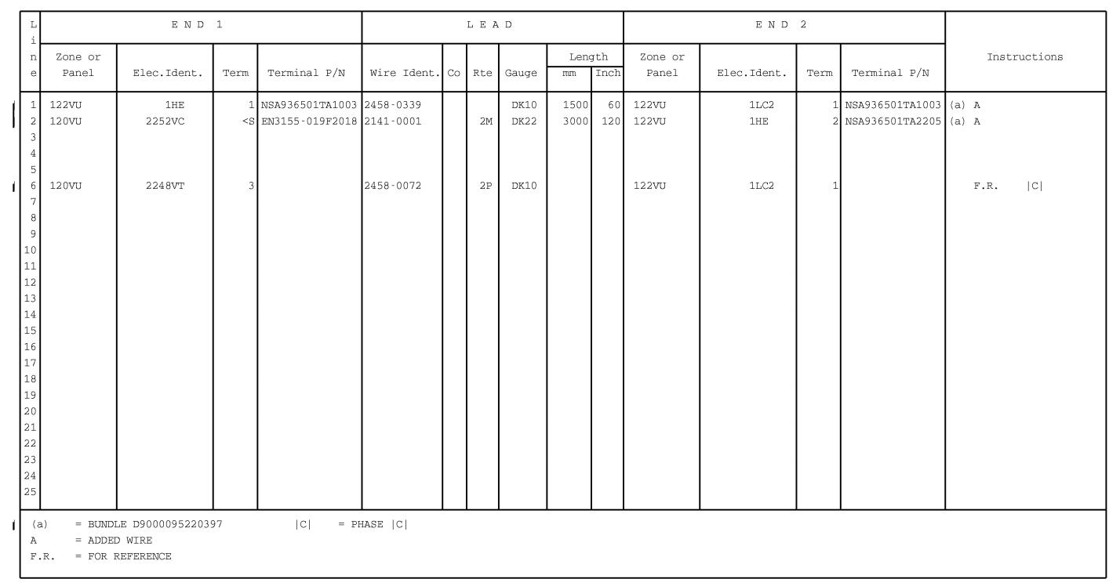

Figure 23 Sheet 1

Config . 02 thru 03 : Hook-up Chart

DATE : Mar 08/06

REVISION No . : 01 — Mar 30/07

SERVICE BULLETIN No . : A320— 21— 1908

Page : 127/128

Printed in FRANCE © AIRBUS, 2007 All rights reserved

@ Ac18/Ac16/Ac20/Ac21

SERVICE BULLETIN

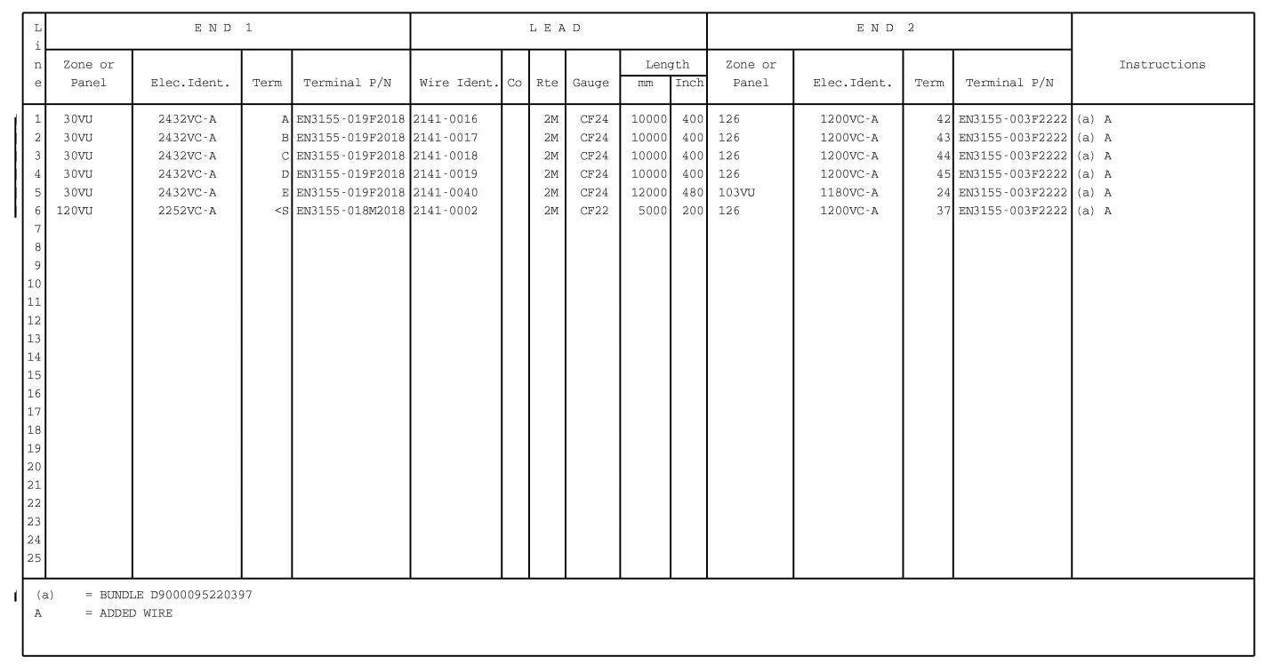

Figure 24 Sheet 1

Config . 02 thru 03 : Hook-up Chart

DATE : Mar 08/06

REVISION No . : 01 — Mar 30/07

SERVICE BULLETIN No . : A320— 21— 1908

Page : 129/130

Printed in FRANCE © AIRBUS, 2007 All rights reserved

@ Ac18/Ac16/Ac20/Ac21

SERVICE BULLETIN

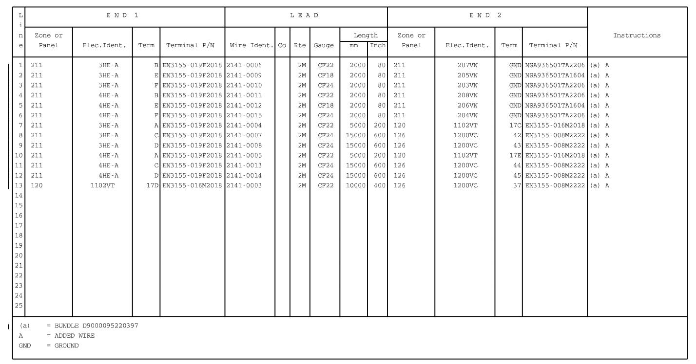

Figure 25 Sheet 1

Config . 02 thru 03 : Hook-up Chart

DATE : Mar 08/06

REVISION No . : 01 — Mar 30/07

SERVICE BULLETIN No . : A320— 21— 1908

Page : 131/132

Printed in FRANCE © AIRBUS, 2007 All rights reserved

@ Ac18/Ac16/Ac20/Ac21

SERVICE BULLETIN

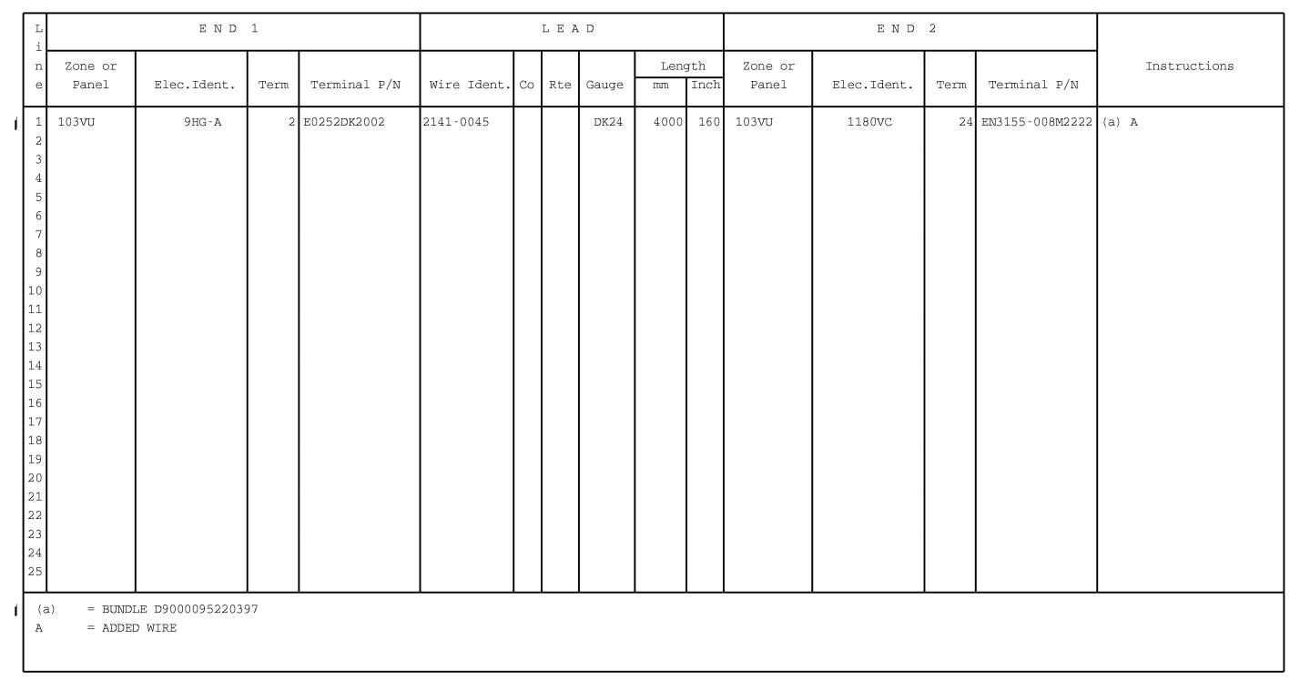

Figure 26 Sheet 1

Config . 02 thru 03 : Hook-up Chart

DATE : Mar 08/06

REVISION No . : 01 — Mar 30/07

SERVICE BULLETIN No . : A320— 21— 1908

Page : 133/134

Printed in FRANCE © AIRBUS, 2007 All rights reserved