Determining the Angle of Incidence (θ_i)
cos(θi​)=sin(δ)sin(ϕ)cos(β)−sin(δ)cos(ϕ)sin(β)cos(γ)+cos(δ)cos(ϕ)cos(β)cos(ω)+cos(δ)sin(ϕ)sin(β)cos(γ)cos(ω)+cos(δ)sin(β)sin(γ)sin(ω)
Where: δ= Solar declination angle
ϕ= Latitude of the location
β= Tilt angle of the panel
γ= Surface azimuth angle (angle between north and the panel's facing direction)
ω= Hour angle (related to the time of day)
Solar Irradiance Components Ipanel = DNI * cos(θi) + DHI (1+cos(β) /2)
β= Tilt angle of the panel
Weighted Energy and the Logic and Math Behind Weight Assignments
Energy Mismatch refers to the difference between energy production (from solar panels) and energy consumption (by the household or system) Energy Mismatch=Energy Consumption−Energy Production
Weighting allows prioritizing certain types of mismatches based on their significance, cost implications, or other criteria. Weight Assignments:
- Time of Day: Mismatches during peak consumption hours may be weighted more heavily.
- Duration of Mismatch: Longer periods of mismatch can have a greater cumulative impact.
- Severity: Larger mismatches (in kWh) might be given higher weights.
- Cost Implications: Financial losses associated with mismatches can inform weight values.
- System Goals: Objectives like maximizing self-consumption or minimizing grid reliance influence weighting.

Weighted Energy Mismatch:
WEM = WEM= t=1 ∑ T​w t​⋅∣E consumption,t​−E production,t​∣

Where:
T = Total number of time intervals (e.g., hours)
wt= Weight assigned to time interval t
Econsumption,t= Energy consumed at time t
Eproduction,t= Energy produced at timet
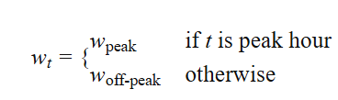
Examples of Weight Assignments:
Time-Based Weights: Higher weights during peak hours: ​
Severity-Based Weights:
Proportional to the magnitude of mismatch:
wt​=k⋅∣Econsumption,t​−Eproduction,t​∣
Where kis a scaling factor
Cost-Based Weights:
Reflecting the cost associated with each mismatch:
w t Cost per kWh at time t
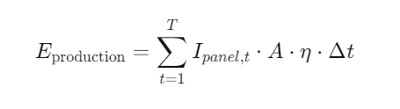
Energy Production Calculation :
Where:
- T= Total number of time intervals
- Ipanel,t= Irradiance on the panel at time tt (W/m²)
- A= Area of the solar panel (m²)
- η= System efficiency (dimensionless, e.g., 0.15 for 15%)
- Δt= Duration of each time interval (hours)
Energy Consumption Calculation:
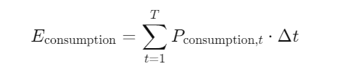
Weighted Energy Mismatch Calculation:
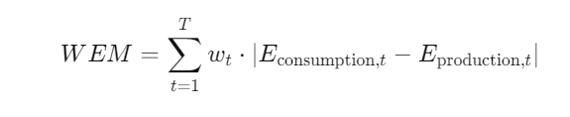
Calculate Hourly Mismatch:
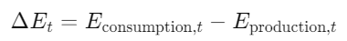
Apply Weights:
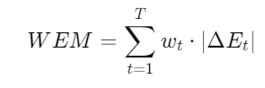
Aggregate:
  - Sum over all time intervals to obtain the total weighted mismatch.

