1.获取mysql yum源

IP：<https://dev.mysql.com/downloads/repo/yum/>

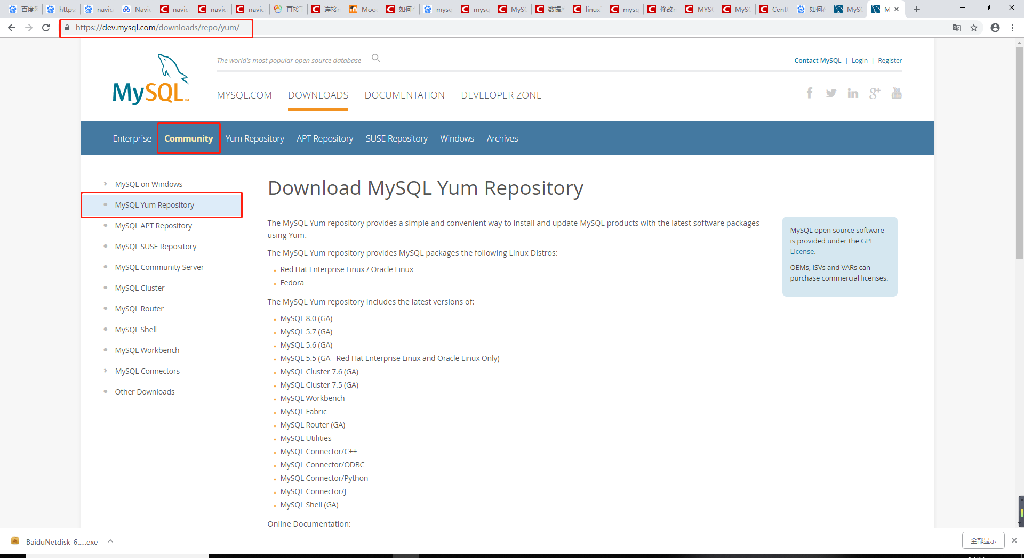

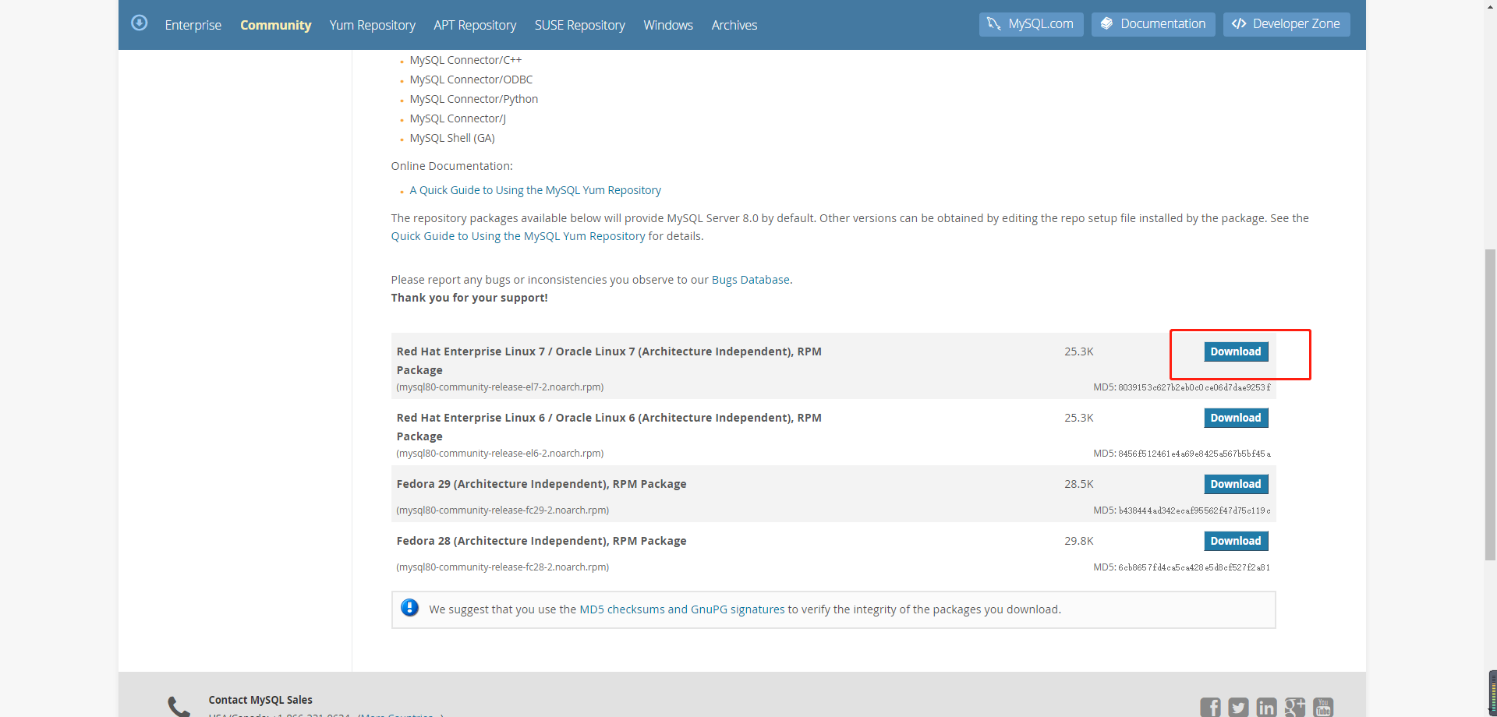

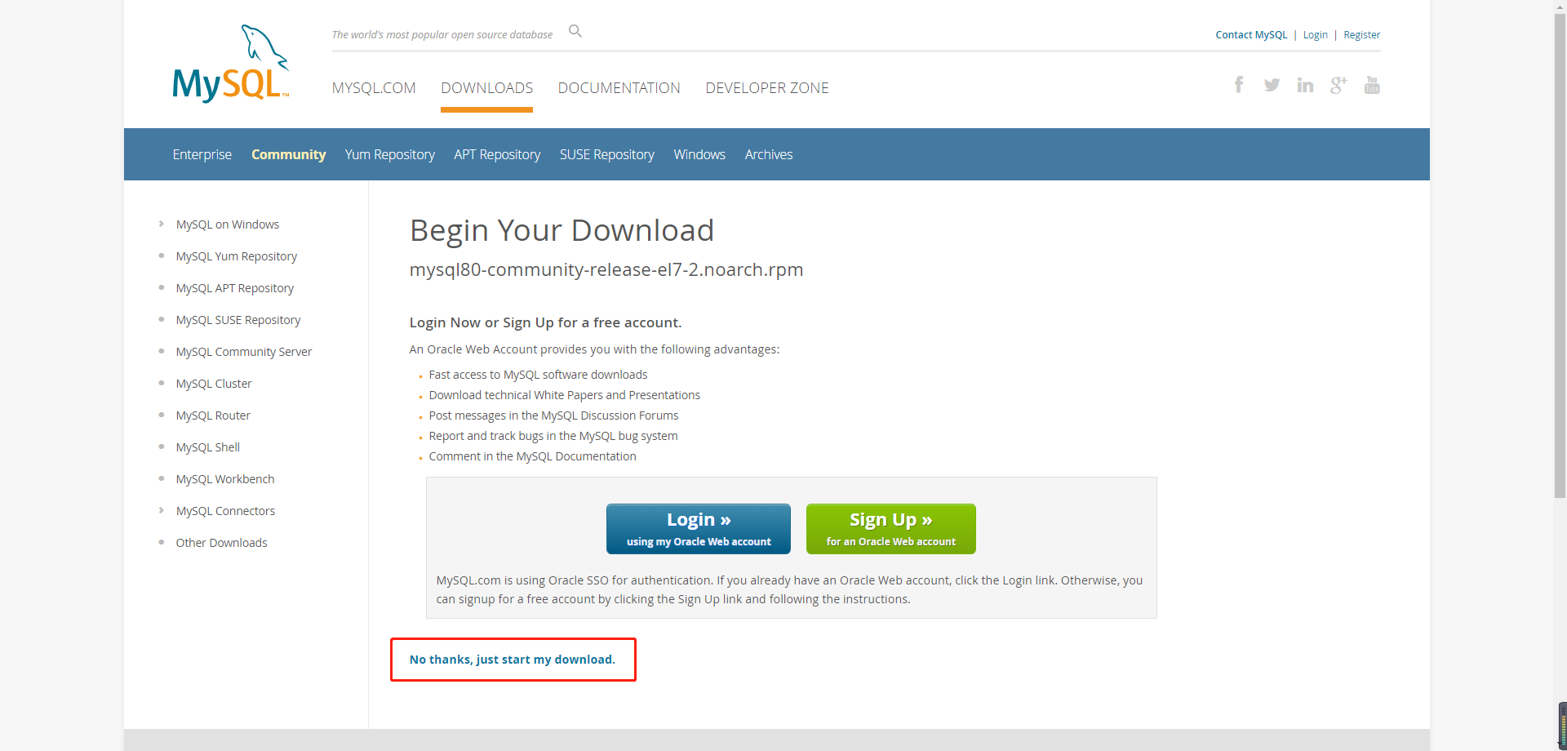

2.将mysql 源文件上传到Linux虚拟机上

3.更新yum资源仓库

命令：rpm -Uvh mysql80-community-release-el7-2.noarch.rpm

4.查看并修改

命令：cd /etc/yum.repos.d

命令：vi mysql-community.repo

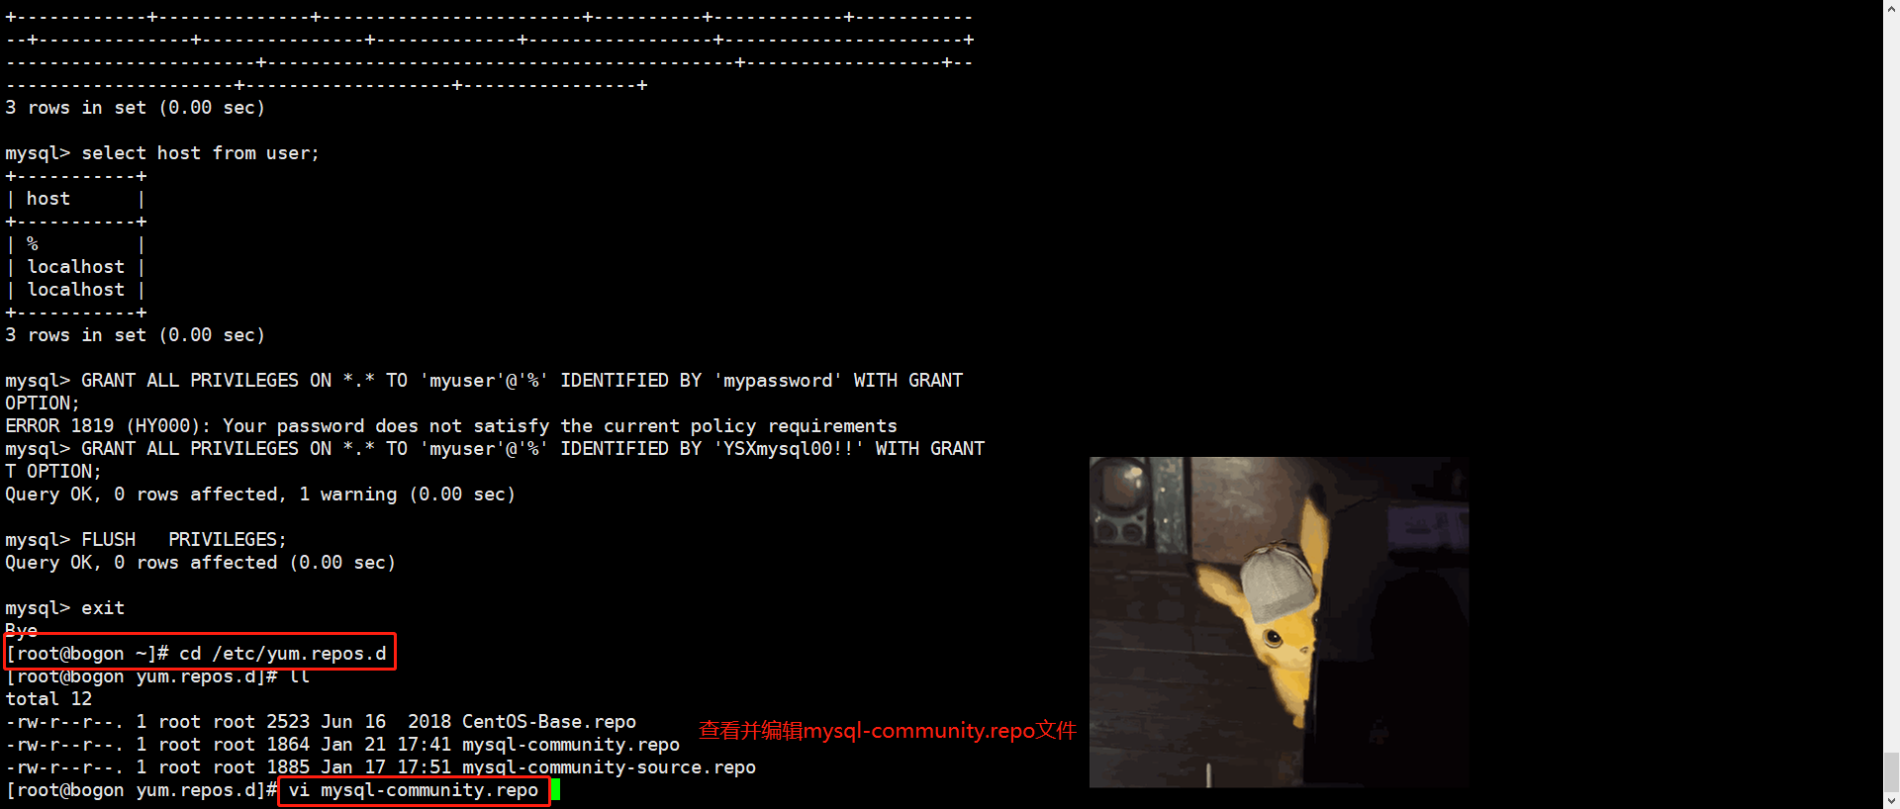

修改5.7版本的enabled为1，8.0版本的enabled为0（默认8.0版本的enabled为1）

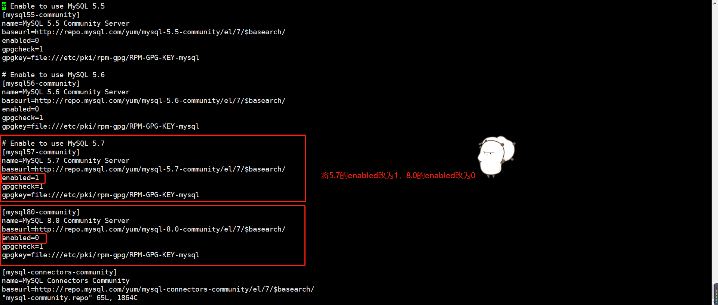

5.查看可用的安装包

命令：yum repolist enabled | grep mysql

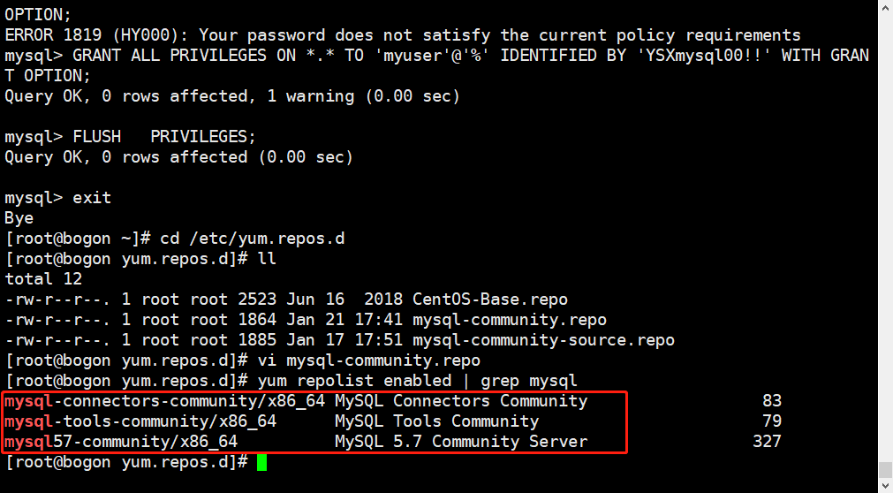

6.安装mysql

命令：yum install mysql-community-server

7.查看mysql状态

命令：systemctl status mysqld.service

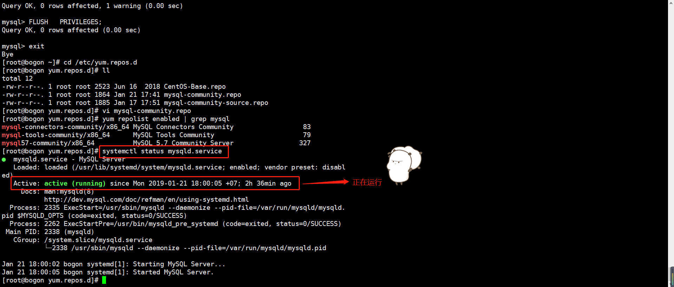

8.停止mysql

命令：systemctl stop mysqld.service

9.启动mysql

命令：systemctl start mysqld.service

10.查看首次登陆的默认密码

命令：grep 'temporary password' /var/log/mysqld.log

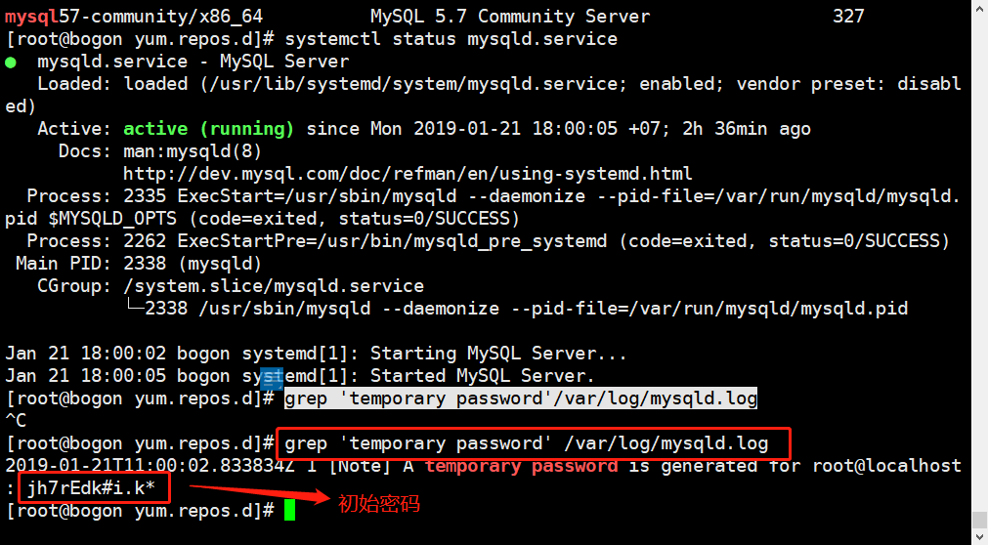

11.登陆mysql

命令：mysql -uroot -p

12.修改密码（3选一，有的可能不好用）

命令：set password for root@localhost = password("YSXmysql00!!")

命令：update user set authentication_string=passworD("YSXmysql00!!") where user='root';

命令：alter user user() identified by "YSXmysql00!!";

13.修改权限

命令：use mysql

命令：update user set host='%' where user='root'

命令：grant all privileges on *.* to root@'%' identified by "YSXmysql00!!";

命令：flush privileges;