User's doc
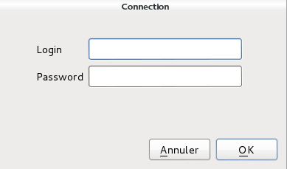
Firstly the user must to connect via window connection
The identifiers are such as the
MySQL connection

Once connected you have the possibility to select database on which you want to effect the queries and also see all the tables,their fields. To use the fields from table it needs just to click on table.

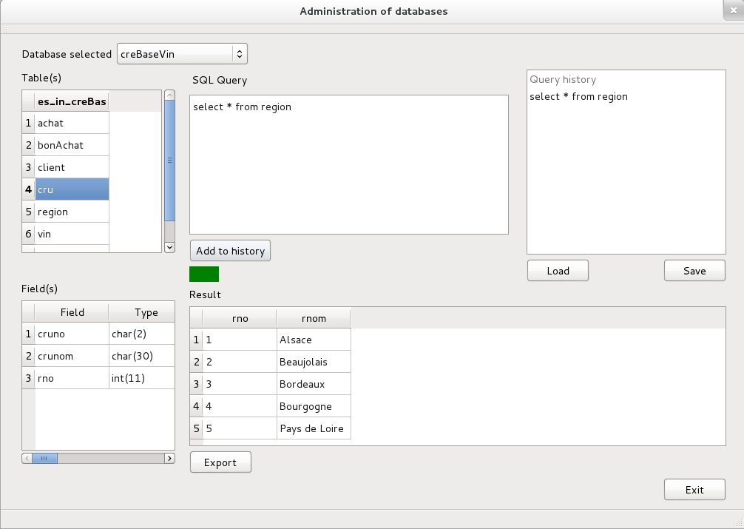

While our query isn't correct the button 'Add to history' is disabled and the label is red
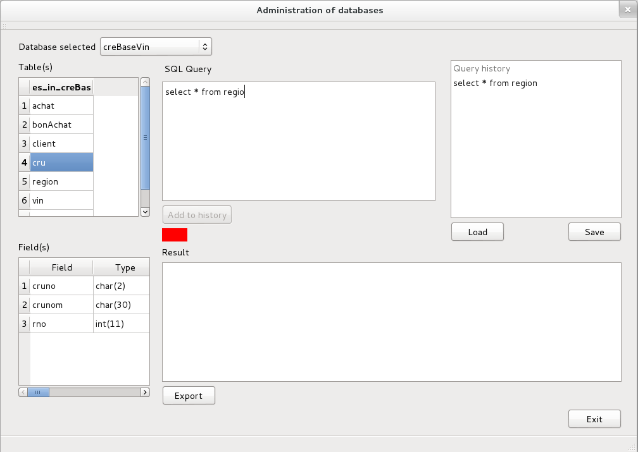

Here we are the correct query, the button is enabled and the label is green and we also can see the results
It's possible also to save the query history
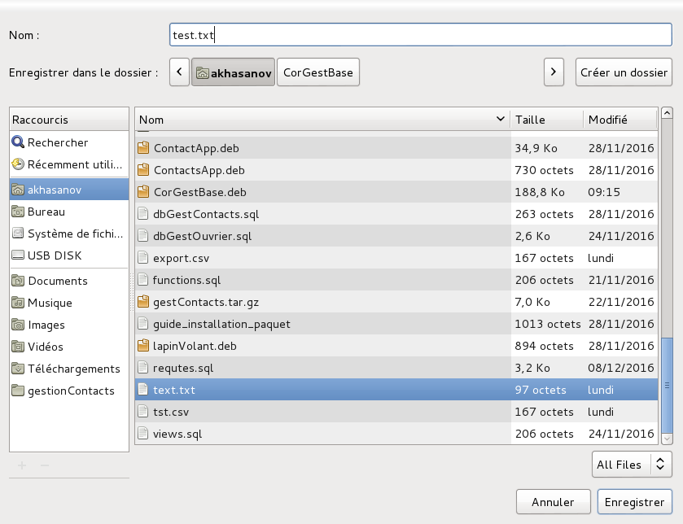
And the results is
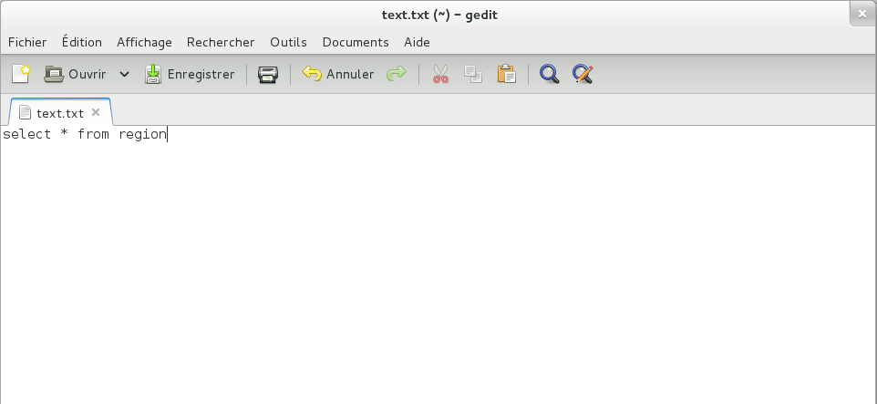

Load the file
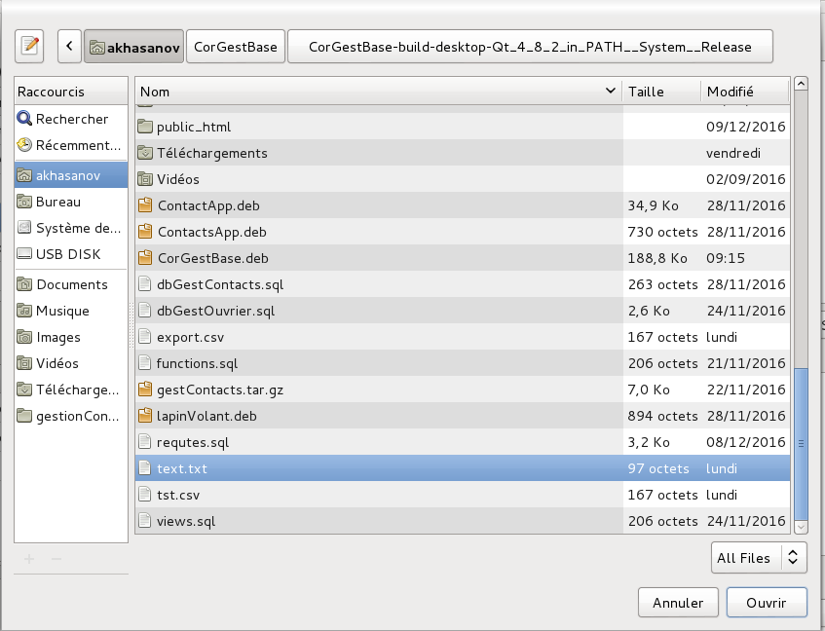

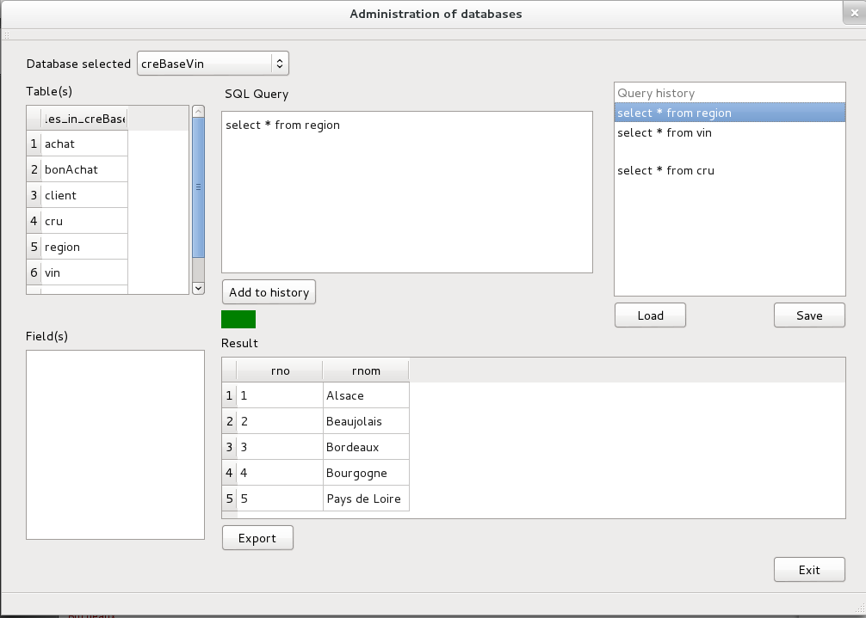

Double click on the query in history will effect the query
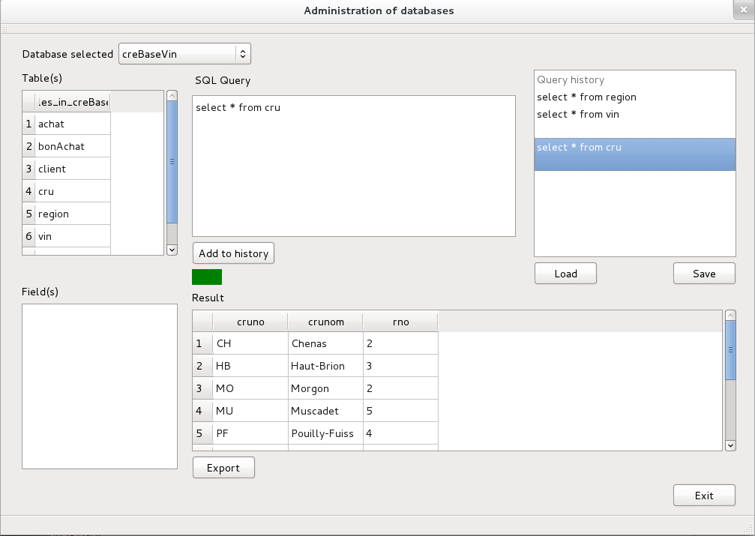

Possibility to export the result in file CSV
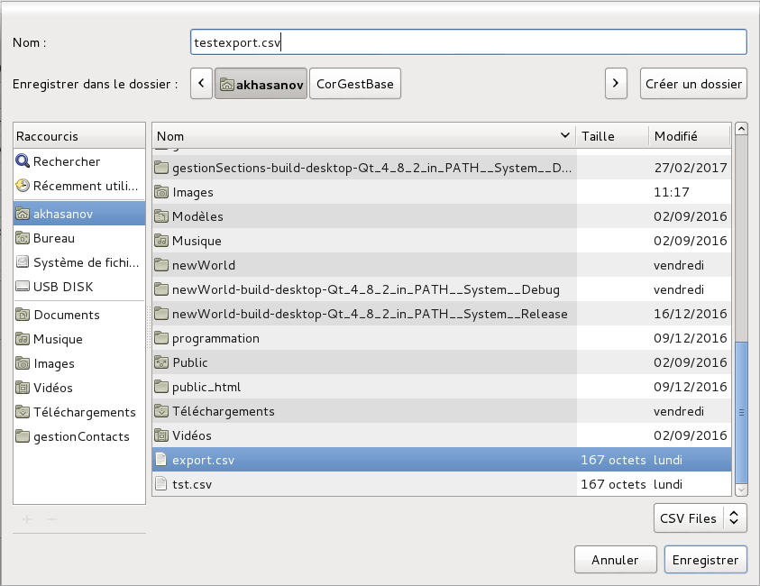
In the file created
