KULLIYYAH OF INFORMATION AND COMMUNICATION TECHNOLOGY

DEPARTMENT OF INFORMATION SYSTEMS
INFO 4335 — Mobile Application Development
Final Group Project Report

TaskFlow: Smart Academic Task and Collaboration Management System

Module: File Metadata and Reminder System

Lecturer: Mohd Khairul Azmi Hassan
Submission Date: 19 June 2026
GitHub Repository: https://github.com/Apalpics/TaskFlow-Mobile-App

1. Group Members and Task Contribution Table
The TaskFlow project was developed collaboratively by a team of five members, each responsible for a specific module:

Name | Matric Number | Assigned Module | Main Contribution
Abdulgafar Abdullahi Ibrahim | 2311279 | Firebase Setup, Authentication, User Profile, Integration | Firebase config, login/register, profile screen, GitHub push
Adil Emadeldin Abdelkarim | 2320799 | Dashboard UI, Theme Design, Navigation | Dashboard screen, app theme, bottom navigation
Newal Yeshak Abduljalil | 2315376 | Assignment Management Module | Add/view/update assignments, Firestore assignments
Marwa Mustafa Ali | 2110126 | Group Project Management Module | Group tasks screen, Firestore groupTasks, report support
Abubakar Abdulsalam | 2328587 | File Metadata and Reminder System | Files screen, reminders screen, report compilation

2. Project Introduction
TaskFlow is a Flutter-based academic productivity mobile application that helps university students manage their academic assignments, deadlines, file information, group project tasks, and progress tracking in one unified platform.

Students today often rely on multiple disconnected tools WhatsApp for communication, phone notes for task lists, and manual calendars for deadlines. This fragmented approach leads to missed deadlines, poor task visibility, and difficulty managing group work responsibilities. TaskFlow addresses this by integrating assignment tracking, deadline reminders, progress overview, group task management, and file metadata records into a single Flutter/Firebase application.

3. Objectives
The Task Flow application aims to achieve the following objectives:
• To provide a mobile app for managing academic assignments with deadlines and status tracking.
• To support group project task division and accountability tracking among team members.
• To provide a progress overview showing completed, pending, and overdue task statistics.
• To allow students to store and organise file metadata related to their academic work.
• To integrate Firebase Authentication and Cloud Fire store for secure user data storage.
• To deliver a clean, Shariah-compliant, and user-friendly interface for university students.

4. Target Users
Primary Users:
• University students manage multiple course assignments and deadlines.
Secondary Users:
• Academic group project teams needing shared task tracking.
• Students manage files, notes, and submission evidence across multiple courses.

5. System Features and Functionalities
Task Flow includes the following core modules:

Module | Description
Authentication | Firebase email/password login and registration. User profile stored in Firestore users collection.
Dashboard | Summary cards showing total, pending, completed, overdue assignments and upcoming deadlines.
Assignment Management | Add, view, and update academic assignments with title, course, description, deadline, priority, and status.
Progress Tracking | Visual progress overview based on assignment status counts.
Group Project Management | Track group tasks with project name, assigned person, deadline, and status.
File Metadata | Store file records (name, type, assignment, note) without real file upload due to Firebase Storage billing limitation.
Reminders | Deadline categorisation: Overdue, Due Today, Due Tomorrow, and Upcoming.
Profile | View and edit username, email display, and logout functionality.

6. UI Screenshots — My Module (File Metadata & Reminder System)
The following screenshots show the screens developed for my assigned module:

6.1 Screenshot 1: Register Screen
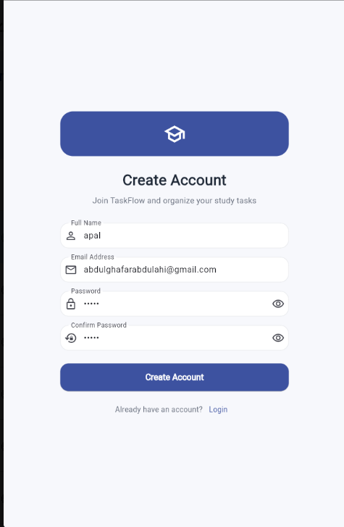

6.2 Screenshot 2: Login Screen
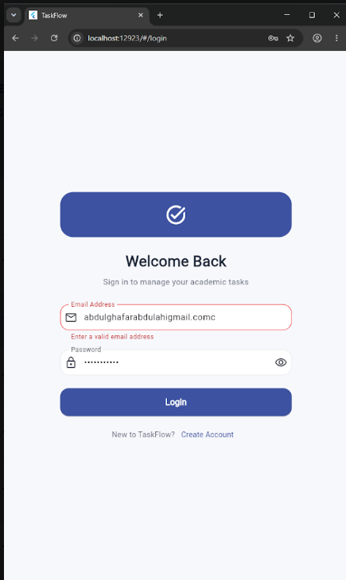

6.3 Screenshot 3:Dashboard
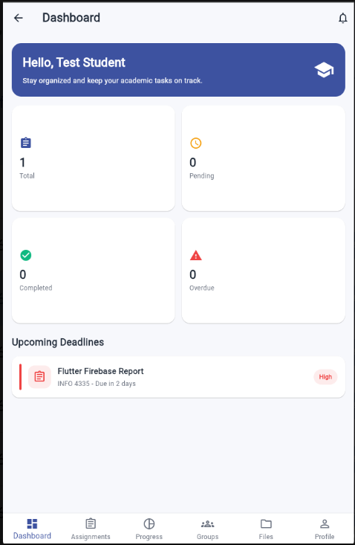

6.4 Screenshot 4: Reminders
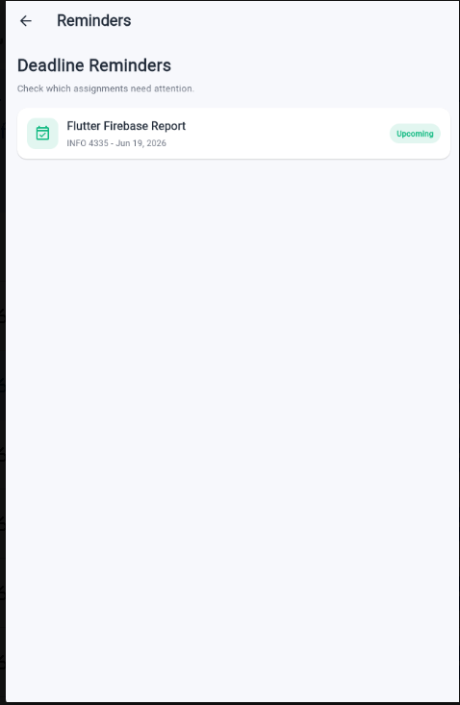

6.5 Screenshot 5: Assignments
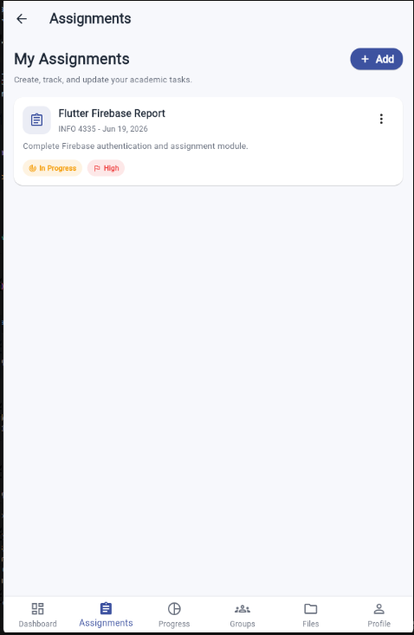

6.6 Screenshot 6: Add Assignments
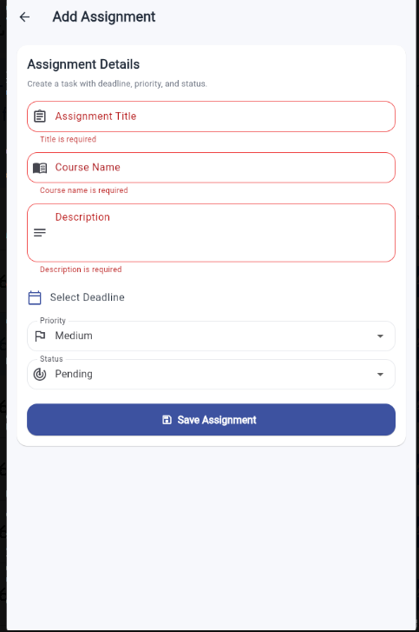

6.7 Screenshot 7: Progress Screen
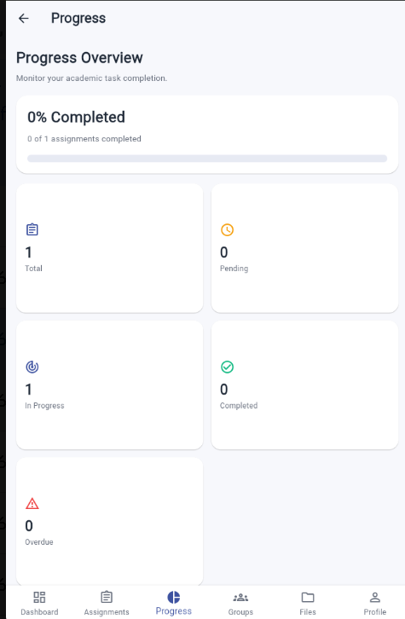

6.8 Screenshot 8: Groups Screen
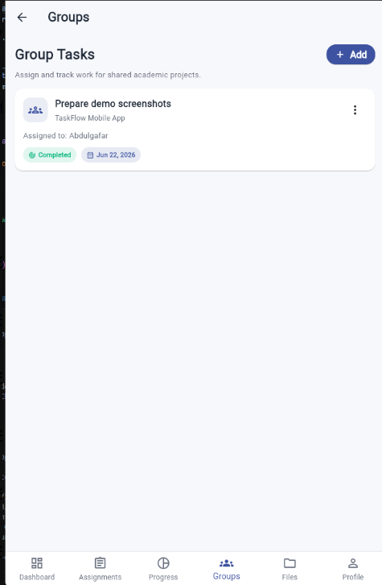

6.8 Screenshot 8 : Add Group Task Screen
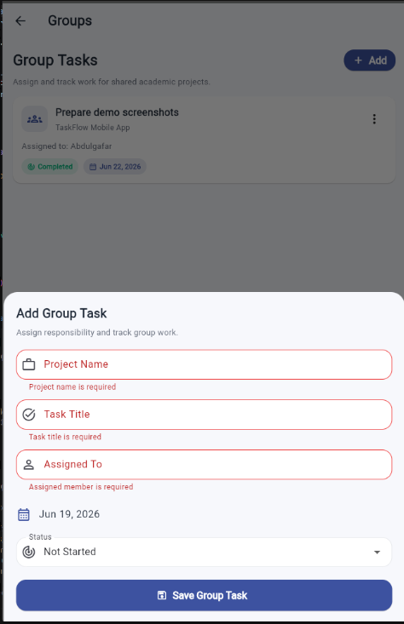

6.9 Screenshot 9 : Add File Screen
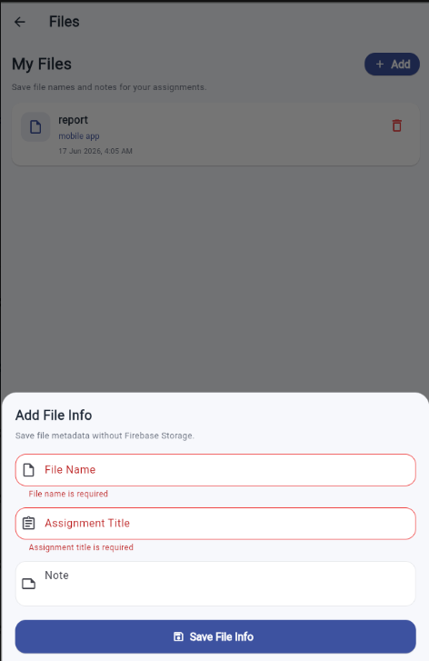

7.0 Screenshot 10: My Files Screen

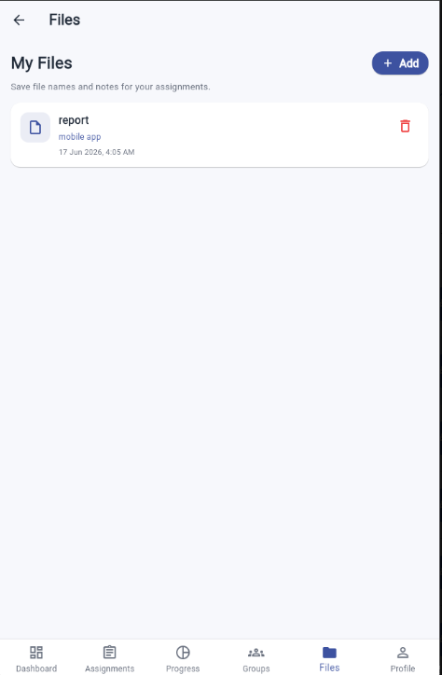

7.1 Screenshot 11: Edit profile Screen
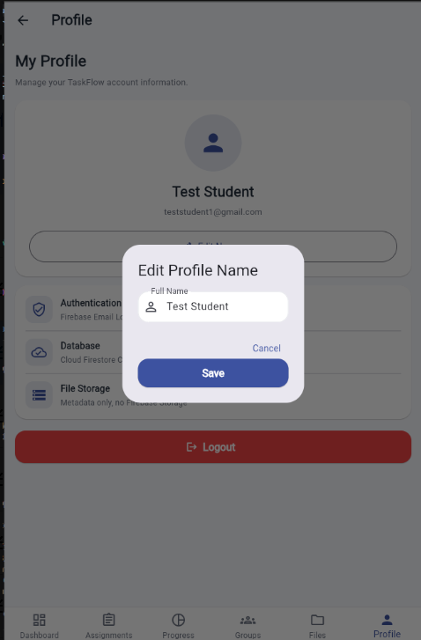

7.2 Screenshot 12:My Profile Screen
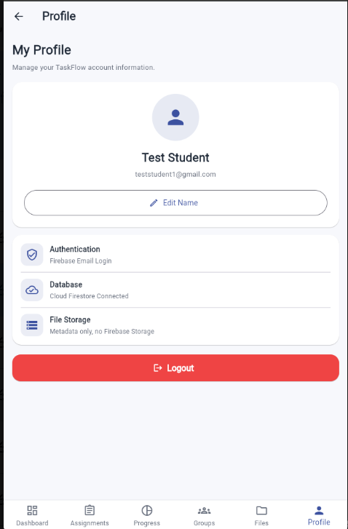

7.3 Screenshot 13: FIre base Authentication Screen
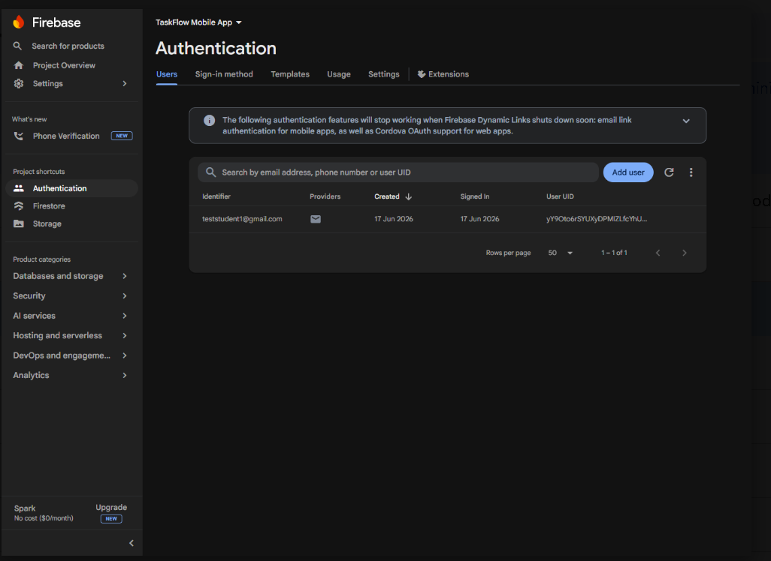

7.4 Screenshot 14: Database Screen

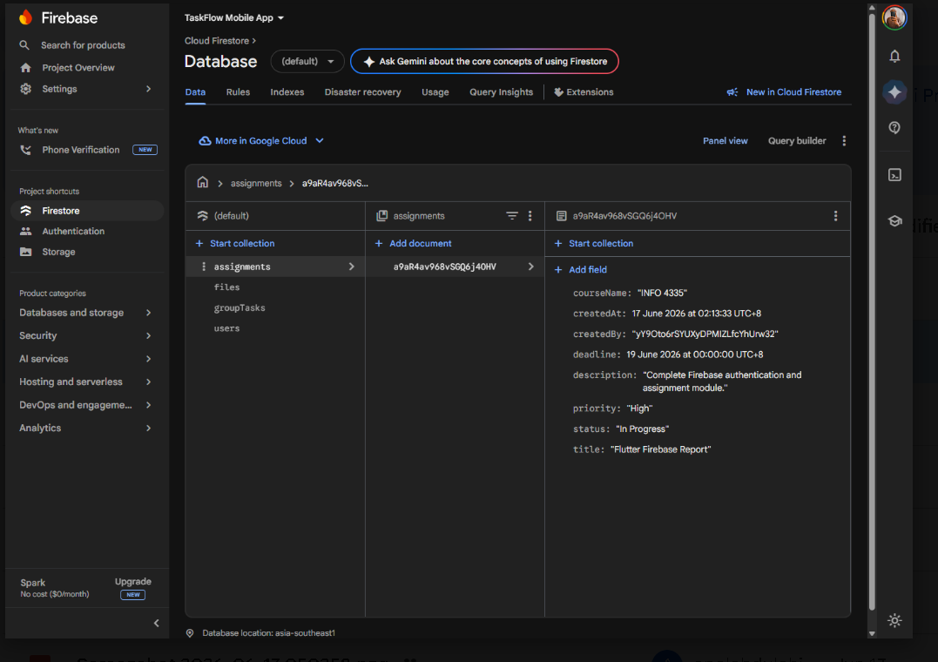

7.5 Screenshot 15 :Firebase Storage Limitation Screen
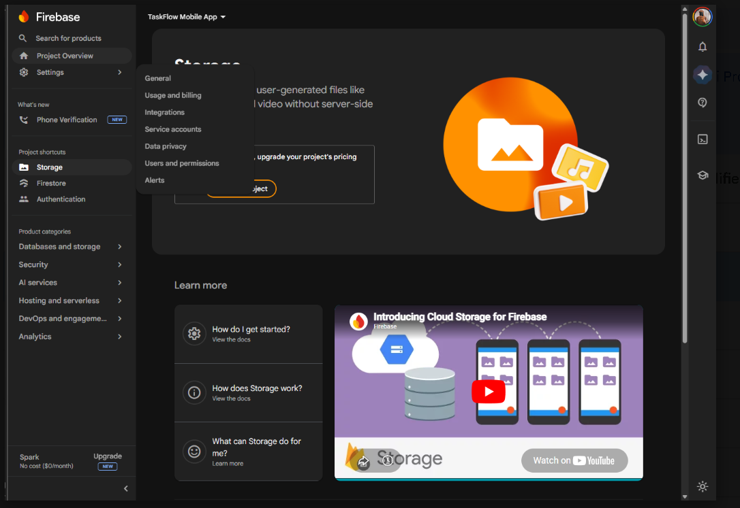

8. Architecture and Technical Design
The TaskFlow application uses a feature-based folder architecture. Each module is isolated in its own folder under lib/features/, which improves code readability, maintainability, and modularity.

8.1 Project Folder Structure
lib/ main.dart firebase_options.dart core/ routes/app_routes.dart theme/app_theme.dart features/ auth/ (login, register) dashboard/ (dashboard, navigation) assignments/ (list, add, card) progress/ groups/ files/ ← My Module screens/files_screen.dart screens/reminders_screen.dart profile/

8.2 State Management
The app uses setState for local UI state within each screen. Firebase StreamBuilder widgets are used in some screens to reactively listen to Firestore collection changes. This approach is straightforward and appropriate for the scope of this application.

8.3 My Module: Files and Reminders
files_screen.dart : This screen displays the Files page and contains the Add File Info form. It reads from and writes to the Firestore files collection. The form collects fileName, fileType, assignmentTitle, note, uploadedBy, and uploadedAt.

reminders_screen.dart : This screen reads all assignments from the Firestore assignments collection, compares each deadline with today's date, and categorises them into: Overdue, Due Today, Due Tomorrow, and Upcoming. This gives students a clear priority view of their pending work.

Firebase Storage Limitation : Real file uploads were not implemented because Firebase Storage required upgrading the project billing plan. Screenshot evidence of this limitation is included. The module uses metadata-only records as an acceptable workaround, which can be upgraded in future.

9. Data Model - Firestore Collections
The application uses Cloud Firestore as its database. The relevant collections for my module are:

9.1 files Collection
Field | Type | Description
fileName | String | Name of the file (e.g., taskflow_report.pdf)
fileType | String | Type of file (PDF, DOCX, ZIP, PNG, etc.)
assignmentTitle | String | The assignment this file belongs to
note | String | Optional note or description about the file
uploadedBy | String | UID of the user who added this file record
uploadedAt | Timestamp | Date and time the record was created

9.2 assignments Collection (used by Reminders)
Field | Type | Description
title | String | Assignment title
courseName | String | Course the assignment belongs to
deadline | Timestamp | Deadline date used for reminder categorisation
status | String | Pending / In Progress / Completed
createdBy | String | UID of the user

9.3 Firestore Data Model Diagram
The Firestore Data Model Diagram illustrates how data is organized and related within the TaskFlow application. The database consists of four main collections: users, assignments, groupTasks, and files.
The users collection stores information about registered users, including their unique user ID (uid), name, email address, and account creation date. This collection serves as the central reference for user-related activities throughout the application.
The assignments collection stores academic assignment information created by users. Each assignment contains details such as the assignment title, course name, description, deadline, priority level, status, creator information, and creation date. A single user can create multiple assignments, establishing a one-to-many relationship between the users and assignments collections.
The groupTasks collection stores tasks related to group projects. Each record contains the project name, task title, assigned team member, deadline, task status, creator information, and creation date. Similar to assignments, one user can manage multiple group tasks.
The files collection represents the File Metadata module, which was my assigned contribution to the project. This collection stores metadata about academic files, including the file name, file type, assignment title, notes, uploader information, and upload date. Since Firebase Storage was not implemented due to pricing limitations, only file metadata is stored in Cloud Firestore.
The relationships shown in the diagram indicate that a single user can create multiple assignments, manage multiple group tasks, and upload multiple file records. Additionally, assignments can be associated with multiple files because students may have several documents, reports, screenshots, or supporting materials related to a single assignment.
This Firestore structure provides an organized and scalable database design that supports authentication, assignment management, group collaboration, file organization, and reminder functionality within the TaskFlow application.

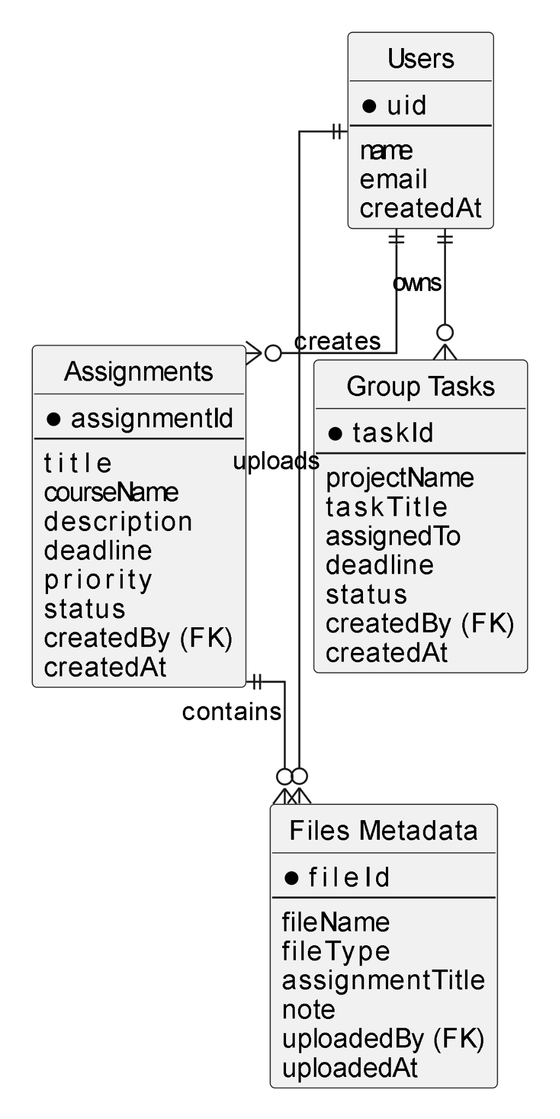

10. Flowchart / User Interaction Flow

10. Flowchart / User Interaction Flow
The following describes the user navigation flow for the File Metadata and Reminder System module:
- The user opens the TaskFlow application and navigates to the Files Module.
- The system displays the Files screen, which contains existing file metadata records stored in the Firestore files collection.
- The user chooses whether to add a new file record or view existing files.
- If the user selects Add File Info, a form appears requesting File Name, File Type, Assignment Title, and Notes.
- The user enters the required information and taps the Save button.
- The system validates the input and stores the file metadata in the Firestore files collection.
- After the data is saved successfully, the system displays a confirmation message and updates the Files screen.
- The user may view the saved file metadata cards, which display information about academic files related to assignments and projects.
- The user then opens the Reminder Module from the application.
- The Reminder Module retrieves assignment deadline information from the Firestore assignments collection.
- The system compares each assignment deadline with the current date.
- Assignments with deadlines that have passed are categorized as Overdue.
- Assignments due on the current date are categorized as Due Today.
- Assignments due on the following day are categorized as Due Tomorrow.
- Assignments with later deadlines are categorized as Upcoming.
- The categorized reminder list is displayed to the user, helping them prioritize tasks and manage deadlines more effectively.
- The process ends after the reminders have been displayed successfully.

10.1 FlowChart Diagram

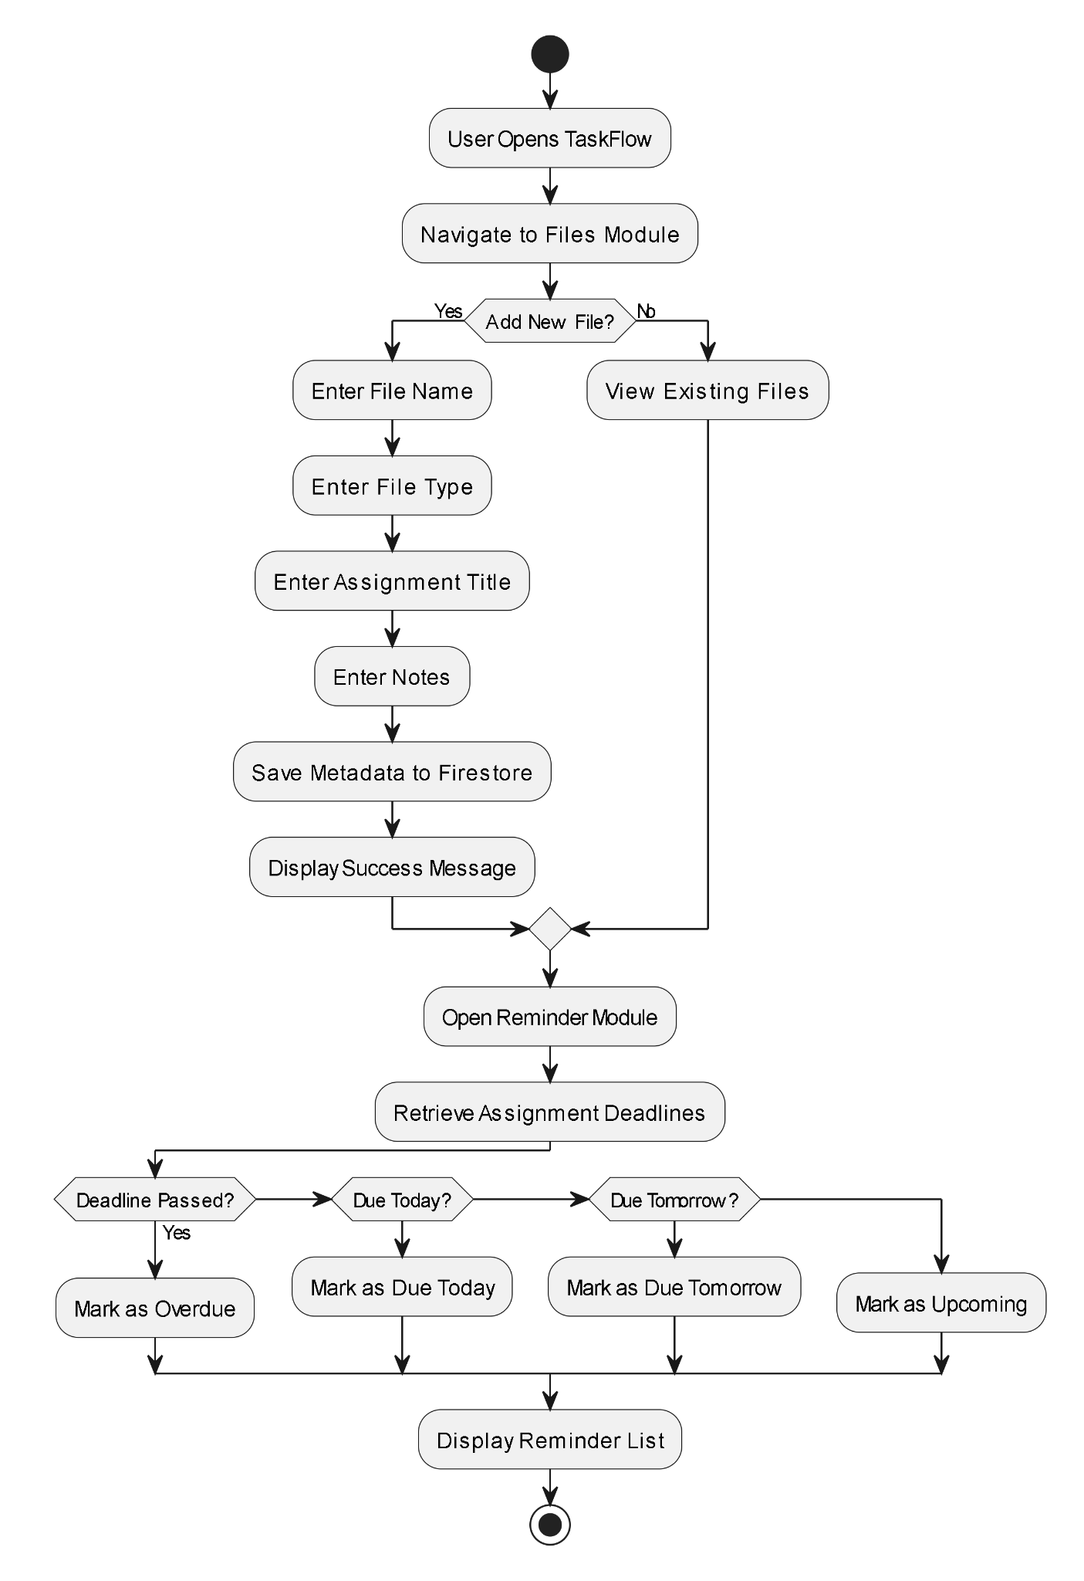

11. Technical Explanation of My Contribution

11.1 files_screen.dart
This file is the core of my module. It contains:
The code above demonstrates the Firestore integration used to store assignment information in the assignments collection. When a user creates a new assignment, details such as title, course name, description, deadline, priority, status, creator ID, and creation timestamp are saved to Cloud Firestore using the add() method.

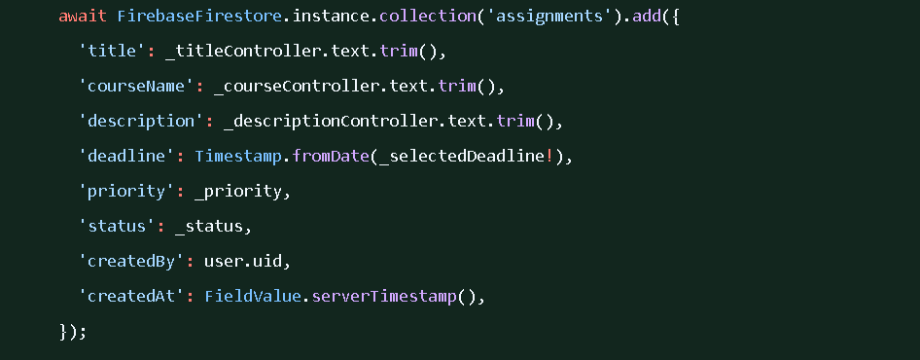

11.2 reminders_screen.dart
This file contains the Reminders screen logic:
• Reads all assignments from Firestore assignments collection using a StreamBuilder.
• Compares each assignment's deadline field with DateTime.now() to classify it.
• Displays four sections: Overdue (red), Due Today (orange), Due Tomorrow (yellow), Upcoming (green).

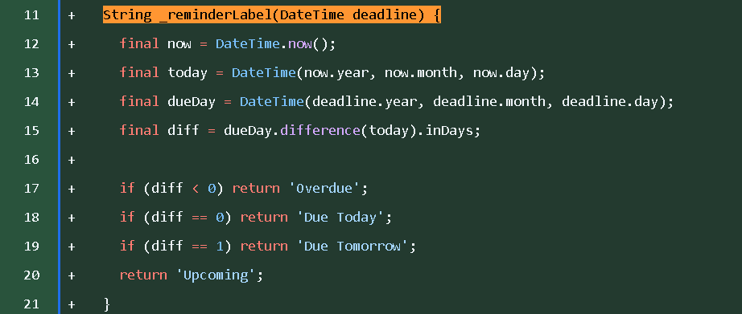

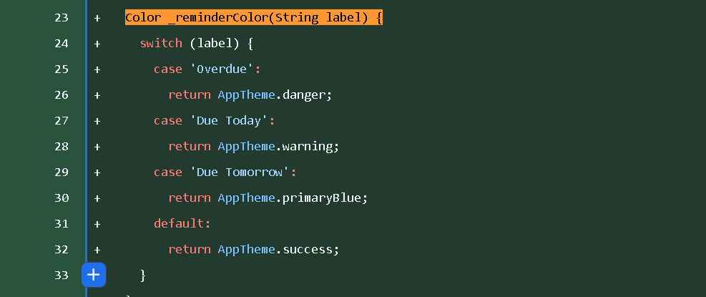

12. Testing Evidence
The following tests were performed for my module:

Test Action | Expected Result | Status | Evidence
Add file metadata using Add File Info form | File record appears in Files screen and Firestore files collection | Pass | Files screen screenshot + Firestore screenshot
View Files screen after adding records | File cards display correctly with correct metadata | Pass | Files screen screenshot
Open Reminders from Dashboard bell icon | Reminders page opens and shows categorised deadlines | Pass | Reminders screenshot
Check Overdue category with past deadline assignment | Assignment correctly appears under Overdue section | Pass | Reminders screenshot
Attempt to use Firebase Storage upload | Firebase requires pricing plan upgrade | Limitation | Firebase Storage screenshot proof
Run flutter analyze | No issues found | Pass | Terminal screenshot
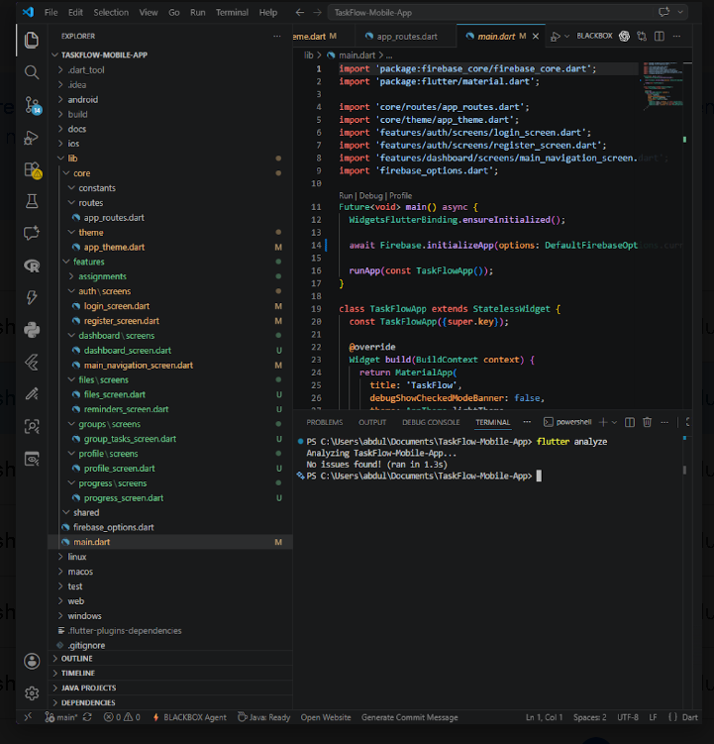

13.1 Task Division

13. Teamwork Reflection and Task Division
The TaskFlow project was completed through teamwork and cooperation among all group members. Each member was assigned a specific module and was responsible for developing, testing, and explaining their own contribution.
Abdulgafar Abdullahi Ibrahim was responsible for Firebase Setup, Authentication, User Profile, and Final Integration. He configured Firebase services, implemented user login and registration, managed user profile functionality, integrated all modules into one application, and performed the final GitHub push.
Adil Emadeldin Abdelkarim was responsible for the Dashboard UI, Theme Design, and Navigation. He designed the dashboard interface, application theme, bottom navigation system, and ensured users could move smoothly between different screens.
Newal Yeshak Abduljalil was responsible for the Assignment Management module. She developed the assignment creation form, assignment cards, status tracking, priority management features, and Firestore integration for assignment data.
Marwa Mustafa Ali was responsible for the Group Project Management module. She developed group task creation, task assignment, deadline management, status updates, and Firestore storage for group project activities.
Abdulsalam was the File Metadata and Reminder System module. I developed the Files page, file metadata storage, reminder categorization features, and Firestore integration for file information. In addition, I managed the final report compilation by organizing screenshots, testing evidence, module descriptions, and supporting documentation.
The team communicated regularly through our WhatsApp group to discuss progress, solve technical issues, share screenshots, and coordinate project activities. Whenever a member faced a challenge, other members provided assistance and feedback to ensure the project continued smoothly.
Together, the team successfully implemented the required Flutter development components, including responsive user interfaces using Flutter widgets, forms and user input validation, navigation between screens, Firebase Authentication and Cloud Firestore integration, state management using Flutter's setState() approach, and external packages from pub.dev. Through effective communication and clear task division, all modules were completed and integrated into a fully functional TaskFlow mobile application.

13.2 Collaboration Process

13.2 Collaboration Process
The team , We primarily communicated through a WhatsApp group where project updates, discussions, screenshots, GitHub links, and reminders were shared. Each member was assigned a specific module based on the agreed task division. This approach allowed members to focus on their own responsibilities while contributing to the overall project.
As the report manager, I coordinated with Marwa,Abdul and Adil to compile and organize the final report. Marwa assisted with reviewing the Group Project Management section and checking report clarity, while Adil contributed to the Dashboard UI, Theme Design, and Navigation sections and helped review visual explanations and screenshot placement. Team members shared their module explanations, testing evidence, screenshots, and video preparation materials through the group.
Regular communication and cooperation ensured that all modules were integrated successfully and that every member had access to the resources needed to complete their assigned tasks. This collaborative approach helped the team meet the project requirements and submission deadline effectively.

13.3 Challenges Faced and How They Were Resolved
Challenge 1 - Firebase Storage billing requirement:
Firebase Storage required upgrading to a paid pricing plan which was not feasible for a student project. This was resolved by implementing the Files module as a metadata-only solution using Cloud Firestore, which still demonstrates file organisation functionality and can be fully upgraded in the future.

Challenge 2 - Module integration:
Integrating all five independently developed modules into one stable application required careful coordination. We managed the final integration and GitHub push. Regular communication through the team group ensured all modules connected correctly through the bottom navigation.

Challenge 3 - Time management and Report Compilation
As we compile the report , one of the challenges we faced was collecting screenshots, module explanations, testing evidence, and report contributions from different team members within the limited project timeline. Since each member was responsible for a different module, delays in receiving information could affect the completion of the final report.

This challenge was resolved through regular communication using our WhatsApp group, where progress updates, reminders, and file-sharing were coordinated. Team members were assigned specific responsibilities, as we worked closely with each other to organize the report structure, verify screenshots, and ensure all contributions were properly documented. Effective teamwork and task division helped us complete the report before the submission deadline.

14. Known Limitations and Future Enhancements

14.1 Known Limitations
• Firebase Storage was not used for real file uploads due to billing plan requirements. The file module uses Firestore metadata only.
• Push notifications via Firebase Cloud Messaging were not implemented in this version.
• Assignment editing feature is not available; users can only add and change status.
• The application was tested primarily via Flutter web (Chrome). Full mobile device testing was limited.

14.2 Future Enhancements
• Enable Firebase Storage for real file upload, download, and preview after upgrading the billing plan.
• Add push notifications using Firebase Cloud Messaging for deadline reminders.
• Add assignment editing functionality.
• Add a calendar view to visualise deadlines across the month.
• Add dark mode support.
• Release as a mobile APK for Android deployment.

15. Conclusion
TaskFlow successfully demonstrates a fully functional Flutter and Firebase academic productivity application. The File Metadata and Reminder System module, which is my assigned contribution, enables students to organise file information linked to their assignments and view deadline-based reminders categorised by urgency.

Although Firebase Storage billing requirements prevented real file uploads, the metadata-only approach still effectively demonstrates file organisation functionality using Firestore. The Reminders feature adds meaningful value by helping students prioritise their workload based on deadline proximity.

This project has strengthened my understanding of Flutter widget composition, Firestore integration, state management using setState and StreamBuilder, and collaborative mobile application development following software engineering best practices.

References
Flutter Documentation. Available at: https://docs.flutter.dev
Firebase Documentation. Available at: https://firebase.google.com/docs
Cloud Firestore Documentation. Available at: https://firebase.google.com/docs/firestore
Firebase Authentication Documentation. Available at: https://firebase.google.com/docs/auth
Pub.dev Flutter Packages Repository. Available at: https://pub.dev
Material Design 3 Guidelines. Available at: https://m3.material.io
GitHub Repository (TaskFlow Project):
https://github.com/Apalpics/TaskFlow-Mobile-App

