Azure Data Storage Services
Azure Data Lake Storage can store large amounts of data in raw format. But this data cannot be directly consumed by AI services.
Azure Data Lake Storage (to store raw data files from multiple sources) -> Azure Data Factory (to extract, clean, copy subset of data to other storage services) -> Azure Blob Storage (to store unstructured data) / Azure SQL Database (to store structured data) / Azure Cosmos DB (NoSQL data or graph data)
Now the AI services can consume the data.

Azure AI Services for Chatbot Development
- Azure Cognitive Services - offers pre-built models and APIs that you can use out-of-the-box for various tasks, such as image recognition, text analysis, and speech processing.
- Azure LUIS - Tool within Azure Cognitive Services for intent detection and NER.
Pipeline –
  - User question (What is the weather in Delhi?) -> Create LUIS bot for intent detection and NER ({intent: weather, entity: Delhi} -> get endpoint for LUIS api -> Create app using Nodejs + Typescript that has pipeline (LUIS api -> weather api) -> Deploy app on Azure Web App (same as AWS ElasticBeanstalk)
  - Create LUIS bot and get endpoint -> Create app using Nodejs + Typescript -> Create Docker image -> Push image to ACR -> Run Container on ACI
- Azure QnA Maker - Tool within Azure Cognitive Services for making QA bot. You can upload QA pairs to Knowledge base and deploy the bot for QA. It will give you an endpoint url for bot which you can integrate with your app.

- Azure Machine Learning – allows developing your own custom models and deploying them.
- Azure Machine Learning Pipelines – Tool within Azure ML to handle end-to-end machine learning workflows, including data preparation, model training, and model deployment without drag-and-drop interface.
- Azure Machine Learning Designer - Tool within Azure ML to handle end-to-end machine learning workflows, including data preparation, model training, and model deployment with a drag-and-drop interface. Suitable for users who prefer a low-code, visual approach to designing machine learning workflows.

- Azure Bot Service – Service to build chatbots. Similar to Amazon Lex or Google Dialogflow. Allows Speech Recognition, intent detection, NER, response generation, and Integration with platforms like Telegram and Slack.

- Azure OpenAI Service – To use foundation (pre-trained) models from OpenAI. Allows fine-tuning them. It will give you an endpoint url for the OpenAI model which you can integrate with your app.

Azure OpenAI Studio

Deploy Pre-trained models for RAG

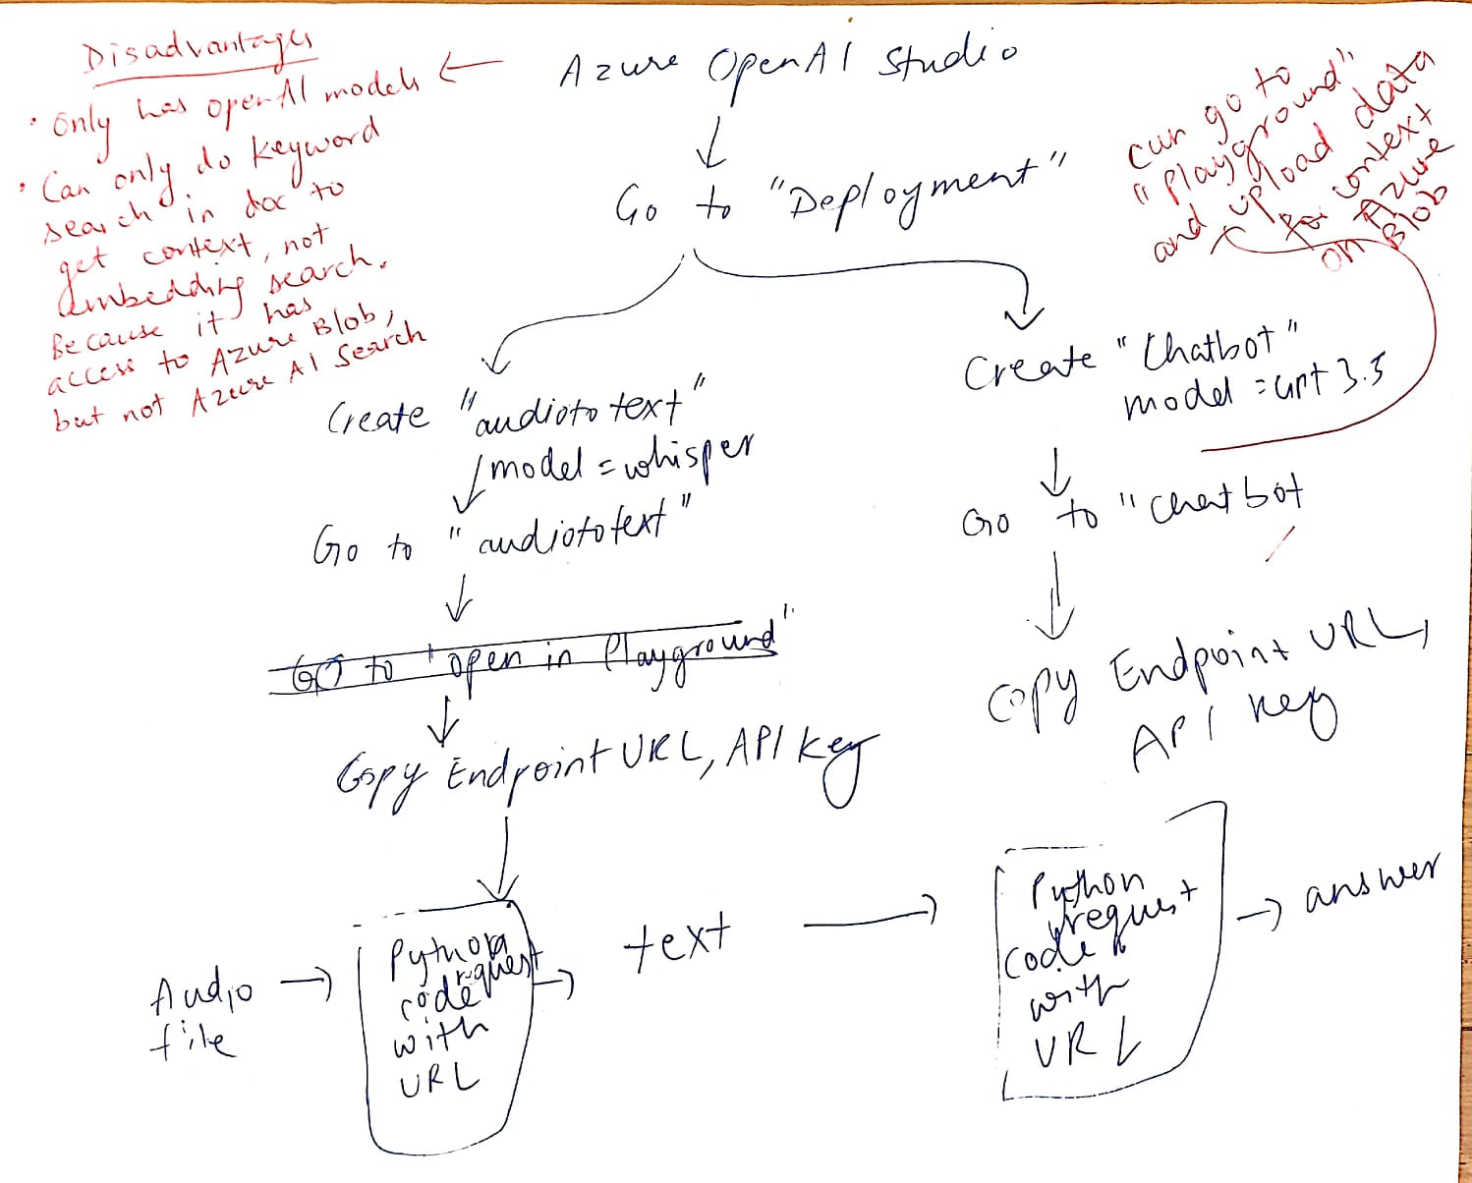

Function calling & Third-party API calling
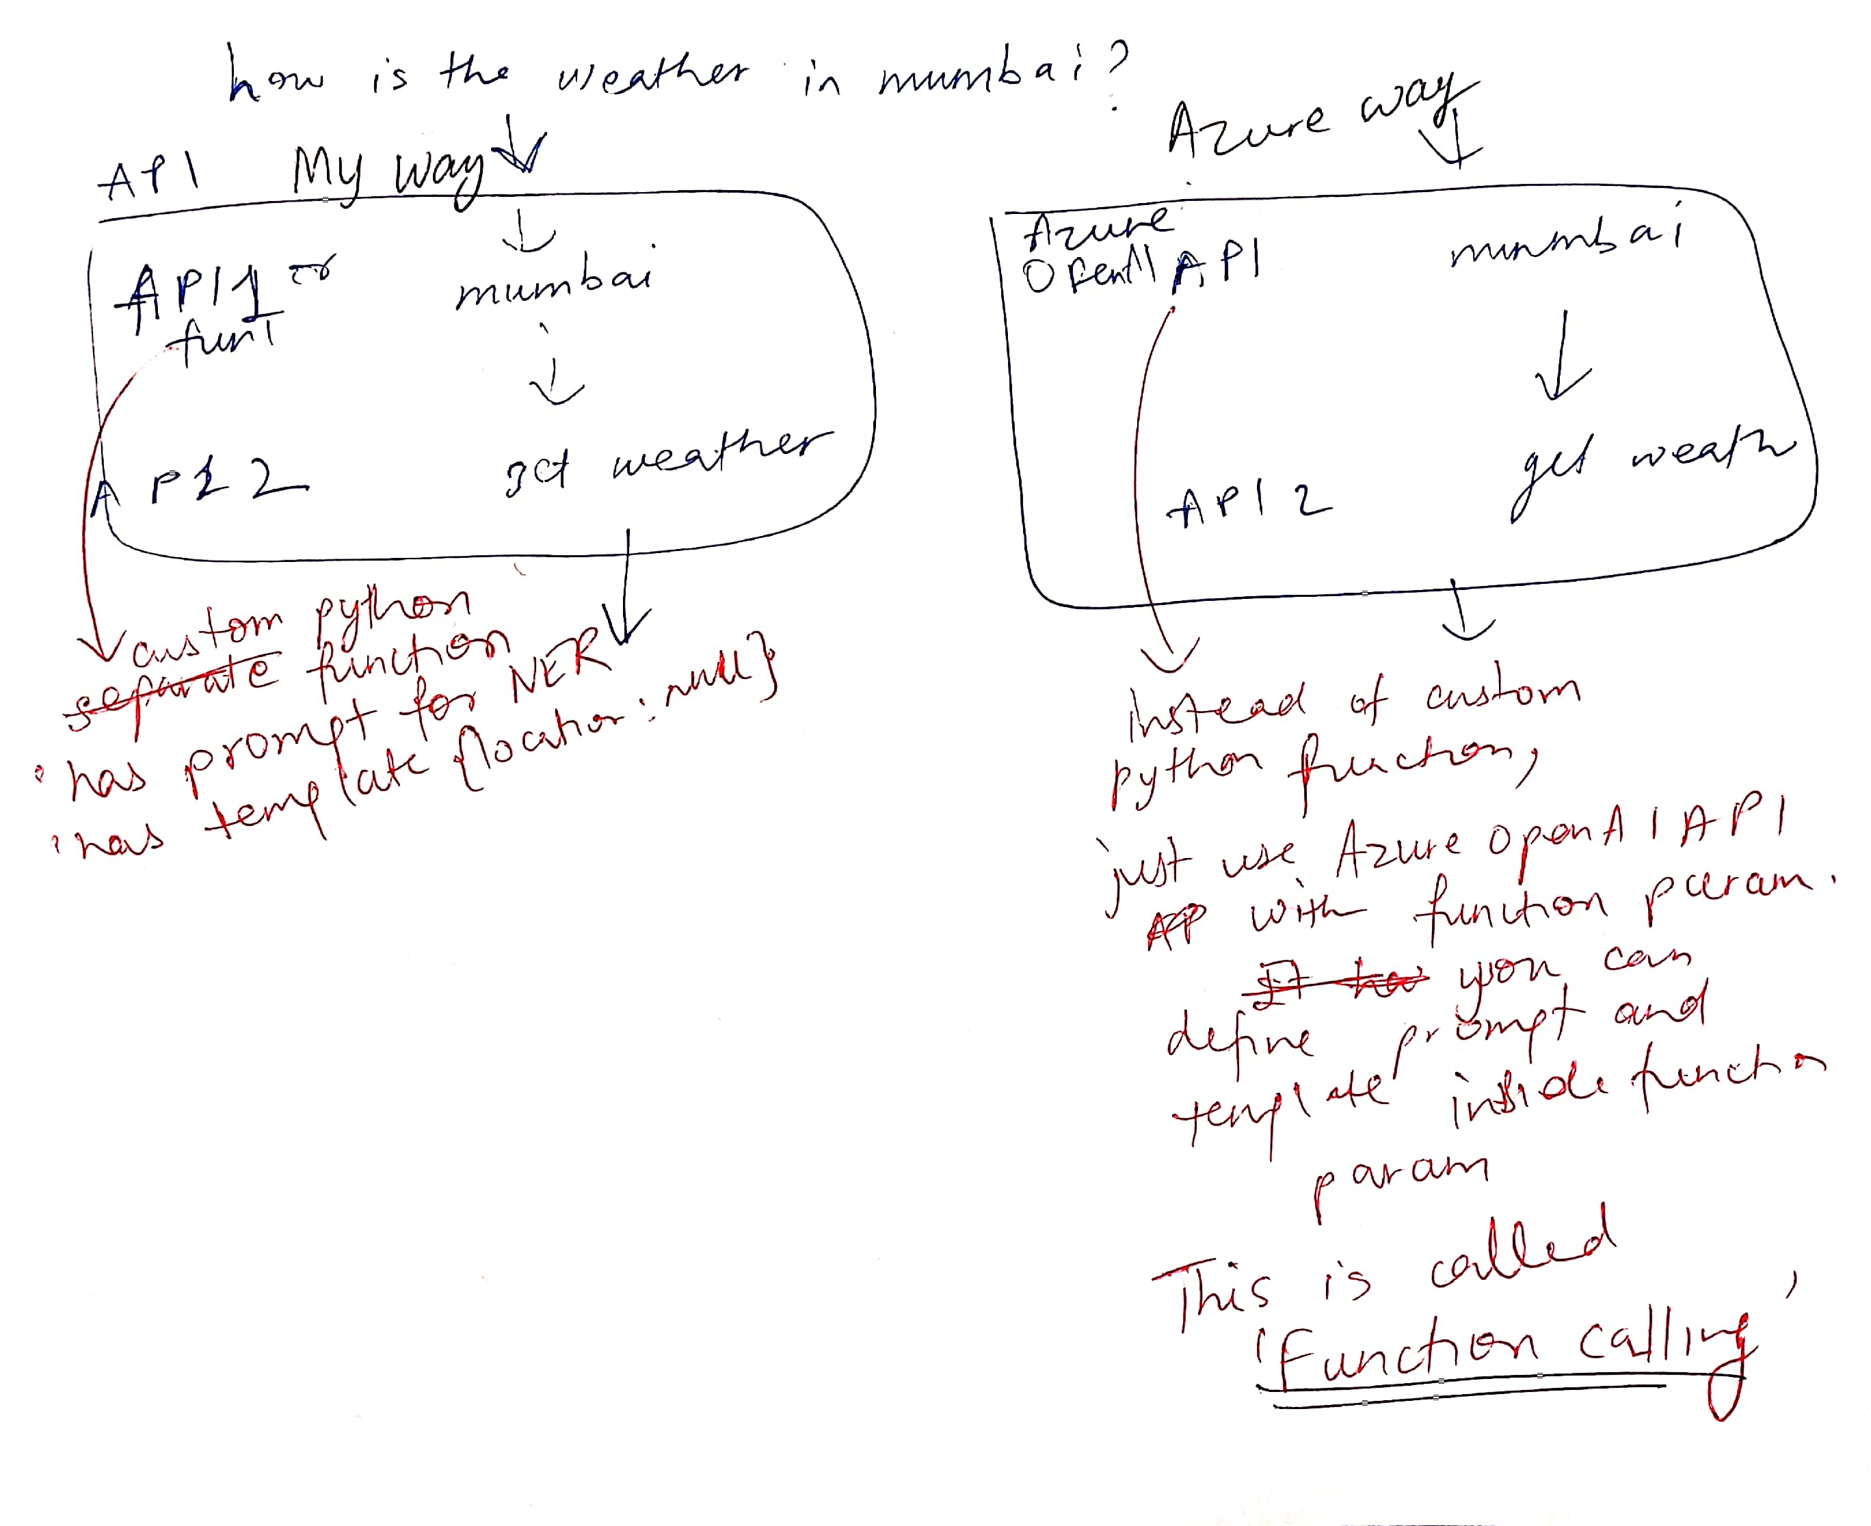

Fine-Tuning a model
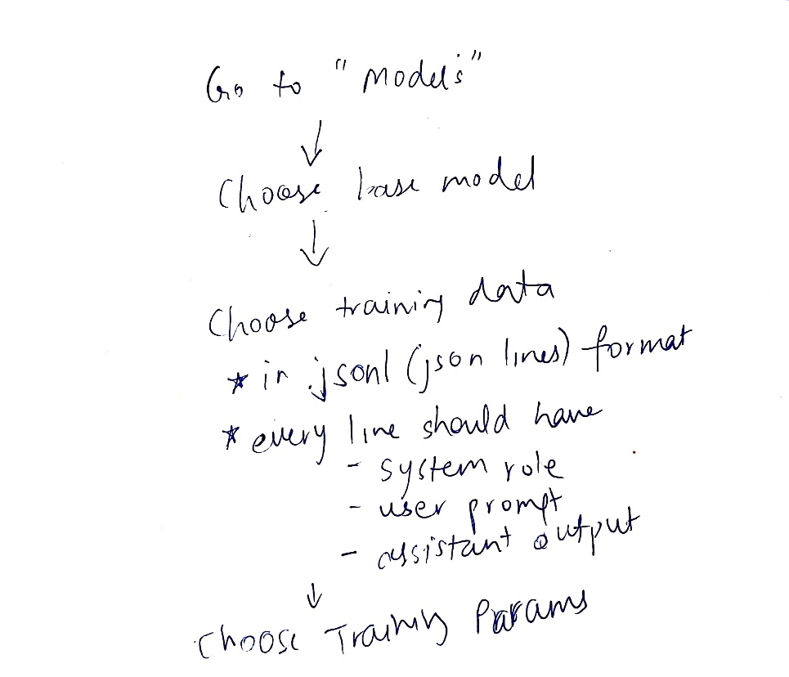

Azure AI Studio

Deploy Pre-trained models for RAG
