**Aparajithan Venkateswaran**

**Recitation 13**

**TA: Yang Li**

**Instructor: Rhonda Hoenigman**

Upon compiling and running for the first time, I encountered a segmentation fault:

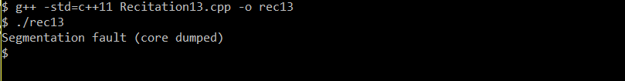

After running gdb, I found where the code broke and set a break point at that line to inspect code closely.

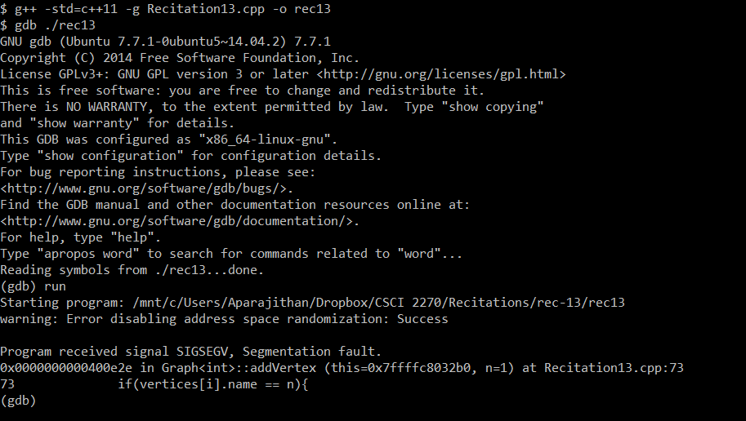

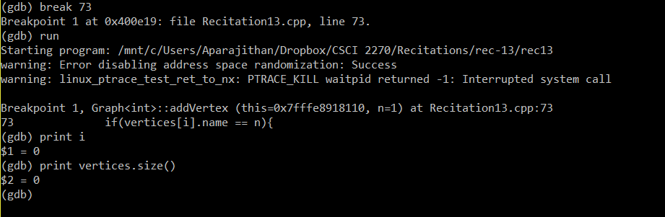

The program was trying the access the first element (index 0) in a vector when the vector had a size of 0. Upon inspecting the code, I found the following mistake in the end condition for the loop and corrected it.

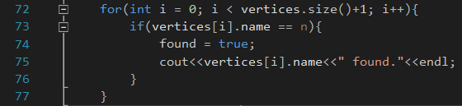

Now, fixing it and running the program resulted in an infinite loop:

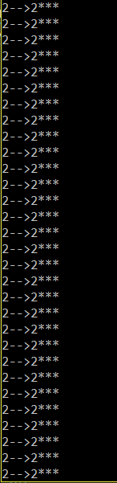

Using gdb, I set a break point to where these print statements are called and inspected the loop variables.

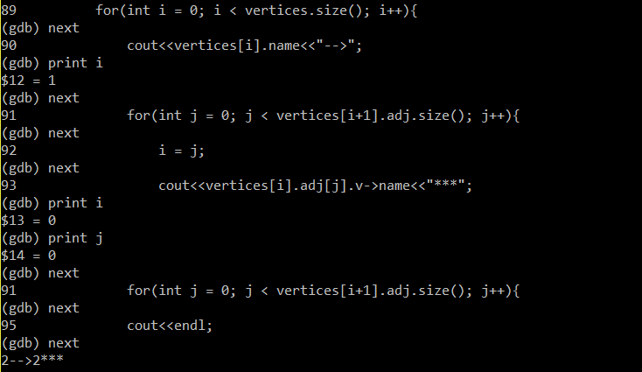

The i = j at line 92 keeps resetting i resulting in an infinite loop. And I removed that line in the code:

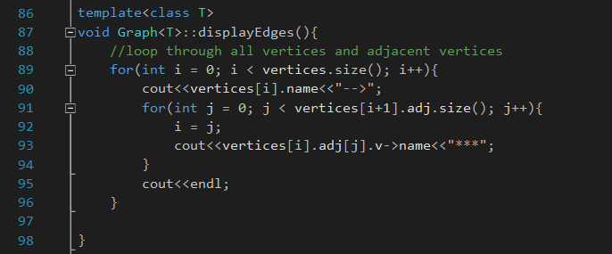

After running the modified program, I ran into another segmentation fault.

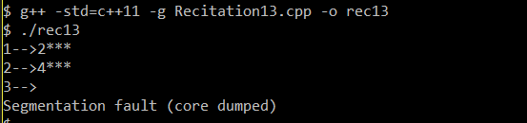

I set a break point and inspected the code in the debugger:

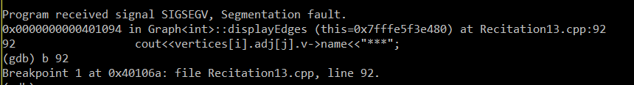

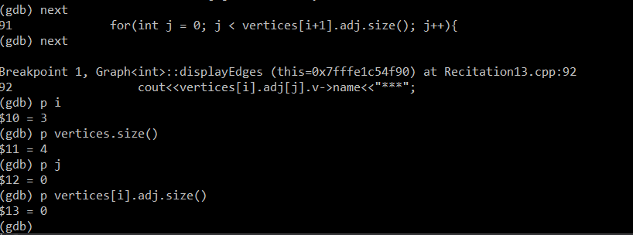

Once again, we are trying to access an element that is outside the size of the array and this caused due to line 91. So after fixing that and running the program, finally the program runs without errors:

