BAMAZON:

This is the mysql homework assignment for the UCF Coding Bootcamp.

In this assignment, we were asked to create a Bamazon app using mysql.

Getting Started

Bamazon

Bamazon is basically a online shopping application. Customers can buy products from the list that is displayed.

Instructions:

This Bamazon app is designed with 3 options as below.

1.Customer

2.Manager

3.Supervisor

When you are a **Customer** you can either purchase a product or quit the application. When you choose to purchase a product you are asked to enter the item id that you want to purchase and the quantity. Upon successful submission the app displays your total amount of purchase and the database is updated successfully.

When you are a **Manager** there 5 options that you can choose from. They are

* View Products for Sale - lists all the products available for sale
* View Low Inventory - lists all the products whose stock quantity is less than 5
* Add to Inventory - You can add stock quantity for any of the item you want
* Add New Product - You can add a new product
* Quit - quit the application

When you are a **Supervisor** there 3 options that you can choose from. They are

* View Products Sales by Department - lists sales of all products by department
* Create New department - allows you to create a new department
* Quit - quit the application

Go ahead! Click on the following link to preview the completed assignment.

You can also refer the screenshots to know what the application looks like and how it works.

Products table:

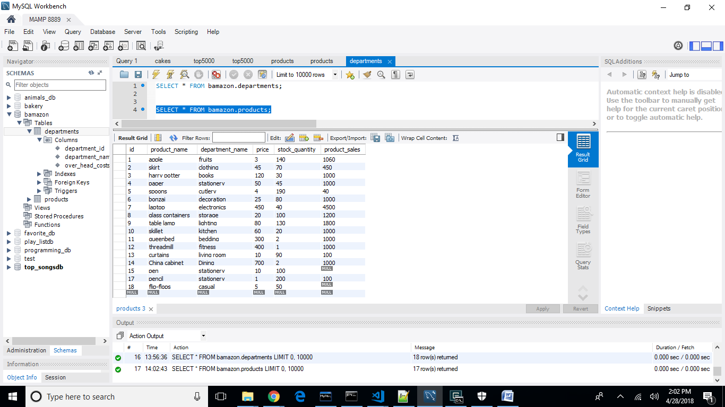

Departments table:

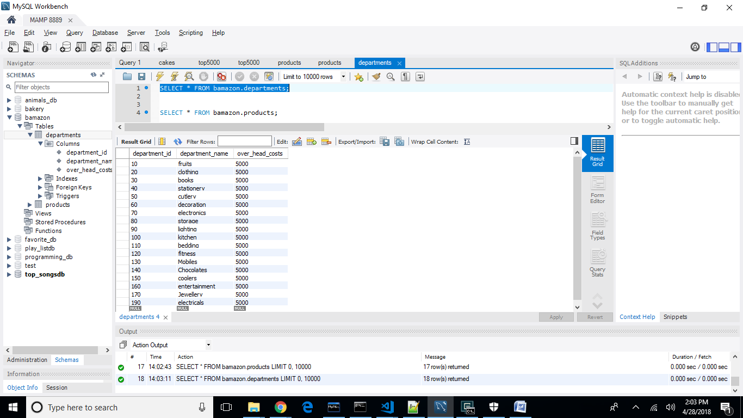

Bamazon Customer:

GIF : <https://thumbs.gfycat.com/DismalInferiorHousefly-size_restricted.gif>

Ordering a product:

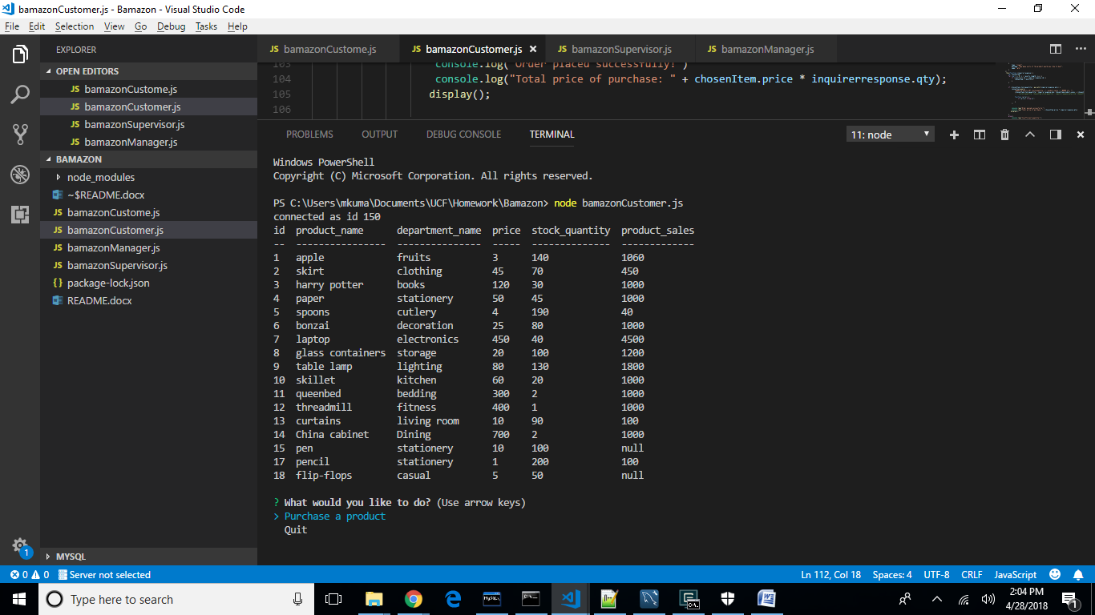

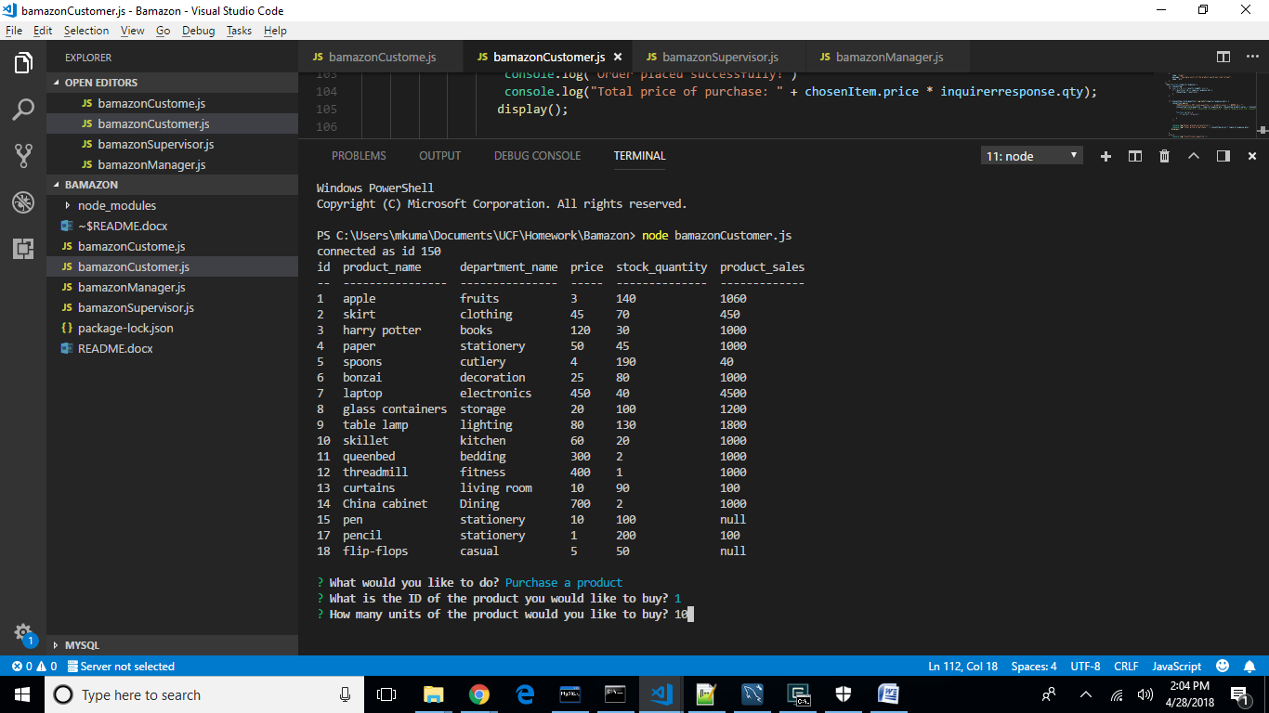

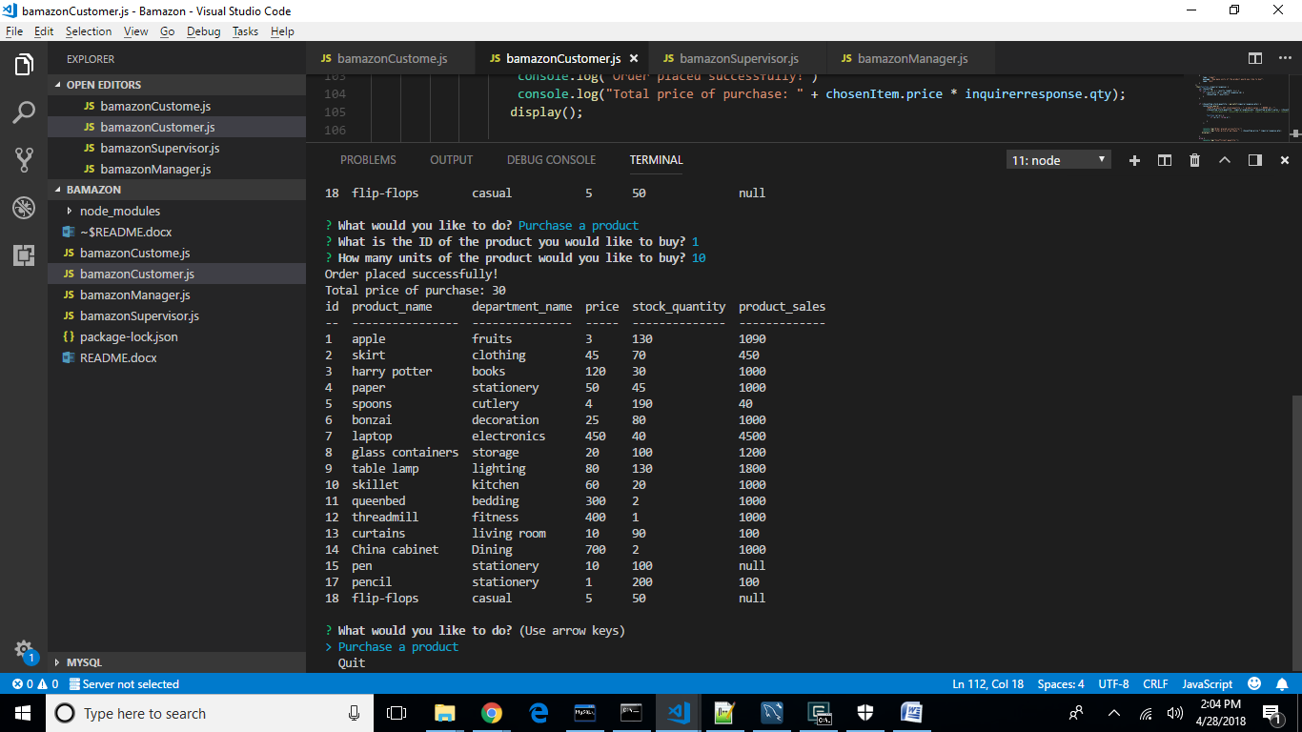

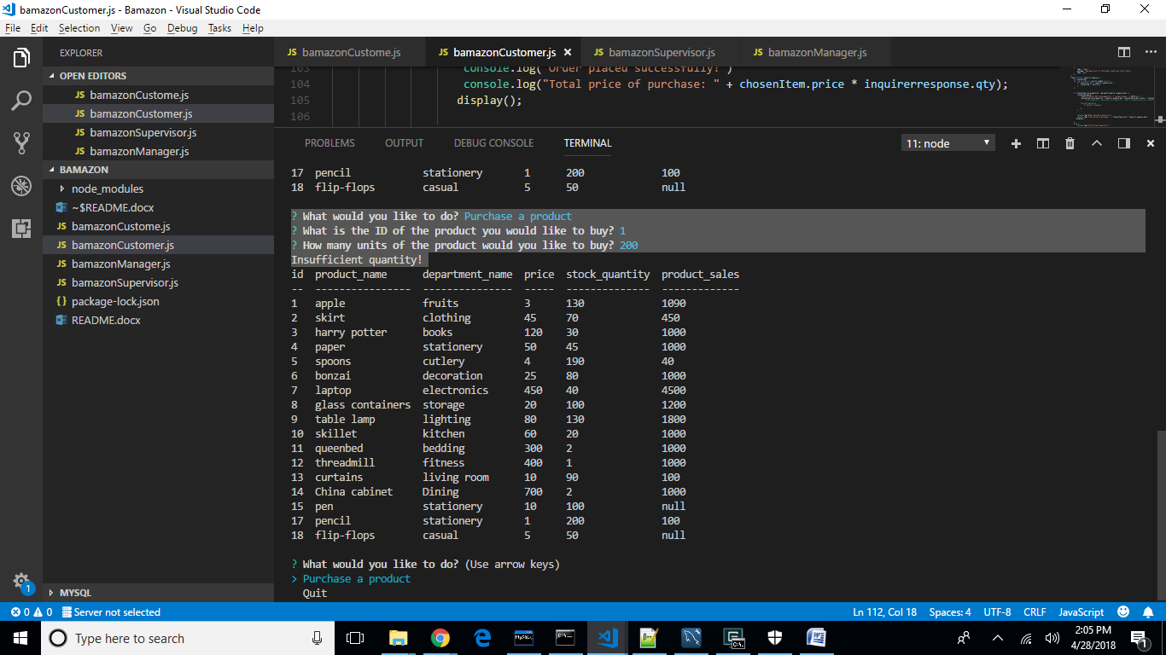

Bamazon Manager:

GIF : <https://thumbs.gfycat.com/WideeyedMammothBorer-size_restricted.gif>

View Products for sale:

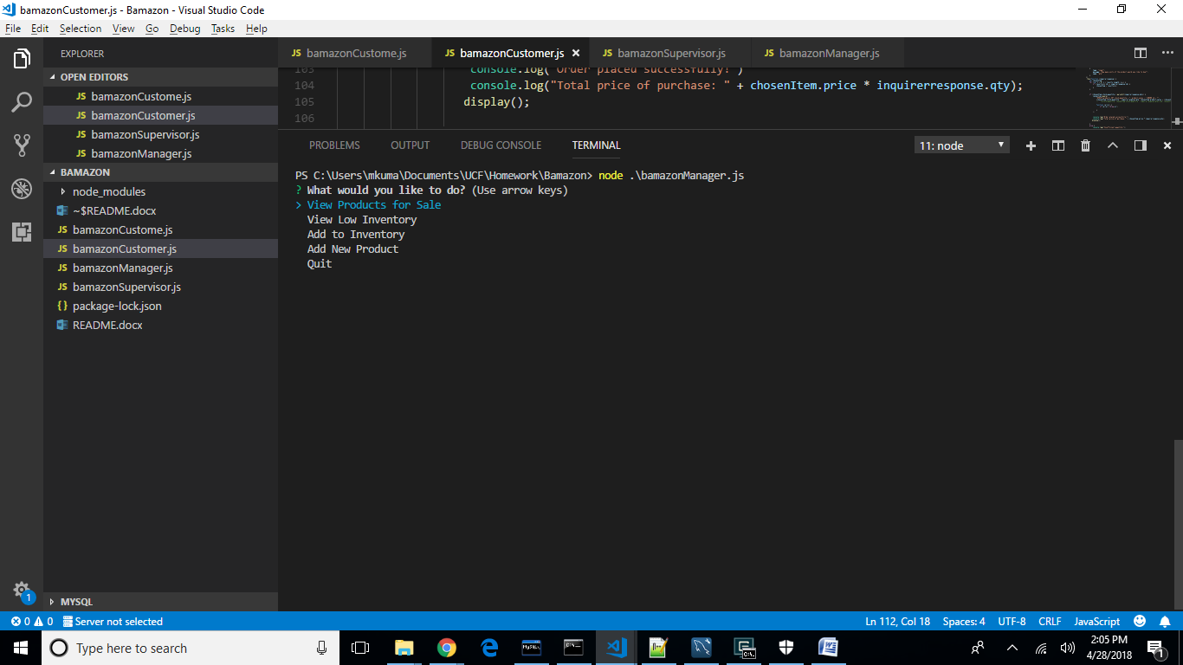

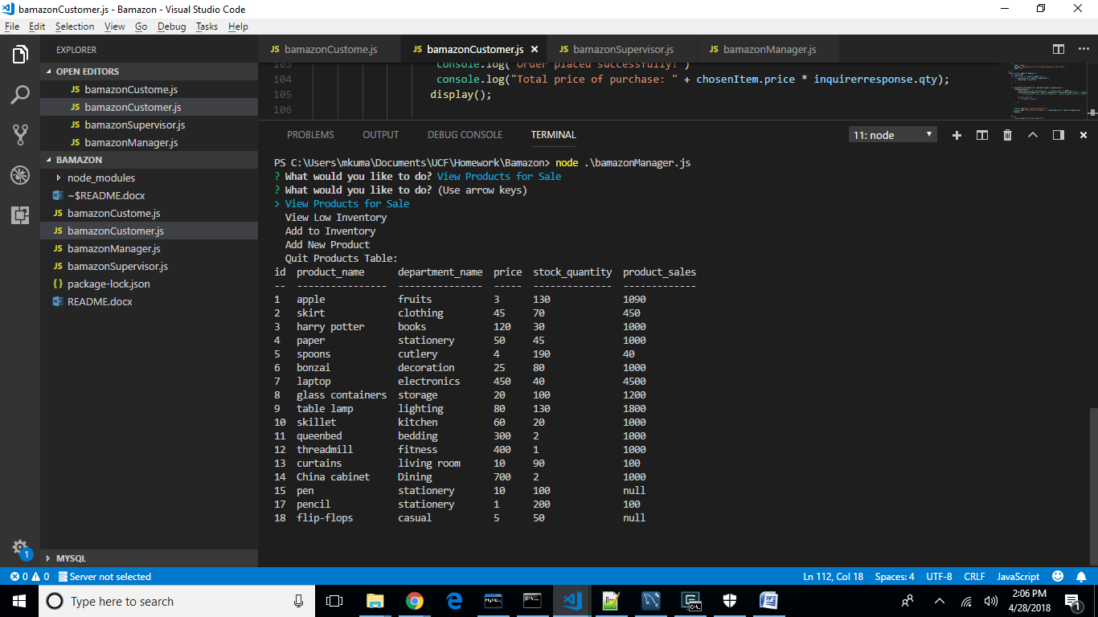

View Low inventory:

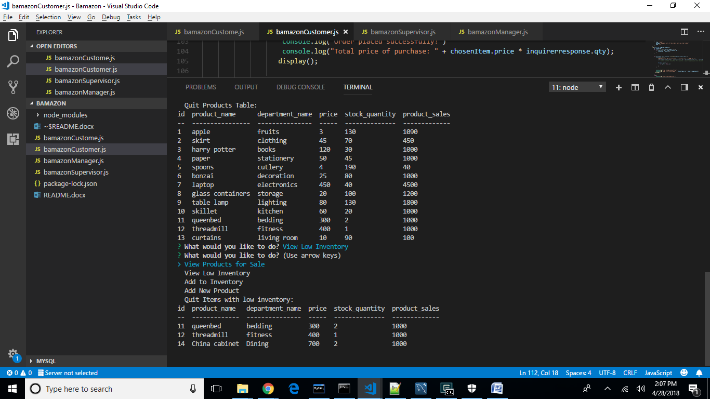

Add to inventory:

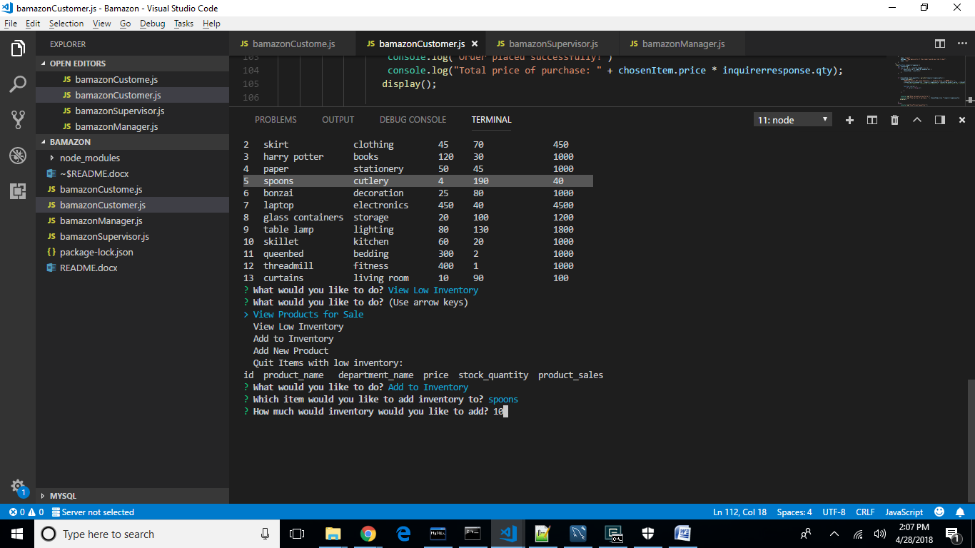

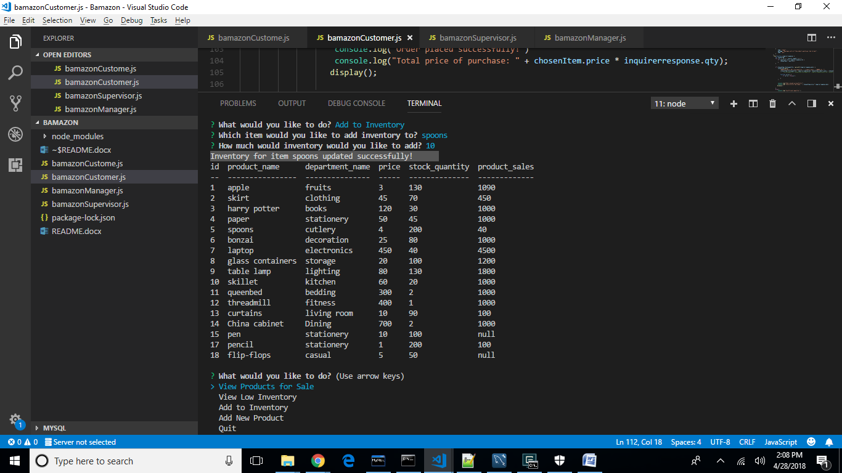

Add new product:

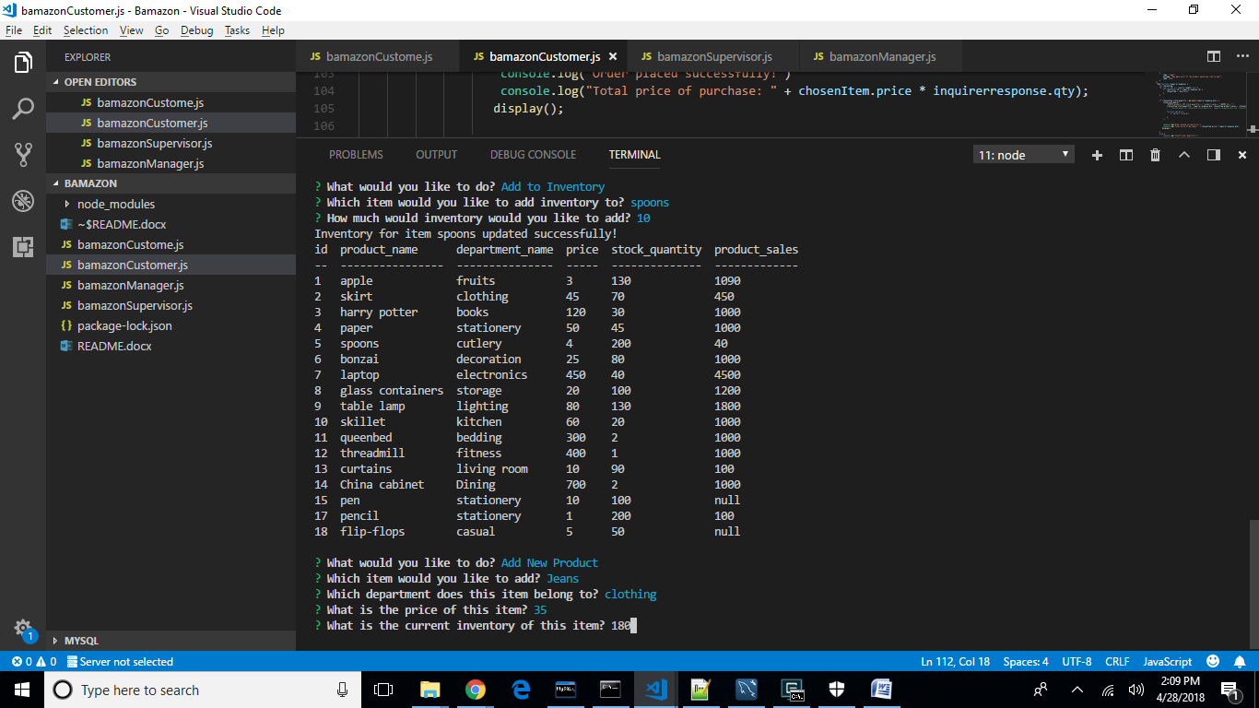

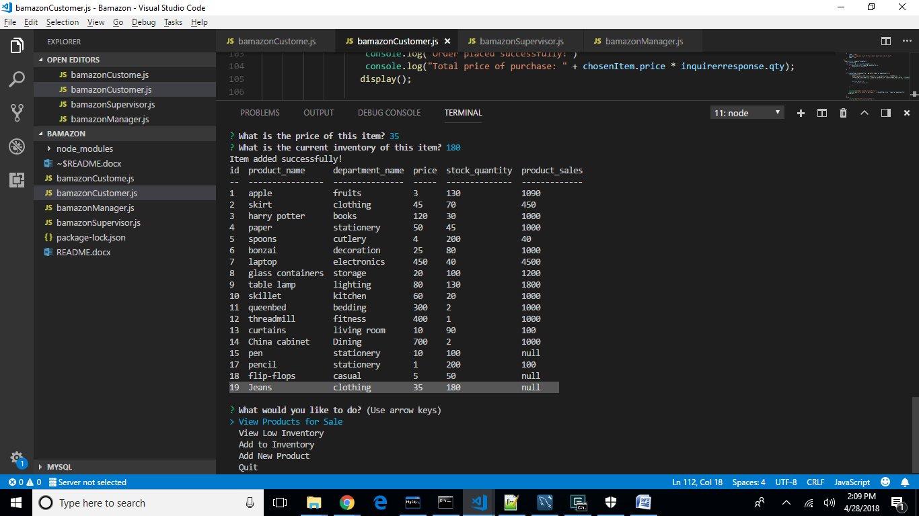

Bamazon Supervisor:

GIF : <https://thumbs.gfycat.com/WellwornObedientAsianconstablebutterfly-size_restricted.gif>

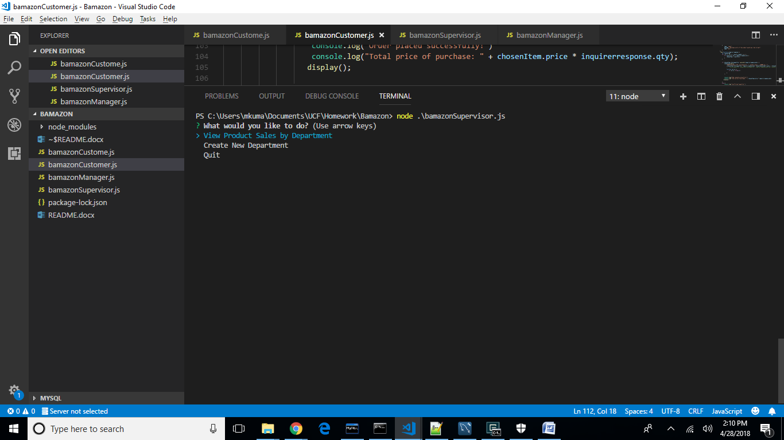

View Product sales by department:

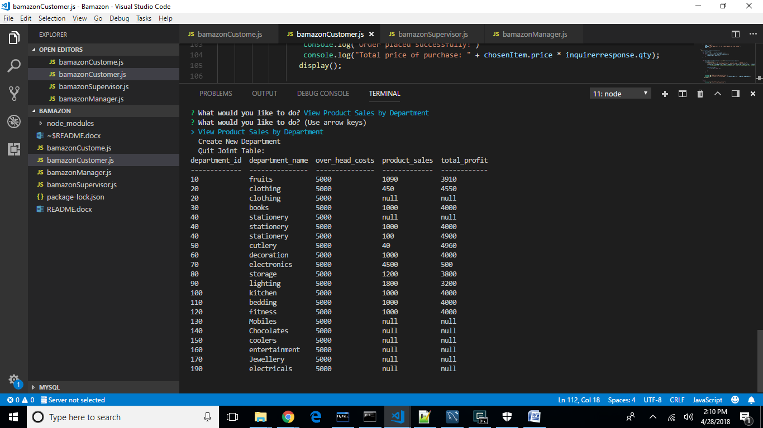

Create new department:

