**Grace Educational Website**

**Module and Slide Management**

To access all features of this guidance, your account must be an admin type; otherwise, you will not have access to the actions. For more information, please contact the CSE sub team.

**Module Management**

**Steps:**

* Open the following link: <http://grace.auburn.edu/Student/Modules/Index>
* Click the “Module Management” button.
* Manage modules from this interface.
  + Create New: Create a new module. You can designate it as a submodule by selecting “Parent Module.” This will be reflected in the link above, where modules are displayed in a tree view for students.
  + You can also edit, delete modules, or view related slides.

Note: Once a module is deleted, it cannot be restored!

**Slide Management: Add a New Slide**

**Steps:**

* Open the following link: <http://grace.auburn.edu/Student/Modules/Index>
* Click the “Module Management” button.
* Click on the module where you want to add a slide
* Click on the “Add a New Module" button

Once the popup appears, you'll see sections for entering basic information and UI Controller details. The following explains all the required information.

**Base Info**

* Slide Title: Display the title at the top of the slide.
* Display Title: Toggle the visibility of the slide title (especially useful for the first slide to introduce the module).
* Forward/Backward Button: Enable or disable navigation buttons (particularly useful for the first and last slides).
* Order: Determines the slide's position in the sequence, sorted in ascending order.
* Display Thumbnail Slide: Toggle the visibility of a small thumbnail slide at the bottom of the corresponding main slide.
* Thumbnail Slide Title: A brief title for the thumbnail slide, which can differ from the main "Slide Title."
* Thumbnail Slide Icon: Can be left blank.
* Slide Type: Specify whether the slide layout is vertical or horizontal.

1st COL

2ND COL

3RD COL

4TH COL

Title

4TH ROW

1st ROW

3RD ROW

2ND ROW

Title

Horizontal Design Vertical Design

Depending on the chosen "Slide Type," multiple rows or columns can be added. Each row or column should include an interactive UI controller to display information and engage students in hands-on training. Below, we outline the UI controllers that can be added to a row or column.

**UI Controllers**

1. **Text:**

* Activate Text-to-Speech: Activating this feature allows students to listen to the text as it's read aloud.
* Description: The information we wish to display in the relevant row or column.

1. **Simple Clickable Image:**

* Image
* Width: The width in pixels. The height will automatically adjust according to the width.
* Alternative Text: If the image fails to display, this text will be shown in its place.
* Display Slide on Click: Enabling this feature allows students to view the selected slide by clicking on the image.

1. **Video:**

* Video Link: Enter the YouTube video URL here.

1. **Professional Clickable Image:**

* Image
* Color: The border color of the clickable circular area.

**Steps:**

* Select the image.
* Choose the border color.
* Click on the specific spot of the image where you want to create a clickable area.
* Enter your title.
* Add more clickable areas or remove any unnecessary ones.
* In the table, you can view the coordinates and the entered titles. Select the slide you want to display by clicking on each area.

1. **Charts**

* Chart Type: Currently, only the pie chart type is available.

**Steps:**

* Select the chart type (pie chart).
* In the first row of the table, enter the details for a slice of the pie chart, including the label, the percentage value (as a number without the % symbol), and the color of the slice.
* Click the + button.
* Enter the information for additional slices.
* Ensure that the sum of the values in all rows totals 100.

1. **Drag and Drop Items**

* Title of Repository
* Background Image of Repository: This background image is shown on the left side of the UI Controller (see the image above, the vase).
* Title of Answer Section
* Background Image of Answer Section: This background image is displayed on the right side of the UI Controller.
* Item Table: If an item should be draggable by the student to the answer section, activate the “Is one of the answers?” feature. Also, enter a Title and Description for the item. The description will be visible while dragging the item.

**Steps:**

* After entering the repository and answer information, input the details for each item in the table. If an item is an answer, enable the “Is one of the answers?” feature.
* Click the + button to add more items.
* Note: Students cannot proceed to the next slide without answering the question correctly.

1. **Displaying Process**

* Title of Left Image: The label for the left image.
* The corresponding arrows color: Select the color from the palette for the arrows associated with the left image.
* Left Image: The image displayed on the left.
* Title of Right Image: The label for the right image.
* The corresponding arrows color: Select the color from the palette for the arrows associated with the right image.
* Right Image: The image displayed on the right.
* Title of Main Image: The label for the main image.
* Main Image: The primary image displayed.

**Steps:**

* Fill out all the fields above.
* To add an arrow to the image, click on the main image at the point where you want the arrow to start.
* The arrow may flash when you click on the left or right image. You will be prompted to choose whether the arrow should flash when clicking on the left or right image. Please follow the instruction.
* Click on the main image again and select the end point for the arrow.
* You can delete any unnecessary arrows.

1. **Flying Items to Image**

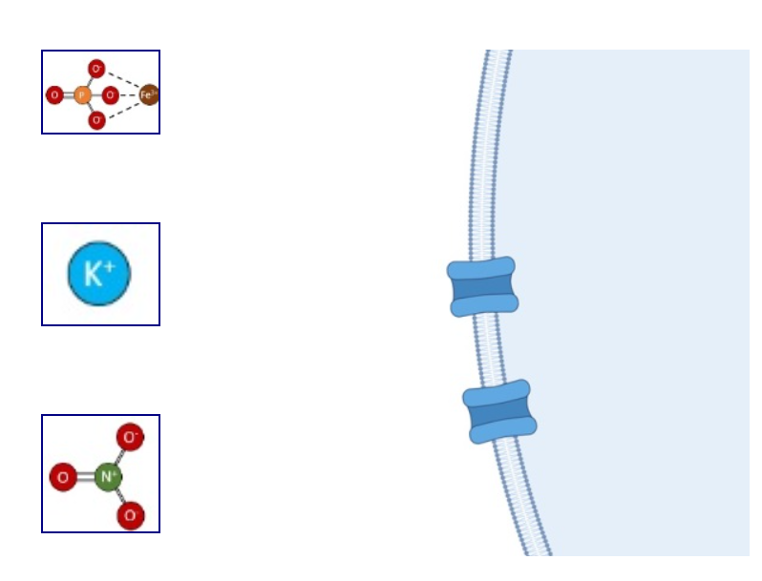

* Background Image of Repository: The image displayed as the background for the repository.
* Item Table: The items whose movement towards the main image and their movement type information will be displayed (You cannot add more than 3 items).

**Steps:**

* Select your Main Image.
* In the table, choose the item's image and enter the distance from this item to the main image in pixel. Then, provide a description of the item.
* Finally, select the movement type. Options include “Going Forward” or “Going Forward and Back to the First Location.”

**Slide Management: Updating a Slide**

**Steps:**

* Open the following link: <http://grace.auburn.edu/Student/Modules/Index>
* Click the “Module Management” button.
* Click on the module where you want to add a slide
* Select the slide you wish to update.
* Click the “Update Current Slide” button.
* All slide information will be displayed, allowing you to edit the details or add, update, or delete UI Controllers (the process for these actions is the same as when adding a slide).
* Click on the “Save Changes” button.

**Slide Management: Deleting a slide**

**Steps:**

* Open the following link: <http://grace.auburn.edu/Student/Modules/Index>
* Click the “Module Management” button.
* Click on the module where you want to add a slide
* Select the slide you wish to delete.
* Click the “Delete Current Slide” button.

Note: Once deleted, the slide cannot be restored!