F5 DNS Portal

Solution Proposal Document

Prepared by: Azalio Technologies
Date: Aug 17, 2026
Version: 2.0

Revision History
DATE | REVISION | DESCRIPTION | AUTHOR | APPROVER
23-11-2025 | 1.0 | Initial Draft | Azalio
17-08-2026 | 2.0 | DC/DR HA architecture, integration alignment and infrastructure dimensioning | Azalio

Table of Contents
Revision History 2
1. Executive Summary 4
2. Background & Objectives 4
2.1 Background 5
2.2 Objectives 5
3. Scope of Work 5
3.1 In Scope 5
3.2 Out of Scope 5
4. Requirements Traceability (K1–K5) 6
5. Solution Architecture 6
5.1 High-Level System View 6
5.2 Logical Architecture 8
5.2.1 Presentation Layer 8
5.2.2 Application Layer 9
5.2.3 Data & Security Layer 9
5.2.4 Integration Layer 10
5.3 Architecture Traceability 11
5.4 Workflow Diagram 13
6. Infrastructure Dimensioning 14
6.1 Production - Primary DC 14
6.2 Production - DR Site 15
6.3 Cross-Site HA/DR Control Services 15
6.4 Separate UAT Environment 16
6.5 Production Capacity Summary 16
7. Assumptions and Dependencies 16
8. Responsibility Assignment (RACI) 17

Executive Summary
This document presents a detailed proposal & scope for Portal requirement for F5 DNS. The Bank is deploying F5 BIG-IP DNS (GTM) across DC, DR and AZ sites and requires a front-end DNS management solution (“Portal”) that:
- Centralizes all DNS record changes across all F5 DNS sites.
- Enforces strong governance, including maker–checker workflows, role-based access, and scheduled changes.
- Integrates with Bank’s AD/IdP and MFA, SIEM, and ITSM.
- Provides complete auditability, reporting and analytics over DNS changes for the next 7 years.
Azalio proposes to design, implement and support a custom DNS Management Portal deployed across the Bank’s production DC and DR environments on Bank-provided virtual infrastructure. The portal provides a single governed entry point for DNS management, with local component resilience and cross-data-center continuity. Stateless application services are deployed at both sites, while persistent workflow, audit and configuration state is maintained in PostgreSQL with local high availability and cross-site replication. The portal integrates with the F5 DNS environment through F5-supported management APIs/interfaces applicable to the selected BIG-IP/BIG-IQ software versions.
The solution is built on a modern, open-source based stack (Spring Boot, React, PostgreSQL, NGINX, Fluent Bit, Vault/KMS) and is designed to meet the front-end portal requirements with secure integration, controlled change execution, two-site management continuity, and a clear 7-year support and maintenance model.

Background & Objectives

Background
The Bank uses, or is planning to use, F5 BIG-IP DNS as the authoritative DNS platform for critical banking services across multiple geographic sites. Current DNS change processes are either manual (via CLI/GUI on F5) or spread across multiple tools, leading to:
- Inconsistent governance.
- Limited auditability.
- High risk of errors in critical DNS changes.
The Bank’s RFP (K1–K5) calls for a central “front-end solution” that provides:
- End-to-end DNS change governance.
- Integration with existing security and ITSM ecosystems.
- Compliance with internal IS policies and regulatory expectations.

Objectives

The key objectives of this solution are:
- Provide a single controlled entry point for all F5 DNS changes.
- Enforce strong access control, MFA, and maker–checker approval workflows.
- Automate DNS changes across F5 DC/DR/AZ using APIs, ensuring consistency.
- Provide complete audit trails, SIEM integration, and compliance reporting.
- Ensure high availability and continuity of the management plane through local component resilience and a pre-deployed DR capability across data centres, while keeping DNS resolution independent of portal availability.
- Enable 7-year support and evolution of the portal aligned with Bank and F5 roadmaps.

Scope of Work

In Scope
- Design, implementation and deployment of the DNS Management Portal (“front-end solution”) across the Bank’s production DC and DR environments, with a separate UAT deployment on Bank-provided virtual infrastructure.
- Functional coverage as per K1:
  - DNS record search/list/filter.
  - Create/modify/delete operations with validations.
  - Logical grouping (department, application, location, user group).
  - Maker–checker workflow and scheduling.
  - Dashboards and reports.
- Integration as per K2:
  - AD/IdP and MFA (Single Sign-On).
  - Integration with the F5 DNS environment through F5-supported management APIs/interfaces for DNS record operations across DC/DR/AZ.
  - SIEM log export (audit and security logs).
  - ITSM integration for change and incident management, including ticket correlation, status validation/workflow gating where applicable, execution updates and failure/incident correlation.
- Security & compliance as per K3: TLS, encryption, audit trail, VA/PT support and remediation.
- Availability & performance as per K4, for the management portal.
- 7-year support and maintenance as per K5.
- Documentation, KT to Bank and Network Integrator (NI), and runbook creation.

Out of Scope
- Managing non-F5 DNS platforms (e.g., Windows DNS, BIND, Cloud DNS).
- IP Address Management (IPAM), DHCP scope automation, and reverse zone automation beyond record-level operations.
- DNSSEC key lifecycle and signing management.
- Native F5 device lifecycle operations (for example firmware/image management and packet capture) remain within the F5 platform unless explicitly brought into the custom portal scope.
- Detailed SIEM correlation rules (to be defined by Bank SOC using the logs we provide).
- Native mobile clients (the portal is provided as a web UI).

Requirements Traceability (K1–K5)
Detailed compliance mapping is maintained in the separately shared compliance workbook. This proposal describes the implementation architecture and controls that support the front-end portal requirements.

Solution Architecture
This section describes how the proposed DNS Management Portal is structured, how the main components interact, and how the architecture satisfies the Bank’s functional, security, and availability requirements.
At a high level, the architecture is split into:
  - User access layer (Bank users accessing the portal via browser and SSO).
  - Portal stack distributed across the Bank DC and DR sites (global/local access, application services, database, security, logging and recovery components).
  - F5 DNS infrastructure (authoritative DNS platforms at DC/DR/AZ).
  - Bank shared services (IdP/AD with MFA, SIEM, ITSM).
The portal management plane is distributed across the production DC and DR sites. During normal operation the DC site is active and the DR site is maintained ready for controlled failover. Local application/database resilience protects against component failure, while cross-site replication and service failover protect the management plane against a site outage. F5 DNS remains distributed across DC/DR/AZ and continues to provide DNS resolution independently of portal availability.

High-Level System View

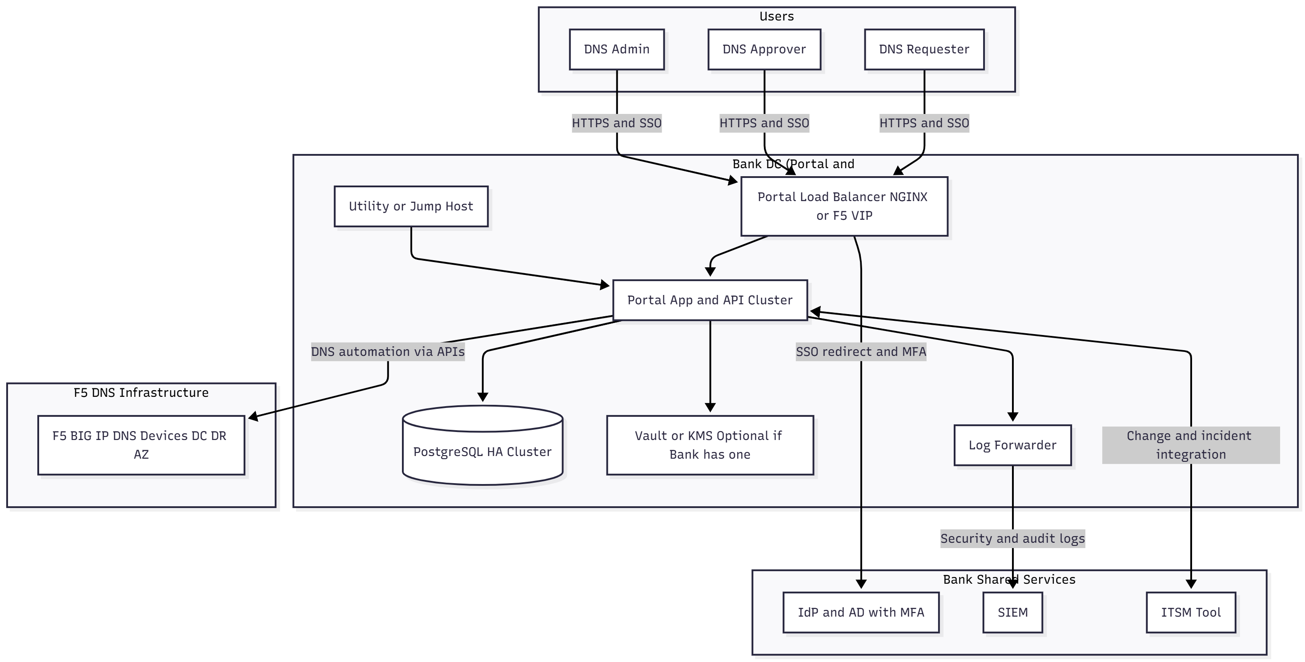
Figure 1 - Functional high-level system view
The functional view above remains applicable to the portal services and integration boundaries. The physical deployment of those services is distributed across DC and DR as shown below, F5 DNS remains the authoritative resolution plane while the portal provides management, governance, workflow and audit controls.
DC/DR Deployment Architecture
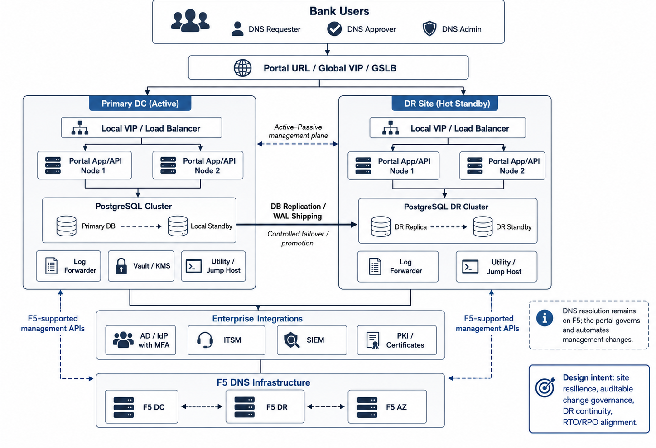
Figure 2 - Production DC/DR high-availability deployment architecture
Figure 2 shows the production management plane distributed between the Primary DC and DR site. Users access a single Portal URL through a Bank/F5 global VIP/GSLB or equivalent traffic-management service. The DC site is active during normal operation, and the DR site remains hot-standby. A lightweight Portal HA/DR Controller, co-deployed with the Portal application control services at each site, coordinates site role, database promotion, scheduler/background-worker activation and site-readiness signaling. The global VIP performs user-traffic switching only after the target site is declared ready. PostgreSQL state is continuously replicated to DR, while an Infrastructure Fencing Adapter uses an approved Bank private-cloud or virtualization control interface to isolate the former active Portal/database resources before DR database promotion. Both sites maintain the required enterprise-integration and F5-management connectivity, so DR service does not depend on the failed DC.
DNS resolution is intentionally outside this failover path: F5 DNS continues to answer queries independently. The portal failover protects DNS management and change governance, not the DNS resolution plane.
The high-level system view can be summarized as:
  - Bank users (DNS Requesters, DNS Approvers, DNS Admins) access a single portal URL over HTTPS. A global VIP/GSLB or equivalent Bank/F5 service directs traffic to the active site, where a local VIP/load balancer distributes requests across healthy portal nodes.
  - The load balancer forwards traffic to a cluster of Portal App/API nodes, which implement business logic, workflow, validation and integrations.
  - All request, workflow, audit and configuration data is persisted in a PostgreSQL HA design with local standby capacity and cross-site replication to DR.
  - Sensitive secrets (API credentials, DB passwords, tokens) are read from a Vault or KMS component (either Bank’s existing one or an optional, dedicated Vault).
  - Application and audit logs are collected by a Log Forwarder, which ships them to the Bank’s SIEM.
  - A Utility / Jump Host (or Bank enterprise bastion) is available at each required administration boundary for controlled maintenance, connectivity validation and troubleshooting.
  - The Portal App/API cluster integrates with:
    - F5 BIG-IP DNS devices at DC/DR/AZ to perform DNS record automation via APIs.
    - The Bank’s ITSM tool for change and incident correlation.
    - The Bank’s IdP/AD with MFA for SSO and central authentication.
Conceptually, the architecture separates the DNS resolution plane (handled by F5 DNS) from the management and governance plane (implemented by the Portal). This separation remains intact during portal component or site failover.

Logical Architecture

Logically, the solution consists of four primary layers:
- Presentation Layer (Users & Load Balancer)
- Application Layer (Portal App/API Cluster)
- Data & Security Layer (PostgreSQL HA, Vault/KMS, Logs)
- Integration Layer (F5 DNS, IdP/AD, ITSM, SIEM)

Logical Architecture and End-to-End Flow
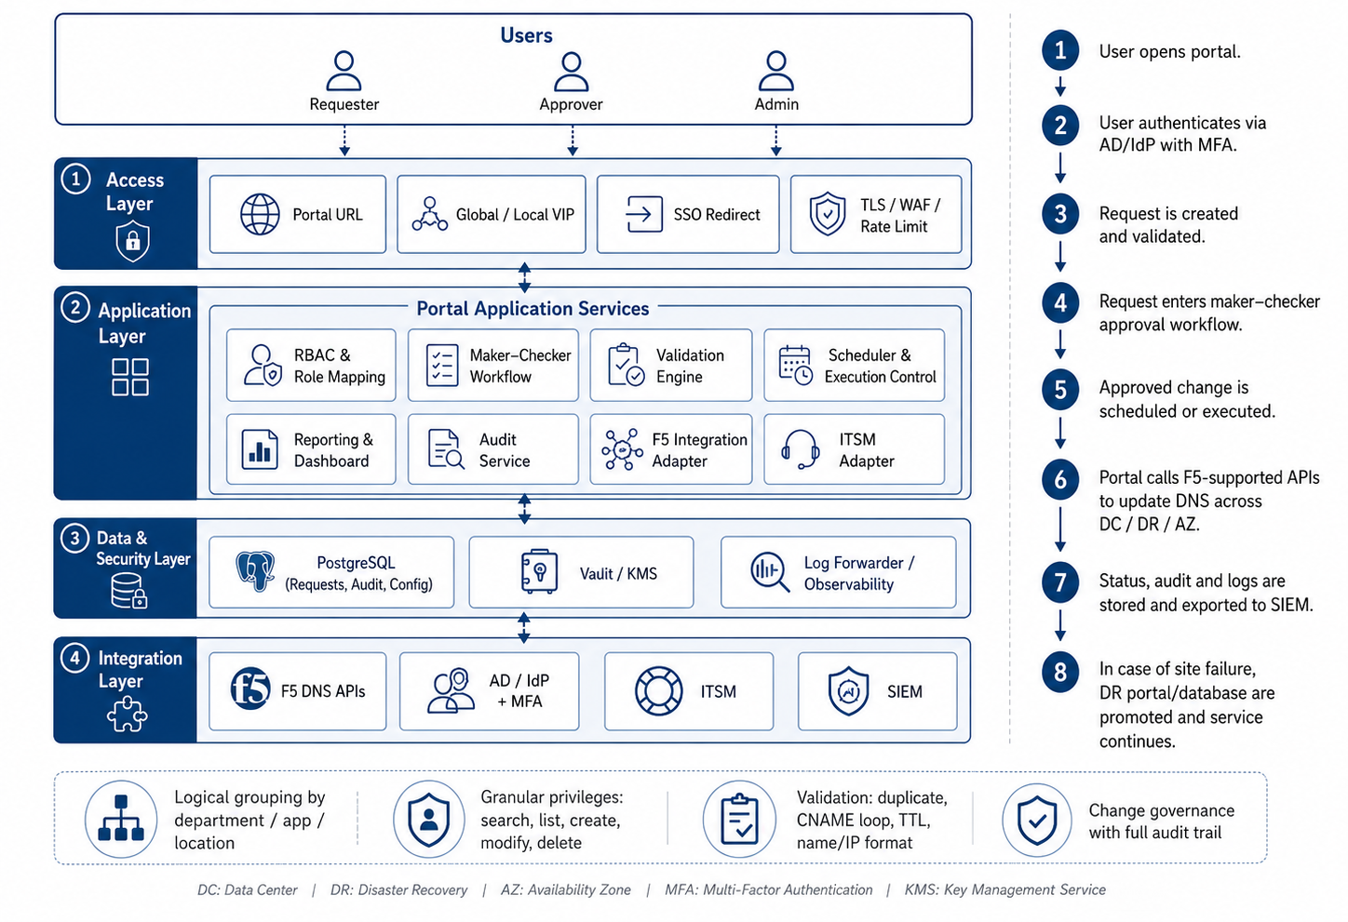
Figure 3 - Logical architecture and request lifecycle
The logical architecture keeps the original four-layer model: access, application, data/security and integration. A DNS request is authenticated through Bank AD/IdP with MFA, validated and subjected to role-based maker-checker workflow, scheduled/executed by the active portal site, applied through the supported F5 management interfaces and recorded in the audit store/SIEM. The same durable workflow state is available after a controlled site failover so pending or in-flight requests can be reconciled before further execution.

Presentation Layer

Users
  - Represented in the diagram as “DNS Requester”, “DNS Approver”, and “DNS Admin”.
  - These are Bank employees authenticated via SSO and MFA who interact with the portal using a web browser.
Portal Access and Load Balancing (Global VIP/GSLB + Local VIP)
  - Presents a single logical portal URL and routes users to the active portal site.
  - Terminates or passes through TLS 1.3 as per Bank/F5 standards, applies WAF/rate-limit policies where required, and forwards requests through the local site VIP to healthy application nodes.
  - Handles SSO redirection to the Bank’s IdP:
    - If a user is not authenticated, the LB or app triggers a redirect to the IdP for login and MFA.
    - After successful authentication, the user is redirected back to the portal with a token.
  - This layer abstracts both application-node and site topology, giving users a single URL and consistent security posture during normal operation and controlled DR failover.

Application Layer

Portal App and API Cluster
Stateless application nodes are deployed with local redundancy at the production DC and DR sites. Each node
runs:
  - React front-end (served as a SPA).
  - Spring Boot back-end services.
Core responsibilities:
  - Implement RBAC based on AD group claims.
  - Enforce maker–checker workflows for DNS changes.
  - Validate DNS records (duplicate checks, CNAME loop prevention, TTL policies, and name/IP/record-format validation).
  - Orchestrate DNS change execution across F5 DC/DR through F5-supported management APIs/interfaces.
  - Expose REST APIs for UI and possible future automation.
  - Integrate with ITSM for change/incident management and with SIEM for centralized audit/security logging.
  - Maintain durable execution state, idempotency keys and reconciliation status so an approved DNS change cannot be executed twice during retry or site failover.
  - Run scheduler/background workers under active-site ownership/leader control, DR workers remain passive until the site is promoted.
Utility / Jump Host
A hardened VM used by administrators for:
  - Controlled access to portal servers (for logs, configuration, advanced troubleshooting).
  - Testing connectivity to F5 management APIs, IdP, SIEM and ITSM endpoints from both production site boundaries as required.
The Utility/Jump Host is not used in normal user workflows but is useful for controlled operations and support. Portal application nodes remain stateless so they can be added, replaced or promoted at either site without losing workflow state, durable state is maintained in PostgreSQL.

Data & Security Layer

PostgreSQL HA Cluster
- Represented as a single logical PostgreSQL service, implemented across DC and DR with local HA and cross-site recovery:
    - One active primary at the serving site.
    - A local standby at the active site plus DR replicas maintained through PostgreSQL streaming/WAL replication, after DR promotion, the second DR node provides local standby capacity.
  - Stores:
    - DNS change requests and their lifecycle states (pending, approved, scheduled, executed, rejected).
    - Audit history of operations.
    - Mapping of zones, environments, and logical groupings (department, application, location).
    - Configuration data (validation rules, workflow definitions, integration settings).
  - High availability is achieved through Patroni or an equivalent approved PostgreSQL HA mechanism, backed by a distributed consensus/DCS design. Promotion is controlled with fencing/split-brain protection, an independent quorum/witness failure domain is recommended for safe cross-site decisions.
Vault or KMS (Optional if Bank Has Existing Solution)
Used to securely store:
  - F5 management API credentials/tokens.
  - Database user/passwords.
  - ITSM API tokens, mail gateways, and any other sensitive secrets.
The Portal App nodes read secrets at startup or on demand. The diagram shows this as a separate block, but in many banks, this will be an existing enterprise KMS/HSM/Vault.

Log Forwarder
A component (e.g., Fluent Bit or rsyslog) responsible for:
  - Collecting logs from the app nodes (and optionally the DB).
  - Normalizing and tagging logs.
  - Forwarding them to the Bank’s SIEM - Ensures all security and audit trails are centrally captured and monitored.
This layer ensures that the portal’s state, secrets and evidence trails are durable, secure and compliant with Bank’s IS policies.

Integration Layer

F5 DNS Infrastructure (DC, DR, AZ)
Shown as a single logical block representing F5 BIG-IP/BIG-IQ DNS management endpoints across DC/DR/AZ.
Represents all F5 BIG-IP DNS instances that:
  - Authoritatively serve the Bank’s DNS zones.
  - Are the actual “resolution plane” for client DNS queries.
The portal does not replace F5, it governs and automates F5 configuration through supported management APIs/interfaces:
  - For each approved change, the Portal App calls:
    - F5 DC for primary site changes.
    - F5 DR and F5 AZ for redundancy and geo-consistency, as required.
  - This supports the requirement that a DNS change raised once in the portal can be applied consistently across all relevant sites.
IdP and AD with MFA
  - Provides central identity and access management.
  - The portal uses SAML or OIDC to:
    - Redirect users for authentication.
    - Enforce MFA at the IdP level.
    - Receive user identity and AD group information in the token.
  - The portal then maps these groups into the internal role model (requester, approver, admin, auditor).
SIEM
  - Receives log streams from the Log Forwarder.
  - Used for:
    - Real-time security monitoring.
    - Correlation with other systems’ logs.
    - Forensic analysis during audits or incidents.

ITSM Tool
  - Represented as a single block “ITSM Tool”.
  - The portal integrates with the Bank-provided ITSM APIs to:
    - Create or link change records corresponding to DNS requests and update execution status/evidence.
    - Validate applicable approval/status conditions before execution and create/link incident records for failed changes as defined during detailed design.
These integrations tie the portal tightly into the Bank’s existing security, change management and DNS ecosystems.

Architecture Traceability

Security and MFA
- All user traffic is TLS-encrypted between the browser and the Portal Load Balancer.
- SSO and MFA are enforced by the IdP/AD, with the portal trusting only validated tokens.
- The Portal App nodes never store or manage local passwords, they operate entirely on trusted IdP-issued identities.
- Secrets used to connect to F5, DB and ITSM are stored in Vault/KMS, not in code or plain-text files.

Governance and Maker–Checker
Centralizing all DNS changes through the Portal App/API cluster allows:
  - Role-based control over who can request and who can approve.
  - Enforcement that requesters cannot approve their own changes (maker–checker).
  - A consistent audit model where every action is recorded in the DB and exported to SIEM.
High Availability and Cross-Data-Centre Continuity
  - Portal application services:
    - Multiple stateless Portal nodes at each production site allow local node failure to be absorbed without loss of management state.
    - Local VIPs route requests only to healthy nodes, the global portal endpoint routes users to the active site based on site health and the agreed failover policy.
  - PostgreSQL HA/DR:
    - A single active PostgreSQL writer is protected by a local standby and cross-site DR replicas. Controlled promotion, fencing and rejoin/failback procedures prevent split-brain and dual-writer scenarios.
    - Database state is replicated locally and to DR using streaming/WAL mechanisms, with backup/PITR retained independently of a single-site failure domain. The active-site scheduler and background workers are gated by site role so that only one site can execute approved DNS changes at a time.
The management plane is designed for local component resilience and controlled cross-site failover. The DR portal remains pre-deployed with F5, IdP, ITSM and SIEM connectivity validated. The architecture is designed to support the stipulated management-plane RTO/RPO, subject to the Bank-provided network, virtualization, VIP/GSLB and storage capabilities. DNS resolution remains independent and continues on F5 even while the portal management plane is failing over.

Cross-Site Failover Orchestration and Safeguards
Cross-site failover separates traffic management from database and execution-state transition. The Bank/F5 global VIP/GSLB is responsible for routing users to the site that exposes an ACTIVE/READY health state, the Portal HA/DR Controller is responsible for determining when a site can safely assume the active role. This prevents user traffic from reaching DR before the database and background-execution layers are ready.

In the event of a confirmed primary-site outage, the controlled failover sequence is:
- Validate loss of the active DC Portal service using multiple health signals such as peer heartbeat, Portal readiness, database state and site/load-balancer health.
- Check the DR PostgreSQL replication state and confirm that the latest available state is within the agreed RPO threshold.
- Invoke the Infrastructure Fencing Adapter using the Bank-approved private-cloud or virtualization management API to power-off or network-isolate the former active Portal/database resources.
- Require positive confirmation of fencing or demotion before allowing the DR database to become writable. If safe isolation cannot be established, automatic promotion is inhibited and a critical recovery event is raised.
- Promote the DR PostgreSQL instance to the writable primary role and validate database availability.
- Switch the DR Portal site role to ACTIVE and enable schedulers/background execution workers only at that site.
- Reconcile requests that were in-flight at the time of failure before any retry is attempted, using persisted workflow state and idempotency/execution identifiers to prevent duplicate DNS changes.
- Expose the DR Portal readiness endpoint as ACTIVE/READY. The global VIP/GSLB then directs user traffic to DR.
- Record the complete failover sequence, state transitions and recovery actions in the audit trail and forward relevant events to SIEM.

Safeguards
- Single-writer database model: only one PostgreSQL primary is permitted across DC and DR.
- Infrastructure fencing: the former primary is isolated before DR promotion, failover does not rely only on network reachability or a failed ping.
- Application role gating: only the ACTIVE site can pick scheduled jobs or execute approved DNS changes.
- Fail-safe promotion: if the previous primary cannot be positively fenced/demoted, automatic promotion is blocked rather than risking split-brain.
- Optional database self-fencing/watchdog controls may be enabled as a second safety layer, subject to the PostgreSQL HA technology selected during detailed design.
- Controlled failback: a recovered DC database rejoins first as a standby and is fully synchronized before a planned role switchover back to DC.

Multi-Site DNS Control
  - The logical block “F5 BIG IP DNS Devices DC DR AZ” emphasizes that:
  - F5 DNS remains distributed for resilience and performance.
  - The portal connects through the F5-supported management interfaces applicable to the selected BIG-IP/BIG-IQ versions.
  - A single approved change in the portal can be automatically applied to F5 at all sites ensuring consistent DNS records across redundant sites without requiring users to login to multiple F5 instances.

Compliance, Logging and Audit
  - The Log Forwarder → SIEM path ensures that:
- All critical events (login, requests, approvals, changes, failures) are available centrally.
- The Bank’s SOC can define alerts, dashboards and correlation rules based on these logs.
  - The PostgreSQL DB maintains a structured, queryable history of changes and approvals, enabling:
- Regulatory audits.
- Internal IS reviews.
- Forensic investigations.

Workflow Diagram
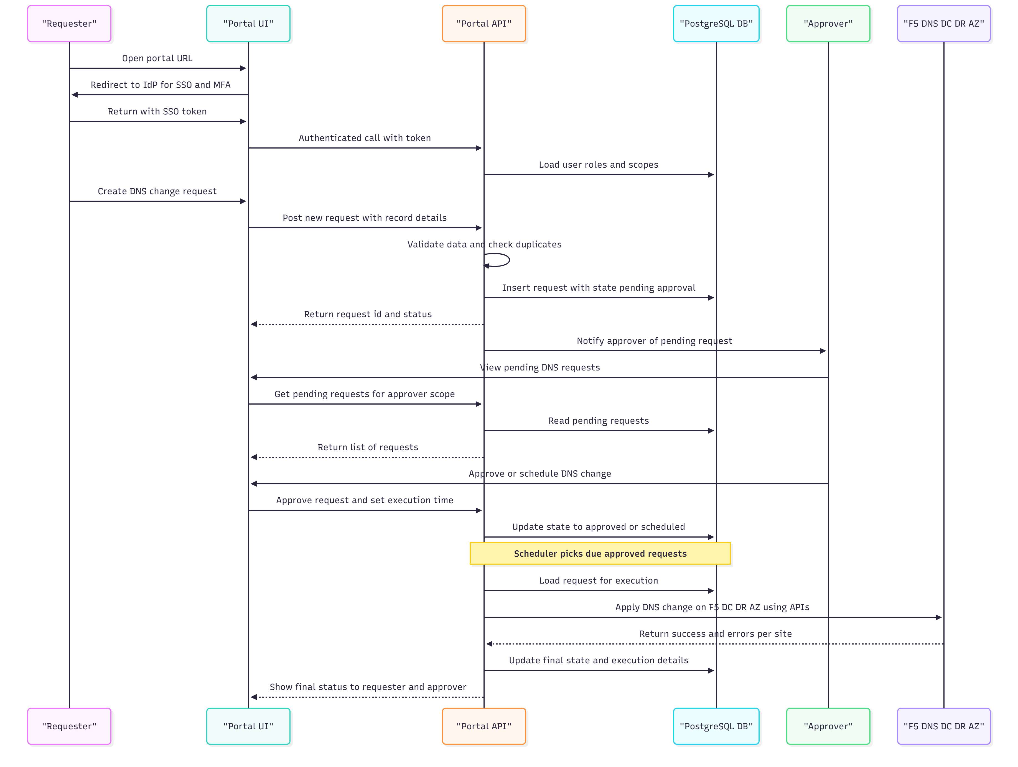
Figure 4 - DNS request, approval, scheduling and execution workflow

The above diagram shows the following flow:
- Users (Requesters, Approvers, Admins) open the DNS Portal URL in a browser.
- Their requests reach the portal endpoint and are directed to the active site (DC during normal operation, or DR following an approved/automated site failover), where the local load-balancing layer:
  - Enforces TLS.
  - Handles SSO redirects to the Bank’s IdP/AD with MFA.
- After successful authentication and MFA at the IdP, the user is redirected back to the portal with a secure token.
- The Load Balancer forwards the authenticated request to one of the nodes in the Portal App and API Cluster.
- The Portal App:
  - Validates user roles and permissions.
  - Interacts with the PostgreSQL HA Cluster for storing/retrieving request, audit and configuration data.
  - Reads secrets from the Vault/KMS when it needs to connect securely to F5, ITSM or other backends.
  - Emits structured logs to the Log Forwarder, which streams them into the SIEM.
  - On demand, calls the ITSM Tool APIs to create or update change tickets.
- When a DNS change request is approved and ready to execute, the active portal site calls the appropriate F5 DNS management interfaces across DC/DR/AZ. Execution state is persisted before and after each operation so retries, reconciliation and recovery can be performed safely if a site or API fails mid-change.
- Throughout, administrators may use the approved Utility/Jump Host or Bank enterprise bastion for controlled maintenance, testing and troubleshooting from either production site, without exposing the portal or F5 directly to unmanaged workstations.
This layered approach keeps the solution modular, secure and maintainable, while tying in naturally with the Bank’s existing F5 DNS, identity, security and ITSM ecosystems.

Infrastructure Dimensioning
The following sizing is an engineering baseline for the production DC/DR and separate UAT deployment. It retains the conservative per-node sizing used in the earlier design while distributing runtime components across two production sites. Final sizing will be validated during HLD against the Bank’s DNS inventory, user/concurrency profile, audit-retention requirements, infrastructure standards and the final F5 integration model.

6.1 Production - Primary DC
Component | Qty | vCPU / node | RAM / node | Storage / Notes
Portal App/API | 2 | 16 | 16 GB | 180 GB each, stateless, local HA behind site VIP
PostgreSQL | 2 | 16 | 32 GB | 500 GB each + WAL, active primary + local standby
Log Forwarder | 1 | 4 | 8 GB | 100 GB, local buffering/forwarding to SIEM
Utility / Jump Host | 1 | 8 | 16 GB | 80 GB, optional if Bank enterprise bastion is available
Local Load Balancer | F5 service | - | - | Reuse Bank/F5 VIP/WAF where available, dedicated nodes only if required

6.2 Production - DR Site
Component | Qty | vCPU / node | RAM / node | Storage / Notes
Portal App/API | 2 | 16 | 16 GB | 180 GB each, hot-standby application capacity, active after site failover
PostgreSQL | 2 | 16 | 32 GB | 500 GB each + WAL, DR replica + DR standby, one promoted during failover
Log Forwarder | 1 | 4 | 8 GB | 100 GB, DR-local log path to SIEM
Utility / Jump Host | 1 | 8 | 16 GB | 80 GB, optional if Bank enterprise bastion is available
Local Load Balancer | F5 service | - | - | Reuse Bank/F5 VIP/WAF where available, dedicated nodes only if required

6.3 Cross-Site HA/DR Control Services
The baseline design does not require a separately sized witness VM solely for cross-site failover. Cross-site role transition is coordinated by logical control services co-deployed with the Portal application and database layers, while the Bank/F5 global VIP/GSLB handles user-traffic switching. The Bank is expected to expose the approved infrastructure-management control interface and restricted service credentials required for automated fencing of the Portal resources, the orchestration logic remains part of the Portal solution.
If the PostgreSQL HA technology selected during detailed design requires a DCS/consensus capability for local database automation, the preferred approach is to use an approved Bank-provided service or to co-deploy the required lightweight control processes across already-sized Portal/control nodes. A dedicated witness VM is therefore not assumed in the baseline sizing.
Control Function | Mechanism | Deployment | Sizing Impact
Portal HA/DR Controller | Peer/site health aggregation, site-role state machine, database-promotion coordination, scheduler/background-worker gating and readiness signalling | 1 logical service per production site, co-deployed with Portal App/API | No standalone VM, included within Portal App/API allocation
Infrastructure Fencing Adapter | Invokes Bank-approved private-cloud/virtualization API to power-off or network-isolate former active Portal/database resources | 1 logical module per production site, co-deployed with HA/DR Controller | No standalone VM, included within Portal App/API allocation
Global VIP / GSLB | Health-based user-traffic routing between DC and DR | Bank/F5 traffic-management service | No dedicated Portal VM where Bank/F5 service is reused
PostgreSQL HA / Promotion Control | Streaming/WAL replication, controlled promotion, rejoin/failback and PITR | Runs with PostgreSQL nodes and selected HA tooling | Included within PostgreSQL allocation
Watchdog / Self-Fencing (where supported) | Secondary safety control to stop/reset a database node that loses valid leadership | Database/hypervisor level, final mechanism selected in HLD | No separate VM

6.4 Separate UAT Environment
Production and UAT are treated as separate deployments. UAT may use reduced compute while preserving the same software stack and integration pattern. Where SBI/F5 requires explicit HA/DR rehearsal in UAT, the second application/database nodes can be enabled as shown below.
Component | Qty | vCPU / node | RAM / node | Storage / Notes
Portal App/API | 1-2 | 8-16 | 16 GB | 120-180 GB, second node preferred for HA validation
PostgreSQL | 1-2 | 8-16 | 16-32 GB | 300-500 GB, second DB when DB failover is to be demonstrated
Log Forwarder | 1 | 2-4 | 4-8 GB | 50-100 GB, UAT SIEM/test logging
Utility / Bastion | 0-1 | 4-8 | 8-16 GB | 60-80 GB, reuse Bank bastion where available

6.5 Production Capacity Summary
Metric | Approximate Production Capacity
Portal App/API | 4 nodes total (2 DC + 2 DR)
PostgreSQL | 4 nodes total (2 DC + 2 DR)
HA/DR control services | 2 site-local logical controller instances + fencing modules, co-deployed, no standalone VMs
Log forwarding | 2 instances / site-local paths
Compute | Described in the table above
Memory | Described in the table above
Local VM storage | Described in the table above
Where SBI/F5 provides the global/local VIP, enterprise bastion, Vault/KMS, backup repository and monitoring services, dedicated portal VMs for those functions are not required. This keeps the portal footprint focused on application, database, execution-state and logging components.

Assumptions and Dependencies
Area | Assumption / dependency
Bank infrastructure | Bank provides the approved virtual infrastructure for Production and UAT, including compute, storage and virtualization capacity required by the final HLD.
DC/DR connectivity | Required inter-DC network connectivity, routing, firewall rules and latency/bandwidth are available for portal traffic, PostgreSQL replication and shared-service access.
Traffic management | Bank/F5 provides or approves the global portal VIP/GSLB and local site VIP/WAF/load-balancing services. If dedicated portal load balancers are required, the BOM will be adjusted.
Enterprise services | AD/IdP/MFA, ITSM, SIEM, PKI and Bank-standard Vault/KMS/backup services are provided as reachable enterprise integration endpoints with the necessary non-production access and service credentials.
F5 API boundary | F5 confirms the supported BIG-IP/BIG-IQ management API/interface and object mapping for the agreed DNS record operations and provides the required documentation/access for integration and testing.
Migration boundary | Legacy DNS migration into the F5 DNS platform remains within the F5/bidder migration workstream. The portal establishes its initial synchronized inventory and reconciliation baseline after the migrated F5 environment is available.
Failover control and fencing | Azalio Portal HA/DR orchestration controls the internal DC/DR role transition. SBI provides an approved private-cloud/virtualization management API or equivalent control interface and a least-privileged service identity that can isolate only the Portal/database resources required for fencing. Automatic DR database promotion is inhibited if safe fencing/demotion of the former primary cannot be confirmed.
RTO/RPO | The portal architecture is designed to support the stipulated management-plane RTO/RPO. Final achievement depends on Bank-provided network, virtualization, storage, VIP/GSLB convergence and the approved infrastructure-fencing interface and will be validated through implementation-stage HA/DR testing.
DNS resolution independence | F5 DNS continues to resolve production DNS traffic independently of the portal, portal HA/DR protects management/change continuity rather than DNS query service itself.
PostgreSQL HA tooling | The exact PostgreSQL HA manager, local leader-election mechanism and optional watchdog/self-fencing implementation will be finalized during HLD. Where a DCS/consensus service is required, an approved Bank service or co-deployment on already-sized Portal/control nodes is preferred, no dedicated witness VM is assumed in the baseline BOM.

Responsibility Assignment (RACI)
The following RACI provides the working responsibility model for the overall solution. It is intended to make the implementation boundaries explicit while keeping the bidder/OEM, Portal supplier and Bank infrastructure responsibilities aligned. The contractual and operational RACI will be reconfirmed during project kickoff and detailed design.
Workstream / Activity | SBI / Bank | F5 / Winning Bidder | Azalio | Network Integrator (NI)
Overall solution delivery / bid accountability | C | A | R | I
Bank private-cloud VM / storage provisioning | A/R | C | C | C
Inter-DC network, firewall and routing readiness | A | C | C | R
Global VIP / GSLB and local site VIP/WAF services | A | R | C | R/C
F5 BIG-IP / BIG-IQ platform deployment and OEM support | C | A/R | C | I
Portal application architecture, design and implementation | C | A | R | C
Portal HA/DR Controller and execution-state safeguards | C | A | R | C
Infrastructure fencing API / restricted service identity provisioning | A/R | C | C | C
Infrastructure Fencing Adapter implementation and configuration | C | A | R | C
PostgreSQL HA/DR, replication, promotion and failback | C | A | R | C
F5 management API documentation, access and supported object mapping | I | A/R | C | I
AD/IdP/MFA, ITSM, SIEM and PKI endpoint availability | A/R | C | R (integration) | C
Legacy DNS migration into F5 platform | C | A/R | C | C
Portal inventory synchronization and post-migration reconciliation | C | A | R | C
Security hardening, VAPT coordination and remediation | A | A/R | R (Portal) | C
Functional/SIT and HA/DR failover testing | C | A | R | C
UAT execution and acceptance | A | R | R | C
Solution documentation, runbooks and KT | C | A | R | C
Portal 7-year maintenance / L3 product support | I | A | R | C/I
R = Responsible | A = Accountable | C = Consulted | I = Informed
Implementation Alignment: Detailed configuration choices, interface contracts, failover thresholds, security controls, operating procedures and final responsibility assignments will be validated with SBI, F5 and the relevant Bank/NI teams during HLD/LLD and implementation planning. This allows the design to remain aligned with the Bank's actual private-cloud, network, security and operational standards without changing the core solution principles described in this proposal.

The architecture described here defines the target control model and safety principles. During project initiation and detailed design, the final HA tooling, health thresholds, fencing API, PostgreSQL promotion/rejoin mechanics, VIP/GSLB monitor behaviour, timeout values and failback sequence will be revalidated jointly with SBI, F5 and the relevant Bank infrastructure teams against the actual private-cloud, network, security and operational standards before production implementation.

