F5 DNS Portal

Solution Proposal Document

Date: Nov 3, 2026
Version: 2.1

Revision History
DATE | REVISION | DESCRIPTION | AUTHOR | APPROVER
23-11-2025 | 1.0 | Initial Draft
17-08-2026 | 2.0 | DC/DR HA architecture, integration alignment and infrastructure dimensioning
03-11-2026 | 2.1 | Local user management (configuration-based Admin; Read, Write and Checker permissions), Bank LDAP/directory user validation, group-scoped access, DNS record versioning, version comparison and scheduled rollback

Table of Contents
1. Executive Summary 4
2. Background & Objectives 4
2.1 Background 4
2.2 Objectives 4
3. Scope of Work 5
3.1 In Scope 5
3.2 Out of Scope 5
4. Requirements Traceability (K1–K5) 5
5. Solution Architecture 5
5.1 High-Level System View 6
5.2 Logical Architecture 8
5.2.1 Presentation Layer 8
5.2.2 Application Layer 9
5.2.3 Data & Security Layer 9
5.2.4 Integration Layer 10
5.3 Architecture Traceability 11
5.4 Workflow Diagram 13
5.5 User Management, Access Control, Versioning and Rollback 14
6. Infrastructure Dimensioning 16
6.1 Production - Primary DC 16
6.2 Production - DR Site 18
6.3 Cross-Site HA/DR Control Services 18
6.4 Separate UAT Environment 18
6.5 Production Capacity Summary 19
7. Assumptions and Dependencies 19
8. Responsibility Assignment (RACI) 20

Executive Summary
This document presents a detailed proposal & scope for Portal requirement for F5 DNS. The Bank is deploying F5 BIG-IP DNS (GTM) across DC, DR and AZ sites and requires a front-end DNS management solution (“Portal”) that:
- Centralizes all DNS record changes across all F5 DNS sites.
- Enforces strong governance, including maker–checker workflows, role-based access, and scheduled changes.
- Integrates with the Bank’s LDAP/directory authentication service, SIEM, and ITSM.
- Provides complete auditability, reporting and analytics over DNS changes for the next 7 years.
The proposed solution is a custom DNS Management Portal, designed, implemented and supported as part of this engagement and deployed across the Bank’s production DC and DR environments on Bank-provided virtual infrastructure. The portal provides a single governed entry point for DNS management, with local component resilience and cross-data-center continuity. Stateless application services are deployed at both sites, while persistent workflow, audit and configuration state is maintained in PostgreSQL with local high availability and cross-site replication. The portal integrates with the F5 DNS environment through F5-supported management APIs/interfaces applicable to the selected BIG-IP/BIG-IQ software versions.
The solution is built on a modern, open-source based stack (Spring Boot, React, PostgreSQL, NGINX, Fluent Bit, Vault/KMS) and is designed to meet the front-end portal requirements with secure integration, controlled change execution, two-site management continuity, and a clear 7-year support and maintenance model.

Background & Objectives

Background
The Bank uses, or is planning to use, F5 BIG-IP DNS as the authoritative DNS platform for critical banking services across multiple geographic sites. Current DNS change processes are either manual (via CLI/GUI on F5) or spread across multiple tools, leading to:
- Inconsistent governance.
- Limited auditability.
- High risk of errors in critical DNS changes.
The Bank’s RFP (K1–K5) calls for a central “front-end solution” that provides:
- End-to-end DNS change governance.
- Integration with existing security and ITSM ecosystems.
- Compliance with internal IS policies and regulatory expectations.

Objectives

The key objectives of this solution are:
- Provide a single controlled entry point for all F5 DNS changes.
- Enforce strong access control and maker–checker approval workflows.
- Automate DNS changes across F5 DC/DR/AZ using APIs, ensuring consistency.
- Provide complete audit trails, SIEM integration, and compliance reporting.
- Ensure high availability and continuity of the management plane through local component resilience and a pre-deployed DR capability across data centres, while keeping DNS resolution independent of portal availability.
- Enable 7-year support and evolution of the portal aligned with Bank and F5 roadmaps.

Scope of Work

In Scope
- Design, implementation and deployment of the DNS Management Portal (“front-end solution”) across the Bank’s production DC and DR environments, with a separate UAT deployment on Bank-provided virtual infrastructure.
- Functional coverage as per K1:
  - DNS record search/list/filter.
  - Create/modify/delete operations with validations.
  - Logical grouping (department, application, location, user group).
  - Maker–checker workflow and scheduling.
  - Local user management with Read, Write and Checker permissions, group-scoped access, DNS record versioning, version comparison and immediate/scheduled rollback.
  - Dashboards and reports.
- Integration as per K2:
  - Bank LDAP/directory API for validating Bank users at portal login.
  - Integration with the F5 DNS environment through F5-supported management APIs/interfaces for DNS record operations across DC/DR/AZ.
  - SIEM log export (audit and security logs).
  - ITSM integration for change and incident management, including ticket correlation, status validation/workflow gating where applicable, execution updates and failure/incident correlation.
- Security & compliance as per K3: TLS, encryption, audit trail, VA/PT support and remediation.
- Availability & performance as per K4, for the management portal.
- 7-year support and maintenance as per K5.
- Documentation, KT to Bank and Network Integrator (NI), and runbook creation.

Out of Scope
- Managing non-F5 DNS platforms (e.g., Windows DNS, BIND, Cloud DNS).
- IP Address Management (IPAM), DHCP scope automation, and reverse zone automation beyond record-level operations.
- DNSSEC key lifecycle and signing management.
- Native F5 device lifecycle operations (for example firmware/image management and packet capture) remain within the F5 platform unless explicitly brought into the custom portal scope.
- Detailed SIEM correlation rules (to be defined by Bank SOC using the logs we provide).
- Native mobile clients (the portal is provided as a web UI).

Requirements Traceability (K1–K5)
Detailed compliance mapping is maintained in the separately shared compliance workbook. This proposal describes the implementation architecture and controls that support the front-end portal requirements.

Solution Architecture
This section describes how the proposed DNS Management Portal is structured, how the main components interact, and how the architecture satisfies the Bank’s functional, security, and availability requirements.
At a high level, the architecture is split into:
  - User access layer (Bank users accessing the portal via browser, authenticated through the portal login).
  - Portal stack distributed across the Bank DC and DR sites (global/local access, application services, database, security, logging and recovery components).
  - F5 DNS infrastructure (authoritative DNS platforms at DC/DR/AZ).
  - Bank shared services (LDAP/directory authentication API, SIEM, ITSM).
The portal management plane is distributed across the production DC and DR sites. During normal operation the DC site is active and the DR site is maintained ready for controlled failover. Local application/database resilience protects against component failure, while cross-site replication and service failover protect the management plane against a site outage. F5 DNS remains distributed across DC/DR/AZ and continues to provide DNS resolution independently of portal availability.

High-Level System View

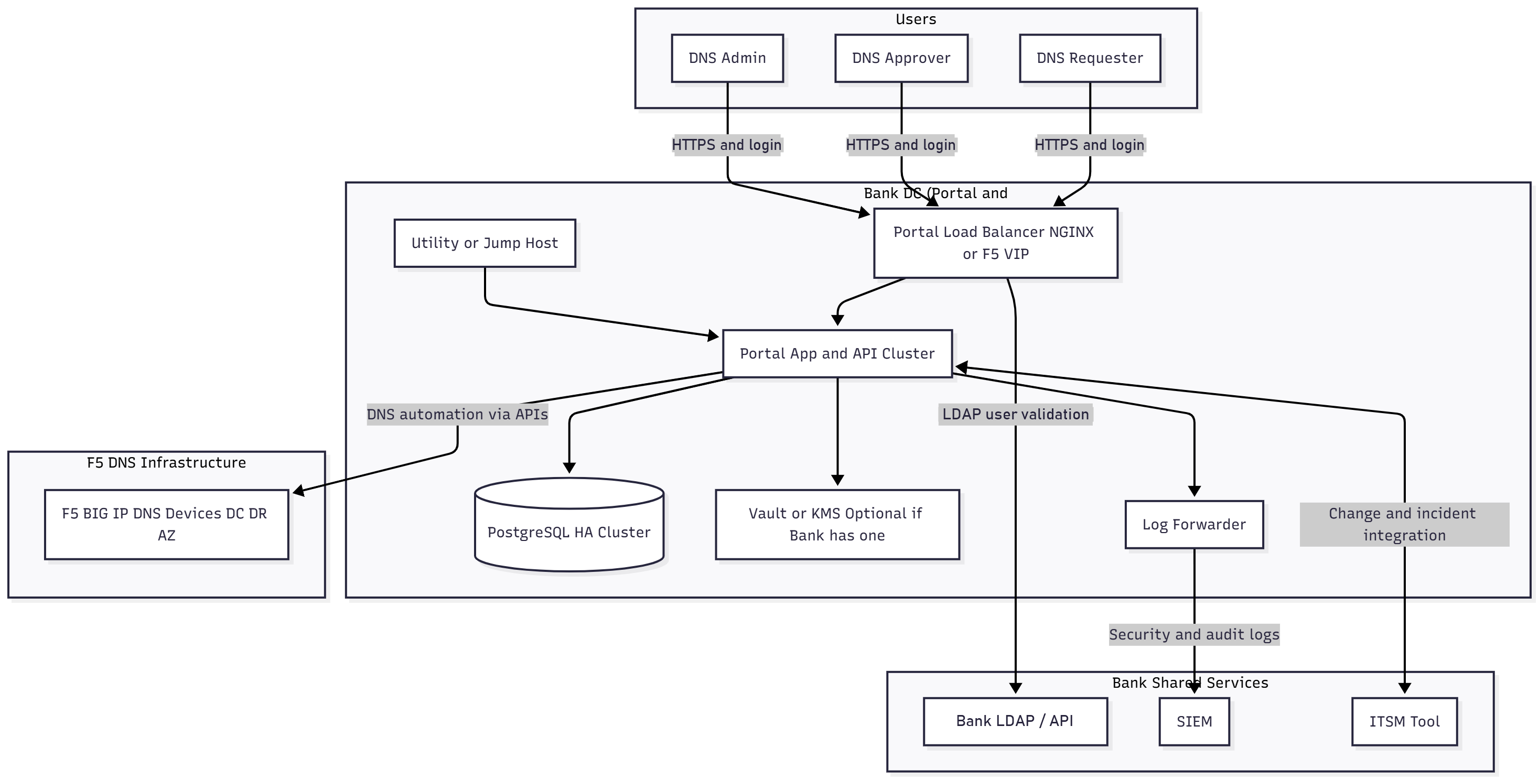
Figure 1 - Functional high-level system view
The functional view above remains applicable to the portal services and integration boundaries. The physical deployment of those services is distributed across DC and DR as shown below, F5 DNS remains the authoritative resolution plane while the portal provides management, governance, workflow and audit controls.
DC/DR Deployment Architecture
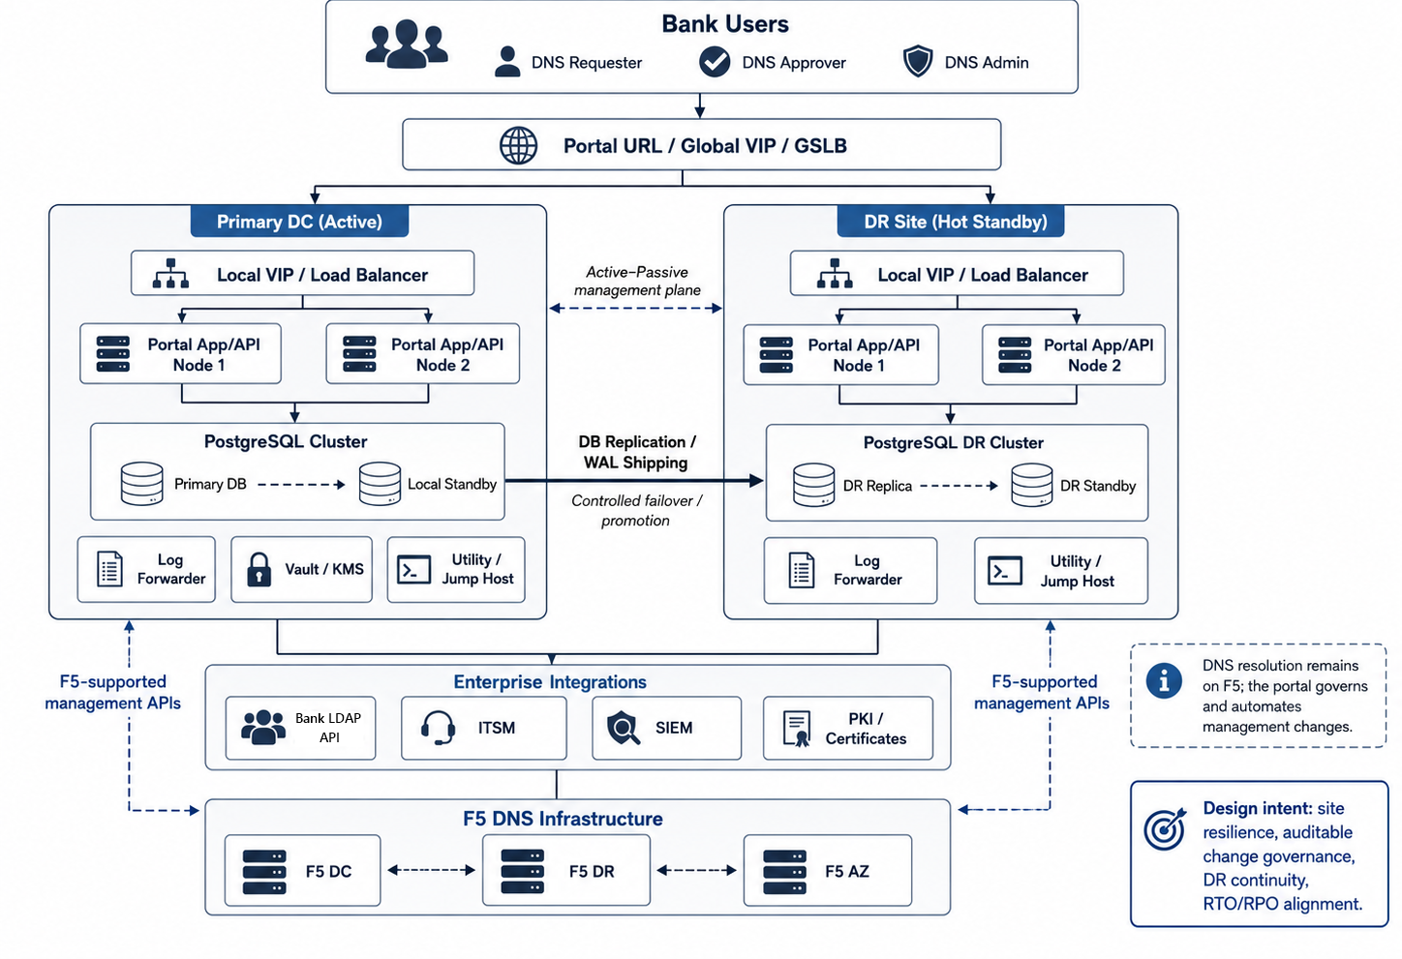
Figure 2 - Production DC/DR high-availability deployment architecture
Figure 2 shows the production management plane distributed between the Primary DC and DR site. Users access a single Portal URL through a Bank/F5 global VIP/GSLB or equivalent traffic-management service. The DC site is active during normal operation, and the DR site remains hot-standby. A lightweight Portal HA/DR Controller, co-deployed with the Portal application control services at each site, coordinates site role, database promotion, scheduler/background-worker activation and site-readiness signaling. The global VIP performs user-traffic switching only after the target site is declared ready. PostgreSQL state is continuously replicated to DR, while an Infrastructure Fencing Adapter uses an approved Bank private-cloud or virtualization control interface to isolate the former active Portal/database resources before DR database promotion. Both sites maintain the required enterprise-integration and F5-management connectivity, so DR service does not depend on the failed DC.
DNS resolution is intentionally outside this failover path: F5 DNS continues to answer queries independently. The portal failover protects DNS management and change governance, not the DNS resolution plane.
The high-level system view can be summarized as:
  - Bank users (makers, checkers and the Admin) access a single portal URL over HTTPS. A global VIP/GSLB or equivalent Bank/F5 service directs traffic to the active site, where a local VIP/load balancer distributes requests across healthy portal nodes.
  - The load balancer forwards traffic to a cluster of Portal App/API nodes, which implement business logic, workflow, validation and integrations.
  - All request, workflow, audit and configuration data is persisted in a PostgreSQL HA design with local standby capacity and cross-site replication to DR.
  - Sensitive secrets (API credentials, DB passwords, tokens) are read from a Vault or KMS component (either Bank’s existing one or an optional, dedicated Vault).
  - Application and audit logs are collected by a Log Forwarder, which ships them to the Bank’s SIEM.
  - A Utility / Jump Host (or Bank enterprise bastion) is available at each required administration boundary for controlled maintenance, connectivity validation and troubleshooting.
  - The Portal App/API cluster integrates with:
    - F5 BIG-IP DNS devices at DC/DR/AZ to perform DNS record automation via APIs.
    - The Bank’s ITSM tool for change and incident correlation.
    - The Bank’s LDAP/directory API for validating users who do not have a local portal account.
Conceptually, the architecture separates the DNS resolution plane (handled by F5 DNS) from the management and governance plane (implemented by the Portal). This separation remains intact during portal component or site failover.

Logical Architecture

Logically, the solution consists of four primary layers:
- Presentation Layer (Users & Load Balancer)
- Application Layer (Portal App/API Cluster)
- Data & Security Layer (PostgreSQL HA, Vault/KMS, Logs)
- Integration Layer (F5 DNS, LDAP/directory API, ITSM, SIEM)

Logical Architecture and End-to-End Flow
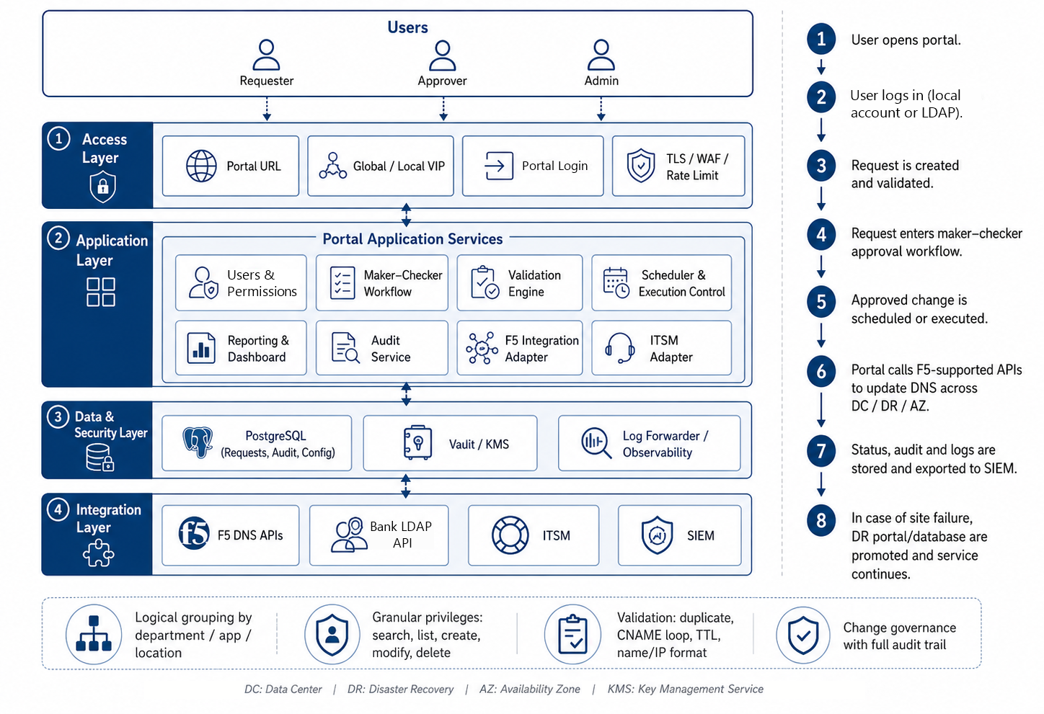
Figure 3 - Logical architecture and request lifecycle
The logical architecture keeps the original four-layer model: access, application, data/security and integration. A DNS request is authenticated against the local portal user store or the Bank LDAP/directory API, validated and subjected to group-scoped maker–checker workflow, scheduled/executed by the active portal site, applied through the supported F5 management interfaces and recorded in the audit store/SIEM. The same durable workflow state is available after a controlled site failover so pending or in-flight requests can be reconciled before further execution.

Presentation Layer

Users
  - Represented in the diagram as “DNS Requester”, “DNS Approver”, and “DNS Admin”.
  - These are Bank employees who sign in through the portal login (local portal account or Bank LDAP/directory validation) and interact with the portal using a web browser.
  - In the portal these map to permissions rather than fixed roles: DNS Requester = Write (maker), DNS Approver = Checker, and DNS Admin = the single configuration-based Admin, as described in section 5.5.
Portal Access and Load Balancing (Global VIP/GSLB + Local VIP)
  - Presents a single logical portal URL and routes users to the active portal site.
  - Terminates or passes through TLS 1.3 as per Bank/F5 standards, applies WAF/rate-limit policies where required, and forwards requests through the local site VIP to healthy application nodes.
  - Presents the portal login and protects the authentication endpoints:
    - Unauthenticated users are directed to the portal login page, where the Portal App verifies the credentials (local user store first, then the Bank LDAP/directory API).
    - After successful authentication, the portal issues a secure, short-lived session token. Login endpoints are protected by rate limiting, account lockout and WAF policies where required.
  - This layer abstracts both application-node and site topology, giving users a single URL and consistent security posture during normal operation and controlled DR failover.

Application Layer

Portal App and API Cluster
Stateless application nodes are deployed with local redundancy at the production DC and DR sites. Each node
runs:
  - React front-end (served as a SPA).
  - Spring Boot back-end services.
Core responsibilities:
  - Implement local user management and permission-based access control (Read, Write, Checker) scoped by DNS group, enforced at the API and data-access layer.
  - Enforce maker–checker workflows for DNS changes.
  - Validate DNS records (duplicate checks, CNAME loop prevention, TTL policies, and name/IP/record-format validation).
  - Orchestrate DNS change execution across F5 DC/DR through F5-supported management APIs/interfaces.
  - Expose REST APIs for UI and possible future automation.
  - Integrate with ITSM for change/incident management and with SIEM for centralized audit/security logging.
  - Maintain durable execution state, idempotency keys and reconciliation status so an approved DNS change cannot be executed twice during retry or site failover.
  - Run scheduler/background workers under active-site ownership/leader control, DR workers remain passive until the site is promoted.
  - Authenticate users against the local portal user store and, only for users not found locally, against the Bank LDAP/directory API.
  - Maintain versioned DNS record configuration (version 1.0 onward) and support version comparison and immediate or scheduled rollback to a previous version.
Utility / Jump Host
A hardened VM used by administrators for:
  - Controlled access to portal servers (for logs, configuration, advanced troubleshooting).
  - Testing connectivity to F5 management APIs, the Bank LDAP/directory API, SIEM and ITSM endpoints from both production site boundaries as required.
The Utility/Jump Host is not used in normal user workflows but is useful for controlled operations and support. Portal application nodes remain stateless so they can be added, replaced or promoted at either site without losing workflow state, durable state is maintained in PostgreSQL.

Data & Security Layer

PostgreSQL HA Cluster
- Represented as a single logical PostgreSQL service, implemented across DC and DR with local HA and cross-site recovery:
    - One active primary at the serving site.
    - A local standby at the active site plus DR replicas maintained through PostgreSQL streaming/WAL replication, after DR promotion, the second DR node provides local standby capacity.
  - Stores:
    - DNS change requests and their lifecycle states (pending, approved, scheduled, executed, rejected).
    - Audit history of operations.
    - Mapping of zones, environments, and logical groupings (department, application, location).
    - Configuration data (validation rules, workflow definitions, integration settings).
    - Local user accounts (salted password hashes for local users only), Read/Write/Checker permissions, DNS group definitions, user-to-group mappings and DNS record ownership per group.
    - Versioned DNS record configuration snapshots with change metadata, used for version comparison and rollback.
  - High availability is achieved through Patroni or an equivalent approved PostgreSQL HA mechanism, backed by a distributed consensus/DCS design. Promotion is controlled with fencing/split-brain protection, an independent quorum/witness failure domain is recommended for safe cross-site decisions.
Vault or KMS (Optional if Bank Has Existing Solution)
Used to securely store:
  - F5 management API credentials/tokens.
  - Database user/passwords.
  - ITSM API tokens, mail gateways, and any other sensitive secrets.
  - The bootstrap Admin credential and the Bank LDAP/directory API service credentials.
The Portal App nodes read secrets at startup or on demand. The diagram shows this as a separate block, but in many banks, this will be an existing enterprise KMS/HSM/Vault.

Log Forwarder
A component (e.g., Fluent Bit or rsyslog) responsible for:
  - Collecting logs from the app nodes (and optionally the DB).
  - Normalizing and tagging logs.
  - Forwarding them to the Bank’s SIEM - Ensures all security and audit trails are centrally captured and monitored.
This layer ensures that the portal’s state, secrets and evidence trails are durable, secure and compliant with Bank’s IS policies.

Integration Layer

F5 DNS Infrastructure (DC, DR, AZ)
Shown as a single logical block representing F5 BIG-IP/BIG-IQ DNS management endpoints across DC/DR/AZ.
Represents all F5 BIG-IP DNS instances that:
  - Authoritatively serve the Bank’s DNS zones.
  - Are the actual “resolution plane” for client DNS queries.
The portal does not replace F5, it governs and automates F5 configuration through supported management APIs/interfaces:
  - For each approved change, the Portal App calls:
    - F5 DC for primary site changes.
    - F5 DR and F5 AZ for redundancy and geo-consistency, as required.
  - This supports the requirement that a DNS change raised once in the portal can be applied consistently across all relevant sites.
Bank LDAP / Directory API
  - Validates Bank users who do not have a local portal account.
  - The portal uses the Bank-provided LDAP/directory API to:
    - Validate the user’s Bank credentials, only when the username is not found in the local portal database.
    - Retrieve basic identity attributes (for example user ID, name, email and department) for the user profile.
    - Return a success or failure result to the portal. Failed attempts count towards account lockout.
  - Group access and permissions are not taken from LDAP. The Admin maps each user to DNS groups and permissions inside the portal, as described in section 5.5.
SIEM
  - Receives log streams from the Log Forwarder.
  - Used for:
    - Real-time security monitoring.
    - Correlation with other systems’ logs.
    - Forensic analysis during audits or incidents.

ITSM Tool
  - Represented as a single block “ITSM Tool”.
  - The portal integrates with the Bank-provided ITSM APIs to:
    - Create or link change records corresponding to DNS requests and update execution status/evidence.
    - Validate applicable approval/status conditions before execution and create/link incident records for failed changes as defined during detailed design.
These integrations tie the portal tightly into the Bank’s existing security, change management and DNS ecosystems.

Architecture Traceability

Security and Authentication
- All user traffic is TLS-encrypted between the browser and the Portal Load Balancer.
- All users sign in through the portal login. Local users are verified against the portal user store, and all other Bank users against the Bank LDAP/directory API.
- Bank (LDAP) passwords are never stored by the portal. Local user passwords are stored only as salted, adaptive hashes (for example bcrypt or Argon2), and the Admin credential is held in protected configuration or Vault/KMS, never in code or the database.
- Secrets used to connect to F5, DB, LDAP and ITSM are stored in Vault/KMS, not in code or plain-text files.

Governance and Maker–Checker
Centralizing all DNS changes through the Portal App/API cluster allows:
  - Permission-based control (Read, Write, Checker) over who can view, who can request and who can approve, scoped by DNS group.
  - Enforcement that requesters cannot approve their own changes (maker–checker).
  - Group-scoped isolation, so users see and raise requests only for the DNS records of the groups they are mapped to, while checkers approve within their assigned groups or all groups.
  - Version-controlled DNS records with comparison and rollback to any previously applied configuration.
  - A consistent audit model where every action is recorded in the DB and exported to SIEM.
High Availability and Cross-Data-Centre Continuity
  - Portal application services:
    - Multiple stateless Portal nodes at each production site allow local node failure to be absorbed without loss of management state.
    - Local VIPs route requests only to healthy nodes, the global portal endpoint routes users to the active site based on site health and the agreed failover policy.
  - PostgreSQL HA/DR:
    - A single active PostgreSQL writer is protected by a local standby and cross-site DR replicas. Controlled promotion, fencing and rejoin/failback procedures prevent split-brain and dual-writer scenarios.
    - Database state is replicated locally and to DR using streaming/WAL mechanisms, with backup/PITR retained independently of a single-site failure domain. The active-site scheduler and background workers are gated by site role so that only one site can execute approved DNS changes at a time.
The management plane is designed for local component resilience and controlled cross-site failover. The DR portal remains pre-deployed with F5, LDAP/directory API, ITSM and SIEM connectivity validated. The architecture is designed to support the stipulated management-plane RTO/RPO, subject to the Bank-provided network, virtualization, VIP/GSLB and storage capabilities. DNS resolution remains independent and continues on F5 even while the portal management plane is failing over.

Cross-Site Failover Orchestration and Safeguards
Cross-site failover separates traffic management from database and execution-state transition. The Bank/F5 global VIP/GSLB is responsible for routing users to the site that exposes an ACTIVE/READY health state, the Portal HA/DR Controller is responsible for determining when a site can safely assume the active role. This prevents user traffic from reaching DR before the database and background-execution layers are ready.

In the event of a confirmed primary-site outage, the controlled failover sequence is:
- Validate loss of the active DC Portal service using multiple health signals such as peer heartbeat, Portal readiness, database state and site/load-balancer health.
- Check the DR PostgreSQL replication state and confirm that the latest available state is within the agreed RPO threshold.
- Invoke the Infrastructure Fencing Adapter using the Bank-approved private-cloud or virtualization management API to power-off or network-isolate the former active Portal/database resources.
- Require positive confirmation of fencing or demotion before allowing the DR database to become writable. If safe isolation cannot be established, automatic promotion is inhibited and a critical recovery event is raised.
- Promote the DR PostgreSQL instance to the writable primary role and validate database availability.
- Switch the DR Portal site role to ACTIVE and enable schedulers/background execution workers only at that site.
- Reconcile requests that were in-flight at the time of failure before any retry is attempted, using persisted workflow state and idempotency/execution identifiers to prevent duplicate DNS changes.
- Expose the DR Portal readiness endpoint as ACTIVE/READY. The global VIP/GSLB then directs user traffic to DR.
- Record the complete failover sequence, state transitions and recovery actions in the audit trail and forward relevant events to SIEM.

Safeguards
- Single-writer database model: only one PostgreSQL primary is permitted across DC and DR.
- Infrastructure fencing: the former primary is isolated before DR promotion, failover does not rely only on network reachability or a failed ping.
- Application role gating: only the ACTIVE site can pick scheduled jobs or execute approved DNS changes.
- Fail-safe promotion: if the previous primary cannot be positively fenced/demoted, automatic promotion is blocked rather than risking split-brain.
- Optional database self-fencing/watchdog controls may be enabled as a second safety layer, subject to the PostgreSQL HA technology selected during detailed design.
- Controlled failback: a recovered DC database rejoins first as a standby and is fully synchronized before a planned role switchover back to DC.

Multi-Site DNS Control
  - The logical block “F5 BIG IP DNS Devices DC DR AZ” emphasizes that:
  - F5 DNS remains distributed for resilience and performance.
  - The portal connects through the F5-supported management interfaces applicable to the selected BIG-IP/BIG-IQ versions.
  - A single approved change in the portal can be automatically applied to F5 at all sites ensuring consistent DNS records across redundant sites without requiring users to login to multiple F5 instances.

Compliance, Logging and Audit
  - The Log Forwarder → SIEM path ensures that:
- All critical events (login, requests, approvals, changes, rollbacks, user and permission changes, failures) are available centrally.
- The Bank’s SOC can define alerts, dashboards and correlation rules based on these logs.
  - The PostgreSQL DB maintains a structured, queryable history of changes and approvals, enabling:
- Regulatory audits.
- Internal IS reviews.
- Forensic investigations.

Workflow Diagram
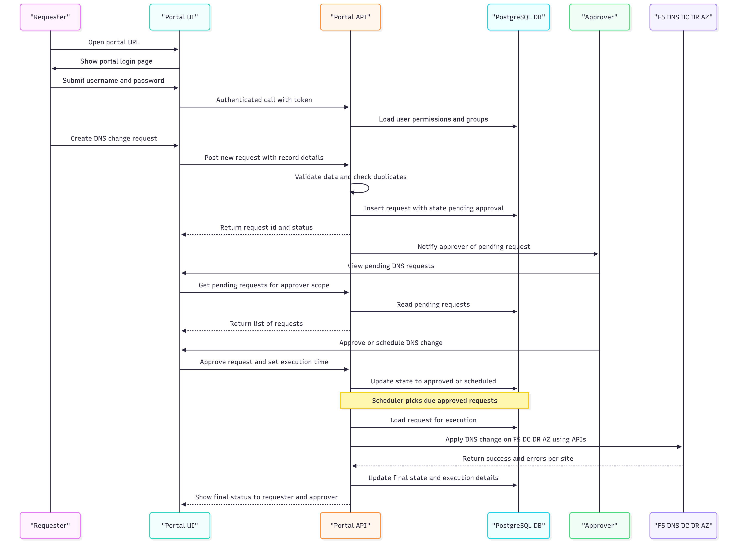
Figure 4 - DNS request, approval, scheduling and execution workflow

The above diagram shows the following flow:
- Users (makers, checkers and the Admin) open the DNS Portal URL in a browser.
- Their requests reach the portal endpoint and are directed to the active site (DC during normal operation, or DR following an approved/automated site failover), where the local load-balancing layer:
  - Enforces TLS.
  - Protects the portal login and authentication endpoints.
- The user signs in on the portal login page. The Portal App verifies the credentials (local user store first, then the Bank LDAP/directory API) and issues a secure session token.
- The Load Balancer forwards the authenticated request to one of the nodes in the Portal App and API Cluster.
- The Portal App:
  - Validates user permissions and group membership.
  - Interacts with the PostgreSQL HA Cluster for storing/retrieving request, audit and configuration data.
  - Reads secrets from the Vault/KMS when it needs to connect securely to F5, LDAP, ITSM or other backends.
  - Emits structured logs to the Log Forwarder, which streams them into the SIEM.
  - On demand, calls the ITSM Tool APIs to create or update change tickets.
- When a DNS change request is approved and ready to execute, the active portal site calls the appropriate F5 DNS management interfaces across DC/DR/AZ. Execution state is persisted before and after each operation so retries, reconciliation and recovery can be performed safely if a site or API fails mid-change.
- Throughout, administrators may use the approved Utility/Jump Host or Bank enterprise bastion for controlled maintenance, testing and troubleshooting from either production site, without exposing the portal or F5 directly to unmanaged workstations.
This layered approach keeps the solution modular, secure and maintainable, while tying in naturally with the Bank’s existing F5 DNS, identity, security and ITSM ecosystems.

User Management, Access Control, Versioning and Rollback
The portal manages its own users and permissions. A single configuration-based Admin creates local users and maps users to DNS groups with Read, Write and Checker permissions, while Bank users who do not have a local account are validated against the Bank LDAP/directory API. All changes remain subject to maker–checker approval, and every DNS record managed through the portal is version-controlled so that any previous configuration can be compared and restored.
User Types
  - Admin: a single Admin account whose username and credential are defined in protected configuration (an environment/.env or application configuration file, preferably injected from the Bank Vault/KMS). The credential is held as a salted hash, not in plain text and not in the database. The Admin account cannot be created, edited or deleted from the UI, can be changed only through a controlled configuration change, and every Admin login and action is audited.
  - Local users: users created by the Admin inside the portal. Their credentials are stored in the portal database as salted, adaptive password hashes, with password complexity, expiry and lockout rules as per Bank IS policy. The Admin can disable a local user or reset their password.
  - Bank (LDAP) users: users who are not present in the local portal database are validated against the Bank LDAP/directory API. The portal never stores their Bank password.
Login Flow
  - The user enters a username and password on the portal login page.
  - The portal first looks up the username in the local portal database (including the configuration-based Admin). For the Admin and local users, the password is verified against the stored hash.
  - Only when the username is not found in the local database does the portal call the Bank LDAP/directory API to validate the credentials.
  - On successful validation, the portal issues a secure, short-lived session token.
  - On the first successful LDAP login, the portal creates a user profile marked as LDAP-sourced, with status Pending Access and no groups or permissions. The user can sign in but sees no DNS records until the Admin maps them. Later logins of an LDAP-sourced profile are still validated against the Bank LDAP/directory API, because the portal does not hold Bank passwords.
  - The new user appears in the Admin’s pending-users list, and the Admin maps the user to one or more DNS groups with the required permissions.
  - Successful and failed logins, lockouts and LDAP errors are audited and forwarded to SIEM. If the LDAP/directory API is unavailable, local accounts and the Admin can still sign in.
Permissions
  - Read: view, search and list the DNS records, request status and version numbers of the assigned groups.
  - Write (maker): everything in Read, plus raising create, modify and delete requests (immediate or scheduled) for records in the assigned groups, and modifying or cancelling their own pending requests until execution.
  - Checker: approve or reject requests for the assigned groups. When granting Checker permission, the Admin can select specific groups or All groups.
  - Permissions can be combined (for example Write and Checker), but maker–checker is always enforced: no user, including the Admin, can approve their own request.
Group Assignment
  - The Admin creates and maintains DNS groups (for example department, application, location or user group, in line with the logical grouping in K1) and assigns every DNS record to one owning group.
  - For each user, the Admin selects the permissions and the groups. Read and Write permissions are always given for one or more specific groups. Checker permission can be given for specific groups or for All groups.
  - A user sees all DNS records listed within the groups they are mapped to, and nothing outside them. This is enforced on the server side at the API and data-access layer, not only in the UI, and any request for a record outside the user’s groups is rejected and logged.
  - Changes to a user’s permissions or groups take effect from the user’s next request, and are recorded in the audit trail.
  - Each group should have at least one checker other than the Admin, so that changes raised by the Admin can also be approved.
Request and Approval Flow
  - A user with Write permission raises a create, modify or delete request for a record in one of their groups, to be executed immediately or at a scheduled date and time.
  - The request is validated (duplicate checks, CNAME loop prevention, TTL policies and format validation).
  - The request is sent to all checkers whose scope covers that group, that is the group’s checkers, any All-groups checkers and the Admin. It appears in their approval queues and they are notified.
  - Any one eligible checker can approve or reject the request, and a rejection requires a comment. Once a decision is taken the request is removed from the other checkers’ queues. Multi-level approval can be configured per group if the Bank requires it.
  - An approved immediate request is executed on F5 at once, and an approved scheduled request is executed at its scheduled time. Modifying an approved scheduled request returns it for re-approval.
Admin Capabilities
  - Create, edit, disable and reset local users, and assign their permissions and groups.
  - Review users created by their first LDAP login and map them to groups and permissions.
  - Create and maintain DNS groups and the ownership of records between groups.
  - Group-wise view of all DNS records, pending requests, scheduled changes and execution history across every group.
  - Act as a checker for all groups, and raise changes in any group (approved by another eligible checker).
  - View the complete version history of any record, compare any two versions, and roll back a record to a previous version immediately or at a scheduled date and time.
Permission Matrix
Capability | Read | Write | Checker | Admin
View / search / list DNS records and version history | Assigned groups | Assigned groups | Assigned or all groups | All groups
Raise create / modify / delete request (immediate or scheduled) | No | Assigned groups | No (unless also Write) | All groups
Modify or cancel own pending request | No | Yes, until execution | No | Yes
Approve / reject requests | No | No | Assigned or all groups, not own | All groups, not own
Compare versions and roll back (immediate or scheduled) | No | No | No | Yes
Manage users, permissions, groups and record ownership | No | No | No | Yes
DNS Record Versioning
  - Every DNS record managed by the portal carries a version number. A record starts at version 1.0 when it is first created and successfully applied to F5, and each subsequent approved and successfully executed change increments the version (1.0 → 1.1 → 1.2 and so on).
  - For every version, the portal saves a complete configuration snapshot of the record (for example zone, name, record type, values/targets, TTL and the related F5 DNS object configuration applicable to the integration model), together with change metadata: group, maker, checker, timestamp, change reason, ITSM reference and execution result per F5 site.
  - Versions are immutable. Pending, rejected or failed requests do not create a new version. A version is committed only after the change has been successfully applied, so the version history always reflects configuration that was actually live on F5.
  - Deleting a record creates a final version marked as deleted that retains the last configuration, so a deleted record can still be reviewed and restored by the Admin through rollback.
  - Version history is retained in PostgreSQL together with the audit trail, in line with the 7-year audit and reporting requirement, and version events are forwarded to SIEM.
Version Comparison
  - The Admin can select any two versions of a record, or a previous version and the current version, and view a field-level side-by-side comparison showing added, changed and removed values.
  - Before a rollback is submitted, the portal also compares the latest version recorded in the portal with the live configuration read from F5, so that any change made directly on F5 outside the portal is highlighted before it is overwritten.
Rollback and Scheduled Rollback
The Admin can restore a record directly to any previous version from its saved configuration snapshot, without re-entering the configuration. The rollback flow is:
  - The Admin selects the record and the target version from the version history, and reviews the comparison between the current and target versions.
  - The Admin chooses to execute the rollback immediately or schedules it for a specific date and time, and records the reason and ITSM reference where applicable.
  - The rollback request is validated using the same rules as any other DNS change and is approved by an eligible checker for that group other than the Admin.
  - At execution time, the active portal site re-validates the request, re-checks the live F5 configuration for drift and applies the target version’s configuration across DC/DR/AZ through the F5-supported management interfaces, using the same idempotent execution engine as other DNS changes.
  - On success, the rollback is committed as a new version. For example, rolling back from version 1.3 to version 1.1 creates version 1.4 containing the configuration of version 1.1. Existing history is never overwritten or deleted.
  - The rollback, its approval, schedule and per-site execution result are recorded in the audit trail, forwarded to SIEM and updated in ITSM.
Scheduled rollbacks are held as scheduled jobs under active-site ownership, so they survive a site failover in the same way as other scheduled changes. If the record is changed again after a rollback has been scheduled, the rollback is held for Admin confirmation instead of being executed automatically.

Infrastructure Dimensioning
The following sizing is an engineering baseline for the production DC/DR and separate UAT deployment. It retains the conservative per-node sizing used in the earlier design while distributing runtime components across two production sites. Final sizing will be validated during HLD against the Bank’s DNS inventory, user/concurrency profile, audit-retention requirements, infrastructure standards and the final F5 integration model.

6.1 Production - Primary DC
Component | Qty | vCPU / node | RAM / node | Storage / Notes
Portal App/API | 2 | 16 | 16 GB | 180 GB each, stateless, local HA behind site VIP
PostgreSQL | 2 | 16 | 32 GB | 500 GB each + WAL, active primary + local standby
Log Forwarder | 1 | 4 | 8 GB | 100 GB, local buffering/forwarding to SIEM
Utility / Jump Host | 1 | 8 | 16 GB | 80 GB, optional if Bank enterprise bastion is available
Local Load Balancer | F5 service | - | - | Reuse Bank/F5 VIP/WAF where available, dedicated nodes only if required

6.2 Production - DR Site
Component | Qty | vCPU / node | RAM / node | Storage / Notes
Portal App/API | 2 | 16 | 16 GB | 180 GB each, hot-standby application capacity, active after site failover
PostgreSQL | 2 | 16 | 32 GB | 500 GB each + WAL, DR replica + DR standby, one promoted during failover
Log Forwarder | 1 | 4 | 8 GB | 100 GB, DR-local log path to SIEM
Utility / Jump Host | 1 | 8 | 16 GB | 80 GB, optional if Bank enterprise bastion is available
Local Load Balancer | F5 service | - | - | Reuse Bank/F5 VIP/WAF where available, dedicated nodes only if required

6.3 Cross-Site HA/DR Control Services
The baseline design does not require a separately sized witness VM solely for cross-site failover. Cross-site role transition is coordinated by logical control services co-deployed with the Portal application and database layers, while the Bank/F5 global VIP/GSLB handles user-traffic switching. The Bank is expected to expose the approved infrastructure-management control interface and restricted service credentials required for automated fencing of the Portal resources, the orchestration logic remains part of the Portal solution.
If the PostgreSQL HA technology selected during detailed design requires a DCS/consensus capability for local database automation, the preferred approach is to use an approved Bank-provided service or to co-deploy the required lightweight control processes across already-sized Portal/control nodes. A dedicated witness VM is therefore not assumed in the baseline sizing.
Control Function | Mechanism | Deployment | Sizing Impact
Portal HA/DR Controller | Peer/site health aggregation, site-role state machine, database-promotion coordination, scheduler/background-worker gating and readiness signalling | 1 logical service per production site, co-deployed with Portal App/API | No standalone VM, included within Portal App/API allocation
Infrastructure Fencing Adapter | Invokes Bank-approved private-cloud/virtualization API to power-off or network-isolate former active Portal/database resources | 1 logical module per production site, co-deployed with HA/DR Controller | No standalone VM, included within Portal App/API allocation
Global VIP / GSLB | Health-based user-traffic routing between DC and DR | Bank/F5 traffic-management service | No dedicated Portal VM where Bank/F5 service is reused
PostgreSQL HA / Promotion Control | Streaming/WAL replication, controlled promotion, rejoin/failback and PITR | Runs with PostgreSQL nodes and selected HA tooling | Included within PostgreSQL allocation
Watchdog / Self-Fencing (where supported) | Secondary safety control to stop/reset a database node that loses valid leadership | Database/hypervisor level, final mechanism selected in HLD | No separate VM

6.4 Separate UAT Environment
Production and UAT are treated as separate deployments. UAT may use reduced compute while preserving the same software stack and integration pattern. Where SBI/F5 requires explicit HA/DR rehearsal in UAT, the second application/database nodes can be enabled as shown below.
Component | Qty | vCPU / node | RAM / node | Storage / Notes
Portal App/API | 1-2 | 8-16 | 16 GB | 120-180 GB, second node preferred for HA validation
PostgreSQL | 1-2 | 8-16 | 16-32 GB | 300-500 GB, second DB when DB failover is to be demonstrated
Log Forwarder | 1 | 2-4 | 4-8 GB | 50-100 GB, UAT SIEM/test logging
Utility / Bastion | 0-1 | 4-8 | 8-16 GB | 60-80 GB, reuse Bank bastion where available

6.5 Production Capacity Summary
Metric | Approximate Production Capacity
Portal App/API | 4 nodes total (2 DC + 2 DR)
PostgreSQL | 4 nodes total (2 DC + 2 DR)
HA/DR control services | 2 site-local logical controller instances + fencing modules, co-deployed, no standalone VMs
Log forwarding | 2 instances / site-local paths
Compute | Described in the table above
Memory | Described in the table above
Local VM storage | Described in the table above
Where SBI/F5 provides the global/local VIP, enterprise bastion, Vault/KMS, backup repository and monitoring services, dedicated portal VMs for those functions are not required. This keeps the portal footprint focused on application, database, execution-state and logging components.

Assumptions and Dependencies
Area | Assumption / dependency
Bank infrastructure | Bank provides the approved virtual infrastructure for Production and UAT, including compute, storage and virtualization capacity required by the final HLD.
DC/DR connectivity | Required inter-DC network connectivity, routing, firewall rules and latency/bandwidth are available for portal traffic, PostgreSQL replication and shared-service access.
Traffic management | Bank/F5 provides or approves the global portal VIP/GSLB and local site VIP/WAF/load-balancing services. If dedicated portal load balancers are required, the BOM will be adjusted.
Enterprise services | The Bank LDAP/directory authentication API, ITSM, SIEM, PKI and Bank-standard Vault/KMS/backup services are provided as reachable enterprise integration endpoints with the necessary non-production access and service credentials.
Users and groups | Bank provides the LDAP/directory API specification, a service account and connectivity for user validation, and confirms the initial DNS groups and record-to-group ownership during detailed design. The Admin credential is provisioned through the Bank’s protected configuration or Vault/KMS process.
F5 API boundary | F5 confirms the supported BIG-IP/BIG-IQ management API/interface and object mapping for the agreed DNS record operations and provides the required documentation/access for integration and testing.
Migration boundary | Legacy DNS migration into the F5 DNS platform remains within the F5/bidder migration workstream. The portal establishes its initial synchronized inventory and reconciliation baseline after the migrated F5 environment is available.
Failover control and fencing | Azalio Portal HA/DR orchestration controls the internal DC/DR role transition. SBI provides an approved private-cloud/virtualization management API or equivalent control interface and a least-privileged service identity that can isolate only the Portal/database resources required for fencing. Automatic DR database promotion is inhibited if safe fencing/demotion of the former primary cannot be confirmed.
RTO/RPO | The portal architecture is designed to support the stipulated management-plane RTO/RPO. Final achievement depends on Bank-provided network, virtualization, storage, VIP/GSLB convergence and the approved infrastructure-fencing interface and will be validated through implementation-stage HA/DR testing.
DNS resolution independence | F5 DNS continues to resolve production DNS traffic independently of the portal, portal HA/DR protects management/change continuity rather than DNS query service itself.
PostgreSQL HA tooling | The exact PostgreSQL HA manager, local leader-election mechanism and optional watchdog/self-fencing implementation will be finalized during HLD. Where a DCS/consensus service is required, an approved Bank service or co-deployment on already-sized Portal/control nodes is preferred, no dedicated witness VM is assumed in the baseline BOM.

Responsibility Assignment (RACI)
The following RACI provides the working responsibility model for the overall solution. It is intended to make the implementation boundaries explicit while keeping the bidder/OEM, Portal supplier and Bank infrastructure responsibilities aligned. The contractual and operational RACI will be reconfirmed during project kickoff and detailed design.
Workstream / Activity | SBI / Bank | F5 / Winning Bidder | Azalio | Network Integrator (NI)
Overall solution delivery / bid accountability | C | A | R | I
Bank private-cloud VM / storage provisioning | A/R | C | C | C
Inter-DC network, firewall and routing readiness | A | C | C | R
Global VIP / GSLB and local site VIP/WAF services | A | R | C | R/C
F5 BIG-IP / BIG-IQ platform deployment and OEM support | C | A/R | C | I
Portal application architecture, design and implementation | C | A | R | C
Portal HA/DR Controller and execution-state safeguards | C | A | R | C
Infrastructure fencing API / restricted service identity provisioning | A/R | C | C | C
Infrastructure Fencing Adapter implementation and configuration | C | A | R | C
PostgreSQL HA/DR, replication, promotion and failback | C | A | R | C
F5 management API documentation, access and supported object mapping | I | A/R | C | I
LDAP/directory API, ITSM, SIEM and PKI endpoint availability | A/R | C | R (integration) | C
Legacy DNS migration into F5 platform | C | A/R | C | C
Portal inventory synchronization and post-migration reconciliation | C | A | R | C
Security hardening, VAPT coordination and remediation | A | A/R | R (Portal) | C
Functional/SIT and HA/DR failover testing | C | A | R | C
UAT execution and acceptance | A | R | R | C
Solution documentation, runbooks and KT | C | A | R | C
Portal 7-year maintenance / L3 product support | I | A | R | C/I
R = Responsible | A = Accountable | C = Consulted | I = Informed
Implementation Alignment: Detailed configuration choices, interface contracts, failover thresholds, security controls, operating procedures and final responsibility assignments will be validated with SBI, F5 and the relevant Bank/NI teams during HLD/LLD and implementation planning. This allows the design to remain aligned with the Bank's actual private-cloud, network, security and operational standards without changing the core solution principles described in this proposal.

The architecture described here defines the target control model and safety principles. During project initiation and detailed design, the final HA tooling, health thresholds, fencing API, PostgreSQL promotion/rejoin mechanics, VIP/GSLB monitor behaviour, timeout values and failback sequence will be revalidated jointly with SBI, F5 and the relevant Bank infrastructure teams against the actual private-cloud, network, security and operational standards before production implementation.

