Data Cleaning

5 steps frame work
Clean
- Conceptualize the data (identify granularity, metrics and dimensions)
- Locate solvable issues
- Evaluate unsolvable problems
- Augment the data
- Note and documentation
When is the data ready? There is no point where one should get when cleaning the data. The data is ready when the “modifications” applied are enough to answer the business questions proposed.
Data cleaning can be divided into 3 steps.
- Getting rid of the unnecessary stuff
- Polish and standardize it
- Refine and revisit after first analyze.
Sample
The sample is fictitious, however with tons of business relevance as per its metrics, dimensions and massiveness. The company was founded in 1989. The company sell electronics online in diverse ways.
Conceptualize the data
Before even starting the analysis, it is necessary to ask what are your goals for the data, how can this data help me tell a story. The are 3 questions one should answer.
- What are the granularity of the data?
- What are the metrics? And
- What are the dimensions?
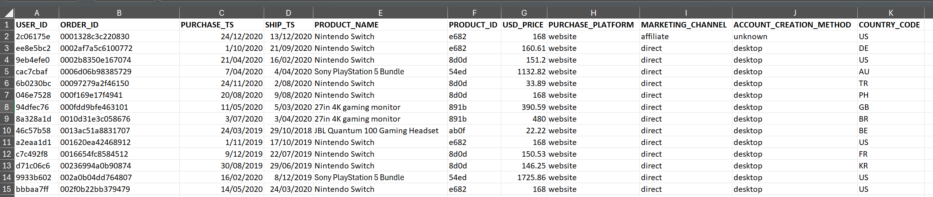
The picture above is shows the data. From this pic one can conclude that the column ORDER-_ID is the unique (primary) column of the data. One say order “x” was made on the “y”, and shipped out on day “z”. The product was “a” and product ID is “b” with value of “c”. The purchase was “online” and was made “on the company website”. The customer used its “smartphone” and its “location is USA”.
The metric for this database is USD_PRICE and the dimensions are PURCHASE_TS, SHIP_TS, PRODUCT_NAME, PRODUCT_ID, PURCHASE_PLATFORM, MARKETING_CHANNEL, ACCOUNT_CREATING_METHOD and COUNTRY_CODE.
Understand the granularity of the data and which attribute represents for the stand point analysis are crucial to answers the business questions that the stakeholers or the team wants from you.
Locate solvable issues
Solvable issues falls into 4 categories
- Inconsistent data format
- Inconsistent categorizations
- Null (sometimes solvable, sometimes not) and
- Duplicates.
To locate and solve the mentions issues, the analyst first can do a quick scan on the data and after that analyse attribute by attribute using filter to better locate the problems. Each problem must be documented in the issue log which helps the analyst document its work.
The following pic shows the issue_log tab on the file excel describing the issue located on the database.
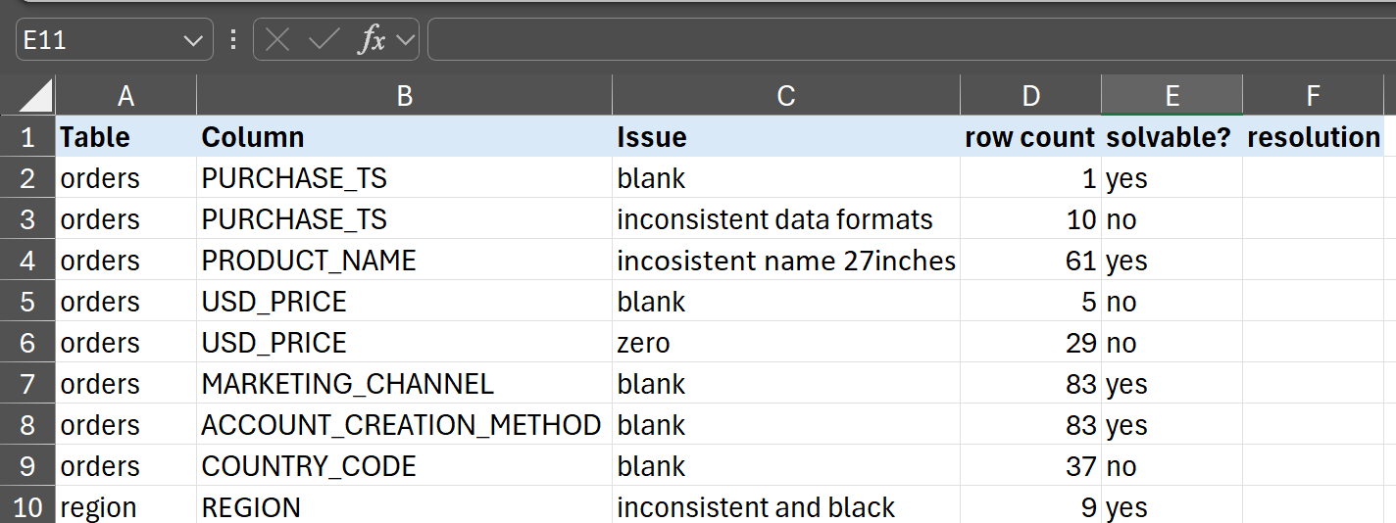
So in the first step, we only looked each column to identify any problem. Notice that nothing fancy was done. We also documented all issues in a issue log each help us prioritize what should be solved first and the magnitude of each issue found.
The next step is to solve the problems that can be solved. For this, I will duplicate the database into a new tab so I do not work on the original data. Additionally, I will not overwrite the attributes, rather I will create new one on the right side of the columns with issue to work on this new ones.
After dealing with each rows on the data, it is time to check for duplicates. In this example I used pivot table, however there are many ways to do it.
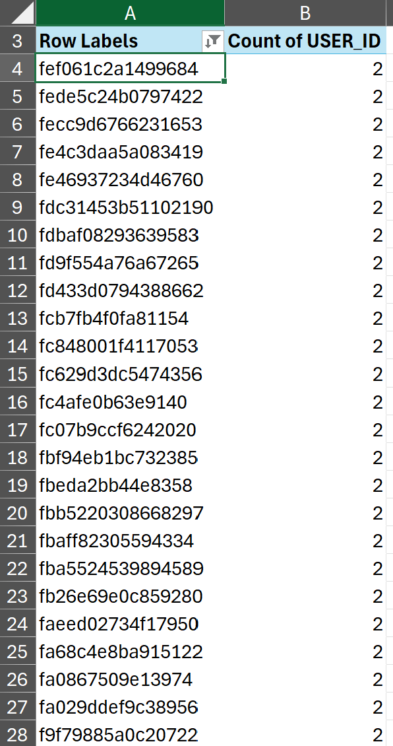

Evaluating Unsolvable issues
In this phase we deal with 3 kinds of issues:
- Null values with no table of truth.
- Outliers, and
- Business logic violations.
Since this project relates to business analytcs we are not worrying about fulfilling the empty cells with information unless we have a table of trugh, in out case we do not have one. Outliers and anomalies values may skew our data, however if it is a real event, we should keep it as it is. Finally, for business logic violations we should look things like parchase date again shipped out data the make shore the shipped out happened after the purchase.
Augment the data
In this phase new attributes may be create based on the existing attributes of the data. Again, the intention here is not to be fancy on analysis, only to generate columns that may be handy according to the business questions in the particular situation.
Note and Documentation

