**5.GIT – HOL**

**Commands entered on GitBash**

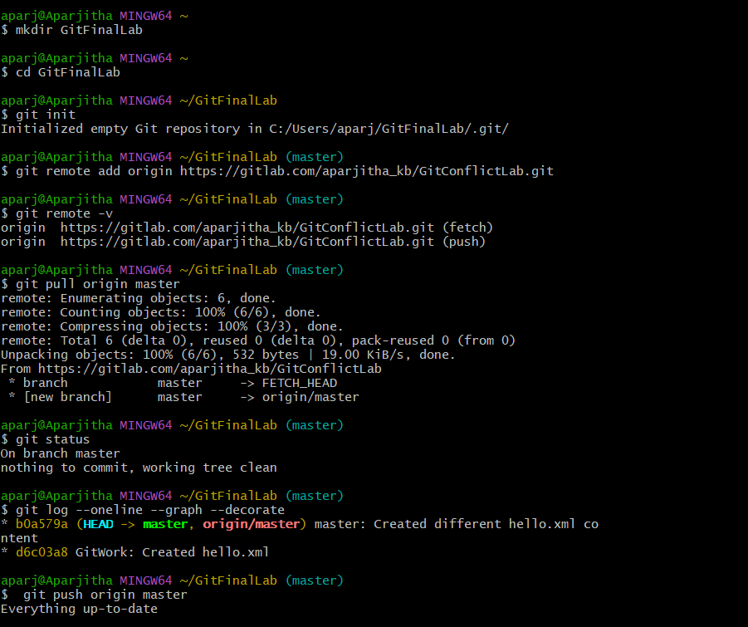

**GIT LAB SITE OUTPUT**

