**Summary:**

**1.) K means Clustering on Image slices of Conv1 layer output.**

* Network used: Caffenet classification network.
* Dataset used: ILSVRC’12
* Input test image of a particular class to the network and obtain the filter output images for a given layer (conv1 in our case).
* So there are 96 , 55 * 55 images. To perform clustering on a slice we randomly selected one slice of 55 so the size of slice is 96X55, each row of which is output of corresponding filters (96 filters)

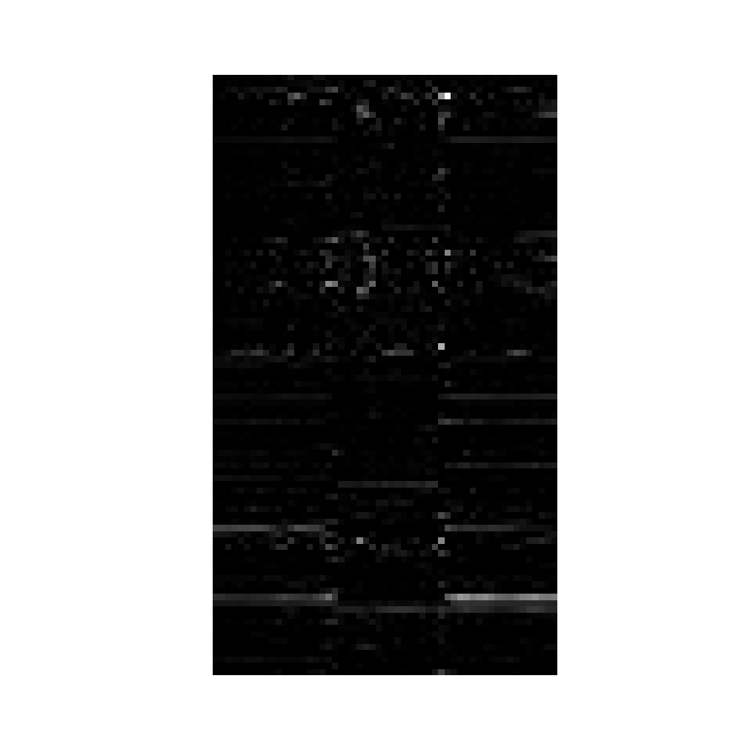

**Input Image Slice (96X55)**

* We performed k means clustering with varying k= 3,7,10, corresponding outputs are attached.

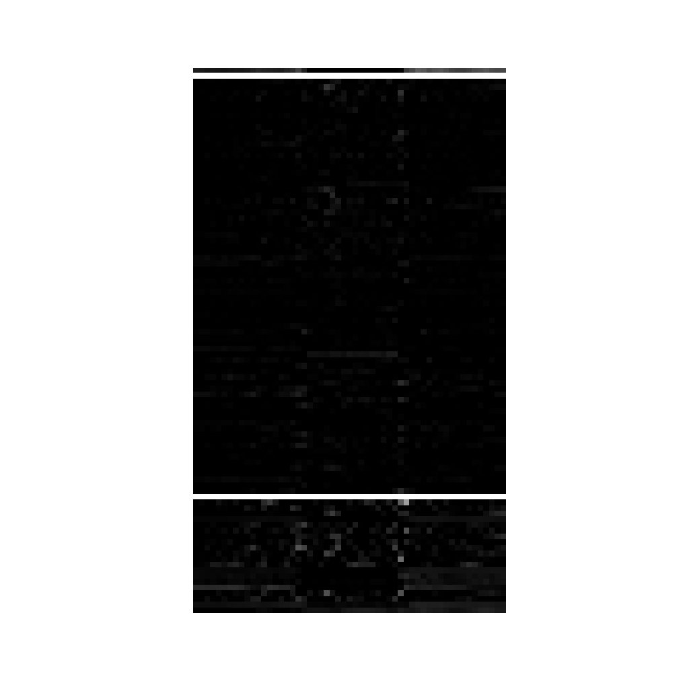

k means with k =3 showing 3 clusters seperated by white line. 3 clusters are of sizes 1,73,22.



k means with k =7 shwing 7 clusters seperated by white line. 3 clusters are of sizes 6,8,65,0,0,3,24

**Reordering of filter output images of a given layer using PCA on Image Slice**

* Simiar Input and network specification and same 96X55 slice.
* Now performed PCA considering 96 data points each a vector of length 55 and obtain a ordering of rows.
* Ordering varies according to positioning of slices but for consecutive slices ordering almost remain same.

**Reordering of filter output images of a given layer using PCA**

* Network used: Caffenet classification network.
* Dataset used: ILSVRC’12
* Input test image of a particular class to the network and obtain the filter output images for a given layer.
* Stack rows of each of these output images to form a vector and stack these vectors into a matrix.
* This matrix is input to the function ‘pca’ which does Principal Component Analysis on the input image vectors and gives the projection matrix as output.
* The vector corresponding to the top eigen value in the projection matrix is extracted and reshaped to fit the original image.
* The original images (filter outputs) are each multiplied with this reshaped projection vector and summed to give a scalar which is the index of the image in the reordered output.
* The original images are reordered according to indexes obtained above and the output is fed to a .vox file which is visualised using the volume renderer software.

