# **EVEN-C1-DWDM_MODEL_EXAM_10.04.2021**

# 

**Name: Aparna.M**

**Register number: 18BCS017**

# **1.Download a suitable dataset for classification from any Repository. List the attributes and its type.**

The dataset uploaded is country_vaccinations.csv from kaggle.com

Country- this is the country for which the vaccination information is provided.

Country ISO Code - ISO code for the country.

Date - date for the data entry; for some of the dates we have only the daily vaccinations, for others, only the (cumulative) total.

Total number of vaccinations - this is the absolute number of total immunizations in the country.

Total number of people vaccinated - a person, depending on the immunization scheme, will receive one or more (typically 2) vaccines; at a certain moment, the number of vaccinations might be larger than the number of people.

Total number of people fully vaccinated - this is the number of people that received the entire set of immunization according to the immunization scheme (typically 2); at a certain moment in time, there might be a certain number of people that received one vaccine and another number (smaller) of people that received all vaccines in the scheme.

Daily vaccinations (raw) - for a certain data entry, the number of vaccinations for that date/country.

Daily vaccinations - for a certain data entry, the number of vaccinations for that date/country.

Total vaccinations per hundred - ratio (in percent) between vaccination number and total population up to the date in the country.

Total number of people vaccinated per hundred - ratio (in percent) between population immunized and total population up to the date in the country.

Total number of people fully vaccinated per hundred - ratio (in percent) between population fully immunized and total population up to the date in the country.

Number of vaccinations per day - number of daily vaccinations for that day and country.

Daily vaccinations per million - ratio (in ppm) between vaccination number and total population for the current date in the country.

Vaccines used in the country - total number of vaccines used in the country (up to date).

Source name - source of the information (national authority, international organization, local organization etc.).

Source website - website of the source of information.

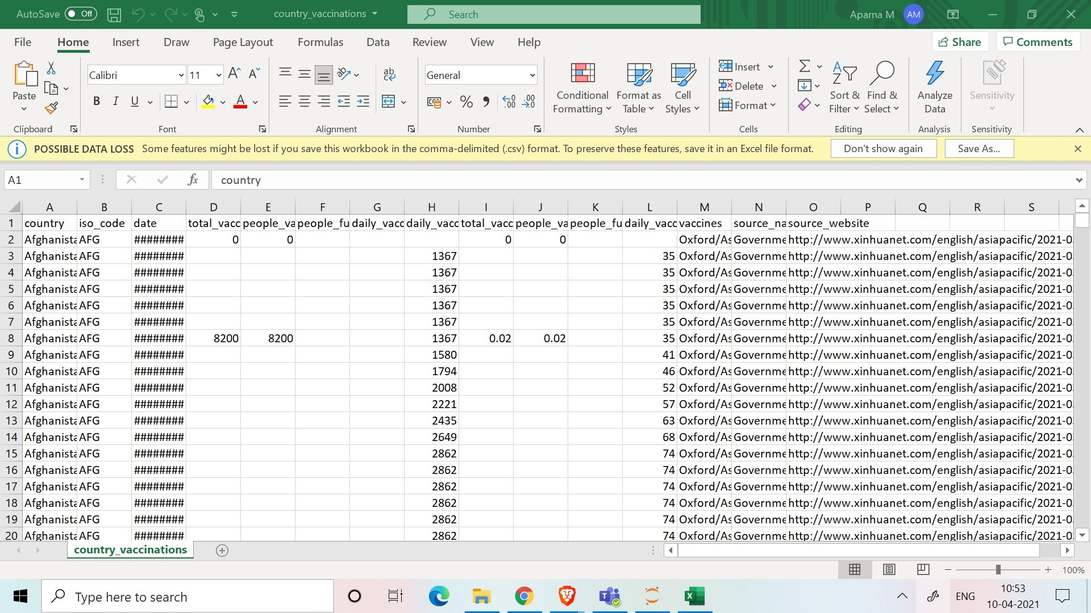

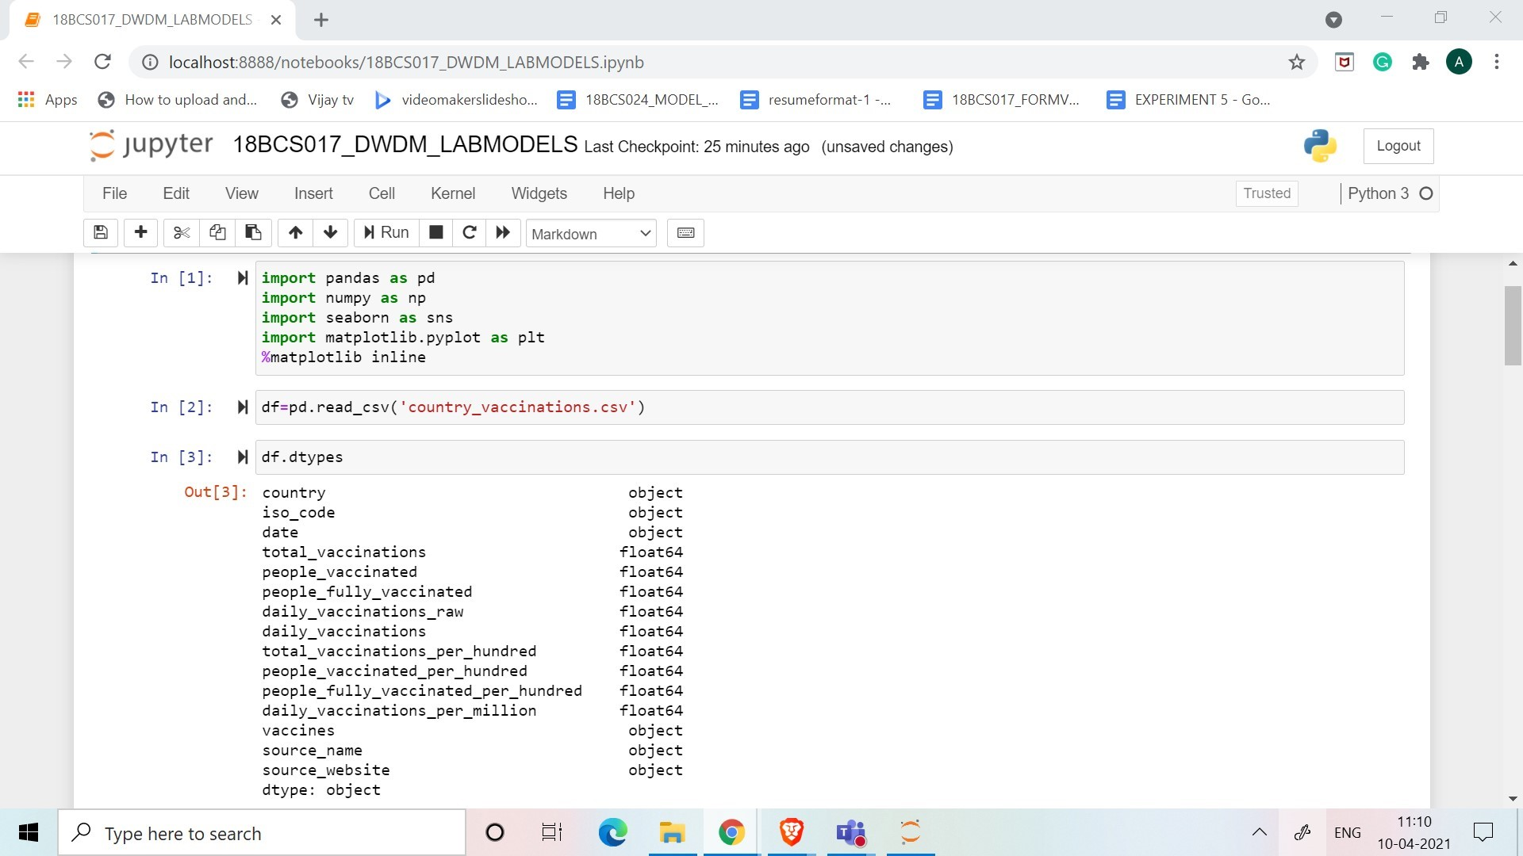

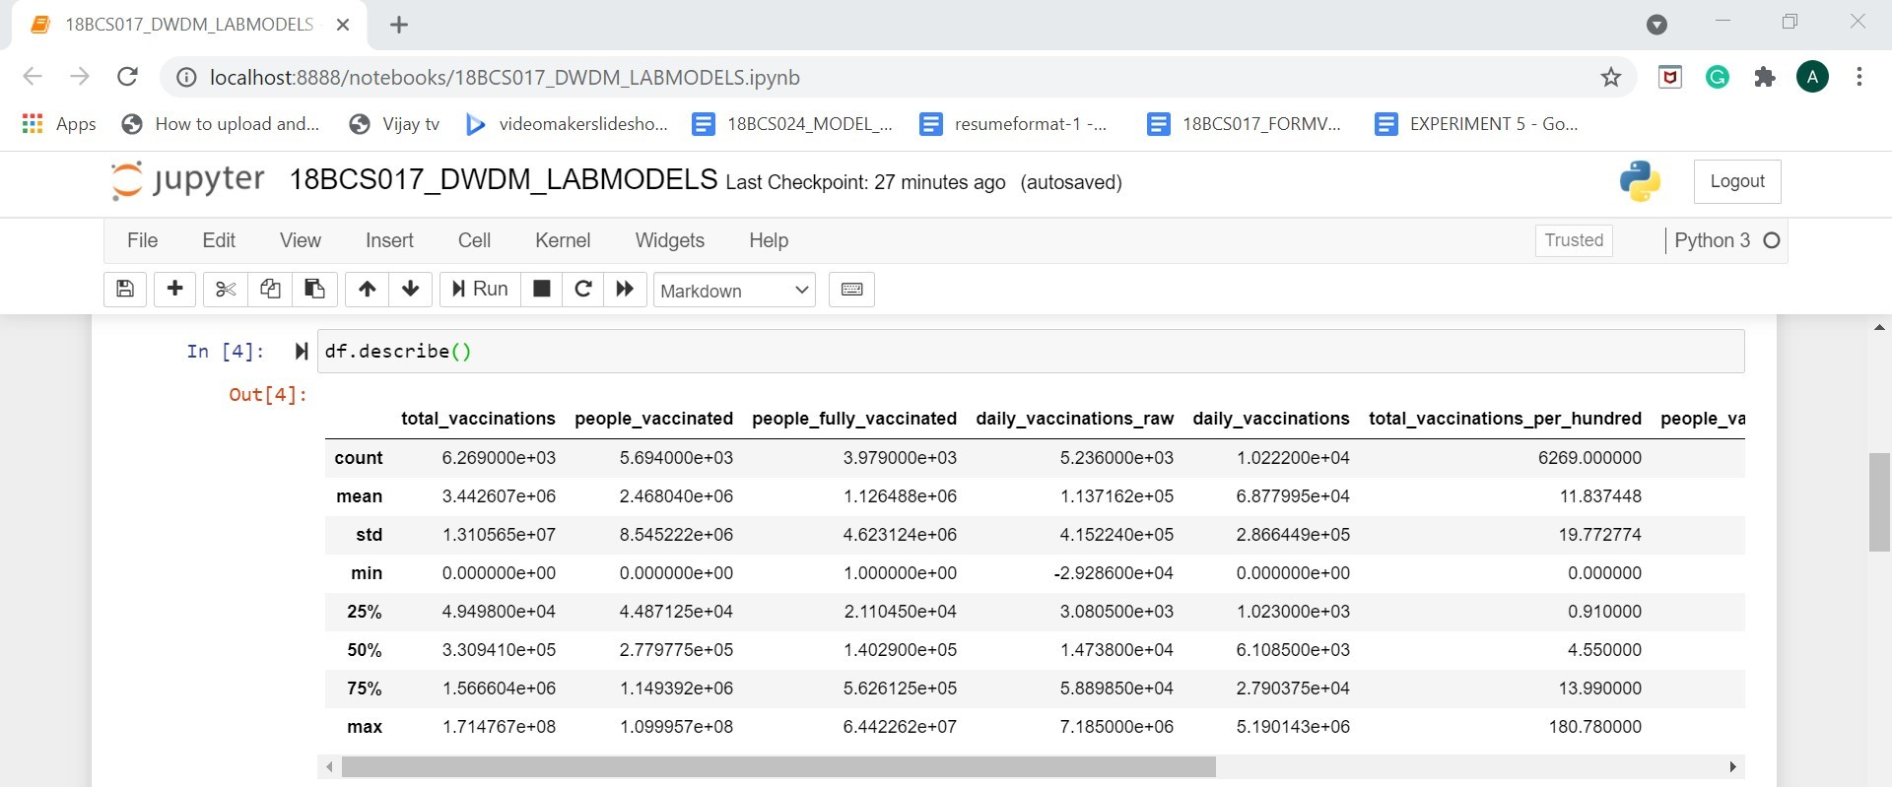

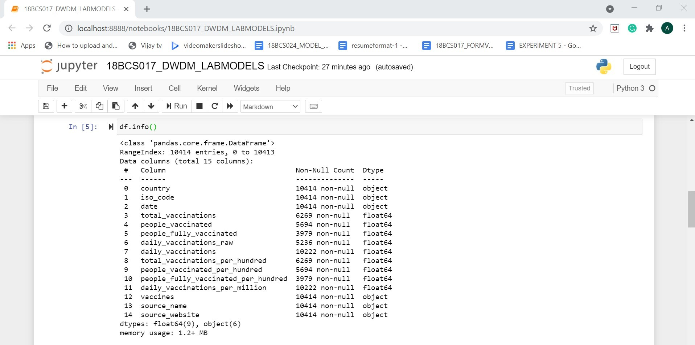

**2.Create a random dataset of 30 elements with x and y variables using random function between 30 to 80 integers for x and 60 to 100 integers for y. Apply K- means clustering to cluster the data into 2 clusters. Plot the graph and display the result. Use Tkinter GUI to Display the Results.**

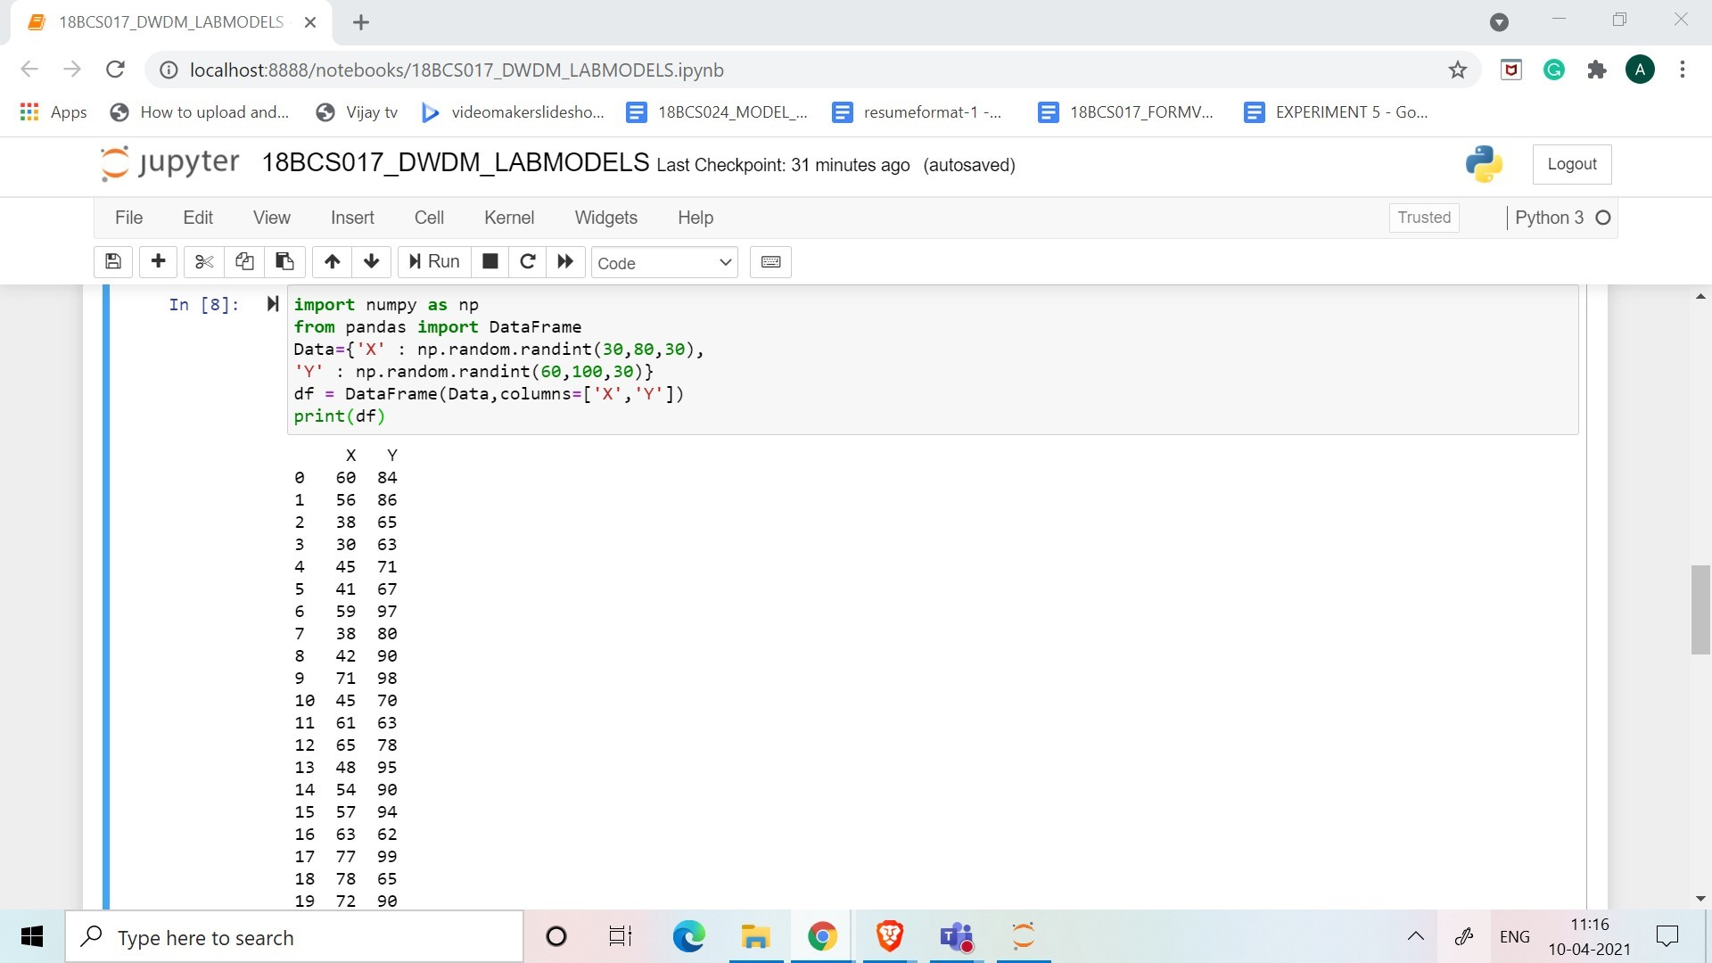

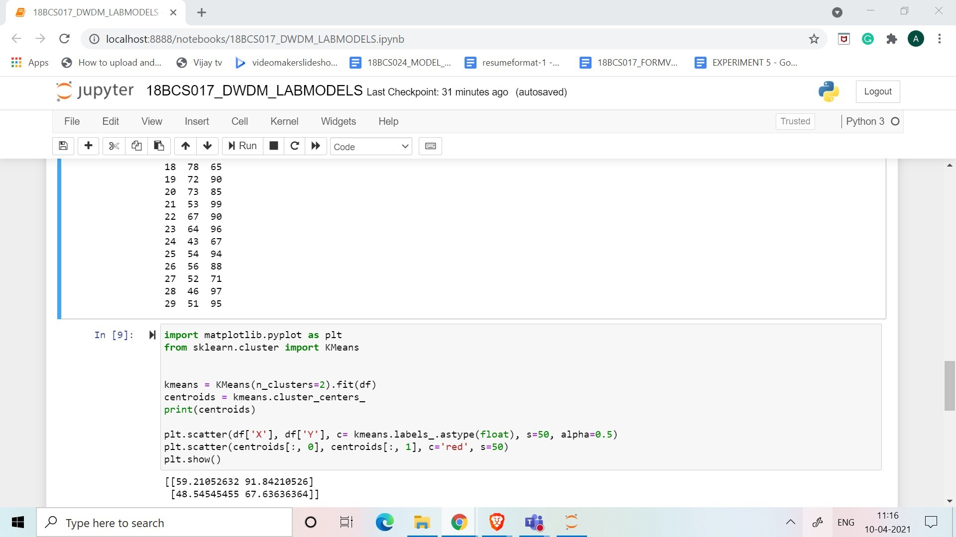

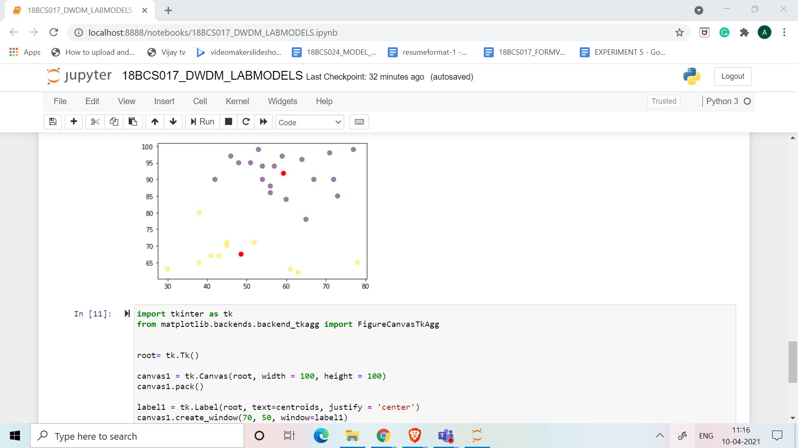

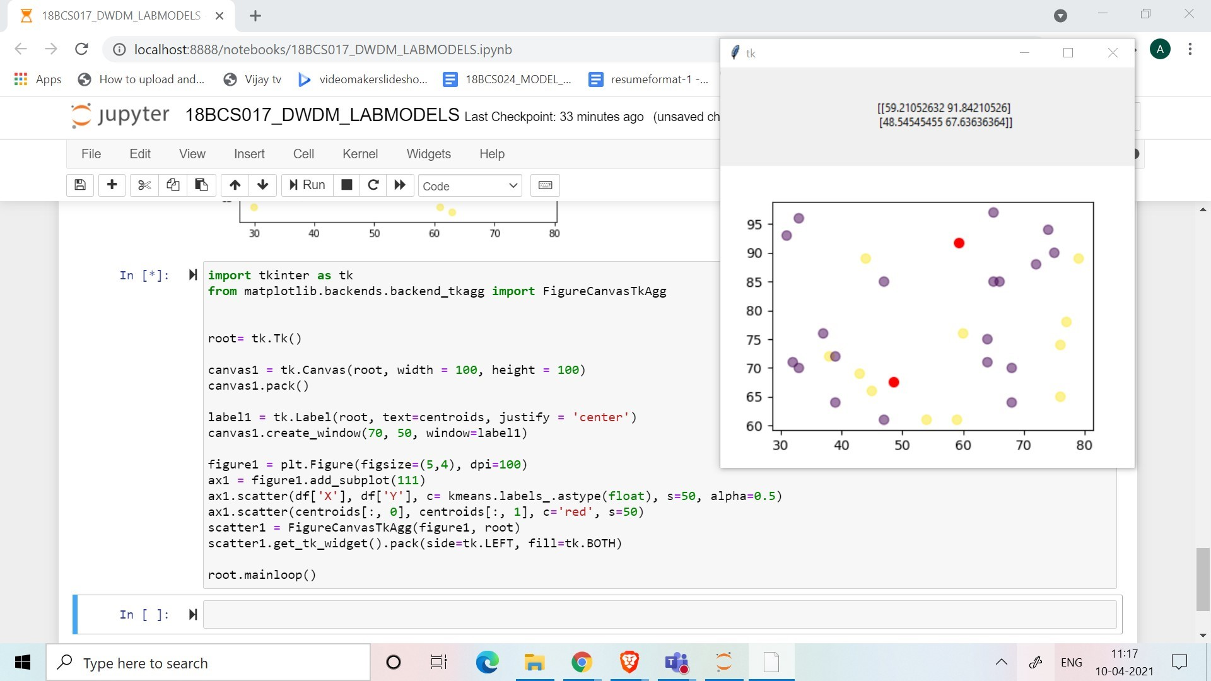

**3.Upload in your github account. Provide the link for access.**

https://github.com/Aparna-vmk/Dataset