1.why java is platform independent?
-java class is coverted to source code and can be compiled at any env like unix,linux.

2.write a simple factorial program;

3.what will happen if you don't put break statement in switch?
-if we don't put vreak it will print the next case even though it matches or not

4.what is imporance of default in switch statement?
-if nothing matches it will print default

5.which primitive type is allowed in switch?
-int and char

6.class name should have same name as source file name is it true statement?
only public class should have same name as source file name.
For example:
class ClassN{
public static void main(String[] args) {

}
}
if we save above with name as ClassName.java file and try to compile will get below error:
class ClassN is public, should be declared in a file named ClassN.java

7.If i have declared a variable inside a block and trying to print outside block what will happen?
package javafundamental;

public class VariableOutsideBlock {
public static void main(String[] args)
{
{
int a =10;
}
System.out.println("pring variable"+ a);
}

}
Ans:-A can't be resolved as variable.will give compile time error.

8.If method type is void what will be in return statement?will return null; is same as return;
Ans:-return;No
9.how does accessor and mutator will help ?give me an example.

10:what o/p below program will provide?

package javafundamental;

public class Flight {

private int passenger=10;
private int seat =40;

public Flight(int pass , int seat)
{
this.passenger = pass;
this.seat = seat;
}
public boolean hasRoom(Flight f2)
{
int total = passenger + f2.passenger;
return total <= seat;
}
public Flight createNewFlight(Flight f2)
{
Flight newFlight = new Flight();
newFlight.seat=seat;
newFlight.passenger = passenger + f2.passenger;
return newFlight;

}
public static void main(String[] args) {
Flight f11 = new Flight();
Flight f12 = new Flight();
Flight f13;
if(f11.hasRoom(f12))
{
f13 = f11.createNewFlight(f12);
System.out.println(f13.passenger);
}
}
}

Ans:-programmer has to define the no parameter constructer as he has created constructor with argument.program will give compilation error

11.Which block will execute first?tell the order of block.
Example:
package javafundamental;

/**
*
* @author Aparna:below code shows the order of belocks.
* 1.Field Initialization
* 2.Initialization block
* 3.constructer block
*
*/
public class InitializationConstructorBlock {
private int theField = 1;//field initialization

public int getTheField() {
return theField;
}

public InitializationConstructorBlock()
{
//custructor block
theField = 3;
}

{
//Initialization block
theField = 2;
}

public static void main(String[] args) {
InitializationConstructorBlock ib = new InitializationConstructorBlock();
System.out.println("Field is:" +ib.getTheField());
}

}
Ans:Field Initialization,Initialization Block,Custructor block

12: If Java uses the pass-by reference, why won't a swap function work?

Ans: Java does manipulate objects by reference, and all object variables are references. However, Java doesn't pass method arguments by reference; it passes them by value.

Example:
public void tricky(Point arg1, Point arg2)
{
arg1.x = 100;
arg1.y = 100;
Point temp = arg1;
arg1 = arg2;
arg2 = temp;
}
public static void main(String [] args)
{
Point pnt1 = new Point(0,0);
Point pnt2 = new Point(0,0);
System.out.println("X: " + pnt1.x + " Y: " +pnt1.y);
System.out.println("X: " + pnt2.x + " Y: " +pnt2.y);
System.out.println(" ");
tricky(pnt1,pnt2);
System.out.println("X: " + pnt1.x + " Y:" + pnt1.y);
System.out.println("X: " + pnt2.x + " Y: " +pnt2.y);
}
If we execute this main() method, we see the following output:

X: 0 Y: 0
X: 0 Y: 0
X: 100 Y: 100
X: 0 Y: 0

13.Inheritence:
how does field and method works in inheritence?Give example.
Field hides base class fields with same name but methods overrides base class method with same signature.
example for field hiding:
package javafundamental;

public class Inheritence {
int seat = 150;
int passenger = 1;
public void addOnePassenger()
{
if(hasSeat())

passenger+=1;
else
handleTooMany();

}
private boolean hasSeat()
{
return passenger > seat;
}
private String handleTooMany()
{
return "Many Passengers";
}

}

package javafundamental;
/**
*
* @author Aparna
*Here seat field is present in both Inheritence and CargoFlight Class
*So field work with refrence type(left side of =) but method works with (right side of =)new object
*Field hides base class fields with same name but methods overrides base class method with same signature.
*/
public class CargoFlight extends Inheritence {
int seat = 12;

public static void main(String[] args) {
Inheritence in = new Inheritence();//150
System.out.println(in.seat);

CargoFlight Cg = new CargoFlight();//12
System.out.println(Cg.seat);

Inheritence Ic = new CargoFlight();//150 v.v.i
System.out.println(Ic.seat);
}

}

14.Every class inherits directly or indirectly from objectclass
15.How does equal method works?what will be o/p of below code?and what code will be added so it will printboth objects are equal

package javafundamental;

public class equals {
private int flightNumber;
private int flightClass;
public static void main(String[] args) {
equals eq1 = new equals();
equals eq2 = new equals();
if(eq1 == eq2)
{
System.out.println("both objects are equal");
}
else if(eq1.equals(eq2))
{
System.out.println("both objects are equal");
}
else
{
System.out.println("Not equal");

}

}

}
o/p:not equals, because code in both == and equals case will compare that both refrences pointing to same object or not.
So,here they are actually pointing to two diffrent object.To make them print equal we have to override equals method
Modified program:
package javafundamental;

public class equals {
private int flightNumber;
private int flightClass;
public static void main(String[] args) {
equals eq1 = new equals();
equals eq2 = new equals();
if(eq1 == eq2)
{
System.out.println("both objects are equal");
}
else if(eq1.equals(eq2))
{
System.out.println("both objects are equal");
}
else
{
System.out.println("Not equal");

}

}
@Override
public boolean equals(Object obj) {
if (this == obj)
return true;
if (obj == null)
return false;
if (getClass() != obj.getClass())
return false;
equals other = (equals) obj;
if (flightClass != other.flightClass)
return false;
if (flightNumber != other.flightNumber)
return false;
return true;
}

}
16.Is it possible for a abstract class to have no abstract method in it?is vice versa is true?
yes,but with a abstract method class should be abstract.

17.which keyword will help to know wether object is of the specified type (class or subclass or interface).
Ans:instanceof operator
example:
class Simple1{
public static void main(String args[]){
Simple1 s=new Simple1();
System.out.println(s instanceof Simple1);//true
}
}

18.what do you mean by string objects are immutable?
Once string object is created it can't be changed

19.Give example of String equals method.what is diffrece between equals and ==.when do we we use intern() method?
Equals method compare charecter by charecter but == method checks refrences pointing to same object or not.
intern() method is used to larger String comparision.When the intern method is invoked, if the pool already contains a
string equal to this {@code String} object as determined by the {@link #equals(Object)} method, then the string from the pool is
returned.
Example:

package javafundamental;
/**
* intern is used when larger string in compared to make cost less
* @author Aparna
*
*/
public class StringIntern {
public static void main(String[] args) {
String s1 = "I Love";
s1 += " Java";
String s2 = "I";
s2 += " Love Java";
if (s1 == s2) {
System.out.println("s1 and s2 are equal by ==");
}
if (s1.equals(s2)) {
System.out.println("s1 and s2 are equal by equal method");
}

String s3 = s1.intern();
String s4 = s2.intern();
if (s3 == s4) {

System.out.println("s3 and s4 are equal by intern");
}
}

}

20.How to convert integer to String?
Ans:-ValueOf
Example:
int iVal =100;

o/p:"100"

21.String representation of class

Ans:toString

22.when java already had Atring class why String builder still keep importance?provide example.
diiference between String buffer and builder?
Ans:
String does not allow appending. Each method you invoke on a String creates a new object and returns it. This is because String is immutable - it cannot change its internal state.

On the other hand StringBuilder is mutable. When you call append(..) it alters the internal char array, rather than creating a new string object.

Thus it is more efficient to have:

StringBuilder sb = new StringBuilder();
for (int i = 0; i < 500; i ++) {
sb.append(i);
}

rather than str += i, which would create 500 new string objects.

Note also that there is StringBuffer in addition to StringBuilder. The difference is that the former has synchronized methods. If you use it as a local variable, use StringBuilder. If it happens that it's possible for it to be accessed by multiple threads, use StringBuffer.

23.Diffrence between final and static final variable/fields/methods?
Ans:https://stackoverflow.com/questions/8005250/difference-between-a-static-and-a-final-static-variable-in-java

24.what does enum classes means ?provide example
class enum colors
{yellow,red,green;
}

25.what is Runtime exception?Example of runtime exception
NullPointerExceptions

26.what is Unchecked Exception and checked exction?
Runtime exceptions are unchecked exceptions,any class inherits from runtime exceptions are unchecked exception.
Example:NullPointerExceptions.
For checked exception compiler throws error.Any class inherits from exception but not runtime exception is checked exceptions.

27:what will be order of catch block while catching exception ?
-Each catch block start with most specific exception type to General

28. multiple or multilevel inheritence in java, which is supported?
https://www.journaldev.com/1775/multiple-inheritance-in-java
Multilevel inheritence is supported in java.Example:A extends B and B extends C.But multiple is not because of diamond problem in java.

To understand diamond problem easily, let’s assume that multiple inheritance was supported in java. In that case, we could have a class hierarchy like below image.

diamond problem in java

Let’s say SuperClass is an abstract class declaring some method and ClassA, ClassB are concrete classes.

SuperClass.java

package com.journaldev.inheritance;

public abstract class SuperClass {

public abstract void doSomething();
}

ClassA.java

package com.journaldev.inheritance;

public class ClassA extends SuperClass{

@Override
public void doSomething(){
System.out.println("doSomething implementation of A");
}

//ClassA own method
public void methodA(){

}
}

ClassB.java

package com.journaldev.inheritance;

public class ClassB extends SuperClass{

@Override
public void doSomething(){
System.out.println("doSomething implementation of B");
}

//ClassB specific method
public void methodB(){

}
}

Now let’s say ClassC implementation is something like below and it’s extending both ClassA and ClassB.

ClassC.java

package com.journaldev.inheritance;

public class ClassC extends ClassA, ClassB{

public void test(){
//calling super class method
doSomething();
}

}
Notice that test() method is making a call to superclass doSomething() method. This leads to the ambiguity as compiler doesn’t know which superclass method to execute. Because of the diamond shaped class diagram, it’s referred as Diamond Problem in java. Diamond problem in java is the main reason java doesn’t support multiple inheritance in classes.

Notice that the above problem with multiple class inheritance can also come with only three classes where all of them has at least one common method.

29.Is Multiple Inheritance in Java Interfaces is possible?
Yes.

Example:
InterfaceA.java
----------------
package com.journaldev.inheritance;

public interface InterfaceA {

public void doSomething();
}

InterfaceB.java
--------------------
package com.journaldev.inheritance;

public interface InterfaceB {

public void doSomething();
}

Notice that both the interfaces are declaring same method, now we can have an interface extending both these interfaces like below.

InterfaceC.java

package com.journaldev.inheritance;

public interface InterfaceC extends InterfaceA, InterfaceB {

//same method is declared in InterfaceA and InterfaceB both
public void doSomething();

}

This is perfectly fine because the interfaces are only declaring the methods and the actual implementation will be done by concrete classes implementing the interfaces. So there is no possibility of any kind of ambiguity in multiple inheritance in java interfaces.
Thats why a java class can implement multiple inheritance, something like below example.
InterfacesImpl.java

package com.journaldev.inheritance;

public class InterfacesImpl implements InterfaceA, InterfaceB, InterfaceC {

@Override
public void doSomething() {
System.out.println("doSomething implementation of concrete class");
}

public static void main(String[] args) {
InterfaceA objA = new InterfacesImpl();
InterfaceB objB = new InterfacesImpl();
InterfaceC objC = new InterfacesImpl();

//all the method calls below are going to same concrete implementation
objA.doSomething();
objB.doSomething();
objC.doSomething();
}

}
30.What will happen if we define a concrete method in an interface?

Ans: By default interface methods are abstract.
if we declare any concrete method in an interface compile time error will come.
Error:Abstract methods do not specify a body

31.Can we create non static variables in an interface?

No.We can not create non static variables in an interface.
If we try to create non static variables compile time error comes.
By default members will be treated as public static final variables so it expects some value to be initialized.

Example:
package com.instanceofjava;
interface JavaInterface{

int x, y; // compile time error

}

32.Can we declare interface members as private or protected?

Ans: No.

33.Can we create object for an interface?

NO. We can not create object for interface.
We can create a variable from an interface

Example:

package com.instanceofjava;
interface JavaInterface{

void show();

}

package com.instanceofjava;
interface A implements JavaInterface {

void show(){
// code
}
public static void main(String args[]){

JavaInterface obj= new JavaInterface(); // Error: Cannot instantiate the type JavaInterface

}
}

34.Can we declare interface as final?

No. Compile time error will come.
Example:
final interface Sample
{
int x =10;
void show();
}

35.Can we declare constructor inside an interface?

No. Interfaces does not allow constructors.
The variables inside interfaces are static final variables means constants and we can not create object fro interface so there is no need of constructor in interface that is the reason interface doesn't allow us to create constructor.

36.How can we access same variables defined in two interfaces implemented by a class?

By Using corresponding interface.variable_name we can access variables of corresponding interfaces.
Example:

public interface JavaInterface {
int x =100;
}

public interface JavaInterface1 {
int x =200;
}

package javafundamental;

public class InterfaceImpl implements JavaInterface,JavaInterface1 {
public static void main(String[] args) {

JavaInterface1 we = new InterfaceImpl();
System.out.println("Value is:"+we.x);
System.out.println(JavaInterface.x);
System.out.println(JavaInterface1.x);

}

}

37.If Same method is defined in two interfaces can we override this method in class implementing these interfaces.

Yes implementing the method once is enough in class.
A class cannot implement two interfaces that have methods with same name but different return type.
package javafundamental;

public interface JavaInterface {
int x =100;

public void add();
}

package javafundamental;

public interface JavaInterface1 {
int x =200;
public int add();
}

package javafundamental;

public class InterfaceImpl implements JavaInterface,JavaInterface1 {
public static void main(String[] args) {

JavaInterface1 we = new InterfaceImpl();
System.out.println("Value is:"+we.x);
System.out.println(JavaInterface.x);
System.out.println(JavaInterface1.x);

}

public int add() {//here we are getting error as we had method with same name and have diffrent return type.
{
return 0;
}

}

38.How many types of stream?give example
Binary,Text

Reading one byte at a time use InputStream to read individual charecter use Reader class:
For byte reader and writer:
InputStream
int read()
int read(byte[] buff)

op straem:
void write(int b)
void write(byte[] buff)

For Text reader and writer:
int read()
int read(char[] buff)

void write(int ch)
void write(char[] buff)
void write(String str)

InputStream input =//Create input stream
int intVal;
while((intVal = input.read())>0)
{
byte byteVal =(byte) intVal;
//do Something with byteVal;
}

Reading Charecter at a time
Reader reader ;
int intVal;
while(intVal = reader.read()) > = 0)
{
char charVal =(char) intVal;
}

39.tell some of the reader/writer class:
readerClasses:
charArrayReader
StringReader
pipedReader
InputStreamReader->FileReader

WriterClass:
charArraywriter
StringWriter
PipedWriter
OutputStreamWriter

Collection:
__________________
38.Tell me about array and its limitations?
Staiacally sized.
Require explicit position managment.

39.write a program to create a list which will have names in that and then print all the name which is added.

package javafundamental.collections;

import java.util.ArrayList;

import javafundamental.CargoFlight;

public class ArrayListExample {
public static void main(String[] args) {
//String args[] = new String[10];//Array declaration
ArrayList<String> name=new ArrayList();//Creating arraylist
ArrayList<String> name2=new ArrayList();//Creating arraylist
name.add("Ravi");//Adding object in arraylist
name.add("Aparna");
for(Object o : name)
{
System.out.println(name);
}
CargoFlight cr = new CargoFlight();
name.add(cr.getClass().toString());//As Array List was of type String that is why had to do toString
name2.addAll(name);
System.out.println(name);

}
}

39.How to decide on collection:
Ans:

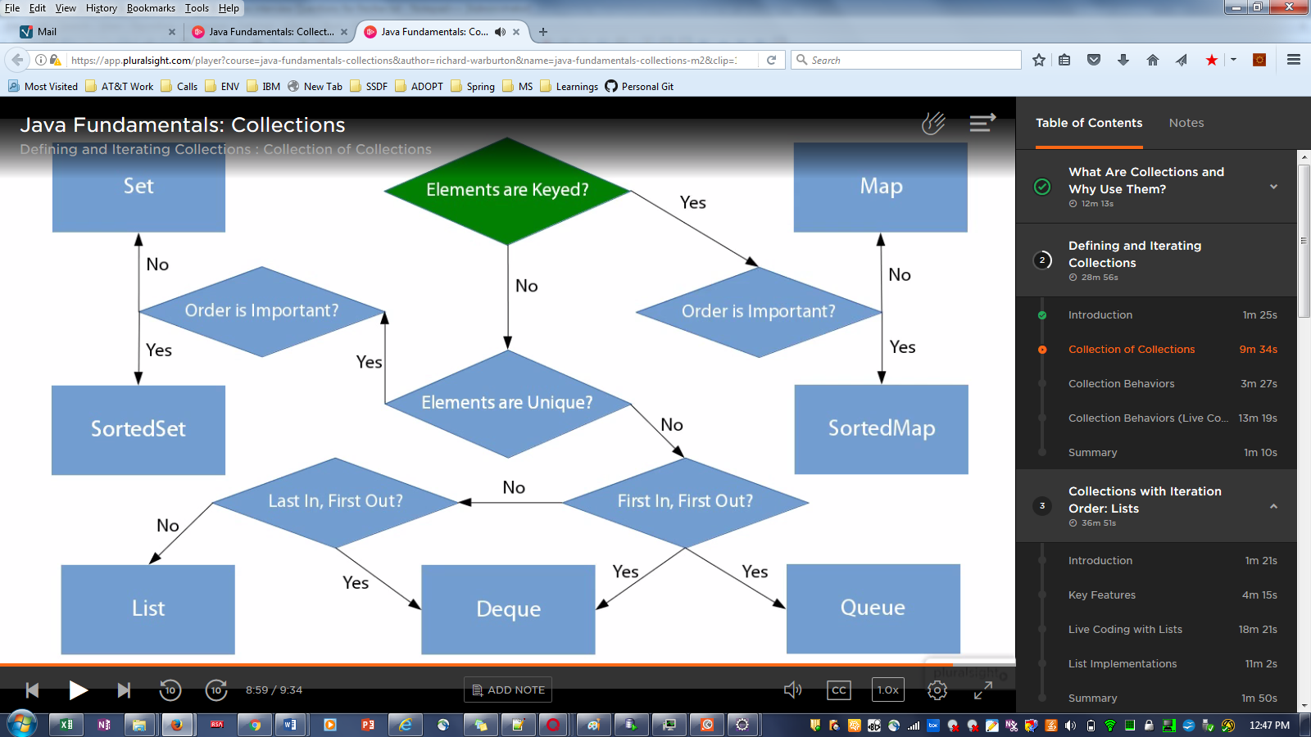

40.while iterating through collection if we have to remove elemnt ,what should we use?
Ans:For each loop will give ConcurrentModification exception.
We should always use iterator.
Example:
package javafundamental.collections;

public class Product {
private final String name;
private final int weight;

public Product(String name, int weight) {
this.name = name;
this.weight = weight;
}

public String getName() {
return name;
}

public int getWeight() {
return weight;
}

@Override
public String toString() {
return "Product [name=" + name + ", weight=" + weight + "]";
}

}

package javafundamental.collections;

import java.util.ArrayList;
import java.util.Collection;
import java.util.Iterator;

public class CollectionConecpt {
public static void main(String[] args) {
Product door = new Product("WoddenDoor",35);
Product floorPanel = new Product("FloorPanel",20);
Product window = new Product("GlassWindow",35);

Collection<Product> products = new ArrayList<Product>();
products.add(door);
products.add(floorPanel);
products.add(window);

//printing all collection element
//System.out.println(products);

//printing them one at atime
/*for(Product product : products)
{
System.out.println(product);
}*/

//printing using iterator
final Iterator<Product> productIterator = products.iterator();
while(productIterator.hasNext())
{
Product product = productIterator.next();
if(product.getWeight() > 20)
{
System.out.println(product);
}
else
{
productIterator.remove();
}
}
System.out.println(products);
}

}

41.If we have to add or remove element from list which list should be use and why?Arraylist or Linked :It Ans:should use linked list as to add or remove element only pointer will change.But in arraylist all elements should be shuffle.

44.If we want to get 5 elemt from list what should we choose between Atrray and link list?
Ans:Array list,Because in case of link list we have to jump though pointers 5 times.But in arraylist we have to jusr refrence 5th elemnt.

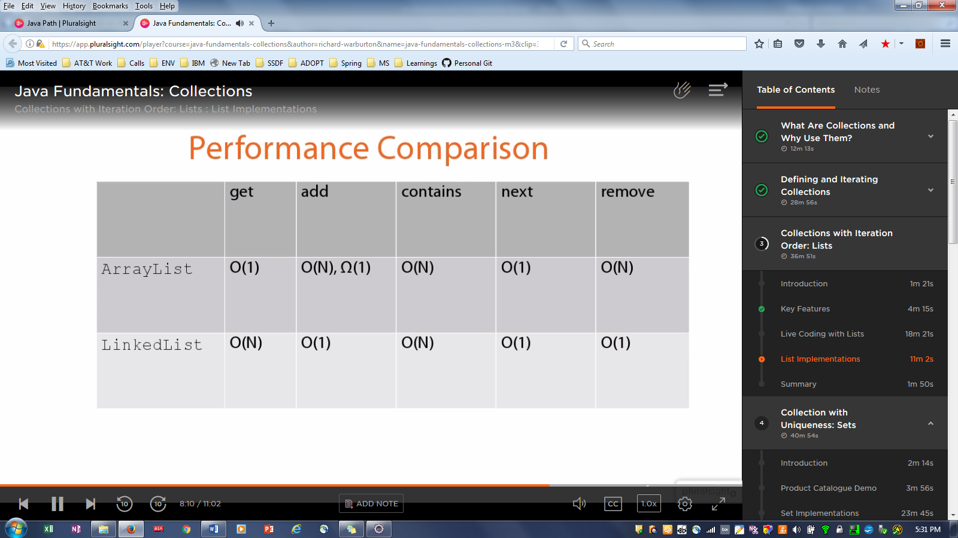
45.If we have to have unique elements ,which to use?
Ans:SET;
46.Write a set example and iterate it and print the value:
package javafundamental.collections;

import java.util.HashSet;
import java.util.Iterator;
import java.util.Set;

public class ProductCatalog implements Iterable<Product> {
private Set<String> expSet=new HashSet();;
public static void main(String[] args) {
ProductCatalog pc = new ProductCatalog();
pc.addValue();
pc.iterator();
}

public void addValue()
{

expSet.add("Aparna");
expSet.add("Soni");
expSet.add("Mishra");
expSet.add("Soni");//here same elemnt is added in set

}
public Iterator<Product> iterator() {
Iterator<String> itr=expSet.iterator();
while(itr.hasNext())
System.out.println(itr.next());//here set will return only unique element.
return null;
}

}
45.Method of sorted set
tailSet(E fromElement)
headset(E fromElement)
subSet(E fromElement,E to Element)
46.what is map?Can map contains duplicate keys?
A Map is an object that maps keys to values. A map cannot contain duplicate keys: Each key can map to at most one value. It models the mathematical function abstraction. The Map interface includes methods for basic operations (such as put, get, remove, containsKey, containsValue, size, and empty), bulk operations (such as putAll and clear), and collection views (such as keySet, entrySet, and values).

47.Let me know the output of below for map?
Ans:As map has same key 1 inserted again it is overwriting the value.So o/p will be
{1=Aparna, 2=Shali, 3=Jahnavi}
package javafundamental.collections.map;

import java.util.HashMap;
import java.util.Map;

public class MapExample {
public static void main(String[] args) {
Map<String,String> mapExp= new HashMap();
mapExp.put("1", "Soni");
mapExp.put("2", "Shali");
mapExp.put("3", "Jahnavi");
mapExp.put("1", "Aparna");
System.out.println(mapExp);

}

}
48.Write a program to add some value in newly created map and retrieve element one by one
package javafundamental.collections.map;

import java.util.HashMap;
import java.util.Map;

public class MapExample {
public static void main(String[] args) {
Map<String, String> mapExp = new HashMap();
mapExp.put("1", "Soni");
mapExp.put("2", "Shali");
mapExp.put("3", "Jahnavi");
mapExp.put("1", "Aparna");
mapExp.put(null, null);// map will null ask q?
//System.out.println(mapExp);
for (Map.Entry m : mapExp.entrySet()) {
System.out.println(m.getKey() + " " + m.getValue());

}

}
}

Collection:
49.what is difference between Array and ArrayList?
Ans:Array we have to specify size.we have to specify variable type.
Example :int[] num = new int[5];
AtrrayList:
We need not to specify size,
We need not to specify data type of variables.
But disadvantage is while retriving the value from Array List we should know the datatype.
Example: package collections;

import java.util.ArrayList;

public class Application {

public static void main(String[] args) {
ArrayList words = new ArrayList();
words.add("Soni");
words.add("12");
words.add("14.8");
String item1 = (String) words.get(0);//here we have to explicitly cast it
System.out.println(words.get(0));

}

}

After java 5 they came up with parameter for ArrayList.
package collections;

import java.util.ArrayList;

public class Application {

public static void main(String[] args) {
ArrayList<String> words = new ArrayList<String>();
words.add("Soni");
//words.add(12);
//words.add(14.8);
String item1 = words.get(0);
System.out.println(item1);

}

}

