 | Aparna Dharmalingam  Functional Safety | ISO 26262 | ADAS & System Safety  M.Sc. candidate in Functional Safety Engineering with hands-on experience in applied research and automotive projects. Focus areas include HARA, ISO 26262, SOTIF, System Safety, and the safe development of automated driving functions. Currently seeking a full-time role in Functional Safety, System Safety, or ADAS Safety. |  |  |  |  |  | 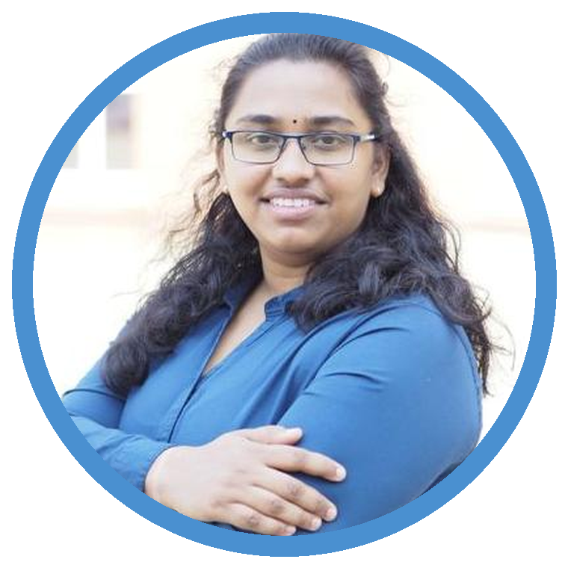
 |  aparna.dharmalingam@outlook.com |  +49 157 50176304 |  |  Bamberg, Germany |  |  LinkedIn |  03.04.1998
 | EDUCATION  M.Sc. Functional Safety Engineering  University of Kassel  10/2020 – Present Kassel, Germany  - Specialization: Automotive Functional Safety - System Safety and system-level safety concepts  Bachelor of Engineering – Mechatronics  SCSVMV University  08/2015 – 04/2019 Kanchipuram, India  - Focus areas: MEMS, power electronics, control systems, and robotics  PROFESSIONAL EXPERIENCE  Student Research Assistant – Safety Engineering  Fraunhofer IESE  01/2026 – 04/2026 Kaiserslautern  - Transformed free-text hazardous events from HARA artifacts into standardized YAML safety models, creating a consistent, machine-readable basis for further safety analysis.  - Hazardous events to ODD parameters and operating conditions, improving the traceability of ASIL classification.  - Developed a Python-based tool chain to automate the processing of TOD elements and hazardous-event mappings, reducing manual data-preparation effort.  Working Student – Functional Safety (ADAS & AD)  Mingabyte GmbH  03/2024 – 09/2024 Munich  - Developed technical training material on automated-driving functions and ADAS Safety, enabling the structured communication of complex safety topics.  - Structured vehicle-level safety requirements and safety concepts, improving their clarity, consistency, and technical readability.  - Contributed as a co-assessor to a Functional Safety Assessment of a hydrogen fuel-cell system, supporting the systematic evaluation of safety-related evidence.  Working Student – Functional Safety  DEKRA Digital Products & Services  03/2023 – 09/2023 Stuttgart  - Tested an internal Functional Safety Assessment tool against ISO 26262 and IEC 61508, identifying gaps between tool logic and applicable requirements.  - Developed standards-based checklists and review workflows, supporting more consistent and repeatable internal safety assessments.  - Documented test findings and improvement proposals, contributing to further tool development and improved usability. |  |  |  | CORE COMPETENCIES  Safety Standards & Methods ISO 26262 · IEC 61508 · IEC 61131-3 · IEC 61511 · ISO/SAE 21434 · ISO 21448 (SOTIF) · HARA · FMEA · FMEDA · HAZOP · FTA · Requirements Engineering MBSE System-level documentation, simulation, and design Software & Tools Ansys medini analyze · Python · NI LabVIEW · NI Multisim · PSIM · MATLAB/Simulink · ROS/SLAM · MS Office · PTC Creo · VBA · Git · YAML · B&R Automation Studio Personal Strengths Analytical thinking · structured approach · initiative · teamwork  ACADEMIC THESES  Master's Thesis – Developing a Criticality Taxonomy for Situation Analysis in Safety Engineering (in preparation)  Literature-based identification and structuring of criticality factors for driving situations, with planned application in SentryCraft for systematic scenario analysis.  Bachelor's Thesis – Sensor Assisted Braking System (09/2018 – 04/2019)  Modelled, developed, and validated a semi-electronic braking system on the Smart Trike hybrid vehicle; published under DOI: 10.1166/asem.2020.2606  ADDITIONAL EXPERIENCE  Autonomous Systems Engineer  Herkules Racing Team  02/2023 – 12/2024 Kassel  - Developed and tested ROS- and Python-based software modules for perception and planning on an autonomous competition vehicle.  - Supported sensor integration and safety-related troubleshooting at vehicle level.  Secretary – Technical University Club  Electro Infinity  09/2017 – 04/2019 Kanchipuram  - Organized a PCB design and manufacturing workshop and coordinated weekly technical meetings, including a classroom automation project.  LANGUAGES  English C1 German B1 Tamil C2  INTERESTS  Motorcycling & Motorsport · Fencing · Singing · Cooking · Travel

