BEGINNER-FRIENDLY PROJECT DOCUMENTATION
SafeStop AI-FMEA Pipeline
How a robot safety description becomes a review-ready failure report
A simple guide for readers with no background in robots, AI, FMEA, Python or GitHub.
Important: This is a fictional learning project. It does not prove that a real machine is safe and it is not certification evidence.

Project owner: Aparna Dharmalingam
Portfolio project | September 2026

1. The project in one sentence
Simple answer: The project turns a robot emergency-stop description into a list of possible failures that a human safety engineer can review.

2. Why this project exists
Before using a machine, engineers ask: “What could fail, what would happen next, and how would we notice it?” FMEA is a method for organising those questions.
AI can suggest possible failures quickly, but it may also repeat ideas or invent facts. This project gives AI clear evidence and checks its output before a human makes any decision.

3. The fictional robot system
Imagine a robot working inside a fixed factory cell. If a person presses the emergency-stop button, the robot must lose the power that allows dangerous movement.
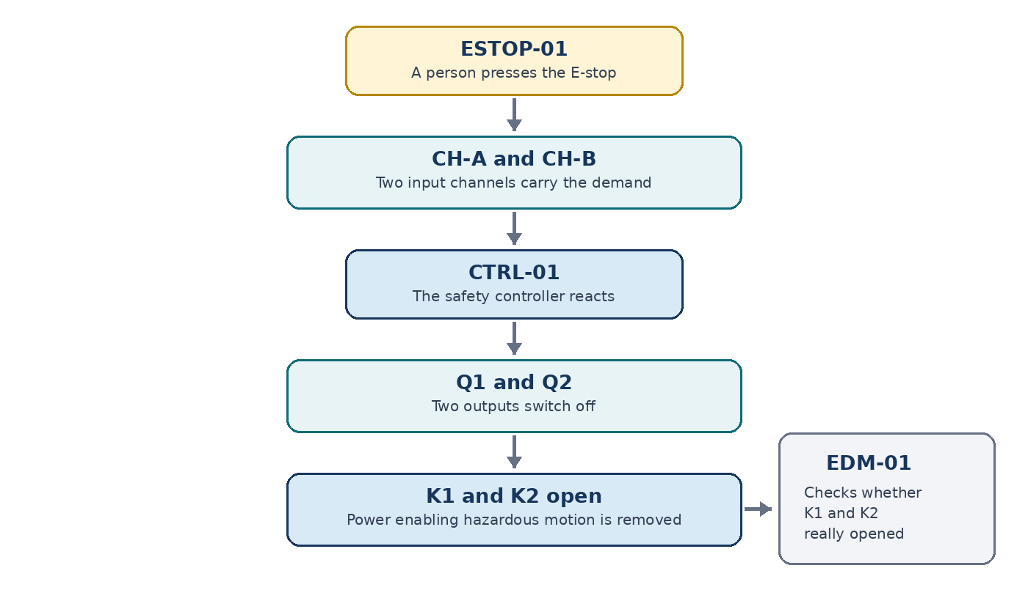
Simplified safety path used by this learning project
Key assumption: K1 and K2 are in series. If either one opens, power enabling hazardous motion is removed. A real project would need a verified electrical drawing.

4. What should happen when the E-stop is pressed
- ESTOP-01 changes the state of two input channels: CH-A and CH-B.
- CTRL-01 sees the emergency-stop demand.
- The controller switches off outputs Q1 and Q2.
- The outputs de-energise contactors K1 and K2.
- K1 and K2 open the series power path.
- EDM-01 checks that the contactors really opened.
- Releasing the E-stop alone must not restart the robot. A deliberate reset is still needed.

5. Project inputs
The project does not start with a finished FMEA. It starts with controlled information about the system.
Input | What it contains
system.yaml | The robot safety parts, their links and the project boundary.
assumptions.yaml | Things used for the exercise that still need confirmation in a real project.
requirements.yaml | Draft statements describing what the safety function should do.
fmea_prompt.md | Rules that tell ChatGPT what it may use and what it must not claim.

Why IDs matter: Names such as A-006 and SR-005 let a reviewer trace each AI suggestion back to the supplied evidence.

6. How the pipeline works
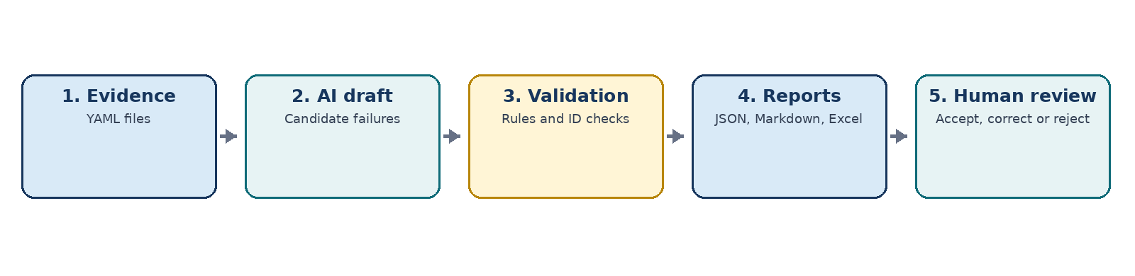
- Check the inputs. Python checks that the YAML files have the expected fields and valid IDs.
- Create AI suggestions. The evidence and prompt are given to ChatGPT. ChatGPT returns candidate failure modes as JSON.
- Save one trial. The JSON is stored as a named trial, such as TRIAL-01, so the result can be tracked.
- Validate the candidates. GitHub Actions checks the structure, evidence links, allowed labels, duplicate mechanisms and prohibited safety claims.
- Build reports. A successful run creates JSON, Markdown and Excel files.
- Review as a human. The assessor accepts, corrects or rejects each candidate and enters any approved scores.
Automation level: Candidate generation is currently a manual ChatGPT step. Validation and report creation are automatic. This avoids paid API use and keeps a human transfer point.

7. Project outputs
Output | Purpose
fmea_candidates.json | Structured candidate data that computers can check.
fmea_report.md | A simple text report that is easy to read on GitHub.
fmea_report.xlsx | An editable review workbook for a human assessor.

8. One simple failure example
Example: K1 is commanded to open, but its main contact stays welded closed.
- Local effect: K1 stays closed.
- System effect: If K2 opens and the series-path assumption is correct, drive power is still removed, but the safety system has lost one independent path.
- Detection: EDM-01 should notice that K1 did not open and should block reset.
- Human task: Confirm the electrical design, test the fault and decide the final FMEA wording and scores.
Why the chain matters: The report does not jump from “K1 failed” directly to “someone is hurt.” It explains the local effect, the safety-function effect and only then the possible consequence.

9. What AI does—and does not do
AI may help with | AI must not do
Suggest candidate failure modes | Approve the FMEA
Organise a causal chain | Certify the machine
Point to supplied evidence IDs | Claim SIL, PL or standards compliance
Highlight assumptions and missing facts | Replace schematics, tests or expert judgement

10. What is automatic and what is human work
Automatic | Human-controlled
Check YAML and JSON structure | Define and confirm the real system evidence
Check IDs and evidence links | Review technical credibility
Find some duplicate candidates | Accept, correct or reject candidates
Build Markdown and Excel reports | Enter Severity, Occurrence and Detectability
Calculate RPN after S, O and D are entered | Make safety, design and compliance decisions

11. How to use the project
- Update the system, assumption or requirement YAML files when the fictional design changes.
- Commit the change to GitHub. The validation workflow runs automatically.
- Use the controlled prompt with ChatGPT and save the returned JSON as a new trial.
- Run the report workflow in GitHub Actions.
- Download the artifact and open the Excel workbook.
- Review every candidate before entering S, O and D. RPN appears only after all three are entered.

12. Main limitations
- The robot system is fictional and simplified.
- Several details are assumptions, not verified machine facts.
- The timing values are examples, not approved stopping limits.
- AI suggestions may be wrong, incomplete or duplicated.
- The included S/O/D descriptions are learning placeholders, not an approved company method.

13. What this portfolio project demonstrates
It shows how functional-safety thinking, structured data, prompt rules, Python checks, GitHub Actions and Excel reporting can work together while the final judgement remains with a person.
Honest project position: This is an independent portfolio implementation built with ChatGPT/Codex assistance. It does not claim to invent FMEA or AI-assisted FMEA.

Glossary
Short meanings of the words used in this guide.
Term | Simple meaning
AI | Software that can generate suggestions from instructions and information.
API | A way for one software program to call another. This project does not currently use a paid AI API.
Assumption | Something treated as true for the exercise but still needing proof in a real project.
Candidate | A suggested item that has not yet been accepted by a human reviewer.
CH-A / CH-B | The two emergency-stop input channels.
Contactor | An electrically controlled switch used to connect or remove power.
CTRL-01 | The fictional safety controller.
EDM-01 | Feedback that checks whether K1 and K2 actually opened.
Emergency stop / E-stop | A control used to demand a stop during an emergency.
Evidence ID | A short name, such as A-006 or SR-005, used to trace a statement to its source.
FMEA | Failure Mode and Effects Analysis: a structured way to study how things may fail and what happens next.
Git | A tool that records changes to project files.
GitHub | An online place for storing Git projects and running workflows.
GitHub Actions | Automatic jobs that run checks or build reports in GitHub.

Glossary (continued)
Term | Simple meaning
Human-in-the-loop | AI or automation helps, but a person reviews and controls the important decision.
JSON | A structured text format used for the AI candidate list.
K1 / K2 | The two contactors in the fictional power-removal path.
Local effect | What happens first at the failed part.
Q1 / Q2 | The two controller outputs that command K1 and K2.
Reset | A deliberate action that prepares the safety system after the fault or E-stop demand is cleared.
RPN | Risk Priority Number: S × O × D. It helps prioritise review; it does not prove safety.
Safe state | The defined condition in which power enabling hazardous motion is removed and restart is blocked.
S / O / D | Severity, Occurrence and Detectability ratings entered by a human reviewer.
System effect | How a local failure changes the whole safety function.
Validation | Automatic checks that data follows the expected rules. It is not the same as proving machine safety.
YAML | A readable text format used for the system, assumptions and requirements.

End of beginner guide

