**FOP Project Outputs**

**Code Crackers Team**

**This project is about Airline Ticket Reservation System in which there are different options that can be selected.**

**They are also below:**

1. **Displaying List of Flights: Displays all the flights that are available in the data that we used.**

************************* Hearty welcome to our flight ticket purchase system! ***********************************

------------------------------------------------------------------------------------------------------------------------------

-------------------------------------------------- 1. Display List of Flights -------------------------------------------------------

-------------------------------------------------- 2. Search for a flight ----------------------------------------------------

-------------------------------------------------- 3. Booking a flight Ticket ----------------------------------------------------------

-------------------------------------------------- 4. Display List of Tickets--------------------------------------------------------

-------------------------------------------------- 5. Printing a ticket --------------------------------------------------------

-------------------------------------------------- 6. Ticket cancellation-------------------------------------------------------

-------------------------------------------------- 7. Exit and Save ----------------------------------------------

------------------------------------------------------------------------------------------------------------------------------

Please enter the serial number for required operation from the list of operations:1

------------------------------------------------------------------------------------------------------------------------------

1-

Flight's code: AirAsia

From: hyderabad HYD

To: kolkata CCT

Departure: Mon, 09 Jan 2023 14:19

Arrival: Mon, 09 Jan 2023 01:30

Price 6000.0

Number of available tickets: 250

------------------------------------------------------------------------------------------------------------------------------

2-

Flight's code: AirIndia

From: delhi DEL

To: hyderabad HYD

Departure: Mon, 12 Dec 2022 12:21

Arrival: Mon, 12 Dec 2022 17:30

Price 7000.0

Number of available tickets: 297

------------------------------------------------------------------------------------------------------------------------------

3-

Flight's code: VISTARA

From: banglore BGL

To: delhi DHL

Departure: Fri, 24 Feb 2023 05:30

Arrival: Fri, 24 Feb 2023 07:00

Price 6500.0

Number of available tickets: 287

------------------------------------------------------------------------------------------------------------------------------

4-

Flight's code: Indigo

From: delhi DHL

To: banglore BGL

Departure: Sat, 25 Mar 2023 11:30

Arrival: Sat, 25 Mar 2023 17:00

Price 8200.0

Number of available tickets: 299

------------------------------------------------------------------------------------------------------------------------------

5-

Flight's code: GoAir

From: banglore BGL

To: hyderabad HYD

Departure: Fri, 20 Jan 2023 20:30

Arrival: Fri, 20 Jan 2023 23:00

Price 7300.0

Number of available tickets: 98

------------------------------------------------------------------------------------------------------------------------------

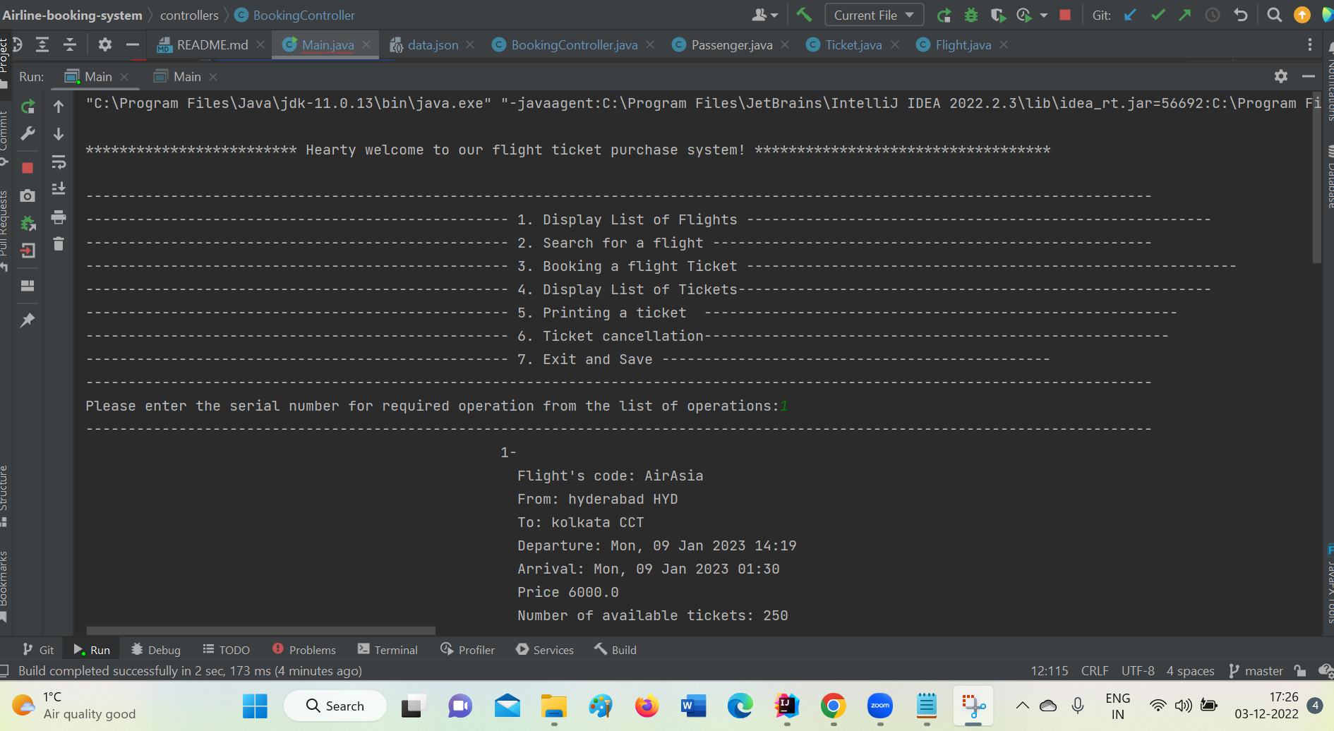

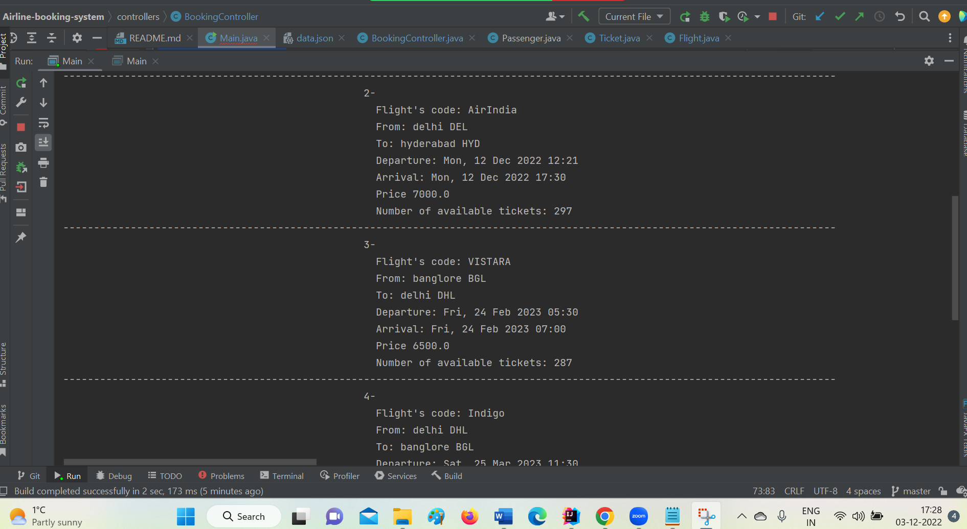

1. **Searching for Flight: In this we can search a particular flight based on date, from where we need the flight and where to go then we get information time departure and arrival times and flight charges for that particular flight.**

**Output :**

************************* Hearty welcome to our flight ticket purchase system! ***********************************

------------------------------------------------------------------------------------------------------------------------------

-------------------------------------------------- 1. Display List of Flights -------------------------------------------------------

-------------------------------------------------- 2. Search for a flight ----------------------------------------------------

-------------------------------------------------- 3. Booking a flight Ticket ----------------------------------------------------------

-------------------------------------------------- 4. Display List of Tickets--------------------------------------------------------

-------------------------------------------------- 5. Printing a ticket --------------------------------------------------------

-------------------------------------------------- 6. Ticket cancellation-------------------------------------------------------

-------------------------------------------------- 7. Exit and Save ----------------------------------------------

------------------------------------------------------------------------------------------------------------------------------

Please enter the serial number for required operation from the list of operations:2

------------------------------------------------------------------------------------------------------------------------------

Enter from where that flight you want to book:

hyderabad

Enter to where that flight you want to book:

kolkata

Enter the timing of flight in format: yyyy-MM-dd

2023-01-09

Flight's code: AirAsia

From: hyderabad HYD

To: kolkata CCT

Departure: Mon, 09 Jan 2023 14:19

Arrival: Mon, 09 Jan 2023 01:30

Price 6000.0

Number of available tickets: 250

-------------------------------------

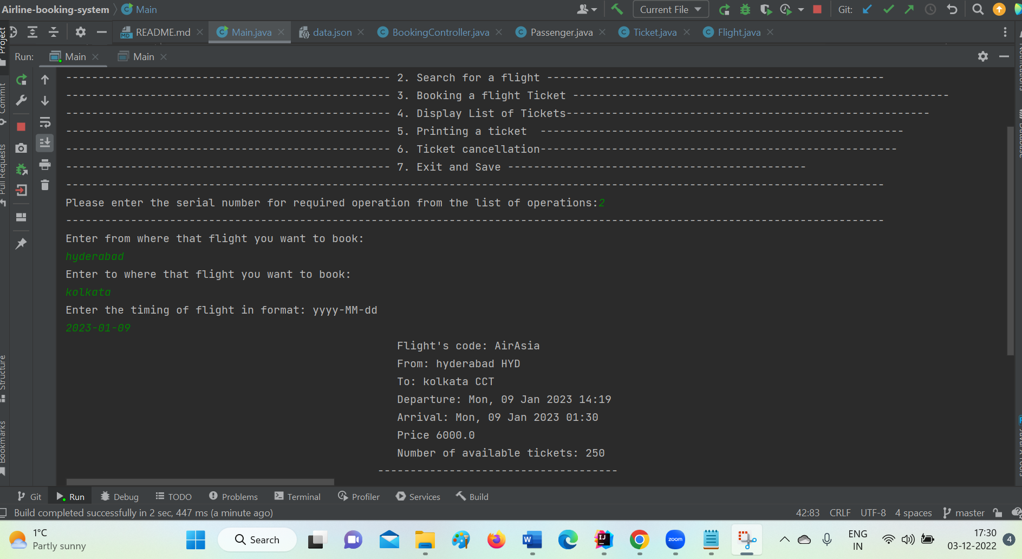

1. **Booking a Ticket: when we select this option it will show all the list of flights that are available in that we need to select one flight based on our requirement. Then we can book a ticket by giving passenger information like name, passport number, age, nationality.**

************************* Hearty welcome to our flight ticket purchase system! ***********************************

------------------------------------------------------------------------------------------------------------------------------

-------------------------------------------------- 1. Display List of Flights -------------------------------------------------------

-------------------------------------------------- 2. Search for a flight ----------------------------------------------------

-------------------------------------------------- 3. Booking a flight Ticket ----------------------------------------------------------

-------------------------------------------------- 4. Display List of Tickets--------------------------------------------------------

-------------------------------------------------- 5. Printing a ticket --------------------------------------------------------

-------------------------------------------------- 6. Ticket cancellation-------------------------------------------------------

-------------------------------------------------- 7. Exit and Save ----------------------------------------------

------------------------------------------------------------------------------------------------------------------------------

Please enter the serial number for required operation from the list of operations:3

------------------------------------------------------------------------------------------------------------------------------

1-

Flight's code: AirAsia

From: hyderabad HYD

To: kolkata CCT

Departure: Mon, 09 Jan 2023 14:19

Arrival: Mon, 09 Jan 2023 01:30

Price 6000.0

Number of available tickets: 250

------------------------------------------------------------------------------------------------------------------------------

2-

Flight's code: AirIndia

From: delhi DEL

To: hyderabad HYD

Departure: Mon, 12 Dec 2022 12:21

Arrival: Mon, 12 Dec 2022 17:30

Price 7000.0

Number of available tickets: 297

------------------------------------------------------------------------------------------------------------------------------

3-

Flight's code: VISTARA

From: banglore BGL

To: delhi DHL

Departure: Fri, 24 Feb 2023 05:30

Arrival: Fri, 24 Feb 2023 07:00

Price 6500.0

Number of available tickets: 287

------------------------------------------------------------------------------------------------------------------------------

4-

Flight's code: Indigo

From: delhi DHL

To: banglore BGL

Departure: Sat, 25 Mar 2023 11:30

Arrival: Sat, 25 Mar 2023 17:00

Price 8200.0

Number of available tickets: 299

------------------------------------------------------------------------------------------------------------------------------

5-

Flight's code: GoAir

From: banglore BGL

To: hyderabad HYD

Departure: Fri, 20 Jan 2023 20:30

Arrival: Fri, 20 Jan 2023 23:00

Price 7300.0

Number of available tickets: 98

------------------------------------------------------------------------------------------------------------------------------

Enter the number of the flight that you want to book:1

------------------------------------------------------------------------------------------------------------------------------

Enter the details of the passenger:

Enter the Passenger Name :

Geetha

Enter the Passenger's passport :

S029836

Enter the passenger's age

30

Enter Passenger's nationality

Indian

Do you want to print the ticket? (please Type yes/y if you want to print or no/n if not)

y

Your ticket saved atTickets/Geetha_14.pdf

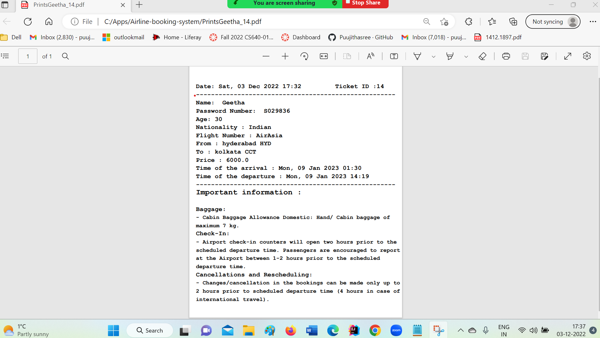

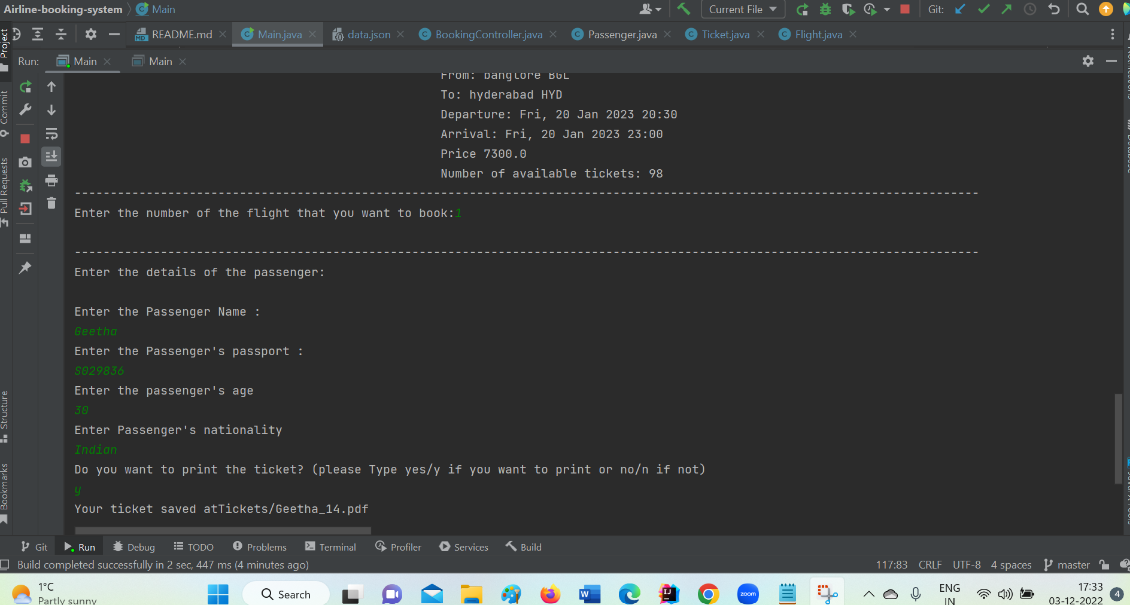

1. **Displaying list of tickets: Here we can display the ticket that we booked.**

************************* Hearty welcome to our flight ticket purchase system! ***********************************

------------------------------------------------------------------------------------------------------------------------------

-------------------------------------------------- 1. Display List of Flights -------------------------------------------------------

-------------------------------------------------- 2. Search for a flight ----------------------------------------------------

-------------------------------------------------- 3. Booking a flight Ticket ----------------------------------------------------------

-------------------------------------------------- 4. Display List of Tickets--------------------------------------------------------

-------------------------------------------------- 5. Printing a ticket --------------------------------------------------------

-------------------------------------------------- 6. Ticket cancellation-------------------------------------------------------

-------------------------------------------------- 7. Exit and Save ----------------------------------------------

------------------------------------------------------------------------------------------------------------------------------

Please enter the serial number for required operation from the list of operations:4

------------------------------------------------------------------------------------------------------------------------------

1-

-------------------------------------

Flight details:

-------------------------------------

Flight's code: Indigo

From: delhi DHL

To: banglore BGL

Departure: Sat, 25 Mar 2023 11:30

Arrival: Sat, 25 Mar 2023 17:00

Price of the ticket :8200.0

-------------------------------------

Passenger details:

-------------------------------------

Full name: APARNA ABBIREDDY

Passport No: S024561

Age: 26

Nationality: Indian

------------------------------------------------------------------------------------------------------------------------------

2-

-------------------------------------

Flight details:

-------------------------------------

Flight's code: GoAir

From: banglore BGL

To: hyderabad HYD

Departure: Fri, 20 Jan 2023 20:30

Arrival: Fri, 20 Jan 2023 23:00

Price of the ticket :7300.0

-------------------------------------

Passenger details:

-------------------------------------

Full name: SOWMYA PONDURU

Passport No: S03467

Age: 23

Nationality: Indian

------------------------------------------------------------------------------------------------------------------------------

3-

-------------------------------------

Flight details:

-------------------------------------

Flight's code: GoAir

From: banglore BGL

To: hyderabad HYD

Departure: Fri, 20 Jan 2023 20:30

Arrival: Fri, 20 Jan 2023 23:00

Price of the ticket :7300.0

-------------------------------------

Passenger details:

-------------------------------------

Full name: aparna

Passport No: s02981

Age: 26

Nationality: Indian

------------------------------------------------------------------------------------------------------------------------------

4-

-------------------------------------

Flight details:

-------------------------------------

Flight's code: GoAir

From: banglore BGL

To: hyderabad HYD

Departure: Fri, 20 Jan 2023 20:30

Arrival: Fri, 20 Jan 2023 23:00

Price of the ticket :7300.0

-------------------------------------

Passenger details:

-------------------------------------

Full name: aparna

Passport No: s09871

Age: 26

Nationality: indian

------------------------------------------------------------------------------------------------------------------------------

5-

-------------------------------------

Flight details:

-------------------------------------

Flight's code: AirAsia

From: hyderabad HYD

To: kolkata CCT

Departure: Mon, 09 Jan 2023 14:19

Arrival: Mon, 09 Jan 2023 01:30

Price of the ticket :6000.0

-------------------------------------

Passenger details:

-------------------------------------

Full name: Geetha

Passport No: S029836

Age: 30

Nationality: Indian

------------------------------------------------------------------------------------------------------------------------------

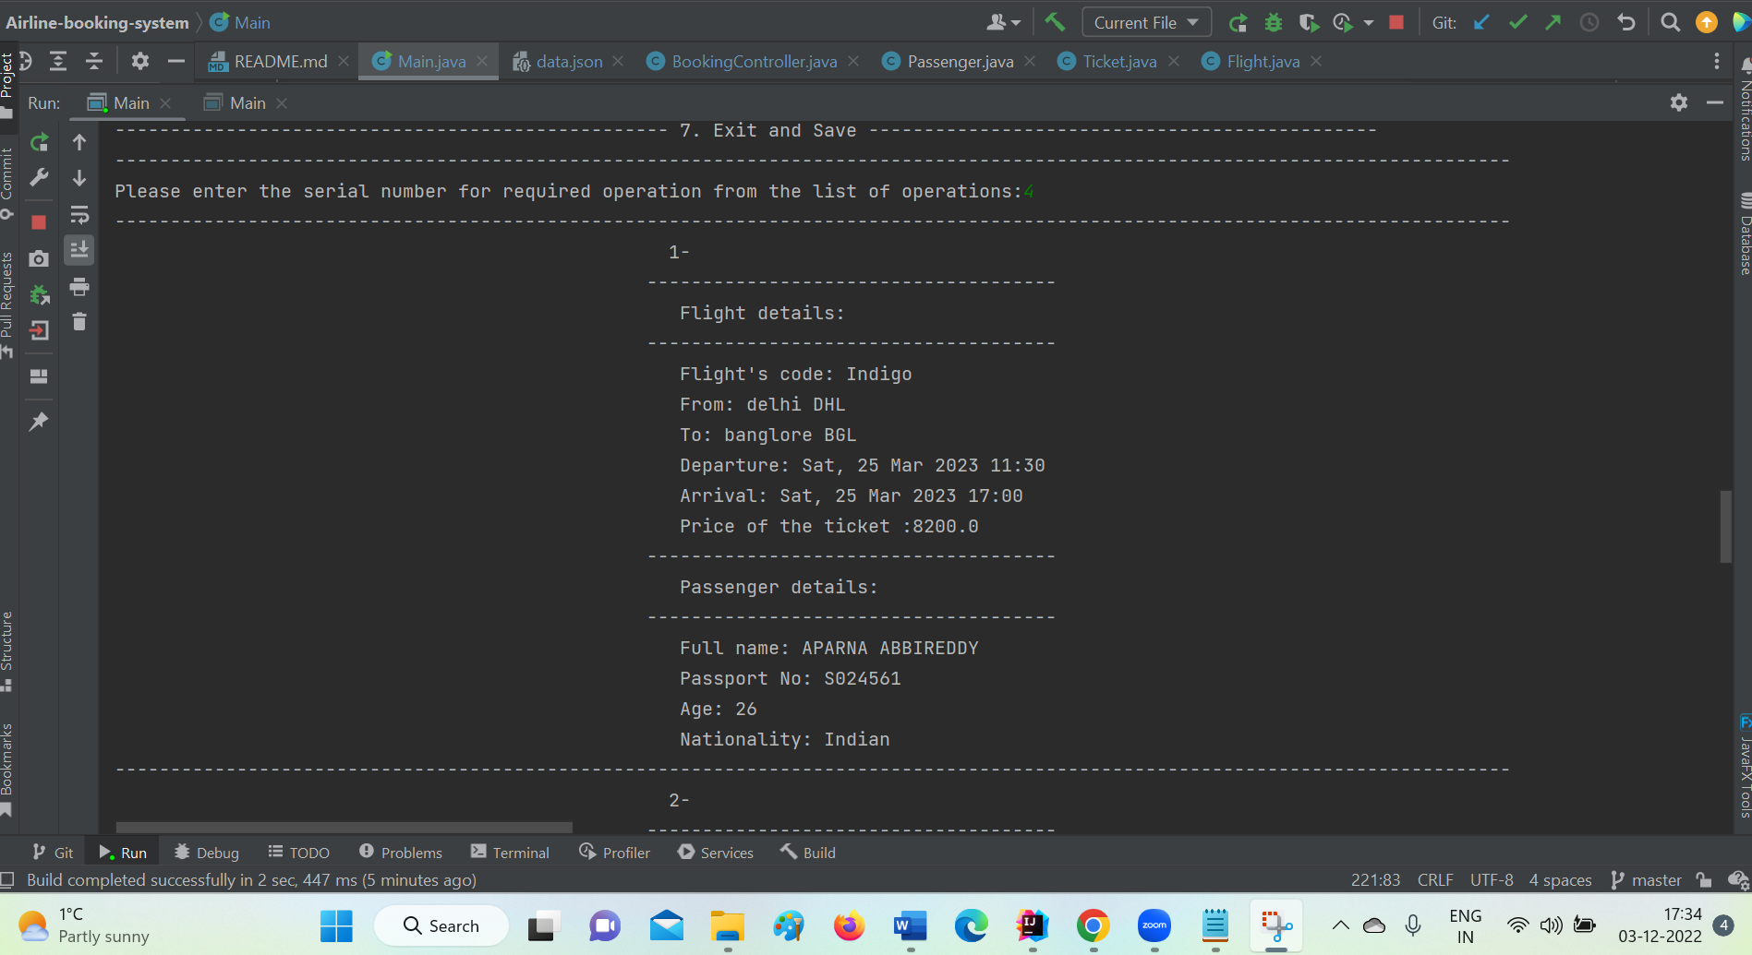

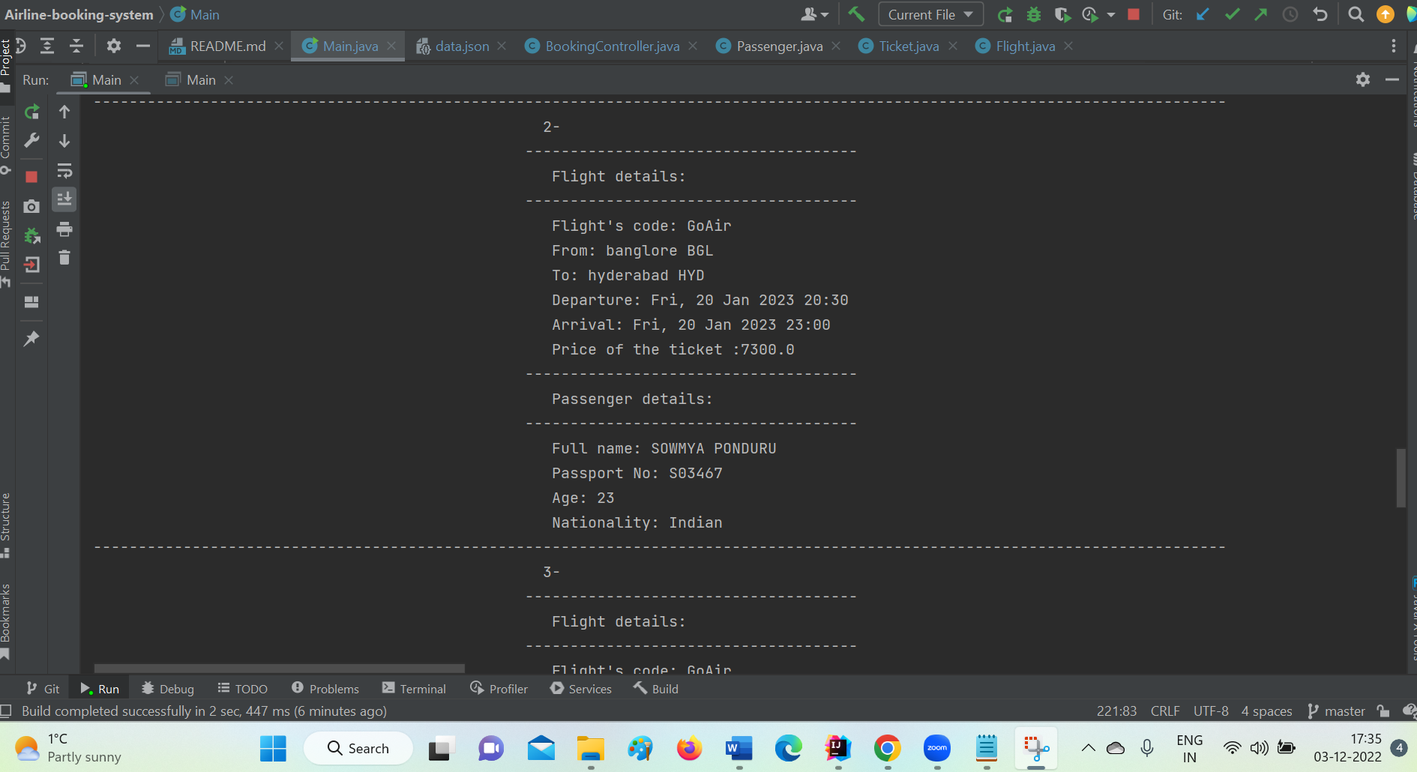

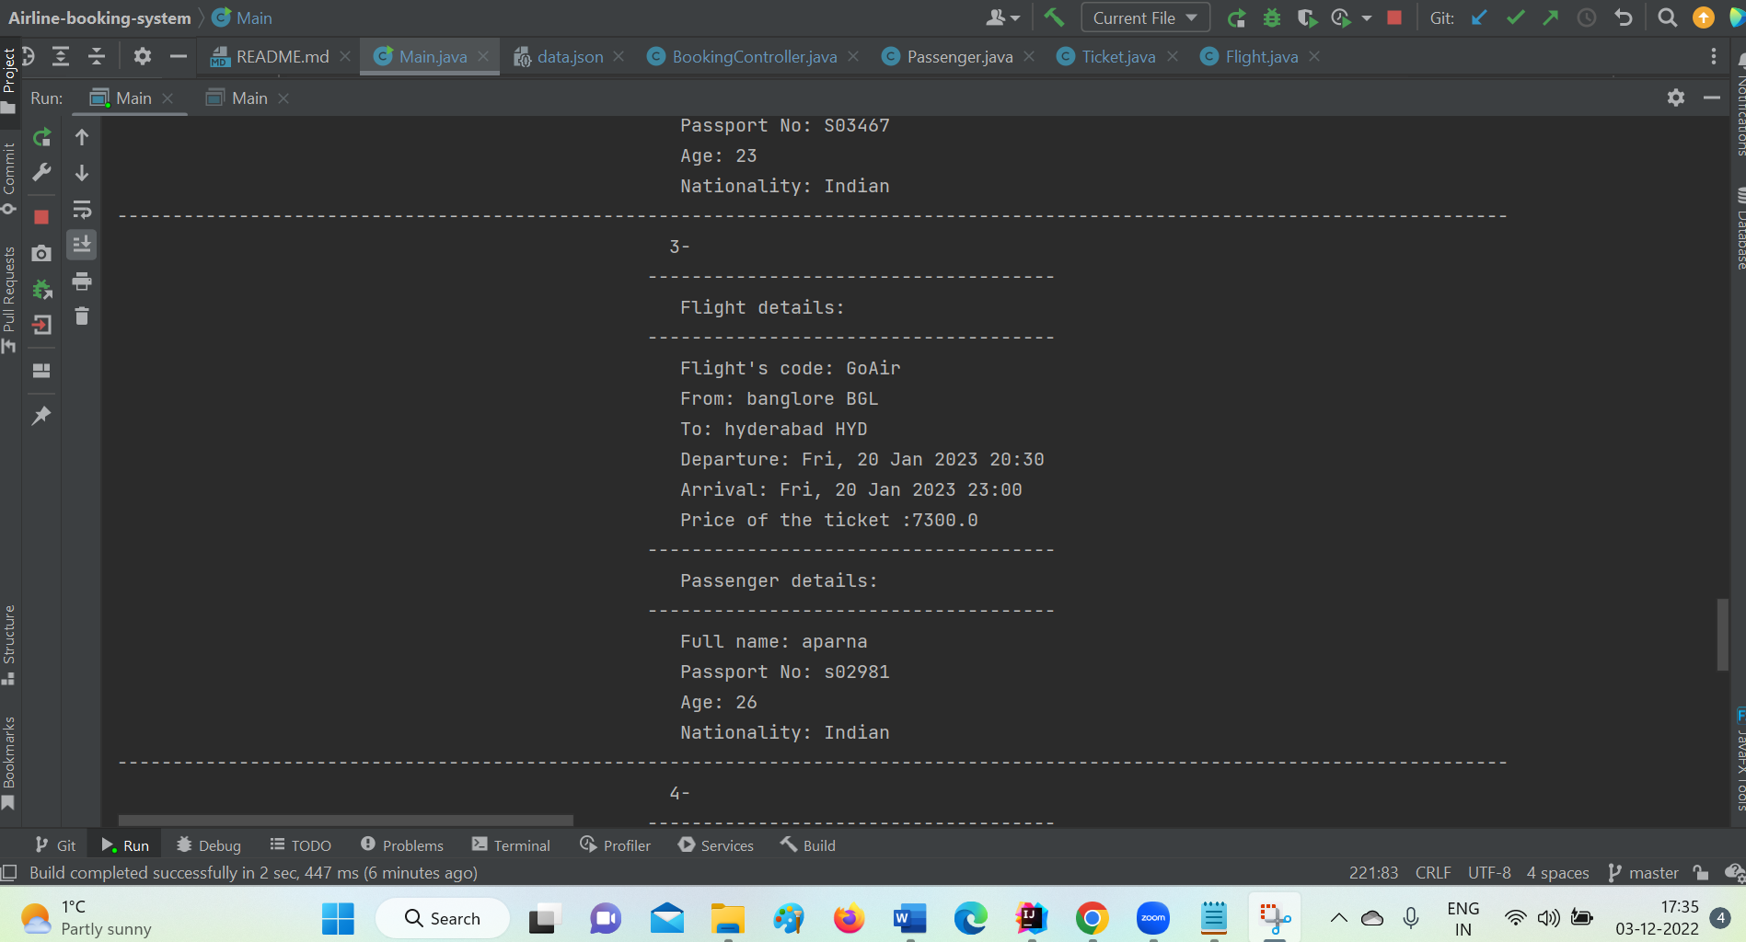

1. **Printing a Ticket: Here we can print the ticket that we booked as pdf.**

************************* Hearty welcome to our flight ticket purchase system! ***********************************

------------------------------------------------------------------------------------------------------------------------------

-------------------------------------------------- 1. Display List of Flights -------------------------------------------------------

-------------------------------------------------- 2. Search for a flight ----------------------------------------------------

-------------------------------------------------- 3. Booking a flight Ticket ----------------------------------------------------------

-------------------------------------------------- 4. Display List of Tickets--------------------------------------------------------

-------------------------------------------------- 5. Printing a ticket --------------------------------------------------------

-------------------------------------------------- 6. Ticket cancellation-------------------------------------------------------

-------------------------------------------------- 7. Exit and Save ----------------------------------------------

------------------------------------------------------------------------------------------------------------------------------

Please enter the serial number for required operation from the list of operations:5

------------------------------------------------------------------------------------------------------------------------------

1-

-------------------------------------

Flight details:

-------------------------------------

Flight's code: Indigo

From: delhi DHL

To: banglore BGL

Departure: Sat, 25 Mar 2023 11:30

Arrival: Sat, 25 Mar 2023 17:00

Price of the ticket :8200.0

-------------------------------------

Passenger details:

-------------------------------------

Full name: APARNA ABBIREDDY

Passport No: S024561

Age: 26

Nationality: Indian

------------------------------------------------------------------------------------------------------------------------------

2-

-------------------------------------

Flight details:

-------------------------------------

Flight's code: GoAir

From: banglore BGL

To: hyderabad HYD

Departure: Fri, 20 Jan 2023 20:30

Arrival: Fri, 20 Jan 2023 23:00

Price of the ticket :7300.0

-------------------------------------

Passenger details:

-------------------------------------

Full name: SOWMYA PONDURU

Passport No: S03467

Age: 23

Nationality: Indian

------------------------------------------------------------------------------------------------------------------------------

3-

-------------------------------------

Flight details:

-------------------------------------

Flight's code: GoAir

From: banglore BGL

To: hyderabad HYD

Departure: Fri, 20 Jan 2023 20:30

Arrival: Fri, 20 Jan 2023 23:00

Price of the ticket :7300.0

-------------------------------------

Passenger details:

-------------------------------------

Full name: aparna

Passport No: s02981

Age: 26

Nationality: Indian

------------------------------------------------------------------------------------------------------------------------------

4-

-------------------------------------

Flight details:

-------------------------------------

Flight's code: GoAir

From: banglore BGL

To: hyderabad HYD

Departure: Fri, 20 Jan 2023 20:30

Arrival: Fri, 20 Jan 2023 23:00

Price of the ticket :7300.0

-------------------------------------

Passenger details:

-------------------------------------

Full name: aparna

Passport No: s09871

Age: 26

Nationality: indian

------------------------------------------------------------------------------------------------------------------------------

5-

-------------------------------------

Flight details:

-------------------------------------

Flight's code: AirAsia

From: hyderabad HYD

To: kolkata CCT

Departure: Mon, 09 Jan 2023 14:19

Arrival: Mon, 09 Jan 2023 01:30

Price of the ticket :6000.0

-------------------------------------

Passenger details:

-------------------------------------

Full name: Geetha

Passport No: S029836

Age: 30

Nationality: Indian

------------------------------------------------------------------------------------------------------------------------------

Enter the number of the ticket:1

------------------------------------------------------------------------------------------------------------------------------

Your ticket saved atTickets/aparna_25.pdf

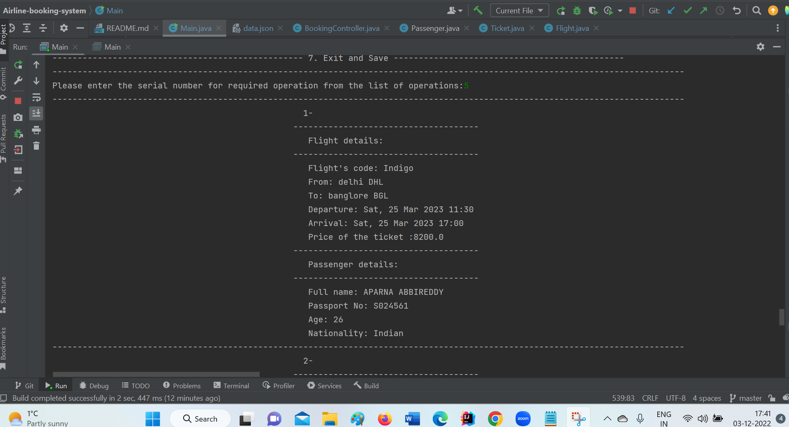

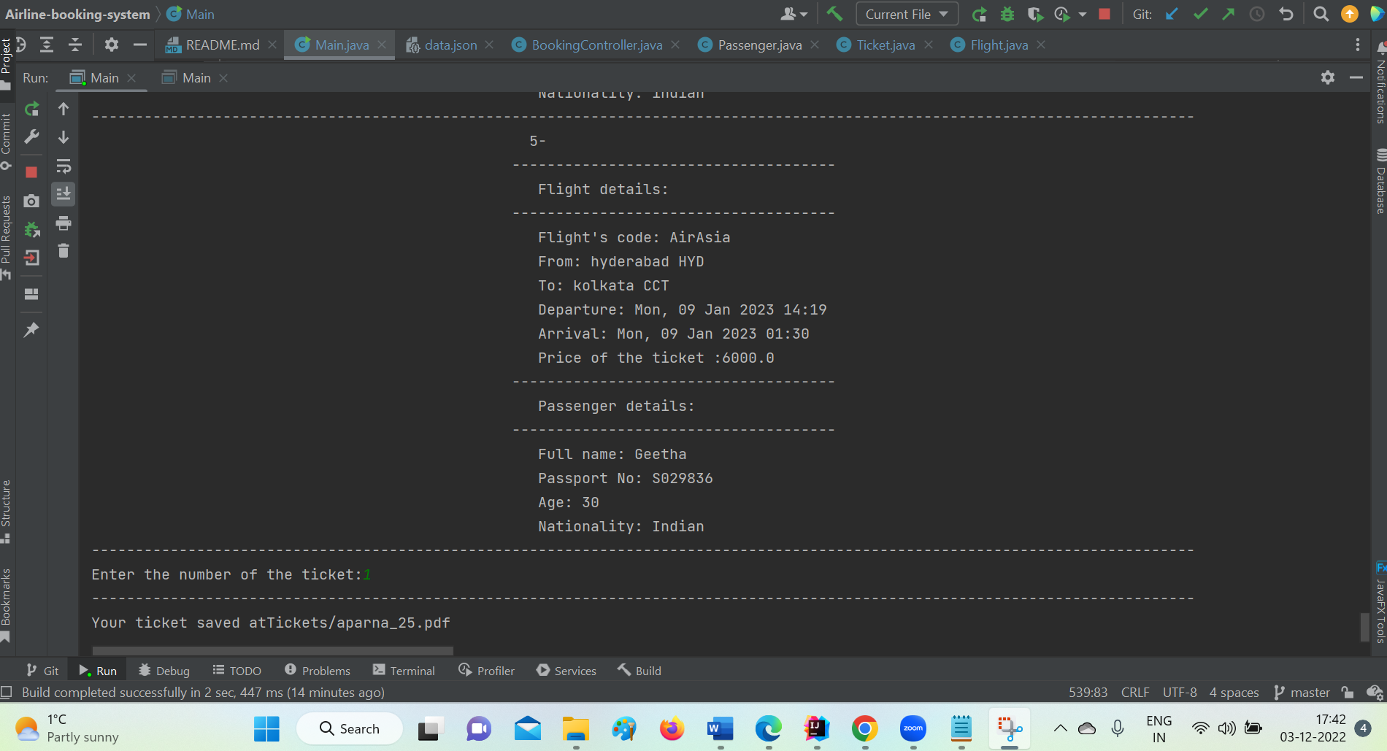

1. **Ticket cancellation: Here we can cancel the booked tickets if needed.**

************************* Hearty welcome to our flight ticket purchase system! ***********************************

------------------------------------------------------------------------------------------------------------------------------

-------------------------------------------------- 1. Display List of Flights -------------------------------------------------------

-------------------------------------------------- 2. Search for a flight ----------------------------------------------------

-------------------------------------------------- 3. Booking a flight Ticket ----------------------------------------------------------

-------------------------------------------------- 4. Display List of Tickets--------------------------------------------------------

-------------------------------------------------- 5. Printing a ticket --------------------------------------------------------

-------------------------------------------------- 6. Ticket cancellation-------------------------------------------------------

-------------------------------------------------- 7. Exit and Save ----------------------------------------------

------------------------------------------------------------------------------------------------------------------------------

Please enter the serial number for required operation from the list of operations:6

------------------------------------------------------------------------------------------------------------------------------

1-

-------------------------------------

Flight details:

-------------------------------------

Flight's code: Indigo

From: delhi DHL

To: banglore BGL

Departure: Sat, 25 Mar 2023 11:30

Arrival: Sat, 25 Mar 2023 17:00

Price of the ticket :8200.0

-------------------------------------

Passenger details:

-------------------------------------

Full name: APARNA ABBIREDDY

Passport No: S024561

Age: 26

Nationality: Indian

------------------------------------------------------------------------------------------------------------------------------

2-

-------------------------------------

Flight details:

-------------------------------------

Flight's code: GoAir

From: banglore BGL

To: hyderabad HYD

Departure: Fri, 20 Jan 2023 20:30

Arrival: Fri, 20 Jan 2023 23:00

Price of the ticket :7300.0

-------------------------------------

Passenger details:

-------------------------------------

Full name: SOWMYA PONDURU

Passport No: S03467

Age: 23

Nationality: Indian

------------------------------------------------------------------------------------------------------------------------------

3-

-------------------------------------

Flight details:

-------------------------------------

Flight's code: GoAir

From: banglore BGL

To: hyderabad HYD

Departure: Fri, 20 Jan 2023 20:30

Arrival: Fri, 20 Jan 2023 23:00

Price of the ticket :7300.0

-------------------------------------

Passenger details:

-------------------------------------

Full name: aparna

Passport No: s02981

Age: 26

Nationality: Indian

------------------------------------------------------------------------------------------------------------------------------

4-

-------------------------------------

Flight details:

-------------------------------------

Flight's code: GoAir

From: banglore BGL

To: hyderabad HYD

Departure: Fri, 20 Jan 2023 20:30

Arrival: Fri, 20 Jan 2023 23:00

Price of the ticket :7300.0

-------------------------------------

Passenger details:

-------------------------------------

Full name: aparna

Passport No: s09871

Age: 26

Nationality: indian

------------------------------------------------------------------------------------------------------------------------------

5-

-------------------------------------

Flight details:

-------------------------------------

Flight's code: AirAsia

From: hyderabad HYD

To: kolkata CCT

Departure: Mon, 09 Jan 2023 14:19

Arrival: Mon, 09 Jan 2023 01:30

Price of the ticket :6000.0

-------------------------------------

Passenger details:

-------------------------------------

Full name: Geetha

Passport No: S029836

Age: 30

Nationality: Indian

------------------------------------------------------------------------------------------------------------------------------

Enter the number of the ticket that you want to cancel it:5

------------------------------------------------------------------------------------------------------------------------------

the deleted ticket:

-------------------------------------

Flight details:

-------------------------------------

Flight's code: AirAsia

From: hyderabad HYD

To: kolkata CCT

Departure: Mon, 09 Jan 2023 14:19

Arrival: Mon, 09 Jan 2023 01:30

Price of the ticket :6000.0

-------------------------------------

Passenger details:

-------------------------------------

Full name: Geetha

Passport No: S029836

Age: 30

Nationality: Indian

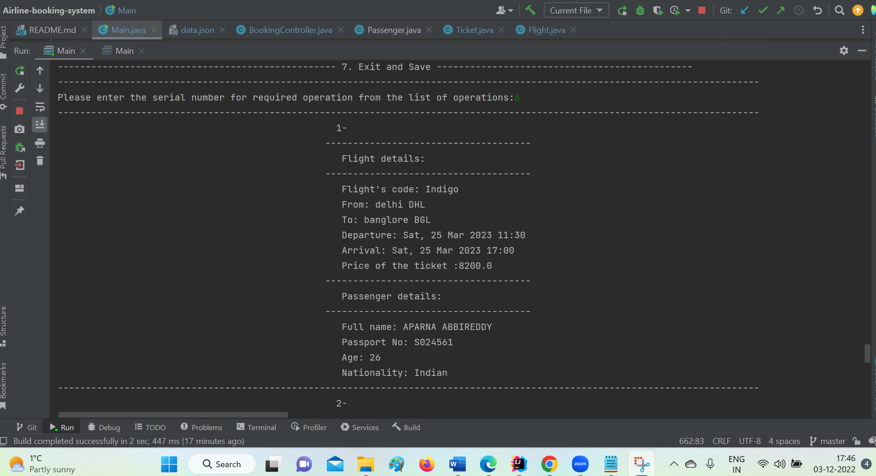

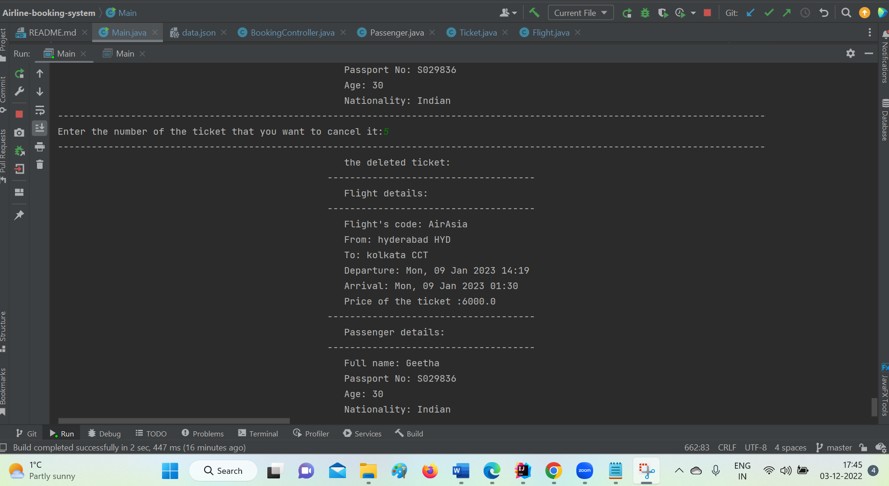

1. **Exit and Save:**

************************* Hearty welcome to our flight ticket purchase system! ***********************************

------------------------------------------------------------------------------------------------------------------------------

-------------------------------------------------- 1. Display List of Flights -------------------------------------------------------

-------------------------------------------------- 2. Search for a flight ----------------------------------------------------

-------------------------------------------------- 3. Booking a flight Ticket ----------------------------------------------------------

-------------------------------------------------- 4. Display List of Tickets--------------------------------------------------------

-------------------------------------------------- 5. Printing a ticket --------------------------------------------------------

-------------------------------------------------- 6. Ticket cancellation-------------------------------------------------------

-------------------------------------------------- 7. Exit and Save ----------------------------------------------

------------------------------------------------------------------------------------------------------------------------------

Please enter the serial number for required operation from the list of operations:7

***Success***

Process finished with exit code 0

